Construction Materials

2008886 Jenny Stroud

Module Tutor: Allan Nantel
Contents

1.0 - Introduction 3
2.0 - Burj Khalifa 3
2.1 - Building Material 3
3.0 - Empire State Building 5
3.1 - Building Material 6
4.0 - Comparison of Steel and Concrete 6
5.0 - References 7

1.0 - Introduction

This report compare two habitable buildings one which is made from concrete and the other made from steel and compare them both and if that type of material is the better option for the buildings location, these two building are the Burj Khalifa and the Empire State Building.

2.0 - Burj Khalifa

The Burj Khalifa is located in Dubai, it is the tallest building and structure in the world and has been since 2009. The purpose for the building was originally to help the new area called Downtown Dubai, this new area was to create at least 30,000 new homes, 9 new hotels, green space and a new shopping centre. During the engineering and architectural stage the developers Emaar starting having financial issues and were in desperate need for extra funding. United Arab Emirates ruler Sheikh Khalifa helped aid the companies financial issue with the build, this resulted in them changing the name from Burj Dubai and naming the building after the ruler (Wikipedia, February 2021).

In the building process the Burj received many complaints about the labour team as most of the workers were from South Asia, as the UAE prefer government jobs and don’t tend or have an interest to go into trades work. Having the workers from South Asia allowed them to keep wages low and according to a documentary from BBC shown the labours being poorly housed while they worked and also worked longer hours than what would normally be expected from labours (Wikipedia, February 2021).

(Image 1, Wikipedia 2021)

2.1 - Building Material

The main structure of the Burj is reinforced concrete, during the build they broke world records of how high they managed to build with concrete as the structure, there was special mixes of concrete used to be able to hold the buildings pressure and each concrete batch was tested to make sure it will hold the weight of such a large building. A company called CTLGroup done testing called the creep and shrinkage to help with the analysis of the build. Once it reached the 156th floor the remaining structure was made from steel. The building would have been easy to mould into the shape that it is, as when the concrete will dry into the shape it is filled into when a liquid. The special mixes of concrete were very important to the build as they also had to make sure it could withstand the Persian Gulf temperatures that can potentially reach 50 degrees celsius. The benefit for using concrete for the build would have allowed them to source the materials locally as they have a large amount of sand because of the location of Dubai. To improve the fire safety of the Burj they installed pressurised air conditioning systems to allow people to be able to have shelter, this is located on every 13 floors. This is in place as the building is so tall and during a fire lifts will be out of use people can have a break on their way done to the bottom floor (Wikipedia, February 2021). Concrete is very useful in hotter climates as concrete and brick are more cooler than other building materials, this can be useful as it will make the building cooler because of their high thermal mass. As the material also allows the building to release the heat slower this will help the building feel warmer during the cooler evenings (Science alert, July 2019).

As well as the concrete under going tests the finished building plan also had tests to see what the wind force would be like for the occupants and if the tower would suffer any damage. Over all they conducted more than 40 wind tests, the initial tests were Dubai’s worst wind year to that date and increased the force until they believe the tower would start to see any issues taking place (Burj Khalifa).

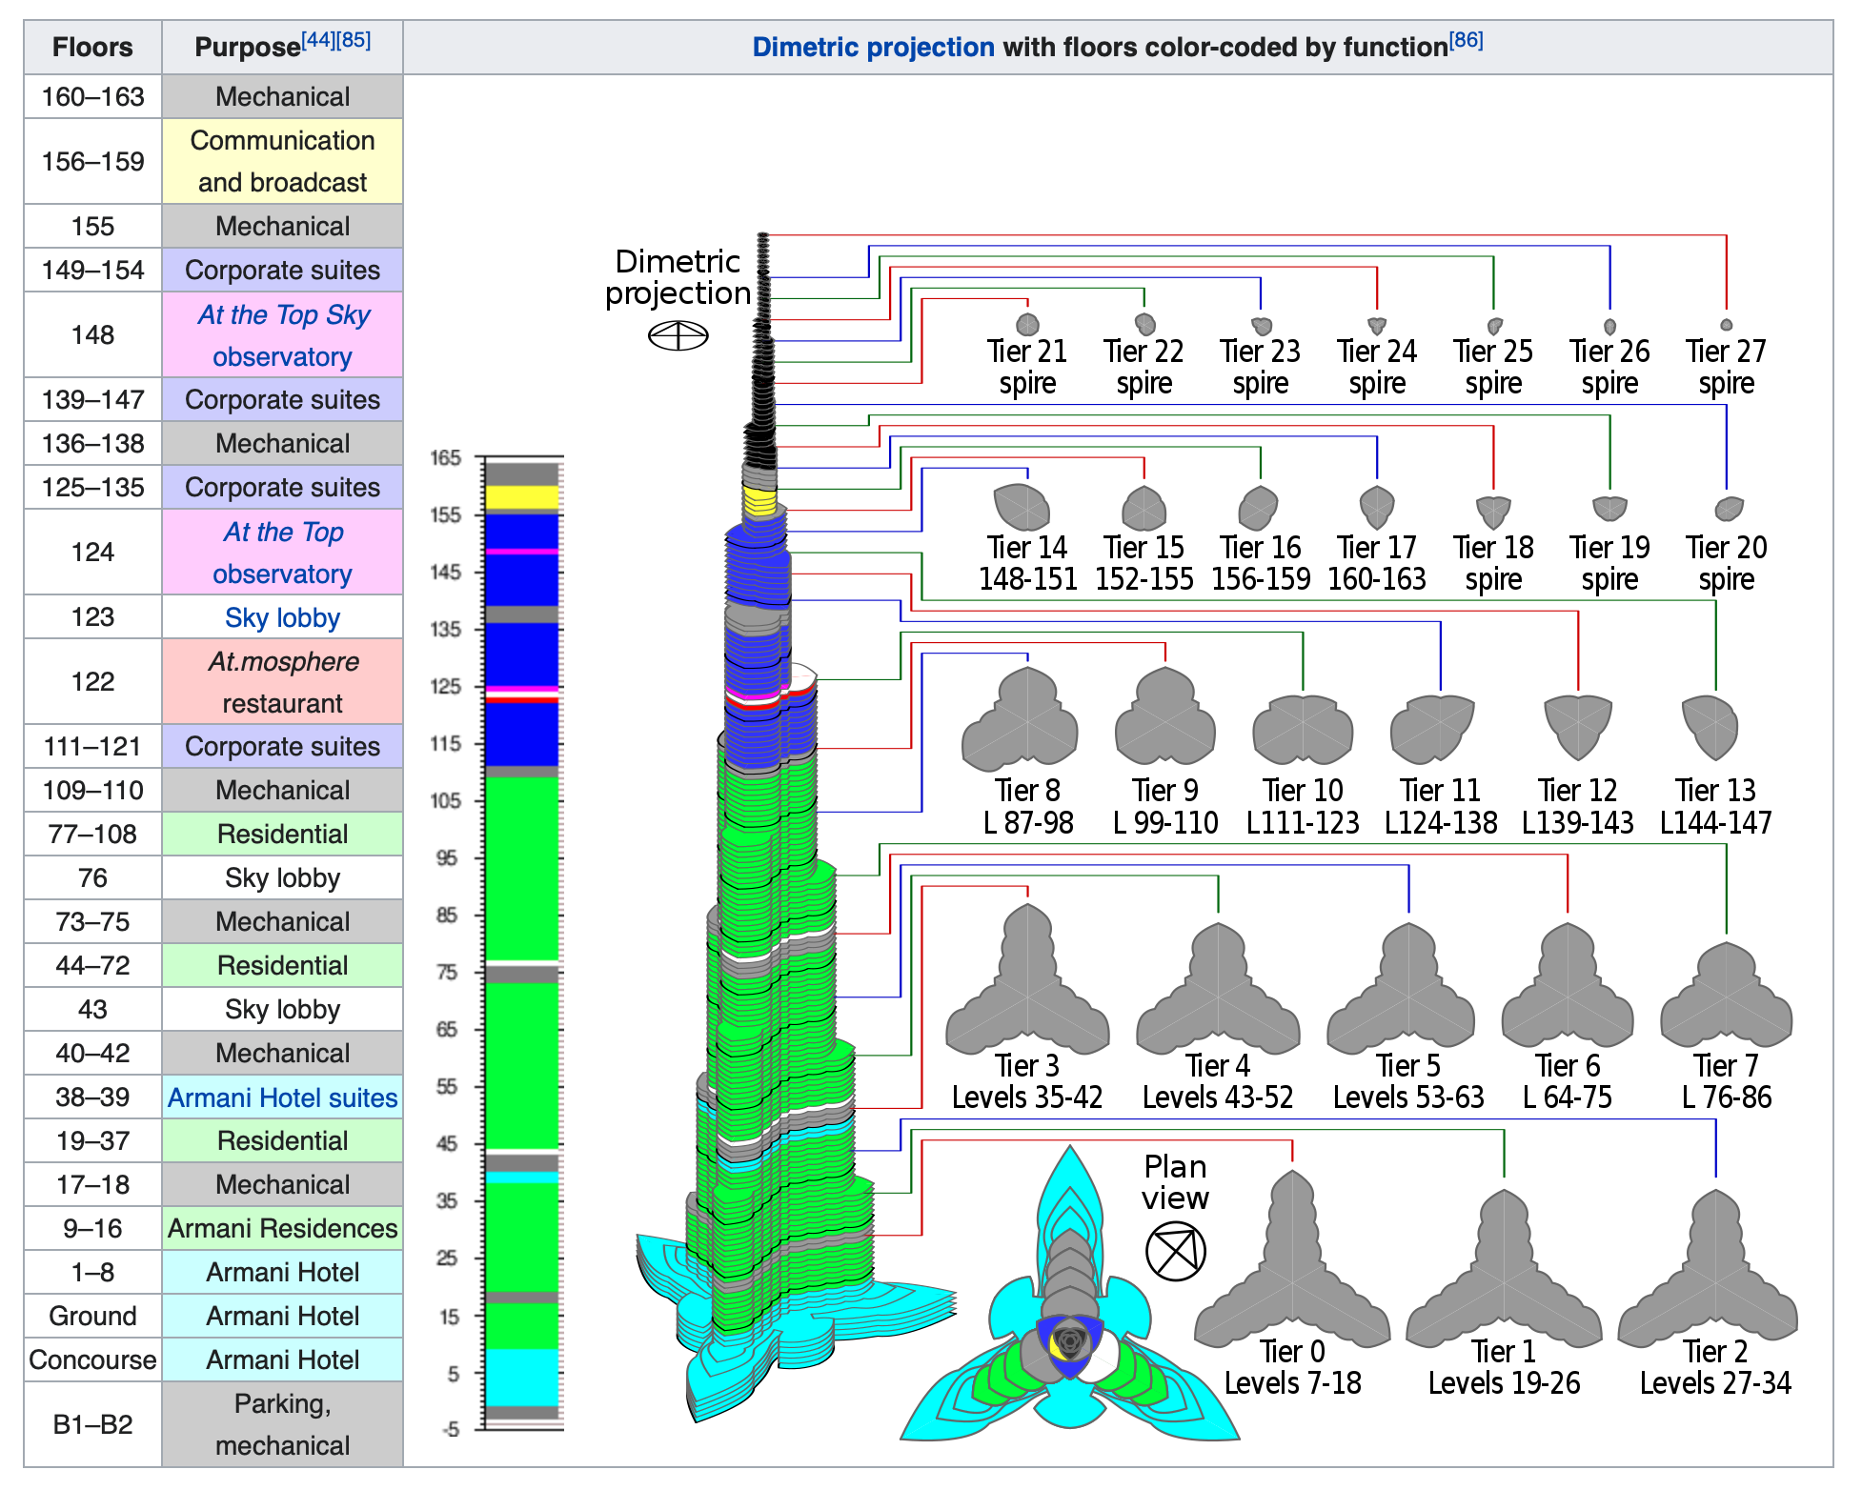
Below shows an image of what the purpose of each floor is for and the shape each floor has been moulded to with the concrete is also shown on the right hand side of the image.

(Image 2, Wikipedia 2021)

3.0 - Empire State Building

The Empire State Building was the tallest building from 1931 to 1970, the building now is mainly used for office space. Including the antenna the building is 1,454 feet tall, before the building plans were confirmed the architects changed the drawing plans 15 times to ensure that this was going to be the tallest building in the world. The original plan was to build a 25 story office building the bank requirements a down payment of $1 million before the build could take place, but Floyd De L.Brown who was the president of the company who owed the site had to borrow $900,000 from the bank and then defaulted the loan. The land then got sold to the Empire State inc, when they were making changes to the plan they got height restrictions placed on many near by buildings so they wouldn’t be able to exceed a certain height as they wanted to make sure the 80 story building would have full views of New York with no obstructions (Wikipedia B, February 2021).

(Image 3, New York State Archives)

During the 1920s in New York it was classed as “The Race to the Sky”. The title came to be because there was three buildings being built during the same time which were all competing for the tallest building in the world, these were the Empire State Building, the Manhattan Bank and the Chrysler Building. Once the Chrysler Building was complete it was named the tallest building and tallest brick building in the world, but the Empire State Building once completed took the title of the tallest building by being 222 feet taller than the Chrysler Building. The Empire State Building in 2001 became New Yorks largest building again after the fall of the World Trade Centre or more commonly known as the Twin Towers (Wikipedia B, February 2021).

3.1 - Building Material

The Empire State Building is the 4th largest steel building in the world. During the building they placed multiple food stalls and water pipes on unfinished floors, this was to help save time so the buildings can work longer rather than have to travel down multiple floors to get to the street to be able to have food and water breaks (Wikipedia B, February 2021).

In 2011 the Empire State Building had a retrofit worth an estimate of $550 million, this retrofit has named the building as New York City’s largest renewable energy building. The aim as well as reducing the building’s usage costs are to help show that older buildings can be more energy efficient. One of the buildings biggest energy saving areas is the adaptable light bulbs, the light bulbs will vary in brightness depending on the sunlight coming through the buildings windows. During the retrofit they replaced all of the windows in the building which is 6,514, they changed them the quadruple glazed windows (The Empire State Building, 2021).

4.0 - Comparison of Steel and Concrete

Concrete is made up from a mix of gravel, sand, concrete and water and air. Concrete has a long life time and doesn’t need much maintenance during its life, concrete is non-combustible meaning that it has a high fire protection level to it. To purchase the concrete is also cheap to buy but If not mixed correctly then the structure or the use for the concrete can crack and cause structural issues (Designing Buildings, February 2021). Once the concrete has dried in place the concrete will not be as ductile as steel because the steel will be able to move and mould to different shapes by using heat to remould it and wouldn’t need to be new steel, while the concrete will need to be broken to change or adapt a room or building if required (Designing Buildings B, September 2020). Concrete pouring has to be at the correct temperature as using concrete in heat should also help the setting time decrease, as the concrete is only mouldable and will be a liquid as long as it has moisture in the mix but as the heat will dry out the moisture the concrete will harden allowing the build to progress faster. If the climate is too hot this could lead the concrete to dry out too fast, this would lead the concrete to start to dry before it has come out of the pouring tube many it will be lumpy and not have the finish the company would like to the build. Another issue with the concrete drying out too fast can cause the concrete to crack if the moisture is dried out too fast, these are areas the architects and builders would have to consider before starting the build (Cemex, 2020).

“Steel is an alloy of iron” and normally has a percentage of carbon in to improve the strength of the material. Steel is rather cheap to buy and also has a fast installation time when it has arrived on site and can help reduce the labour costs because of the speed. Unlike concrete steel doesn’t have a natural fire protection on it and will have to have intumescent coating to help protect the structure from fire damage. Steel frame work is normally 60 percent lighter than a concrete frame (Designing Buildings B, September 2020). Unlike concrete, steel doesn’t have the same worry of the climate being too warm or too cold to be installed, as steel needs a temperature at over 400 degrees celsius to weaken in strength or start to lose its shape and the cold has very little impact on the material. Steel has a high durability level meaning it can hold pressure and be able to stand wear, it can also be resistant to multiple issues some included are earthquakes, water damage and hurricanes (Intelligent HQ, 2021).

5.0 - References

(Burj Khalifa), The Burj Khalifa, https://www.burjkhalifa.ae/en/the-tower/design-construction/ accessed on 23rd February 2021

(Cemex, 2020), Cemex, https://www.cemex.co.uk/concrete-hot-weather-guide accessed on 28th February 2021

(Designing Buildings, February 2021), Designing Buildings, https://www.designingbuildings.co.uk/wiki/Concrete accessed on 25th February 2021

(Designing Buildings B, September 2020), Designing Buildings, https://www.designingbuildings.co.uk/wiki/Concrete_vs._steel accessed on 25th February 2021

(The Empire State Building, 2021), The Empire State Building, https://www.esbnyc.com/about/sustainability accessed on 28th February 2021

(Intelligent HQ, 2021), Intelligent HQ, https://www.intelligenthq.com/what-are-the-benefits-of-steel-buildings/ accessed on 28th February 2021

(Image 1, Wikipedia 2021), Wikipedia, https://en.wikipedia.org/wiki/Burj_Khalifa Accessed on 18th February 2021

(Image 2, Wikipedia 2021), Wikipedia, https://en.wikipedia.org/wiki/Burj_Khalifa Accessed on 18th February 2021

(Image 3, New York State Archives), New York State Archives, http://www.archives.nysed.gov/education/empire-state-building-new-york-city-1932 accessed on 21st February 2021

(Science alert, July 2019), Science Alert, https://www.sciencealert.com/there-s-other-ways-to-keep-buildings-cool-without-energy-intensive-air-conditioning accessed on 28th February 2021

(Wikipedia, February 2021), Wikipedia, https://en.wikipedia.org/wiki/Burj_Khalifa accessed on 18th February 2021

(Wikipedia B, February 2021), Wikipedia, https://en.wikipedia.org/wiki/Empire_State_Building accessed on 21st February 2021

