Module: Effective Team Working and Communication
Module code: BMSW4002
Assignment Title: Component 1 Report Effective Teamworking for team success
Lecturer: Hafiz Rahman
Student name and number: Zlatina Zhecheva Belcheva (2025319)
Executive summary
The overview of the team working has been described in the context of Green Fields Care Home in this report. The explanation of the meaning of team and effective contribution of teamwork have been made in the comprehensive explanation of the overview of the stage. The effective model of team development and its impact in improving teamwork have been discussed with appropriate theoretical explanation. Through advantages and disadvantage analysis of team working help to identify about possibilities regarding future goals. Although using of team, working culture organization get benefits to achieve goals, however some of conflict could be rise in this activity. Moreover, some of recommendation has been suggested for future progression with team working culture in organization.

Table of Contents
1.0 Introduction 4
2.0 Overview of team working 4
2.1 Definition of team 4
2.2 Contribution towards effective teamwork 4
3.0 Models of the team development 5
3.1 Selection of the team development model 5
3.2 Identification, justification and explanation of team development 6
3.3 Description of the model and usefulness of the option 6
4.0 Team roles 7
4.1 Roles need to be implemented to create effective and cohesive team 7
4.2 Theories related with improving team roles 7
4.3 Relative reasons to justify team roles in recruiting new staffs 7
5.0 Discussion 7
5.1 Advantages of effective team working 7
5.2 Barriers to the effective team working identified to the scenario 7
6.0 Conclusion and recommendation 7
6.1 Conclusion 7
6.2 Recommendation 7
Reference list 8

1.0 Introduction
The key areas related with the report is to evaluate the daily operational activities of Green Fields Care Home. The overview of the team and its contribution towards the effective management strategies evaluated in this report. The managerial activities will be analysed in this evaluation as the justification of the model development. The roles related with the effective and cohesive team are evaluated that can help in considering various areas of the organization. The relative advantages of team working and proper visualization of the team performances of the barriers are comprehensively mentioned in which PEE such as explanation, point and evidence will be considered to assess the real-life examples of team working. In the concluding part of the report, the recommendations are going to be provided that will help in developing the prospects which can be able to improve the team working in Green Fields Care Home.

2.0 Overview of team working

2.1 Definition of team
The main purpose of improving the level of team working is to figure out the deficiencies related with the team management. Identification of the proper solutions and maintaining the business strategies of the business facilitated in developing the overall performance of the organization. As opined by Ellis and Sevdalis (2019), in health and social care, the importance of team working in health and social care is very big. The health care services are said to be a combined services of the physicians and doctors who give their full effort to cure the health issues of the patients. The importance of team working can be categorized under four different heads such as accountability as it is the role of everybody to visualize what the steps need to be performed into the scheduled time which evaluates the accountability of the staff. As narrated by Nandakumar and Qorri (2021), the second most important reason which signifies that team working is important for health care services is that prevention of errors. The third most important factor that is considered as an advantage of team working is that it helps in making a better environment for the services. The fourth important aspect which is related with the team working is that it is related with several learning initiates performed among the staff. The rules that are able to define the team as creating interdependencies, application of team-based reward system, focusing on the collective mission, establishing goals and demonstrating a learning environment (Fletcher et al. 2020).

2.2 Contribution towards effective teamwork
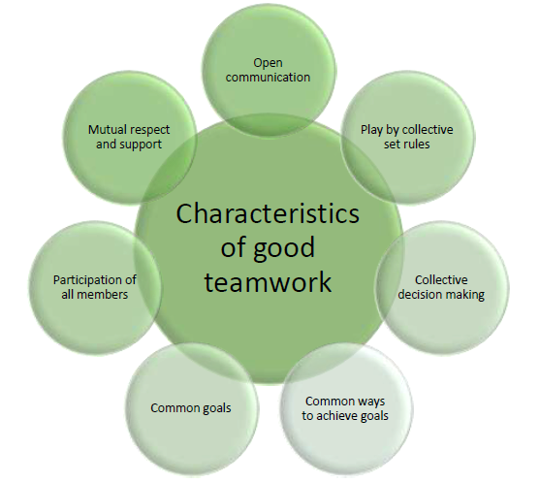
Figure 1: Characteristics of effective teamwork
(Source: Kumar et al. 2019)
The contribution to effective management can be observed as it is necessary to understand the differences of teams and groups. The type of groups can be evaluated as informal and formal groups as it can help in defining proper organizational structure of the business. However, the effectiveness of the informal groups can be observed as it does not consider any organization structure into the team. As believed by Noguera et al. (2018), the team is associated with the collectively accountable procedures and the group directly associated with individual accountable procedures. The size of the team is limited and the size of the groups is large or medium. The common problems within the teams such as lack of commitment, poor communication activities, poor leadership and productivity losses have been faced.

3.0 Models of the team development

3.1 Selection of the team development model
A manager of Green Fields Care Home, it is the responsibility of the person to evaluate the performance level of each and every staff engaged in its services as it was not possible for the doctor to assess the experience level of the staff. The team development model of Tuckman is required to be considered as it will help in giving proper feedback to the knowledge level of the staff. The significance of using the Tuckman model is that it helps in explaining the leader's roles into the Green Fields Care Home. As viewed by Apriati et al. (2021), the five stages of the Tuckman models are forming, norming, performing, adjourning and storming respectively. The selection stages of these stages are directly connected with improving the total level of operational activities within the services. The evaluation of the roles and responsibilities can be possible as the structure of the organization has been adequately mentioned in the performing stage of the Tuckman model.
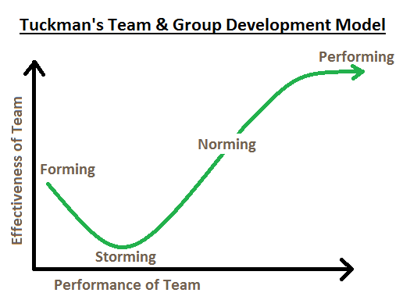
Figure 1: Tuckman’s model of team development
(Source: Schonhaut et al. 2019)

3.2 Identification, justification and explanation of team development
Team development is directly connected with the improvement of the team morale and the overall group performances can be improved through maintaining the professional level of services. The other important theories of team development are Wheelan team development theory and Gersick team morality improvement theory which are said to be two important aspects of improving the level of team development of the organization. As stated by Putriningtias and Kurniawan (2021), the stages included with the Wheelan theory are categorized in four broad stages such as counter dependency, work and productivity, trust and dependency with inclusion. However, the stages of the Gresick theory are stability and instability. The one of the major differences in between the steps are the impact of task and relationship which made an impact into the several important stages of the Green Field Care Home.

3.3 Description of the model and usefulness of the option
The first stage of the Tuckman model is the forming stage in which the characterization has been made with evaluating the leading and structure into the organization. The second stage of the storming stage which is related to the intra conflict. As evaluated by Fitriani and Arwin (2021), the selection of the effective techniques and the policies implemented to develop the financial tactics of the healthcare services. The third stage is norming in which a strong sense of identity has been established among the staff and manager. The fourth stage of this model is performing stage in which the team energy and performance of their business has been evaluated. The fifth stage is the adjourning stage in which the development process and the interconnection among the wrapping up procedures of the team management has been properly explained in this stage (Schonhaut et al. 2019).

4.0 Team roles

4.1 Roles need to be implemented to create effective and cohesive team
The role has to be implemented to develop the effective and cohesive team leader who needs to identify each team member's weakness and strengths. According to leadership theory, leaders of the team need to be dignified about leadership models which help to develop team efficiency. Furthermore, productivity of them has to be implemented through team structure and leadership for future development of work. Members need to “test the water” to determine the type of behaviour that has to be performed in the team. Along with that, leadership should be effective to determine the factors which will help to produce collective ideas for more efficiency of jobs. Proactive roles need to be implemented for decision making about productivity of jobs. Although management of the team needs to be followed by each prospect of jobs to deliver higher effective strategies for more productivity of the team.

4.2 Theories related with improving team roles
Improvisation of team roles could be possible by following Wheelan's Model, which helps to carter dependency and inclusion between team members. Using this model, organization productivity would be increased by the team working model. There are different behaviour-oriented team members who participate in a team where using this model helps to create coordinated work by team members. Dependency on leadership will be built by this model, which would add trust between team members. Team members always wait for leadership decisions which will increase team roles in organized performance.

4.3 Relative reasons to justify team roles in recruiting new staffs
Recruiting new team members is a tough job to assign new work to them. Justification about redirecting new members in jobs roles helps to provide inclusive ideas for new challenges. New team members are working as fresh energy for the new team, which helps to produce out of box thinning to achieve selected goals (Ipsen et al. 2021). Although, implementation of leadership with appropriate work schedule help to carry an effective and cohesive team to work. Along with that proper work planning needs to be implemented and followed by teams for improvisation of team management quality. Using standard protocol in Green Fields Care Home helps to gain a more effective team working with proper communication.

5.0 Discussion
Team working is the active work activity, which helps to achieve the goal of organization for future development. There are different advantages and drawbacks oriented with team working, which are going to be represented with proper justification.

5.1 Advantages of effective team working
Solve problems with better decision:
One of the best advantages of team working is help to make decisions for better implementation of work. According to term working methods all members have different strength to deliver higher productivity to work. Decision making is the important factor to ensure huge productivity and quality in job roles to achieve targets. In the team, working activity team very different ideas help to achieve selected targets with minimum effects.
Increase innovation in works:
Different team members would be useful to identify possible risks of working to achieve a target, where innovative ideas of term members help to achieve targets easily. Innovative ideas are being generated by team members to improve the quality of jobs along with obligations that would be mitigated by the innovation process of organizations (Aksela and Haatainen, 2019). Although the process of team working helps to identify more sufficient activity to use resources with innovative ideas that help to evaluate the factors to develop working quality. Obligation of job procedure helps to generate practice of new innovative ideas. Most successful businesses have become successful by adoption of new ideas. Enhanced personal growth of each member becomes more effective to achieve goals. Communication between team members helps to gain more advantage to gather knowledge, which helps to manage critical situations of organization.

5.2 Barriers to the effective team working identified to the scenario
During team members participation in any particular working activity increases productivity, but lack of communication creates an obligation to achieve goals. Dominating nature of team members would be issues for organization performance. Dominating nature of team members raises issues in internal communication which directly affect them negatively (Emirilyasova, 2022). Poor performance of team work would become issues for organization activity. Although, using team members help to gain more effectiveness in organization activity, differences of thinking between team members could harm organization activity.
Poorly managed team conflict increases issues in the organization, which could disrupt the work procedure of the organization. Although, effective team has been made by leadership to deliver higher productivity to the organization, conflict in decision making could raise issues between coordinated working practices (Dyrhage, 2020). Team members would be demotivated by organizational conflict, which will directly influence work quality of the team. Another factor about team working is the need to be adopted correlated working habits in organizational activity. However, team members productivity would be reduced due to lack of participation in organization activity.

6.0 Conclusion and recommendation

6.1 Conclusion
Based on the above analysis regarding team working culture in Green Fields Care Home it is concluded that some requirements need to be implemented for better results. Team working reading activity has faced challenges for lack of coordination between team employees. Coordinated work is required for this organization, where participation of team members is not toward allocated work. However, team leaders of this organization also need to adopt culture to motivate team members to improvise more effectively. Using team member culture some of the benefits have been identified in this organization, however more efficiency would be delivered by team members through proper leadership management.

6.2 Recommendation
Considering all factors about team working culture of Green Fields Care Home need some changes for better productivity. Leadership management needs to be implemented in this organization through proper vision about future goals, which help to deliver tasks to team members. Conflicts between team members need to be rectified through proper managerial strategy to improve each team member's productivity or contribution. Team members need to proactive regarding their allocated jobs, where allocated jobs of team members would be well managed and coordinated with other employees. Through coordinated activity organization would get better results from team working culture.

Reference list
Aksela, M. and Haatainen, O., 2019. Project-based learning (PBL) in practise: Active teachers' views of its' advantages and challenges. Integrated Education for the Real World.
Apriati, L., Mulawarman, W.G. and Ilyas, M., 2021. Pengembangan bahan ajar menyimak berbasis multimedia interaktif pada pelajaran tematik dengan tema “indahnya kebersamaan” untuk siswa kelas iv sekolah dasar. Diglosia: Jurnal Kajian Bahasa, Sastra, dan Pengajarannya, 4(1), pp.13-22.
Dyrhage, A., 2020. What are the advantages and disadvantages for digital B2C service companies when working with innovation in an agile way?.
Ellis, G. and Sevdalis, N., 2019. Understanding and improving multidisciplinary team working in geriatric medicine. Age and Ageing, 48(4), pp.498-505.
Emirilyasova, S.S., 2022. ADVANTAGES OF EFL IN LAW UNIVERSITIES THROUGH DIGITALIZATION. Современное педагогическое образование, (1), pp.64-66.
Fitriani, M. and Arwin, A., 2021. Pengembangan Media Pembelajaran Video Growtopia Powerpoint pada Tema 7 Subtema 2 Indahnya Keragaman Budaya Negeriku Siswa Kelas IV Sekolah Dasar. Jurnal Pendidikan Tambusai, 5(1), pp.1240-1247.
Fletcher, M.J., Tsiligianni, I., Kocks, J.W., Cave, A., Chunhua, C., Sousa, J.C.D., Román-Rodríguez, M., Thomas, M., Kardos, P., Stonham, C. and Khoo, E.M., 2020. Improving primary care management of asthma: do we know what really works?. NPJ primary care respiratory medicine, 30(1), pp.1-11.
Ipsen, C., van Veldhoven, M., Kirchner, K. and Hansen, J.P., 2021. Six key advantages and disadvantages of working from home in Europe during COVID-19. International Journal of Environmental Research and Public Health, 18(4), p.1826.
Kumar, H., Morad, R. and Sonsati, M., 2019. Surgical team: improving teamwork, a review. Postgraduate Medical Journal, 95(1124), pp.334-339.
Nandakumar, V. and Qorri, A., 2021. Improving team performance working on global software development projects using agile methods. A case study of team performance in GSD, Sweden.
Noguera, I., Guerrero-Roldán, A.E. and Masó, R., 2018. Collaborative agile learning in online environments: Strategies for improving team regulation and project management. Computers & Education, 116, pp.110-129.
Putriningtias, A.D. and Kurniawan, D., 2021. Development of Android Based Game „Weiβt du das?“for German Vocabulary Learning. Journal DaFIna-Journal Deutsch als Fremdsprache in Indonesien, 5(1), pp.16-20.
Schonhaut, L., Martinez-Nadal, S., Armijo, I. and Demestre, X., 2019. Reliability and agreement of ages and stages questionnaires®: results in late preterm and term-born infants at 24 and 48 months. Early human development, 128, pp.55-61.

