
HTML & CSS Web development
ACCA4023

22 July 2026
moses pappoe 2507709
LECTURER: SHAH ROOM.

Contents
Introduction 2
Requirements 3
Purpose: 3
Subject matter 3
Intended audience 3
Implementation 4
Screenshots of the Webpages 4
Validation 5
HTML Validation 5
CSS Validation 5
Evaluation 6
Part A 6
Website usability- 6
Website accessibility: 6
Search engine optimisation 6
Part B 6
Usefulness (Usability and Utility) 6
Search Engine Optimisation (SEO) 6
Accessibility: 6
Part C 6
References: 7

Introduction
This report provides an overview of the design and building process undertaken to create a responsive website for Crenshaw Parks & Gardens, a fictional private company that manages children's parks, family recreation parks and garden allotments for rent. The website has been designed using HTML and CSS, which aligns with current web standards and responsive design principles. This ensures accessibility across desktop, tablet and mobile devices. The report outlines the planning, design decisions, implementation process and key features of the website. These features include navigation, page layout, visual styling and user interaction. It also explains how the website meets the project requirements by providing an attractive, functional and user-friendly online presence for the company.
Requirements
Purpose

The purpose of the Crenshaw Parks & Gardens website is to provide the company with a professional online presence and increase its visibility to potential customers. The website promotes the company's children's parks, family leisure parks and garden allotments by showcasing the services, facilities and pricing available. It also highlights the excellent value for money offered which help visitors make informed decisions. With clear information and easy navigation, the website aims to attract new customers, encourage enquiries and strengthen the company's reputation as a trusted provider of outdoor recreational spaces.

Subject matter

The Crenshaw Parks & Gardens website has been designed to provide visitors with an engaging and informative experience while promoting the company's services. The homepage features a large hero image amid other high-quality images throughout the website to showcase children's play areas, family picnic spaces, landscaped gardens and available allotments.
Short promotional videos are included to give visitors a virtual tour of the parks and demonstrate the range of facilities available. A customer reviews section allows previous visitors to share their experiences, helping to build trust and confidence in the company's services. The website also includes a pricing section that clearly displays the cost of hiring garden allotments and any admission or membership fees, enabling customers to compare options easily. Additional features include a responsive navigation menu, contact form, location information, social media links and clear calls-to-action encouraging visitors to book, enquire or rent an allotment. Together, these features create a modern, user-friendly website that effectively promotes the company's services and enhances its online presence.
Future ideas for the website includes a slideshow that will highlight the company's parks, gardens and recreational facilities. A simple chart or statistics table to show how customers will benefit from affordable pricing compared to similar leisure facilities offered by competitors. Social media links will be integrated for better customer engagement.

Intended audience

The Crenshaw Parks & Gardens website is designed to appeal to a broad range of visitors who enjoy outdoor recreation and gardening. Its primary audience includes families with young children looking for safe and enjoyable parks, individuals and families seeking picnic and leisure facilities and garden enthusiasts interested in renting allotments. The website also targets pensioners, horticulturists, schools, nurseries, stay-at-home parents and local community groups who wish to spend time outdoors, participate in gardening activities or enjoy the company's well-maintained parks and green spaces. The content is presented in a clear and accessible way to meet the needs of users of all ages.

Implementation

Screenshots of the Webpages

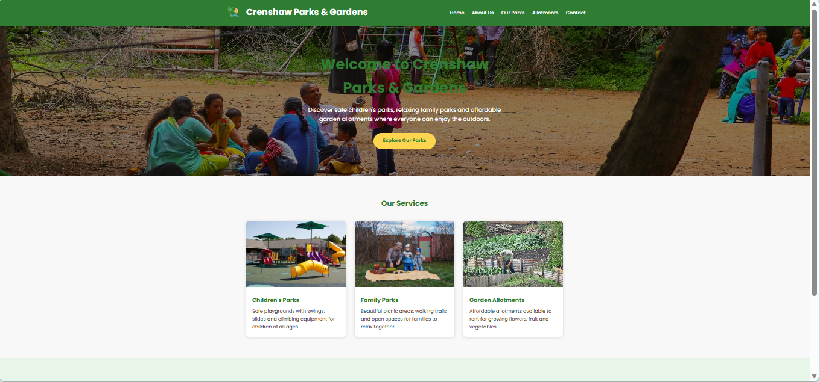
Figure 1: screenshot of Homepage(index.html).

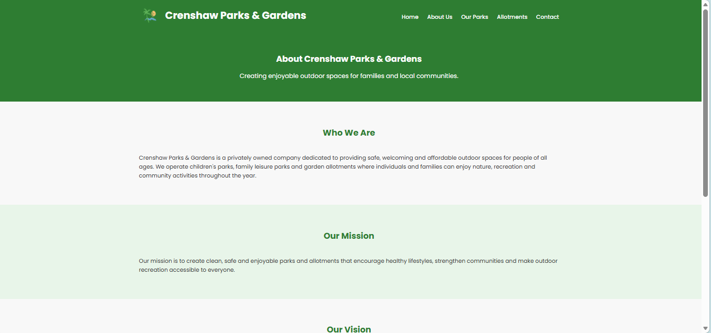
Figure 2: Screenshot of About Us page (about.html).

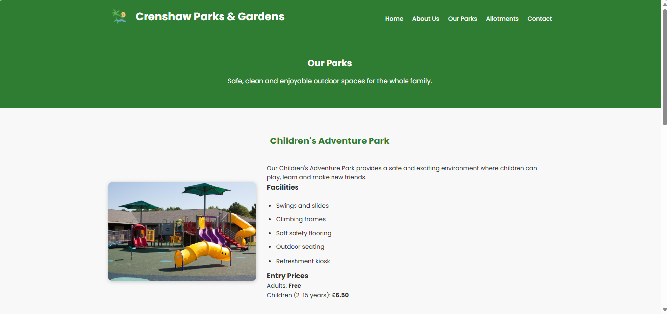
Figure 3: Screenshot of Our Parks page(parks.html)

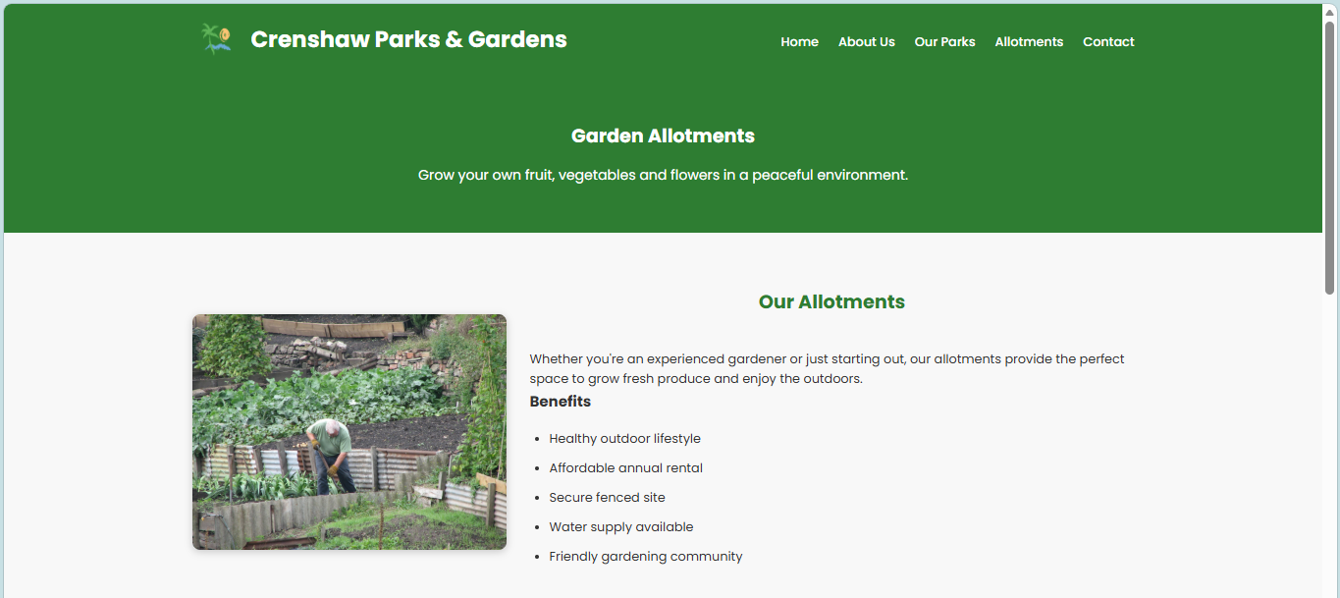
Figure 4: Allotment page screenshot(allotment.html)

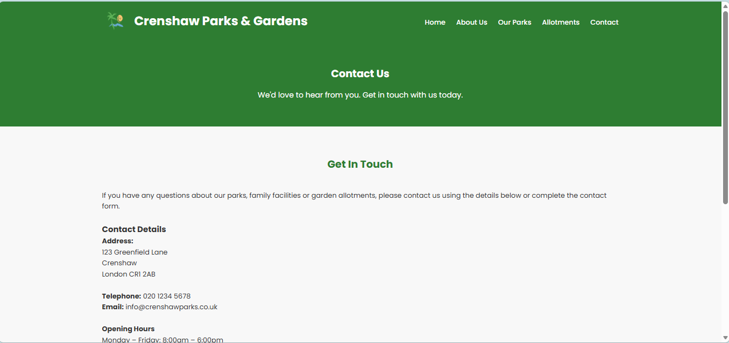
Figure 5: Screenshot of contacts page(contacts.html)

Validation

HTML Validation
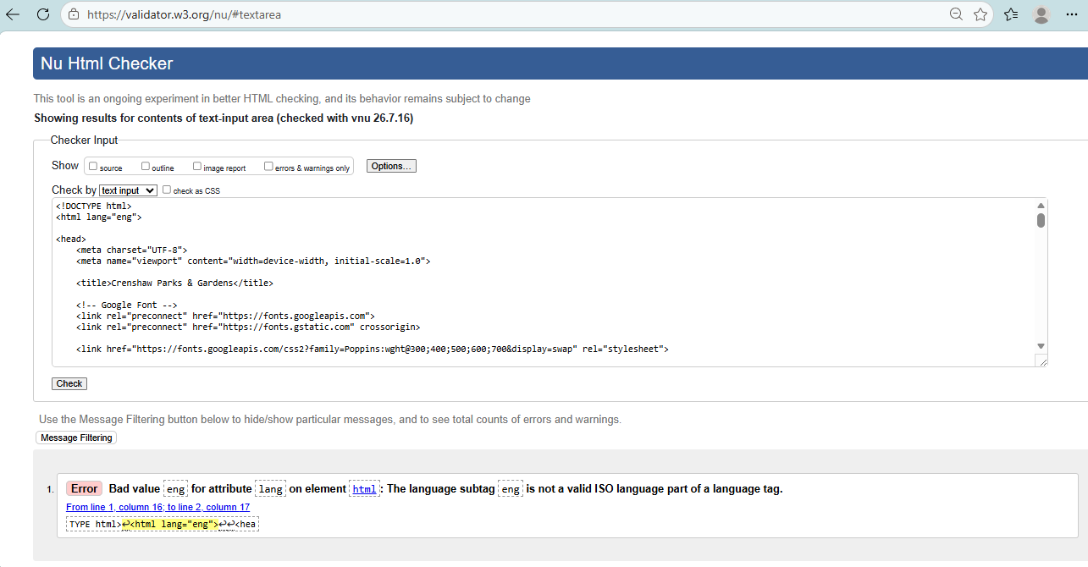
Figure 6 : Screenshot of HTML Validation with error.
Had one error in the validation, which was a ‘bad value’ for ‘lang’ attribute. Typed in ‘eng’ instead of ‘en’. Rectified the error and run the checker again and it was all clear.

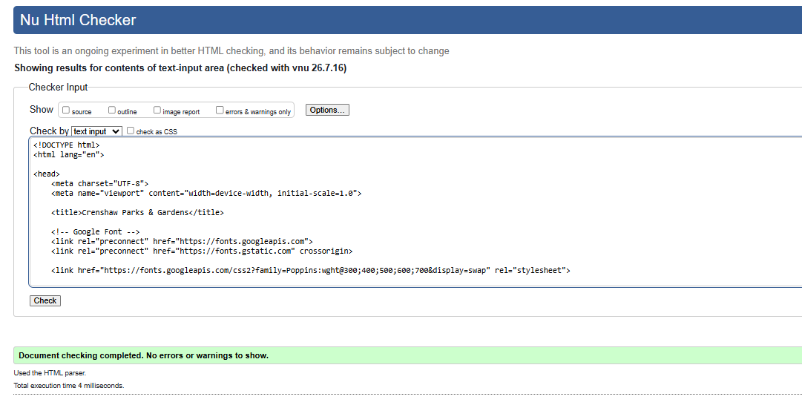
Figure 7: HTML validation without errors.

CSS Validation
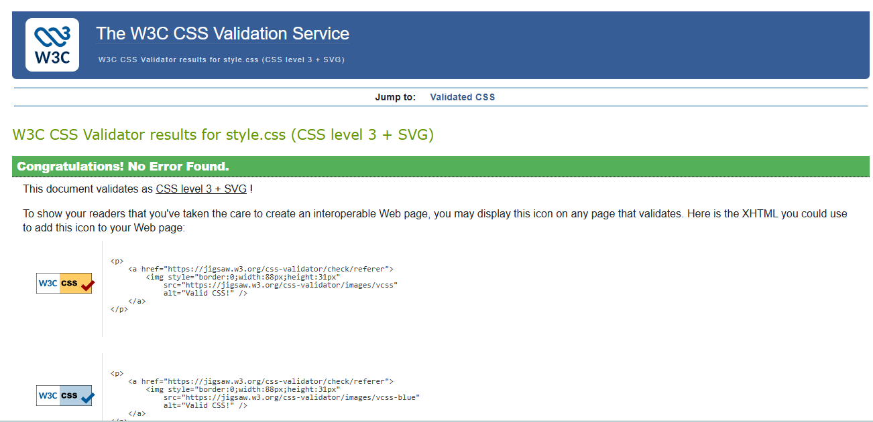
Figure 8: CSS validation without errors.

Evaluation

Website usability
This focuses on how easy and pleasant a website is to use. It is concerned with how smoothly users can accomplish their goals such as browsing for information, signing up for services or finalising purchases. Therefore, it dictates layout architecture and user experience (UX) design during the development process and research has found that website usability can positively affect conversion rates [1]. By creating intuitive navigation paths like placing a company logo in the top-left corner for aesthetic look but which also links back to the homepage, ensures fast page-load times and helps not to overwhelm users otherwise they’ll just move on to a competitor’s website. The researchers discovered that websites that made having a cleanly structured usability layout a priority, experienced significantly lower abandonment rates and immediate boosts in user conversion.

Website accessibility:
This means that developers must ensure that every user regardless of disability or otherwise, will be able to perceive, understand and navigate the digital content created. That means individuals with visual, auditory, motor, speech or cognitive disabilities will be able to use the website built. Developers are required to build accessible websites by adhering to the global Web Content Accessibility Guidelines (WCAG), which require an HTML structure that has meaningful alternative text for images, maintains a high colour-contrast ratio between text and backgrounds and implements seamless keyboard navigation so that usage of a mouse is optional. ARIA (Accessible Rich Internet Applications) attributes can be used to translate dynamic elements accurately to assistive tools like a screen reader. According to research [2], most web inaccessibility issues stem from developers not ensuring that accessibility is a priority during development but treat as an administrative afterthought or an external "patch". The study found that embracing accessibility significantly expands a platform's market reach and avoids the financial cost of having to structurally overhaul an established site later to avoid legal liabilities.

Search engine optimisation
This refers to the intentional practice of strategically structuring and positioning a website in a way to optimize its presence to achieve greater visibility, easy discoverability and to be highly ranked on search engines results pages (SERPs) like Google or Bing. Web developers lay the structural foundation called Technical SEO where they optimize a site for search spiders by implementing server-side rendering (SSR) so bots can easily read complex JavaScript text. This creates a clean XML sitemap, builds logical URL hierarchies and ensures excellent Core Web Vitals performance metrics like page loading speeds, visual stability and interaction responsiveness are tracked. A research study found that modern search engine algorithms are increasingly evolving to favour technical quality and content relevance over previous methods [3], which confirms that technical SEO execution is a foundational business asset.

Part B: Review of My Website.
Usability
The Crenshaw Parks & Gardens website was designed to provide visitors with clear and relevant information about the company's parks, leisure facilities and garden allotments. The website enables users to quickly access information on available services, pricing, opening hours and contact details through a simple navigation menu that is consistent across all five pages.
From a usability perspective, the website has a clean and uncluttered layout with a consistent colour scheme, easy to read and a logical page structure. Images are used to support the written content, making the website visually appealing while helping visitors understand the services offered. The responsive design also allows the website to adapt to different screen sizes, improving accessibility for users on desktop computers, tablets and mobile devices.
The website provides useful information for families, garden enthusiasts and potential allotment renters. Visitors can easily browse the services available and contact the company using the online contact form.
Search Engine Optimisation (SEO)
Many Search Engine Optimisation (SEO) styles were implemented in the making of this web page to improve its visibility within search engines. Every single html page is made with a concise and descriptive HTML title tag title that accurately reflects the content. For example, ‘Home – Crenshaw Parks & Gardens’, ‘About Us – About Us | Crenshaw Parks & Gardens’. Unique page titles help search engines identify the purpose of each webpage.
The website uses logical heading levels ‘<h1>, <h2> and <h3>’ to organise content into clear sections. This improves both readability and search engine indexing.
All images include descriptive alternative (alt) text. Examples are ‘alt="Children's Park", alt="Garden Allotments". This gives search engines the ability to understand image content while also improving accessibility.

Accessibility
The accessibility of the website was evaluated against the four principles of the Web Content Accessibility Guidelines (WCAG 2.1):
Perceivable: Information is presented using clear headings, readable fonts and sufficient spacing between sections. Alternative text has been added to images which aids tools like screen readers to convey their content to visually impaired users. It has consistent colour scheme with good contrast making content easier to read.
Operable: The website can be navigated using clearly labelled navigation links that appear consistently on every page. Buttons and links are large enough to select easily using either a mouse or keyboard. The contact form includes clearly labelled input fields, making user interaction straightforward.
Understandable: The website uses simple language suitable for a wide audience, including families and community members. Navigation labels such as Home, About Us, Our Parks, Allotments and Contact are familiar and easy to understand
Robust: The website was developed using semantic HTML5 elements such as <header>, <nav>, <section>, <footer> and <form>. These elements improve compatibility with modern web browsers and assistive technologies. The website also separates HTML structure from CSS styling, making future maintenance easier.

Part C
Contrasting two real-world websites.

Topic | First Site | Second Site
Website Link | H&M | Online Fashion, Homeware & Kids Clothes | H&M GB | Womens, Mens, Kids & Home | Matalan
Usability | The site looks nice and the menus are well placed and clear. It uses large pictures and makes sales impossible to miss. The search bar and filters let users skip endless scrolling to get straight to the item. | The design isn't fancy, but it is built for speed so you can find what you want instantly. It puts reviews, prices and sales right in front of you so you can decide if a product is worth buying.
Accessibility | The setup doesn't change unexpectedly from page to page. The menus automatically adjust to look good on phones, laptops and tablets. It is designed so that people of all abilities can browse without any hassle. | The website has simple menus and a clean layout, making it fast to find your way around. It also includes helpful, easy-to-use shopping features like a search bar, sorted categories and a store locator.
SEO | Because this website is highly trusted and popular worldwide, it shows up right at the top of search results. Also, constantly adding new collections keeps search engines engaged and keeps the site highly visible. | It has a huge presence in the British retail market, so lots of shoppers already know and trust the brand. It therefore has SEO but not as highly placed as H&M in results rank as its more of a domestic brand.
Mobile Friendliness | Shopping on your phone is quick and easy. The simple setup lets you browse items, search and buy things easily. Plus, the mobile site looks and feels just like the desktop version, so it always feels familiar. | You can browse easily using their mobile-friendly website or app. It has features like barcode scanning, Click & Collect, loyalty card and store map built into it for convenience.
Conclusion | H&M wins by a narrow margin because its site looks sleek and stylish for a world-renowned brand. It’s easy to navigate (Usability), built for users of all abilities (Accessibility), and easy to find on Google (SEO). | Matalan is also good as it prioritises value, promotions and convenience, by offering a straightforward shopping experience and strong mobile functionality where it excels in this comparison.

References:

[1] | E. B. V. a. M. Weideman, “An empirical study on website usability elements and how they affect search engine optimisation,” South African Journal of Information Management, vol. 13, no. 1, p. 428, March 2011.
[2] | J. C. a. M. Markel, “Web accessibility for people with disabilities: An introduction for Web developers,” IEEE Transactions on Professional Communication, vol. 44, no. 4, p. 225–233, Dec 2001.
[3] | R. R. E. R. F. S. T. A. S. P. Usmany, “The Effectiveness of Search Engine Optimization:A Meta-Analysis Study.,” COSTING: Journal of Economic, Business and Accounting, vol. 7, no. 5, p. 807–811.

