

MODULE CODE: Digital Skills for
Personal Development and Business Growth BMSW4008

ASSESSMENT COMPONENT: PORTFOLIO

STUDENT NAME: Michal Zubko

STUDENT NUMBER: 2524436

DATE: 16.03.2026

Contents
Task 1 ..................................................................................................................... 3
Assessment of Digital Skills...................................................................................... 3
References .......................................................................................................... 3
Task 2 ..................................................................................................................... 4
LinkedIn Learning Certificates for Office365 .............................................................. 4
Task 3 ..................................................................................................................... 5
Essay on Relevance of Excel in professional and personal life. ...................................5
References .......................................................................................................... 5
Task 4 ..................................................................................................................... 6
7 Minute Reflective Presentation .............................................................................. 6
References .......................................................................................................... 6

Task 1

Assessment of Digital Skills
Portfolio Example
Image 1
Screen shot of my report
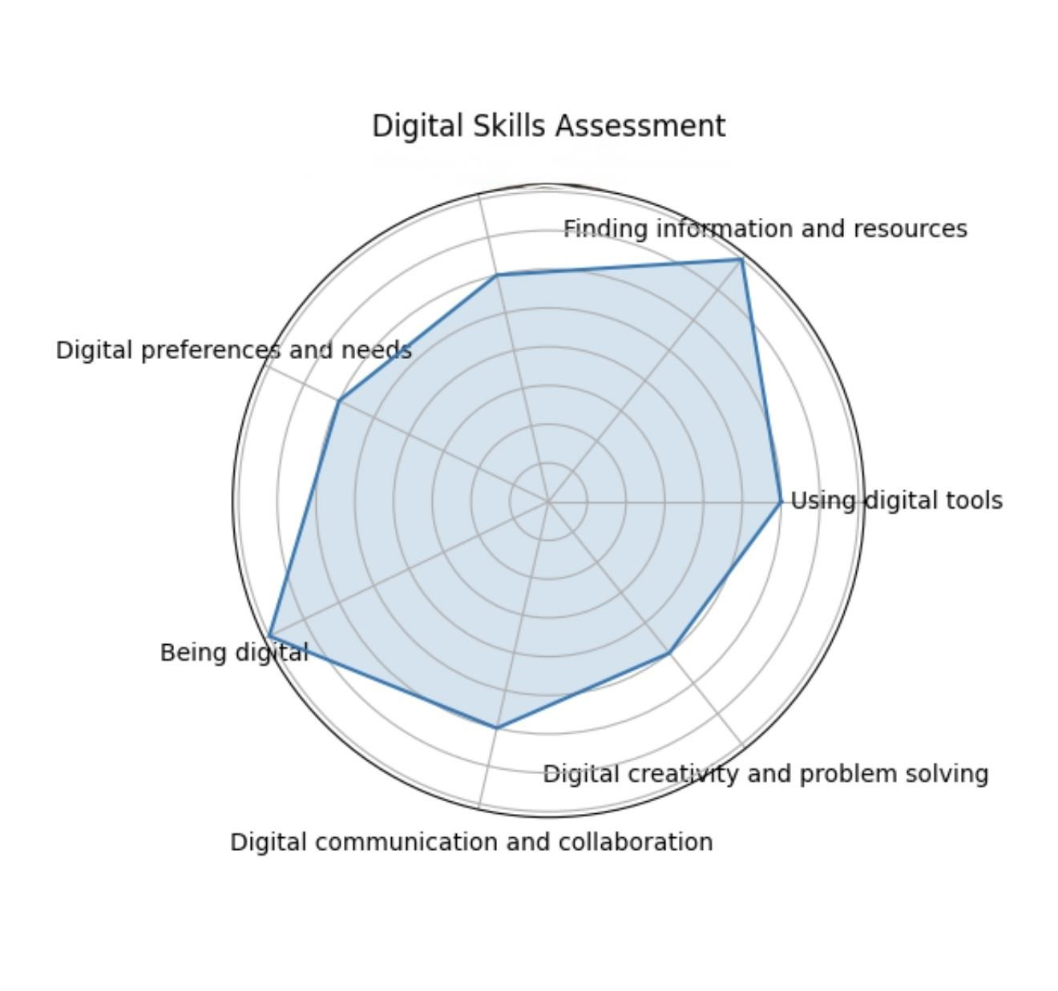
The digital skills assessment provided a useful overview of my current abilities when using digital technologies for learning and everyday activities. The diagram above shows the results of my self-assessment across several areas of digital capability. These include using digital tools, finding information and resources, managing digital learning, digital communication and collaboration, digital creativity and problem solving, digital preferences and needs, and being digital. The assessment helped me understand both my strengths and the areas where I still need improvement.
One of the stronger areas in my assessment is finding information and resources. I scored relatively high in this category because I regularly use online sources for my academic work. As a university student, I often search for articles, learning materials, and information through university platforms such as Moodle, Google Scholar, and other academic websites. I have developed the ability to compare different sources and identify reliable information for assignments and research tasks. According to Jisc (2022), the ability to locate and evaluate digital information is an important skill for students in higher education, as it supports effective learning and research.
Another strong area shown in the diagram is being digital. This refers to understanding how to behave responsibly and safely when using digital technologies. I have developed a good awareness of online safety, including protecting personal information, using secure passwords, and understanding the importance of digital identity. In today’s digital environment, it is important for students to be responsible when using online platforms and sharing information. Digital responsibility helps prevent risks such as data breaches or misuse of personal information (European Commission, 2020).
The diagram also shows a moderate score in using digital tools. I have experience using common digital tools such as Microsoft Word, PowerPoint, and Excel. For example, I often use Microsoft Word to prepare assignments and reports, while PowerPoint helps me create presentations for class activities. However, my skills in some of these tools are still developing, especially when using more advanced features. To improve my knowledge, I completed several LinkedIn Learning courses related to Microsoft Office applications. These courses helped me understand important features such as formatting documents, creating effective presentations, and using formulas in Excel.
Another area where my skills are moderate is digital communication and collaboration. As a student, I regularly communicate with lecturers and classmates using email, university platforms, and online discussion forums. These tools help us share ideas and work together on academic tasks. However, I believe that I can still improve my collaboration skills by using more advanced communication tools and participating more actively in online group work. Digital communication is becoming increasingly important in education and professional environments, where teamwork often takes place online (Redecker, 2017).
The assessment also highlighted managing digital learning as an area that can be improved further. Managing digital learning involves organizing study materials, keeping track of deadlines, and using digital platforms effectively. While I use Moodle and other online systems for accessing course materials, I sometimes find it challenging to organize digital files and manage time efficiently. Developing better digital organization strategies will help me improve my productivity and academic performance.
The lowest score in the diagram appears in digital creativity and problem solving. This suggests that I need to develop stronger skills in creating digital content and using technology to solve problems. For example, although I can prepare presentations and documents, I have limited experience with advanced digital tools such as data analysis software or design platforms. To improve this area, I plan to continue learning new digital tools and practicing creative ways of presenting information.
Based on the results of the assessment, several recommendations for improvement can be identified. First, continuing to complete LinkedIn Learning courses will help strengthen my practical skills in Microsoft Office applications. Second, practicing data management and analysis in Excel will improve my ability to solve problems using digital tools. Finally, developing better organizational methods for managing digital learning will help me become a more effective and independent learner.
Overall, this digital skills assessment has helped me understand my current capabilities and identify areas where I can improve. While I already have a solid foundation in finding information and using digital tools, there is still room for growth in creativity, problem solving, and managing digital learning. By continuing to develop these skills through training and practice, I will be better prepared for both academic study and future professional work.

References
European Commission (2020) ‘Digital Education Action Plan 2021–2027’. Brussels: European Commission.
Jisc (2022) ‘Developing digital capability’. Available at: https://www.jisc.ac.uk (Accessed: 10 March 2026).
Redecker, C. (2017). ‘European Framework for the Digital Competence of Educators’. Luxembourg: Publications Office of the 'Union.
Selwyn, N. (2016). ‘Education and Technology: Key Issues and Debates’. London: Bloomsbury.
Beetham, H. and Sharpe, R. (2019) ‘Rethinking Pedagogy for a Digital Age’. London: Routledge.

Task 2
LinkedIn Learning Certificates for Office365

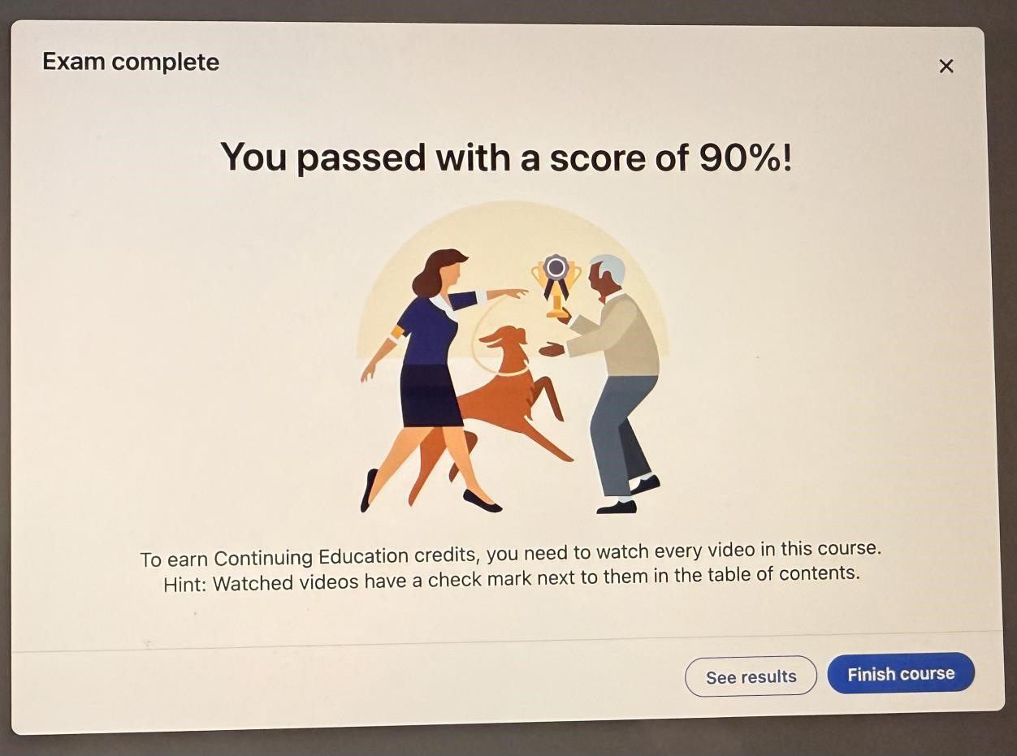
Task 3
Essay on Relevance of Excel in professional and personal life.
During this module I learned how Microsoft Excel can be used as a practical tool for organizing information and solving real-life problems. Before studying this course, I only had basic knowledge of Excel and mostly used it for simple tables. Through this assignment I was able to understand how Excel can be used for financial planning and budgeting. This task focuses on creating a spreadsheet to manage the income and expenses of a single father who is self-employed and lives with his son. By using Excel, financial information can be organized clearly, and calculations can be done automatically using formulas.
In the scenario created for this assignment, the father earns approximately £1700 per month through self-employment. Because he is responsible for supporting himself and his child, it is very important that he manages his money carefully. In addition to his monthly self employment income, he also receives student finance support of £1600 every three months. Since this payment is not received monthly, it needs to be converted into a monthly equivalent so that the budget can be managed more realistically.
In the Excel spreadsheet, the student finance payment is divided into three using a formula. This means that £1600 divided by three equals approximately £533 per month. When this amount is added to the father’s self-employment income, the total monthly income becomes around £2233. This calculation helps provide a clearer understanding of the actual financial situation. Using Excel formulas makes this process easier because the spreadsheet can automatically update the results when values change.
The spreadsheet also includes a list of monthly household expenses. These expenses represent common living costs for a single parent and child. The categories include rent, council tax, electricity, gas, water, food, car insurance, car tax, fuel, child-related expenses, and other basic costs. Each expense is recorded in the spreadsheet so that the total monthly spending can be calculated automatically.
One of the most important features used in this spreadsheet is the SUM formula. This formula is used to calculate the total amount of all expenses. Instead of calculating each value manually, Excel adds the numbers together instantly. This reduces the possibility of errors and makes financial management more efficient. Once the total expenses are calculated, Excel can also determine the remaining balance by subtracting total expenses from total income.
For example, if the father’s total monthly income is around £2233 and his total monthly expenses are close to that amount, the spreadsheet will show how much money remains after all essential costs are paid. This information is important because it helps the user understand whether the current income is enough to cover household expenses. If the remaining balance is low, the father may need to adjust his spending or increase his income. In this way, Excel supports better financial decision-making.
Excel is also widely used in professional environments. Many organizations use Excel to analyze data, track financial performance, and create reports. Employees who have good Excel skills are often able to work more efficiently because they can organize information and perform calculations quickly. According to Microsoft (2023), Excel remains one of the most widely used digital tools in businesses around the world because of its flexibility and powerful data management features.
For self-employed individuals, Excel can also help manage business activities. The father in this example could use Excel not only for personal budgeting but also for tracking his self-employment income and business expenses. By recording payments and expenses in a spreadsheet, he can monitor his financial situation more clearly and prepare accurate financial records when necessary.
Another advantage of Excel is that it can help visualize information. Data from the spreadsheet can be converted into charts or graphs that show how income is distributed across different expenses. This makes it easier to understand spending patterns and identify areas where money could be saved. Visualizing financial data can therefore support better planning and decision making.
Overall, this assignment helped me understand how useful Excel can be in both personal and professional life. By creating a spreadsheet and applying formulas, I learned how digital tools can simplify financial management and organize data effectively. The example of a single father managing his income from self-employment and student finance shows how Excel can support everyday financial planning. Developing Excel skills is therefore an important part of digital literacy and will be valuable for both academic work and future employment.
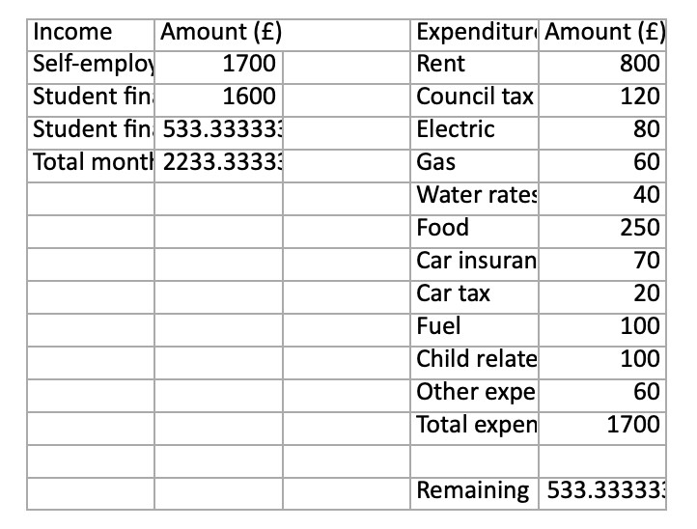

Embed you excel here task3_budget_single_father_adjusted.xlsx

References

Behl, A. (2020) ‘Mastering Microsoft Excel’. London: Routledge.
Gallo, A. (2017). ‘HBR Guide to Excel Basics for Managers’. Boston: Harvard Business Review Press.
McFedries, P. (2018). ‘Microsoft Excel Data Analysis’. Indianapolis: Qui Publishing.
Microsoft (2023) ‘Microsoft Excel Overview’. Available at: https://www.microsoft.com (Accessed: 12 March 2026).
Walkenbach, J. (2019) ‘Excel Bible. Indianapolis: Wiley’.
Beynon-Davies, P. (2020). ‘Business Information Systems’. 3rd end. London: Palgrave Macmillan.
Laudon, K. and Laudon, J. (2021). ‘Management Information Systems: Managing the Digital Firm’. 17th end. Harlow: Pearson.
Rainer, R. and Prince, B. (2021). ‘Introduction to Information Systems’. 8th end. Hoboken: Wiley.

Task 4
Reflective Presentation
E digital_skills_reflective_presentation.pptx

References

European Commission (2022) ‘The Digital Competence Framework for Citizens’ (Dig Comp). Luxembourg: Publications Office of the European Union.
GOV.UK (2023) ‘Essential Digital Skills Framework’. Available at: https://www.gov.uk (Accessed: 16 March 2026).
JISC (2022) ‘Building Digital Capability: The Six Elements Framework’. Available at:
https://www.jisc.ac.uk(Accessed: 16 March 2026).
Microsoft (2023) ‘Microsoft Excel Documentation and Learning Resources’. Available at: https://support.microsoft.com(Accessed: 16 March 2026).
Rainer, R. and Prince, B. (2021). ‘Introduction to Information Systems’. 8th end. Hoboken: Wiley.
Van Deursen, A. and Van Dijk, J. (2019) ‘The first-level digital divide shifts from inequalities in physical access to inequalities in material access’, New Media & Society, 21(2), pp. 354– 375.
OECD (2021) ‘Skills for a Digital World’. Paris: OECD Publishing.
UNESCO (2018) ‘A Global Framework of Reference on Digital Literacy Skills’. Paris:
UNESCO.

