

Module Name: Marketing Fundamentals
Module Code: BMBM4005
Assignment Name
Topic: Marketing in Practise
Student Name: Toni Jones
Student Number:2521465
Lecturer: Gwyneth Jones
Deadline: 17.11.2025

Toni Jones
2125465

Toni Jones
Jack Parsons
Destiny Edwards
Sarah-Jayne James
Lidia Ciszynska

https://uwtsdmarketingfundamentals.blogspot.com/2025/11/join-fight-against-food-poverty-every.html
https://uwtsdmarketingfundamentals.blogspot.com/2025/11/why-food-banks-are-not-just-short-term.html


Join the fight against food poverty – Every donation counts!

Food banks see first hand how deeply food poverty affects families with young children, many parents skip meals, so their children are able to eat a meal. These families often struggle to afford school lunches for their children and often face hard realities, they often must choose between household bills such as heating or food!
This should not be happening!
The trust work towards providing emergency relief through food banks, often which are food parcels. They also offer referrals to specialist services if a person or family is in need.
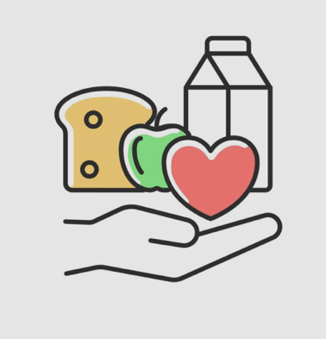
Life can be hard sometimes, getting help shouldn’t be! Click here for support
This time of the year is where a lot of people struggle, christmas can be the most difficult time for families. They more than often struggle not just for food but warm clothing and heating their homes, this is where the trust expresses all the different support services they offer. Everyone deserves a full stomach, we are here when you need us!
Help Families this Christmas
Many parents arrive at food banks, especially those with young babies that need formula, when money runs out, its not just food that they struggle to afford, its basic needs every child and adults need. With help from donations, if that’s food being donated to the food bank in the local areas, in supermarkets that then go on to donate to the trust or Money donated through their online donation links. Many food banks have partnerships with companies that work with them providing donations and aid.
By Giving your time, if that is by donating or volunteering, you are ensuring that someone or even families are receiving the help they need in these challenging times!
Donate here to support people and families this christmas
Why food banks are not just a short term fix!
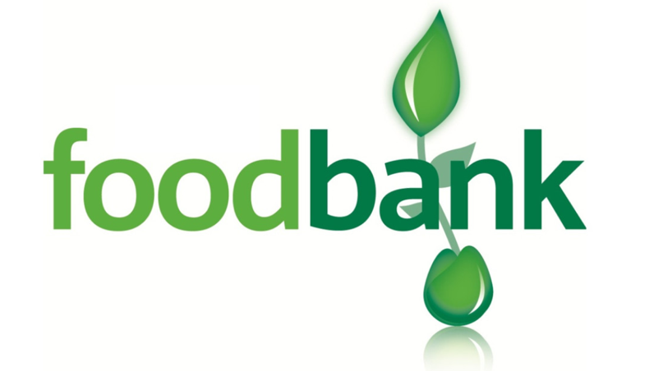
Why food banks are not just a short term fix is because the strain on the Trussell Trust is at all time high. In the year from April 2024 to March 2025, food banks across the Trussell network distributed 2.9 million emergency food parcels to the public, which in turn is equivalent to one food parcel every 11 seconds.
People may argue that the root of the problem is not just temporary hardship, it is the cost of living rising but wages are not!

From 2004, church networks started to provide vital support to people, with the help of volunteers. Many workplaces, schools and many different companies have organised fundraisers such a cake sale, skydives and many more!

Eat Cake, Help End Hunger
Book here to join us for a delicious fundraiser supporting our local food banks, every slice you buy helps put meals on tables for our communities!

The trust could not do what they do without the help of all the volunteers, partnerships and community around them, this is why is it so important to help when you can even if it is a small donation or a free weekend you may have. Your time can change lives, from sorting donations to welcoming families or a person in crisis, every volunteer helps a person feel supported, a child going to bed with a full stomach and the communities growing stronger!
Click here to
Give a few hours – make a lasting difference, Join as a volunteer!
Evaluation of marketing theory that underpins your blog/ social media site

When people hear the word food bank, they often picture plain tinned food and empty shelves with queues of people. But the reality with Trussell is the network it runs, food banks are not just giving out food, they are restoring dignity, supporting people through crisis and campaigning for a better society. My main aim was to apply the marketing theory to increase both donations and volunteer sign ups. My main approach was influenced by research that shows charities such as Trussell engage emotionally, use clear and motivational call to actions, while building trust with the public to take action. According to the Fundraising Regulators research on public experience and expectations of charitable fundraising (Fundraising Regulator, 2024), I learned that donors respond more positively when charity messages are more transparent, emotional and clearly show supporters how much difference their support makes.
My target audience is to towards adults, including younger people as well as students that may want to volunteer. Another sector I looked at was the community, members who already support charity work and often involved in local campaigning. The blue state (2024), which highlights that the most engaged supporters tend to be adults aged 25 to 54, particularly women, parents and people in community are the most like to donate or be a volunteer is what I based my audience on. In some cases, people that want to donate want to understand the scale of the issue before taking action. Sources from the Food Foundations (2024) and their Roadmap to to reducing food insecurity (2025), helped me justify why food banks are still essential and why policy change is part of Trussell’s mission.
In my first blog I focused more on food poverty during the Christmas season, my main goal was to increase donations both physical and financially, by raising the issue of seasonal hardship that is faced by many. Christmas can be the most trying time for many families and seasonal charity events typically generate higher engagement due to emotions associated with giving, compassion and togetherness (Institute of Fundraising, 2023). By making it clear that parents are often skipping meals to feed their children and sometimes being unable to heat their homes, I aimed to prompt the readers to donate urgently. My second blog had two main objectives, one to promote community fundraising, which was the Cake sale which pointed out that every slice that was sold would put another meal on a table for someone in need, and the second to encourage people to volunteer. My aim is to inspire action to volunteer by showing they are essential to the running of food banks and helping families in crisis. This blog was more about the statistics of how Trussell runs as a source stated in the blog and below which is that the trust from April 2024 to March 2025 (Trussell, 2025) distributed 2.9 million food parcels across their food banks in the UK (Trussell Trust, 2025).
I used both emotional and rational tools. Emotionally, I used relatable scenarios that involved parents facing incredibly tough decisions choosing between household bills and food. These statements deeply resonate with uk readers, especially as the cost of living is at its highest in recent memory ONS (2024). Including key facts, such as the 2.9 million emergency food parcels distributed across the Trussell network. Placing heavy emphasis on the cost of living crisis, parents are unable to buy food for school lunches because (winter 2024) shows that 5.4 million low income households couldn’t afford enough food, resulting in skipped meals.
To engage the audience I used clear, informative language and structured the posts in a way to guide the readers to take action. I included community focused statements such as ‘we are here for you when you need us and ‘help families this Christmas’ which helps the readers engage. Social marketing research suggests that people are more than likely to act when they feel included in a collective effort (Public Health England, 2022).
I used several calls to action’s, they were intentionally direct, action oriented and easy to follow. By placing them after factual and emotional information, it is more likely that readers will act. Examples of some of the call to actions were ‘Click here for support’ and ‘Give a few hours – make a lasting difference’. To evaluate the the success of each blog, using a combination of digital metrics I would be able to track the number of links, value and quantity of donations and eve the number of clicks on the links. As for volunteering and fundraising data, I would measure the number of volunteer sign ups, sales in the fundraisers and website traffic to volunteer pages.

References
Fundraising Regulator (2024) The public’s experience and expectations of charitable fundraising. Opinium Research, 29 May. Available at: https://www.fundraisingregulator.org.uk/sites/default/files (Accessed: 17 November 2025)
Trussell Trust (2025) End-of-year food bank stats: 2.9 million emergency food parcels in 12 months. Trussell Trust. Available at: https://www.trussell.org.uk/news-and-blog/latest-stats/end-year-stats/ (Accessed: 17 November 2025).
Trussell Trust (2025) Emergency food parcel distribution factsheet (1 April 2024 – 31 March 2025). Available at: https://cms.trussell.org.uk/sites/default/files/2025-07/eys_UK_factsheet_230725.pdf (Accessed: 17 November 2025).
Blue State (2024) UK Charity Supporter Insight Report 2024. Blue State. Available at: https://www.bluestate.co (Accessed: 17 November 2025).
Food Foundation (2024) Food Insecurity Tracking. Available at: https://foodfoundation.org.uk.
Food Foundation (2025) A Roadmap to Ending UK Food Insecurity. Available at: https://foodfoundation.org.uk.
Joseph Rowntree Foundation (2024) No end in sight for living standards crisis: JRF’s Cost of Living Tracker, Winter 2024. Available at: https://www.jrf.org.uk/cost-of-living/jrfs-cost-of-living-tracker-winter-2024 (Accessed: 17 November 2025).
Office for National Statistics (2025) Public opinions and social trends, Great Britain: March 2025. Available at: https://backup.ons.gov.uk/wp-content/uploads/sites/3/2025/04/Public-opinions-and-social-trends-Great-Britain-March-2025.pdf (Accessed: 17 November 2025).

