An Evaluation of Contemporary Human Resource Management Challenges and Practices: Rush Hair and Beauty UK

In service-based companies, Human Resource Management is crucial since employee performance affects customer experience. Rush Hair & Beauty, a renowned UK salon chain with over 90 establishments, is known for its hairdressing. The success of this labour-intensive business depends on trained stylists, customer service workers, and good management.
The UK hair and beauty industry is under pressure from technological disruption, shifting employee expectations, and increased diversity and inclusion awareness. High staff turnover, talent shortages, and the requirement to maintain service quality across several locations make these difficulties particularly difficult for Rush Hair & Beauty. These issues are highly relevant to the salon industry, where innovation, creativity, and interpersonal skills are essential for competitiveness.
This report examines three critical HR challenges: adapting to technological advancements, attracting and retaining talent, and embedding Diversity, Equity, and Inclusion (DEI).
The report also critically reviews modern HR techniques to meet these difficulties and departmental managers involvement in implementing them. In a fast-paced service environment, managers must implement HR strategy.

Recommendations
- Invest in digital booking systems and continuous staff training.
- Develop structured career pathways and apprenticeship programmes.
- Strengthen employee engagement and recognition schemes.
- Embed DEI into recruitment and leadership development.
- Enhance managerial accountability through performance metrics.
Businesses should invest in digital booking systems and staff training to improve efficiency and service. Structured career ladders and apprenticeships can help retain talent. Employee acknowledgement can boost motivation and reduce attrition. DEI must be included into recruitment and leadership development to create an inclusive workplace. Clear performance indicators will also improve managerial responsibility and HR strategy execution.

Factors Affecting HR

Technological Advancement
Technology is changing the hair and beauty industry, forcing Rush Hair & Beauty to adapt. Hairdressing has historically relied on artistry, expertise, and personal interaction, but technology is changing its future. AI-powered tools, online management systems, and smart gadgets make salons more efficient, customised, and accessible.

Booking Software
Manual appointment scheduling is time-consuming and error prone. Modern internet booking systems allow customers to choose their favourite times.

Virtual Imaging

Social media is a powerful tool for hairdressers. Highlight your salon's skills on Instagram, Facebook, and TikTok by showing your latest work and engaging with clients.
Virtual imaging technology now allows clients to "try on" different hairstyles and colours before committing to a change. (Hairdressing Supplies, 2026).

Salon Management Systems
Running a salon is more than just creating beautiful hairstyles—there’s also inventory, payroll, and client records to manage. A salon management system can help with these tasks, making the business side of hairdressing more efficient.

Smart Hairbrushes
Innovation in hair tools has led to the creation of smart hairbrushes. These brushes are equipped with sensors that analyse the condition of the hair and provide feedback for improving care routines.

Smart Skincare
Salons often extend their services to skincare, and technology has taken this area to new levels. Tools like AI-powered skin analysis and LED light therapy can offer clients personalised skincare treatments.

However, deploying these technologies is difficult. New solutions may be difficult to deploy for salon staff without significant digital abilities. Staff training takes time and money, straining resources. Technology adoption differences across salons can also cause inefficiency and poor customer service.
As social media marketing grows, it puts more pressure on workers to keep up with their online presence, which may not be something all of them are good at. Data protection and system integration are very important, especially for client data.

Talent Acquisition and Retention

The UK hair and beauty sector is marked by elevated staff turnover and a deficiency of skilled labour. Rush Hair & Beauty faces significant difficulties in finding and retaining qualified stylists. Competent workers are in great demand and frequently transition between salons for enhanced salary, flexibility, or career advancement.
Retention is notably challenging because of the difficult nature of the labour, extended hours, and the pressure to achieve sales targets. A significant number of employees, particularly younger individuals, emphasise work-life balance and career advancement, which may not consistently receive sufficient attention.
Apprenticeships are frequently employed to cultivate talent; they necessitate a long-term investment and do not ensure retention.
Moreover, competition from freelance and self-employed stylists exacerbates recruitment challenges.
Absence of defined professional advancement and inadequate acknowledgement may result in employee discontent. In a service-oriented context, this directly influences customer happiness and organisational performance.

Staff hiring and retention are major concerns for professional beauty businesses today. Many salons offer increased compensation, professional advancement, shorter shifts, and free items to retain staff. These are helpful and will help retain personnel, but combining benefits with an open, honest, and human-centered salon environment is more sustainable. Your teammates are people with hopes, dreams, anxieties, and objectives outside of work. Meeting them personally fosters mutual respect and a happy workplace. Employees are more likely to stay if they feel heard, valued, and recognised for their efforts.
Individuals and salons benefit from continuing education. In a fast-changing sector, keeping your team up to date on standards and best practices is crucial to corporate growth. Nurturing your staff's unique interests and investing in their professional growth shows that you care about their development and gives them a reason to stay loyal to your salon.
Businesses throughout the world struggle to find and maintain outstanding teams, but creating a secure, open, honest, inclusive, and growth-focused workplace will likely keep employees. Workers want to feel respected and heard at work. They want to work where they can progress and be treated decently. Communication, education, expectations, culture, and a thoughtful hiring procedure may help your salon succeed.

Employee engagement is a critical element of contemporary talent management within Rush Hair & Beauty. Performance reviews, recognition programs, and open communication can help employees feel appreciated and supported. The fast-paced nature of salon work, workload pressures, and branch-specific management styles may make engagement difficult to maintain. Thus, Rush Hair & Beauty must create engagement activities across all sites and support them with managerial leadership.

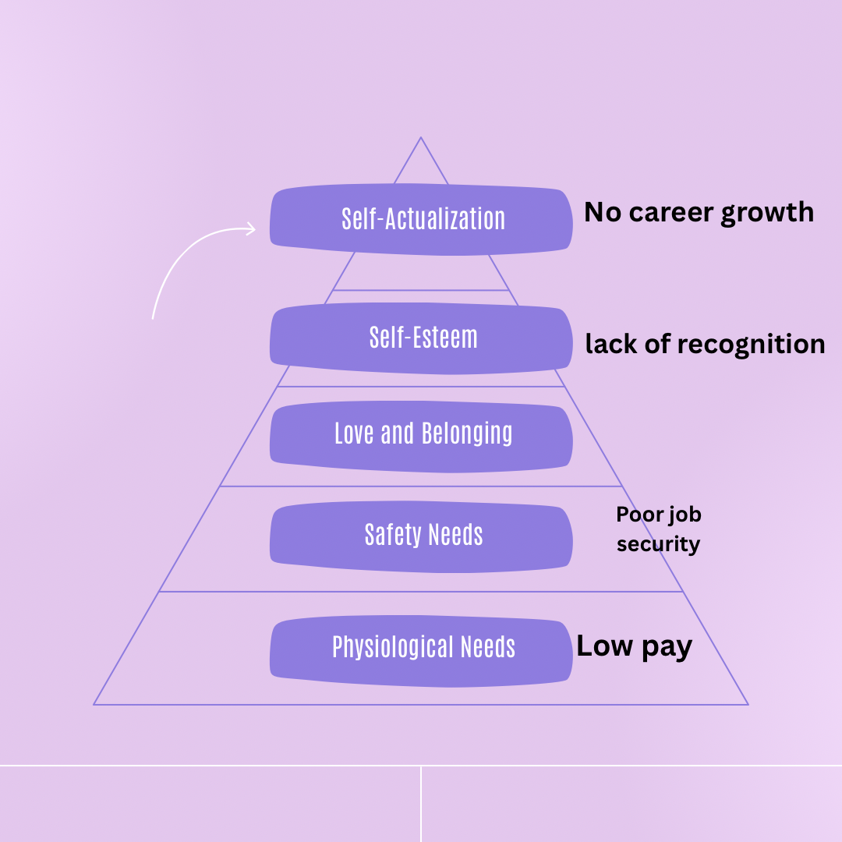

Maslow Theory

Maslow's Hierarchy of Needs offers a valuable foundation for comprehending talent acquisition and retention. At the physiological level, inadequate compensation deters candidates and repels employees. The necessity for safety highlights the significance of employment security, as unstable positions reduce employee retention.
Belonging emphasises workplace relationships and an inclusive culture, which affect engagement. Self-esteem demands emphasise the need of recognition, since a lack of appreciation lowers motivation and elevates turnover rates. Ultimately, self-actualization signifies job advancement; in the absence of developmental chances, employees pursue progression elsewhere. Therefore, companies must address all levels of need to recruit, motivate, and keep a dedicated and high-performing workforce.

Diversity, Equity and Inclusion (DEI)
Rush Hair & Beauty employs personnel from diverse cultural, ethnic, and social backgrounds. Diversity fosters innovation and customer engagement, however hampers equity and inclusion.
The National Occupational Standards for Hairdressing was a notable achievement. This modification guarantees that professionals are trained to manage all hair varieties, especially Afro and textured hair, which were previously neglected in beauty education.
This modification makes beauty education and services more inclusive. Thorough Industry Census. The British Beauty Council conducted "A Beauty Industry That Looks Like You," a survey with 4,000 participants from the industry. Diversity in modelling, including older generations and many body shapes, is replacing beauty standards (British Beauty Council, 2026)
Unconscious bias, unequal opportunity, and insufficient leadership diversity can undermine employee morale and retention rates. In the salon industry, where aesthetics and self-expression are essential, services and the work atmosphere must be inclusive.
Disregarding DEI can adversely affect reputation and staff engagement. Customers increasingly want organisations to represent diverse communities, hence elevating DEI to a strategic priority.

Evaluation of Contemporary HR Practices

Technological HR Practices

Rush Hair & Beauty can implement integrated digital systems such as online booking platforms and HR management software. These tools improve operational efficiency and enhance customer experience.

- Virtual Try-Ons & AR: Tools like ModiFace(L'Oréal) and virtual try-on apps allow customers to test hair colours, makeup, and skincare instantly

- AI-Powered Personalization: Companies utilize AI for skin diagnostics (e.g. Neutrogena Skin360, Shiseido Skin Visualizer) and customized product creation based on skin tone or hair type.

- Digital Retail and Social Selling: Platforms are integrating social media with booking systems to enable immediate booking.

- Smart Devices: Wearable UV trackers and AI-powered skin sensors help monitor skin health in real time

Training programmes are essential to ensure employees can effectively use new technologies. E-learning platforms and on-the-job training can support skill development. However, the success of these initiatives depends on employee engagement and management support.
While technology improves efficiency, over-reliance on digital tools may reduce personal interaction, which is a key aspect of the salon experience. Therefore, a balanced approach is necessary.

Talent Management Practices

Modern HR talent management includes organised career development, employee engagement, and flexible working. In the salon sector, apprenticeship programs provide skilled staff.
Awards and performance incentives boost employee motivation and retention. Advanced training and certifications boost job satisfaction. Flexibility in working arrangements can improve work-life balance and attract new employees by offering commission, retail bonuses, competitive compensation packages, and "employee of the month" programs. Flexibility in a customer-facing business is difficult and requires careful scheduling.
Another key strategy is employer branding. Promoting Rush Hair & Beauty as an employer of choice on social media and at industry events helps attract top talent.
Effective hair and beauty talent management uses structured training, positive culture, and performance-based rewards to attract, develop, and retain experienced personnel. Instagram helps the salon attract like-minded employees by showcasing its workplace. Building partnerships with local beauty schools and colleges to mentor or intern new talent. Providing in-salon training, advanced masterclasses, and trade show attendance to stay current. Salons offer professional paths (e.g., junior stylist to creative director) to give staff a future (Salon Cadence, 2026).

DEI Practices
- Diversity: The presence and participation of individuals with varying backgrounds and perspectives, including those who have been traditionally underrepresented

- Equity: Equal access to opportunities and fair, just, and impartial treatment

- Inclusion: A sense of belonging in an environment where all feel welcomed, accepted, and respected

Diversity, equity, and inclusion (DEI) initiatives are essential to fostering a positive work culture. Diversity boosts employee morale, business ethics, and creative problem-solving and innovation (Harvard Business School Online, n.d.).
Companies are using inclusive recruitment, diversity training, and employee resource groups to promote DEI. Rush Hair & Beauty can post jobs to varied prospect pools.
Unconscious prejudice and inclusive leadership training can improve workplace equity. Diversity indicators let companies track success and improve.
DEI projects must transcend policy and become organisational culture. Without leadership commitment, such approaches may seem shallow.

Departmental Managers

Departmental managers are crucial to Rush Hair & Beauty's HR implementation. They immediately affect employee behaviour, engagement, and performance as frontline leaders.
Managers must model technological adoption and encourage personnel to adopt new systems. They organise training, resolve change opposition, and ensure team use of digital tools.
For talent management, managers help retain employees. They give criticism, acknowledge accomplishments, and promote careers. A good manager-employee relationship reduces turnover.
Managers must also promote workplace inclusivity. This includes preventing discrimination, encouraging equality, and making employees feel valued. Their activities shape teamwork and company culture.
Managers should set performance indicators and track progress to expedite HR practises. Employees must grasp company goals and expectations through effective communication.
However, managers encounter workload demands and training gaps. In a fast-paced salon, balancing HR and operational duties is difficult.
Organisations must provide managers with training, resources, and accountability. Without this support, well-designed HR initiatives may fail during execution.

Conclusion
Rush Hair & Beauty faces significant HR challenges that reflect broader trends in the UK service sector. By adopting contemporary HR practices and empowering managers, the organisation can enhance employee satisfaction, improve service quality, and achieve sustainable growth.
Finally, long-term success requires a comprehensive and integrated HR approach. Technology, talent management, and an inclusive culture can boost employee happiness and organisational success at Rush Hair & Beauty. For sustainable growth and competitive advantage, good management leadership and consistent HR practises are essential.

Referencing

British Beauty Council (2026) British Beauty Council. Available at: https://britishbeautycouncil.com (Accessed: 20 April 2026).
Salon Cadence (2026) Salon coaching and business training. Available at: https://saloncadence.com(Accessed: 20 April 2026).

Rush Hair & Beauty (2024) About us. Available at: https://www.rush.co.uk (Accessed: 20 April 2026).

Maslow, A.H. (1943) ‘A theory of human motivation’, Psychological Review, 50(4), pp. 370–396.

Hairdressing Supplies (2026) Hairdressing supplies and professional salon products. Available at: https://www.hairdressingsupplies.com (Accessed: 20 April 2026).

Harvard Business School Online (n.d.) What is diversity, equity, and inclusion (DEI) Available at: https://online.hbs.edu/blog/post/what-is-dei (Accessed: 20 April 2026).

Armstrong, M. and Taylor, S. (2020) Armstrong’s Handbook of Human Resource Management Practice. 15th edn. London: Kogan Page.

CIPD (2022) Resourcing and talent planning survey. Chartered Institute of Personnel and Development. Available at: https://www.cipd.org (Accessed: 20 April 2026).

CIPD (2023) People profession: technology and HR. Chartered Institute of Personnel and Development. Available at: https://www.cipd.org (Accessed: 20 April 2026).

