

Programme: International Hotel Management
Module: Hospitality and Guest Services
Module code: BMIH4003
Student ID: 2241338
Student name: Adam Maria-Monica
Lecturer’s name: Charlotte Joyner
Assignment Title: 1500 Report The importance of effectively monitoring guest service approaches

Executive Summary
This study elucidates the necessity for boutique hotels, such as Hotel Indigo, to maintain a vigilant oversight of their guest service practices due to the intense competition within their market. In order to prosper in the contemporary economically volatile climate, hotels and other establishments within the hospitality industry must exhibit a high degree of adaptability. This study examines the various aspects that impact the customer service of Hotel Indigo, specifically emphasizing reputation management and the establishment of a robust service culture. The principles' utility is demonstrated by the inclusion of illustrative examples and empirical analysis derived from renowned international hotels, such as Hotel Indigo properties. Hotel Indigo’s effective recuperation from a significant data breach serves as a noteworthy example in the field of reputation management. This case study underscores the criticality of actively overseeing online reviews and guest perception, particularly within the context of boutique hotels such as Hotel Indigo. The Ritz-Carlton and other luxury hotels have implemented a corporate strategy that promotes proactive behavior among its employees in providing service to guests. This approach is one that boutique hotels, such as Hotel Indigo, would benefit from adopting. The report encompasses various subjects that hold significance for hotels of diverse scales, encompassing boutique establishments such as Hotel Indigo. These topics include the maintenance of brand consistency, adherence to hotel standards, fostering customer loyalty, evaluating the influence of technology, and addressing service failure. Furthermore, the report offers recommendations aimed at surmounting challenges and capitalizing on potential opportunities. There are various strategies that can assist hotels, even boutique establishments such as Hotel Indigo, in achieving success within the highly competitive hospitality sector of the present period. Boutique hotels, such as Hotel Indigo, can derive advantages from various strategies, including the implementation of efficient reputation management and service recovery plans, the creation of distinctive loyalty programs tailored for recurring guests, the delegation of autonomy to employees to deliver exceptional service, and the adoption of innovative technologies.

Table of Contents
Executive Summary 2
1. Introduction 4
2. Main Findings 5
2.1 Reputation Management 5
2.2 Service Culture 5
2.3 Brand Consistency 6
2.4 Hotel Standards 7
2.5 Customer Loyalty 7
2.6 Future Technological Impacts 8
2.7 Service Failure 8
3. Conclusion 8
4. Recommendations 9
5. References 10

Introduction
In the highly competitive hospitality industry, maintaining a competitive edge is of utmost importance. To sustain a prominent market position, it is imperative to demonstrate unwavering commitment towards meeting the dynamic preferences and expectations of clients. The significance of providing assistance to tourists necessitates a continual assessment and adaptation of approaches, since it transcends mere verbal communication (Abdullah et al., 2022). This study investigates the importance of hotels monitoring their guest satisfaction programs. Staying abreast of the most recent advancements and the continuously changing demands of travelers is vital inside this dynamic field. The argument made in the study is supported by an investigation of various elements, including the establishment of an internal service culture and the management of reputation.
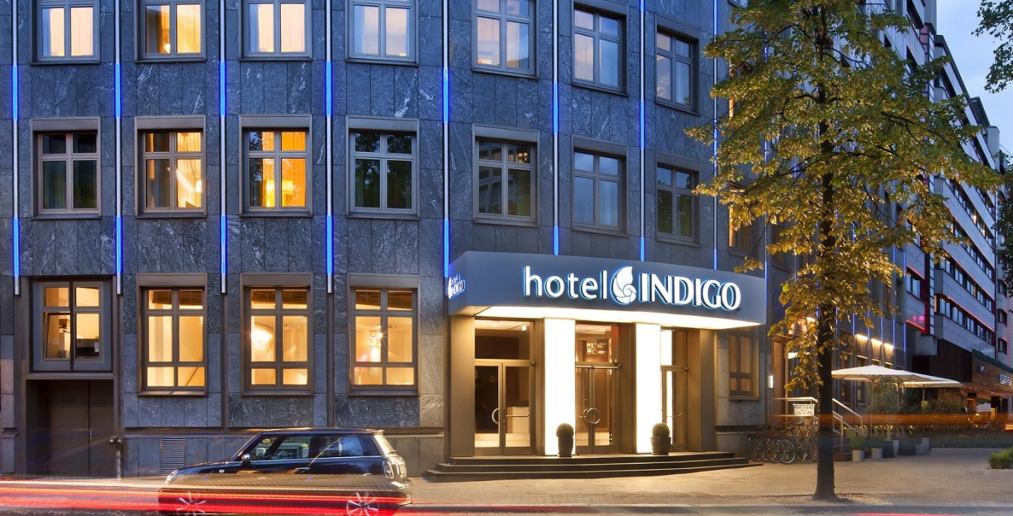
Figure 1 Hotel Indigo
(Source: IHG, 2023)
Upon further examination of this subject matter, it becomes evident that the provision of service that surpasses consumers' expectations is of utmost importance in achieving success within the hospitality industry. According to El-Adly (2019), it is a common expectation for businesses operating in the hospitality industry, regardless of their scale, to prioritize the provision of a satisfactory experience for their customers. This study aims to provide assistance to organizations in attaining their goals through the utilization of the provided data, intelligent analysis, and helpful advice.

Main Findings

2.1 Reputation Management
In the contemporary interconnected world, hotels and other entities operating within the hospitality industry are compelled to acknowledge the significance of their internet reputations. The online reputation of a hotel plays a crucial role in determining its capacity to attract customers and create money. Taking Hotel Indigo as a concrete instance. In the year 2018, Hotel Indigo experienced a significant data breach, resulting in the unauthorized disclosure of the personal information belonging to a substantial number of guests. The credibility of the individual or entity in question was significantly compromised. However, Hotel Indigo successfully restored the confidence of its clientele through prompt action and diligent efforts to improve its cybersecurity practices (Goeltom et al., 2020).
In the contemporary market, it is imperative for hotels to adopt proactive strategies aimed at effectively managing their reputation in order to achieve sustained success. It is advisable to actively monitor internet discourse pertaining to oneself, promptly address any concerns or feedback, and accentuate positive client experiences as integral components of this approach. In order to mitigate the adverse consequences of their online reputation, Huarng and Yu (2019) argue that hotels should implement comprehensive training programs aimed at consistently delivering exceptional service to their customers. Artificial intelligence (AI)-powered tools have the potential to be utilized for the assessment of customer sentiment.

2.2 Service Culture
Establishing a culture of committed service is crucial for the retention and expansion of one's customer base. The Ritz-Carlton is a renowned hospitality brand that operates a series of luxury hotels, distinguished for its exceptional commitment to delivering unparalleled client service. The organization promotes a culture that fosters innovative thinking and encourages employees to generate novel solutions to challenges (Su et al., 2022). A loyal customer base has evolved as a result of this technique. In order to maintain a competitive edge, hotels must cultivate a service-oriented culture that prioritizes visitor happiness (Hamenda, 2018). The training courses offered by The Four Seasons have the potential to serve as a significant source of motivation for employees. This is primarily due to the fact that these programs effectively instruct individuals on how to wholeheartedly embrace and exemplify the guiding principles and values of the business. In the meanwhile, the hospitality sector encounters distinct challenges, exemplified by the persistent issue of elevated staff attrition. Hilton's human resource management is considered to be progressive as it places a high emphasis on fostering the professional development and well-being of its employees. This comment offers a pragmatic approach to addressing the current issue.
In order to thrive in the contemporary competitive market, hotels must cultivate a culture that prioritizes service orientation, innovation, and continuous enhancement of the guest experience. In order to stay abreast of market trends and enhance tourist satisfaction, it is advisable to allocate resources towards technology advancements such as chatbots for streamlined customer service and mobile applications for personalized guest experiences (Leninkumar, 2017). According to Thielemann et al. (2018), hotels have the potential to enhance their likelihood of success within the highly competitive hospitality business by assimilating the methods implemented by industry frontrunners and modifying their operational approaches to effectively address the unique challenges they encounter.

2.3 Brand Consistency
The establishment of a reputable and reliable hotel brand hinges upon the consistent adherence to standardized practices and characteristics across all of its properties. The strategic significance of a cohesive branding strategy is exemplified by Hotel Indigo's comprehensive portfolio of brands, encompassing both the luxury and economy segments. Consistency with the brand is crucial throughout all facets of the hotel, encompassing elements such as decor, customer service, and marketing. According to Lu et al. (2015), brand audits play a crucial role in enabling hotels to uphold their distinct identities amongst the swift advancements in technology. This, in turn, can grant them a competitive advantage. The potential for brand dilution is a concern associated with swift expansion, although this issue can be alleviated by the allocation of resources towards robust brand management systems and the provision of comprehensive employee training.

2.4 Hotel Standards
Maintaining a consistently high level of service quality at the hotel is vital for the purpose of maintaining existing customers and attracting new clientele. Due to its persistent dedication to maintaining brand standards, the InterContinental Hotels Group (IHG) has emerged as a formidable competitor in the industry. In order to maintain a competitive edge in the hospitality industry and meet the needs of their guests, hotels must regularly review and improve their operational standards (Sigala, 2020). The difficulty lies in maintaining uniform application of these standards across a wide variety of properties in a portfolio. The use of technology to conduct regular audits and provide training is one way in which hotels can tackle this problem. By highlighting and showing their commitment to maintaining superior quality, hotels may set themselves apart from the competition.

2.5 Customer Loyalty
The hotel sector, similar to other industries, must strive to enhance client loyalty. The Hilton Honours loyalty program exemplifies a high level of efficiency and efficacy. Hotels have the ability to adapt to changes in the hospitality business by implementing tailored loyalty program, offering new advantages, and enhancing existing ones. One of the primary issues confronting contemporary firms is the preservation of consumer loyalty during fierce market rivalry. According to Mokhtar and Sjahruddin (2019), hotels have the potential to utilize data analytics as a means to enhance their ability to meet the specific preferences of their visitors, thereby addressing this issue. Enhancing customer loyalty might potentially be achieved through the provision of incentives such as priority check-in services or exclusive and unique experiences. Hotels may enhance the frequency of repeat bookings and good reviews by establishing effective communication channels and expressing gratitude towards their most devoted patrons.

2.6 Future Technological Impacts
The impact of emerging technology on the hotel industry is significant. Accor, a prominent hotel operator, is among the numerous entities that have employed Internet of Things (IoT) and smart room technologies. In order to remain competitive in the contemporary market, hotels must provide contactless payment alternatives and implement artificial intelligence chatbots to promptly address guests' concerns. According to Kaura et al. (2015), hotels could enhance cost savings and improve guest service by increasing their financial investments in technology. Nonetheless, maintaining the security of client information and incorporating a personal touch are imperative during customer interactions. In order to meet the expectations of its guests, hotels should aim to achieve a harmonious equilibrium by incorporating advanced technological amenities while also delivering personalized attention.

2.7 Service Failure
The reputation of a hotel may be negatively impacted if the quality of its service is below standard. The incident involving United Airlines and the passenger who was involuntarily removed serves as a pertinent example of the adverse financial consequences that might arise from service failures. According to the research conducted by Al Halbusi et al. (2021), it is suggested that hotels should place emphasis on the establishment of service recovery mechanisms that provide personnel the authority to promptly address issues and effectively adapt to changes in the market. Achieving consistent returns from a portfolio's diverse holdings poses a considerable challenge. The mitigation of this issue could be achieved through the adoption of standardized service recovery training and the utilization of problem-tracking software. In the event of a service failure, it can be advantageous for a hotel to publicly acknowledge the issue and demonstrate a sincere commitment to ensuring customer happiness, since this can positively impact the hotel's reputation.

Conclusion
In the highly competitive hotel sector, characterized by ongoing innovation, it is imperative to engage in proactive monitoring of client service. This study emphasizes several key variables that contribute to successful online reputation management, including the implementation of effective strategies, the cultivation of a strong service culture, the maintenance of consistent branding, a dedication to upholding high hospitality standards, the promotion of customer loyalty, the adoption of technical advancements, and the prompt resolution of service failures. In order to ensure their survival, contemporary hotels must prioritize inventiveness and flexibility (Tussyadiah and Sigala, 2018). Through the process of assimilating the errors made by predecessors in the industry and surmounting challenges such as maintaining brand coherence and enforcing standards, hotels have the potential to enhance visitor experiences, foster customer loyalty, and fortify their standing within the progressively competitive realm of hospitality.

Recommendations
The subsequent guidance is proffered to assist individuals employed in the hospitality sector in effectively navigating problems and capitalizing on possibilities. In order to achieve cost savings and enhance customer service, it is advisable to consider the utilization of artificial intelligence and the internet of things. To ensure the establishment of a robust and acknowledged brand identity, it is imperative to conduct periodic assessments and maintain consistent adherence to brand guidelines across all platforms and resources (Akhmedova et al., 2021). Ensure that the workforce is equipped with the necessary tools and incentives to consistently provide exceptional customer service. The subsequent concepts will assist the hotel sector in adapting to the changing preferences of visitors, addressing developing challenges, and delivering exceptional service.

References
Abdullah, O., Sufi, T. and Kumar, S., 2023. Impact of Food and Beverage Quality and Service Quality Towards Customer Satisfaction and Retention, A Study of Five-Star Hotels. International Journal of Professional Business Review: Int. J. Prof. Bus. Rev., 8(5), p.98.
Akhmedova, A., Manresa, A., Escobar Rivera, D. and Bikfalvi, A., 2021. Service quality in the sharing economy: A review and research agenda. International Journal of Consumer Studies, 45(4), pp.889-910.
Al Halbusi, H., Al-Sulaiti, K., Abbas, J. and Al-Sulaiti, I., 2022. Assessing factors influencing technology adoption for online purchasing amid COVID-19 in Qatar: moderating role of word of mouth. Frontiers in Environmental Science, p.1039.
El-Adly, M.I., 2019. Modelling the relationship between hotel perceived value, customer satisfaction, and customer loyalty. Journal of Retailing and Consumer Services, 50, pp.322-332.
GOELTOM, V.A.H., KRISTIANA, Y., Juliana, J., BERNATO, I. and PRAMONO, R., 2020. The effect of service quality and value of five-star hotel services on behavioural intentions with the role of consumer satisfaction as mediator. The Journal of Asian Finance, Economics and Business (JAFEB), 7(11), pp.967-976.
Hamenda, A., 2018. An integrated model of service quality, price fairness, ethical practice and customer perceived values for customer satisfaction of sharing economy platform. International Journal of Business & Society, 19(3).
Huarng, K.H. and Yu, M.F., 2019. Customer satisfaction and repurchase intention theory for the online sharing economy. Review of Managerial Science, 13, pp.635-647.
Kaura, V., Durga Prasad, C.S. and Sharma, S., 2015. Service quality, service convenience, price and fairness, customer loyalty, and the mediating role of customer satisfaction. International journal of bank marketing, 33(4), pp.404-422.
Leninkumar, V., 2017. The relationship between customer satisfaction and customer trust on customer loyalty. International Journal of Academic Research in Business and Social Sciences, 7(4), pp.450-465.
Lu, C., Berchoux, C., Marek, M.W. and Chen, B., 2015. Service quality and customer satisfaction: qualitative research implications for luxury hotels. International Journal of Culture, Tourism and Hospitality Research, 9(2), pp.168-182.
Mokhtar, S. and Sjahruddin, H., 2019. An examination of the relationships between customer relationship management quality, service quality, customer satisfaction and customer loyalty: The case of five-star hotels. Advances in Social Sciences Research Journal, 6(2).
Polo & Tweed ., 2018. Hospitality Industry Training Importance: Enhance Your Brand | Polo & Tweed. [online] Polo & Tweed. Available at: https://poloandtweed.com/blog/the-importance-of-maintaining-systems-and-standards-in-the-hotel-industry [Accessed 4 Oct. 2023].
Sigala, M., 2020. Tourism and COVID-19: Impacts and implications for advancing and resetting industry and research. Journal of Business Research, 117, pp.312-321.
Su, L., Yang, Q., Swanson, S.R. and Chen, N.C., 2022. The impact of online reviews on destination trust and travel intention: The moderating role of online review trustworthiness. Journal of Vacation Marketing, 28(4), pp.406-423.
Thielemann, V.M., Ottenbacher, M.C. and Harrington, R.J., 2018. Antecedents and consequences of perceived customer value in the restaurant industry: A preliminary test of a holistic model. International Hospitality Review, 32(1), pp.26-45.
Tussyadiah, I.P. and Sigala, M., 2018. Shareable tourism: tourism marketing in the sharing economy. Journal of Travel & Tourism Marketing, 35(1), pp.1-4.

.

