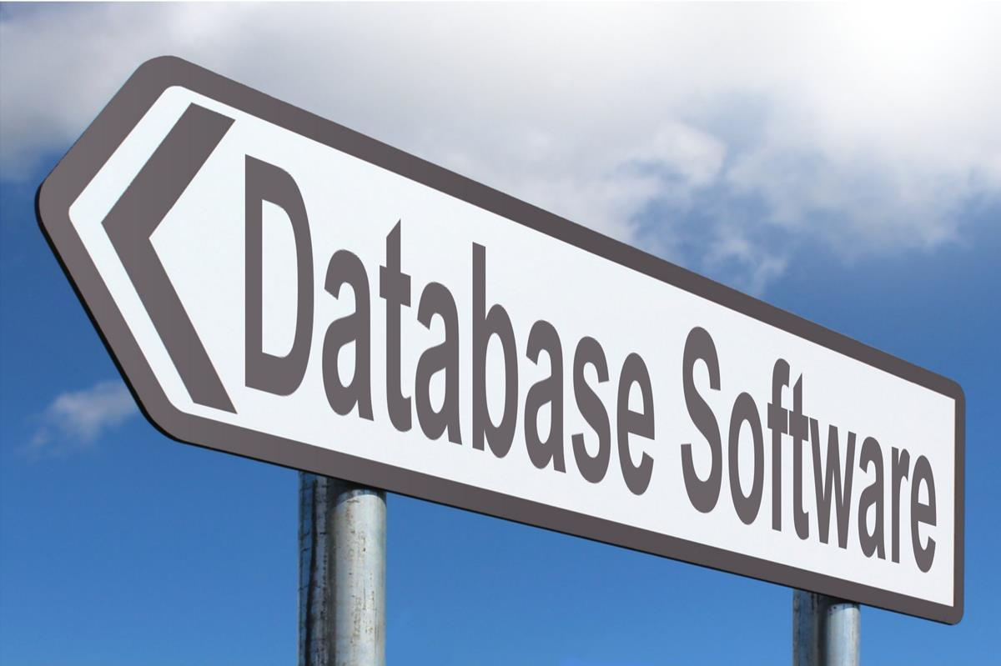

University of Wales Trinity Saint David Birmingham

Scenario: Design and Implementation of a Relational Database System
AutoPark Management System

Program: CERTHE Computing Skills for the Workplace
Module Title: Introduction to Web and Database Concepts
Module Code: ACCA4023
Lecturer: Shah Room
Student Name: Simal Mughal
Student ID: 2511477

Table of Contents
Table of Contents 2
1. Introduction and Scenario Analysis 3
2. Entity-Relationship Diagram 3
3. Data Structure Development 4
3.1 ParkingSite Table 4
3.2 ParkingSlot Table 4
3.3 Customer Table 5
3.4 Vehicle Table 5
3.5 Booking Table 6
3.6 Payment Table 6
4. Normalization Compliance 7
5. Sample Data Population 7
6. Query Development 8
Query 1 – Available Slots 8
Query 2 – Occupied Slots 8
Query 3 – Customer Data 9
Query 4 – Payment Pending 10
Query 5 – Vehicle in Slot (Parameterized) 10
Query 6 – In-Demand Site 11
Query 7 – Revenue by Site 12
Query 8 – Active Booking Duration 12
Query 9 – Completed Booking Duration 13
Query 10 – Slot Occupancy Rate 13
Query 11 – Top Spending Customers 14
Query 12 – Vehicle in Given Time (Parameterized) 15
7. Validation and Testing 16
8. Design Decisions and Reflection 18
9. Challenges and Future Work 18
10. References 18

1. Introduction and Scenario Analysis
A parking organization called Auto Park Management System handles a number of locations across South Wales. Before this automated project, employees manually worked with funds, customer data, parking places, and vehicle entries. This complex procedure often resulted in errors, misplaced documents, and unnecessary utilization of parking spots at five functional locations. In order to improve day-to-day operations, the project intended to create a consolidated relational database in Microsoft Access. With the goal to help employees achieve more efficient and informed decisions, it now allows real-time tracking of parking spots, car movements, and payment records.
Six primary entities are part of the system. Site information, including name, address, city, total number of spaces, and phone number, is stored on the parking site. The parking slot keeps track of slot data. The consumer maintains personal information. Each vehicle is linked to its owner by the registration, type, make, model, and color of the vehicle. Entry, exit, and booking status are all monitored by booking. Payment keeps track of each booking's amount, payment date, method, and status.

2. Entity-Relationship Diagram
An entity relationship diagram (ERD) is an illustration that demonstrates the relationships between various database entities. It describes connections and data movement among the database's six tables. Parking site uses SiteID as its primary key. Parking slot contains SiteID as a foreign key, which implies that an individual parking site may have multiple spots for parking, but each parking place is specific to that location. Customer uses CustomerID as its primary key.
Vehicle stores CustomerID as a foreign key since a single customer can register many vehicles yet each vehicle is owned by a single customer, A booking ties a customer's car to a parking spot by using VehicleID and SlotID as foreign keys. It also logs the moment the car enters and exits the parking lot. Payment uses BookingID as a foreign key, creating one payment record for each booking. Figure 1 in Microsoft Access verifies these connections and demonstrates that all tables are appropriately connected via one-to-one and one-to-many relationships.
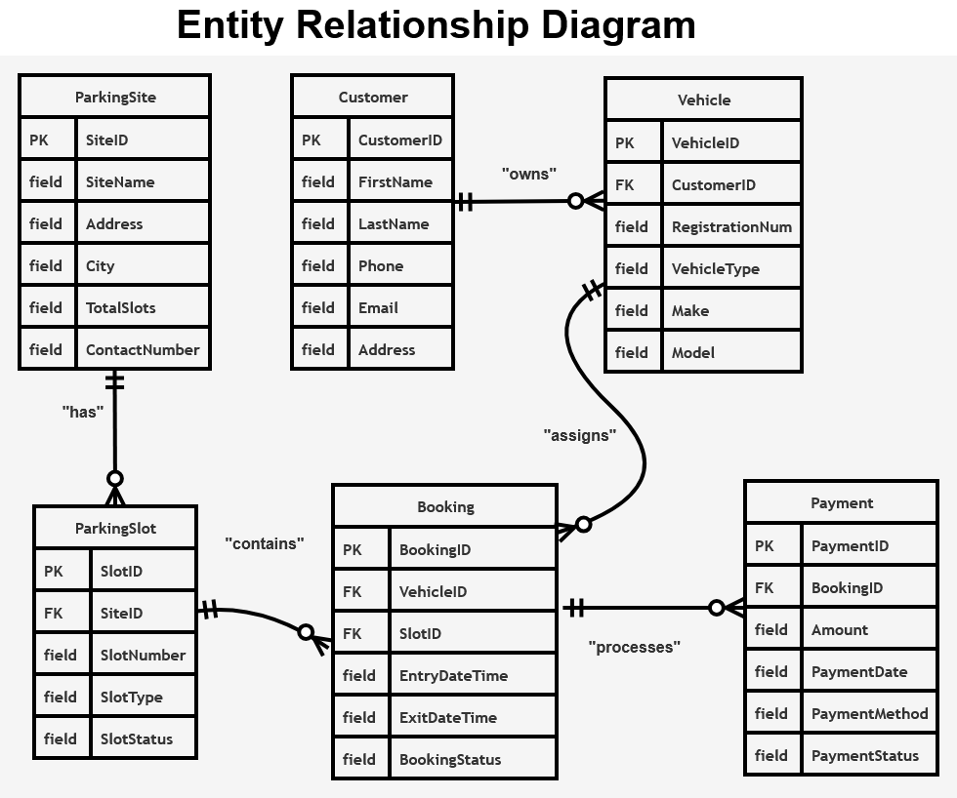
Figure 1: ERD Diagram

3. Data Structure Development
To ensure relational integrity across the system, six tables with specified data types and important constraints were built in Microsoft Access.

3.1 Parking site Table
This table stores parking site details. SiteID is the primary key, The remaining fields save site information for precise record maintenance, whereas Total Slots stores capacity.
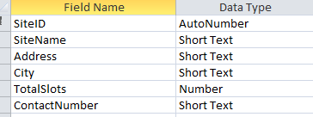
Figure 2: Parking Site – Design View
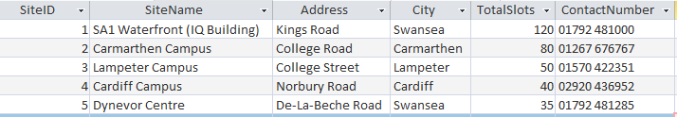
Figure 3: Parking Site – Datasheet View

3.2 Parking Slot Table
Information about specific parking spaces is stored in this table. SlotID is the primary key, the slot number, type, and current status are recorded in the remaining fields, meanwhile SiteID corresponds each slot to a parking location.
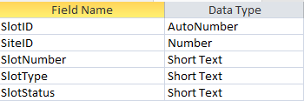
Figure 4: Parking Slot – Design View
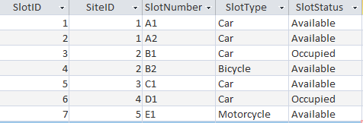
Figure 5: Parking Slot – Datasheet View

3.3 Customer Table
This table stores customer details. CustomerID is the primary key, while FirstName, LastName, Phone, Email, and Address are personal information components that guarantee organized and effective data administration.

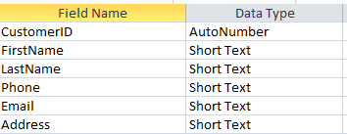
Figure 6: Customer – Design View
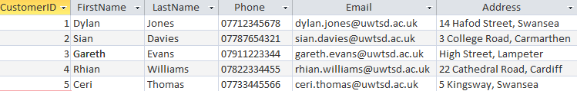
Figure 7: Customer – Datasheet View

3.4 Vehicle Table
This table stores vehicle details. VehicleID is the primary key. The remaining fields record car information in text format, whereas CustomerID links to customers.

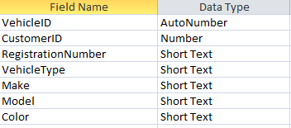
Figure 8: Vehicle – Design View
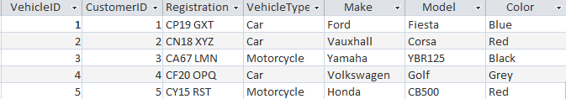
Figure 9: Vehicle – Datasheet View

3.5 Booking Table
This table tracks bookings. BookingID is the primary key, entry/exit time and status are stored in the remaining fields, while VehicleID and SlotID are foreign keys.
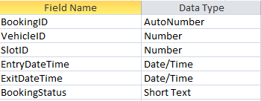
Figure 10: Booking – Design View
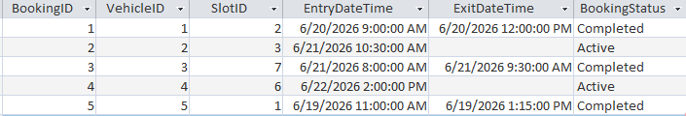
Figure 11: Booking – Datasheet View

3.6 Payment Table
This table stores payment records. PaymentID is the primary key, BookingID links to bookings, and the remaining fields track amount, date, method, and status.
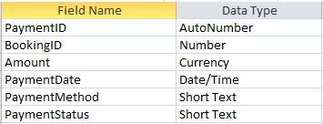
Figure 12: Payment – Design View
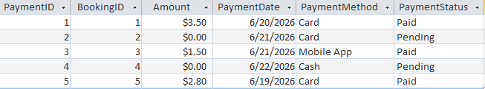
Figure 13: Payment – Datasheet View

4. Normalization Compliance
Third Normal Form (3NF) was used in the database schema's design to prevent redundant data and minimize issues with updates, insertions, and deletions.
- First Normal Form made sure that each table had just one, indivisible value. Every row is different since each entry has a single AutoNumber primary key.
- Partial dependencies are eliminated by Second Normal Form since each table has a single-column primary key.
- Third Normal Form maintains the independence of non-key attributes. Site information is kept in Parking Site, customer data is kept in Customer, and payment information is only kept in Payment. Booking does not repeat information; it merely connects relevant data.

Staff members adjust site names, customer addresses, and payment methods in one location. The technique preserves the database's accuracy, consistency, and ease of maintenance. It also strengthened data integrity, decreased undesirable duplication, and enabled the system function consistently when new entries were added over time. Additionally, this architecture simplifies modifications for administrators and frequent users in the future.

5. Sample Data Population
Based on a Welsh university parking setting, at least five authentic records were added to each table.
- Five parking lots with spaces ranging from 35 to 120 are included in the database.
- Five of the seven parking spots were designated as accessible and two as occupied for several vehicle categories.
- Users from Swansea, Cardiff, Carmarthen, and Lampeter are accounted for in customer records; all of them utilize university email addresses to correspond with the campus environment.
- A range of vehicles and motorcycles with valid UK registration numbers can be found in the vehicle table.
- Booking records include both completed and current reservations made between June 19 and June 22, 2026.
- Card, mobile app, and cash payment methods are used to record the paid and pending statuses of payments, which range from $1.50 to $3.50.

6. Query Development
To illustrate the Auto Park system's operational capability, twelve inquiries were created. Each is shown together with a screenshot and output of its SQL code.

Query 1 – Available Slots
This query sorts the results by site name and combines parking site and parking slot data to display every available parking space.
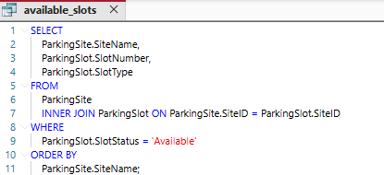
Figure 14: Query 1 – SQL Code
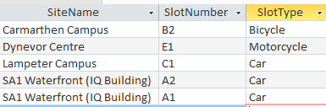
Figure 15: Query 1 – Output

Query 2 – Occupied Slots
By merging information from the Parking Site and Parking Slot tables, this query returns all parking spaces that are presently occupied.
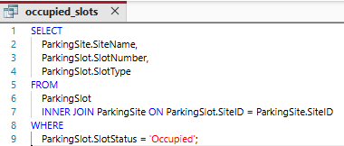
Figure 16: Query 2 – SQL Code
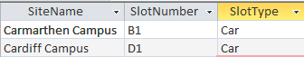
Figure 17: Query 2 – Output

Query 3 – Customer Data
This query connects the Customer, car and Booking tables to obtain each customer's name, car registration, entry/exit times and booking status, sorted by last name and entry time, it gives managers a comprehensive picture of recent and ongoing client activities.

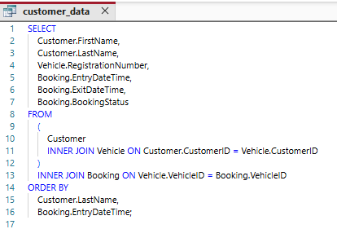
Figure 18: Query 3 – SQL Code
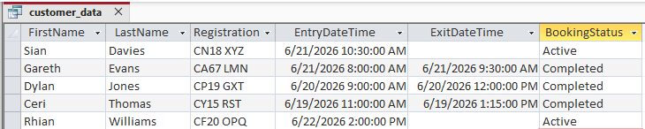
Figure 19: Query 3 – Output

Query 4 – Payment Pending
This query shows all outstanding payments by merging data from the Payment, Booking, Vehicle, and Customer tables, enabling inspection of unpaid invoices and associated booking and consumer data.
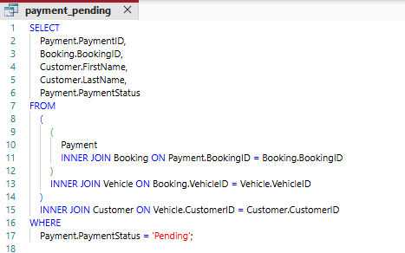
Figure 20: Query 4 – SQL Code
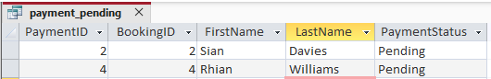
Figure 21: Query 4 – Output

Query 5 – Vehicle in Slot (Parameterized)
By merging information from the Parking Slot, Booking, Vehicle, and Customer databases and looking for an active booking depending on the entered SlotID, this parameter query demonstrates the specifics of the car and customer utilizing a chosen parking space. SlotID entered is 3.

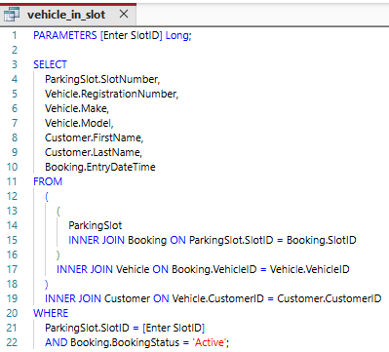
Figure 22: Query 5 – SQL Code and Parameter Dialog
Figure 23: Query 5 – Output

Query 6 – In-Demand Site
This query displays the busiest parking sites by collecting information from the Parking Site, Parking Slot, and Booking tables, calculating the total number of reservations for each site, and ranking the results from highest to lowest.
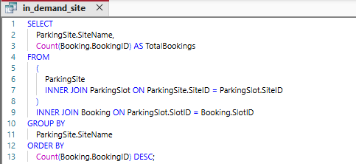
Figure 24: Query 6 – SQL Code

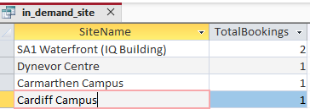
Figure 25: Query 6 – Output

Query 7 – Revenue by Site
This query determines each parking site's total revenue from paid transactions and shows the sites in order of highest to lowest revenue.
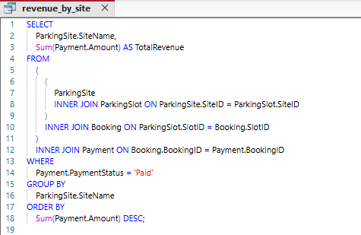
Figure 26: Query 7 – SQL Code
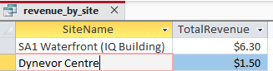
Figure 27: Query 7 – Output

Query 8 – Active Booking Duration
This query presents the longest-parked automobiles first after computing the parking period of all active vehicles by evaluating their entry time with the current time.
Figure 28: Query 8 – SQL Code
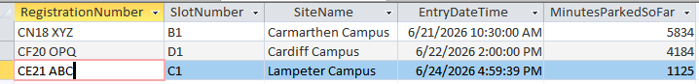
Figure 29: Query 8 – Output

Query 9 – Completed Booking Duration
By assessing the entry time with the current time, this query returns the length of each ongoing parking session in minutes. The longest active bookings are listed first.
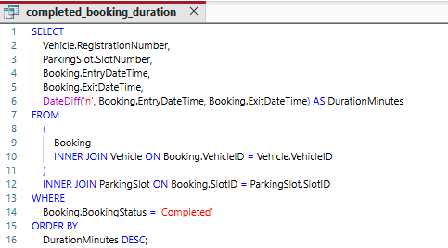
Figure 30: Query 9 – SQL Code
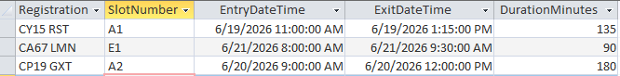
Figure 31: Query 9 – Output

Query 10 – Slot Occupancy Rate
This query exhibits each parking site's occupancy rate by ranking the sites from highest to lowest occupancy by evaluating the number of occupied parking spaces to the total number of available spaces.
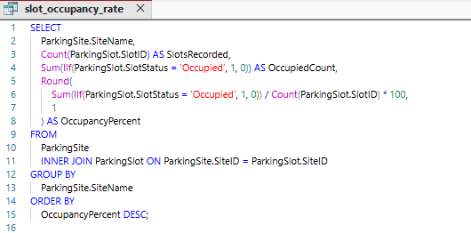
Figure 32: Query 10 – SQL Code

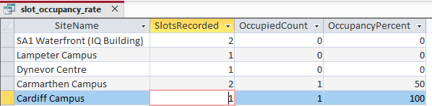
Figure 33: Query 10 – Output

Query 11 – Top Spending Customers
This query calculates each customer's total payments and completed bookings to discover the highest-spending consumers, then classifies them from highest to lowest spending.
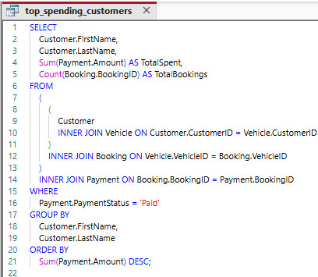
Figure 34: Query 11 – SQL Code

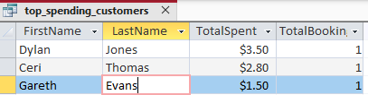
Figure 35: Query 11 – Output

Query 12 – Vehicle in Given Time (Parameterized)
By determining if the time specified falls between each vehicle's entry and exit records, this query displays whether cars were parked at a user-selected date and time.
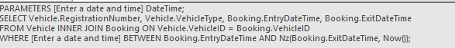
Figure 36: Query 12 – SQL Code
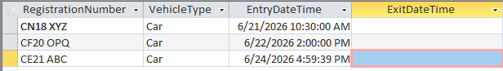
Figure 37: Query 12 – Output

7. Validation and Testing
Tests that verified proper system procedures, integrity of data across connected tables, and accurate reporting were used to validate the functional requirements. Data entry, referential integrity, and aggregation accuracy were determined using five INSERT and SELECT queries.
- Test 1:
Insert New Customer: By adding the requested personal information such as the name of the customer, phone number, email address, and address to the customer table, this query generates a new customer record.
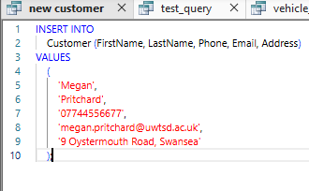
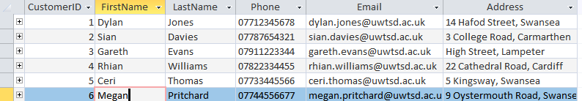
Figure 38: Test 1 – New Customer INSERT and Result

- Test 2:
Link Vehicle to Customer: This query ensures that every car is linked to a legitimate customer by creating a new vehicle record and connecting it to an existing customer using the CustomerID. Because of either a duplicate registration number or a missing Customer ID (999), Microsoft Access is preventing the insert query (INSERT INTO Vehicle (CustomerID, RegistrationNumber, VehicleType, Make, Model, Color) VALUES (999, 'XX99 ZZZ', 'Car', 'Test', 'Test', 'Test')) in Figure 40.

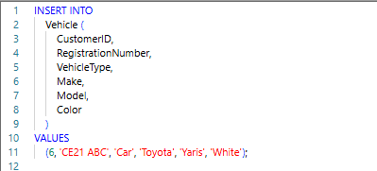
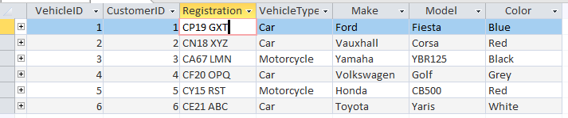Figure 39: Test 2– Link Vehicle to Customer and Result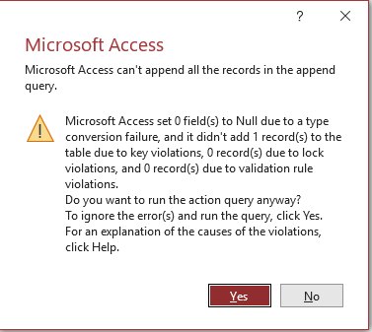
Figure 40: Error
- Test 3:
Create Booking: By associating a car with a parking space, noting the current entrance time, and setting the booking status to Active, this query generates a new parking reservation. Additionally, it ensures referential integrity by confirming that invalid slot IDs are rejected. The insert query (INSERT INTO Booking (VehicleID, SlotID, EntryDateTime, BookingStatus) VALUES (6, 999, Now (), 'Active’) ;) is prevented by Microsoft Access due to a missing Slot ID (999), as seen in Figure 42.

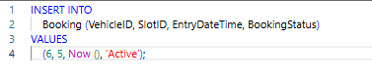
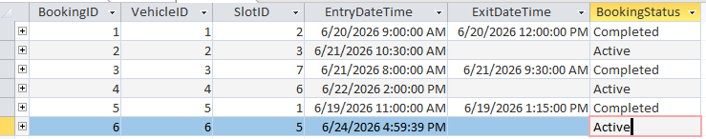Figure 41: Test 3 – Booking INSERT Result
Figure 42: Error
- Test 4:
Calculate Total Revenue: By adding up all of the transactions in the Payment table that have a Paid status, this query determines the total revenue.
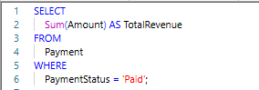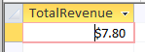
Figure 41: Test 4 – Calculate Total Revenue and Result

- Test 5:

Check Slot Occupancy: This query obtains every parking space that is currently marked as occupied in order to confirm parking occupancy at every location.
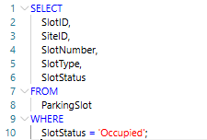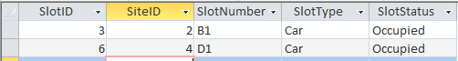
Figure 42: Test 35– Check Slot Occupancy and Result

8. Design Decisions and Reflection
To eliminate manual key errors from the prior paper-based process, AutoNumber was utilized for all main keys to automatically produce unique sequential values. Short Text was utilized to manage several state values, such as Active, Completed, Available, and Pending, for status fields like, Booking Status, and Payment Status that a Boolean Yes/No field was unable to express. The payment was made using the kind of money. Amount for precise two-decimal financial calculations without rounding errors caused by floating points.
For all analytical queries, INNER JOIN was chosen over LEFT JOIN in order to deliver only complete, actionable records, eliminating missing entries that could distort management reporting. In order to avoid orphaned entries during data entry, referential integrity was enforced on all foreign key relationships via the Access Relationships panel.

Challenges and Future Work
Developing SQL queries that connected several tables in MS Access was one of the biggest difficulties I encountered. Because MS Access demands a tight parenthetical join structure, even minor flaws in the query syntax could result in errors, unlike other database systems. Managing changeable date and time parameters and utilizing the DateDiff method to calculate parking durations presented another difficulty. To make sure the queries produced accurate results for all booking scenarios, this needed extensive testing.
To further accommodate various customer requirements, the system could be upgraded in the future by including flexible daily and monthly parking permit options, providing loyalty discounts for frequent users, and introducing peak and off-peak parking prices.

10. References
[1] K. Domdouzis, P. Lake, and P. Crowther, *Concise Guide to Databases: A Practical Introduction*, 2nd ed. Cham, Switzerland: Springer, 2021.
[2] J. C. Patni, H. K. Sharma, R. Tomar, and A. Katal, *Database Management System: An Evolutionary Approach*. Boca Raton, FL, USA: CRC Press, 2022.
[3] D. Taniar and W. Rahayu, *Data Warehousing and Analytics: Fueling the Data Engine*. Cham, Switzerland: Springer, 2022.
[4] P. Baumann, D. Misev, V. Merticariu, H. Manns, and B. Siemen, "Array databases: Concepts, standards, implementations, and challenges," *Journal of Big Data*, vol. 8, no. 1, Art. no. 28, 2021.
[5] A. Azcorra, Lightning Guide to Databases with Microsoft Access and SQL. Arturo Azcorra-Saloña, 2021.
[6] “Introduction to queries | Microsoft Support,” Microsoft.com, 2024. https://support.microsoft.com/en-us/access/introduction-to-queries. [Accessed: Jun. 28, 2026]

‌

