Eunice Ojo 1703977
Project planning
EMPL4009

Content
1.1 project explanation
1.2 executive summary
1.3 mission statement
1.4 meet the team
1.5 start-up cost
1.6 Risk assessment
1.7 Stake holders
1.8 phase 1
1.9 phase 2/ SMART Targets
2.0 Deliverables
2.1 Milestones
2.2 WBS
2.3 Scheduling
2.4 Phase 3
2.5 Phase 4
2.6 Phase 5

As a successful taxi service based in Kennington called, DreamTaxiHire, me and my team have decided to go ahead with an expansion. We currently have around four cars which is based in the Kennington area only. Having considered our savings and the amount of over booked taxi’s, we feel it would be a great step to expand our company to all surrounding areas in London with a total of 12 cars. As a result, to, Dream Taxi’s success, we have an outstanding budget of £50,000. As we have seen, our office is a very familiar and popular firm in Kennington, so we have decided to keep the main office, just including a little bit of refurbishment and technology updates.
Executive summary
Dream Taxi Hire, wants to ensure all clients receive the best quality taxi service they have ever imagined. To be able to have a smooth-running service with no complaints with great price rates and occasional offers. Dream Taxi, is a quick and reliable way of getting around when needed, with fast response times within minutes, it is our aim to make sure clients have the most comfortable and relaxing journey.

Mission statement
Delivering efficient service, with quality experience, which shows the character of our success driven company.
Dream taxi offerings,
- Updated newer date vehicles.
- Providing mobile app, quick booking services.
- Taxi Wifi

Meet the team
- Chief executive officer, it is their responsibility to make sure management effectiveness is at its best. Their role is to undertake the recruitment process and selecting capable applicants for specific roles while training and monitoring their progress. They are also responsible for implementing the business vision and fixing prices and signing finalised deals.

- It specialist, dream taxis it specialist are responsible for making sure the tracking system for the online mobile app is correct and running smoothly. Also, writing reports and proposals and contacts within the business.

- HR manager, Responsible for calculating stocks and maintenance repairs.

- Marking and sales, identify profitable business opportunities to wider co-operates to remain on top and are the ones to research to keep clients on our side.

- Accountant, they are the ones to prepare reports and financial budgets, in the business, ensuring we keep on track and remain profitable.

- Taxi drivers, they are the ones to pick up and drop off, clients to their designated location, providing a friendly customer service and a professional driving service.

- Admin workers, they are the voice of dream taxi, they are the ones to pick up customer calls when they book and communicating effectively in a kind manor to build up customers interest in the services.

2015, website, profitableVenture.com (Accessed 4th January 2018)
Start-up cost

Business register fee £750
Licencing for drivers £1500
Car costs £20,000
App Design £300
Phone and utility deposits £300
Petrol starting up cost £1000
It equipment £4000
Office facility space remodelling £8000
Employee salary start up wages £4000
Car WIFI access Cost £950
Accountant payroll software £4000

2015, website, profitableVenture.com (Accessed 4th January 2018)

Dream taxi acknowledge that before carrying out any project phases, a risk assessment should be done to identify any potential risks to our business. Here is our companies risk assessment. The steps to take when reviewing a risk is to,
-identify the risk, this is outline the reoccurring risks that could potentially affect your project. Techniques and tools can be used to identify risks.
-Analysing the risk, when the risk is determined, team members of the project can identify when the risks are developing.
- evaluating the risk, when at this stage this is seeing if the risk is actually a potential threat to your project or a minor one. If it is evaluated as a risk, then thinking of potential actions will help.
- Taking action, this is when the risk is treated and risk response planning will take place.
- Lastly monitor and review the risk on a regular basis, tracking the risk helps make sure the risk does not re occur again, this will help you have a clear mind and feel comfortable to achieve goals needed.

Risk | Why is it a risk? | How to carry out risk? | Any further risk control? | Action by? | When to take action? | Action Completion.
Verbal abuse from clients to driver. | Drivers could be harmed due to abuse from confrontational clients which could turn physical, | - All jobs should be pre-booked and tracked.  - Drivers should be trained to handle clients who are abusive and manage their emotions.  - How to call for emergency help in situations. | - Managers should ensure they have support systems to help any drivers in distress. | - Manager | 13/12/2017 | 13/12/2017
Customer Review | Bad reviews can drive other clients away for bad feedback. | - Provide quality service.  - Remain reliable  - Customer friendly | - Ask for regular feed back to keep clients priority | - Manager | 13/12/2017 | 13/12/2017

2017 ,Website: https://www.scribd.com/doc/67855491/Car-Rental-Service-Business-Plan ( Accessed 22nd December 2017)
In order for our business to reach its main goal, there are 5 stages to make project management achievable, this is a range of tools techniques that help meet our business requirements. This is a start of a project, the initiation stage to outline the objectives of the plan, this is when research can be done to see whether the goal is achievable and should be undertaken. Main stake holders, will decide if the plan is realistic if it can go ahead. If it is seen as a potential plan, a project initiation document will be created which shows the purposes and requirements of plan. Also, showing business needs and key stake holders.
Stakeholders
These are individuals who take interest dream taxi hire project, they are the ones likely to be affected by the project. They are the ones who make an impact on the business.
- Customers, internal customers are vital stake holders for the project, they are the ones who make decisions on whether to accept or reject dream taxi service
- The Government, they are the ones who are able to give you a licence to start up your project in the required area without their permission the whole project would be useless.
- - Managers/Workers, they are the ones who make the most important decisions in regards to dream taxi hire, like promotions and how to remain profitable.
- Bank/supplier, money loans and support.
- Community, people who will take interest in company services and will help promote.
- Business owner, who owns the business and looks for its best interest and profitable opportunities.
2015 ,E Esposito, Ariticle: Demystifying the 5 phases of project mangment,smarsheetinc.
Wrike.com (Accessed 26th December 2017)

Phase 1
This is a start of a project, the initiation stage to outline the objectives of the plan,
- It is Dream taxi’s role, to deliver the best customer service, being friendly and reliable, which will build a loyal customer base.
- Advertising our services to wider corporates to get noticed.
- Making sure every client is satisfied at the end of every journey.
- To provide the most up to date classy vehicles.
If it is seen as a potential plan, a project initiation document is created, which shows the purpose of the requirement plan. Also, showing business needs and stake holders. (Accessed 26th December 2017)
2017 ,Website: https://www.scribd.com/doc/67855491/Car-Rental-Service-Business-Plan ( Accessed 22nd December 2017))

Phase 2
This is the essential tool needed to be a successful project manager, the project planning stage, this is setting up SMART targets in place to help, make sure Dream taxi service is successful business.

Also, to identify the project scope, Smart targets have been put in place to make this goal achievable.
Starting off with being specific and knowing what is needed to achieve the objective of a good running taxi company. As employees, to deliver reliable and friendly customer service in order to build trusting relationships with clients from all around south-east London and surrounding areas, which will want them to come back and to tell others about the good taxi service, which will bring in more customers and profit. Also, being able to advertise to customers the taxi services, letting them know it’s an experience that cannot be missed, allowing them to acknowledge the perks of the up to date vehicles on offer. To promote the services to a wide range of co-operates to expand the business to a wider range.
2017 Website: https://www.scribd.com/doc/67855491/Car-Rental-Service-Business-Plan (Accessed 22nd December 2017)
In order to achieve this, it’s also important to be measurable, being able to know if the goal is achievable and how long it will take to reach it. Starting up a taxi service can be a very competitive, due to the, high numbers of taxi services around the area. Promoting it on flyers, adverts and making a website will help catch clients attention. After a long think to determine when best it is to start up our company we decided to give ourselves a 3month time frame to complete all tasks for the project. Starting from the 1st of January 2018 and to be completed on the 31st of march 2018 with are budget of £50.000. It is believed that if customers increase by 20% by advertising, in 2018 we will be making a at least £120.000.000 in 2018 which means our goal has been accomplished.
2017 Website: https://www.scribd.com/doc/67855491/Car-Rental-Service-Business-Plan (Accessed 22nd December 2017)
Being attainable is also essential, in making sure relevant team members put their knowledge and skills together to reach the best outcome, for example, Hr and chief executive for dream taxi, can work together finding the best project opportunities and plan to put in place, through research and analysing the best way to attract customers.
Relevant, to ensure all targets for dream taxi is relevant to the main objective plan.
Time based, dream taxi has made sure, that put in place have individual completion dates, to prevent, work slacking, due to not having a deadline. My team deadline for all finalised team work has been enforced to make sure it is achievable.
A scope Statement is a document which outlines the objectives and mission of the company which covers the result of the project. This also includes, the taxi services deliverables and key milestones.
Deliverables
. | Assigned by; | Action made on | Deliverable to take place on | Deliverable completed by
Staff training | Manger | 15/1/18 | 17/2/18 | 26/5/18
App Design Drawing, for mobile booking app. | Market Research Team | 16/1/18 | 17/2/18 | 26/5/18
Drivers review, from customers. | Manger | 16/4/18 | 26/5/18 | Review every 12 weeks. Starting from 26/5/18
Customer service efficiency from drivers and admin workers. | Manger | 16/4/18 | 26/5/18 | Review every 12 weeks. Starting from 26/5/18

(Accessed 26th December 2017)
Milestones, this is to help are company see the achievements made, with no duration time, this shows events leading up to project completion, this is a way to see how the project is advancing and ensuring all deliverables are met, outlining the start of work and the end, also showing when decisions are made and assigned by who. 2017 , A Bunner, milestones and how to define them?, www.clarizen.com (Accessed 4th January 2018)
WBS, this is a scope of the project which is divided into manageable sections for team members which breaks down the project into phases and deliverables and work packages, this helps organise the project that needs to be completed and the identifying the estimated budget costs. Here is a template, Dream taxi have based their WBS on, 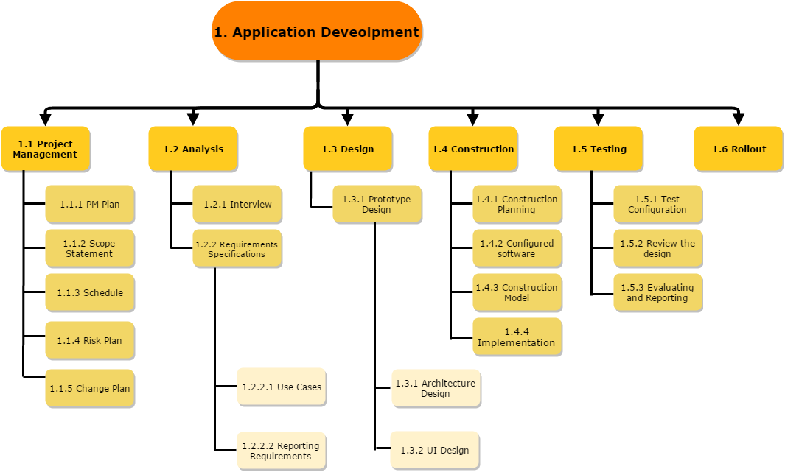
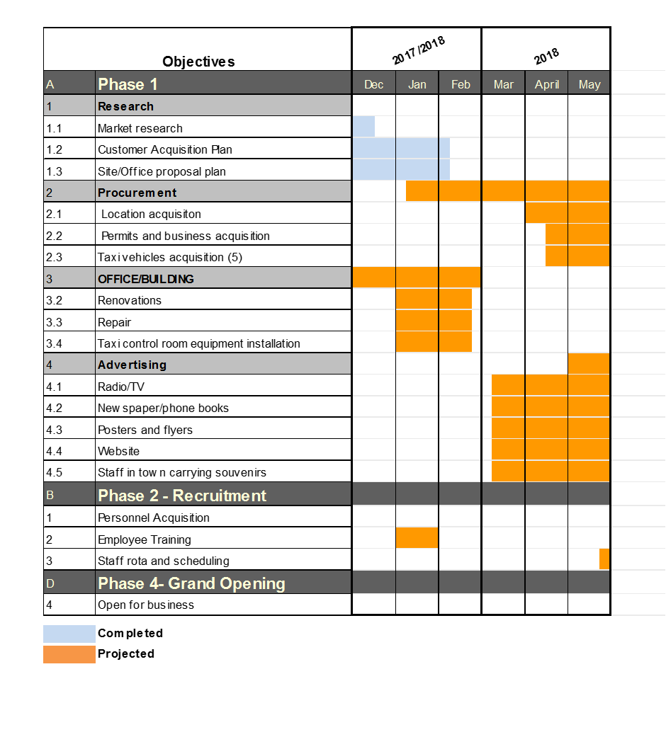
Project mangers use a range of tools and techniques to make a successful project plan, this helps determine project control, controlling schedules and monitoring the project. Dream taxi have created a GANTT Chart below, which is a chart with tasks we need to complete and completion dates for each task to help us maintain schedule control and monitoring. 2015,P Baskerville,Scheduling tools and techniques for project management,Skillmaker.edu.au (Accesssed 4th January 2018)
Phase 3, project execution, this is when all deliverables stated for dream taxi have been completed and finalised, the best teams will be developed and recruited, different tasks and resources will be assigned to the appropriate colleague, project plans will be executed at this point, product schedule for our company will be updated followed by the tracking system. Website:Smartsheetinc(Accessed 1st January 2018)
Phase4, project performance and monitoring, this is when the business monitors and controls the tasks been taken and completed, this is a continuous process from gathering information from clients and colleagues, gaining feedback, on potential plans, at this stage we can monitor all the processes taken identifying any potential risks for Dream taxi and assigning each team member to the appropriate role. 2017,P Bartle, Articall, The nature of monitoring and evaluation,cec.vcn.bc.ca (Accessed 26th December 2017)

Finally phase 5, finally reaching the project closure, this is the project completion, all valuable team members will be noticed and rewarded for their contributions. An evaluation can be made for the project, to outline the, what went well? And what didn’t go to well? for future lessons to avoid any failure for future project plans.
E Esposito,article,Demystifying the 5 phases of project management,smartsheetinc.(accessed 1st January 2018)

Written by Eunice Ojo
References:

2015, website, profitableVenture.com (Accessed 4th January 2018)

2015, website, profitableVenture.com (Accessed 4th January 2018)
2017 ,Website: https://www.scribd.com/doc/67855491/Car-Rental-Service-Business-Plan ( Accessed 22nd December 2017)
2015 ,E Esposito, Ariticle: Demystifying the 5 phases of project mangment,smarsheetinc.
Wrike.com (Accessed 26th December 2017
2017 ,Website: https://www.scribd.com/doc/67855491/Car-Rental-Service-Business-Plan ( Accessed 22nd December 2017))
2017 Website: https://www.scribd.com/doc/67855491/Car-Rental-Service-Business-Plan (Accessed 22nd December 2017)
2017 Website: https://www.scribd.com/doc/67855491/Car-Rental-Service-Business-Plan (Accessed 22nd December 2017)
. 2017 , A Bunner, milestones and how to define them?, www.clarizen.com (Accessed 4th January 2018)
2015,P Baskerville,Scheduling tools and techniques for project management,Skillmake2017,P Bartle, Articall, The nature of monitoring and evaluation,cec.vcn.bc.ca (Accessed 26th December 2017)
r.edu.au (Accesssed 4th January 2018)
E Esposito,article,Demystifying the 5 phases of project management,smartsheetinc.(accessed 1st January 2018)

Prensentation.

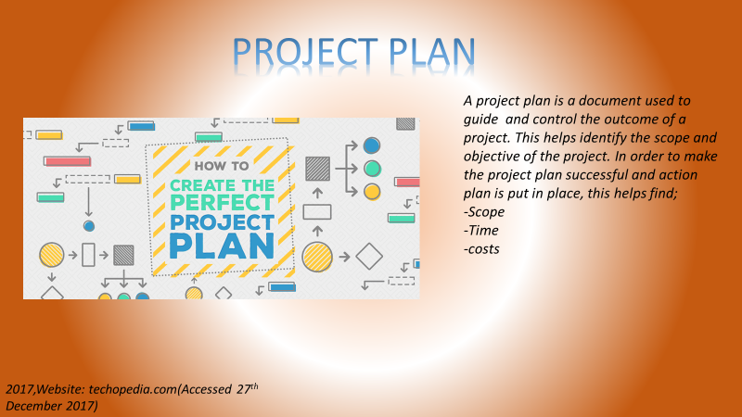



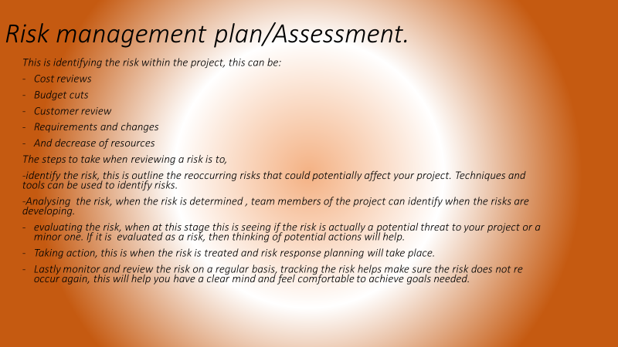

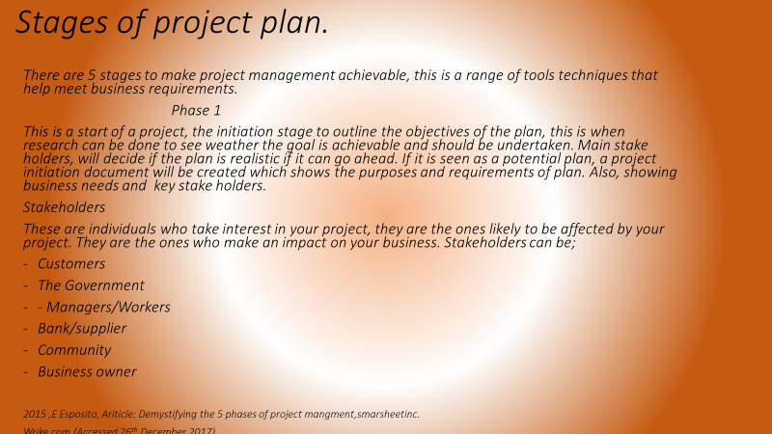

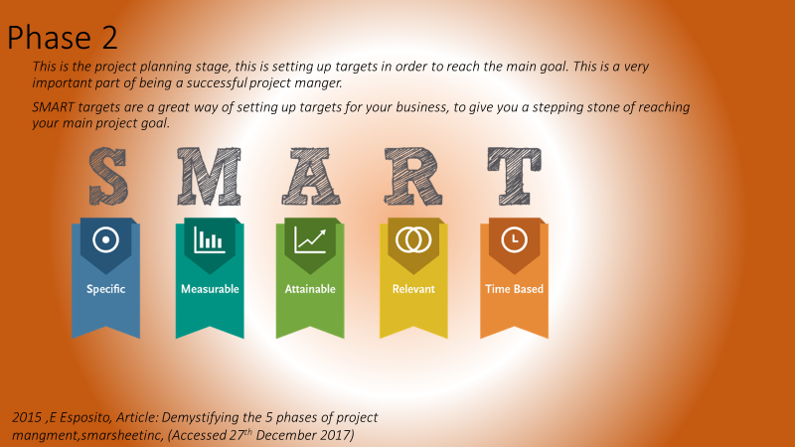

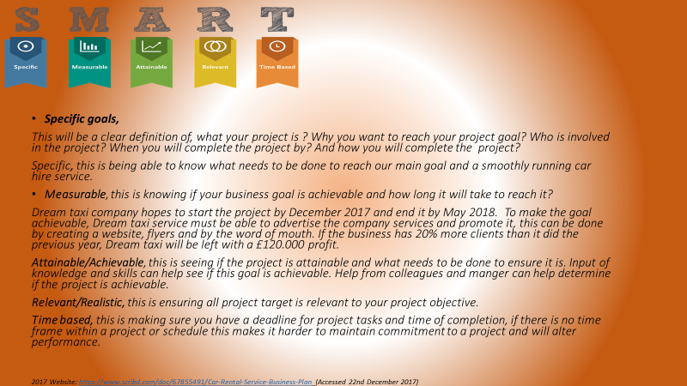

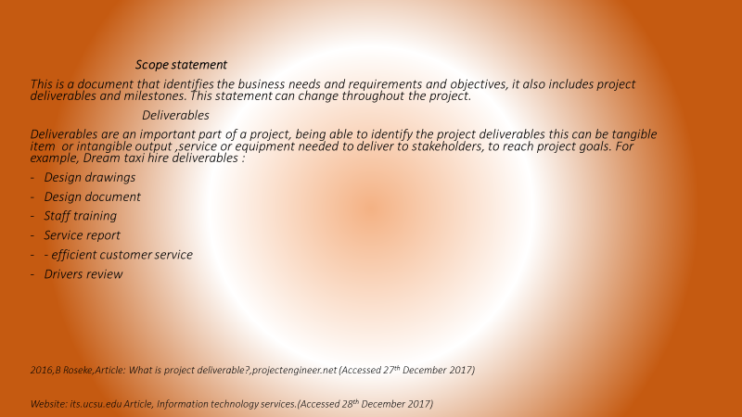



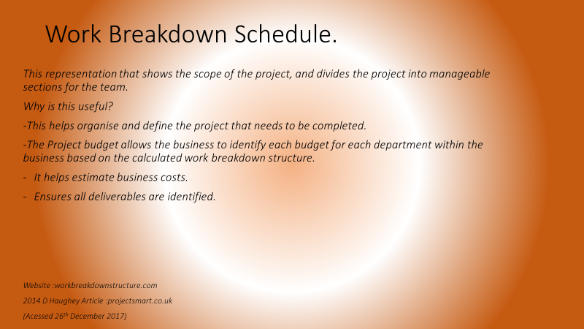
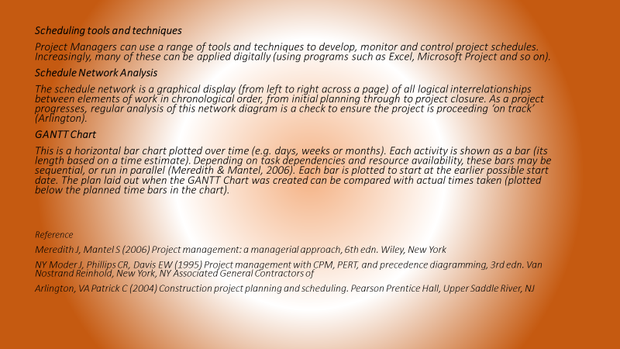

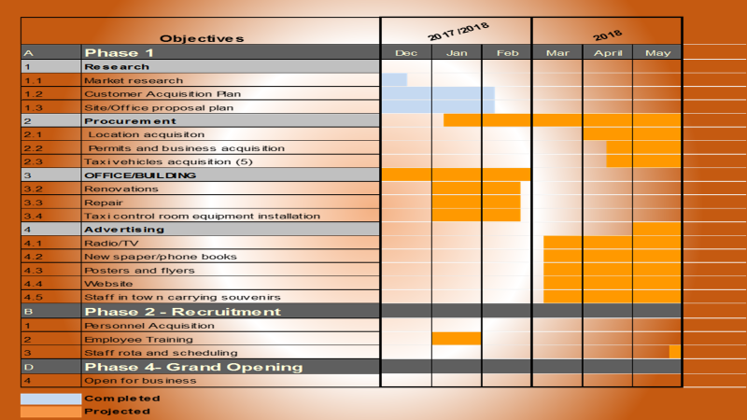
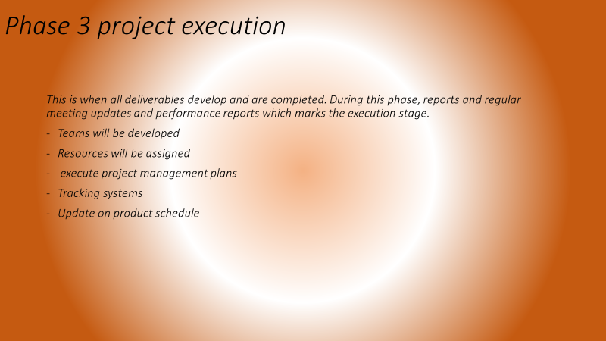
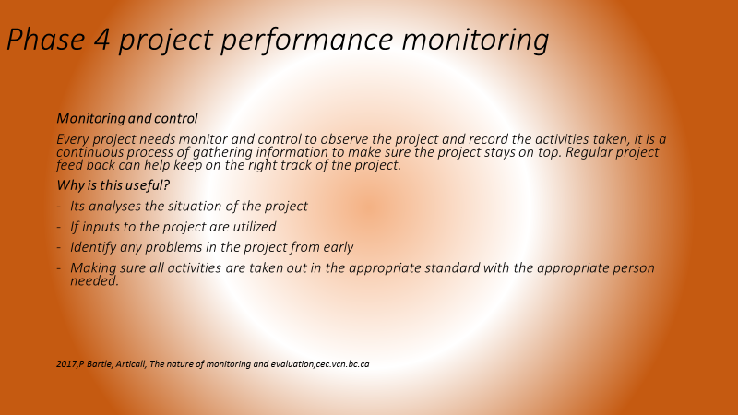
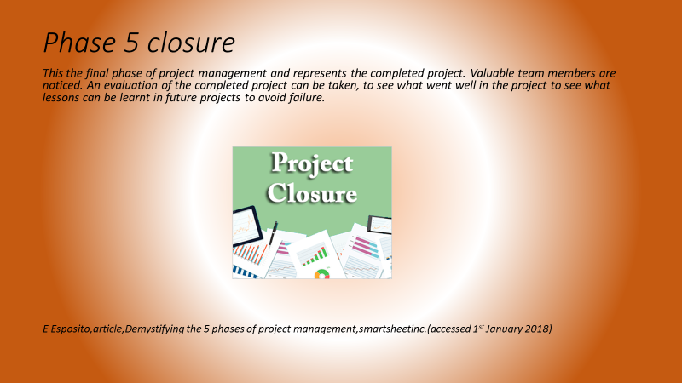

The presentation was written by me Eunice ojo, but presented with Rachel for group presentation.

