Module: Introduction to Health and Social Care
Module code: LCHS4003
Assignment Title: Portfolio – Two Tasks
Submission deadline: Monday 17th Nov 2025, by 2pm

Contents
Component 1 Poster : 3
Community Antenatal Midwifery Services in the UK 3
Component 2 – Essay 4
Introduction 4
Origins of the NHS 4
Current Structure of the NHS 5
Present System of NHS Work. 5
Conclusion 6
References 7

Component 1 Poster :

Community Antenatal Midwifery Services in the UK
Conclusion
Community based antenatal midwifery services are very important in the support of the pregnant women, healthy pregnancies, and early risk detection. In spite of the factors like staffing shortages and inequalities, midwives still provide the necessary, patient-centred care, which enhances the safety and outcomes of mothers and babies.

Two Significant Service Problems.
Challenge 1: Staffing and Higher Workload.
A shortage of midwives is being reported in many NHS Trusts, and it causes more caseloads on the community teams. This is capable of shortening appointment times, stress levels, and ability to provide care in a personalised manner. Staffing problems have an impact on continuity of care, which influences the establishment of trust with pregnant women.
Challenge 2: Health Inequalities and Barriers to Access.
There are those women who have challenges with accessing antenatal care as a result of language barrier, financial constraints, transportation, or ignorance. Women living in the impoverished regions or in minority ethnic groups tend to be at risk of having more health issues, and lack of constant access to services may have implications on pregnancy outcomes. The community midwifery teams should strive more in order to access vulnerable people and lessen inequalities.

Present Operations of Community Antenatal Midwifery Services.
During the period of pregnancy, community midwives provide scheduled antenatal visits. These include:
Booking appointment (8-12 weeks): blood tests, Risk assessment, health history.
Frequent visits: an issuance of blood pressure, urine samples, assessment of fetal development, and conversation about wellbeing.
Prevention of health: diet, physical activity, elimination of smoking, psychological assistance.

Protective factors: uncover risk factors (domestic violence, social vulnerabilities, etc.).

Birth planning: place of birth, birth pain relief, and care.

Referrals: when in need, hospitals, specialist midwives, obstetricians, mental health teams or social workers.

The electronic maternity notes are also kept by the community midwives and these other professionals are contacted to facilitate the safe integrated care.
The Short History of the Midwifery on Antenatal in the UK.
Midwifery in UK is a centuries old practice, and its organisation of antenatal services began in the early 20 th century. Midwives Act 1902 initiated the regulation of the field and by 1948 when the NHS was introduced, all women were allowed free access to midwifery. Community antenatal care was greatly increased in the 1970s and 1980s where more services were to be transferred to community establishments.

Midwives have been accepted as the lead professionals in that regards to normal pregnancies today. Community midwifery teams in modern communities are addressed in terms of prevention, early intervention as well as continuity of care.
Introduction to the Service
The community antenatal midwifery services undertakes care and support services to pregnant women during early pregnancy up to the postnatal phase. Such services are commonly provided in the health centres, GP practices and the clinics as well as in the home of the woman in some cases. Its primary goal is to encourage safe pregnancies, early identification of any danger, and help women to sustain their physical and mental health during pregnancy . The community midwives are in close collaboration with the families, GPs, hospital, health visitor service, and social care services. They assist in ensuring that women are provided with a personalised, safe, and continuous care which equips them with childbirth and early parenting.
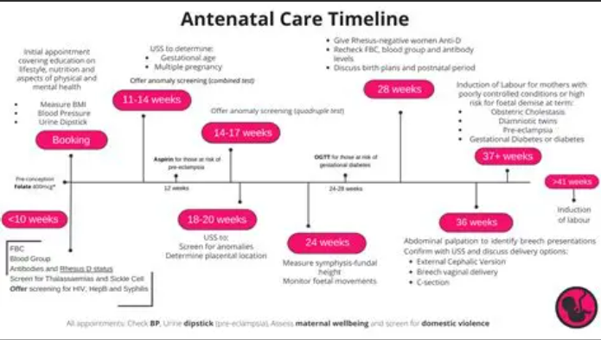

Component 2 – Essay

Introduction
National Health Service (NHS) is the most powerful health care system in the world that is based on the principles of universal access and equity. This essay examines the origins of the NHS by discussing its historical background, the social factors that influenced the development of the NHS, and the key principles according to which the NHS was created in 1948. It then analyzes the existing framework of the NHS and its functioning in present times. Knowledge of its history helps in understanding the reason why NHS has been a crucial component of health and social care in UK.

Origins of the NHS

Its formation dates back to the year 1948, when the NHS was founded under the influence of Aneurin Bevan who was a Minister of Health in the post-war Labour government. It was influenced by the social and economic problems that the UK had to deal with following the Second World War. In the 1930s and 1940s, a large number of individuals were unable to cover healthcare cost because medical care relied on the capacity to pay or the voluntary insurance plans (Rivett, 2011). This resulted in high disparities in doctor, hospital and maternity care access.
One of the major factors that led to the initiation of the NHS was the Beveridge Report (1942). Beveridge proposed universal health system financed through taxation as one of the key national progress inhibitors due to poor health, which was one of the main social evils, (Beveridge, 1942). The public backed his proposed solutions as they had received free emergency healthcare throughout the war under the Emergency Medical Service.
- Aneurin Bevan established NHS based on three principles:
- Universality - health care to all people.
- Free at point of use - individuals could receive care without having to pay.
- Funded due to taxation - to hold the financial responsibility in common (Ham, 2021).
With the creation of the NHS in 1948, there came a radical transformation of the healthcare system that was characterized by privatisation and charitable forms of health service to a nationalised healthcare system that was meant to narrow inequalities and enhance the health of the people.

Current Structure of the NHS

Since 1948, NHS has evolved greatly and currently has a complicated organisational set up. In England, the Department of Health and Social Care (DHSC) has the general responsibility of policy, funds and national priorities. The primary body that regulates the provision of healthcare services, budget funds, and regulates the quality standards is NHS England (Walshe and Smith, 2022).
Since 2022, the healthcare planning is structured around the ICSs. Every ICS consists of hospitals, GPs, mental health services, community services, local councils, and voluntary organisations, which coordinated care in a particular area (NHS England, 2023). The intention is to enhance the work of various components of the system and minimize their separation.
Services are provided below ICS level by:
- NHS Trusts - supervising hospitals, mental medical services, and community care.
- GP practices - this means the primary care approach, and the point of first stay.
- Local government - provide both adult social care and public health services.
By doing so, this structure gives the NHS an opportunity to handle its diverse range of goals of acute care, public health, mental health, community services, and long-term care.

Present System of NHS Work.

The NHS operates as a result of primary, secondary, and tertiary care. The majority of first-contact care is based on GPs, and the specialist treatment is provided in hospitals. It has a publicly funded system based on taxation, which has free access to the point of use by the residents.
Major modern challenges are still being experienced by the NHS. The services are under pressure due to increasing demand among an ageing population, long-term conditions like diabetes, and labour shortages (Kings Fund, 2023). The waiting time and the accessibility to resources are also influenced by the matter of financial constraints. In spite of such problems, patient-centred care, safety and equity are still priorities of the NHS.
The NHS is also changing its operation due to the digital transformation. The electronic records, remote consultations, and integrated systems of data are some of the services that are meant to enhance efficiency and continuity of care (Greenhalgh et al., 2020).

Conclusion

The establishment of the NHS was founded on the principles of fairness and collective responsibility, its purpose was to address the gaps in inequalities and offer all people access to healthcare. It has developed a structure that is a big and complicated system comprising of numerous bodies however its values have not changed. Despite the considerable struggle NHS is going through, it still remains a core element, that helps the population of the UK in maintaining health and wellbeing.

References

Beveridge, W. (1942) Social Insurance and Allied Services. London: HMSO.

Department of Health and Social Care (2022) Health and Social Care Workforce Overview. London: DHSC.

Greenhalgh, T., Wherton, J., Shaw, S. and Morrison, C. (2020) ‘Video consultations for COVID-19’, BMJ, 368, pp. 1–2.

Ham, C. (2021) Health Policy in Britain. 8th edn. London: Palgrave Macmillan.

King’s Fund (2023) NHS Key Facts. London: The King’s Fund.

NHS England (2023) Integrated Care Systems: Design and Delivery. London: NHS England.

Royal College of Midwives (2021) State of Maternity Services Report. London: RCM.

Rivett, G. (2011) From Cradle to Grave: Fifty Years of the NHS. London: King’s Fund.

Walshe, K. and Smith, J. (2022) Healthcare Management. 3rd edn. Maidenhead: Open University Press.

