Gregor McClenaghan 2,145 words, excluding picture captions, title, and references

HPAH7014 Assignment 2

Object analysis

Boar‑tusk helmet from Dendra, Tomb 12 (The Cuirass Tomb), on display at the Archaeological Museum of Nafplion. No catalogue number available.

“Meriones gave Odysseus a bow and quiver and a sword, and on his head he put a helmet of leather, carefully made. It was stretched tight on the inside by many straps: and outside rows of white tusks from a shining-toothed boar ran round it this way and that, well and skilfully fastened: and a layer of felt was fixed between. Autolykos had once stolen it from Amyntor son of Ormenos, breaking through his strong house in Eleon: and he gave it to Amphidamas of Kythera to take to his home in Skandeia. Amphidamas gave it as a gift of friendship to Molos, and he gave it to his son Meriones to wear. And now it was put over Odysseus’ head to cover it.”
- Homer, Iliad X, 260-271

When these lines were composed, around the 8th century BCE (Kirk 1962), the type of boar-tusk helmet they describe had not been used for at least three hundred years, and would have been an ancient, near-obsolete design at Troy. Perhaps the poet (or poets) had never seen one, and repeated a description handed down over the years (Hencken 1971). Examples have been found in more than fifty Mycenaean Bronze Age tombs in Greece and Crete, (Everson 2013), and they are depicted in frescos, carvings, and other art from as far away as Egypt (Schofield and Parkinson 1994).

They may be the first armour used in Greece; the earliest dates to before 1600 BCE, and the latest to around 1150 BCE. They appear to be an independent Mycenaean invention that was not influenced by existing helmets worn by the Hittites or Egyptians (Everson 2013). As such, and given how they have been found and depicted, they can show us several aspects of Mycenaean culture, including funerary practices; the importance of hunting and martial prowess; gift-giving and trade; natural resource use and management; and technological innovation in response to an increasingly violent age.

I will focus on one from Chamber Tomb 12 at Dendra, found in 1960 during the second excavation of that site, together with a bronze cuirass and other armour pieces known as the “Dendra Panoply”.

The tomb also contained swords, knives, and silver and bronze cups; some items were looted prior to excavation (Flouris et al 2024).

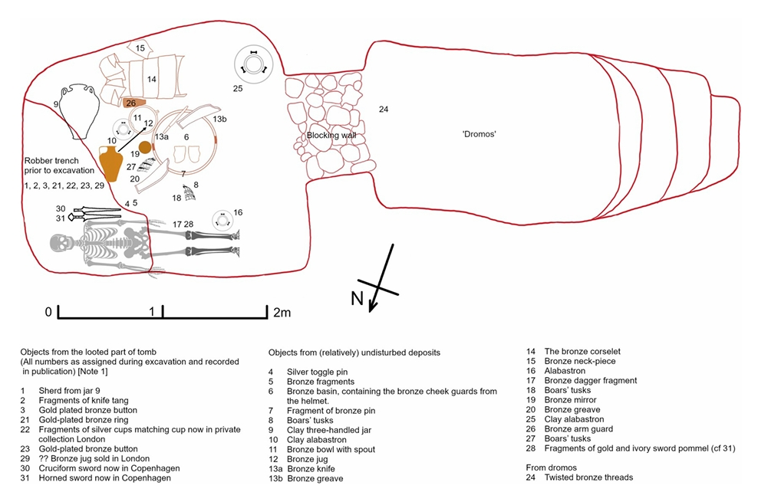
Illustration of Dendra Tomb 12 by Flouris et al (2024), based on information from the original excavation report by Åström (1971).

Axel Persson first excavated the Dendra cemetery in 1926, and from Alan Wace’s classification of tholos tombs, concluded it was built in the 15th Century BCE, with primary use between Late Helladic II to Late Helladic III B, around 1450 – 1180 BCE (Persson 1931). Paul Åström, who led the 1960 excavation, dated Tomb 12 to 1400 BCE (Åström 1977, cited in Howard 2011).

Many Mycenaean tombs were used repeatedly, but this apparently did not happen in Tomb 12; it contained a single occupant, and there is no suggestion it had been used before.

The dating is significant. Voutsaki (2025) says there was a sudden and profound societal change from the “kin-based, introverted, and austere village societies” of the Greek Middle Bronze Age to the “highly differentiated, expansionist, and ostentatious” Mycenaean kingdoms, during which the construction of extramural cemeteries inscribed on the physical world cosmological boundaries between the living and the dead, while society adopted more rigid definitions of personal identity, status, and gender, with elaborate deposits of grave goods being one reflection of this. Boyd (2014) emphasises the performative aspect of Mycenaean funerals, with the deposited objects acting as non-human participants, “playing a crucial role in creating spectacle” as they were gathered, chosen, and carried to the grave.

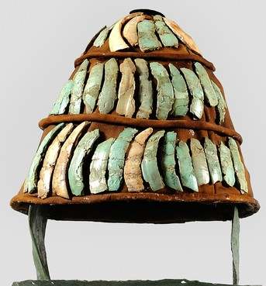
The context of the tomb makes it difficult to determine exactly how the helmet was placed within it. Pieces of armour may have been moved when the tomb was looted. The boar tusks were found in two groups, separated by an armoured greave; the cheek pieces were in a central bronze basin.

We cannot tell how old the helmet was when deposited, or why it was chosen, but the Iliad hints at it being an object of great value; the one given to Odysseus is stolen, given twice in friendship, inherited from father to son, and finally re-gifted to Odysseus as he sets out on a dangerous mission, presumably for its symbolic power, stemming in part from its long history, rather than utilitarian function, as he surely already possessed a helmet of his own.
The boar-tusk helmet from Dendra tomb 12, showing the tusks and bronze cheek pieces attached to a leather cap. It is not clear how the museum has done this, as stitching is not visible. Image from the Archaeological Museum of Nafplion.

Our knowledge of its manufacture is largely based on the Iliad. No leather or textile portions of the helmets have survived, and the tusks themselves are often in poor condition, but there is enough evidence for modern researchers to replicate the process. The tusks are split in half to form small plates, which have holes drilled through, to allowing them to be stitched to the leather cap in two to five rows, alternating which way the tusks curve. Modern reconstructions found this leaves the lacing vulnerable, which is compensated for by covering the stitching with a leather strap, creating a thin band, like those seen in some illustrations (Everson 2013). Most depictions and several found examples of this type include a socket at the top of the helmet to hold a plume, probably of horse hair, but no metal socket was found at Dendra; if there was one it has not survived.
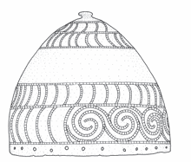
Over fifty boar-tusk plates were found in Tomb 12, plus two bronze plates identified as cheek pieces. This is unique; other examples of boar-tusk helmets have been found with cheek pieces made from tusk, but not metal. Hencken (1971) suggests that the Dendra helmet marks a transitional stage between helmets entirely made of tusk to those entirely of bronze. He mentions a bronze helmet found in Knossos that resembles a boar-tusk helmet, noting that real tusks were rare in Crete. Mödlinger (2013, 2017) gives details of another, unprovenanced bronze helmet decorated to resemble boar tusks, suggesting a symbolic power inherent in the design, even in a different material.
Sketch of an unprovenanced bronze helmet showing boar tusk decoration. Mödlinger 2013.

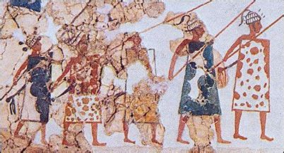
Was this a practical piece of defensive war gear? Modern consensus suggests that it was; Howard (2011) points out that the earliest depiction of a boar-tusk helmet, dating to around 1600 BCE, is from a fresco found at Akrotiri on Thera, showing warriors armed with shields and spears; the helmet is their only obvious armour. Everson (2013) says the brittle bronze available in this period may have made it harder to shape a helmet, and suggests that while boar tusks might shatter under a blow, this would disperse the kinetic energy, in much the same way as the ceramic plates in modern body armour. The leather part of the helmet would also have defensive properties, depending on how it was treated and how many layers were used.
Detail from the fresco “Meeting on the hill”, Akrotiri west house, Thera, c. 1600 BCE. Picture from Pinterest, credit unknown.

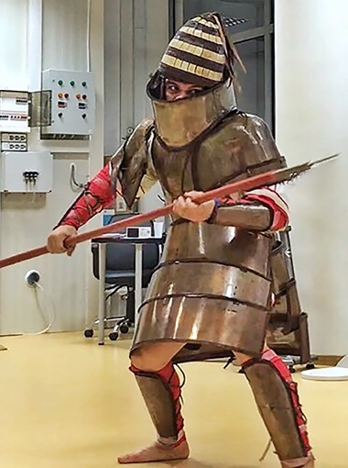
Flouris et al (2024) used a reconstruction of the Dendra panoply, including the helmet, to put members of the Greek armed forces through scientifically monitored drills designed to mimic the typical activities and movements involved in a day of Bronze Age fighting, based on the descriptions of combat in the Iliad. They found the soldiers could function effectively while wearing it, laying to rest earlier suggestions that the Dendra cuirass was purely ceremonial. While the helmet formed a relatively minor part of the replica equipment, it nevertheless worked, in terms of not being too hot or heavy to wear. Given how often boar-tusk helmets are depicted, it is reasonable to consider it genuinely functional. There is obvious practical value in protecting the head in combat, regardless of the level of technology. Swinney (2016) and Sapounakis et al (2006) analysed the text of the Iliad, and found head injuries are frequently given as the cause of death; Swinney found several descriptions of a helmet saving a character’s life, albeit not in a statistically significant number of cases.
Replica of the Dendra panoply, including boar-tusk helmet, being tested by a Greek marine. Picture from Flouris et al (2024).

Clearly not all the pieces of the Dendra helmet survived, but the sheer number of tusks required raises important questions about the helmet’s practicality, prestige, and the effort involved in creating it. Howard (2011) says that between twenty and fifty boars would be needed to make one helmet. Even for a culture in which boar hunting is frequently depicted and was important to the lives of the elite (Morris 1990), this represents a colossal expenditure of time and effort.

Wild boar were hunted and eaten long after domestication of animals meant it was no longer an economic necessity. Morris says that hunting involved practicing many of the skills required for war, such as weapon use, stealth, and physical fitness, but also functioned as a form of territorial control over the unclaimed or disputed spaces between citadels, given that Mycenaean art represents it as an “organised, palatial activity involving a high degree of display”; it was a ruler’s responsibility to keep territory free from dangerous animals that could interfere with crops.

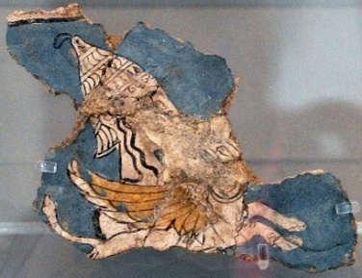
Morris argues that the symbolism of the helmet was not purely martial. She refers to a fresco fragment that shows a female figure wearing a boar-tusk helmet while riding a griffin, and suggests the helmet symbolized not only warfare, but also hunting, sacrifice, the protection of territory, and peoples’ interaction with the natural world.
Mycenaean fresco fragment showing a female figure wearing a boar-tusk helmet. Picture from National Archaeological Museum, Athens.
Wild boar mature quickly, with females reproducing at around four months, although they continue to gain weight for up to three years (Wehr 2020). Wild boars subject to increased hunting by humans give birth up to 12 days earlier than normal (Gamelon et al 2011); the more they are hunted, the faster they breed. But it would still take a long time and many expeditions to gather the tusks for a single helmet, even in regions where boar were plentiful. Boar-tusk helmets have been found on a number of Aegean islands, including Crete; Hencken (1971) notes that Meriones in the Iliad passage came from Crete, and Amphidamas was from Kythera; while these islands had wild boar populations (Slim et al 2020), it is unclear if they could consistently maintain enough mature boar to provide a steady supply of tusks.

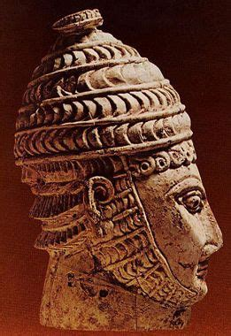
It is possible that helmets, or unworked tusks, might have been traded. Cline (2021) has posited that there was a robust network of trade across the Aegean by 1450 BCE, and I can imagine a market for the raw material of easily portable ivory tusks, for a variety of uses. Howard (2011, p. 170) mentions a piece of worked boar tusk that was excavated from a workshop at Qantir, in the Eastern Egyptian delta, suggesting it is evidence of Mycenaean mercenaries. We must consider whether tusks bought or traded would hold the same symbolic power as those hunted oneself. Morris (1990) says possession of such a helmet proclaimed that the wearer had the bravery and skill needed to acquire the tusks, and perhaps symbolically appropriated some of the animal’s power; Connerton (1989, p.87) asserts that “objects attesting to nobility… cannot be acquired by proxy or in haste.”
Carved ivory warrior wearing a boar-tusk helmet, found in Mycenae. Picture from National Archaeological Museum, Athens.

The importance of this, I think, would depend on the individual. Some soldiers might care deeply how much prestige or history was invested in a helmet; others may have cared more about its physical effectiveness, the message it sent to the enemy, or that it marked the wearer as a leader. In the heat of battle, would anyone know or care where and how a particular helmet was acquired?

The helmet found in Tomb 12 probably worked as a uniform and personal banner, allowing friends to easily recognise each other in the confusion of a fight. I have not been in a bronze age battle, but I have been to some concerts that came close, and know from experience how quickly friends can be swallowed by a crowd. A tall, striking helmet with a crest or plume would stand above the melee, giving allies and subordinates a visual focus to rally round, amongst noise, terror, and confusion. Gell (1998) talks about art as a technical system; this helmet, and the art that went in to its making, would work as broadcast technology, communicating the most basic message: “I am here”.

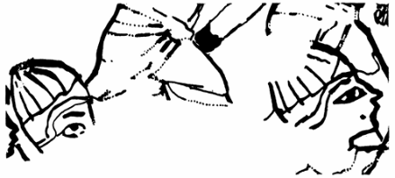
Boar-tusk helmets were iconic. Schofield and Parkinson (1994) have explored whether a piece of Egyptian papyrus shows Mycenaean soldiers wearing them, and speculate that the helmet’s distinctive appearance might have been used as visual shorthand for Mycenaeans as a people. Even after it fell out of use, horns and tusks were widely used as decoration on metal helmets, not only in the Mediterranean, but as far west as the Iberian peninsular and as far north as Scandinavia. Indeed, the “royal” tholos tomb at Dendra contained two lead horns, and pieces of green and blue glass paste shaped to resemble the boar tusk plates from tomb 12, which were interpreted as decoration for a helmet (Persson 1931).
Detail of Egyptian papyrus found at el Amarna, possibly showing foreigners wearing boar-tusk helmets. Drawing by R.B. Parkinson, in Schofield and Parkinson (1994)

While it is not the most complete example of its type, the Dendra helmet has helped advance our understanding of Mycenaean culture, warfare and technology, and may offer a glimpse in to the mental and spiritual world of the man who was laid to rest beside it.

Reference List

Boyd, M. (2014) ‘The materiality of performance in Mycenaean funerary practices’, in World Archaeology, Vol. 46(2): 192-205, https://doi.org/10.1080/00438243.2013.879045

Cline, E. (2021) 1177 B.C. The Year Civilization Collapsed, revised edition, Princeton University Press.

Connerton, P. (1989) How Societies Remember. Cambridge University Press.

Everson, T. (2013) Warfare in Ancient Greece: Arms and Armour from the Heroes of Homer to Alexander the Great. 1st ed. Stroud: The History Press.

Flouris, A. et al (2024) ‘Analysis of Greek prehistoric combat in full body armour based on physiological principles: a series of studies using thematic analysis, human experiments, and numerical simulations’, in PLoS ONE Vol. 19(5) https://doi.org/10.1371/journal.pone.0301494

Gamelon, M. et al (2011) ‘High hunting pressure selects for earlier birth date: wild boar as a case study’, in Evolution Vol. 65(11): 3100–3112

Gell, A. (1992) ‘The Technology of Enchantment and the Enchantment of Technology’, in Coote, J. and Shelton, A. (eds), Anthropology Art and Aesthetics, Oxford Academic https://doi.org/10.1093/oso/9780198277330.003.0003

Hencken, H. (1971) The Earliest European Helmets: Bronze Age and Early Iron Age. Cambridge, Massachusetts: Peabody Museum Press.

Homer (1987) The Iliad. Translated by Martin Hammond. Harmondsworth: Penguin Classics (reprint).

Howard, D. (2011) Bronze Age Military Equipment. Pen & Sword Military, Barnsley.

Kirk, G. (1962) The Songs of Homer, Cambridge At The University Press.

Mödlinger, M. (2013) ‘From Greek boar’s-tusk helmets to the first European metal helmets: new approaches on development and chronology’, in Oxford Journal of Archaeology Vol. 32(4): 391-412 https://doi.org/10.1111/ojoa.12021

Mödlinger, M. (2017) Protecting the Body in War and Combat Metal Body Armour in Bronze Age Europe, Austrian Academy of Sciences, Vienna.

Morris, C. (1990) ‘In Pursuit of the White Tusked Boar: Aspects of Hunting in Mycenaean Society’, in Hägg, R. and Nordquist, G. (eds) Celebrations of Death and Divinity in the Bronze Age Argolid, Proceedings of the Sixth International Symposium at the Swedish Institute at Athens 11-13 June 1988, Stockholm.

Persson, A. (1931) The Royal Tombs at Dendra Near Midea, Oxford University Press.

Sapounakis, C. et al (2006) ‘Injuries to the head and neck in Homer’s Iliad’, in British Journal of Oral and Maxillofacial Surgery Vol. 45: 112-115. https://doi.org/10.1016/j.bjoms.2006.04.003

Schofield, L. and Parkinson, R. (1994) ‘Of Helmets and Heretics: A Possible Egyptian Representation of Mycenaean Warriors on a Papyrus from El-Amarna’, in The Annual of the British School at Athens Vol. 89: 157-170 https://www.jstor.org/stable/30102567
Slim, F. et al (2020) ‘Pigs in Sight: Late Bronze Age Pig Husbandries in the Aegean and Anatolia’, in Journal of Field Archaeology, Vol. 45(5): 315-333, https://doi.org/10.1080/00934690.2020.1754081

Swinney, C. (2016) ‘Helmet Use and Head Injury in Homer’s Iliad’, in World Neurosurgery Vol. 90: 14-19. http://dx.doi.org/10.1016/j.wneu.2016.02.002

Voutsaki, S. (2025) ‘Mortuary practices and societal change in Early Mycenaean Greece’, in Norstein, F. and Selsvold, I. (eds) Archaeological Perspectives on Burial Practices and Societal Change: Death in Transition, Routledge, Abingdon.

Wehr, N. (2020) ‘Historical range expansion and biological changes of Sus scrofa corresponding to domestication and feralization’, in Mammal Research Vol. 66: 1-12 https://doi.org/10.1007/s13364-020-00534-7

