AI use acknowledgement.
I acknowledge the use of Grammarly (https://www.grammarly.com/) on multiple dates during March and April 2026 to check spelling, grammar, punctuation and reword sentences for improved clarity.

I acknowledge the use of ChatGPT on multiple dates in March and April to assist with planning and structure, and to provide guidance on using SPSS.

I confirm that I have not presented any AI-generated text or images as my own work. I confirm that I have copies of my notes and other resources used before and after using AI tools, which I may be asked to provide as evidence.

Maintaining operational fitness in a midlife female firefighter: a physiological case study

Exercise physiology (BMSS5001)

Sophie Grenfell
2317557

Introduction
Firefighting is a physically demanding occupation that requires a high level of aerobic fitness, strength, and power to perform operational tasks safely and effectively. Firefighters regularly perform tasks such as climbing stairs and ladders, handling equipment, carrying loads, and casualty evacuation, often in stressful, physically demanding situations while wearing personal protective equipment. Maintaining optimal physical fitness is essential not only for performance but also for reducing the risk of injury (Michaelides et al., 2011; Ras et al., 2023b). There is also strong evidence that higher fitness levels are associated with improved overall health and enhanced job performance in firefighters (Ras et al., 2023a).
Aerobic capacity is particularly important as it enables firefighters to work for longer periods and recover between highly intensive efforts. Maximal oxygen uptake (VO₂ max) testing is commonly used to assess operational readiness and overall cardiovascular fitness. VO₂ max reflects the body’s ability to utilise oxygen during sustained exercise (Liguori, 2021; Hart et al., 2024). Muscular strength is also a major factor, especially for tasks such as lifting, carrying, and handling equipment. Grip strength is often used as a simple measure of overall strength and has well-established reference values (Rubin et al., 2025). Full-body strength is also necessary for lifting and carrying, while lower-body power helps with movements such as stair climbing and quick changes in direction. These areas were selected for assessment due to their relevance to firefighting tasks and frequent use in fitness assessment.
Body composition plays an important role in influencing both performance and health in firefighters. Lower body fat levels and greater lean muscle mass are generally associated with improved movement efficiency and reduced cardiovascular strain (Ras et al., 2023a). Maintaining a healthy balance between fat and muscle is therefore essential for remaining operationally active.
Despite the well-established physical demands of firefighting, research has predominantly focused on male firefighters, with less information being available on female firefighters, particularly midlife female firefighters. This represents an important gap, as fitness levels can decline with age, especially in aerobic fitness, strength, and recovery (Kirlin et al., 2017). These changes, along with potential musculoskeletal issues, may affect performance and increase the risk of injury (Iwańska et al., 2025). As more women enter the fire service, it is important to understand these factors better (Jahnke et al., 2012; Perroni et al., 2023).
Previous research has shown that laboratory-based fitness assessments and simulated firefighting tasks can serve as good performance indicators for actual firefighting tasks (Heimburg et al., 2013; Lin et al., 2025). There is, however, still a lack of specific data for female firefighters, which can make it harder to interpret results.
This case study aims to assess the fitness profile of a midlife female firefighter and compare her results with both general and firefighter norms, as well as Z-scores from a group of female students. The main areas assessed include aerobic fitness, strength, power and body composition, as all these are relevant to firefighting performance. This study aims to provide an evidence-based evaluation of the participant's current fitness levels and identify areas for development to enable her to remain an operationally active firefighter.

Method
One participant, a midlife female firefighter, volunteered for this case study. Before any testing, she completed a PAR-Q health questionnaire and an informed consent sheet. In these forms, the participant reported having arthritis in her right hand and big toes, which limited mobility in these areas. It was also requested that the participant had not eaten for 2-4 hours, had not engaged in any physical activity for 12 hours, had not consumed alcohol for 24 hours, and was well hydrated before commencing testing.
Baseline measurements were taken in the following order. Resting blood pressure and heart rate using a Bosu Medicus automated blood pressure monitor (Bosch + Sohn GmbH u. Co. KG (boso), Jungingen, Germany). The participant was seated and relaxed with her arms resting at 90° for 5 minutes. Two readings were taken on each arm, and the mean values were recorded. Height was measured using a Seca 213 stadiometer (Seca GmbH & Co. KG, Hamburg, Germany) with the participant standing barefoot, upright in the correct position.
Body composition was measured using an InBody 380 bioelectrical impedance analyser (InBody Co., Ltd., Seoul, South Korea). The participant followed the InBody guidelines for the test.
A standardised warm-up was performed, consisting of a pulse raiser, dynamic stretching, and task-specific preparation. Whole body strength was assessed using a Takei Back and Leg Dynamometer (Takei Scientific Instruments Co., Ltd., Niigata, Japan). The participant stood barefoot, feet shoulder-width apart, knees slightly bent, arms straight, holding the bar at mid-thigh level. When ready, the participant pulled upward as hard as possible. Three attempts were recorded, with a one-minute recovery between attempts. The highest value (kg) was recorded.
Grip strength was recorded using a Takei Hand Grip Dynamometer (Takei Scientific Instruments Co., Ltd., Niigata, Japan). The participant stood upright with her arm straight by her side, not touching her body. The participant completed three attempts on each hand, alternating sides with a rest between attempts. The highest attempt (kg) was recorded for each hand.
Lower body power was assessed using a countermovement jump (CMJ) on a FP8 2003 force platform (HUR Oy, Kokkola, Finland). The participant kept her hands on her hips to reduce upper-body movement. From a standing position, she performed a quick downward movement followed by a maximal jump. Four attempts were recorded, and the highest jump (cm) was recorded.
Aerobic fitness was measured using a maximal cycling ramp test on the Wattbike Atom X (Wattbike Ltd, Nottingham, UK). The participant wore a face mask throughout the test. Expired air was collected using a 100 L Douglas Bag (Hans Rudolph Inc., Shawnee, KS, USA), analysed using a Servomex miniHF 5200 gas analyser (Servomex Group Ltd, Crowborough, East Sussex, UK) and Harvard DGM1 dry gas meter (Harvard Apparatus, Holliston, MA, USA). Heart rate was measured using a Polar OH1 sensor (Polar Electro Oy, Kempele, Finland). Perceived effort was recorded using the Borg scale. The test started at 70W and increased by 15W every minute until the participant reached 1 minute from maximum. Expired air was collected over the final minute and then analysed.
Data analysis included calculating Z-scores to compare participant’s results with a female student group using the formula: Z = (participant score – group mean) / standard deviation. Results were also compared to published female normative data and female firefighter data where available.

Results
The participant’s physiological test results are presented in Table 1, with comparative Z-score analysis scores against a female student group shown in Figure 1. Z-scores were used to compare the participant's performance relative to the group mean and standard deviation across the measured variables. Four physiological variables were assessed: aerobic capacity, body fat percentage, strength, and power.
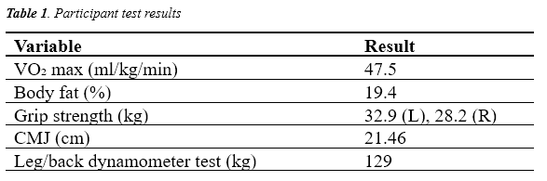
Z-score analysis comparing the participant to a female student group is presented in Figure 1
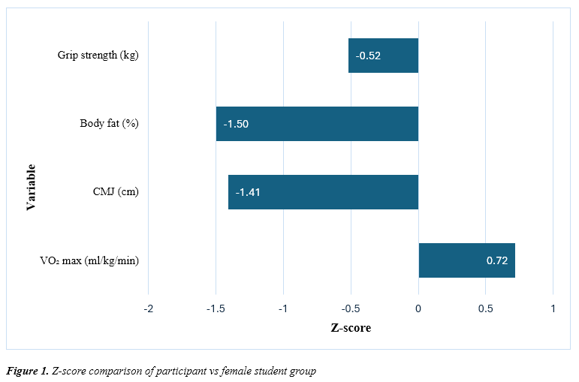
Z-score (Figure 1) showed values ranging from 0.72 to -1.50. The participant’s VO₂ max was above the group mean (Z = 0.72), while CMJ performance (Z = -1.41), grip strength (Z = -0.52) and body fat percentage (Z = -1.50) were below, with body fat showing the greatest deviation.
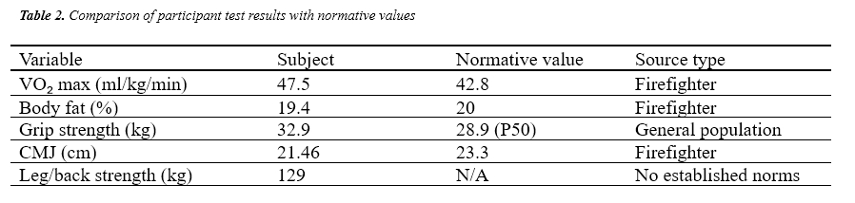
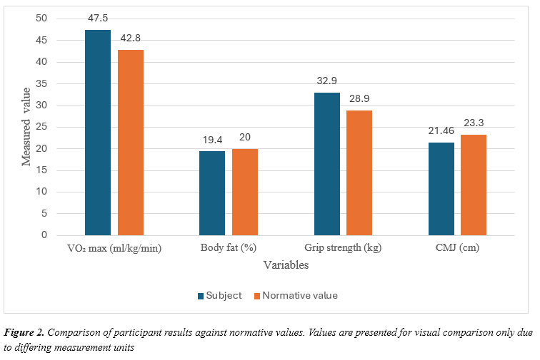
Comparison with normative data is presented in Table 2 and Figure 2
The participant’s VO₂ max (47.5 ml/kg/min) exceeded the reported mean value for firefighters (~42.8 ml/kg/min), and body fat percentage was within the upper end of the athletic range (~20%). Grip strength showed asymmetry between hands, with the left hand exceeding the reported population value of 28.9 kg, while the right hand (28.2 kg) was slightly below this value. The highest grip strength value (left hand) was used for comparison. CMJ performance (21.46 cm) was lower than the reported firefighter normative value of 23.3 cm, indicating reduced lower-body power compared to occupational standards.
Overall, variation was observed across all physiological variables when compared with both the student group, firefighter norms and general population norms. With differences between aerobic fitness, strength, power and body composition measures.

Discussion and conclusion.
This case study aimed to assess the physiological profile of a midlife female firefighter and to compare her results with those of a group of female university students and with available normative data for firefighters and the general population. The results showed a mix of strengths and weaknesses: strong aerobic capacity and body composition, but lower performance on strength and power measures.
Aerobic capacity was a key strength, with a VO₂ max of 47.5 ml/kg/min, which falls within and towards the higher end of the range expected for firefighters. Fire service guidelines suggest that a minimum level of aerobic fitness (42.3 ml/kg/min) is required for safe operational performance (South Wales Fire and Rescue Service, 2018). This indicates that the participant is well within the required operational range, and aerobic fitness is unlikely to be a limiting factor in her ability to perform firefighting tasks. High aerobic capacity is associated with increased stroke volume, cardiac output and mitochondrial density, improving oxygen delivery and utilisation during exercise (Liguori, 2021; Ras et al., 2023b). This is essential for tasks such as climbing stairs, carrying equipment and casualty evacuation (Michaelides et al., 2011; Lin et al., 2025). The participant’s 28 years in the fire service, along with a background in long-distance and ultra running, may have contributed to this high level of aerobic fitness.
Body composition was also within the optimal range, with a body fat percentage of 19.4%. This is within the expected range for both athletic populations and firefighters. Lower body fat is associated with improved movement efficiency and reduced strain on the body during physically demanding work tasks (Lockie et al., 2022; Ras et al., 2023a). Maintaining an appropriate body composition is important in firefighting, where additional body mass can increase fatigue and physiological load.
Lower body power was identified as a weakness. The participant’s CMJ score was below both the student group and the firefighter normative value (23.3 cm). This may be due to reduced neuromuscular efficiency and force production, both of which decline with age due to reduced fast-twitch muscle fibre recruitment (Kirlin et al., 2017; Nindl et al., 2016). CMJ performance could also be affected by the reported arthritis in the participant's toe, which may limit force production.
Grip strength (32.9 kg, highest value) was slightly below the student group but still above the general population normative data (28.9 kg). There was also a noticeable difference between left and right-hand grip strength. This is likely due to arthritis in her thumb. This highlights a limitation of grip strength testing, as localised injury can affect the result. Grip strength is important in firefighting for tasks such as equipment handling and hose control (Michaelides et al., 2011). 28 years of service may contribute to musculoskeletal stress, which has been reported among firefighters (Iwańska et al., 2025).
Leg and back strength was measured at 129kg. While this reflects the participant’s capacity to generate maximal force, the absence of directly comparable normative data limits the ability to compare with other populations. This test may reflect the physical demands of firefighting duties, such as lifting and carrying (Bortolini et al., 2025; Peterson et al., 2008). Due to this, the leg-back dynamometer results were not included in the comparative analysis. This represents a limitation of the current study, as the lack of normative data restricts direct comparison for this variable.
Based on these results, several training recommendations can be made. Lower-body power should be prioritised, using plyometric exercises adapted to the participant's arthritis-related restrictions and resistance training to improve the participant's rate of force development. Grip strength training should also be included, again considering arthritis limitations. Aerobic fitness should be maintained through regular steady-state and interval training. By combining multiple approaches, the client should be able to reduce strain on arthritis-affected areas of the body. Mobility and rehabilitation work should be included to address musculoskeletal limitations. Research shows that structured strength and conditioning programmes can improve firefighter performance (Peterson et al., 2008; Lockie et al., 2022).
In conclusion, the participant shows strong aerobic fitness and good body composition, both of which support Firefighting performance. However, lower body power and grip strength were identified as areas for improvement. Targeted training may help maintain performance and reduce injury risk, which is particularly important in midlife firefighters with long service careers.

References
Bortolini, M.J.S. et al. (2025) “Back-leg-chest test as an alternative to the handgrip testing for measuring body strength in adults,” Journal of bodywork and movement therapies, 42, pp. 1085–1090. Available at: https://doi.org/10.1016/j.jbmt.2025.03.007.

Hart, W., Taylor, D. and Bishop, D.C. (2024) “Validity of submaximal aerobic capacity and strength tests in firefighters,” Occupational medicine (Oxford), 74(2), pp. 161–166. Available at: https://doi.org/10.1093/occmed/kqae004.

Heimburg, E. von et al. (2013) “Performance on a Work-Simulating Firefighter Test Versus Approved Laboratory Tests for Firefighters and Applicants,” International journal of occupational safety and ergonomics, 19(2), pp. 227–243. Available at: https://doi.org/10.1080/10803548.2013.11076981.

Iwańska, D., Tabor, P., Urbanik, C., Wiszomirska, I. and Mastalerz, A., 2025. Overload of the lower limbs of firefighters as a result of external conditions. PLoS One, 20(12), pp. 15.

Jahnke, S.A., Poston, W.C., Haddock, C.K., Jitnarin, N., Hyder, M.L. and Horvath, C., 2012. The health of women in the US fire service. BMC Women's Health, 12, pp. 39.

Kirlin, L.K. et al. (2017) “The effect of age on fitness among female firefighters,” Occupational medicine (Oxford), 67(7), pp. 528–533. Available at: https://doi.org/10.1093/occmed/kqx123

Liguori, G. (ed.) (2021) ACSM’S Guidelines for Exercise Testing and Prescription. Eleventh edition. Philadelphia: Lippincott Williams & Wilkins.

Lin, Y.-W. et al. (2025) “Predicting firefighting simulation tasks performance from firefighters’ specific fitness tests,” Work (Reading, Mass.), 81(4), pp. 3202–3210. Available at: https://doi.org/10.1177/10519815251329282.

Lockie, R.G. et al. (2022) “Body Composition and Fitness Characteristics of Firefighters Participating in a Health and Wellness Program: Relationships and Descriptive Data,” International journal of environmental research and public health, 19(23), p. 15758. Available at: https://doi.org/10.3390/ijerph192315758.

Michaelides, M.A. et al. (2011) “Assessment of Physical Fitness Aspects and Their Relationship to Firefightersʼ Job Abilities,” Journal of strength and conditioning research, 25(4), pp. 956–965. Available at: https://doi.org/10.1519/JSC.0b013e3181cc23ea.

Nindl, B.C. et al. (2016) “Operational Physical Performance and Fitness in Military Women: Physiological, Musculoskeletal Injury, and Optimized Physical Training Considerations for Successfully Integrating Women Into Combat-Centric Military Occupations,” Military medicine, 181(1S), pp. 50–62. Available at: https://doi.org/10.7205/MILMED-D-15-00382.

Perroni, F. et al. (2023) “Sex differences in muscle quality of firefighter recruits: a new exploratory approach to evaluation,” Sport sciences for health, 19(1), pp. 95–102. Available at: https://doi.org/10.1007/s11332-022-01005-z.

Peterson, M.D. et al. (2008) “Undulation Training for Development of Hierarchical Fitness and Improved Firefighter Job Performance,” Journal of strength and conditioning research, 22(5), pp. 1683–1695. Available at: https://doi.org/10.1519/JSC.0b013e31818215f4.

Ras et al. (2023a) “Physical fitness, cardiovascular and musculoskeletal health, and occupational performance in firefighters,” Frontiers in public health, 11. Available at: https://doi.org/10.3389/fpubh.2023.1241250.

Ras, J. et al. (2023b) “Association between Physical Fitness and Cardiovascular Health in Firefighters,” International journal of environmental research and public health, 20(11), p. 5930. Available at: https://doi.org/10.3390/ijerph20115930.

Rubín, L. et al. (2025) “International norms for adult handgrip strength: A systematic review of data on 2.4 million adults aged 20 to 100+ years from 69 countries and regions,” Journal of Sport and Health Science, 14(4). Available at: https://doi.org/10.1016/j.jshs.2024.101014.

South Wales Fire and Rescue Service (2018) On-call physical and practical assessment booklet. Available at: https://www.southwales-fire.gov.uk/app/uploads/2018/07/2250-On-Call-Physical-and-Practical-Assessment-Booklet-2018_en_web.pdf (Accessed: 1 April 2026).

