
Master of Business Administration

International Business pathway

The report of internationalization of Patagonia in india
Assessment 1: Individual report. Weight: 100%
Module Name: International Business Concepts
Module code: LCMB7034
Lecturer Name: Jean Wang

Student Name: Shubham Sanjaybhai Dudhat
Student ID: 2526722

Word count: 4933
Submission Date: Friday 14th August 2026

AI use acknowledgement
Note: One acknowledgement is needed for each used AI tool.
There was no use of any Ai tools to complete the work or conduct research, analyze reports, write content or any part of the project. The complete work has been solely done by me while using academic sources, reports and other information available on google. I take complete responsibility for the content as my own and no use of any Ai tools.

Table of Contents
Part 1: Introduction 4
Part 2: Organisational Classification and Global Strategy 5
2.1 Organisational Classification 5
2.2 Classification Using Bartlett and Ghoshal's Framework 6
2.3 Global Footprint and Competitive Advantage 6
Part 3: Macro-Environmental Appraisal & Market Attractiveness 8
3.1 Political Environment 8
Political Stability and Country Attractiveness 8
FDI Policy and Political Risk 8
Trade Policy and Strategic Implications 8
3.2 Economic Environment 9
3.3 Legal Environment 11
3.4 Cultural Environment: Hofstede Model 12
Power Distance 12
Individualism 13
Achievement and Long-Term Orientation 13
Uncertainty Avoidance and Indulgence 13
3.5 Ownership Advantages 14
3.6 Location Advantages 15
3.7 Internalisation Advantages 16
Internalisation Theory 16
Part 4: Entry Mode Strategy and Strategic Synthesis 18
4.1 Historical Entry Modes 18
4.2 Suitability of Historical Mode for India 18
4.3 Alternative Entry Modes 19
Exporting 19
Licensing 19
Joint Venture 19
Wholly Owned Subsidiary 20
4.4 Recommended Entry Strategy 20
Recommended Entry Mode 20
Strategic Justification 20
Conclusion 21
Reflection: Gibbs’ Reflective Cycle 22
Description 22
Feelings 23
Evaluation 23
Analysis 24
Conclusion 24
Action Plan 25
References 26

Part 1: Introduction
The aim of this report is to conduct a critical analysis of the possible internationalisation of Patagonia in India as well as the strategic considerations for market entry. Patagonia is a United States based multinational company operating in the industry of manufacturing outdoor apparel and is known for its superior quality product offering, sustainability and environmental consciousness (Patagonia, 2026). To begin, this report conducts an analysis of Patagonia’s organisational structure, global strategies, international presence and competitive advantages using Bartlett and Ghoshal’s approach. Moreover, the political, economic, legal and cultural environment of India is studied to understand the opportunities, costs and threats involved in the expansion process. Further, by using Dunning’s Eclectic Paradigm this report analyses Patagonia’s advantages of ownership, location advantages and internalisation advantages. In addition, the current international strategies will be discussed to identify an effective market entry strategy for India. Finally, the process of research and analysis will be presented by writing a reflection.

Part 2: Organisational Classification and Global Strategy

2.1 Organisational Classification
Patagonia is a US multinational corporation which deals with designing and manufacturing outdoor clothing and gear, and its international business operations encompass direct retailing, online business, wholesale marketing, and a dispersed global supply chain network (Patagonia, 2026). The global headquarters of Patagonia located in Ventura, California takes care of product design and sourcing, whereas products are marketed through Patagonia’s sales channels and by its wholesalers in over 40 countries around the world. In addition to its global headquarters, Patagonia maintains its offices in the US, the Netherlands, Japan, South Korea, Australia, Chile and Argentina, and maintains over 100 stores across the world (Patagonia, 2026). Hence, Patagonia can be regarded as a multinational corporation.
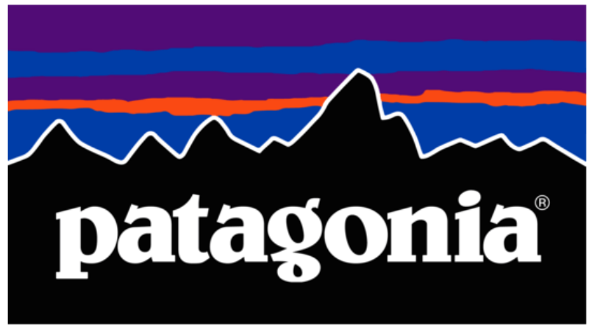
Figure 1: Patagonia brand logo
(Source: Patagonia, 2026)

2.2 Classification Using Bartlett and Ghoshal's Framework
The Bartlett and Ghoshal model differentiates international business organisations based on their integration pressures and pressure for local responsiveness. Using the Bartlett and Ghoshal’s model, Patagonia fits best into the category of a firm with a global strategy even though certain aspects of its activities are also transnational. The global strategy is characterised by coordination and standardisation of competitive advantage while transnational strategy aims at achieving global efficiency and responsiveness and organisational learning (Lu, 2024).
Patagonia illustrates global integration due to its consistent core value proposition throughout different countries (Patagonia, 2022). High quality and high durability of its products, commitment to the environment and superior performance outdoors are the core of its differentiation. In addition, the company’s unique ownership structure adds to this consistency from 2022 voting ownership belongs to the Patagonia Purpose Trust and the Holdfast Collective redirects all the economic value that cannot be used for growth towards tackling environmental issues (Chouinard, 2022).

2.3 Global Footprint and Competitive Advantage
This strategy is reinforced by the global value chain in Patagonia. It shows 50 completed factories for finished goods in 11 countries and material suppliers in 22 countries in its disclosure for 2026 (Patagonia, 2026). These factories are not owned by Patagonia but are linked to Patagonia by common social and environmental standards. This way the company can access niche production capabilities without having to buy the equipment. Particularly, although India is not one of the key markets for the cotton owned by Patagonia, it is a significant contributor to the upstream value chain of Patagonia's cotton.
However, Patagonia should not be seen as being totally standardised. There are some flexibilities in terms of individual markets through international subsidiaries, regional offices and wholesale relationships. This produces a restricted transnational feature. However, its product philosophy, sustainability criteria, brand identity, and sourcing requirements suggest that it is more integrated to the global than to the local dimensions (Patagonia, 2025). Patagonia's global strategy is based on the safeguarding of the unique sustainability-based competitive advantage, while also enabling a selective adaptation in case local market conditions demand it. The strategic challenge in India will be to maintain this global brand image while adjusting to the Indian market and distribution.
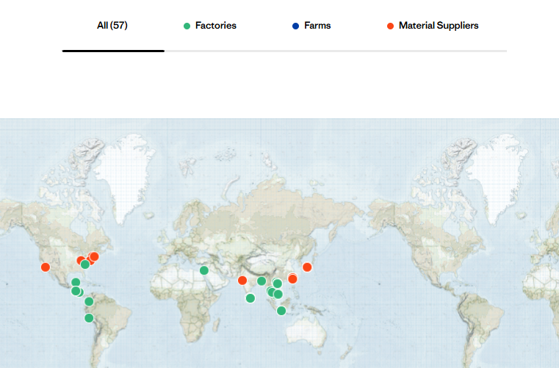
Figure 2: Company's Supply Chain Globally
(Source: Patagonia, 2026)

Part 3: Macro-Environmental Appraisal & Market Attractiveness

3.1 Political Environment

Political Stability and Country Attractiveness
The political landscape in India offers opportunities and challenges to Patagonia's expansion plans. The attractiveness of a country is a function of the market potential and the political costs and risk of operating in the country (Damodaran, 2022). India has a well-developed federal parliamentary system, and has adopted policies fostering foreign investment, infrastructure development and domestic manufacturing. The government has taken various measures to boost its manufacturing capacity and to attract foreign investment, including the initiative to 'Make in India' (PMINDIA, 2026). Patagonia has a relatively favourable environment for the development of markets over the long term in these conditions. However, the federal nature of the Indian government may cause variations in the rules and practices across states, adding complexity to choosing retail, distribution and sourcing locations.

FDI Policy and Political Risk
The foreign direct investment policy is significant for Patagonia as their operations would come under single brand retail. Under the Consolidated FDI Policy, foreign investment in single brand retail trading is allowed at 100 per cent and for investments above 51 per cent, there is a local sourcing requirement of 30 per cent on certain conditions (Investment policy hub, 2020). This condition imposes compliance expenses but could also have advantages for Patagonia since the company already gets materials from India. Therefore, increasing responsible local sourcing could help to meet regulatory requirements and enhance its sustainable supply chain. However, procedural political risk is still relevant, as the regulatory environment, administrative processes and implementation variations can lead to higher transaction costs and slow down business decisions.

Trade Policy and Strategic Implications
An added difficulty is government intervention in international trade. Tariff measures are an example of protective policy that can raise the price of foreign goods, thereby helping domestic industries (Dong and Kouvelis, 2020). A dependence on technical apparel imports may result in export price increases, due to tariffs and transportation and distribution costs. This is especially important because Patagonia's high-end marketing strategy already puts their products in a better class than mass-market products. Overall, the political scenario in India provides good market opportunities but regulatory and trade costs. Therefore, Patagonia should consider gradual expansion and step up responsible Indian sourcing, while continuing to monitor the regulations to minimise procedural and tariff risks.

3.2 Economic Environment
India offers Patagonia an economic climate due to its strong economic growth, growing consumer market and investment climate. India presents a huge demand for quality apparel and lifestyle items in the long run as the market is growing at a value of $102.8 billion in 2022 and is projected to be $146.3 billion by 2032 (IBEF, 2025). The rising middle and upper class, urbanisation and improved purchasing power are all positive trends for Patagonia's sustainability-driven business model which resonates with consumers who value high-quality, eco-conscious products. India is the fastest-growing major economy for the fourth year in a row with a growth rate of 7.4% in FY 2025 - 26 and a growth projection of 6.8 -7.2% for 2027 (PIB, 2026). The foreign direct investment (FDI) inflows totalled $81.04 billion in 2025, marking a 14% rise from the previous year, amid ongoing economic uncertainties in the world (PIB, 2025). The indicators reflect the strength of the economy to sustain Patagonia's long-term growth and its high-quality positioning in the market.
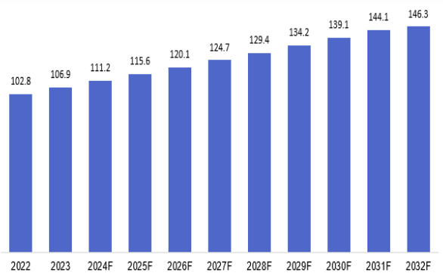
Figure 3: Apparel Market Projection by 2032
(Source: IBEF, 2025)
The company's strategy is based on the durability of the product, environmental responsibility and high quality instead of low prices. The government's investment in infrastructure, digital transformation and logistics is enhancing the accessibility of the retail market and the efficiency of the supply chain, making it more helpful to international retailers (Kumar, 2023). Moreover, the growing organised retail and e-commerce releases several distribution channels for Patagonia and lower the entry barriers. These advancements can increase the company's capacity to supply the growing demand for sustainable and ethically produced goods among wealthy urban consumers (Dona, et al., 2025). The retail inflation of India has reached 4.38%, creating uncertainty surrounding operating costs and consumer purchasing power (Sarkar, 2026). Patagonia faces some economic risks that need to be managed. The company would initially be dependent on imported products which would make it vulnerable to the volatility of the Indian Rupee against the US Dollar and would increase transportation costs

3.3 Legal Environment
The Indian legal landscape offers opportunities and challenges for Patagonia's expansion. The country has improved its legal system through foreign investment and guarantees consumer protection, environmental sustainability and fair market competition (DPIIT, 2025). While these changes improve transparency in the business environment for foreign firms, observance to various national regulations is crucial for market entry. The FDI of 100% is allowed for setting up single-brand retail trading in India, without any government approval, provided that it meets the specified sourcing and operational conditions for the company (PIB, 2025). The government has implemented reforms to ease the process of business registration, digital approvals and investment procedures which will enhance the ease of doing business in India and remove administrative limitations for foreign investors. These reforms offer Patagonia improved strategic control over its operations and help in long-term investment planning. The Consumer Protection Act 2019 mandates that businesses need to give product information, fair pricing, effective grievance mechanisms and the Legal Metrology Act 2009 calls for transparency in labelling of imported products in India (Digital Sansad, 2026).
The regulations would help to build consumer confidence and support Patagonia for the quality of its products and their sustainability in India. In addition, trademarks, brand identity and product designs are safeguarded under the Trade Marks Act 1999, minimising the risk of IP infringement and supporting a competitive edge in the Indian market (Banerjee and Basu, 2026). India has implemented various measures to enhance environmental governance such as the Environment Protection Act 1986, Plastic Waste Management Rules and the Extended Producer Responsibility (EPR) framework to minimise environmental threats and promote better waste management practices (Ministry of Environment, Forest & Climate Change, 2023). Patagonia's current dedication to recycled materials, responsible sourcing and circular manufacturing puts the company in a strong position to meet these regulations and improve its reputation as a company. While there are possible additional complexities in compliance costs, changing sustainability standards and import regulations at the time of market entry. Patagonia’s consumer, environmental and intellectual property laws with the country's legal framework are stable which offers a base for sustainable long-term business activity with a Tier 1 monitoring program (Patagonia, 2022).

3.4 Cultural Environment: Hofstede Model
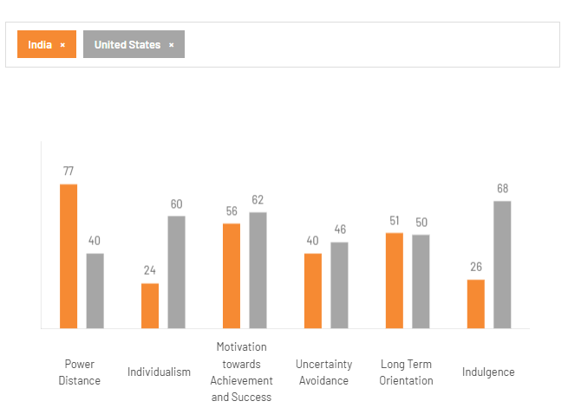
Figure 4: Country Comparison
(Source: The Culture Factor Group, 2026)

Power Distance
India has a score of 77 on Power Distance, much higher than the score of 40 for the United States (US) which means that Indian society is more hierarchical, more authoritarian and more formal in its organisational structures. People like to buy from well-known brands, trustworthy sources and institutions and they like to work for companies that have good leadership and clear roles. For Patagonia, this cultural trait is a key element to establishing trust through trusted retail partners, clear messaging and visible corporate social responsibility efforts. By building trust and showing dedication to the local communities, brand acceptance and customer loyalty can be enhanced in the Indian market (Sah, et al., 2025).

Individualism
India has a score of 24 for Individualism and the US has a score of 60, showing that Indian society is more collectivist and community-oriented. Family members, social networks and cultural values can play a role in purchasing decisions, as opposed to personal preferences. Patagonia can focus its products on the common environmental responsibility, on the community well-being and on sustainable living, rather than on individual achievement. Collective action marketing campaigns that encourage consumers to take action to protect the environment are likely to adopt greater emotional connections with Indian consumers.

Achievement and Long-Term Orientation
The two countries have similar cultural attributes in relation to achievement and future orientation. India has a score of 56 for Masculinity and the US has a score of 62 which indicates that consumers in both markets value success, quality and performance. Patagonia can thus continue to appeal to its high-end market niche by focusing on the durability, innovation and technical performance of its products. Similarly, India has a score of 51 for LTO which is almost equal to the score of the US (50) which means that consumers appreciate long-term benefits and sensible investments. Patagonia's focus on creating long-lasting products, providing repair services and promoting circular consumption resonates with these cultural values, encouraging deeper connections with customers and repeat business (Patagonia, 2025).

Uncertainty Avoidance and Indulgence
With a score of 40, India is less uncertain than the US (46) which means that Indians are more willing to take risks and embrace change and innovation. This results in a favourable environment for the implementation of Patagonia's sustainable business model and circular economy initiatives. Meanwhile, the cultural gap in Indulgence, with India at 26 and the US at 68, indicates that Indian consumers are more disciplined and take their buying decisions seriously, focusing on the long-term value they can get from the purchase. For Patagonia, this means that the marketing should be on product durability, environmental benefits and quality rather than luxury and aspirational consumption.

3.5 Ownership Advantages
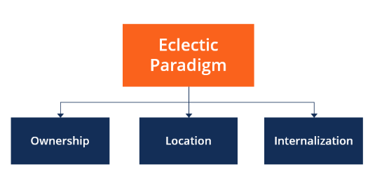
Figure 5: The Eclectic Paradigm Flow Chart
(Source: CFI, 2026)
Dunning's Eclectic Paradigm views ownership advantages as firm-specific assets and capabilities that allow a firm to be a successful competitor in foreign markets (Shah, et al., 2025). Patagonia has a few ownership strengths to control its India expansion such as its established brand, sustainability-driven business model, product innovation and responsible supply chain management. These resources distinguish the company from its rivals and reduce the risks of entering a new market. Patagonia makes products from recycled and responsibly sourced materials and prolongs the lifespan of its products through the Worn Wear repair and resale programme (World Economic Forum, 2023).
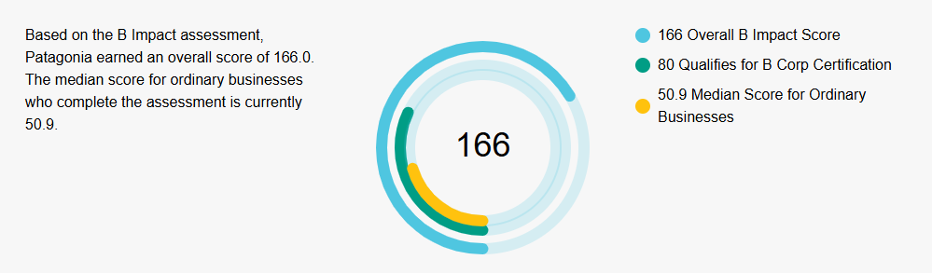
Figure 6: Certification score of the company
(Source: B Corporation, 2026)
These practices help to provide shifts in consumer preferences towards sustainable consumption and enhance customer trust. Patagonia is a Certified B Corporation, a testament to its dedication to environmental, social and governance principles with a growing demand in India for responsible business practices (B Corporation, 2026). The company invests in product design, material innovation and quality control to ensure that the products have consistent performance in the international market (Patagonia, 2025). It has already established supplier relationships and ethical sourcing practices which help to ensure consistency in its operations and safeguard its brand reputation. These firm-specific resources enable Patagonia to have ownership advantages that can be transferred to the Indian market which can be used to differentiate its products by sustainability, durability and responsible production, as opposed to price competition.

3.6 Location Advantages
There are a number of location advantages in India that facilitate Patagonia's international expansion. Dunning's Eclectic Paradigm suggests that location advantages are those that are specific to a country and that make it attractive for a firm to engage in FDI as opposed to only exporting to the country (Bakar, et al., 2022). The favourable conditions for Patagonia's long-term growth in India are its large consumer market, growing retail sector and investment environment. India is home to a billion people so urbanisation and a rising middle class have led to a greater demand for high-quality with eco-friendly consumer goods. In 2025, the country attracted FDI inflows, indicating sustained investor interest and policy measures to encourage international investment (PIB, 2025).
The government has taken several measures to enhance transport infrastructure, digital connectivity and supply chain efficiency which have lowered the operational hurdles for foreign retailers, such as the National Logistics Policy, PM Gati Shakti and Digital India (DPIIT, 2026). India's rich textile and apparel manufacturing industry offers potential for Patagonia to establish local partnerships for responsible production and minimise transportation expenses and reliance on imports. Besides, the quick growth of organised retailing and e-commerce helps to reach consumers in key metros. These location-specific attributes make Patagonia a promising market to sustain its presence in and to expand its operations in India in the future.

3.7 Internalisation Advantages

Internalisation Theory
The Internalisation Theory suggests that MNEs internalise business activities when the advantages of keeping ownership and control outweigh the disadvantages of using external market transactions (Narula, et al., 2019). The theory proposes that firms will be able to lower transaction costs, safeguard their proprietary knowledge and increase the efficiency of their operations by keeping the activities internal instead of outsourcing them. This helps organisations to protect strategic assets while maintaining the same quality and governance across international markets. Patagonia's international expansion into India is in line with this theoretical viewpoint as its competitive advantage is based on being able to control sustainability practices, ethical sourcing and premium brand positioning.
Licensing and franchising may lead to a reduction in control over environmental requirements, responsible production, product quality and reputation (Farida and Ardiansyah, 2022). Patagonia would be able to guarantee the consistency of its environmental commitments and safeguard its field of sustainable materials and circular initiatives, including the Worn Wear programme, through internalising retail operations and supply chain management (Patagonia, 2025). Moreover, direct operational control enables faster decision-making for strategic operations and enables the company to react to changing consumer preferences and regulatory demands in the country (Rahman, 2025). Therefore, internalisation would help to enhance Patagonia's long-term competitiveness while maintaining the organisational values that set the brand apart in the international market.
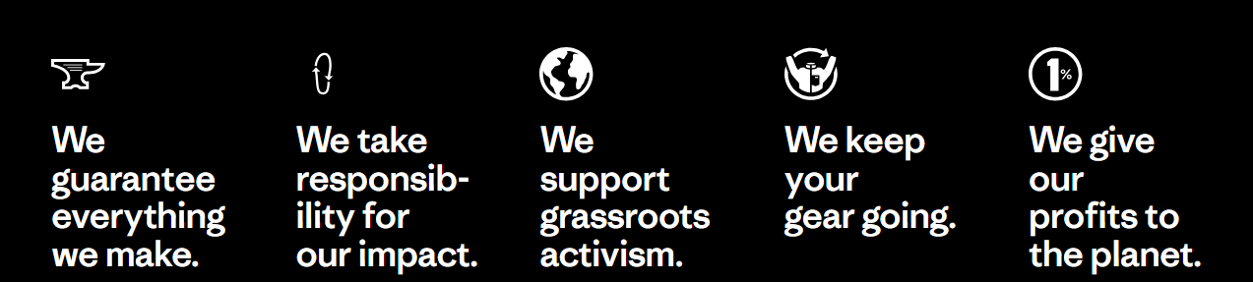
Figure 7: Company’s Worn Wear Programme Key Points
(Source: Patagonia, 2025)

Part 4: Entry Mode Strategy and Strategic Synthesis

4.1 Historical Entry Modes
Patagonia has gradually taken the path of international markets. The company has opted not to grow fast but rather to focus on markets where it can control its products, brand and sustainability practices. It has primarily penetrated foreign countries through company-owned shops and direct-to-consumer (DTC) e-commerce, particularly in the major markets of Japan, Europe, Australia and South Korea (Patagonia, 2024). In some smaller markets, Patagonia has engaged with authorised distributors and chosen wholesale partners to increase its market share and ensure that its environmental and ethical standards are supported. The company has not pursued franchising and licensing as entry modes as they offer less control over business operations and customer experience (Kencebay and Ertugan, 2025). This historical perspective reveals that Patagonia is more inclined towards progressive international growth while safeguarding its brand values. Hence, its previous entry strategy is a good starting point to determine if it is appropriate to use the same strategy to enter the Indian market.

4.2 Suitability of Historical Mode for India
Patagonia's historical international expansion strategy is appropriate for India as it helps in the gradual development of the market and minimises the business risk. While India has great long-term potential, the premium outdoor wear market is emerging and people are not aware of Patagonia. A phased market entry would enable the company to gain an understanding of the local consumer preferences, assess the demand and adjust its marketing strategy accordingly before moving into the market on a larger scale (Nweke and Adelusi, 2025). This will give flexibility to react to the variations in buying habits of the various regions of India. However, using only physical retail stores in the first phase can limit market access and necessitate significant investment in high-quality retail outlets. Patagonia can implement a new approach to its historical strategy which is a combination of a few company-owned flagship stores and DTC e-commerce. This balance would help in strengthening the brand, making it more accessible to customers, mitigating expansion risks and aligning with the company's premium positioning and long-term growth goals in India (Bhattacharjee, et al., 2025).
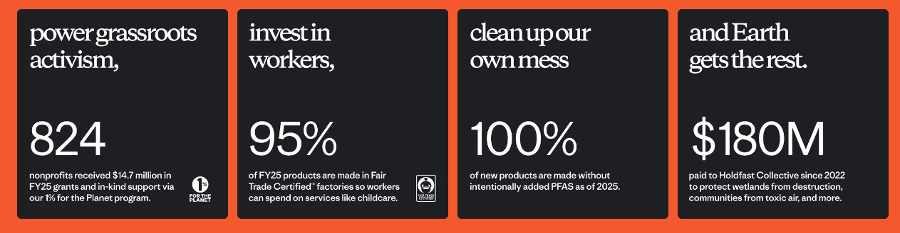
Figure 8: Actions taken by the company in progress
(Source: Patagonia, 2025)

4.3 Alternative Entry Modes

Exporting
Exporting is a low-risk option for Patagonia to enter the Indian market as it requires low investment and enables the company to test customer demand before investing a lot of resources. Import taxes, transportation expenses and longer delivery times could lead to higher retail prices which would affect Patagonia's competitiveness in the price-conscious Indian fashion market.

Licensing
Licensing would enable Patagonia to grow faster by giving a local company the rights to produce and sell products. This option is less capital intensive and has reduced operational risk (Xie, et al., 2025). The company focuses on control over product quality, environmental standards and brand image, to reduce challenges in premium positioning and sustainability efforts.

Joint Venture
Partnering with an established Indian retail partner would result in access to local market knowledge, distribution networks and consumer insights. The investment expenses would be shared which would minimise the financial risk (Gabrielli, et al., 2022). However, variations in business goals and management decisions may impact Patagonia's capacity to keep its sustainability standards and long-term strategic direction.

Wholly Owned Subsidiary
By being a wholly owned subsidiary, Patagonia has the greatest degree of control over its operations and can ensure that its brand, customer experience and sustainability practices are consistent. While it is an investment and comes with financial risk, it is a good support for the company's long-term growth strategy and it helps the company to establish a strong and independent position in the Indian market (Gupta, 2024).

4.4 Recommended Entry Strategy

Recommended Entry Mode
DTC e-commerce is the best possible entry mode for Patagonia's expansion in India through a wholly owned subsidiary. This allows the company to gain a foothold in the market while keeping its options open. The DTC platform can increase brand awareness and connect with customers throughout India and a handful of company-owned flagship stores in key cities such as Mumbai, Delhi and Bengaluru can enhance customer engagement (McKee, et al., 2023; Shah, et al., 2026).

Strategic Justification
This approach is in line with the Indian government's positive attitude toward permitting 100% FDI in single-brand retail trading, subject to government regulations (PIB, 2019). It helps Patagonia achieve its long-term goal of growing into high-growth international markets while providing consistency of operation. If the company were to own the business directly, it would be able to make strategic decisions on its own, react faster to changes in the market and have a better relationship with customers. A gradual start in metropolitan areas would minimise financial risk and give Patagonia time to test the market demand before expanding into other areas. Moreover, the combination of physical stores and e-commerce would allow for wider market coverage and better customer accessibility without the need for quick expansion across the country. A subsidiary with DTC e-commerce is the most suitable option to ensure Patagonia's successful market entry in India as it provides a balance between growth opportunities, operational control and long-term sustainability.

Conclusion
The Indian market is a strong long-term growth opportunity for Patagonia with a growing premium consumer base, investment-friendly climate and rising demand for sustainable products. It reveals that India offers economic, legal and location advantages and Patagonia's brand reputation, sustainability and operational capabilities are conducive to successful international expansion. Keeping the business operations directly under their control would help to preserve the company's values and provide a uniform customer experience. Therefore, a phased entry through a wholly owned subsidiary supported through DTC e-commerce is the best approach, allowing Patagonia to build a sustainable and competitive business, minimising investment risk and facilitating future growth.

Reflection: Gibbs’ Reflective Cycle
Gibbs' Reflective Cycle is a structured reflective model which helps to learn from experience by following six stages (Ocampo, et al., 2025). The model invites people to reflect on their experiences, to discover what they are good at, what they need to improve, and to use learning to improve their future academic and professional practice.
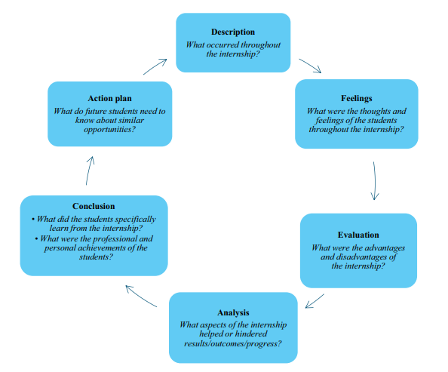
Figure 9: Six Stages of Gibbs Reflective Cycle
(Source: Ocampo, et al., 2025)

Description
This report involved me in assessing the possibilities of Patagonia expanding into India, using the concepts of international business and analysing the external business environment in India. After studying Patagonia's organisational classification, I studied Patagonia's global strategy with competitive position and then I assessed the political, economic, legal and cultural environment in India. I looked at the company's ownership, location and internalisation advantages to determine an appropriate market entry strategy. In this report, I used secondary sources such as academic literature, company reports and other credible sources to support my analysis and to make evidence-based recommendations. This process allowed me to gain insight into international market entry from theoretical and practical aspects.

Feelings
I was confident at the start of this report that I would be able to convey secondary research but was unsure whether I would be able to apply international business theories to an actual organisation. It was difficult to choose the most suitable theories and to describe concepts in a clear manner. I felt confident in connecting theory with Patagonia's business model and the context of the Indian market. I saw the need to use credible and updated sources to support my arguments. The report helped build my confidence in analysing international business decisions and providing structured and academic recommendations based on evidence.

Evaluation
I realised this report was a valuable learning experience as it helped me to develop my research and analytical skills. I realised I did well because I was able to gather information from academic journals, government publications, company reports and other reputable secondary sources to support my arguments. This helped me in making evidence-based recommendations instead of basing my recommendations on my own opinion. I learned more about the application of international business concepts in assessing a firm's entering a new market. Initially, it was hard to differentiate between descriptive writing and critical analysis, especially when writing about the business environment in Patagonia and the international strategy. I found that it took longer than I had thought to locate informed and credible company-specific information from various sources and evaluate the information before using it. Despite these difficulties, the process helped me to develop my skills in interpreting evidence, comparing various points of view and presenting a balanced argument.

Analysis
This experience was a good reminder that for international expansion to be successful, it is important to consider the external business environment as well as a company's internal capabilities before making strategic decisions. In the process of writing this report, I came to understand that the theories of international business are best used to explain actual business scenarios, rather than just theories. The use of Bartlett and Ghoshal's framework helped me to see how Patagonia manages to achieve global integration with less local responsiveness and the analysis of the political, economic, legal and cultural environment in India helped me to understand how the external environment can affect the decision to enter a market. These experiences helped me to understand how to link theory and practice in the business world as opposed to theory and practice being separate entities.
The report helped me to think critically as I had to sift through various pieces of evidence to come to a conclusion. I discovered that company reports were very useful to find out more about Patagonia's business model and sustainability practices while academic literature and government publications were useful to understand the international business environment. I was able to compare information from various sources to identify commonalities and to form well-balanced arguments with credible evidence. I identified the need to move beyond description to analysis, providing strategic implications for each finding with regard to Patagonia's expansion into India. This helped to enhance the quality of my arguments and to create evidence-based recommendations.

Conclusion
This report has reinforced my knowledge of the factors that impact international market entry and strategic decision-making. Gained a deeper understanding of the way business theory, market analysis and credible evidence can be combined to drive practical recommendations. This experience helped me to develop my independent research skills, to evaluate various sources and to present a balanced argument in a structured academic format. I realised that for any business to be successful in the international arena, it must be constantly assessed both in terms of organisational capabilities and external market conditions. These learning outcomes have improved my self-confidence in tackling complex problems in international business in future academic and professional settings.

Action Plan
I will take a more systematic approach to research and report preparation to enhance my future academic work. Before beginning the writing process, I will create a comprehensive research plan which includes a list of academic journals, company reports, government publications and industry sources. This will enable me to get good quality evidence in a more efficient way and minimise the time I have to spend looking for reliable evidence. I plan to improve my critical analysis skills through interpreting evidence and explaining its strategic implications as opposed to describing information. I will enhance my skill in applying business theories by only choosing the most relevant theories and putting them in a natural way into my analysis. To develop my academic writing, I will seek feedback from tutors, work on making my writing more concise with analytical and make sure to take time to proofread my work before submitting it. I will keep building my knowledge of international business through continuing to read academic texts and articles on current business issues, which will help me to create more informed, evidence-based and professionally structured assignments in the future.

References
B Corporation. (2026) Patagonia. [Online]. Available at: https://www.bcorporation.net/en-us/find-a-b-corp/company/patagonia-inc/ [Accessed on: 31 July 2026].
Bakar, A.H.A., Sinnappan, P., Salim, F.A.A. and Teo, P.C. (2022) Factors influencing foreign direct investment (FDI) location selection: a review of the literature. International Journal of Academic Research in Business and Social Sciences, 12(7), pp.1271-1291.
Banerjee, K. and Basu, M. (2025) Trademark and Design Registration Strategies in the Indian Market. [Online]. Available at: https://www.iam-media.com/guide/india-managing-the-ip-lifecycle/2026/article/trademark-and-design-registration-strategies-in-the-indian-market [Accessed on: 30 July 2026].
Bhattacharjee, J., Singh, R. and Singh, N.K. (2025) Embracing sustainability: Role of corporate social responsibility in promoting green growth amidst a competitive business environment in India. Integrating Environmental Sustainability and Corporate Social Responsibility: A Move Beyond Profit: Corporate Social Responsibility for Environmental Sustainability. Cham: Springer Nature Switzerland. pp. 205-223.
CFI. (2026) Eclectic Paradigm. [Online]. Available at: https://corporatefinanceinstitute.com/resources/management/eclectic-paradigm/ [Accessed on: 30 July 2026].
Chouinard, Y. (2022) Earth is now our only shareholder. [Online]. Available at: https://www.patagonia.com/ownership/ [Accessed on: 30 July 2026].
Damodaran, A. (2022) Country risk: determinants, measures and implications-the 2022 edition. Measures and Implications-The.
Digital Sansad. (2026) Ministry Of Consumer Affairs, Food And Public Distribution. [Online]. Available at: https://sansad.in/getFile/app/lsscommittee/Consumer%20Affairs,%20Food%20and%20Public%20Distribution/18_Consumer_Affairs_Food_and_Public_Distribution_15.pdf?source=app [Accessed on: 30 July 2026].
Dona, I.D.D.M., Campus, L.C. and Lanka, S. (2025) Sustainable Consumption: Unveiling the Rise of Ethical and Eco-Friendly Purchasing in Modern Markets. International Journal of Research and Innovation in Social Science, IX, pp.1735-1744.
Dong, L. and Kouvelis, P. (2020) Impact of tariffs on global supply chain network configuration: Models, predictions, and future research. Manufacturing & Service Operations Management, 22(1), pp.25-35.
DPIIT (2026). PM Gati Shakti and Related Portals/ Initiatives. [Online]. Available at: https://www.dpiit.gov.in/offerings/schemes-and-services/details/pm-gati-shakti-kjNyATMtQWa [Accessed on: 31 July 2026].
DPIIT. (2025) Annual Report 2025-26. [Online]. Available at: https://www.dpiit.gov.in/static/uploads/2026/03/863a5fef349d79a1bba316c4b51eaacb.pdf [Accessed on: 30 July 2026].
Farida, I. and Ardiansyah, W. (2022) Technology acceptance model factors: implications on digital-wallet on interest to buy in franchise business. Golden Ratio of Marketing and Applied Psychology of Business, 2(2), pp.147-157.
Gabrielli, P., Aboutalebi, R. and Sansavini, G. (2022) Mitigating financial risk of corporate power purchase agreements via portfolio optimization. Energy Economics, 109, p.105980.
Gupta, R.K. (2024) Strategies for long term business survival and growth (What you do today to stay in business tomorrow). Internafional Journal of Research in Management, 6(2), pp.495-504.
IBEF. (2025) Fashion Forward: An Analysis of India’s Growing Apparel Market. [Online]. Available at: https://www.ibef.org/blogs/fashion-forward-an-analysis-of-india-s-growing-apparel-market [Accessed on: 30 July 2026].
Investment policy hub. (2020) Foreign single brand retailers can source from SEZs to satisfy FDI requirements [Online]. Available at: https://investmentpolicy.unctad.org/investment-policy-monitor/measures/3516/india-foreign-single-brand-retailers-can-source-from-sezs-to-satisfy-fdi-requirements [Accessed on: 30 July 2026].
Kencebay, B. and Ertugan, A. (2025) Understanding the mediating effect of brand equity on sustainability and omnichannel operation and phygital experience. Sustainability, 17(5), p.1878.
Kumar, K. (2023) The Rapid Transformation of India's Retail Sector and Its Economic Impacts. Journal of Policy Options, 6(1), pp.11-16.
Lu, R. (2024) Set it in stone: Patagonia and the evolution toward stakeholder governance in social enterprise business structures. Columbia Journal of Law and Social Problems, 57(4), pp.587-631.
McKee, S., Sands, S., Pallant, J.I. and Cohen, J. (2023) The evolving direct‐to‐consumer retail model: A review and research agenda. International Journal of Consumer Studies, 47(6), pp.2816-2842.
Ministry of Environment, Forest & Climate Change. (2023) Presentation on Policy on Waste Management. [Online]. Available at: https://www.mospi.gov.in/sites/default/files/main_menu/Seminar/Policy%20on%20Waste%20Management%20-%20MOEFCC.pdf [Accessed on: 30 July 2026].
Narula, R., Asmussen, C.G., Chi, T. and Kundu, S.K. (2019) Applying and advancing internalization theory. Journal of International Business Studies, 50(8), pp.1231-1252.
Nweke, O. and Adelusi, O. (2025) Utilizing AI driven forecasting, optimization, and data insights to strengthen corporate strategic planning. International Journal of Research Publication and Reviews, 6(3), pp.4260-4272.
Ocampo, F.A., McIntyre, B.G., Massey, D. and Saunders, R. (2025) Nursing student reflections on a research internship: A reflective discussion following the Gibbs' reflective cycle. Nurse education today, 145, p.106481.
Patagonia. (2022) Working with Factories. [Online]. Available at: https://eu.patagonia.com/dk/en/our-footprint/working-with-factories.html [Accessed on: 31 July 2026].
Patagonia. (2024) Owned and Operated. [Online]. Available at: https://www.patagonia.com/where-we-do-business/owned-and-operated.html [Accessed on: 31 July 2026].
Patagonia. (2024) Supply Chain Environmental Impact Program. [Online]. Available at: https://www.patagonia.com/our-footprint/supply-chain-environmental-responsibility-program.html [Accessed on: 31 July 2026].
Patagonia. (2025) Core Values. [Online]. Available at: https://www.patagonia.com/core-values/ [Accessed on: 31 July 2026].
Patagonia. (2025) Everything we make has an impact on the planet. [Online]. Available at: https://www.patagonia.com/our-footprint/ [Accessed on: 30 July 2026].
Patagonia. (2025) Our footprint. [Online]. Available at: https://www.patagonia.com/our-footprint/ [Accessed on: 31 July 2026].
Patagonia. (2025) Work In Progress. [Online]. Available at: https://eu.patagonia.com/gb/en/progress-report/?srsltid=AfmBOoppJ4epzUuTwjpyjR7ZWTeAisQ9BPLCUc8dBZro2XX7eyDo1NWI [Accessed on: 31 July 2026].
Patagonia. (2026) Everything we make has an impact on the planet. [Online]. Available at: https://www.patagonia.com/our-footprint/ [Accessed on: 30 July 2026].
Patagonia. (2026) Factories, Farms and Material Suppliers [Online]. Available at: https://www.patagonia.com/factories-farms-material-suppliers/ [Accessed on: 30 July 2026].
Patagonia. (2026) Owned and Operated [Online]. Available at: https://www.patagonia.com/where-we-do-business/owned-and-operated.html [Accessed on: 30 July 2026].
PIB. (2019) Guidelines for Single Brand Retail Trade. [Online]. Available at: https://www.pib.gov.in/newsite/printrelease.aspx?relid=192173&reg=48&lang=2 [Accessed on: 31 July 2026].
PIB. (2025) India Records USD 81.04 Billion FDI Inflow in FY 2024-25. [Online]. Available at: https://www.pib.gov.in/PressReleasePage.aspx?PRID=2131716&reg=48&lang=2 [Accessed on: 30 July 2026].
PIB. (2026) Highlights: Economic Survey 2025-26. [Online]. Available at: https://www.pib.gov.in/PressReleasePage.aspx?PRID=2219907&reg=48&lang=2 [Accessed on: 30 July 2026].
PMINDIA. (2026) Make In India [Online]. Available at: https://www.pmindia.gov.in/en/major_initiatives/make-in-india/ [Accessed on: 30 July 2026].
Rahman, M.M. (2025) Data analytics for strategic business development: a systematic review analyzing its role in informing decisions, optimizing processes, and driving growth. Journal of Sustainable Development and Policy, 1(01), pp.285-314.
Sah, A.K., Hong, Y.M. and Huang, K.C. (2025) Enhancing brand value through circular economy service quality: The mediating roles of customer satisfaction, brand image, and customer loyalty. Sustainability, 17(3), p.1332.
Sarkar, S. (2026) India's retail inflation rises to 4.38% in June, breaches RBI's 4% target. [Online]. Available at: https://www.fortuneindia.com/economy/indias-retail-inflation-rises-to-438-in-june-breaches-rbis-4-target/147923 [Accessed on: 30 July 2026].
Shah, A., Jain, A.R. and JAIN, A. (2026) Adoption of Emerging Business Trends among Retailers in Four Metropolitan Cities: A Mixed-Method Study on Strategic and Technological Integration. Cureus Journals, 3(1).
Shah, M.H., Ali, I. and Kiramat, K. (2025) Theoretical Evolution of Foreign Direct Investment Theory. The Journal of Humanities & Social Sciences, 33(2), pp.1-13.
The Culture Factor Group. (2026) Country Comparison Tool. [Online]. Available at: https://www.theculturefactor.com/country-comparison-tool [Accessed on: 30 July 2026].
World Economic Forum. (2023) Patagonia - Sparking the Sustainability Cultural Shift at Every Level. [Online]. Available at: https://initiatives.weforum.org/industry-net-zero-accelerator/case-study-details/patagonia---sparking-the-sustainability-cultural-shift-at-every-level/aJYTG00000001H34AI [Accessed on: 31 July 2026].
Xie, W., He, J., Huang, F. and Ren, J. (2025) Operational risk assessment of commercial banks’ supply chain finance. Systems, 13(2), p.76.

