

Postgraduate/Distance Learning
Assignment coversheet & feedback form

THIS SHEET MUST BE THE FIRST PAGE OF THE ASSIGNMENT YOU ARE SUBMITTING (DO NOT SEND AS A SEPARATE FILE)

For completion by the student:
Student Name: Wing Kit Chan

Student University Email: 2519506@student.uwtsd.ac.uk
Module code: HPCA 7015  Module title: Cultural Astronomy and Astrology | Student ID number:  2519506 |  |  | Educational support needs:  No
Assignment title: Essay based on a Sky Journal

Assignment due date: 27 November 2025
This assignment is for the 1st 2nd 3rd 4th 5th 6th module of the degree
I confirm that this is my original work and that I have adhered to the University policy on plagiarism.
Signed ……………………………………………………………
Email submission:if you are submitting this form via email, please tick this box □
(as a substitute for your signature) to confirm that you agree to the above declaration.
Assignment Mark
1st Marker’s Provisional mark
2nd Marker’s/Moderator’s provisional mark
External Examiner’s mark (if relevant)
Final Mark

NB. All marks are provisional until confirmed by the Final Examination Board.

For completion by Marker 1 :
Comments:

Marker’s signature: |  |  | Date:
For completion by Marker 2/Moderator:

Comments:

Marker’s Signature: |  | Date:
External Examiner’s comments (if relevant)

External Examiner’s Signature: |  | Date:

Essay based on a Sky Journal
Elevating sensation through observing the night sky, ‘’life seems enchanted after all’’.
Word Count: 2083
This essay shares my experiences and thoughts on observing the sky from 22 October to 21 November 2025 in Hong Kong. During this month, I had very little free time because I worked from 0900 to 2400 every day. The best time to observe the sky was after work, when I could see the moon and stars. My workplace is in a busy, vibrant part of Hong Kong where the lights never turn off, even at midnight. In contrast, my home is in a remote village far from the city. My travelling time from home to work is 1.5 hours. I want to describe the differences in viewing the same sky from the busy city and the quiet village. Van Gogh's quote—"Be clearly aware of the stars and infinity on high. Then life seems almost enchanted after all"—resonates with me deeply. When I connected more deeply with the sky, my body and senses opened up, especially my sense of hearing. It felt magical and enchanting. I wondered why it felt so enchanting and why it elevated my whole being. I linked this to some readings and studies on neuroscience. In neuroscience, sound waves vibrate directly into our body cells and nervous system. This contrasts with older biology and physics theories, which say sound waves travel through the air to our ears and then send signals to the brain. So, why do I feel so enchanted under a starry or moonlit sky? Do planets and stars emit sound waves that resonate with our body, mind, and spirit, helping humans reach a higher state of consciousness?
I selected observations from five days between 22 October and 21 November 2025. I focused on midnight at two locations: 1) Wan Chai, a lively city center in Hong Kong where I work, and 2) Ng Tung Chai waterfall, a remote village where I live. My feelings, mood, and sensations changed under the same sky but in different surroundings.
Day 1: From 12:00 am onwards, 22 October 2025, from Wan Chai to Ng Tung Chai
This was the first night of sky observation. I looked up at the sky with a tired body. Visibility of stars and the moon was limited due to few cloud cover, heavy urban light pollution, and tall, dense buildings. The surrounding atmosphere was full of noise, like traffic, footsteps, and people talking. Since I could not see any sky phenomena, my mind was still filled with work thoughts, and my energy was low. However, after more than an hour of travel to the village, I could see a faint view of stars and a thin waxing crescent moon with my eyes. Staring at the sky in that moment made me feel more relaxed, and my breathing became calmer and deeper.

 Fig. 1 cityscape in Wanchai, no stars nor moon could be seen.
Press the speaker twice to listen to the city soundscape

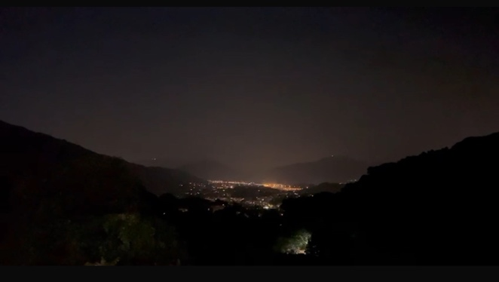Fig. 2: Nature in Ng Tung Chai, cloudy with few stars.
Press the speaker twice to listen to the nature soundscape

Day 8: From 12:00 am onwards, 29 October 2025, from Wan Chai to Ng Tung Chai
This was the eighth night of sky observation. The moon was covered by clouds, with almost no stars visible. When I reached the village, the sky was clearer, with glimpses of stars and a clear gibbous moon at about half illumination. After a full week of observations, I felt my body becoming more relaxed from this practice. I was observing on the way from the city center to the village. The noise and light pollution remained the same. However, whenever I looked at and observed the sky, it trained my body and mind to become still. I felt my senses become more sensitive. In the city, I could hear more details in the sounds around me. In the village, the soundscape became more like a clear picture: insects, light wind, leaves, and the stream. Everything felt very immersive. At some moments, my body felt connected to the moon and stars.
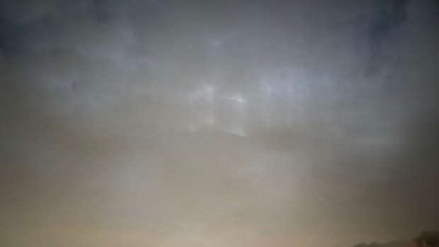 Fig. 3 cityscape in Wanchai with cloud covering the moon

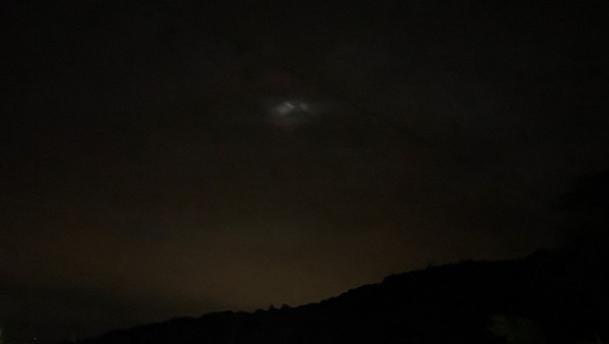Fig. 4 Nature in Ng Tung Chai, cloudy with few stars and moon

Day 15: From 12:00 am onwards, 4 November 2025, from Wan Chai to Ng Tung Chai
This was the fifteenth night of sky observation. It was nearly a full moon night. The moon was bright, the sky was clear, and a few stars were visible. Compared to the ongoing two-week process, my feelings were more open even in Wan Chai that night, because I could see the moon and stars directly against the busy cityscape. The noise from traffic, bar music, shouting drunks, and people laughing on the street was still loud, but it seemed less annoying when I gazed at the moon. What resonated with me during these two weeks of practice? After arriving in the village, the moon looked even brighter and larger, with more stars around it. The sky was beautiful and peaceful. I felt blissful. In that moment, I felt so connected that for one second, I forgot who I was and melted completely into the universe. The lightness, like zero gravity, brought me tranquillity. I could forget all the urgent work and my packed schedule. I found release when I focused on the beautiful skyscape. When my mind calmed down, my sense of hearing became more active. The harmonious sounds of nature were like a symphony all around me: the mountains, the distant waterfall, the wind, the soil, the trees, even the moon and planets. It felt like they were all vibrating through me with sound waves.
"Be clearly aware of the stars and infinity on high. Then life seems almost enchanted after all." Halfway through the observation period, my senses were opened, and I understood Van Gogh's ideas more deeply.

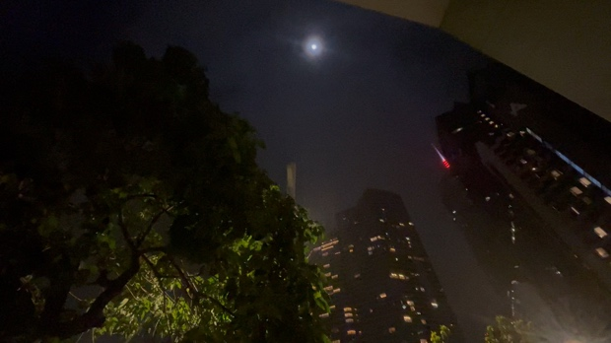

Fig. 5 Full Moon in cityscape with no stars

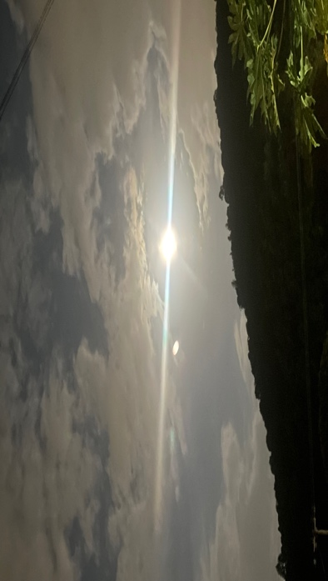 Fig. 6 Cloudy moon with some stars in Ng Tung Chai

Day 20: From 12:00 am onwards, 9 November 2025, from Wan Chai to Ng Tung Chai
This was the twentieth night of observation. It was another exhausting night after work. The moon was still quite full that night. Seeing the moon felt powerful. The moon's colour in the city was more orange than in the village. There were more visible and brighter stars in the village. Like the previous day, with fewer city distractions in the village, my sense of hearing seemed amplified. I could hear details and qualities I could not notice in the busy world. This was a good experience for opening my senses, and it was unexpectedly interesting.
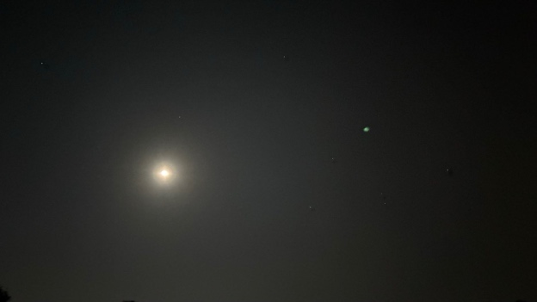 Fig. 7 City’s sky

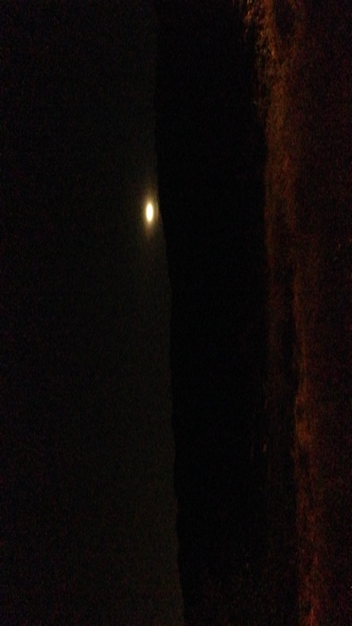 Fig. 8 Nature Sky

Day 29: From 20:00 pm onwards, 20 November 2025, Ng Tung Chai
This was the twenty-ninth night of observation. Tonight was the only night I could observe the skyscape without working first. I felt relaxed and happy. Another moon cycle began tonight. The weather was colder, and the sky was darker. No moon or stars were visible in the deep, dark sky, but I did not feel the same frustration as on the first night. All 29 nights of observation felt magical to me. The changes in the skyscape were amazing. The most fascinating part was how different connections with the sky in various spots powerfully enhanced my sense of hearing. It felt mostly magical and enchanting under the sky, and even like becoming the sky. The song below is by composer Philippe Glass & Tenzin Choegyal; “Be the Sky” resonates with me a lot.
Fig 11, an album cover: Be the Sky. Press the speaker twice to listen. Total length: 11mins 17secs. OR
https://www.youtube.com/watch?v=Ou2DvYMlLfg&list=RDOu2DvYMlLfg&start_radio=1

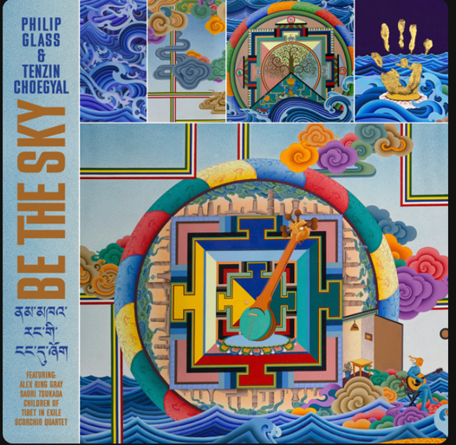
Van Gogh wrote a letter to his beloved brother Theo in August 1888. As usual, his life was full of hardship, but he never stopped painting. In the letter, he mentioned working on a portrait with his first attempt at a starlight background. And he felt enchanted after all. After that, he created paintings with starry nights as the main theme. ‘’The sun and moon and the evening star all spoke to him of the love of God’’. After becoming clearly aware of his connection with the stars, he felt enchanted and produced his famous paintings. (Fig 12-Fig 14)
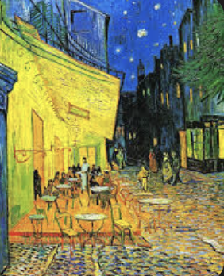Fig 12, Café Terrace at Night (1888)
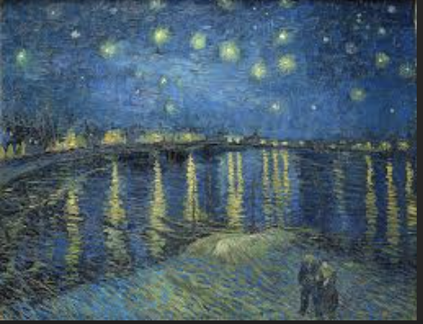Fig 13, Starry Night Over the Rhone (1888)
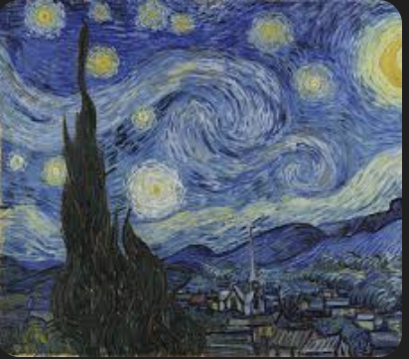Fig 14, The Starry Night (1889)
In my sky journal process, I felt the difference when the environment changed. With clearer views and fewer obstacles to connect to the sky, my sensations grew wider, especially in hearing. Do stars emit sounds that lift people to a higher state or enchant them? There is an article from Astronomy Magazine in February 2025 that discusses sonification as a new approach in astronomy and data science. For example, projects like the Chandra X-ray Observatory and the TRAPPIST-1 system show how it makes science accessible through multi-sensory experiences. Advances in technology deepen our understanding of the universe and inspire more support for astronomy research. A NASA article says: "We can’t hear it with our ears, but the stars in the sky are performing a concert, one that never stops." This proves that stars have their own frequency vibrations. However, due to the human ear's limits, our audible range is only 20 Hz to 20 kHz. When sonification is used, we get evidence that stars emit sound waves that are not audible to humans. From a neuroscience view, sound vibrations affect brainwave patterns through brainwave entrainment, which can change cognitive and emotional states. A research paper from Harvard Medical School states that high or low frequencies of sound vibration "picked up by ultra-sensitive mechanoreceptors in the skin called Pacinian corpuscles are not exclusively channeled into the somatosensory cortex—the area of the brain where bodily sensations are processed." This means we can feel the vibration's touch directly. That is why Shafaq Zia stated that Beethoven could still write good music despite being deaf in one ear. According to all this research, stars and planets in the sky vibrate with certain sound frequencies that human ears may not hear. However, many astronomy and scientific studies show these tones exist. The sound waves still vibrate on our skin, body, cells, and nerves.
In conclusion, this month-long journey of sky observation from 22 October to 21 November 2025, during my busy theatre production period in Hong Kong, revealed deep contrasts and unexpected enchantments. Travelling daily from Wan Chai's chaotic urban glow—where light pollution and noisy sounds often hid the sky's wonders—to the peaceful remote village of Ng Tung Chai, I saw how the same sky changed my inner world. In the city, brief views of the moon and stars cut through distractions, slowly training my mind to be still and sharpening my senses in the noise. But in the village, under clearer and darker skies, those celestial bodies created a deeper connection, boosting my hearing to pick up nature's subtle symphony: rustling leaves, distant streams, and even the imagined hum of the cosmos. This increased hearing sensitivity was not just imagination; it echoes Van Gogh's quote, which rang true in my experiences, like his starry-night masterpieces that captured transcendence amid personal struggles.
Exploring neuroscience and astronomy shed more light on this magic: stars and planets do emit vibrational frequencies. These waves, though invisible, interact with our bodies through mechanoreceptors, guiding brainwaves and raising consciousness. This explains why, under starlight, I felt boundaries fade, merging with infinity in moments of joyful release. Last but not least, this practice bridged the gap between city chaos and natural peace. It confirmed that tuning into the sky's silence can enchant even the most tired soul, creating a higher state where everyday life gives way to the cosmic. I carry this raised awareness with me.

Bibliography
Dow, H. J. (1964). Van Gogh: Both Prometheus and Jupiter. The Journal of Aesthetics and Art Criticism, 22(3), 269–288. https://doi.org/10.2307/427231
Grossman, D. (2025, February 14). Listen to the universe: How sonification turns data into sound. Astronomy Magazine. https://www.astronomy.com/science/how-sonification-turns-data-into-sound/
Hermann, T., Hunt, A., & Neuhoff, J. G. (Eds.). (2011). The Sonification Handbook. Logos Verlag. (pp. 41–59)
Landau, E. (2024, November 8). Symphony of stars: The science of stellar sound waves. NASA Science. https://science.nasa.gov/universe/exoplanets/symphony-of-stars-the-science-of-stellar-sound-waves/ (Original publication: July 30, 2018)
Van Gogh, V., & de Leeuw, R. (1997). The Letters of Vincent van Gogh. Penguin Classics. (p. 392; Quote: "Be clearly aware of the stars and infinity on high. Then life seems almost enchanted after all" from Letter to Theo van Gogh, Arles, on or about Friday, 23 December 1881.)
Zia, S. (2024, December 18). How sound and vibration converge in the brain to enhance sensory experience. Harvard Medical School. https://hms.harvard.edu/news/how-sound-vibration-converge-brain-enhance-sensory-experience

Gogh, Vincent van, and Ronald de Leeuw. The Letters of Vincent Van Gogh. London: Penguin Books, 1997, p.392
ibid
Ibid
Dow, H. J. (1964). Van Gogh Both Prometheus and Jupiter. The Journal of Aesthetics and Art Criticism, 22(3), 269–288, 271 https://doi.org/10.2307/427231
Hermann T, Hunt A, Neuhoff JG, eds (2011) The Sonification Handbook (Logos Publishing House, Berlin) 41-59
David Grossman, Listen to the universe: How sonification turns data into sound Astronomy Magazines February 14, 2025 https://www.astronomy.com/science/how-sonification-turns-data-into-sound/
Elizabeth landau, Symphony of Stars, the science of stellar sound waves, NASA's Exoplanet Exploration Program, NASA Editorial Team, Jul 30 2018 https://science.nasa.gov/universe/exoplanets/symphony-of-stars-the-science-of-stellar-sound-waves/
SHAFAQ ZIA, How sound and vibration converge in the brain to enhance sensory experience Harvard Medical School Research Paper, 18 Dec 2024 https://hms.harvard.edu/news/how-sound-vibration-converge-brain-enhance-sensory-experience#:~:text=When%20the%20researchers%20exposed%20the%20mice%20to,combined%20sensory%20experience%20a%20more%20profound%20one.

