Mikolaj Michalski (1900885)
1900885@student.uwtsd.ac.uk
Network operating systems and services
Assignment 1: Report worksheet 1

Table of Contents
1. Introduction 2
2. Worksheet 1 2
2.1. Creating the virtual machines. 2
2.1.1. Servers 2
2.1.2. Clients 5
2.1.3. Created machines. 6
2.2. Installing the OS’. 7
2.2.1. Servers (Windows Server 2019) 7
2.2.2. Clients (Windows 10) 14
2.3. Preparing machines for network configuration. 16
2.3.1. All machines. 16
2.4. Completing the network configurations 19
2.4.1. Server side 19
2.4.2. Client side 21
2.5. Ping connectivity test. 22
2.6. Observational tasks 26
2.6.1. Differences between type 1 and type 2 hypervisors 26
2.6.2. Significance of the subnet mask in IPv4 addressing. 26
2.6.3. Cloud computing and the way it revolutionised enterprise networks 27
2.6.4. Description of different terminologies 27
3. References 29

Introduction
This document covers the entirety of worksheet 1 and its completion. This included the practical sections as well as the observational tasks which are done at the end of the worksheet. Finally, you can find the reference page at the end of the document to see the sources used.

Worksheet 1

Creating the virtual machines.

Servers
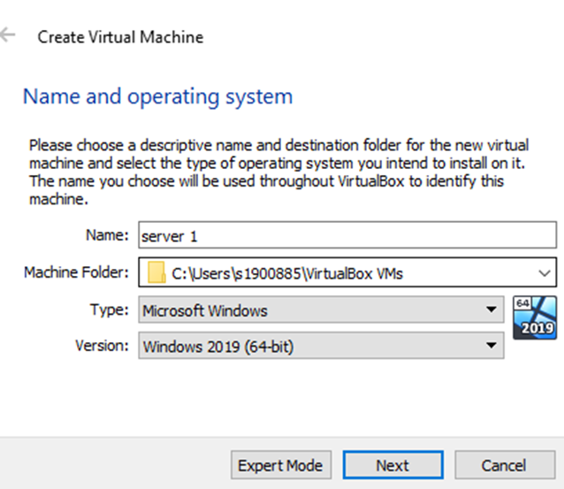
Server 1 machine being created.
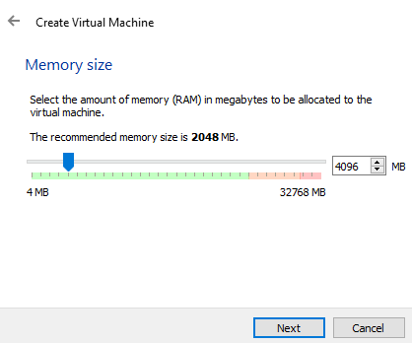
4GB of RAM set to allow faster loading and better usage.

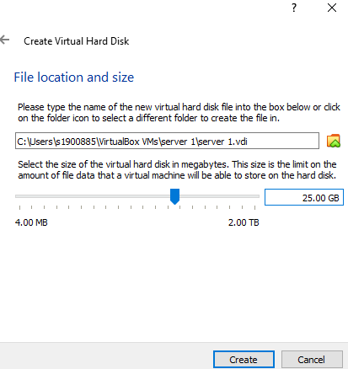
Virtual hard disk created for storage. This creates the virtual machine. The same thing was done for the second server machine.

Clients
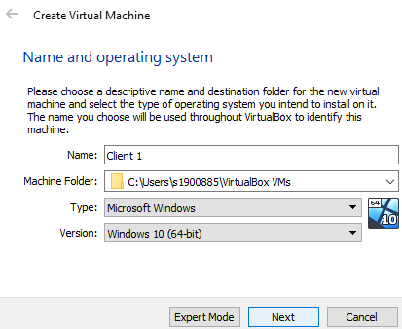
Selecting windows 10 for the client machine.
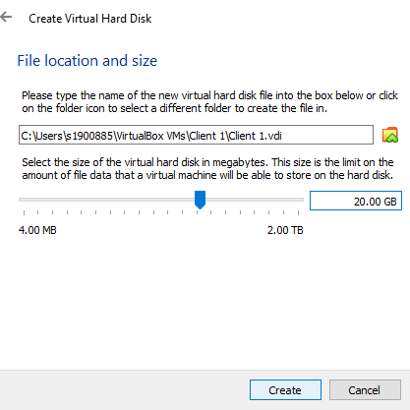
Same amount of RAM was chosen as for the servers however, the hard disk space is changed to 20GB as more is not needed. This is done for both machines.

Created machines.
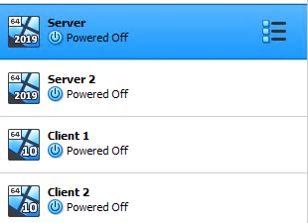
Here are the created machines. They have the same RAM but slightly vary in hard disk size.

Installing the OS’.

Servers (Windows Server 2019)
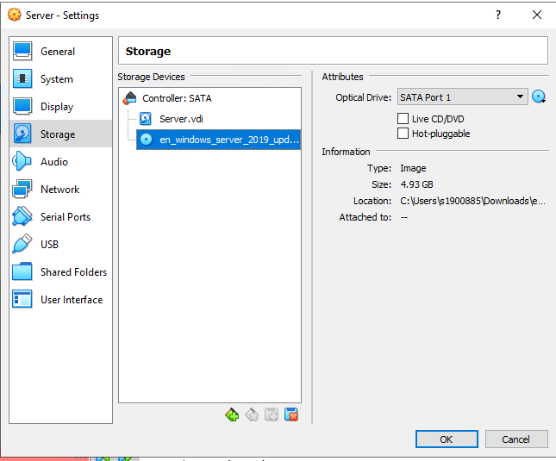
To install windows server. The correct ISO is downloaded then selected from the files. The client machines also sued the same machines but used a different ISO.
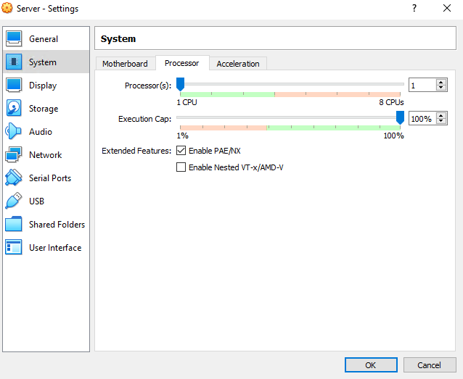
Enabling PAE/NX to allow the CPU to be more accessible making the machine run better.
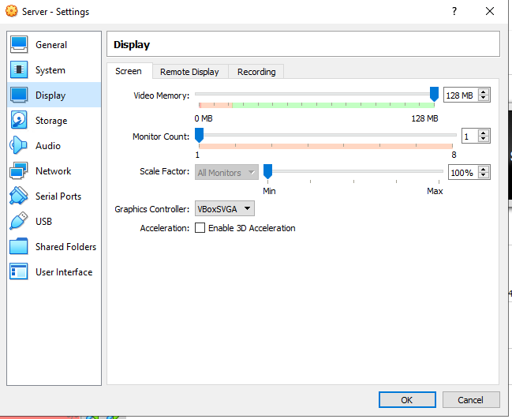
The display memory is set to maximum for all the machines.
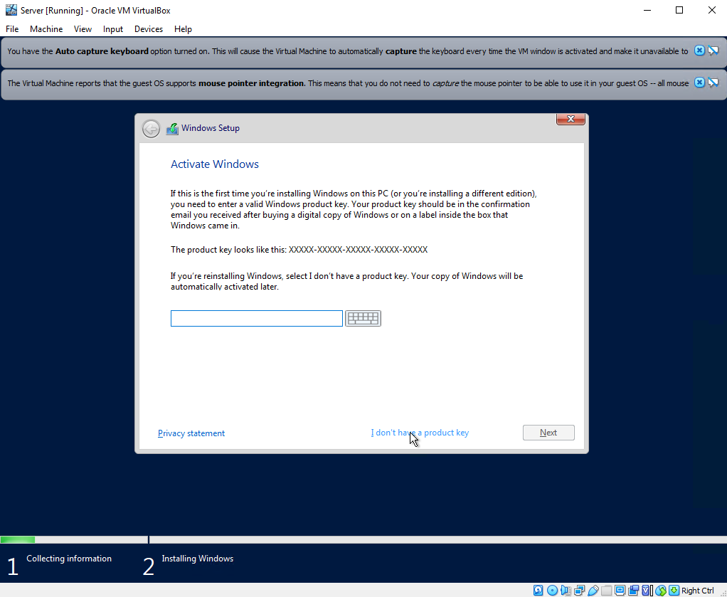
This process is skipped as there is no product key.
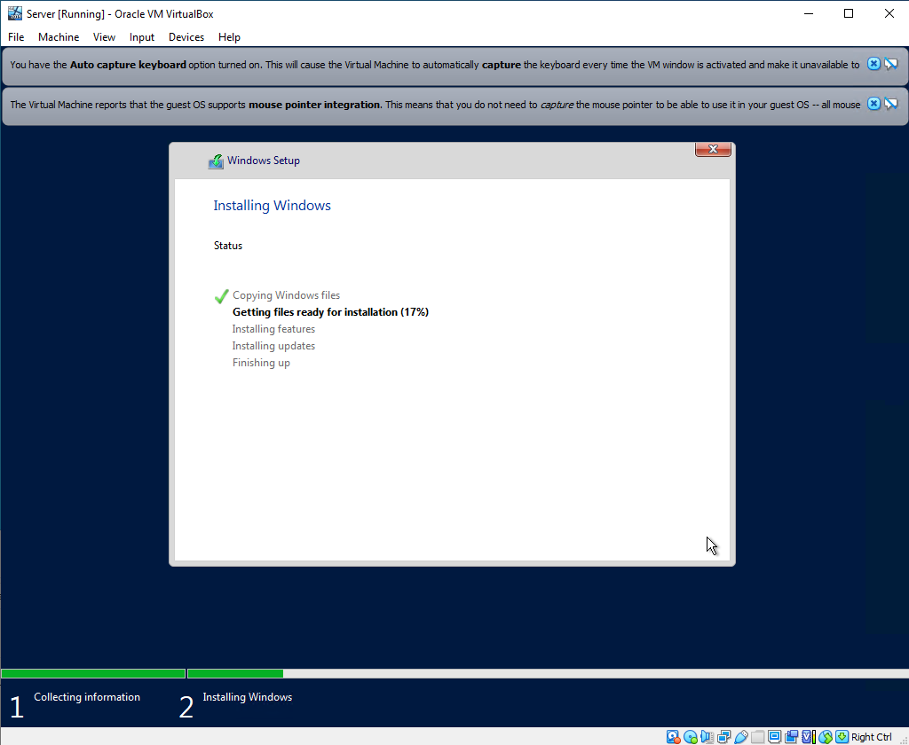
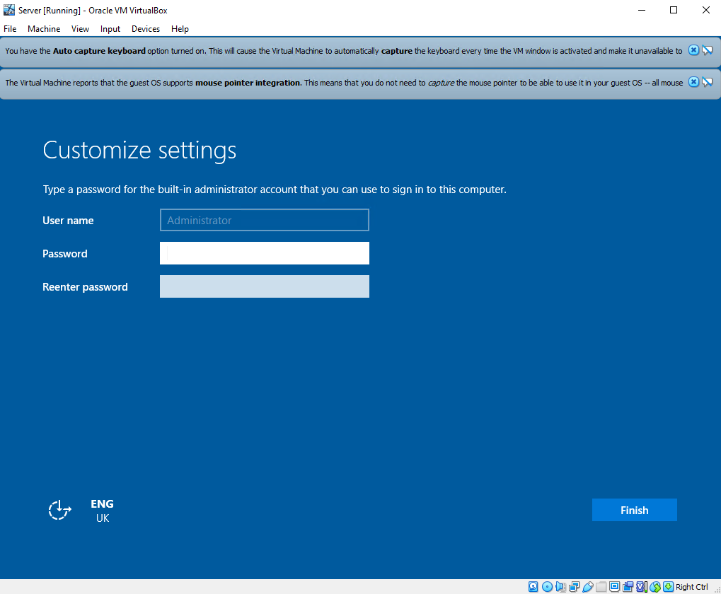
This is the important section where the server account is created with a password.

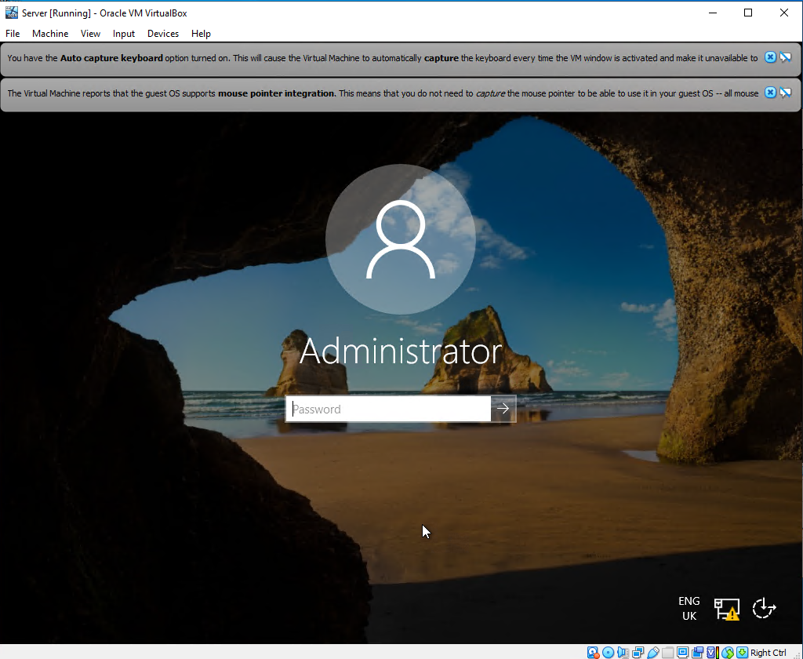
This is the created server account on the machine.

Clients (Windows 10)
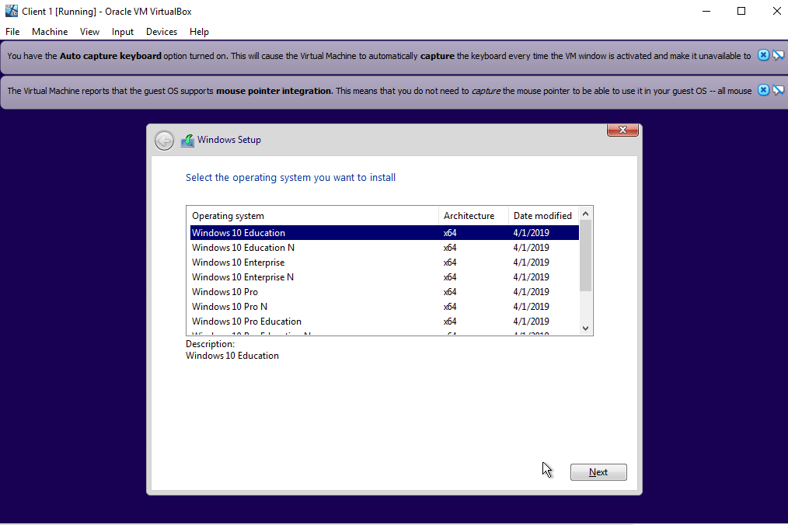
For the clients machine there was a different ISO chosen and well as a different windows version selected.
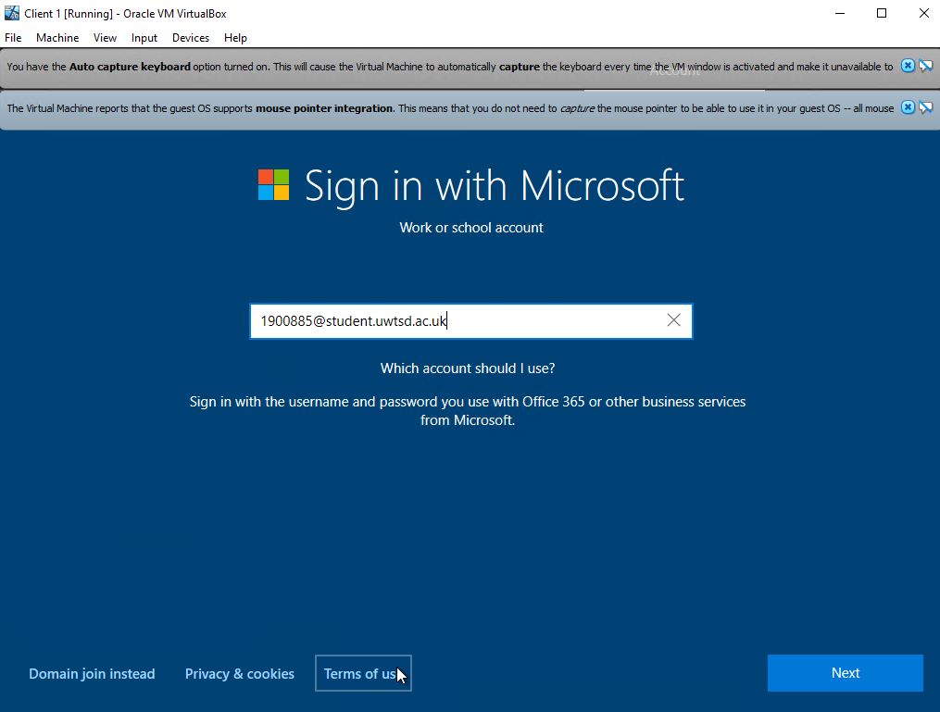
This was much quicker than the server as all it required was a simple sign in that would be used. In this case it got typed. However, the machine did not use it and went by the name of client.
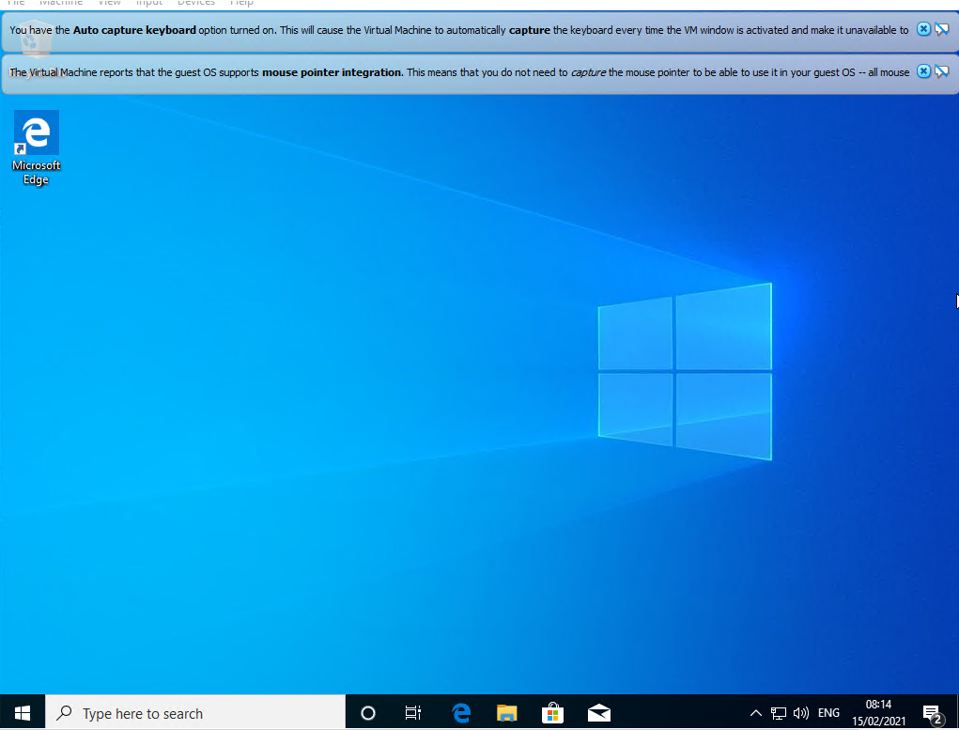

Preparing machines for network configuration.

All machines.
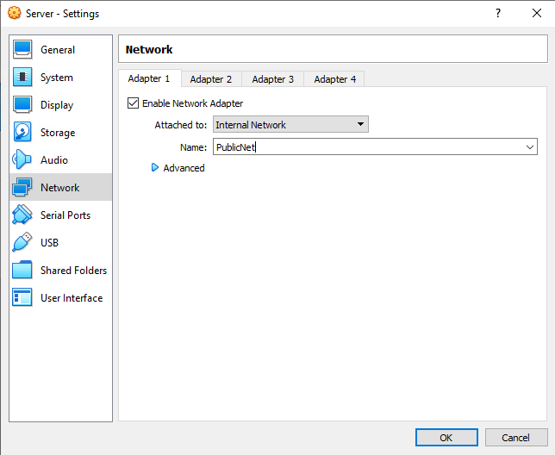
The network PublicNet got created as an internal network within the server machine.
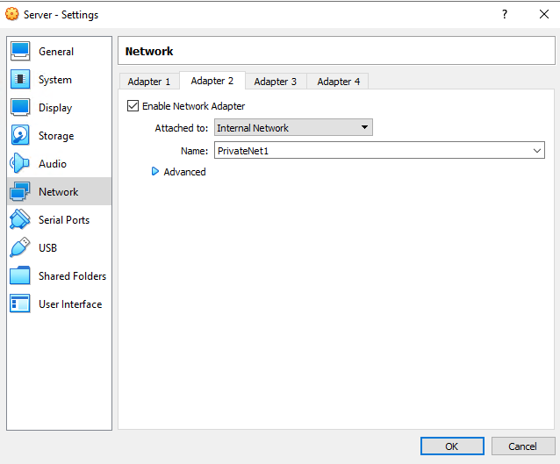
The creation of “PrivateNet1” after enabling a second network adapter.

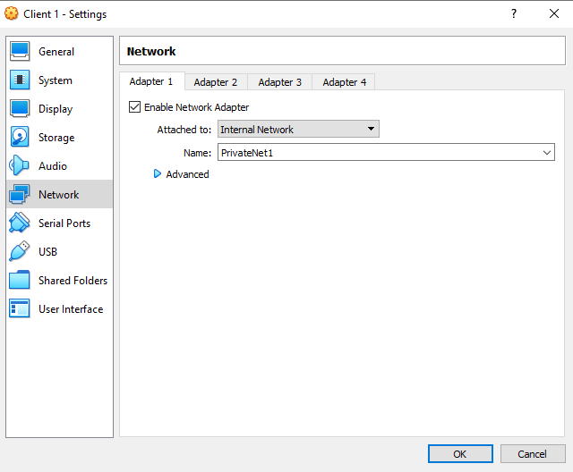Setting the network adapter ready for connection to servers network.

Completing the network configurations

Server side
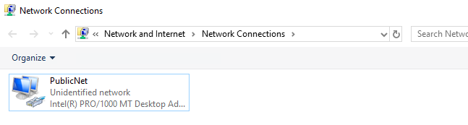
Changing the name of the network on the server machine before editing the IP.

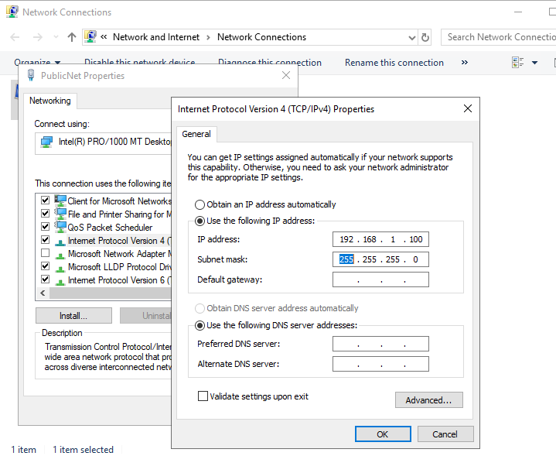
Setting the IP and Subnet mask for the PublicNet network.

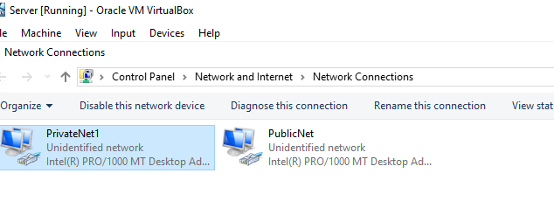
Evidence of both created networks on server.

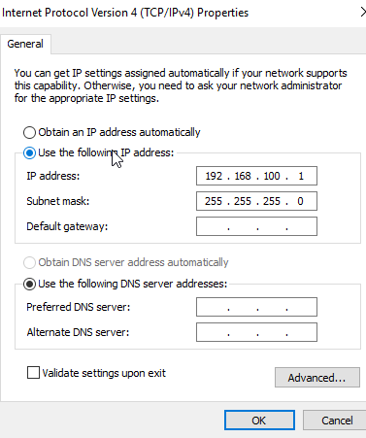
IP set up for the new network.

Client side
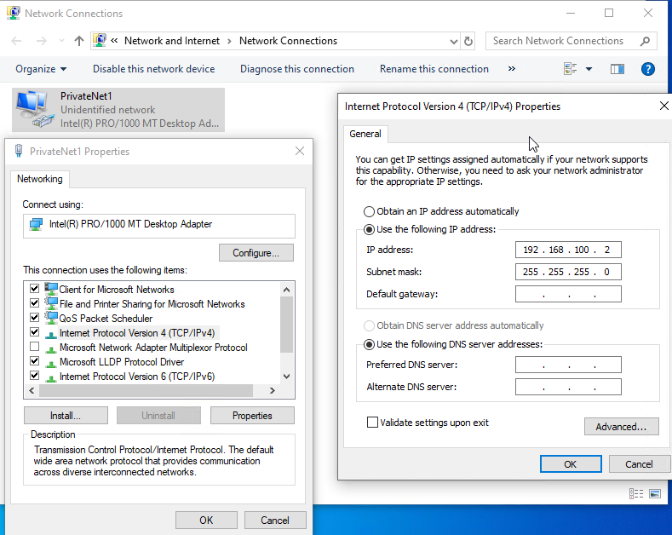
Here the client machine was given the correct IP as well as having the adapter renamed.

Ping connectivity test.
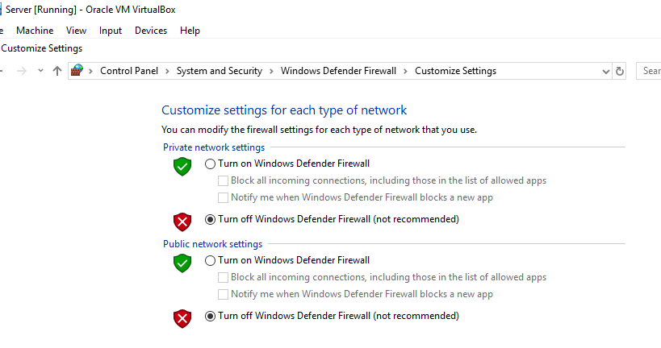
To ping the machines the firewall has to be turned off as in OOBE environments the firewalls will deny the ICMP protocol.

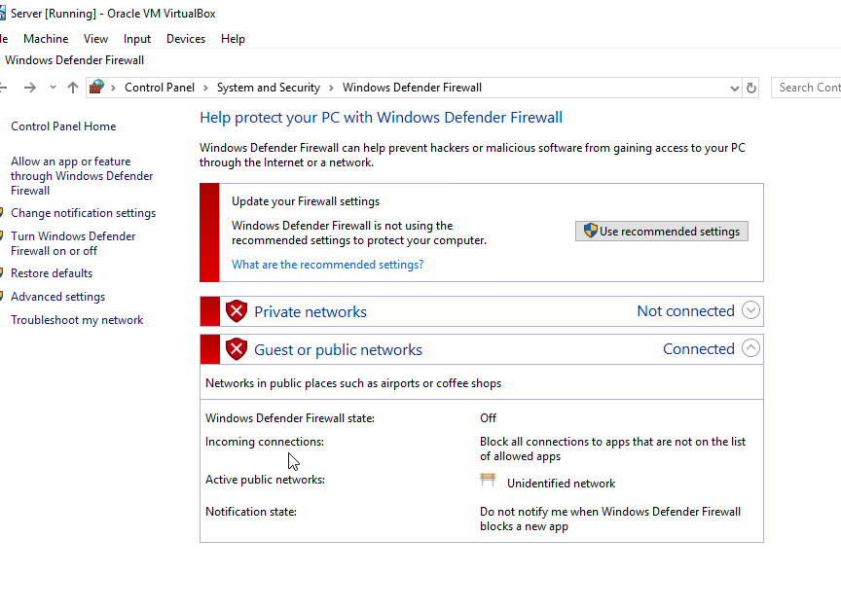
Firewall completely disabled.

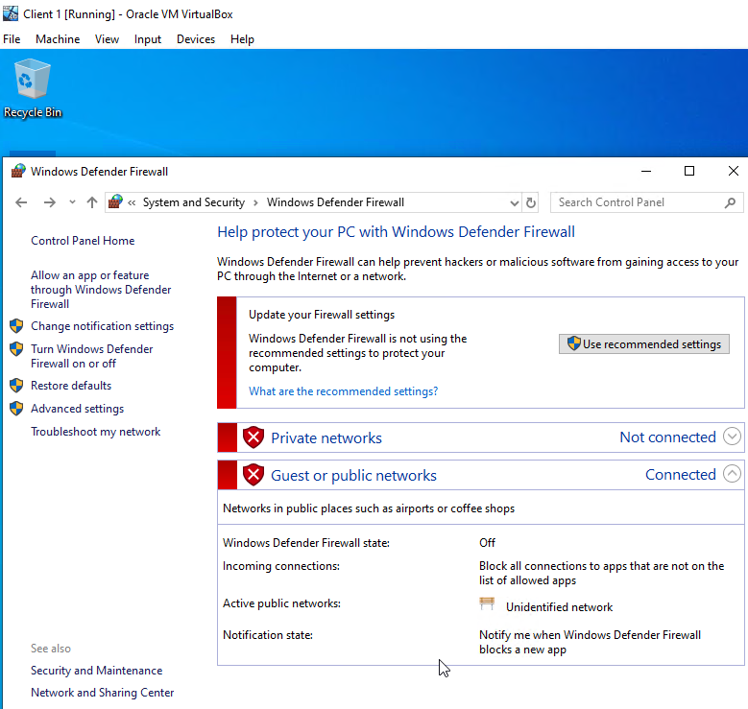
Client-side firewall also disabled.

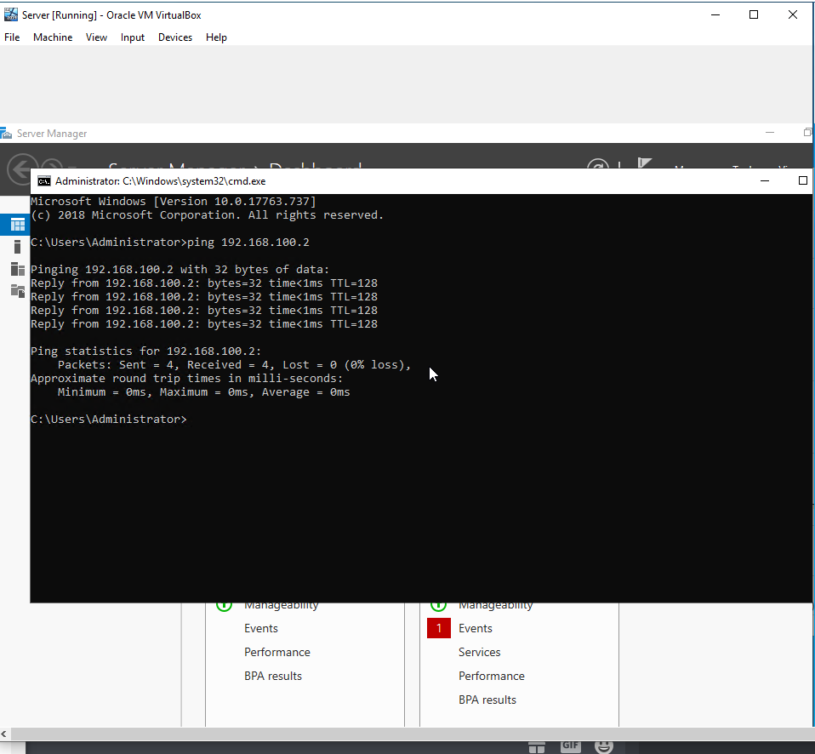
Server 1 ping to client 1 successful.
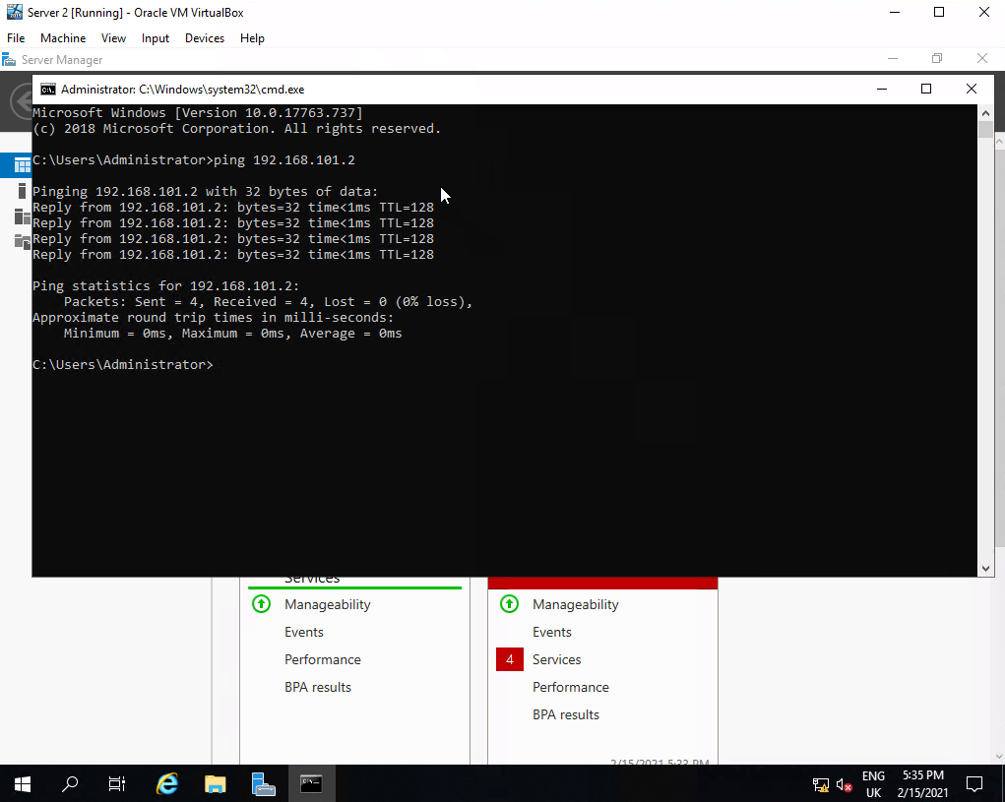
Server 2 ping to client 2 successful.

Observational tasks

Differences between type 1 and type 2 hypervisors
Type 1 hypervisors use direct access to the computer’s hardware. Often called hardware acceleration allowing them to perform better. Having direct access to the hardware also increases the security of these hypervisors [1], this is because there is nothing that can be compromised between them and the CPU unlike the type 2 hypervisors OS.
The downside of the type 1 hypervisor is the fact it requires a separate machine that will be used to administer different VMs and make use of the hardware. Therefore, the type 1 hypervisor is often referred to as the bare-metal hypervisor.
Here are some examples of type 1 hypervisors. “VMware” have 5 commercial versions as well as one free version of their products. The product they have that is type 1 is vSphere/ESXi [2]. Even the free version of this supports up to 32GB per server and has low-cost offerings. Finally, there’s also Hyper-V which is second to VMware in most cases. There are 4 editions of this hypervisor that all also come with additional features just like VMware does.

Type 2 hypervisors allow access to more that one VM to run on the hosts’ system. This is great for several different reasons. Type 2 hypervisors have a multitude of features [3]. It can be used to test whether a newly created VM network is operating correctly as a user can be made that is launched through another VM machine etc. in the end this makes very good end-user productivity. This also allows for the ability to use multiple different operating systems. For example, using Linux on one and windows on another.
On the other hand, type 2 hypervisor must access all the resources requires through the host OS, which has the primary access to the physical machine. This then introduces delay and latency issues as well as affecting performance. Also, this introduces potential security risks as it allows the host OS to potentially be compromised by an attacker causing them to be able to manipulate any of the other OS running in the hypervisor [4].
Here are some examples of recommended type 2 hypervisors. For the first choice comes VMware again. With the products being Workstation/Fusion/Player. Out of the batch, VMware player is surprisingly a free virtualization hypervisor. However, VMware Workstation has much better use with features such as running multiple different operating systems of one OS on one desktop. Finally, for another choice there I VMware Server. This is a free hosted virtualization hypervisor that is like Workstation. However, VMware stopped the development on this since 2009 which could mean a better option would be something like Microsoft Virtual PC.

Significance of the subnet mask in IPv4 addressing.
The subnet mask is very important when it comes to IPv4 addressing [5]. It will determine whether the IP connectS to the correct network or not. There are different classes of subnet masks each one telling the user a set number of bits for the IP address that represents the network portion of the address. The rest of the mask then proceeds to represent the host portion of the address. The subnet mask also allows for the network address to be created. The subnet mask is also one of the things responsible for the ANDing process. Which determines what kind of network it is.

Cloud computing and the way it revolutionised enterprise networks
The way that cloud computing has changed the way enterprise networks is beyond what anyone ever imagined it could do. Even to this day, the cloud computing area keeps expanding and allowing more things to be done online in a much easier way. Cloud computing has allowed companies to move all their content onto the cloud meaning it could simply be accessed virtually anywhere with an internet connection and the right access [6]. This alone allows for so much to be done, such as companies being able to access files without the need to constantly send them to each other. This can just be done by uploading it to the cloud network and the individuals can now access these files. With the right restriction and security, cloud computing networks can sometimes be a much better option for certain companies than a normal network that requires everything to be done more “manually”. When using cloud services, the pressure is off the individual’s shoulders and has moved over to the cloud service provider. But that is where the drawbacks of cloud computing begin.
As stated previously there is a shift of weight onto the cloud service provider. This means there is also the loss of control [7]. This is because everything may now be relying on the cloud service provider to keep the service going. Another downside of the whole cloud computing service is security. One of the more serious reasons behind this is the misconfiguration of the cloud security settings. This is because many cloud security strategies are inadequate for protecting their own cloud-based infrastructure. This also happens due to the fact cloud infrastructure being made to be easily accessible for usability and data sharing, thus making it a difficult task to make sure all information is accessed only by the authorized parties.

Description of different terminologies
Through this worksheet, there was certain terminology used that can be compared to other operating system equivalents. One of the terms used is quite a common one in the networking field which is “firewall”.
The firewall is used as a security system in most if not all networks that monitors the flow of incoming and outgoing traffic based on the security rules that it gets given. The firewall is often a barrier between the trusted network and the untrusted (Public) network such as the internet. The firewall is the essential layer of security [8]. When using the Windows firewall, you can pick and choose which connection requests you wish to block. You can even block all of them if any reason appears. This allows for the containment of computer worms as well as different viruses. Doing so also creates a security log of all attempts of connection to the computer. The configuration of the firewall is one of its great features, allowing it to be set in whatever way you want to fit the network a correctly configured firewall is very important [9]. Comparing this to a Linux firewall in the way it works is similar. However, many people think Linux firewalls are better for a few reasons. To start, the windows firewall cannot work straight from the kernel due to the multiple services windows offers. Whereas Linux allows the firewall to be exposed to the kernel which it can then show its full potential. With the Linux firewalls such as “Netfilter” or “Iptables”, you can create a very tight firewall without any setback. the Linux firewall allows for more overall capabilities with its filtering and fine-tuning.

Server management is another term that was used. This is the process of maintaining and monitoring servers so that they can operate and peak performance. This also involves the management of security software hardware and even backups. The overall goals of server management are to make sure you minimize any potential server slowdowns and downtime. As well as building a secure environment and ensuring the servers meet the expected requirements and needs of the organisation it involves. With Windows, server management has access to several tools that can help administer and manage the network. With the windows server 2019, there is a heavy influence on security [10]. Windows defender being enhanced by additional technologies that provide additional protection against threats. There is also the ATP (Advanced threat protection) which is a windows defender with a combination of technologies working together in almost an ecosystem. The server also allows for easier administration of the server core as it gives a full GI that is very similar to windows 10. However, if the decision is made for more security, efficiency and more. Then Server core is almost fully code based for faster and more security-focused benefit. Overall allowing for more efficient computing. [11] For Mac, server management features differ quite a bit. One of the features that can be compared is the app store. You can install applications onto mac devices without the app store being available on those accounts. Same as the Microsoft server. You can pre-install the applications onto user accounts, so the user does not need permission to use the store to potentially use it for other things. macOS there are several restrictions for the devices. This can also be done on windows preventing the users from accessing certain applications as well as option changes with the computer itself.

References

[1] | J. Szefer and R. B. Lee, “Architectural Support for Hypervisor-Secure Virtualization,” in Proceedings of International Conference on Architectural Support for Programming Languages and Operating Systems, 2012.
[2] | A Performance Comparison of Hypervisors, Palo Alto: VMware, 2007.
[3] | Q. u. Ain, U. Anwar, A. Mehmood and A. Waheed, “HTTM - Design and Implementation of a Type-2 Hypervisor for MIPS64 Based Systems,” Journal of Physics Conference Series, vol. 1, p. 787, 2017.
[4] | A. V. Nikolskiy and Y. S. Vasil'ev, “Formal model of cyber attacks on virtualization tools and a measure of hypervisor vulnerability,” Automatic Control and Computer Sciences, vol. 49, pp. 751-757, 2015.
[5] | A. C. Caputo, “Understanding Networks and Networked Video,” in Digital Video Surveillance and Security (Second Edition), 2014, pp. 107 -143.
[6] | P. Abdalla and A. Varol, “Advantages to Disadvantages of Cloud Computing for Small-Sized Business,” in 2019 7th International Symposium on Digital Forensics and Security (ISDFS), 2019.
[7] | A. V. Peshraw Abdalla, “Advantages to Disadvantages of Cloud Computing for Small-Sized Business,” in 2019 7th International Symposium on Digital Forensics and Security (ISDFS), 2019.
[8] | X. Song, “Firewall Technology in Computer Network Security in 5G Environment,” ournal of Physics: Conference Series, 2020.
[9] | K. Salah-ddine, “Managing Windows Embedded Firewall Programmatically,” in Overview Of Firewalls: Types And Policies , 2017.
[10] | P. M. Zamora, M. Kwiatej, V. N. Bippus and E. C. Elejalde, “Increasing Windows security by hardening PC configurations,” The European Physical Journal Conferences , vol. 8, no. 19, p. 214, 2019.
[11] | “Features for iOS,” Apple, [Online]. Available: https://www.apple.com/uk/macos/server/features/. [Accessed 07 March 2021].
[12] | N. Poojary, “How DNS Works – the Domain Name System (Part One),” Cloud academy, 26 March 2019. [Online]. Available: https://cloudacademy.com/blog/how-dns-works/. [Accessed 05 March 2021].

