DEVELOPING WORKPLACE CRITICAL THINKING

How do individual beliefs, attitudes and values impact workplace behaviour?



NAME: Sofaia B Midtskau (1813661
10 Dec 2021
LECTURER: S.KHAN

EXECUTIVE SUMMARY

An important and often overlooked aspect of management theory is the organisation's culture that despite its subliminal nature, is effectively tuned for people to instinctively recognize and react ot it. It act a kind of sign language.
From the researcher research in this report, organisations need to change their leadership style. In with the new modern theory to be implemented and out with the old. The British Armed Forces has a long way to go but with its rigid organisation it will slightly to adopt change and become more flexible. The British Armed Forces will try and be flexible but at the same time maintain discipline structure with its organisation and bureaucratic . Tesco has come a long way and has succeeded in the past decades. Tesco needs to acknowledge the importance of control and monitoring in organisational settings in able to be honest with its customers, employees and communities. If Tesco aligned its core values with its organisation , we can see another 100 years of success coming its way.

CONTENT PAGE
EXCUITIVE SUMMARY………………………….1
1.0 INTRODUCTION………………………………….3-4
2.0 FINDINGS......................................................5-9
3.0 CONCLUSION………………………………………..9-10
4.0 REFERENCE LIST.......................11-12

1.0 INTRODUCTION
This report is based on the topic of How individual beliefs, attitudes and values impact inn workplace behaviour. The researcher has used Tesco and other organisations based on research on workplace settings in Management's theories and implementation of values in the organisation. Tesco is a multinational grocery and merchandise retailer. The main aim of the report is to critically assess, analyse and evaluate the impact on Tesco employees as well as on wider society in terms of future sustainability and impact on the environment.
Organisation core values are convictions, methods of insight, and standards that drive the organisation trade. According to the research (Eonx,2020), these values affect the employee encounter that is provided as well as the relationships that are created with customers, accomplices, and shareholders. A few of the foremost common organisational values are integration, responsibility, respect, teamwork, customer satisfaction, prevalent quality and putting employees first. Employees encounter inside battles when their individual values clash with the organisational values, coming about in sentiments of unease toward the organisation. In the long run, this inner rival begins to meddle with the employee’s work life and home life, and as a result of looking for another new job that aligns with their values.
1.0.1 What is Tesco's core Value?
Tesco's core values include "customer focus, all and little help that makes a difference." For over a century, these have been the main principles that define Tesco as a company. Tesco has created a strong in-house culture within its organisation, making it a trusted brand based on customer appreciation. Tesco value helps its organisation to understand how to put this into practice (How we do business, 2021).
However, implementing effective compensation strategies today is one of the most important and most discussed matters in many organisations. When effectively managed and distributed, rewards can benefit many organisations, including Tesco. A data survey (Alam and Raut-Roy,2019) was conducted and as a result, Tesco employees were pleased with the existing reward system and believed that the current reward strategy was useful and effective.
Truss et al (2012:45); Hutchinson, (2013) proposed that strategic performance management is a plan that interacts with an organization's vision, mission, goals, and aims, as well as how resources will be used. To fully understand the developing strategic performance management process, employees must align the organisation vision and mission statement, which are effective in assimilating and communicating what the organisation is about and its future achievements and present status (Hutchinson,2013). Therefore, rewarding employees motivated to perform well at the workplace.

1.0.2 What Management Theory did Tesco implement in this research?
By understanding and applying management theory best practices, an organisation can lead their teams to success more effectively. The researcher revealed that many of these theories lead to the leadership approaches commonly used today for business operations and growth. Organisations can choose one to find the best strategy for their team. Recognizing and applying management theories requires practice and in some cases, trial and mistake(Indeed, 2021)
In this research, the researcher explored that Tesco implements both Classical and Modern theories into practice within the organisation. Taylor and Webber are implemented in Tesco for coordination, organised and efficiency (Armstrong and Taylor, 2020). However, in Modern Management theory Herzberg is implemented in Tesco for job satisfaction and dissatisfaction in this research. Tesco focuses on two groups, their customers and employees to accomplish motivation by offering rewards to both employees and customers, thus as a customer loyalty card for rewards, and discounts allowance for employees (Benefits | Tesco Careers, 2021) Offering rewards leads to stability in their personal and work life. However, studies ( Trevor,2012; Armstrong and Brown,2019) have shown that many organisations' attempts to use reward strategically are more burdensome than benefits and create conflicts rather than agreements.

2.0 FINDINGS

The researcher voiced in the introduction about the implementation of the modern and classical theory. In the Findings, the researcher identifies the benefits of the management theories and analyses the theories relevant to Tesco and other organisations.
2.0.1 What are the Benefits?
Increase Productivity: These theories benefit leaders learn how to get the most out of their team members, improve performance and increase productivity. The drawback here could be the capital financial to produce sales profits if provided. Training and planning would be put into to increase work processes.
Decision Making: Provides managers with strategies that help accelerate the decision-making process and fulfil their roles effectively. In the retail market, this management theory faces a crucial situation if leadership skills are not met.
Collaboration: Managers learn how to encourage team members to participate and improve collaboration in the workplace. Drawback employees may feel belittled and disaffected which may lead to absenteeism.
Improved Objectivity: Management theory encourages management to make scientifically proven changes rather than relying on judgment. The weakness of this objectivity would be less effective for teams and groups and venture interaction between employees which may lead to conflicts(Reddy,2016)
2.02 Tesco implement Classical and Modern Management Theories
The classical theory measures that Taylor inspiration works only for money. Tesco has the same relationship with Taylor’s theory as it has an employee compensation program that provides monetary compensation to encourage employees. Furthermore, there are other aspects that motivate people. They are simply personal and work life. Tesco surpasses Taylor’s theory to support the distinct lifestyle of all men or women who work for them, not just paying for them but taking advantage of significant benefits. For example, at Tesco, employees may want to serve people or improve their basic understanding of customer services and skills (Armstrong and Brown,2019).
Furthermore, in another organisation such as THE BRITISH ARMED FORCES , Fayol and Weber theory are very much dominated within its organisation. Administrative Management generally but some leadership management can be bureaucratic in their individual leadership roles. The military faces many of the same human problems as traditional organisations. In recent research (Jacobs,2017) one of the biggest challenges facing the Ministry of Defence is not sufficiently diversified in terms of gender and ethnicity. But social mobility is their “territory”. "I'm really proud” The important thing is how good soldiers are.
.
How are these soldiers motivated in comparison to Tesco employees ? Tesco employees are motivated through rewards scheme whereas within the armed forces personnel , motivation comes from discipline installed through physical training and inclass courses . As a soldier it is your duty to carry it out. Motivation came from the oath that a soldier took when signed on to fulfil the duties required of them and full abilities through their work. Jacobs(2017) mentioned that armies are based on one size fits all, so it is problematic culturally. Armed Forces need to restructure management style and think about individual.
However, a two-factor motivational model developed by Herzberg (1966, 1987) is a source of job satisfaction and dissatisfaction when asked why accountants and engineers feel very good or very bad about their work. He named these motivational and hygiene factors, respectively. Motivational or "satisfaction factors" are related to individual work and consist of performance requirements, work interests, responsibilities, and promotion opportunities. Hygiene factors are related to work conditions such as wages and working conditions.
The hygiene factor itself is neither satisfactory nor motivational. They primarily help prevent work dissatisfaction but have a minor impact on positive work attitudes. Economical, compellingly emphasizing the positive value of the essential motivational factors in the development of reward systems, as they are easy to understand and appear to be based on real-life rather than academic abstractions. Herzberg`s strengths as a missionary rather than a researcher have a major impact on the work fulfilment movement aimed at maximizing opportunities for essential work satisfaction and thereby improving the quality of work (Armstrong and Brown,2019). Herzberg’s motivation in Tesco is broadly comparable to Maslow’s higher needs, with growing power and achievements in Aldere’s model and McClellan’s theory. One of the most important contributions of these models is the difference between extrinsic and intrinsic motivation(Hutchinson,2013).
Another criticism of Tesco faces within its organisation is when products defects or customer services are lacking. Leaders sometimes fail to deliver methods of approaching such situations in order to analyse and diagnose issues when they arise. In this situation, Situational Leadership theory is needed to be applied and practiced ( Crawford,2014).
2.0.3 Sustainability
Greenpeace launched a campaign in 2020 (Greenpeace,2020) calling Tesco to confront the reality of industrial meat and its role in the destruction of Mazon and other South American forests. 100,000 people have registered and all the public pressure seems to have shaken Tesco. Tesco began advertising on social media, claiming it supports Greenpeace's call to stop deforestation and not to buy meat from Brazil. Tesco has also claimed to achieve the certified zero deforestation target for soybean feed by the end of 2020.
Applying the RED MODEL FOR TESCO.
- Recognising assumptions that implementing Herzberg in Tesco enables it to be more motivated in its services delivery and efficient. This enables Tesco to deliver on its value to employees focused on caring for every” little hjelp” core values.
- Evaluating evidence - Skills Training Tesco develops their leadership (Crawford,2014)which enables them to laminate critical situation occurred and are skilled enough to make decisions on the basis of situations.
- Delivering sustainability initiative- Tesco as the researcher voiced that Greenpeace has accused Tesco of deforestation in Brazil- caring for all as value. Tesco may not buy meat from Brazil but chicken and pork in their supermarket are fed by Brazilian soya. Soya re produced by companies owned by Amazon rainforest slaughter.
- Drawing conclusion - implementing Situational and Contingency (Armstrong and Taylor,2020) theory it provides Tesco with leadership related to environmental factors that are enough to encounter a strong suitable approach. However, leadership in Tesco implement the Webber theory of doing the right thing, fit for all but are in a difficult position.

Chances are, Tesco’s bosses do care about the Amazon and want to do the right thing, but they’re in a difficult position. “Right now, the truth is that you can’t sell industrial meat on a Tesco-like scale without being involved in deforestation.”(Greenpeace,2020)So rather than trying to buy their way out of the problem, Tesco needs to make a serious business decision to reduce their dependence on the global industrial meat system. That means dropping forest-destroying suppliers, and replacing half the amount of meat they sell with healthy, affordable plant-based alternatives by 2025.
However, Tesco's value statement on its own is not enough here. Tesco needs to be well communicated and acted upon. So that employees understand and are committed to what the organisation stands for and are motivated to play their part in achieving it. This emphasises the importance of having a strongly integrated m management approach. (Hutchinson,2013)
Performance management systems impose high demands on management time and skills. Without these requirements and being put into practice, cognitive problems arise. Management training helps leaders to deal with feedback, better skills and reviewing the crucial situation. However, it is clear that motivation and performance are not the only factors in ability, but also their knowledge and skills. It also deals with management motives and politics within the organisation and outside ( Boxall and Purcell,2016). Therefore, Tesco has a decision to make, not only by hiding behind a disconcerting supply chain and carrying on as usual for their business but needs to make vital decisions to reduce the global industrial meat system and align with its core value and mission statement.
The researcher concluded that from this research Tesco is not always what they say they are.

3.0 CONCLUSION

Leaders are often confused by culture, as much of it is fixed to implicit behaviors, ways of thinking, and social patterns. Many executives either leave it unmanaged or refer it to the organisation’s secondary problem, HR. This is a mistake because a well-managed culture helps to achieve change and build an organisation that thrives even in the most difficult times(Groysberg, Lee, Price and Yo-Jud Cheng, 2018).
During the pandemic (Challinor,2020) revealed that Tesco fed the nation by pledging 1 million slots for online shopping. Tesco has provided more jobs and help for vulnerable customers. Tesco has made changes in able to accommodate its customers and community during difficult times. Not only has Tesco restructured its management style but also aligned its core values with its organisation by caring for the customers and employees and also helping the community.
The researcher draws a conclusion based on evidence in this report and also aligns personal values with Tesco.
Figure 1. The researcher's result:
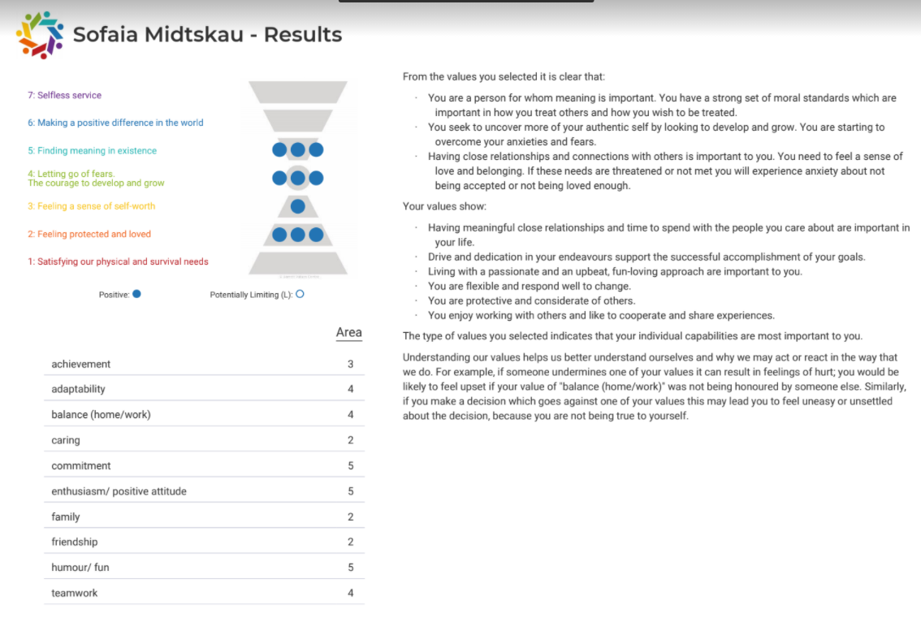
In comparison to the Beliefs Pyramid, the researcher takes to action, aim high and take ownership to improve circumstances. But at the same time the reacher survival needs are low but having close meaningful relationships with others is important in life and is central to being able to make major decisions if crucial situations arise. Furthermore, from the results, the researcher seeks new opportunities to develop and grow that keeps constantly challenging. To conclude the researcher could see her values align with Tesco in so many ways. But there are still certain objectives that need to be changed and more to be done in the near future.

.

4.0 Reference List

Tesco Core Value. 2021. How we do business. [online] Available at: https://www.tescoplc.com/about/how-we-do-business/core-purpose-and-values/
[Accessed 3 December 2021].

Indeed, Career Guide. 2021. 7 Types of Workplace Management Theories | Indeed.com. [online] Available at: https://www.indeed.com/career-advice/career-development/types-of-management-theories
[Accessed 28 November 2021].

Health Knowledge. 2021. Management models and theories associated with motivation, leadership and change management, and their application to practical situations and problems. [online] Available at:
https://www.healthknowledge.org.uk/public-health-textbook/organisation-management/5c-management-change/basic-management-models
[Accessed 3 December 2021].

Greenpeace.org.uk. 2020. Tesco’s deforestation claims are misleading the public. [online] Available at:
https://www.greenpeace.org.uk/news/tesco-deforestation-meat-adverts/
[Accessed 30 November 2021].

Alam, S. and Raut-Roy, U., 2019. Evaluating the Effectiveness of Reward Strategy at Tesco: Evidence from Selected Stores in UK. Indian Journal of Industrial Relations, 55(1).

Woods, M., 2007. Linking risk management to strategic controls: a case study of Tesco plc. International Journal of Risk Assessment and Management, 7(8), pp.1074-1088.

Eonx.com. 2020. The Untold Benefits of Success Built on Core Values | EonX. [online] Available at: https://eonx.com/company/blog/the-untold-benefits-of-success-built-on-core-values
[Accessed 2 December 2021].

Tesco-careers.com. 2021. Benefits | Tesco Careers. [online] Available at:
https://www.tesco-careers.com/explore-our-world/benefits/
[Accessed 5 December 2021]

Guadalupe, M., Kinias, Z. and Schloderer, F., 2021. Aligning Individual and Organisational Values. [online] INSEAD Knowledge. Available at: https://knowledge.insead.edu/leadership-organisations/aligning-individual-and-organisational-values-17561
[Accessed 1 December 2021].
Reddy, C., 2016. Scientific Management Theory: Advantages and Disadvantages - WiseStep. [online] WiseStep. Available at: https://content.wisestep.com/advantage-disadvantage-scientific-management-theory/
[Accessed 1 December 2021].

Jacobs, K., 2017. HR Magazine - HR lessons from the military. [online] HR Magazine. Available at: https://www.hrmagazine.co.uk/content/features/hr-lessons-from-the-military
[Accessed 1 December 2021].

Groysberg, B., Lee, J., Price, J. and Yo-Jud Cheng, J., 2018. The Leader’s Guide to Corporate Culture. [online] Harvard Business Review. Available at: https://hbr.org/2018/01/the-leaders-guide-to-corporate-culture
[Accessed 3 December 2021].

Challinor, S., 2020. Tesco has increased online capacity by 103 per cent, says chief executive | The Leaders Council of Great Britain & Northern Ireland. [online] Leaderscouncil.co.uk. Available at: https://www.leaderscouncil.co.uk/news/tesco-has-increased-online-capacity-by-103-per-cent-says-chief-executive
[Accessed 4 December 2021].

Eboks

Armstrong, M. and Brown, D. (2019) Armstrong’s Handbook of Reward Management Practice. [BibliU version] 6th ed. London, Kogan Page.

Robertson, M. (2021) Sustainability Principles and Practice. [BibliU version] 3rd ed. Taylor and Francis.

Hutchinson, S. (2013) Performance Management. [BibliU version] London, Kogan Page.

Carlson, M. (2017) Performance: A Critical Introduction. [BibliU version] 3rd ed. Taylor and Francis.

Books
Robertson, M. (2021) Sustainability Principles and Practice. [BibliU version] 3rd ed. Taylor and Francis.
Crawford, M., 2014. Developing as an educational leader and manager. 1st ed. London: SAGE Publication Limited.

Boxallr, P. and Purcell, J., 2016. STRATEGY AND HUMAN RESOURCES MANAGEMENT. 4th ed. London: PALGRAVE.

