Research in Practice
Student: Rachel Kestin
Student number: 1907798
BA Course: Creative Advertising
Word Count: 2627
Tutor: Donna Williams

The area I have chosen to research directly relates to my practice and interest in Creative Advertising. I intend to explore three key words, Fear, Shame and Impact in relation to how they are used in the world of advertising. I want to look at, more specifically how these negative emotions are used within advertising and how they can often leave the audience with mixed emotions and in some cases, can leave a positive impression when used correctly. By exploring these three key words and demonstrating the points with three advertising campaign posters that have used negative emotions, I anticipate being led to a question I can potentially research and prepare for my final years independent project.
Fear
A good general definition of fear is “an unpleasant emotion or thought that you have when you are frightened or worried by something dangerous, painful or bad that is happening or might happen.” (Cambridge Dictionary, 2021). Bearing in mind this is an unpleasant emotion it is interesting that it is so popular in advertising. As Brooker suggests, “Fear-arousing appeals in advertising is common.” (Brooker, 1981, p.29). Why would a company or brand push this uncomfortable feeling on its audience? The primary answer is its ability to grab attention. “If fear can heighten drive, there is the possibility of greater attention and interest in the product and message than if no drive were aroused.” (Ray and Wilkie, 1970, p. 55). By creating a situation that evokes fear in the audience, you are creating a universal condition, a condition which makes most people feel very uncomfortable. People will find themselves searching for a way out of this emotion and back into their comfort zone, but for the advertiser in doing this they gain the desired attention with the use of ‘fear appeal’ (Zheng, 2020). “Fear appeals operate by making the viewer uncomfortable and subsequently offering relief in the form of some sort of action desired by the advertiser” (Cochrane and Quester, 2005, p. 12).
There are several different ways in which fear can be used to target an audience. Advertisers can show a person the fear of missing out or being inferior with a low risk/impact tactic, an example of which is the television advert “Don’t be a Doug” (EE Network Envy, 2020). There are other types of fear which may be used in advertising, such as the adrenaline or excitement felt at theme parks or with extreme sports. Alternatively, they can fill people with dread by using high impact adverts employing fear, the kind of fear that scares people or makes them feel vulnerable or anxious. This can be either tongue -in-cheek, as with the Phones4u commercial "missing our deals will haunt you" (Phones4u, 2011), or seriously, as seen in many public information commercials. These have become a cliché of the 1980’s with advertisements such as “Charlie Says – Strangers” (Public Information Films, 1973) or the AIDS awareness commercial “Aids Monolith” (Public Information Films, 1987), and a host of other fear instilling information videos. Finally, political advertising has used fear as a tactic all over the world to reduce the popularity of an opponent many times. They use fear of crime, risk of war or merely the fear of voting for a reckless, incompetent or dangerous person or party.
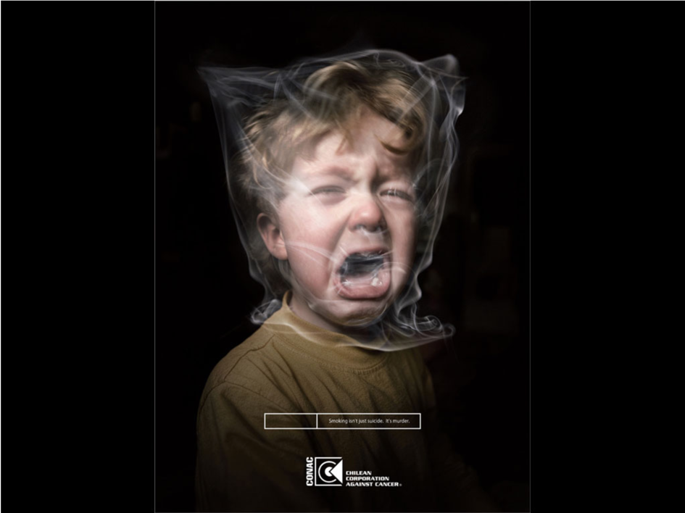
To look at a specific example in more depth, the anti-smoking campaign entitled Brown (2008) by CONAC (Chilean Corporation Against Cancer) in figure one below represents a particularly graphic one. The image shows a distressed young child with his head in a plastic bag and a tagline which reads ‘Smoking Isn’t Just suicide, It’s Murder’. This poster is trying to emphasize the effects of passive smoking on the most innocent in society, through the use of “negative emotional appeals” (Zheng, 2020). In this case a powerful feeling of dread is created, in the form of an image of a suffocating child. This signifies not only smokers killing themselves but are also committing a horrendous crime against children through passive smoke.

Figure One. Brown (2008) CONAC (Chilean Corporation Against Cancer).

This advertisement leads to a number of important questions; where is the boundary of taste or sensibility when challenging such important issues? Who is the specific target market for this advert? A smoker, a parent who smokes, or a non-smoker with children who may be affected? I would suggest it is trying to target all parents. No parent would ever want to put their child in harm’s way, so what better way to advertise the effects of passive smoking or just being around a smoking in general, by tugging on the heart strings of a parent. I feel however this poster would not have the desired effect on a smoker without children, narrowing the target audience size.
What is the desired outcome for this campaign? It is clearly aimed at encouraging smokers to consider quitting, reducing the amount they smoke, or think about smoking in areas which less affect others. In my opinion this poster advertisement would have the desired effect of a high impact ‘fear appeal’ (Zheng, 2020) as the child is in clear peril, but is also incorporates shame and guilt from a parent’s perspective, as they may be the ones causing this child to be in peril.
Reflecting on this research around the use of fear in advertising, I find that it is a complex emotion that needs to be used carefully and only in specific circumstances, otherwise the advertiser may risk the loss of the audience attention or place a potentially destructive stigma on to their brand which could have damaging long term effects.
Shame
A general definition of the word shame is “an uncomfortable feeling of guilt or of being ashamed because of your own or someone else’s bad behaviour.” (Cambridge Dictionary, 2021). This differs from fear in that it is an emotion caused by an internal stimulus. With fear the danger is mostly an external threat, but shame relates to the feelings we have about our own actions or thoughts. It is similar to guilt, although guilt is more about the negative impact your actions have on someone else. There are many ways in which a person can experience shame. Bradshaw’s research in ‘Healing the Shame That Binds You’ (2006) proved insightful when looking into this second keyword. Bradshaw attempts to define shame and get to the root of the issues behind this powerful emotional feeling. According to him, “there are two forms of shame: nourishing shame and toxic/life-destroying shame. As toxic shame, it is an excruciatingly internal experience of unexpected exposure. It is a deep cut felt primarily from the inside.” (Bradshaw, 2006, p. 5). This has several implications. Although mainly negative, it has a positive side to it as well. It is a universal feeling, one that every person will have experienced at some point in their lives, and it is a very deep routed emotion if it risks becoming a “sickness to the soul” (Bradshaw, 2006. p. 5). Shame can be built up from many negative feelings about oneself such as doing the wrong or a bad thing, creating self-esteem and other mental health issues.
Shame is also an emotion we experience from a very young age. When a child is experiencing shame, maybe for having a tantrum in the supermarket they will simply just hide or close their eyes as “Hiding the eyes is a characteristic of shame because shame guards against over exposure.” (Bradshaw, 2006, p. 11). This appears to be a defence mechanism, one which a child does not fully understand, but as adults we cannot simply close our eyes and imagine we are not feeling shame. The experience is inescapable. The charity sector has understood this for many years, with advertising campaigns arguably over-exposing the audience to shame and guilt.
There are also issues around fat-shaming and undermining body positivity. These include ‘Are You Beach Body Ready?’ (Sweney, 2015), and ‘Cancer Research UK obesity campaign’ (Plummer, 2019) linking obesity to increased cancer risk. Both of these campaigns appear to have inadvertently triggered the shame emotion, and as will be discussed later, resulted in public backlashes.
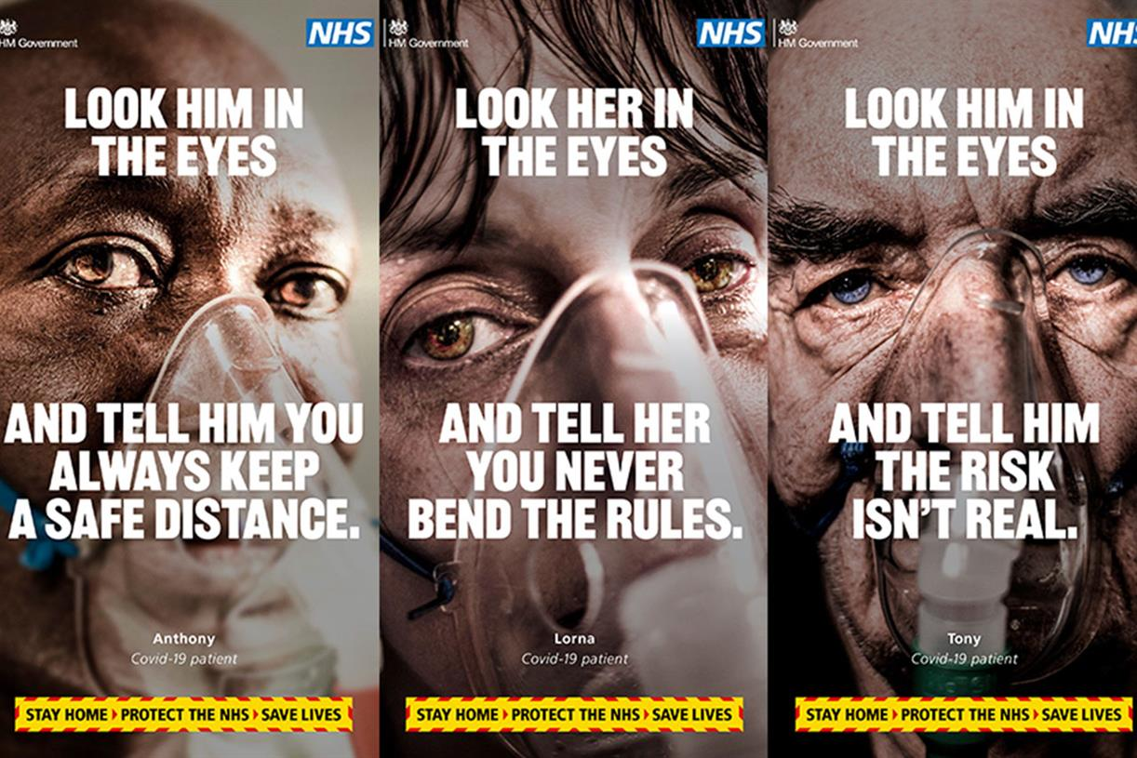
Brenè Brown, a research professor at the University of Houston spent many years studying emotions such as shame, especially in women. A definition of shame she developed in her research was “an intensely painful feeling or experience of believing we are flawed and therefore unworthy of acceptance and belonging" (Brown, 2006, p.45). This, along with the information in Bradshaw’s book, makes it seem strange that advertisers would put shaming tactics in their advertisements. Does shaming people really sell products or inspire change in people’s behaviour? A recent advertisement campaign tried just this (see figure two below). “Look Them in the Eyes” (GOV.uk, 2021) attempted to challenge recent behaviour of people by making them look into the eyes of real-life, suffering Covid patients and rethink their decisions on breaking the lockdown rules, with one clear message to “Stay at home” (Matt Hancock, 2021).

Figure Two. Look them in the eyes. (2021). GOV.uk
This advertisement is targeting those people who have broken the rules or those that may intend to break the rules in the future. It is a grave reminder that this infection is real and affecting people daily. In my opinion, the desired direct emotional response to this style of advertisement is shame followed by an extra negative emotion, guilt. As already mentioned, shame often gets associated with guilt. According to Huhmann and Brotherton “guilt is related to the negative emotion of shame, fear and regret.” (Huhmann and Brotherton, 1997, p. 35) but they are not the same. “The thing to understand about shame is, it’s not guilt. Shame is a focus on self, guilt is a focus on behaviour.” (Brown, 2012).
The shame and guilt that this advert causes, comes mainly from the image, the strategic close up of the faces of the sick, worn out eyes of the people directly affected by this terrible disease. Between their image and the government messaging, you are expected to feel those negative emotions. It is almost as if they are looking to place blame on the audience for this life-threatening situation. To the audience that this poster advertisement is aimed at, they will feel shame in a very personal way, with thoughts such as “I am bad” (Brown, 2012), and guilt if they know they have done wrong and have to admit that to themselves “I did something bad” (Brown, 2012). To those who have not broken the rules of lockdown however, this advertisement may come across as patronising, or finger pointing and provoke anger as a response.
There is a clear preference to use shame as an emotional tactic in relation to adverts focussed on behavioural issues, especially public information campaigns and charity appeals. This is consistent with the definitions relating it to a self-reflective emotion, rather than an external threat.

Impact
The first two key words are abstract ideas relating to negative emotions. The final key word relates to the effect they have on the audience. To start with, a general definition of the word impact is “a powerful effect that something, especially something new, has on a situation or person.” (Cambridge Dictionary, 2021). In relation to this research, the term impact describes the link between the idea behind an advert, and the outcome it creates. It may be anticipated or judge beforehand, although there is always the risk of an unpredictable effect if judged incorrectly. As Stewart, Morris and Grover warn, “emotion can be measured in many different ways that do not always produce the consistent results.” (Stewart and Morris and Grover, 2007, p. 120)
The joy of advertising is that there is always something new just around the corner. Be it a new trend or a new political campaign, advertising is constantly changing and evolving. The one important element for all advertisements is attention. The advertiser needs to be able to grab the attention of the audience and somehow keep it “One of the most widely used methods of drawing attention to social advertising is the use of negative emotions.” (Borawska and Oleksy and Maison, 2020, p.1). As discussed previously negative emotions have the ability to make or break an advertisement. I chose the word Impact as one of my key words as negative emotion advertisements will inevitably have some form of impact on the audience especially those with an emotional connection. Take figure one Brown (2008) for example, this advertisement would have a particularly high impact on an audience due to the nature of the imagery used, and the fact it includes peril to a child. This may also be seen with video campaigns. These advertisements can risk a high impact strategy, as even if they push the emotional button too hard, it has the safety net of being for an extremely ethical cause. Not all campaigns have this benefit.

Throughout my research of the three chosen key words I came across a large amount of political advertisements that involved the use of negative emotions. However, not being a politically minded person, I chose to steer clear of them, until I came across Figure 3, New Labour New Danger. (1997). I do not feel the word impact could have a better representation other than this image. The impact this advertisement had on the population caused much controversy, it divided people. The conservatives, in an attempt to destroy their opponents campaign used a “Direct attack ad” (Faber and Tims and Schmitt, 1993. p. 68) and ended up destroying their own credibility, thereby suffering their worst defeat. This example of such high impact negative emotion just goes to show that boundaries can be pushed too far sometimes and can be extremely counterproductive.

Figure 3, New Labour New Danger. (1997). M&C Saatchi.
As damaging as this was for the conservative’s campaign, it still managed to serve a purpose, and the campaign advertisers felt that it was worth the risk.
The body-image adverts referred to earlier both also received public backlashes as a result of the perceived fat-shaming they used to promote their agendas. Although these outcomes were probably not intentional, it demonstrates the impact a misguided strategy may result in.
A similar outcome was received after years of fundraising charity campaigns based on guilting the audience into contributing. It eventually became known as poverty porn “a label that acknowledges the prurient and voyeuristic nature of such programming as well as the objectification of its subjects.” (Feltwell, T et al. 2017, p. 345).
and resulted in the entire industry moving away from crude imagery and towards one of helping their recipients of aid to help themselves.
It appears that most sectors have realised that using negative emotions such as fear and shame in advertising is a delicate balance between high impact and high risk. The benefits of high impact advertising are well understood, but this comes with a much bigger risk, the risk of your advertisement failing, or even worse the tainting of a company with a stigma that is difficult to remove.
Conclusion
From the exploration of my three keywords I found that negative emotions play a huge part in advertising, sometimes for the greater cause but occasionally they can miss there mark completely, even if unintentional. My key words were far more complex than first thought, there are so many different connotations for the term negative emotions. Take fear for example, there are many different characteristics for this one emotion, and I feel I only scratched the surface with my research. What particularly sparked my interest throughout my research was the use of babies and children in the negative emotional adverts. This led me to the question ‘how does the use of babies and children within negative emotional advertisement impact our decision making.

Bibliography
Books
Bradshaw, J. (2006). Healing the Shame that binds you. Rev Ed edition. Florida: Health Communications Inc.

Stewart, D. W. and Morris, J. and Grover, A. (2007). The Sage Handbook of Advertising. 1st Edition. London: SAGE Publications Ltd.

Journals
Borawska, A. and Oleksy, T. and Maison, D. (2020). ‘Do negative emotions in social advertising really work? Confrontation of classic vs. EEG reaction toward advertising that promotes safe driving.’ PLoS ONE, 15(5), pp 1-20. Available at: https://search-proquest-com.ezproxy.uwtsd.ac.uk/docview/2403302527/fulltextPDF/6354DC5B419844CCPQ/1?accountid=130472 (Accessed: 15th April 2021)

Brooker, G. (1981). ‘A Comparison of Persuasive Effects of Mild humour and Mild fear Appeals,’ Journal of Advertising, 10 (4), 29-40 Available at: https://www-jstor-org.ezproxy.uwtsd.ac.uk/stable/pdf/4188374.pdf?refreqid=excelsior%3Ad5f5a5efcc1d6b1ab89e023e3d374e85 (Accessed: 13th April 2021)

Brown, B. (2006). Shame Resilience Theory: A Grounded Theory Study on Women and Shame. Families in Society, 87(1), pp. 43-52. Available at: https://search-proquest-com.ezproxy.uwtsd.ac.uk/docview/230162319/fulltext/14BEC872655343E8PQ/1?accountid=130472 (Accessed: 15th April 2021)

Cochrane, L, and Quester, P. (2005). Fear in Advertising. Journal of International Consumer Marketing, 17(2-3), pp. 12–32. Available at: https://www.tandfonline.com/doi/abs/10.1300/J046v17n02_02 (Accessed:13th April 2021).

Faber, R. Tims, A. and Schmitt, K. (1993). Negative Political Advertising and Voting Intent: The Role of Involvement and Alternative Information Sources. Journal of Advertising, 22(4), pp 68-76. Available at: http://www.jstor.org/stable/4188900 (Accessed: 15 April 2021)

Feltwell, T et al. (2017). Counter-Discourse Activism on Social Media: The case of challenging “Poverty Porn” Television. Computer Supported Work, 26(3), pp 345-385. Available at: https://link-springer-com.ezproxy.uwtsd.ac.uk/content/pdf/10.1007%2Fs10606-017-9275-z.pdf (Accessed: 17th April 2021)

Huhmann, B. & Brotherton, T. (1997). A Content Analysis of Guilt Appeals in Popular Magazine Advertisements. Journal of Advertising, 26(2), pp.35-46. Available at: http://www.jstor.org/stable/4189032 Accessed: 14th April 2021)

Ray M, L and Wilkie W. L. (1970). ‘Fear: The Potential of an Appeal Neglected by Marketing’, Journal of Marketing. 34(1):54, pp. 55-62 Available at: https://www.researchgate.net/publication/272594699_Fear_The_Potential_of_an_Appeal_Neglected_by_Marketing (Accessed: 12th April 2021). DOI:10.2307/1250296

Zheng, M. X. (2020). ‘When and Why Negative Emotional Appeals Work in Advertising: A Review of Research.’ Open Journal of Social Sciences, 8, 7-16. https://doi.org/10.4236/jss.2020.83002 (Accessed: 12th April 2021)

Electronic News Article
Plummer, J. (2019). Cancer Research UK defends ‘harmful and misleading’ obesity campaign. ThirdSector, 5th July. Available at: https://www.thirdsector.co.uk/cancer-research-uk-defends-harmful-misleading-obesity-campaign/communications/article/1590155 (Accessed: 17th April 2021)

Sweney, M. (2015). ‘Protein World’s ‘beach body ready’ ads do not objectify women, says watchdog.’ The Guardian, 1st July. Available at: https://www.theguardian.com/media/2015/jul/01/protein-world-beach-body-ready-ads-asa (Accessed: 17th April 2021)

Internet
Cambridge University Press. (2021). Cambridge Dictionary. [Online]. Available from: https://dictionary.cambridge.org/dictionary/english/fear (Accessed 12th April 2021)

Matt Hancock (2021). GOV.co.uk [Online]. Available from: https://www.gov.uk/government/news/new-hard-hitting-national-tv-ad-urges-the-nation-to-stay-at-home (Accessed 15th April 2021)

Images
Figure One
CONAC (Chilean Corporation Against Cancer). (2008). Brown. [Online]. Available at:https://www.adforum.com/creative-work/ad/player/6711271/brown/conac-chilean-corporation-against-cancer (Accessed: 13th April 2020)

Figure Two
GOV.uk. (2021). Look them in the eyes. [Online]. Available at: https://www.campaignlive.co.uk/article/will-governments-new-emotive-covid-ad-people-obey-rules/1705634 (Accessed: 12th April 2021)

Figure Three
M & C Saatchi. (1997). New Labour New Danger. [Online]. Available at: https://www.theguardian.com/politics/election2001/images/0,9350,449562,00.html (Accessed: 14th April 2021)

Video
Brown, B. (2012). TED: Listening to Shame: Brenè Brown. [Video] Available at: https://www.ted.com/talks/brene_brown_listening_to_shame?language=en#t-828814 (Accessed: 15th April 2021)

EE Network Envy. (2020). Don’t be a Doug. [Video]. Available at: https://youtu.be/01SjVXoOQ0Y (Accessed: 14th April 2021)

Phones4u. (2011). Missing our deals will haunt you. [Video]. Available at: https://www.youtube.com/watch?v=dTEgo0N_xzI (Accessed: 17th April 2021)

Public Information Films. (1973). Charlie Says – Strangers. [Video] Available at: https://www.nationalarchives.gov.uk/films/1964to1979/filmpage_strangers.htm (Accessed: 17th April 2021)

Public Information Films. (1987). Aids Monolith. [Video]. Available at: https://www.nationalarchives.gov.uk/films/1979to2006/filmpage_aids.htm (Accessed: 17th April 2021)

