Digital business
Assignment 2


An Evaluation of Airbnb business model

Contents

introduction

Airbnb landscape

BMC

SFF

Tools/ Systems

Conclusions

References

Introduction

This report aims to evaluate the Airbnb business model, implementing a strategy formulation framework to reveal a financial landscape, P2P market forces, target groups, problems, strategy, current situation, challenges and suggest recommendations for future growth.

Using such strategic tools as the business model canvas (BMC) and the strategic formulation framework (SFF) information about the internal micro and the external macro environments company can be examined and strategy can be formulated the company to obtain competitive advantage thus propelling the business forward and keeping long term profits optomised.

Airbnb landscape

Airbnb came on the scene in 2008, amidst corporate scandal, economic downturn and instability. (How Hotels Can Compete in the Airbnb Landscape, 2021) Airbnb is an internet platform that facilitates hosts to rent shared space, a private room or an entire home (Zeitlyn and Beardmore-Herd, 2018)
Airbnb has grown exponentially from a formally single shared space to a multi -million-dollar industry with over a million listings in only 13 years. Airbnb is an online platform that allows sellers to rent out their accommodation and buyers to book the accommodation directly via Airbnb (Byers & Roserio, 2014, cited in Scholdan & Straaten, 2015)
Airbnb is a collaborative consumption, in which individuals actively engage in the production of service offerings for the benefit of others (De Canio, Pellegrini and Martinelli, 2018) on a multi sided platform, and an industry digital disruptive effect that changes the fundamental expectations and behaviours in a culture, market, industry or process that is caused by, or expressed through, digital capabilities, channels or assets. (Definition of Digital Disruption - Gartner Information Technology Glossary, 2021) Airbnb’s platform, and it’s the collective efforts of our hosts, guests and global community (Diversity at Airbnb, 2021) Airbnb business model is a multi-sided platform and is an example of the sharing economy industry.
It has Hotel consultant Don Landry spoke of the fact that Airbnb is growing faster than any hotel franchise model, without owning any real estate (Zeitlyn and Beardmore-Herd, 2018)
Airbnb is a platform based digital business that captures information from hosts who become suppliers on the platform. It captures information about marketing, trends and shares this information with Hosts. It also captures customer reviews for customers to use in their assessment of the accommodation, choices and hosts.

Airbnb's mission statement
At the heart of our mission is the idea that people are fundamentally good and that every community is a place where you can belong. (Diversity at Airbnb, 2021) emphasises the strengths of their unique accommodation experience.

Business model canvas

The Business Model Canvas is a business tool used to visualise all the building blocks when you want to start a business (Business Model Canvas Explained | Enterprising Oxford, 2021)
Using the BMC to plan strategy with the internal or microenvironment of your business can help managers and upper employees understand and implement essential changes.
The plan (fig 1) is split into 9 different headings relating to the different segments in the business making management understand their business and who they are their target audience and helping to understand the value chain, the segments need to be revised regularly to ensure the model is accurate.

Key partners
Including hosts, business within the travel industry, investors and political lobbyists, plus other essential partners such as photographers, maps, storage, payments and insurance suppliers.

Key activities
Handling all transactions, the scale of the whole operation, engaging all parties involved, and data analysis to improve all aspects of the business. one of Airbnb s best innovations was the instant book, Airbnb can acquire a customer via Google AdWords and with only one click, the customer is on the site and able to immediately book a place to stay (Airbnb: An Analyst's Guide (Part 1) - AllTheRooms Analytics, 2021)

Key resources
listings, user generated content such as reviews and listings themselves, the set up and running of the platform, the staff at Airbnb from data analysts and the staff who collate algorithms the brand itself and the running and design of the app.

Value proposition
Li and Tabari tell us that Travelers are now seeking low-cost accommodation to gain value for their expenditure and simultaneously longing for relatively more direct interactions with local communities (Panda, Verma, & Mehta, 2015)
Dolincar suggests to us that the key partners in Airbnb are-
1. Hosts, it is essential for them to list their rooms to make the platform work, the platform where the hosts can show case their homes, Airbnb manage the risks associated with the rentals, they also manage money transactions for both guest and host plus there is opportunity to make connections as a host within the platform a type of social space.
2.Guests who are looking for the accommodation can access a large amount of competitively priced accommodation all on one platform, Airbnb mitigate the risk and augment the experience.
3.Other partners can include professional photographers, insurance companies who are looking for new clients plus substantial investors.

Customer relationships
Managing interactions within the platform plus the public image of the company, hr, with issue resolution for the hosts and the onboarding of all parties.

Channels
These are the what the company uses to advertise so including digital ads, content marketing, social messaging and influencers and media management and a referral programme.

Customer segment
This is the analysis of the macro or external environment, of the guests and hosts, what is their particular type or needs, or what they want to supply the type of travel, the demographics, geographics and behaviour of a typical guests and hosts.
For example, we can see here the geographical revenues produced by hosts by region (Airbnb: An Analyst's Guide (Part 1) - AllTheRooms Analytics, 2021)

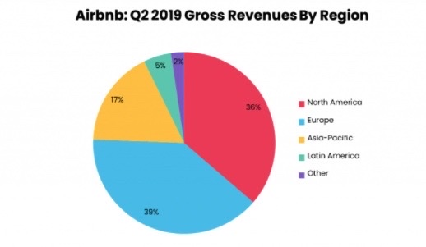
cost structures
this is the analysis of the micro or internal costs associated with the business. costs associated with customer acquisition, development and expansion, all forms of internal business expenses such as payroll, contractors, infrastructure and transaction costs, insurance and legal costs, pus customer support costs.

and lastly Revenue (fig.2)
this is the charging of a transactional fee based on the saving and the costs associated with the low cost of rental for the guest and the higher net income for the hosts.

strategic formulation framework

David’s formulation framework (fig.3) using strategy to generate feasible alternative tools to evaluate them and choose a specific course of action.
Techniques of strategy formulation can be integrated into a decision-making framework torlak& sanal 2021
There are three stages of input on the SFF

Stage 1-the input stage
external factors evaluation matrix (EFE), the competitive profile matrix (CPM) and the internal factor evaluation (IFE) Respectively the organisation would start with the first part of this complex an in-depth strategy framework, with inputting information about the respective organisation in our case Airbnb. such things as EFE Matrix summarises and evaluates economic, social, cultural, demographic, environmental, political, governmental, legal, technological, and competitive information (David, 2007) This and IFE are decided into rated and weighted scores indicating importance of that factor. IFE summarises and evaluates the major strengths and weaknesses in the functional areas of a business. (DEMİR, 2020) CPM matrix identifies a firm's major competitors and their particular strengths and weaknesses in relation to a sample firm's strategic position (David, 2007)

Stage 2 the matching stage
SWOT analysis, the SPACE matrix, the Boston Consulting Group matrix (BCG) the Internal External matrix (IE) and the Grand Strategy Matrix.
A SWOT analysis (fig.4) assess strengths and weaknesses in the micro/internal environment and the opportunities and threats in the external/macro environment, for example the strengths in Airbnb are such things as a strong brand image, trust in the processes within Airbnb and the monetary security that comes with the platform,, Airbnb can effectively personalize the traveller experience. Develop methods to personalize and promote experiential traveller experiences (Zeitlyn and Beardmore-Herd, 2018)
The SPACE matrix is a valuable method for analysing the competitive position of an organization (Radder and Louw, 1998) making the use of two internal considerations, financial strengths and competitive advantage, and two external dimensions, industry strengths and environmental stability, which are plotted onto a chart with weightings attached. The SPACE matrix can be used as a basis for other analyses, such as the SWOT analysis, BCG matrix model, industry analysis, or assessing strategic alternatives (IE matrix). (SPACE Matrix Strategic Management Method, 2021)
The Boston Consulting Group matrix (BCG) The Boston Consulting Group matrix provides the recommendations for the development of strategic resource allocation and strategy development in the typical multi-business company. (2021) The BMC is designed to help with long-term strategic planning, to help a business consider growth opportunities by reviewing its portfolio of products to decide where to invest, to discontinue or develop products (How to use the BCG Matrix | Smart Insights Digital Marketing, 2021) you can plot your products on a graph using the images of a (cash) cow, star, high growth markets, question mark, high growth market with low market shares and dog, low growth or low market share.
Internal -External matrix The IE Matrix is a strategic management tool which is used to analyse the current position of the divisions and suggest the strategies for the future based on an analysis of internal and external business factors which are combined into one suggestive model. (Internal-External (IE) Matrix, 2021) we can use the outcomes from a SWOT analysis to assist with internal, strengths and weaknesses and external opportunities and threats then add the weighting of the scores, which will then be plotted on to the graph. thinking about whether the scores are strong, medium or weak.

the Grand strategy matrix is below within in-depth analysis.

Stage 3
quantative strategic planning matrix has become widely used in strategic management but is only rarely used in marketing strategy, the qspm should be commonly used in marketing strategy to assess the relativeness attractiveness of alternative strategies being considered (David, David and David, 2016)

All these planning and analytic tool aid strategic thinking for an organisation to plot a way forward for their business benefiting the company in strategy. All these tools have a positive and negative limitations as the perspective is held by the person doing the analysis, the draw backs to analysis in a complex and changing environment means these types of analysis have to be performed regularly and with the current situation involving a pandemic, and the changing political and legal issues, all of this analysis is relative to immediate problems, but it is still a worthwhile tool to an organisation such as Airbnb.

Tools/ Systems

The Grand strategy matrix is a useful tool that is able to create different strategies in an organization. (2021) The tool used in this analysis is the grand strategy matrix, it’s used to look through alternative strategies for companies and is gaining popularity since the launch in 2017(Introduction to the Grand Strategy Matrix | Resources | Get Lucidity, 2021)
Grand Strategy Matrix is based on two evaluative dimensions: competitive position and market growth (DEMİR, 2020)
The grand strategy charts two dimensions
1 The market growth
2 The organisations competitive position
The tool is split into four quadrants with the headings rapid market growth at the top, weak competitive position, strong competitive position and d slow market growth. Airbnb would be plotted in the top right-hand corner, in quadrant 1, due to its strong competitive position and its rapid market growth.

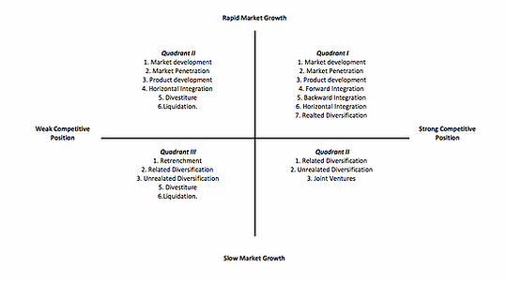

(2021)

Although there are a few draw backs to using this tool such as, it only provides options rather than success criteria around them. You need to use it with other tools. The matrix is simplistic so loses some nuance. Your business may operate in multiple quadrants if you have many products or services (Introduction to the Grand Strategy Matrix | Resources | Get Lucidity, 2021)
Airbnb have been sitting in the top right-hand corner of this matrix with experiential growth since its conception and has been enjoying a strong competitive position in a rapid growth industry. In the last year 2020-21, Airbnb has had to deal with the consequences of the coronavirus pandemic which has had a massive impact on the business, it saw its valuation drop from its 2017 high of $31 billion to around $18 billion. In May, the company laid off about 25 percent of its staff or about 1,900 people. Executive salaries were also reduced for a temporary six-month span. (Airbnb lost millions in revenue due to coronavirus, IPO filing reveals,2021)

Conclusions
li and Saloomeh suggest several things to us about Airbnb’s position, Businesses and communities in less explored areas are also benefiting from Airbnb providing access to local accommodation (Panda et al., 2015). Their strengths lie in growth of the business with people becoming entrepreneur businesses and communities in less explored areas are also benefiting from Airbnb providing access to local accommodation (Panda et al., 2015). that although London like a lot of cities has restriction or barriers to entry Airbnb is still growing.
They also suggest Technology is the key driver for the development of Airbnb because it enables Airbnb’s operation, which relies on online transactions (Daugherty, 2016) Wu et al (2012) suggest that the use of technology is a driver in the growth of the business with the use of mobile apps giving users the full Airbnb the experience from the mobile phone browser, on any platform in key products. (Airbnb by the Numbers: Usage, Demographics, and Revenue Growth, 2021)
Wu et al also suggests that Airbnb’s business could substantially increase untapped domestic customers waiting to lend or rent new accommodations. but also stresses that Airbnb has no sustainable advantage so developing any edge it can is essential. and that Partnerships with car rental services, review services, and airline agencies are all viable options when browsing selections for accommodation providers. is another area for potential growth (2021)
As to Airbnb Four of the top competitors, faces are Wimdu, Roomorama, 9flats, and Couchsurfing.org. These companies have similar offerings in the P2P property rental market. Because they are very similar in structure (low fees, easily accessible) Due to relatively low barriers to enter this market, Airbnb’s competitors can almost perfectly replicate its business model, which makes long-term growth challenging. (2021)
Trust seems to be an important factor with traditional accommodation enjoying a better security measures, A major barrier to the continued proliferation of Airbnb services is establishing consumer trust. Since Airbnb connects individuals to each other versus the traditional model of connecting individuals with an established company, continuing to defy this norm is a challenge that Airbnb constantly faces this with the continue legal issues so Airbnb must be cautious of its expansion to minimize the risks of lawsuits and increased pressure from the hotel industry. (2021)

References

Airbnb.co.uk. 2021. Diversity at Airbnb. [online] Available at: <https://www.airbnb.co.uk/diversity> [Accessed 13 March 2021].

AllTheRooms Analytics. 2021. Airbnb: An Analyst's Guide (Part 1) - AllTheRooms Analytics. [online] Available at: <https://www.alltherooms.com/analytics/airbnb-ipo-going-public-revenues-business-model-statistics/> [Accessed 20 March 2021].
Daugherty, P. (2016). Platform economy: Technology-driven business model innovation from the outside in. Retrieved from https://www.accenture.com/fr-fr/_acnmedia/PDF-2/ Accenture-Platform-Economy-Technology-Vision-2016- france.pdf
David, M., David, F. and David, F., 2016. The quantitative strategic planning matrix: a new marketing tool. Journal of Strategic Marketing, 25(4), pp.342-352.
David, F. R., (2007), Strategic Management Concepts and Cases, (11th ed.), Prentice Hall, New York.
De Canio, F., Pellegrini, D. and Martinelli, E., 2018. Is the collaborative consumption the new buying? Social and economic aspects influencing collaborative consumption. MERCATI & COMPETITIVITÀ, (1), pp.19-38.

DEMİR, M., 2020. TİCARET YOĞUNLUĞUNUN ANALİZİ: TÜRKİYE VE TÜRK CUMHURİYETLERİ ÖRNEĞİ. Karadeniz Uluslararası Bilimsel Dergi, pp.293-310.

Direstrategico.wixsite.com. 2021. [online] Available at: <https://direstrategico.wixsite.com/taitea/grand-strategy-matrix> [Accessed 20 March 2021].

Dolnicar, S. (2017) Peer-To-Peer Accommodation Networks: Pushing the boundaries. Goodfellow Publishers Limited.

Econ.ucla.edu. 2021. [online] Available at: <http://www.econ.ucla.edu/sboard/teaching/tech/Airbnb.pdf> [Accessed 21 March 2021].

Eship.ox.ac.uk. 2021. Business Model Canvas Explained | Enterprising Oxford. [online] Available at: <https://eship.ox.ac.uk/business-model-canvas-explained/> [Accessed 13 March 2021].

Gartner. 2021. Definition of Digital Disruption - Gartner Information Technology Glossary. [online] Available at: <https://www.gartner.com/en/information-technology/glossary/digital-disruption> [Accessed 13 March 2021].

Getlucidity.com. 2021. Introduction to the Grand Strategy Matrix | Resources | Get Lucidity. [online] Available at: <https://getlucidity.com/strategy-resources/introduction-to-the-grand-strategy-matrix/> [Accessed 20 March 2021].

Hvs.com. 2021. How Hotels Can Compete in the Airbnb Landscape. [online] Available at: <https://www.hvs.com/article/8349-how-hotels-can-compete-in-the-airbnb-landscape> [Accessed 13 March 2021]

Luiz de Freitas Vieira, J. and Almeida Có, M., 1997. https://sobraep.org.br/artigo/sistema-retificador-inversor-com-corrente-pulsada-no-barramento-cc-para-acionamento-de-motores-de-inducao/. Eletrônica de Potência, 2(1), pp.35-42.

Maxi-pedia.com. 2021. Internal-External (IE) Matrix. [online] Available at: <http://www.maxi-pedia.com/internal+external+IE+matrix> [Accessed 21 March 2021].

Maxi-pedia.com. 2021. SPACE Matrix Strategic Management Method. [online] Available at: <http://www.maxi-pedia.com/space+matrix+model+strategic+management+method> [Accessed 21 March 2021].

M.na-businesspress.com. 2021. [online] Available at: <http://www.m.www.na-businesspress.com/JHETP/DebrechtD_Web14_3_.pdf> [Accessed 21 March 2021].

Muchneeded.com. 2021. Airbnb by the Numbers: Usage, Demographics, and Revenue Growth. [online] Available at: <https://muchneeded.com/airbnb-statistics/> [Accessed 21 March 2021].

Panda, R., Verma, S., & Mehta, B. (2015). Emergence and acceptance of sharing economy in India. International Journal of Online Marketing, 5(3), 1–17.

Radder, L. and Louw, L., 1998. The SPACE matrix: A tool for calibrating competition. Long Range Planning, 31(4), pp.549-559.
Scholdan, L., & Straaten, N. V. (2015). What are the drivers of the sharing economy and how do they change the customer behaviour? Retrieved from https://www.con textuallearning.nl/wp-content/uploads/2016/01/drivers- of-the-sharing-economy-strategie.pdf
Smart Insights. 2021. How to use the BCG Matrix | Smart Insights Digital Marketing. [online] Available at: <https://www.smartinsights.com/marketing-planning/marketing-models/use-bcg-matrix/> [Accessed 21 March 2021].

The Verge. 2021. Airbnb lost millions in revenue due to coronavirus, IPO filing reveals. [online] Available at:
https://www.theverge.com/2020/11/16/21570416/airbnb-coronavirus-pandemic-travel-hospitality [Accessed 25 March 2021]

Zeitlyn, D. and Beardmore-Herd, M., 2018. Testing Google Scholar bibliographic data: Estimating error rates for Google Scholar citation parsing. First Monday,.

appendix

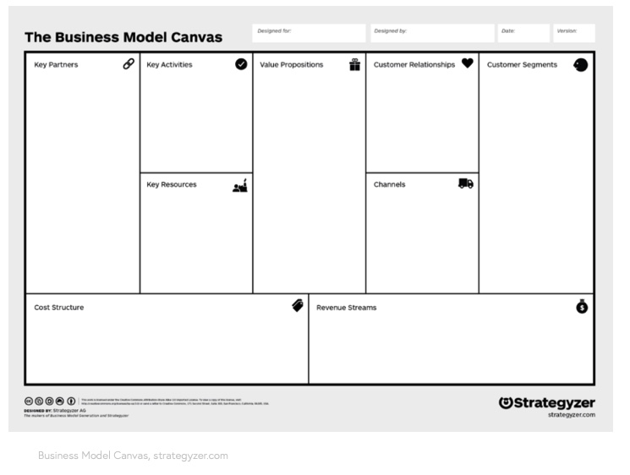
fig. 1



fig.2

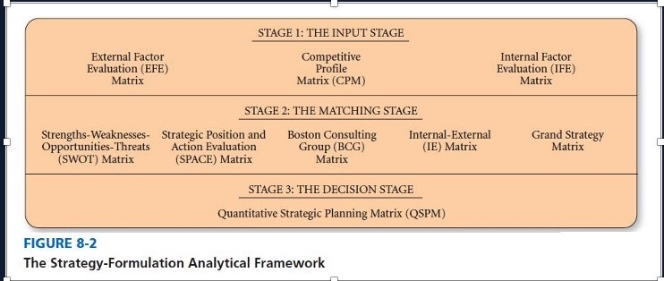

fig.3

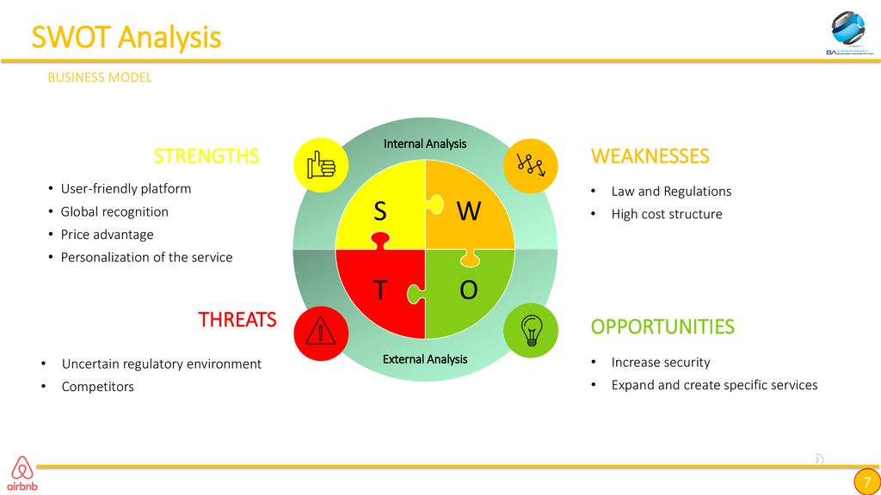

fig.4 (Luiz de Freitas Vieira and Almeida Có, 1997)

