Business Report – Comparison of Shangri-La Hotels and Premier Inn Hotels.

Module: Financial Management for the Hotel Industry BMIH5007

Name: Viktoria Benko

Student ID Number: 2130343

Lecturer: Tristan Hawkins

Word Count: 2198

Table of Contents/

Executive Summary 3
Introduction 3
Total Revenue 4
Market Position: Market share, Customer Demographics and Brand Perception. 11
Growth Potential: Expansion Strategies, market opportunities and potential barriers to growth. 13
Financial Commitment to CSR (Corporate Social Responsibility): Financial Commitment to CSR initiatives. 15
Comparison and Evaluation Table 16
Conclusion 21
Recommendation 21
References 22

Executive Summary

This Business Report analyse, compare and evaluate Shangri-La Hotel Group and Premier Inn Hotels have noticeable record in the Hospitality Industry. This report also collates their financial management strategies, performance, sustainability, practices and their impact. This report also analyses and compare key Revenues, Market Position, Enhancement Opportunity and Financial Commitment to (CSR) Corporate Social Responsibility initiatives.

Introduction

Crises are often unpredictable and unavoidable. Thus, businesses need to understand the potential scope and impact of emergencies. The duration of a crisis and recovery depends significantly on the recovery plan and available resources. Shangri-la Hotel Group one of the fastest growing and loved chain in hospitality Industry, owns, operate and manages over 100 hotels and resorts in 78 destinations around the world and has over 50 years of experience of hosting people to the colourful joys in life keeping their sustainable strategy Stay, Savour, Shine with us. In every location they operate in, they engage with local stakeholders bringing economic opportunities, creating lasting value and nature environment. On the other hand, Premier Inn, A division of Whitbread, has also made a name for themselves as the biggest hotel chain in the UK, with a solid presence and a track record of giving their visitors high-quality service. With more than 80,000 rooms across more than 800 hotels, striving to provide consistently excellent service to travellers on both business and vacation. The popularity may be attached to its dedication to client happiness, careful location choice, and successful marketing techniques and has established themselves as a top option for travellers looking for reasonably priced but high-quality lodging by focusing on the provision of pleasant rooms, excellent amenities, and value for money.

Total Revenue

Shangri-La Hotels generates revenue through various ways. The brand’s emphasis on luxury accommodations and premium services which allows them to command higher room rates, spas, third party franchises and attract affluent clientele and cost structure is influenced by its investment in luxury amenities, prime locations, and high-quality service offerings, leading to higher operational costs.

Shangri-La Hotel SWOT Analysis Table

Strength  - Stable Funding  - Strong Brand Recognition and Reputation attracting new and returning guests.  - Diverse Portfolio  - Global Presence  - Commitment to Quality and Service  - Innovative marketing and Communication Strategies  - Adoption to Technology  - Sustainability and CSR Initiatives | Weaknesses  - High Dependency on Global Travel Market  - Competition from other brands  - Managing Consistency Across Global Properties.  - Adapting to social media trends
Opportunities  - Expansion into Emerging Markets  - Leveraging technology for personalised guests  - Sustainability and Eco-friendly Initiatives  - Diversification of Services and Experience  - Partnerships and Collaboration with other brands | Threats  - Global Economic Fluctuations  - Intense Industry Competition  - Technology Disruptions.  - Geopolitical Instability and Security Concerns can deter customers from visiting.  - Sustainability and Environmental Regulations

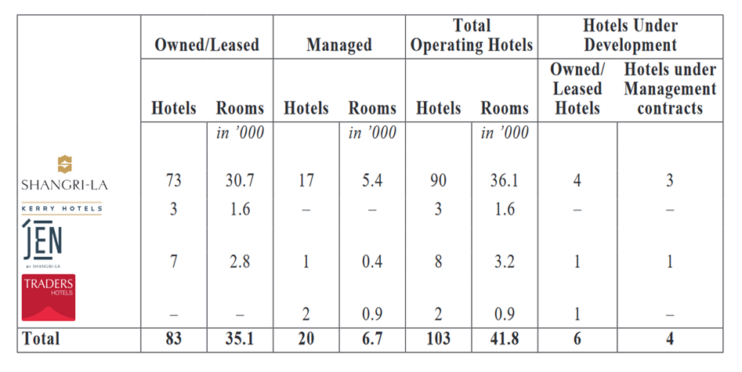
Figure 1: Shangri-La’s Summary of Group Hotels and Rooms.
Source: https://sitecore-cd.shangri-la.com/

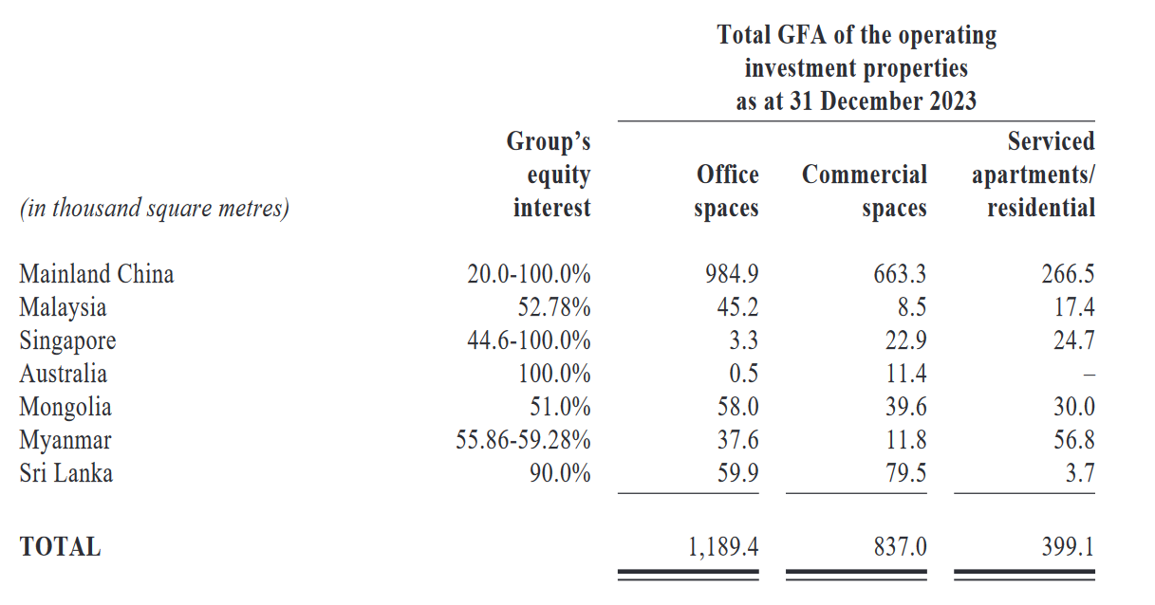
Figure 2: Shangri-La Group GFA of Operating Investment properties
Source: Source: https://sitecore-cd.shangri-la.com/

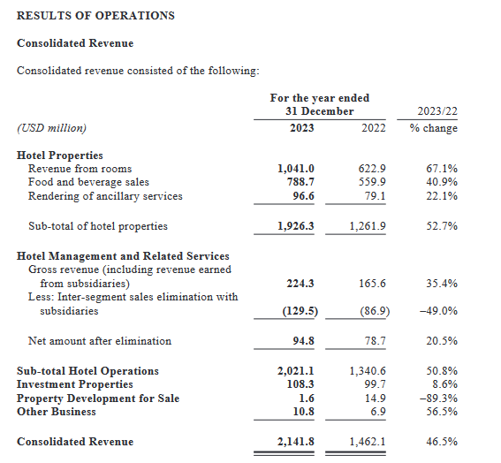
Figure 3: Shangri-La's Consolidated Revenue
Source: Source: https://sitecore-cd.shangri-la.com/

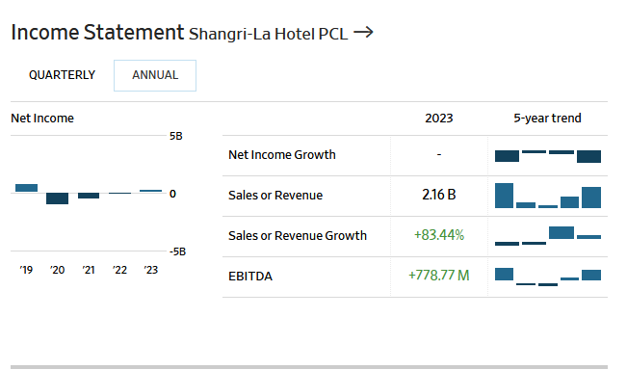
Figure 4: Shangri-La Hotel Group Income Statement 2019-2024
Source: https://www.wsj.com/market-data/quotes/TH/XBKK/SHANG/financials

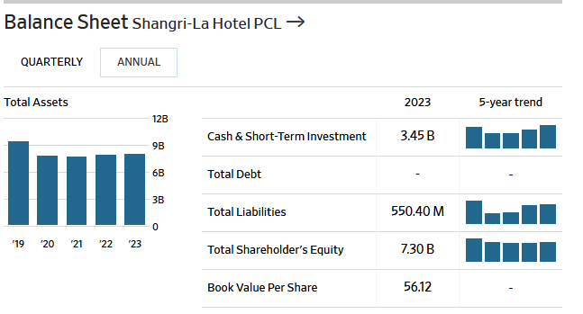
Figure 5: Figure 1: Shangri-La Hotel Group Balance Sheet 2019-2024
Source: https://www.wsj.com/market-data/quotes/TH/XBKK/SHANG/financials

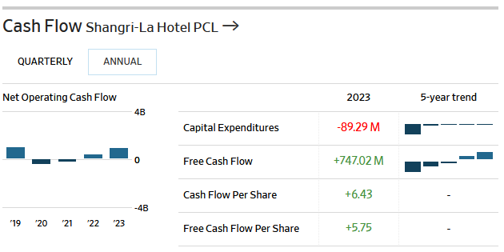
Figure 6: Shangri-La Hotel Group Cash Flow 2019-2024
Source: https://www.wsj.com/market-data/quotes/TH/XBKK/SHANG/financials

Shangri-La Hotels, being a chain seems to have a had a steady growth from 2019 to 2024 unlike many years ago when the group did not have full ownership or as an independent entity. (Chen, 2024).

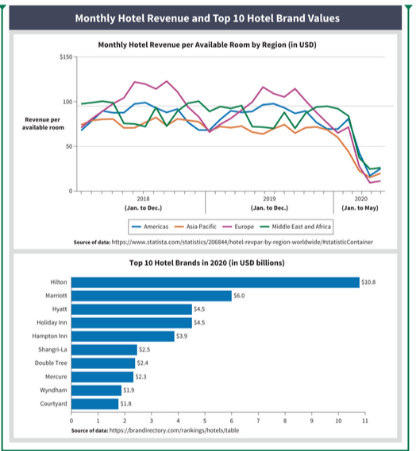
Figure 7: Monthly Hotel Revenue and Top Ten Values
Source: Intermediate Accounting, Volume 2

On the other hand, Premier Inn, owned by Whitbread plc, revenue streams include room bookings, on-site restaurant services, and ancillary services. In the six months leading up to August 29, 2024, Whitbread reported flat revenues of £1.57 billion, with a 22% decline in pre-tax profits to £309 million, attributed to softer demand in the UK hotel market. Premier Inn also focuses on cost efficiency, benefiting from economies of scale and standardized operations across its extensive network, resulting in a more streamlined cost structure.

Premier Inn’s Financial Statements
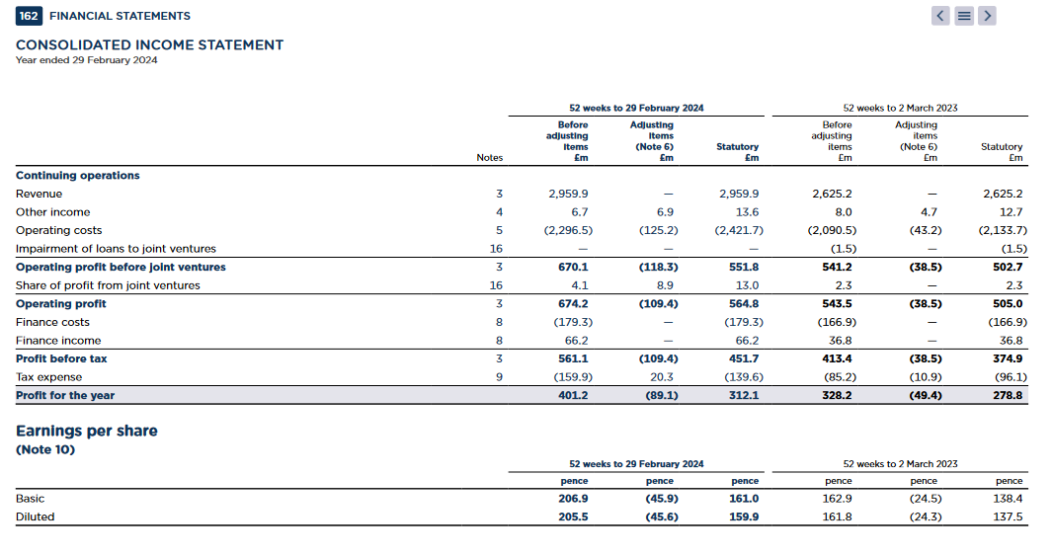
Figure 8: Premier Inn's Financial Statement 2024
Source: https://cdn.whitbread.co.uk/media/2024/05/

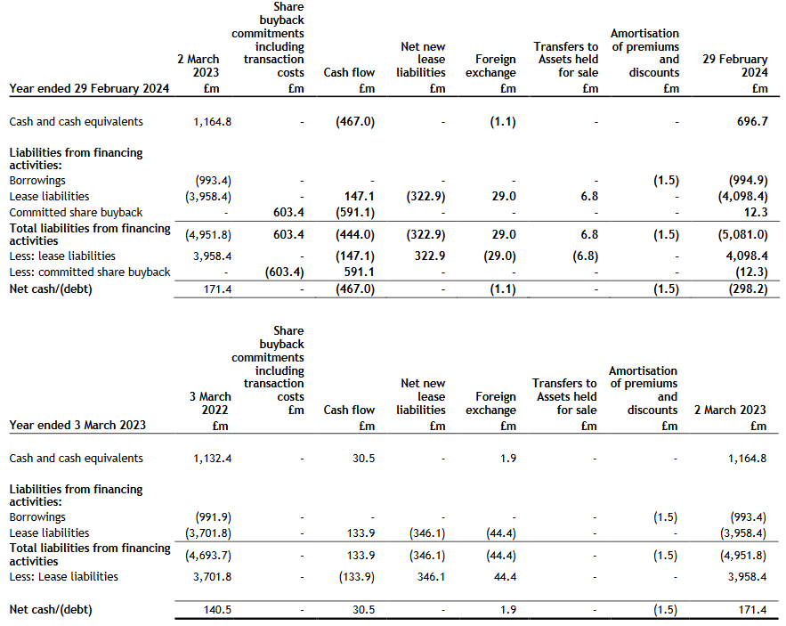
Figure 9: Premier Inn's Balance Sheet 2024
Source: https://cdn.whitbread.co.uk/media/2024/05/

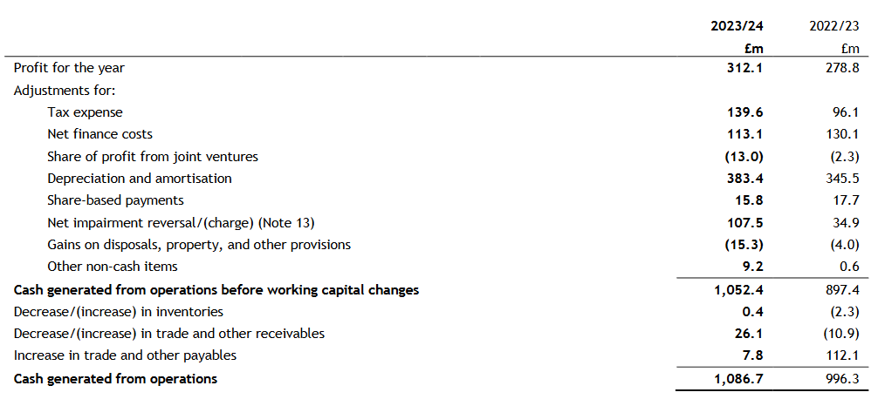
Figure 10: Premier Inn's Cash Flow Statement 2024
Source: https://cdn.whitbread.co.uk/media/2024/05/
Premier Inn SWOT Analysis Table

Strength  - High occupancy rate of more than 68%  - Strong Presence in UK with 840 hotels  - Good Customer base of over 5 million customers per month  - Affordable Rates for customers.  - Good locations near airports and tourists’ attractions  - Good Commitment to Sustainability | Weaknesses  - Limited Global Presence compared to some giants, only operates in limited number of countries.  - Refund Issues, has a lot of refund cases making customers unhappy.  .
Opportunities  - Has opportunity to grow in other countries improving global presence  - Design and Decoration | Threats  - Competition from other brands for example Holiday inn  - Legal threats if they do not respond to queries

Market Position: Market share, Customer Demographics and Brand Perception.

Shangri-La Hotels mostly attracts wealthy individuals’ business travellers seeking premium experiences. Its global presence spans over 100 hotels in 77 destinations, primarily in Asia, Europe, and the Middle East.

Shangri-La’s Marketing Mix includes different Products, Prices, Promotions and in different favourable Places. This brand differentiation helps them increase their market share giving them a competitive advantage against competitors making one of the fastest growing brands in the industry attracting investors.
Shangri-la Hotels is a good example of how a leading Asian Hospitality brand practices branding within organisation by aligning their staff and management with overall brand strategy. Also applied the Shangri-La Philosophy of hiring staffers with right mindset, favouring young inexperienced easily be trained their way. Employees carry booklets which states its core values of respecting, humility, courtesy and sincere, philosophy from a caring family, Mission to improve customer experiences attracting more customers creating a good relationship between customers and employees achieving business goals, vision to make them first choice by customers and guiding principles. (Metin Kozak, 2016) To delight customers, Shangri la hotel group has a staff training program divided into three, Shangri La Care, Delighting Customers and Recover to gain Loyalty for their managers and staff. By doing this Shangri-la has managed to project a consistent brand image in all their hotels, staff members acting as brand ambassadors delivering brand promises, top notch services consistency all over the world. (Roll Martin, 2005) In addition to that, Shangri – la management also applied the Shangri-La Philosophy of hiring staffers with right mindset, favouring young inexperienced easily be trained their way. Employees carry booklets which states its core values, philosophy, mission, vision and guiding principles. (Metin Kozak, 2016)

Whereas Premier Inn targets budget-conscious travellers, including families, tourists, and business travellers seeking affordable accommodations without compromising on quality. Even though they have challenges which includes potential market saturation in the UK and the need to establish brand recognition in new international markets, Premier Inn is still UK’s largest hotel brand and holds a significant share of the budget hotel market, largest UK network and recognized for its consistent quality, affordability, and widespread availability, making it a trusted choice among budget travellers. (Evans, 2024)

Growth Potential: Expansion Strategies, market opportunities and potential barriers to growth.

Shangri-La hotels like Mandarin Oriental, Peninsula, all of which are world famous five-star hotels seems to have capitalised on low taxes in far east for example Hong Kong where universal corporate tax is 16.5%, income tax of 15% is levied and no capital gains tax or dividends are levied. However, there are some countries where growth seems to have been limited for example in countries with high political instabilities where local companies or organisations seems to understand how to manage their own political risks better than foreign companies. (Chen, 2024) Also, They can use professionals from other countries without bureaucratic delays. (Holovnia О., 2022)

Shangri-La’s opportunities lie in capitalizing on the growing demand for luxury travel experiences in emerging markets and by diversifying its brand portfolio to include Traders Hotels, Kerry Hotels, and Hotel Jen. However, it faces challenges such as economic volatility in these regions and competition from other luxury brands.

In contrast, Premier Inn benefits from the increasing trend of budget-conscious travel, especially in the post-pandemic era. Its expansion into the German market presents significant growth potential. Challenges include potential market saturation in the UK and the need to establish brand recognition in new international markets.

And, Premier Inn has outlined ambitious expansion plans, aiming to increase its UK hotel room count to 98,000 by 2030 and expand its German market presence to 20,000 rooms. The company also plans to convert certain restaurant properties into additional hotel rooms to optimize asset utilization and high occupancy rate of more than 68% with strong Presence in UK with 840 hotels and good customer base of over 5 million customers per month putting them in number one position with 12% Market share. Also seems to have been boosted by continued strong revenue growth, disciplined cost management, strong balance sheet and good return of capital despite scaled investment. (Weetman, 2019)
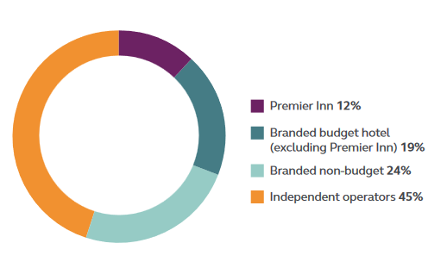
Figure 11: Hospitality Industry Market Share Chart
Source : https://www.premierinn.com/gb/en/home.html

Marketing Strategies includes Market Segmentation which is based on a variety of geographic, demographic, psychographic, and behavioural variables. With a wide variety of visitors looking for different kinds of accommodations, Premier Inn's targeting approach makes sure that it efficiently meets the varied needs of its target market, supporting its position as the top hotel chain in the UK.

In addition to that, Premier Inn Market positioning targets business travellers, vacationers, family and couples looking for affordable accommodation who might consider Premier Inn, which is smartly positioned as a dependable, reasonable, and sensible option. Since the industry has predictable cycles full of upturns and downturns but not sure of how long they last and the magnitude of the highs and lows. (Menon, 2025) They target different marketing segments at different times, with different strategies to ensure operations trades efficiently and profitably. (Dogan Gursoy, 2022)
Furthermore, the business highlights its affordable rates, clean and pleasant rooms, lodging alternatives and handy locations close to transportation routes to be seen as a good deal.

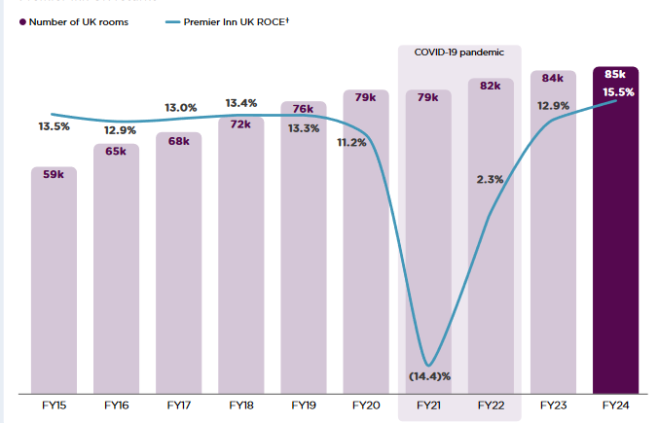
Figure 12: Premium Inn's Rooms and Return of capital Employed
Source : https://cdn.whitbread.co.uk/media/2024/05/

Financial Commitment to CSR (Corporate Social Responsibility): Financial Commitment to CSR initiatives.

Despite Shangri-La hotel's long and difficult process of attaining ISO 14001 certification involving challenging and changing the dominant "non-Green" business mindset and instilling a somewhat foreign environmentally friendly mentality in stakeholders still managed to balance financial profitability with "greening" demands which was central to sustaining the hotel's leadership position in increasingly competitive marketplace. (Terence, 2003-12) Shangri-La also implemented various sustainability initiatives, including environmental conservation programs and community engagement activities for example “Do Good”. Premier Inn, under Whitbread’s ‘Force for Good’ program, focuses on sustainability, community investment, and responsible sourcing.

Comparison and Evaluation Table

 | Shangri-La | Premier Inn
Total Revenue  - Sources of Revenue  - Revenue Trends  - Revenue Growth  - Revenue Decline | - Regular Registered  Customers  - Walk In Customers  - Other Investments e.g. Franchise Partnerships.  - Customers New Customers | - Regular Registered  Customers  - Walk In Customers  - Other Investments e.g. Franchise Partnerships.  - Customers New Customers
Market Position  - Market share  - Customer Demographics  - Brand Perception | - Targets customers with high level of income | - Targets medium to low level income
Growth Potential and Limitations  - Expansion Strategies  - Market Opportunities  - Barriers to Growth | - Shangri-La has more resources allowing them to grow faster and seize market opportunities.  - Politics and laws in some countries do not give them the freedom to grow independently. | - Premier Inn has resources but the budget not allowing them to grow faster Internationally.  - Limited Market opportunities due Politics and laws in some countries limiting growth potential.
Corporate Social Responsibility Initiatives  - Financial Commitment | - Has initiatives for example “Do Good” for the most vulnerable in community and Golden Circle for loyal Customers. | - Has initiatives for example “Force for Good” helping the need.  - There are training programs for staff and communities.

There is no one approach that works for everyone-but there is a best approach for your specific context. And it has never been more important to choose the right one. (Reeves, 2015) In a fast-paced world of business, Chief Executive Officers need to have a robust arsenal of strategies to navigate complexities and drive success. (Mochtar, 2023)

Hotels Bowman’s Strategy Clock Position Comparison Table

Shangri-La Hotel Group | Premier Inn Hotel Group
Bowman’s Strategy Clock Position | Bowman’s Strategy Clock Position
Differentiation and Focused Differentiation  - Higher perceived value at increased prices  - They are focusing on customers with high level of income  - High Perceived value in exchange for high prices  - Customers are charged a premium for perceived value offered by big brands | Low Prices and Hybrid  - Finds the sweet spot between differentiation and low costs  - Products have good quality at reasonable prices  - The room costs are kept low while process efficiency is gained.

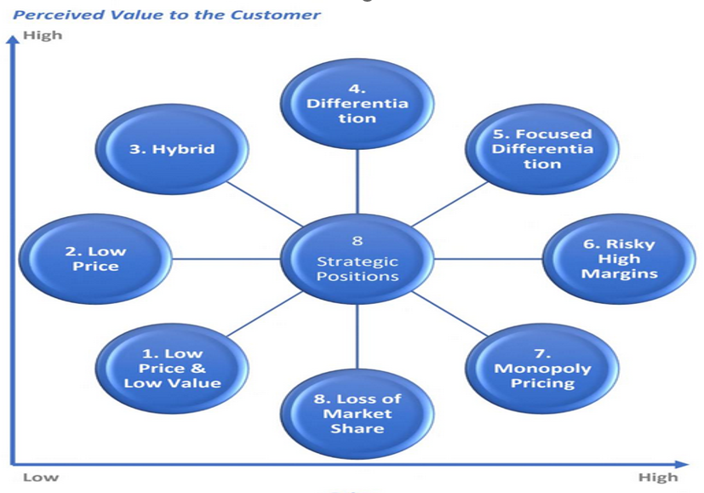
Figure 14: Bowman's Strategy Clock Position
Source: Internet

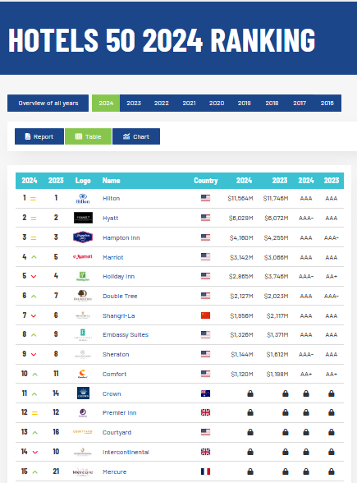
Figure 13: Top Hotel Group Rankings
Source: https://brandirectory.com/rankings/hotels/table

Conclusion
Both Shangri-La and Premier Inn seem to have a lot in common in terms of Total Revenue, Market Position, Growth Potential and Financial Commitment to Corporate Social Responsibility however Shangri-La need to improve their brand image by trying to stay out of bad publicity and Premier Inn needs to improve some of their employee benefits including raising minimum wages to keep staff high retention level.

Recommendation

To boost Revenues both Shangri-La and Premier Inn need to keep customers loyal by keeping up or introducing:

Recommendation | Shangri-La | Premier Inn
Customer Referral programs | Yes – To increase customer loyalty | No – They seem to have good customer base
Customer Care | Yes - To increase customer loyalty | No - To increase customer loyalty
Loyalty Programs | Yes – To increase customer loyalty | Yes- To increase customer loyalty
Gift Cards | Yes – To keep brand awareness | Yes - To keep brand awareness
Reward Cards | Yes - To keep brand awareness | Yes - To keep brand awareness
More Communication | No – They seem to have good communication | Yes – To keep customers engaged
More Marketing Mix | No – Have good marketing strategy that boost Sales | No – Have good marketing strategy that boost Sales

References

Chen, W., 2024. International Hospitality Management. Abingdon: Taylor and Francis.
Dogan Gursoy, F. B. D. B., 2022. Hospitality Marketing Principles and Marketing. London: Taylor & Francis.
Evans, N. G., 2024. Strategic Management for Tourism, Hospitality and Events. Syseney: Taylor & Francis.
Holovnia О., Z. T. L. R. M. S. P. A. S. U. T. O. I. S. G. ?. H. T. Z. R. L. S. M. A. P. U. S. O. T., 2022. Problems and Prospects of Development of Hotels and Restaurent and Tourist Industry in Conditions of Integration Processes. London: Primedia eLaunch LLC.
Kasim, A., 2024. Dooing well By Doing Good: the Evolution of Corporate Social Responsibility in the Hotel Sector. Doing Well by Doing Good: The Evolution of Corporate Social Responsibility in the Hotel Sector (UUM Press). (2024). (n.p.): UUM Press.: UUM Press.
Koc, E., 2020. Cross Cultural Aspects of Tourism And Hospitality. Abingdon : Taylor and Francis.
Menon, A., 2025. Procurement and Supply Chain in Hotel Food & Beverage. Oxford: Educohack Press.
Metin Kozak, N. K., 2016. Tourism and Hospital Management. Leeds: Emerald Group Publishing Limited.
Mochtar, D. M., 2023. 50 Most Powerful Strategy Tools that a CEO should know. London: Heavenly Publishing.
ProQuest Central, 2020. The vertical pandemic: Niches needing help. Accounting Today, Vol.34 (6), pp. p.8-10.
Reeves, M., 2015. Your Strategy needs a Strategy. Massasuchetts: Harvard Business Review.
Roll Martin, 2005. Asian Brand Strategy: How Asia Builds Strong Brands. Switzerland: Palgrave Macmillan.
Terence, T., 2003-12. Island Shangri la's Environmental Managemenet System: A Long way to go. Asian case research journal , 7(2), pp. p.173-194.
Weetman, P., 2019. Financial and Management Accounitng: An Introduction. New York: Pearson.
https://thestrategystory.com/blog/shangri-la-hotels-swot-analysis/
https://cdn.whitbread.co.uk/media/2023/07/Whitbread_ESG_Report_2022.pdf
https://brandirectory.com/rankings/hotels/table
https://www.shangri-la.com/
https://www.shangri-la.com/group/investors/
https://www.macroaxis.com/financial-statements/SHANG.BK

