LEVEL 7 ASSESSMENT SPECIFICATION
Student name: JAIMIN JADAV
Student ID number: 2437156
Programme: MSc Public Health and Social Care in Practice
Module: Health Care System, Organisation and Leadership
Module code: LCHS7002
CASE STUDY ANALYSIS REPORT
Comparative Report on COVID-19 Leadership Responses: Spain, South Korea, and Canada
Total Word Count: 5406

Table of Contents
1. Introduction 4
2. Rich Picture Methodology 7
3. Spain’s Rich Picture 8
4. South Korea’s Rich Picture 12
5. Canada’s Rich Picture 16
6. Key for Rich Picture 20
7. Centralised and Decentralised Systems 24
8. Spain: Centralisation vs. Decentralisation 25
9. South Korea: Centralisation vs. Decentralisation 27
10. Canada: Centralisation vs. Decentralisation 28
11. Leadership Theory Overview 30
12. Leadership in Spain 31
13. Leadership in South Korea 33
14. Leadership in Canada 34
15. Conclusion 36
16. References 38

1. Introduction
The COVID-19 pandemic was the largest health crisis in the world in the 21 st century. It contributed to the death of approximately 14.9 million people more than usual between January 2020 and December 2021 (WHO, 2020). Healthcare systems were also under tremendous strain because of the crisis, and they demonstrated their inability to handle large outbreaks. The ability to establish new services was seen as a weakness, as well as coordination and decision-making by the leaders (Bahreini et al., 2021). Even the wealthy states were touched. Spain recorded an increase of 12.9 per cent more deaths in 2020, Canada 6 per cent, with South Korea recording even fewer than normal deaths (Centre for Evidence-Based Medicine, 2021).
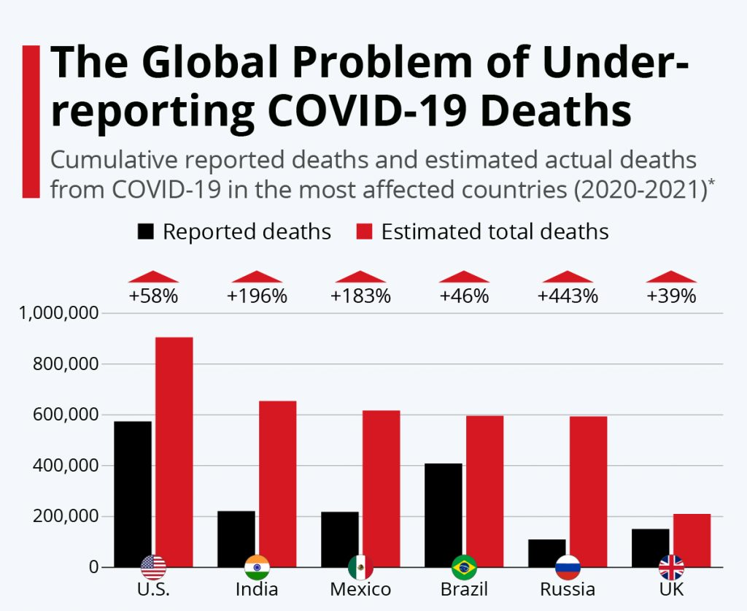
Figure 1: COVID-19 mortality rate
(Source: Bucholz, 2021)
These variations indicate that the structure of the health system of a particular country and the response of its leadership are highly significant. Studies indicate that decentralisation can enhance local flexibility because policies can be implemented more quickly when they are made at a central level (Bakx et al., 2021). A leader’s style also matters. Crisis leadership and adaptive leadership have the potential to make people trust more, enhance compliance, and assist a system to learn during uncertain periods (Sott and Bender, 2025).
This report examines Spain, South Korea and Canada to identify how the organisation of the health systems and actions of the leaders influenced the effects of COVID-19.

2. Rich Picture Methodology
The Rich Picture diagrams have been utilised in this report. They aid us in viewing the COVID -19 response of a country as not a set of policies but a complex system. The technique is of Soft Systems Methodology. The rich Pictures enabled us to draw diagrams of the interaction of people, institutions, information, and pressures (Checkland, 1981). In the case of COVID-19, it is practical since the outcomes were sensitive to numerous relationships between governments, leaders, citizens and health systems' capacity (Legido-Quigley et al., 2020).
Rich Pictures are not just straight-line models. They assist in the detection of issues, including slow testing, ICU overload or disconnected communications that led to varying death rates (Bakx et al., 2021). The diagrams allow us to compare the change in resilience by centralisation and the style of leadership by including data such as excess deaths and strain in the system as the leaders took action. This introduces cause-and-effect comprehensiveness and takes the story beyond a mere description.

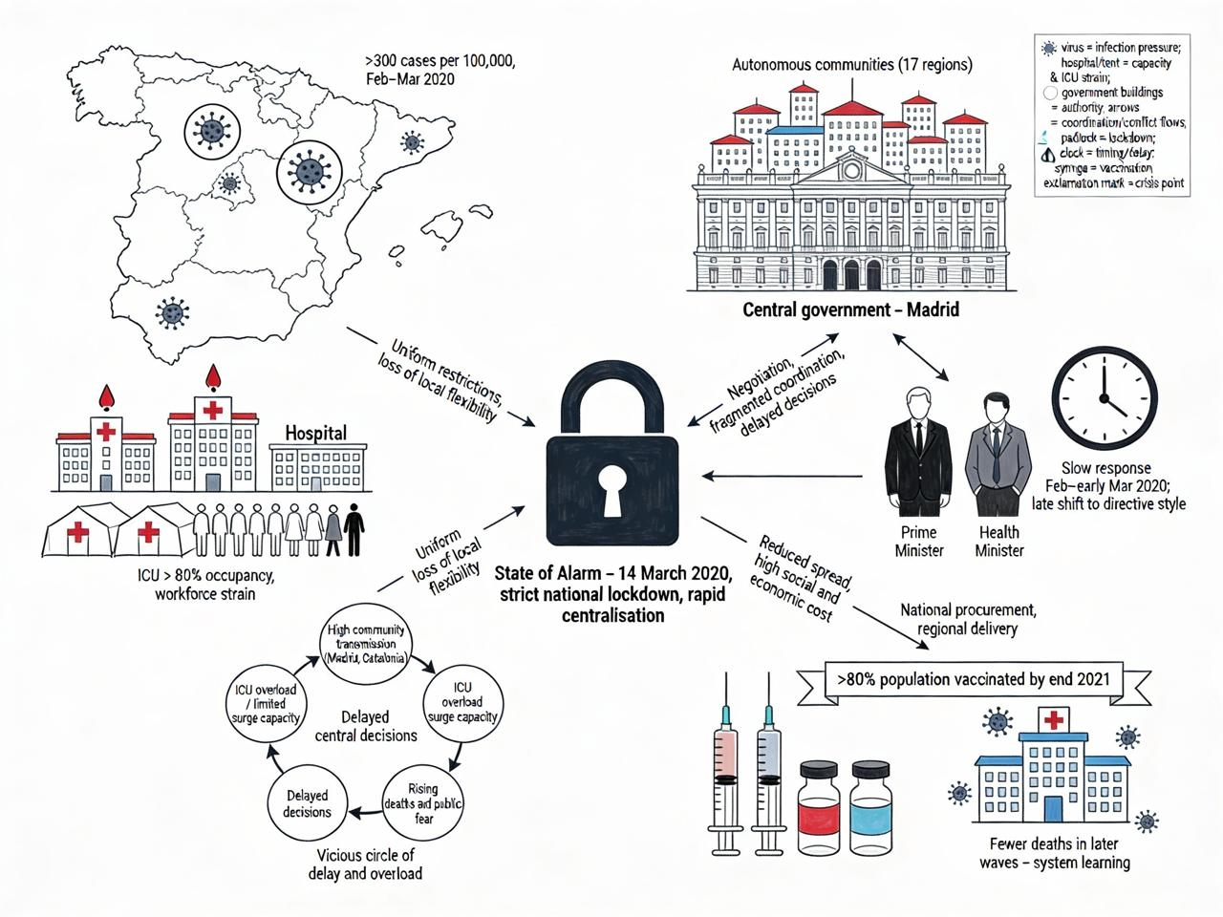
3. Spain’s Rich Picture
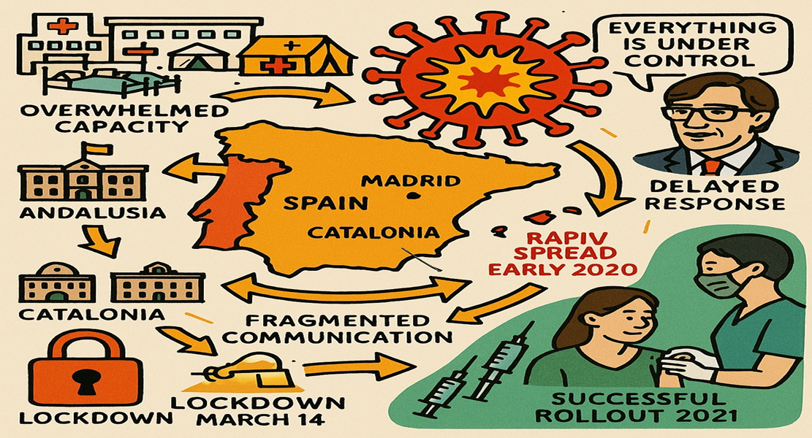
Figure 2: Rich Picture

Figure 3: Spain rich picture
(Source: Author)
The diagram of Spain displays the impact of the early pandemic on the country through decentralised governance and slowness of signals sent by leaders and the capacity of health systems. It is devoted to Madrid and Catalonia in February-March 2020. During those weeks, the number of new cases exceeded 300 per 100,000, making hospitals and emergency rooms overcrowded (Garcia-Basteiro et al., 2020). At the end of March, ICU beds in many areas were more than 80 per cent occupied, and it was indicative of the system losing surge capacity after years of staff and bed reductions (Haldane et al., 2021).
The diagram depicts how governments engage in a battle over power. There was a sense of responsibility among the local communities and the central authority, but they acted slowly. This was pre-empted by the State of Alarm on 14 March 2020. The consultation and then a transition to direct control led by leaders, which characterises crisis leadership theories, was first (Legido-Quigley et al., 2020). The diagram has a padlock symbol indicating the quick centralisation, which reduced the spread at a high social and economic price.
During the recovery stage, learning is depicted in the diagram. The national purchasing and regional distribution allowed Spain to vaccinate over 80% of the population by the end of 2021 and reduced subsequent deaths (Wagner et al., 2022). The Rich Picture demonstrates that the timing of the leaders, along with the system limits and rate of infections, is a vicious circle instead of the fault of one policy.
Table 1: Analytical Insights from Spain’s Rich Picture
(Source: Author)
Rich Picture Element | System Issue Identified | Leadership / Outcome Insight
Early surge icons (Madrid, Catalonia) | High transmission, delayed containment | Underestimation of risk weakened early situational leadership (Garcia-Basteiro et al., 2020)
Overcrowded hospitals & tents | ICU saturation, workforce strain | Limited surge capacity amplified mortality (Haldane et al., 2021)
Regional–central arrows | Fragmented coordination | Decentralisation delayed unified response (Legido-Quigley et al., 2020)
Clock & leadership figures | Slow decision-making | Late shift to directive leadership increased initial impact
Padlock (State of Alarm) | Rapid transmission control | Centralisation enabled decisive action
Vaccine symbols | System learning and recovery | Adaptive governance improved later outcomes (Wagner et al., 2022)

4. South Korea’s Rich Picture
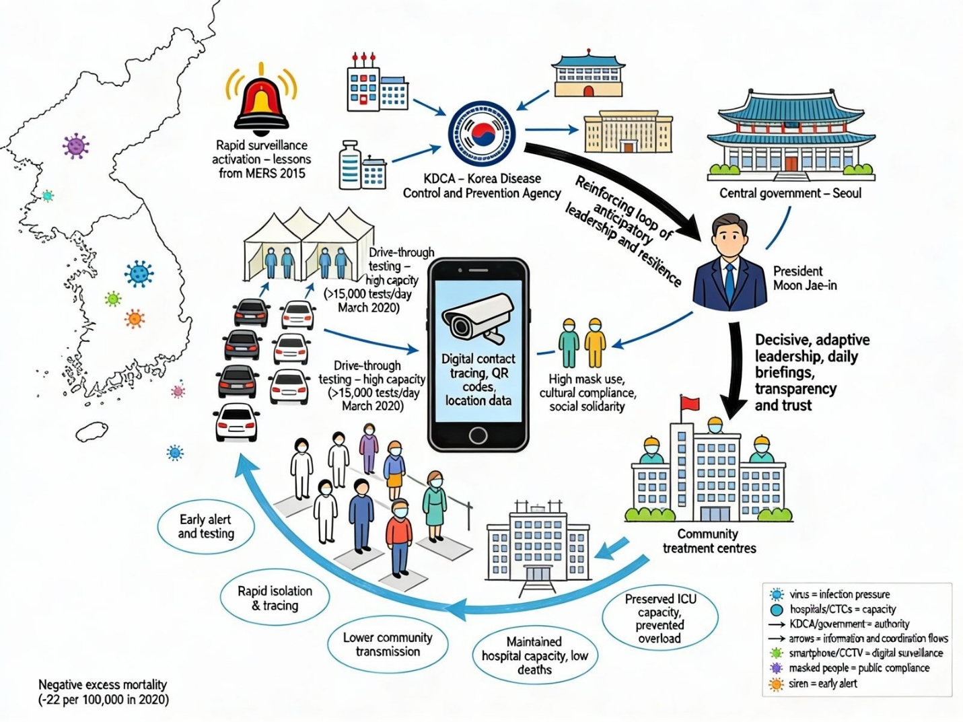
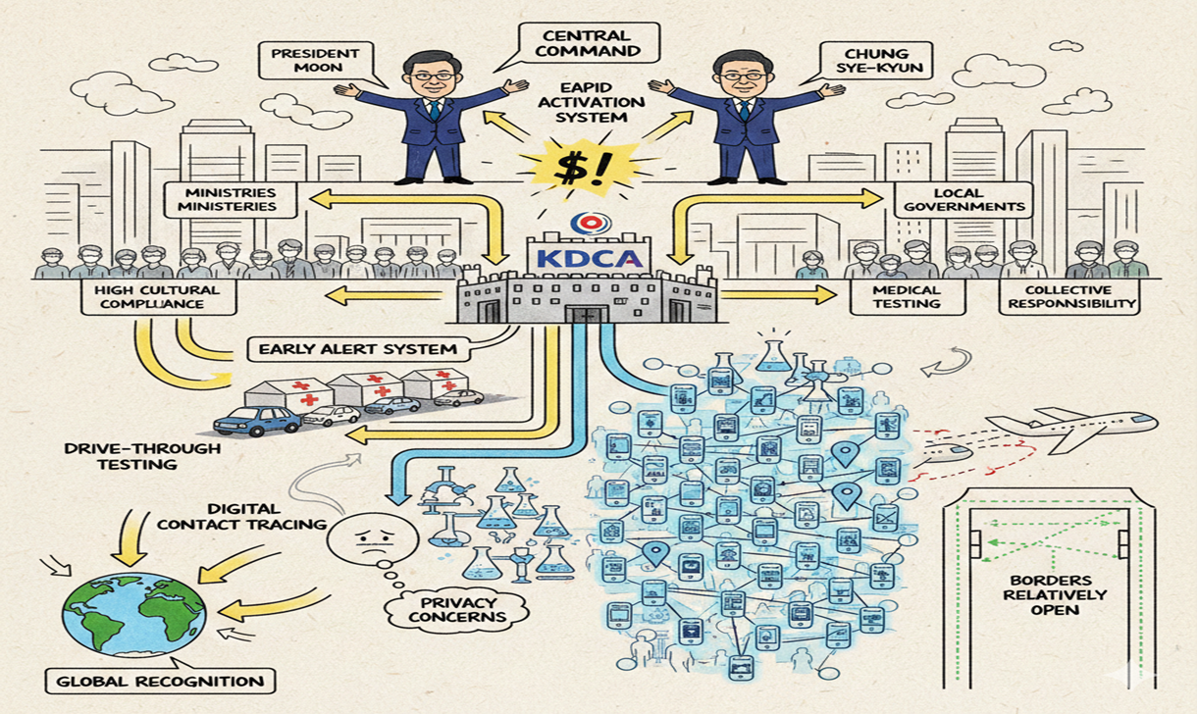
Figure 4: South Korea rich picture
(Source: Author)
The diagram of South Korea reports a very well-organised, technology-intensive reaction which was headed by a powerful central government and adaptable leaders. It starts with the swift alert system following the first case in January 2020, with the lessons of the 2015 outbreak of MERS (Oh et al., 2020). South Korea did not impose a lockdown, unlike Spain. Rather, it relied on mass testing and contact tracing with the aid of a computer. In March 2020, early detection of cases by the high amount of testing (more than 15,000 a day) was reached (You, 2020).
In the diagram, the Korea Disease Control and Prevention Agency (KDCA) is the centre point. President Moon Jae-in's leaders were highly decisive, with adaptive and transformational styles, which focus on learning, transparency and trust (Wang et al., 2020). The community centres also provided hospitals with mild cases, thus not overloading them with severe patients (Witter et al., 2023).
In 2020, South Korea was among the states with the lowest death rate and even negative excess mortality (-22 per 100,000) (Centre for Evidence-Based Medicine, 2021). The diagram then demonstrates that central coordination, digital tools and cultural trust formed a feedback mechanism that transformed leader decisions to greater system strength.
Table 2: Analytical Insights from South Korea’s Rich Picture
(Source: Author)
Rich Picture Element | System Feature | Leadership / Outcome Insight
Early alert symbol | Rapid surveillance activation | Learning from MERS enabled anticipatory leadership (Oh et al., 2020)
Drive-through testing | High testing capacity | Early detection reduced community spread (You, 2020)
Mobile phone & CCTV icons | Digital contact tracing | Central authority enabled decisive, directive action
Masked population figures | Cultural compliance | Trust-based leadership improved adherence (Wang et al., 2020)
KDCA central hub | Institutional clarity | Reduced coordination failures
Community treatment centres | Preserved ICU capacity | Prevented system overload (Witter et al., 2023)

5. Canada’s Rich Picture
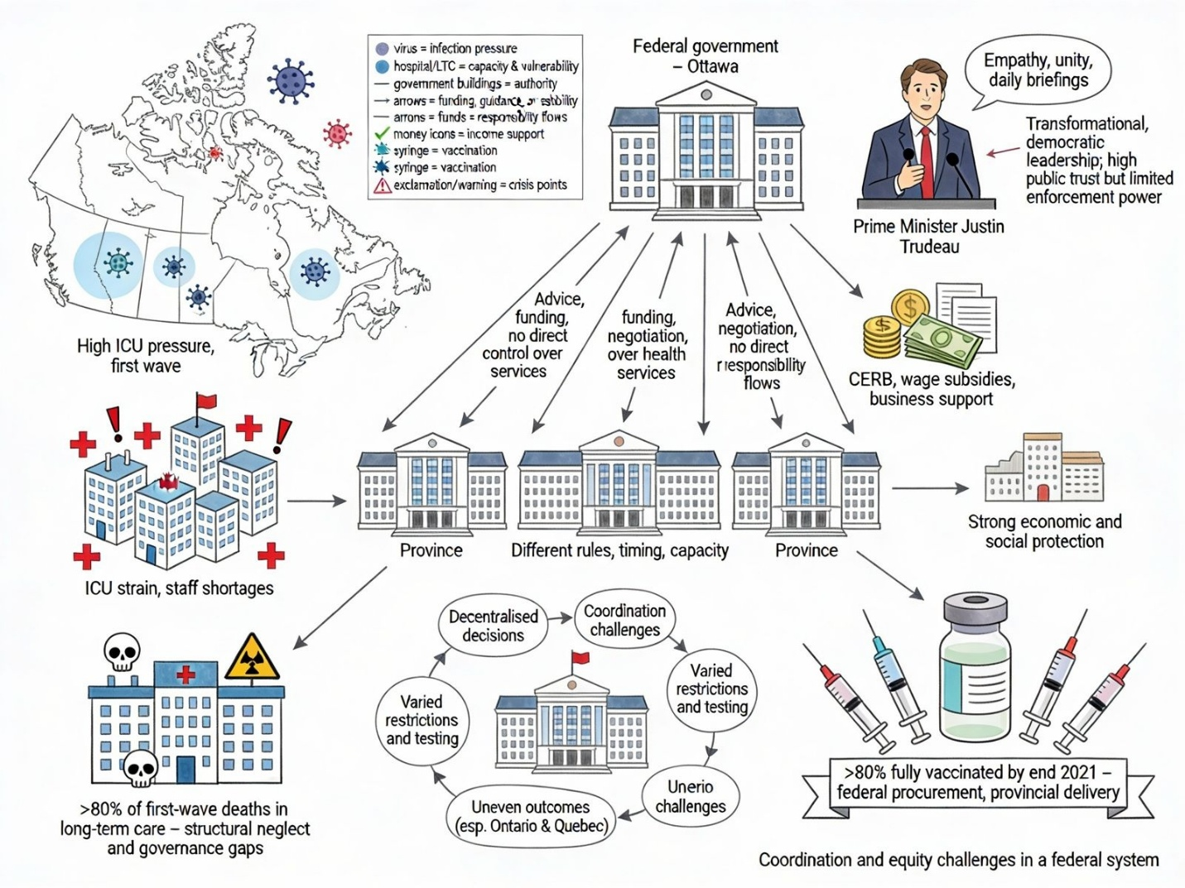
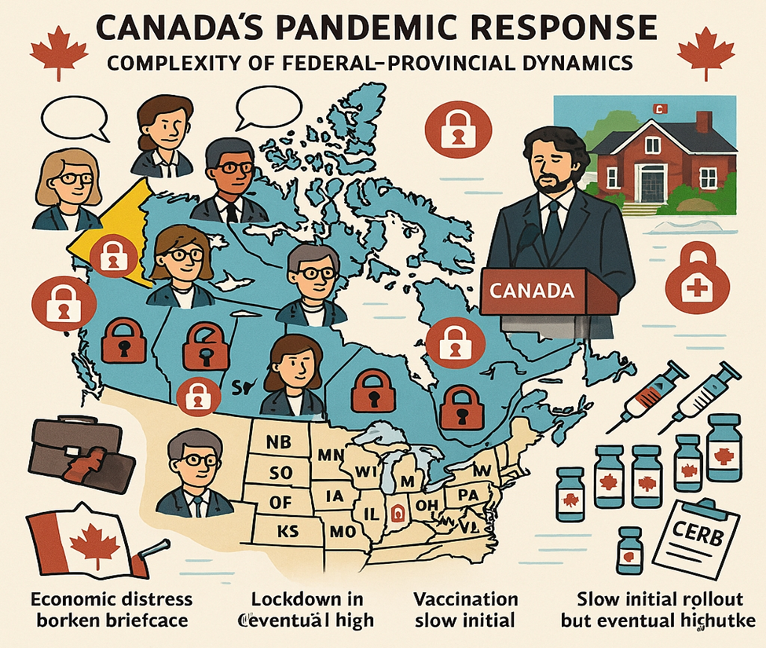
Figure 5: Canada rich picture
(Source: Author)
Rich Picture, Canada demonstrates a complex system of pandemic responses, which was determined by a divided federal-provincial system, an orientation on agreement and leadership that attempts to unify people, and disparities between health system capacity. The province map indicates that the responsible provinces primarily determine health authority, and as a result, lockdowns were conducted at different times in different areas, access to testing varied, and the level of pressure in the ICU varied (Marchildon et al., 2021). Canada in 2020 had approximately 42 additional deaths per 100,000, lower than Spain, but far greater than South Korea, and indicated an intermediate degree of system resilience (Centre for Evidence-Based Medicine, 2021).
Hospitals that are clustering around Ontario and Quebec represent the pressure in the ICU during the waves, particularly in long-term homes, where more than 80 per cent of the COVID-19 deaths in the first wave were observed, which uncovers the issue of long-term lack of investment and governance issues (Hale et al., 2021).
The visuals of leaders in the form of the daily briefings of Prime Minister Justin Trudeau suggest a predominantly transformational and empathetic communication pattern that created the trust of people but relied on the work of the provinces to implement the policies (Detsky and Bogoch, 2020).
The vaccination symbols represent a dynamically adjusting recovery: despite the initial buying lag, the joint efforts of federal buying and provincial distribution have seen more than 80 per cent of Canadians fully vaccinated by the end of 2021, which reduced the number of deaths in subsequent waves (Wagner et al., 2022).
In general, the Rich Picture demonstrates that the decentralised power led to coordination crunches, and social solidarity, as well as a flexible workforce, served to counteract structural constraints.
Table 3: Analytical Insights from Canada’s Rich Picture
(Source: Author)
Rich Picture Element | System Feature | Leadership / Outcome Insight
Provincial map | Decentralised public health authority | Fragmented responses increased regional variation (Marchildon et al., 2021)
ICU icons (Ontario, Quebec) | Capacity strain | Uneven surge capacity worsened outcomes
Long-term care symbols | Structural neglect | Governance failures amplified mortality (Hale et al., 2021)
Federal briefings | Transformational leadership | High trust, limited enforcement power (Detsky and Bogoch, 2020)
Economic icons (CERB) | Social protection measures | Mitigated socioeconomic harm
Vaccine rollout icons | Adaptive coordination | Late but effective recovery phase (Wagner et al., 2022)

6. Key for Rich Picture
All Rich Picture diagrams have a consistent visual key that makes the analysis easy to understand and compare Spain, South Korea and Canada. Rich Pictures are non-linear systems symbolically captured, and, therefore, it is noteworthy to explain the symbols to prevent the use of symbols instead of misinterpreting them, as well as to facilitate systems thinking. Virus icons refer to the points of infection spread and epidemiological pressure. Institutions like hospitals, governmental bodies, and other bodies like public health bodies are buildings, and their interactions influence the capacity to respond. The information, coordination or conflict flows represented by arrows allow us to view governance relationships and the effectiveness of leaders. The use of exclamation marks highlights situations of crisis or critical decisions when the leadership altered the direction of the system. People icons refer to the prominent stakeholders such as political leaders, health workers, and the population. Padlocks imply lockdown policies. Planes demonstrate the border control and travel policies. Syringes are associated with the vaccination programmes and recovery phases. Smartphones imply digital surveillance, tools of communication or contact tracing. This common key allows us to compare the decision paths, the bottlenecks and feedback loops in all of these locations.
Overview of Pandemic Responses: Spain, South Korea, and Canada (Timeline Comparison)
The Spanish, South Korean and Canadian governments adopted varying paths of responding to the pandemic, which is related to their governance systems, institutional capacity and attitudes towards crisis management. The reaction in Spain was extremely centralised, particularly during the initial wave, when the national government employed the emergency powers to impose one of the strictest nationwide lockdowns in Europe (Legido-Quigley et al., 2020). This not only enabled rapid and standardised rules on movement and economy but also restricted regional manoeuvrability and created strains with the independent communities. The initial waves in Spain were very high in death tolls, but subsequent waves experienced learning through the introduction of phased reopening and a highly effective vaccination campaign (Garcia-Basteiro et al., 2020).
On the contrary, South Korea adopted a focused containment approach without lockdowns at the countrywide level. Since the beginning, the government relied on mass testing, digital contact tracing and rapid isolation, with good central coordination and sophisticated surveillance infrastructure (Oh et al., 2020). This helped to reduce the economic disruption and ensure low early mortality by making South Korea one of the best early responders globally (You, 2020). However, subsequent Omicron waves demonstrated the failure of containment as the transmission became widespread even in well-planned systems.

The reaction of Canada was influenced by a federal and decentralised health service, where the provinces provided services primarily with respect to the public health services. This formed large regional disparities in lockdown intensity, educational institution shutdowns and pressure on health care, particularly in Ontario and Quebec (Detsky and Bogoch, 2020). The federal leadership paid much attention to the economic assistance, and it introduced income-support programs, including CERB and wage subsidies, which alleviate the social and economic burden even in the case of prolonged restrictions (GOC, 2025). Although Canada had moderate results in comparison with European counterparts, it was more difficult to coordinate and deliver public messages across waves due to decentralisation.
On the whole, the comparison indicates that there is no single model of governance that is a sure way of success. Quick action in Spain also proved difficult without centralisation, and was also unsuccessful in preventing harsh initial results; the South Korean-focused, tech-oriented strategy was highly effective in the early years. Canada demonstrates that well-established economic backing can neutralise the disruption of the public health system, and decentralisation may result in unequal results without well-grounded intergovernmental coordination (Haldane et al., 2021).
Table 4: Pandemic Response Comparison
(Source: Author)
Dimension | Spain | South Korea | Canada
Governance Approach | Highly centralised under State of Alarm | Central coordination with targeted local execution | Decentralised, province-led
Lockdown Strategy | Strict nationwide lockdowns; phased reopening | No national lockdown; targeted restrictions | Regional lockdowns and stay-at-home orders
Public Health Measures | Mask mandates; PCR testing; regional perimeter lockdowns | Mass testing; digital contact tracing; mandatory masks | Testing, masking, travel quarantine; school closures
Economic & Social Support | Strong (ERTE furloughs, SME aid) | Moderate, targeted support | Very strong (CERB, CEWS, business loans)
Vaccination Rollout | Very high uptake | High uptake | High uptake
Overall Impact | Severe early waves; improved later outcomes | Low early impact; later Omicron surges | Moderate overall; varied by province

7. Centralised and Decentralised Systems
A centralised healthcare system has all the powers of decision-making within the national government. This will enable the nation to establish uniform regulations and distribute funds in a consistent manner across the board (Raudia et al., 2015). In a decentralised system, regional or local authorities govern the way services are operated, the way money is spent, and other decisions related to daily operations (Sapkota et al., 2023).
A centralised system would help form a unified message and a centralised pull during a crisis, as there is a necessity to coordinate all resources and send one message during a crisis. This is a speed that is helpful when there is an urgency in the decisions that need to be made (Moorkamp et al., 2020). Yet, an extremely centralised system could struggle to adapt regulations to various local requirements and will therefore delay responses in areas where the regions are very different (Gaskell and Stoker, 2020).
Decentralised systems will enable local leaders to make swift moves and develop solutions that suit their location (Haldane et al., 2021). However, decentralisation may also divide control, result in poor coordination, uneven allocation of money and spotty application of national plans in times of crises such as COVID-19 (Akinyemi et al., 2021).
The awareness of the degree of centralisation of a health system assists in establishing its preparedness for a crisis. How a system is structured determines the leader, the flow of information and its equilibrium between the national control and local flexibility (Witter et al., 2023).

8. Spain: Centralisation vs. Decentralisation
Spain is reputed to have one of the most decentralised systems of health in Europe. With the termination of the Franco rule, the health duties became the responsibility of the 17 autonomous communities (Gaskell and Stoker, 2020). This also puts regions in control of budget, staff and service delivery, which would make the system more localised. However, the COVID-19 pandemic revealed that this decentralised arrangement during an abrupt crisis was weak.
In systems thinking, the numerous layers of government in Spain made coordination necessary, where quick and concerted decisions had to be made (Rusoja et al., 2018). Initially, the response to the pandemic differed significantly across different regions, leading to unequal containment efforts, testing capacity and timely action in COVID-affected regions such as Madrid and Catalonia. The early high spread and deaths were also caused by these differences, particularly during the first wave (Legido-Quigley et al., 2020).

The transition to centralisation of powers in the State of Alarm in the short term was a turning point. The ability to impose identical lockdown policies, national-level procurement of medical supplies and a single public message helped in part to overcome fragmentation of the past, since central control was implemented (Garcia-Basteiro et al., 2020). Although this enhanced coherence, it also revealed that such coordination groups as the Interterritorial Council of the National Health System were not prepared to perform efficiently in situations of extreme pressure.
In general, the experience of Spain indicates that decentralisation can enhance the performance of everyday flexibility but negatively affects crisis performance, unless it is well coordinated in advance. The pandemic taught that an effective system should switch rapidly between local agility and national control in the case of an increase in risk (Moorkamp et al., 2020).
The COVID-19 response in Spain showed that tensions of decentralisation and centralisation of the health system of Spain, and the necessity of a centralised crisis response, existed. The primary responsibilities of health fall on the 17 communities, which have the freedom to do certain things locally but lead to disjointed monitoring, fluctuating restrictions and slow obstacles in the first wave (Legido-Quigley et al., 2020). This absence of a unified command impaired coordination of early testing, planning of ICU surges and acquisition of protective equipment.
This was partially replaced with a national state of alarm, which made authority more centralised, allowing lockdowns to be more pronounced and resource sharing easier. It did, however, occur once hospitals, particularly in Madrid and Catalonia, were already overstretched, and this is an example of the price of tardiness in centralisation. The example of Spain demonstrates that decentralised systems require in-built step-up mechanisms that will enable swift change of control in the case of health emergencies and at the same time preserve local autonomy. The successful work of crisis governance in such systems does not require permanent centralisation but rather is about the willingness to centralise when there are high rates of case numbers (Garcia-Basteiro et al., 2020).

9. South Korea: Centralisation vs. Decentralisation
The COVID -19 response of South Korea demonstrates the advantages of the highly centralised, whole of government response that is also learning and legally prepared. The central body is the Ministry of Health and Welfare, which allows the country to make timely decisions, establish equal rules and redistribute resources across the country in case an emergency arises (Moorkamp et al., 2020). Following the 2015 outbreak of MERS, legislation was modified to be more robust in the areas of surveillance, testing and isolation, which established a legal framework of crises.
Centralisation also aided South Korea to begin mass testing, digital contact tracing and forced isolation early enough to prevent the spread of the virus without lockdowns at the national level (Oh et al., 2020). In a systems perspective, South Korea had good connections among health care, technology, transport and communication, reducing feedback delays and responding to changes in real time (Khalil and Lakhani, 2022). The integration resulted in a low mortality rate at an early age and made the health system durable at the time of initial waves.
But it was not just structure but operation; centralisation. Open communication and regular national messages established the trust and adherence of the population, reinforcing the effects of the policy (You, 2020). This demonstrates that the centralised systems have the capacity to transform administrative authority into practical health achievements.
Subsequent waves of Omicron demonstrated that despite powerful centralisation, the boundaries are reached in cases of widespread community transmission. South Korea experienced case booms, yet previous investments decreased the fatality and the breakdown of the system, demonstrating resilience instead of complete control (Littlecott et al., 2023).
Overall, South Korea is going to show that centralisation is the most successful when it belongs to a learning system, which has legal power, technological infrastructure and citizen confidence. It demonstrates that centralisation has been the most successful when it allows swift feedback, coordinated action and adaptive change rather than strict and firm top-down control (Witter et al., 2023).

10. Canada: Centralisation vs. Decentralisation
The federal health system in Canada is a combination of local control and central funding and rules. It is to provide equity in the country, but to allow adaptation of provinces. The COVID -19 crisis revealed the issue with this arrangement (Yngson, 2020). The choice of public-health regulations was made at the provincial level and, hence, the opening of the lockdowns, testing, and hospital strain varied significantly.
Due to the division of control, it was not easy to mould one common way soon. This led to the unbalanced regulation of the virus and misleading communications to the population (Gaskell and Stoker, 2020). Ontario and Quebec were particularly badly hit, particularly in the nursing homes. Staff shortage and fragmentation increased the risk of death (Detsky and Bogoch, 2020. Decentralised control risks having the governments replicate policies and take time when a crisis strikes in a short period.
Money spending was also aided by the federal government. Other initiatives, like CERB and wage subsidies, averted much of the social and economic harm. This demonstrates that a decentralised health system can be based on a central budget (GOC, 2025). Many people were also vaccinated in Canada since the federal government purchased supplies and organised them, even though the shots were delivered by the provinces (Ribeiro et al., 2018).
Putting the entire system into perspective, the primary problem was that the regulations regarding who speaks to whom were not stringent. Excessive redundancy caused the system to be difficult to administer and led to delayed reaction (Witter et al., 2023).
In general, in Canada, it can be demonstrated that decentralisation provides democrats with greater input and innovative ideas, but can be detrimental during times when a crisis requires coordination. Good pandemic control has more to do with good integrative institutions rather than the centralisation of the system.
Since the provinces dominate the delivery of health, the federal government cannot compel the provinces to act similarly. This allows provinces to customise reactions but results in arbitrary testing, various restrictions, and low nursing-home protection (Marchildon et al., 2021). Advice, money, and negotiating were the primary actions of the federal government, and not direct orders.
Maintaining independence expedited local response but impeded national action, particularly at the onset of testing and vaccines. The absence of federal regulations on nursing homes also increased the number of deaths. Decentralisation can establish trust, although the federal government needs more powerful instruments during an emergency. The crisis resilience requires distinct roles, data sharing, and the capacity to utilise central power in the event that there is a call to act swiftly and decisively (Detsky and Bogoch, 2020).

11. Leadership Theory Overview
The issue of leadership is important, as it determines the speed and performance of the country during a crisis. During a crisis, time is squandered immeasurably, and leaders should strike a balance between openness and decisiveness.
According to classical leadership conceptions, there is no best style of leadership. The effectiveness of a leader is based on circumstances and limitations (Haldane et al., 2021). The autocratic leaders are quick decision makers who take control of the process and can prevent the spread early, yet when they remain longer, they may lose the trust of the people (Modise, 2024).
Democratic leaders seek contributions and share decisions, both of which develop trust but may slacken urgent action (Kayode et al., 2014). Transformational leaders are vision-oriented and empathetic to support long-term resilience, but typically require other robust measures in the face of a tight crisis (Miller, 2009).
According to situational leadership, a leader must alternate between strict and collaborative styles, depending on the severity of the crisis, the strength of the institutions and the compliance of the public (Giergia, 2025). The concept assists in bridging the gap between leadership decisions and actual policies and the outcomes of the virus.

12. Leadership in Spain
In the beginning, the main person in charge of managing the pandemic in Spain was Prime Minister Pedro Sanchez and Health Minister Salvatore Illa. A very decentralised system was operated in a democratic, talk-and-decide style. Initial decisions were arrived at following consultations with local governments and strategic agencies. That democratic procedure was valid yet caused it to be slow to react in February-March 2020 (Legido-Quigley et al., 2020). The lagging measures occurred concurrently with the rapid transmission of the virus, and Spain experienced one of the highest rates of early deaths during the initial wave in Europe.
From a leadership perspective, the Spanish style is ideal for democratic characteristics, whereby reaching an agreement makes people obey instructions. However, the statistics indicate that waiting excessive time to lock and continue the large-scale celebrations accelerated the pandemic and overwhelmed hospitals in Madrid and Catalonia (Garcia-Basteiro et al., 2020). This indicates that the leadership mode (democratic talk) was not appropriate to the crisis stage, in which theory proposes that it ought to have been boss-like and more to the point.
The leadership became boss-like later when Spain declared a State of Alarm. It helped the country to organise entry and exit restrictions, purchase products, and deliver precise health communication. This increased the consistency of policies and calmed the situation in subsequent waves, particularly when vaccines were introduced, and a large number of the population was vaccinated (WHO, 2023). As the experience of Spain demonstrates, democratic leadership might contribute to the development of long-term trust, though it will have to transform within a short period of time in situations where the threat is rapidly increasing.
The initial style of the pandemic in Spain under Sanchez was democratic and consultative, which included scientists and regional heads. It was understandable and valid, but it slowed the speed at which hard decisions, such as early lockdowns and hospital preparedness, were made. The government then granted itself the emergency powers later, and it became more directive when the hospitals were under pressure (Legido-Quigley et al., 2020). This demonstrates that democratic practices can result in trust building, but they may be slow when situations evolve rapidly. Respondents would be quicker to react with the help of an adaptive style that would switch between talking and commanding in response to the situation shifts (Francisco and Nuqui, 2020).

13. Leadership in South Korea
A good leadership model of strong leadership demonstrated by South Korea under President Moon Jae-in also retains the trust of the people. In the beginning, the decisions were made centrally with the help of new laws that allowed the government to require testing, digital contact tracing, and isolate people (You, 2020). This is equivalent to boss-type leadership in which urgent action and order are important when one does not know what is going on.
Notably, the strict quarantine was accompanied by open communication and briefings daily to ensure that the population's trust is maintained and dissent is minimised. The consequence was a few and good initial control of the virus without nationwide lockdowns despite high levels of testing (Oh et al., 2020). In terms of the entire system, the leadership was effective as the data network soon enabled the officials to monitor the situation and take action.
However, the system in South Korea was ethically flawed. Massive surveillance on the Internet caused concern about privacy, which demonstrated the primary disadvantage of extensive state control (Deep et al., 2022). Nonetheless, the style of Moon is situational and transactional leadership theories, which emphasise regulation and responsibility in case the crisis is acute. The example of South Korea demonstrates that good leadership can be effective when the law is on its side, technology is in place, and the society is embracing it.
President Moon of South Korea had a commanding rule-based approach, implementing rules swiftly and listening to professionals (Oh et al., 2020). Rules and the fact that people followed them were because of his daily briefings and central coordination by the KDCA that ensured that work proceeded without a problem, resulting in low levels of deaths and high levels of tests. His messages were also clear, which created trust and responsibility among people. Nevertheless, the intrusive digital tracing was problematic in terms of privacy. The example demonstrates that effective crisis leadership may combine strong command with the participation of people, take immediate action and retain trust (You, 2022).

14. Leadership in Canada
The leadership of Canada, led by Prime Minister Justin Trudeau, was largely transformational and democratic in nature, caring, open, and sharing responsibility. The reassurance and message of unity presented by Trudeau in his daily talks were fitting for the transformational theory, which fosters motivation and trust (Kwan, 2020). It assisted in keeping people under the rules and getting vaccinated.
The federal system in Canada ensured that it was difficult to be effective. Most of the health regulations are governed by the provinces, and therefore, the federal government cannot impose the same on all. Thus, the leader convinced people primarily without any commands, which decreased the process of matching testing, care with long-term residents, and early action (Marchildon et al., 2021). This resulted in varied outcomes in different provinces with high numbers of deaths in nursing homes (Detsky and Bogoch, 2020).
Transformational leadership assisted in raising money within a short period of time. The central fiscal power is high as the government swiftly implemented income assistance and purchased vaccines (GOC, 2025).
However, according to the situational theory, transformational style requires additional strict regulation at the beginning. The case of Canada reveals that the role of good leaders is based on the quality of the rules that they are allowed to apply: not good talking indeed when the system is divided into parts.
The performance of leaders in all three countries was not only based on their style but also on the compatibility with the government system and the crisis stage. The leadership style that worked well in South Korea at the beginning was strong; Spain took too long to transition to firmer control at the expense of money and lives, and Canada was the caring style that secured the trust but could not coordinate. The lesson: pandemic leaders must shift between styles where necessary, not merely remain committed to a single concept.
In his approach, Prime Minister Justin Trudeau applied a caring, relationship-centred style, laying emphasis on empathy, motivation, and collaboration among provinces (Detsky and Bogoch, 2020). Being open and fostering solidarity, he gained trust and made people adhere to health regulations. However, due to the division of powers between the federal and provincial authorities in the country, it was difficult to work as a nation, which slowed down testing, vaccines, and care among long-term residents. It indicates that although caring style can maintain people interested, additional firm or flexible measures in case of a crisis might be required to make a decision fast. The introduction of flexible and participatory methods would enhance trust and system effectiveness (Yucel, 2021).

15. Conclusion
This paper demonstrates that the nature of organisation of the health systems and actions of leaders played a leading role in the occurrence of COVID-19 in Spain, South Korea, and Canada. The highly centralised health system of South Korea allowed the country to make prompt decisions, coordinate on a national level, and conduct testing and tracing regularly. This made it low on deaths and the system robust. Canada and Spain, in contrast, had more diffused (decentralised) systems which provided them with flexibility, although this again demonstrated poor coordination in the initial wave, particularly during the first. Delays and divided reactions caused pressure on the systems. These structural differences were further enhanced by the manner in which leaders behaved. Moon Jae-in in South Korea was strict, but it was based on trust. His leadership was appropriate for strong institutions of the country and indicated that strong and clear action could work when it is transparent and competent. In Spain, Prime Minister Sanchez began with a consultative approach, which emphasised democratic input. He could not move to decisive and top-down control, quickly revealing that consensus leadership is slow when an emergency strikes. Prime Minister Trudeau employed a transformational and caring style that helped him maintain the trust of the people in Canada. Nevertheless, due to the fact that provinces operated independently, policies were slow and did not necessarily correspond to each other. On the whole, the analysis demonstrates that there is no universal style of leadership which can be effective in all situations. Good pandemic management requires a leader who can switch between stern and democratic as necessary and supports that with excellent coordination, effective communication, and prepared institutions. COVID-19 has demonstrated that global health issues can only be dealt with through strong health systems and leaders who are responsive to the situation.

16. References

Akinyemi, O.O., Popoola, O.A., Fowotade, A., Adekanmbi, O., Cadmus, E.O. and Adebayo, A., 2021. Qualitative exploration of health system response to COVID-19 pandemic applying the WHO health systems framework: Case study of a Nigerian state. Scientific African, 13, p.e00945. https://www.sciencedirect.com/science/article/pii/S2468227621002490

Bahreini, R., Gholizadeh, M., Gedik, F.G., Yousefi, M. and Janati, A., 2021. Components of contributing conditions to strengthen health system management and leadership capacity building: a systematic review and decision making framework. Leadership in Health Services, 34(4), pp.527-545. https://www.emerald.com/insight/content/doi/10.1108/lhs-01-2021-0006/full/html

Bakx, P., Douven, R. and Schut, F.T., 2021. Does independent needs assessment limit use of publicly financed long-term care?. Health Policy, 125(1), pp.41-46. https://www.sciencedirect.com/science/article/pii/S0168851020302384

Bucholz.K., (2021). Chart: The Global Problem of Underreporting COVID-19 Deaths. Available at: https://science.thewire.in/external-affairs/world/chart-the-global-problem-of-underreporting-covid-19-deaths/. [Accessed on: 03.02.2026].

Centre for Evidence-Based Medicine (2021). Excess Mortality across Countries in 2020. Available at: https://www.cebm.net/covid-19/excess-mortality-across-countries-in-2020/. [Accessed on: 03.02.2026].

Checkland, P., 1981. Systems thinking, systems practice. http://www.mtas.ru/search/search_results.php?publication_id=20003

Deep, S., Zheng, X., Jolfaei, A., Yu, D., Ostovari, P. and Kashif Bashir, A., 2022. A survey of security and privacy issues in the Internet of Things from the layered context. Transactions on Emerging Telecommunications Technologies, 33(6), p.e3935. https://onlinelibrary.wiley.com/doi/abs/10.1002/ett.3935

Detsky, A.S. and Bogoch, I.I., 2020. COVID-19 in Canada: experience and response. Jama, 324(8), pp.743-744. https://jamanetwork.com/journals/jama/article-abstract/2769439

Francisco, C.D. and Nuqui, A.V., 2020. Emergence of a Situational Leadership during COVID-19 Pandemic Called New Normal Leadership. Online Submission, 4(10), pp.15-19. https://eric.ed.gov/?id=ED608560

García-Basteiro, A., Alvarez-Dardet, C., Arenas, A., Bengoa, R., Borrell, C., Del Val, M., Franco, M., Gea-Sánchez, M., Otero, J.J.G., Valcárcel, B.G.L. and Hernández, I., 2020. The need for an independent evaluation of the COVID-19 response in Spain. The Lancet, 396(10250), pp.529-530. https://www.thelancet.com/journals/lancet/article/PIIS0140-6736(20)31713-X/fulltext?prm=ep-app

Gaskell, J. and Stoker, G., 2020. Centralized or decentralized: Which governance systems are having a “Good” pandemic?. Democratic Theory, 7(2), pp.33-40. https://www.berghahnjournals.com/view/journals/democratic-theory/7/2/dt070205.xml

Giergia, D., 2025. BEYOND PRESCRIPTIONS: REVISITING SITUATIONAL LEADERSHIP THEORY THROUGH BIBLIOMETRIC ANALYSIS AND CROSS-CULTURAL INSIGHTS. Economic and Social Development: Book of Proceedings, pp.223-233. https://www.esd-conference.com/upload/publications/3/Book_of_Proceedings_esdZagreb_2024_BRS.pdf#page=230

GOC, (2025). COVID-19: Canada’s response. Available at: https://www.canada.ca/en/public-health/services/diseases/2019-novel-coronavirus-infection/canadas-reponse.html. [Accessed on: 02.11.2025].

Haldane, V., De Foo, C., Abdalla, S.M., Jung, A.S., Tan, M., Wu, S., Chua, A., Verma, M., Shrestha, P., Singh, S. and Perez, T., 2021. Health systems resilience in managing the COVID-19 pandemic: lessons from 28 countries. Nature medicine, 27(6), pp.964-980. https://www.nature.com/articles/s41591-021-01381-y

Hale, T., Angrist, N., Hale, A.J., Kira, B., Majumdar, S., Petherick, A., Phillips, T., Sridhar, D., Thompson, R.N., Webster, S. and Zhang, Y., 2021. Government responses and COVID-19 deaths: Global evidence across multiple pandemic waves. PloS one, 16(7), p.e0253116. https://journals.plos.org/plosone/article?id=10.1371/journal.pone.0253116

Kayode, B.K., Mojeed, A.Q. and Fatai, I.A., 2014. Leadership and decision-making: A study on reflexive relationship between leadership style and decision-making approach. British Journal of Education, Society & Behavioural Science, 4(4), pp.473-484. https://www.researchgate.net/profile/Bakare-Kazeem-Kayode/publication/272758407_Leadership_and_Decision-making_A_Study_on_Reflexive_Relationship_Between_Leadership_Style_and_Decision-making_Approach/links/57f3aea808ae91deaa5abef9/Leadership-and-Decision-making-A-Study-on-Reflexive-Relationship-Between-Leadership-Style-and-Decision-making-Approach.pdf

Khalil, H. and Lakhani, A., 2022. Using systems thinking methodologies to address health care complexities and evidence implementation. JBI evidence implementation, 20(1), pp.3-9. https://journals.lww.com/ijebh/fulltext/2022/03000/Using_systems_thinking_methodologies_to_address.2.aspx

Kwan, P., 2020. Is transformational leadership theory passé? Revisiting the integrative effect of instructional leadership and transformational leadership on student outcomes. Educational administration quarterly, 56(2), pp.321-349. https://journals.sagepub.com/doi/abs/10.1177/0013161X19861137

Legido-Quigley, H., Mateos-García, J.T., Campos, V.R., Gea-Sánchez, M., Muntaner, C. and McKee, M., 2020. The resilience of the Spanish health system against the COVID-19 pandemic. The lancet public health, 5(5), pp.e251-e252. https://www.thelancet.com/journals/lanpub/article/PIIS2468-2667(20)30060-8/fulltext

Littlecott, H., Herd, C., O’Rourke, J., Chaparro, L.T., Keeling, M., James Rubin, G. and Fearon, E., 2023. Effectiveness of testing, contact tracing and isolation interventions among the general population on reducing transmission of SARS-CoV-2: a systematic review. Philosophical Transactions of the Royal Society A, 381(2257), p.20230131. https://royalsocietypublishing.org/doi/abs/10.1098/rsta.2023.0131

Marchildon, G.P., Allin, S. and Merkur, S., 2021. Health systems in transition third edition. University of Toronto Press. https://books.google.com/books?hl=en&lr=&id=bhMuEAAAQBAJ&oi=fnd&pg=PP1&dq=Marchildon,+G.P.,+Allin,+S.+and+Merkur,+S.,+2021.+Health+systems+in+transition+third+edition.+University+of+Toronto+Press.&ots=gAoz7bzm7y&sig=vXnnljtTbmKoQRHqYHxa93NznGQ

Miller, M., 2009. Transformational leadership behaviours and empathy with action. Transformation, 26(1), pp.45-59. https://journals.sagepub.com/doi/abs/10.1177/0265378809102176

Modise, J.M., 2024. Assessing the impact of autocratic leadership styles on police department effectiveness and community relations. International Journal of Innovative Science and Research Technology, 9(4), pp.3386-3397. https://www.researchgate.net/profile/Professor-Modise/publication/382243607_Assessing_the_Impact_of_Autocratic_Leadership_Styles_on_Police_Department_Effectiveness_and_Community_Relations/links/671b4f6f393e8533f715c6e8/Assessing-the-Impact-of-Autocratic-Leadership-Styles-on-Police-Department-Effectiveness-and-Community-Relations.pdf

Moorkamp, M., Torenvlied, R. and Kramer, E.H., 2020. Organizational synthesis in transboundary crises: Three principles for managing centralization and coordination in the corona virus crisis response. Journal of Contingencies and Crisis Management, 28(2), pp.169-172. https://onlinelibrary.wiley.com/doi/abs/10.1111/1468-5973.12294

Oh, J., Lee, J.K., Schwarz, D., Ratcliffe, H.L., Markuns, J.F. and Hirschhorn, L.R., 2020. National response to COVID-19 in the Republic of Korea and lessons learned for other countries. Health Systems & Reform, 6(1), p.e1753464. https://www.tandfonline.com/doi/abs/10.1080/23288604.2020.1753464

Raudla, R., Douglas, J.W., Randma‐Liiv, T. and Savi, R., 2015. The impact of fiscal crisis on decision‐making processes in European governments: Dynamics of a centralization cascade. Public Administration Review, 75(6), pp.842-852. https://onlinelibrary.wiley.com/doi/abs/10.1111/puar.12381

Ribeiro, J.M., Moreira, M.R., Ouverney, A.M., Pinto, L.F. and Silva, C.M.F.P.D., 2018. Federalism and health policy in Brazil: institutional features and regional inequalities. Ciencia & saude coletiva, 23, pp.1777-1789. https://www.scielosp.org/article/csc/2018.v23n6/1777-1789/en/

Rusoja, E., Haynie, D., Sievers, J., Mustafee, N., Nelson, F., Reynolds, M., Sarriot, E., Swanson, R.C. and Williams, B., 2018. Thinking about complexity in health: a systematic review of the key systems thinking and complexity ideas in health. Journal of evaluation in clinical practice, 24(3), pp.600-606. https://onlinelibrary.wiley.com/doi/abs/10.1111/jep.12856

Sapkota, S., Dhakal, A., Rushton, S., van Teijlingen, E., Marahatta, S.B., Balen, J. and Lee, A.C., 2023. The impact of decentralisation on health systems: a systematic review of reviews. BMJ Global Health, 8(12). https://gh.bmj.com/content/8/12/e013317

Sott, M.K. and Bender, M.S., 2025. The role of adaptive leadership in times of crisis: A systematic review and conceptual framework. Merits, 5(1), p.2. https://www.mdpi.com/2673-8104/5/1/2

Wagner, C.E., Saad-Roy, C.M. and Grenfell, B.T., 2022. Modelling vaccination strategies for COVID-19. Nature Reviews Immunology, 22(3), pp.139-141. https://www.nature.com/articles/s41577-022-00687-3

Wang, H., Cleary, P.D., Little, J. and Auffray, C., 2020. Communicating in a public health crisis. The Lancet. Digital Health, 2(10), p.e503. https://pmc.ncbi.nlm.nih.gov/articles/PMC7417177/

WHF, (2025). Impact of COVID-19 on Heart Health. Available at: https://world-heart-federation.org/resource/impact-of-covid-19-on-heart-health/. [Accessed on: 02.11.2025].

WHO, (2023). Spain and WHO: longtime partners in the quest for a healthier world. Available at: https://www.who.int/about/funding/contributors/spain. [Accessed on: 02.11.2025].

WHO. (2020). COVID-19 situation reports. Available at: https://www.who.int. [Accessed on: 03.02.2026].

Witter, S., Thomas, S., Topp, S.M., Barasa, E., Chopra, M., Cobos, D., Blanchet, K., Teddy, G., Atun, R. and Ager, A., 2023. Health system resilience: a critical review and reconceptualisation. The Lancet Global Health, 11(9), pp.e1454-e1458. https://www.thelancet.com/journals/langlo/article/PIIS2214-109X(23)00279-6/fulltext

Yngson, M.P., 2020. Canada and coronavirus: could have done better. The Round Table, 109(3), pp.330-331. https://www.tandfonline.com/doi/full/10.1080/00358533.2020.1757286

You, J., 2020. Lessons from South Korea’s Covid-19 policy response. The American Review of Public Administration, 50(6-7), pp.801-808. https://journals.sagepub.com/doi/abs/10.1177/0275074020943708

