Amazon
By Diana Arsenii

Assignment Title: Organisational Structure & Culture
Professor: Dr Anupam Mazumdar
Student Id: 2115683
Module code: LCBB4003
Internal Verifier: Dr. Gregory Cowan

Amazon’s success during coronavirus pandemic:

Evidences, to what extent do you believe that Amazon’s structure, cultures, and behaviors have influenced them to achieve 44% additional sales and 220% profit in the first quarter of 2021?

Introduction
Amazon has millions of customers across the globe, and its vast online shop sells everything from books to music to movies to household goods to electronics to toys. Among the company's Web products are "cloud computing" facilities for data storage and processing. According to Amazon's data centres in North America, one percent of all Internet traffic in the United States in 2012 came from the firm.
Achieving large profit in the first quarter of 2021
Sales at Amazon rose 44 percent in the first quarter of the year, driven by the flu pandemic and a slew of stimulus checks that buyers are cashing in on. A profit of $8.1 billion was also recorded, indicating a 220 percent increase over the same period the year before. The company's first-quarter performance exceeded expectations on Wall Street. Stocks rose as much as 5% in after-hours trading after the market closed. This quarter, Amazon's income from merchants that sell goods on their website and use Amazon's warehouses jumped 64% to $23.7 billion. More than $7 billion in income was generated by the company's "other" business area, which is mostly made up of its profitable advertising division (Weise, 2021).
About $7.6 billion in subscription revenue was generated in the quarter under review by Amazon's Prime memberships and other subscriptions, according to the company's latest press release. On top of the $119 per year or $12.99 per month that Amazon charges for free shipping and other benefits, Morgan Stanley estimates that Prime members spend an average of $3,000 each year on Amazon. This is more than double what non-Prime families pay. Since the pandemic, Amazon has been able to operate more efficiently because of the large volume of orders. It has reduced the amount of time it takes for delivery drivers to travel between clients by operating its warehouses closer to capacity and making more stops on their routes. Despite an increase in sales of 44%, Amazon's fulfilment costs only rose by 31% over the same period. It is estimated that by the year 2021 For Amazon's cloud computing subsidiary, Amazon Web Services, the pandemic's shift to remote computing resulted in an increase in revenue of $13.5 billion last year.
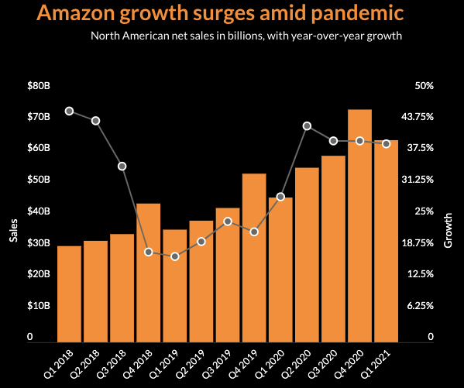
When speaking with reporters, Amazon's finance head, Brian Olsavsky, said that the company has "definitely had good volumes across all of our businesses."There is a lot of money going towards future growth, according to this representative of the company. This year, it spent $50 billion in capital expenditures, an increase of 80 percent from the previous year, mostly on expanding its logistics and data centres. He predicted "another robust year" in terms of capital investment, As stated by Mr. Olsavsky. According to Jeff Bezos, Amazon's founder and CEO, AWS has evolved from a $1 billion annual sales run rate business to a $54 billion yearly sales run rate business, competing with the world's top technology enterprises. Later this year, Mr. Bezos intends to stand down as CEO of Amazon and shift into the post of executive chairman (Weise, 2021).
Between December and the end of March, Amazon's overall labor force decreased by 27,000 people, bringing the total number of employees worldwide to 1,271,000. However, this represented a 51 percent increase in employees compared to the same time previous year. Amazon stated on Wednesday that it will raise wages for half a million employees and that it would hire "tens of thousands" more employees.When speaking with reporters, Amazon's finance head, Brian Olsavsky, said that the company has "definitely had good volumes across all of our businesses."There is a lot of money going towards future growth, according to this representative of the company. This year, it spent $50 billion in capital expenditures, an increase of 80 percent from the previous year, mostly on expanding its logistics and data centres. He predicted "another robust year" in terms of capital investment, according to Mr. Olsavsky(Weise, 2021).
According to Jeff Bezos, Amazon's founder and CEO, AWS has evolved from a $1 billion annual sales run rate business to a $54 billion yearly sales run rate business, competing with the world's top technology enterprises. Later this year, Mr. Bezos intends to stand down as CEO of Amazon and shift into the post of executive chairman. Between December and the end of March, Amazon's overall labor force decreased by 27,000 people, bringing the total number of employees worldwide to 1,271,000. However, this represented a 51 percent increase in employees compared to the same time previous year. Amazon stated on Wednesday that it will raise wages for half a million employees and that it would hire "tens of thousands" more employees (Weise, 2021).
Amazon structure and culture in profit among pandemic
With respect to income per visitor, Amazon beats the competition. This is true for every commercial website, whether it is a news or informational one, a search engine or social network, an e-commerce site or one that offers travel or financial services, for example. Of course, the profit per user for other websites such as Facebook and Google would be substantially higher owing to the significantly lower expenses of those companies. According to Forbes' Q-Factor score, Amazon shares closed at $3386.49 on May 3, 2021, making the stock 'attractive' (Chaffy, 2021).
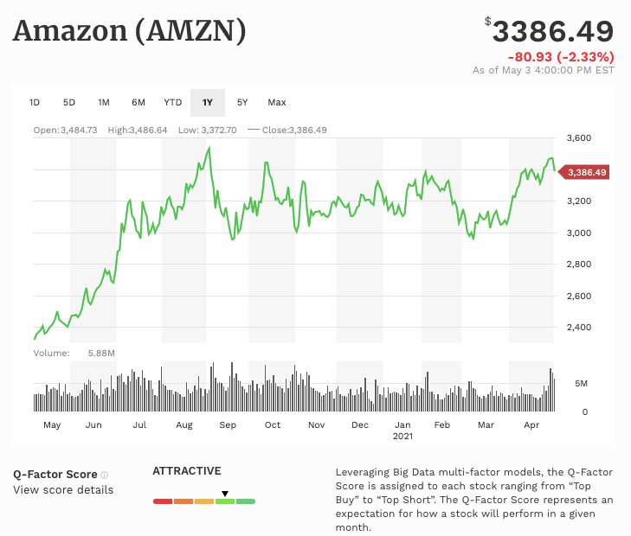
Three rules have contributed to Amazon's success. Initially Despite the fact that Amazon has an unbelievable amount of strands to its company today, strategy is about concentration. Second don’t waste good money on poor investments. What you can and cannot accomplish is determined by your key talents.A key element of Amazon's websites is the "Look Inside the Book" tool, which lets you search the whole contents of many of the books we offer for you to view the chosen internal pages and citations (Chaffy, 2021).
Product reviews, online recommendation lists, wish lists, shopping guides, and wedding and baby registries, among other things, are all made possible by a community of online consumers. To qualify for free delivery, customers must spend a certain amount of money. When it comes to profitability, the amount at which free delivery is established is essential. Amazon has modified this threshold as the competition has changed and for promotional reasons. Delivery shipping alerts and update facilities are only a few of the many ways Amazon communicates its fulfilment promise, including the presenting of inventory availability information, delivery date estimates, and expedited delivery alternatives (Chaffy, 2021).
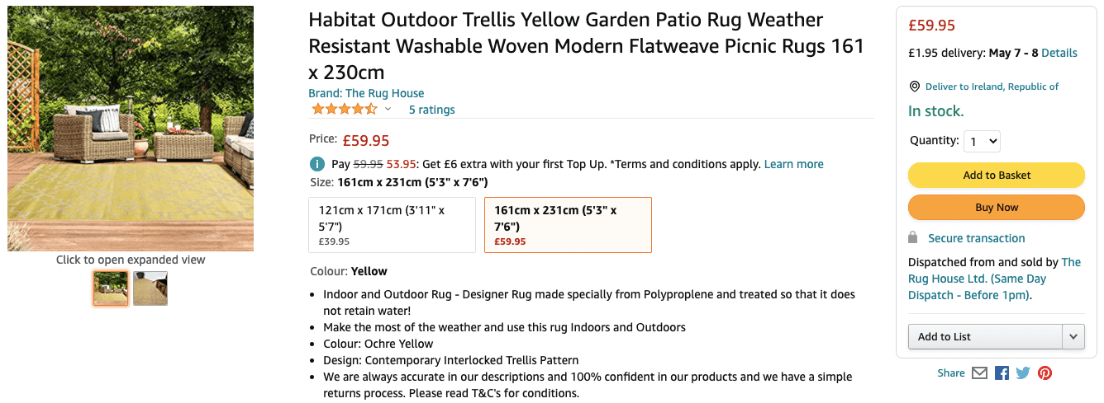

Building up of innovative culture in Amazon
To suggest that Amazon is a unique corporation would be an understatement of the case, in my opinion. Despite the company's best efforts, it has been unable to scale its innovation-driven culture. In contrast to the majority of firms, Amazon has efficiently diversified its activities in every possible direction. This shift in strategy from industry knowledge to innovation and operational excellence is being implemented by Amazon across the company."Apart from being a publicly traded company on the Nasdaq, what exactly is Amazon?" This is a difficult question to answer.However, despite the fact that the company is named after the world's largest river, it has several tributaries that spread out in all directions. The name "store" is no longer enough to characterise the company, which is now a movie studio, artificial intelligence developer, gadget manufacturer, and web-services supplier. It's also not entirely correct to refer to it as a conglomerate because so many of its businesses are either related or will be in the near future (Gustavo, n.d.).
In terms of product searches, Amazon has a 54 percent market share due to the sheer number of products it sells and the number of merchants that sell them. To put it another way, Amazon is the world's most popular e-commerce search engine instead of Google or Yahoo! When it comes to data storage, most worldwide organizations, including the CIA, depend on Amazon's servers. "Amazon's master strategy," says Ben Thompson, creator of Stratechery, a website dedicated to dissecting Silicon Valley corporations. With its "everything and everything" service model he describes Amazon's ultimate goal as providing logistics for everyone and everything. Taxing every transaction—from premium cable channels to first-page search results—is the ultimate goal.
Amazon became the second firm after Apple to reach a trillion-dollar value, but Jeff Bezos maintained the same attitude that he had when he started out in a garage in Seattle. Between "thinking like a startup" and really functioning like a startup, there is a significant gap. When Amazon started out, it had a "Day 1" attitude, a culture, and an operating model that put the customer at the centre of everything it did. Inquisitiveness, agility and experimentation are the hallmarks of Day 1. It entails having the courage to make a mistake. You can improve your ability to surprise and please clients in the future by using a trial-and-error strategy (Gustavo, n.d.).
Consistency is one of Bezos' most distinguishing characteristics. He recognizes that culture is defined by the actions that are regularly rewarded or punished. To serve as a continual reminder to him and all stakeholders, Bezos appended the shareholder letter from 1997 to every letter he sent after that date. Amazon's success is dependent on its unrelenting emphasis on consumers, long-term wealth development and willingness to take reasonable risks are two of the company's core values. Bezos noted in his inaugural shareholder letter that "this is Day 1 for the Internet," and "this is Day 1 for Amazon if we execute effectively."
Amazon isn't exactly recognized for being a nice and kind organization. Competitive and ruthless in its handling of its workers, it has an aggressive culture. Everything is dominated by cold facts and difficult procedures. The organization encourages employees to be forthright, to speak out, and to deal with disagreement in an open and honest manner. This strategy may be effective for extroverts and those with larger voices, but it is very difficult for introverts, women, and members of minority groups to adopt (Gustavo, n.d.). Individuals are not allowed to hide behind others or engage in politics. In an open forum, knowledge and mistakes are openly shared. Open and honest discussions are the building blocks of daily business. Many Amazon workers, on the other hand, believe the company has a poor degree of psychological safety in which they may express themselves freely.
The Amazon CEO urges individuals to battle orthodoxy and challenge traditional thinking, emphasizing that he prefers constructive disagreement than harmonious co-existence. His colleagues put him to the test, and he appreciates the challenge of putting others to the test. There should be facts to back up criticism and objections on the other hand. Leaders are "obligated to respectfully confront choices when they disagree, even when doing so is painful or tiring," according to one of Amazon's Leadership Principles that aids the company in its rapid expansion. Employees are aware of their responsibilities. John Rossman states in his book The Amazon Way that Amazon workers have learned that disagreeing with the company's senior leaders is a great way to advance their careers. Jeff Bezos, the CEO of Amazon, believes that truth is found when conflicting ideas and opinions are put to the test, often brutally (Gustavo, n.d.).
Conclusion
To conclude the whole discussion Amazon achieve 44% additional sales and 220% profit in the first quarter of 2021during pandemic and all because of exceptional strategy and best costumer services when it comes to profitability, the amount at which free delivery is established is essential. Amazon has modified this threshold as the competition has changed and for promotional reasons. Many of Amazon's fulfilment promises are conveyed via the display of inventory availability information, delivery date predictions and alternatives for expedited delivery as well as notice and update capabilities for delivery shipping notifications. In addition, Amazon's success may be attributed to a variety of factors, including its internal structure and culture.

References
Chaffey, D. (2021, May 4). Amazon marketing strategy business case study. Smart Insights. https://www.smartinsights.com/digital-marketing-strategy/online-business-revenue-models/amazon-case-study/
Weise, K. (2021, May 12). Amazon’s profit soars 220 percent as pandemic drives shopping online. The New York Times. https://www.nytimes.com/2021/04/29/technology/amazons-profits-triple.html
How Amazon Built a Culture of Innovation by Working Backwards | By Gustavo Razzetti. (n.d.). Fearless Cluture. Retrieved December 10, 2021, from https://www.fearlessculture.design/blog-posts/how-amazon-built-a-culture-of-innovation-by-working-backwards

