Introduction to
Research

Student Name: Ruhela Begum
Student ID: 1714385
Module Code: BMHP5005
Dr Tayo Korede

Content:

  - Page 2: Abstract
  - Page 2: Introduction
  - Page 2: Methodology
  - Page 3: Childhood Trauma
  - Page 4: Causes of Childhood Trauma
  - Page 6: Impact of Childhood Trauma in Adulthood
  - Page 7: Conclusion
  - Page 8: Bibliography

ABSTRACT
This report is based on the chosen topic Impact of childhood trauma in adulthood. The report investigates the diverse types of abuse and trauma children go through, what the impacts are and how the trauma if left unresolved can affect your life later in adulthood.

IMPACT OF CHILDHOOD TRAUMA IN ADULTHOOD

INTRODUCTION
This report will explore the impact of childhood trauma in adulthood. Childhood trauma can cause long term effects in children and in adulthood which can then leave permanent and psychological deficiencies. (Dye H ,2018). There is also considerable evidence that suggests that adverse early life experiences can have a profound effect on the developing brain. (Nemeroff C, 2004). There are many types of traumas children can go through all of which then leaves an impact on their lives even as they progress into adulthood. Different children react and cope in different ways. Some will share their experiences whilst others may keep quiete and try dealing with it in their own way. Sadly, some can lead to suicidal thoughts or self-harm. Physical or sexual abuse, verbal and mental abuse, neglect, bullying, life changing accidents or disasters are just a few examples of abuse that can lead to trauma. Betrayal is also a form of abuse which can lead to trauma and affect certain individuals' health. (Freyd J et al 2005).

Methodology
I have chosen to do my report on causes of childhood trauma in adulthood. I have chosen to do this topic as this subject is close to my heart. Obviously, I will not be talking about myself or my experiences, but I believe that researching this topic writing about it, conducting research on it will help me to understand certain perspectives. I first started off by gathering all my research. To do my research I went into google and typed in google scholar then I typed in a particular topic I was interested in. Many articles came up, but I had to look through them to see which ones were relevant to me for my chosen area of research. I then used the key points on the articles to reference my work. Straight after I finished my in-text citations I opened another tab and typed in cite me this. I used this page to write my refences making sure that it was set out in Harvard style. At one point I did try to use Scopus but for some reason I could not access the data so I thought I will stick to google scholar as I felt confident using it. Google Scholar had so much useful information, but I just looked out for key factors, important words and used them. I had to make sure that I had least twenty references and all of which were credible sources. After completing my thorough research, I decided to start my assignment. Firstly, I decided to start off by writing about children and what types of traumas they may have endured, then I wrote about how it might affect them and finally about the long-term effects it can cause and the trauma that carries on through to adulthood.

Childhood Trauma
Children are innocent human beings that can later become products of their environment. There are certain memories that they will hold on to, and some will be embedded at the back of their minds. Sadly, not all these memories will be pleasant. Certain situations can bring back forgotten memories that can cause lasting effects.

Abraham Maslow’s hierarchy of needs is a theory of motivation which states five categories of human needs which would dictate an individual's behaviour. He drew a triangle showing what the needs were. The triangle indicated the needs in which he thought was relevant with the bottom one as Physiological need being the most important and the self-fulfilment needs being at the top of the triangle. The physiological needs are especially important for younger children as they will rely on the responsible adults to provide them with the food, water, warmth, and rest. Older children can somehow manage that by themselves even though they may not be doing it happily and may feel resented, but they will be able to somehow manage to do it by themselves better than the younger ones can manage. The safety needs are about feeling safe and secure. To be fair this is a need for children, teenagers and adults need too.
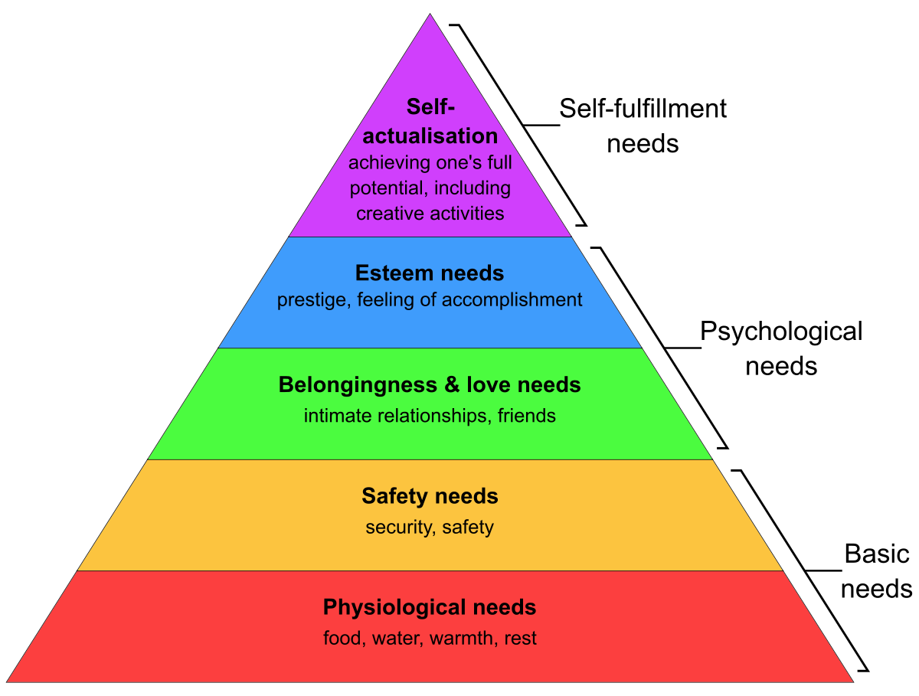
McLeod S (2018)
Children are vulnerable and they need to know that they are loved and protected. They are so virtuous; they just like to happily enjoy themselves unaware of what the future has in store for them. However, if that sense of security is damaged then that can affect them mentally with lifelong lasting effects. It is also especially important for them to feel loved and feel like they belong amongst friends and family. As children get older their psychological needs will kick in, they will crave for accomplishment, so if they have done well in school, they will thrive on the compliments and their esteem and confidence will build up. During this time, it is also important for parents to accomplish the little achievements that children achieve to make them realise their self-worth and make them feel happy and appreciated. Remorsefully whilst children are growing up things can also take a horrible turn for them. Life is unpredictable and will have so many difficulties we need to learn to overcome. Many children horrifically suffer from sexual abuse but do not often report their exploitations and those that do most often do so many years later. Many victims of child abuse that do report the crime often recant their statements as they do not want to go through the trauma of reliving it again. Even though there is no medical evidence certain individuals believe that sexual abuse can leave a child suffering from something called Child Sexual abuse accommodation syndrome (CSAAS) Kenneth J. Weiss, and Alexander J (2013). These types of abuse can also cause the victims to feel frightened, alone, and disheartened. There are many distinct types of abuse but the ones we hear of the most are physical abuse, sexual abuse, emotional abuse, ongoing family arguments, domestic violence, household substance abuse, criminals in household childhood illnesses and disability.

A loving home also needs to be a secure home. Children will always look back on their childhood memories and negative impact can psychologically affect the way they become. There are so many children that do not feel safe within their own environment. Injury is the leading cause of death in childhood and sadly not all of it is accidental (Beers S and Bellis M ,2002). Unfortunately, some of these injuries lead to death whilst others will suffer physically as well as mentally. Children that feel neglected often feel withdrawn and lonely. Different traumas are dealt with differently and certain traumas have certain ways of dealing with it.

Loss of a loved one is an exceedingly tough time and children can find it hard to understand what is going on. This is sadly something that cannot be controlled but it is important to help build healthy coping skills. Different individuals will behave in certain ways, but it is imperative that adults are there for them and can help them understand what is going on. Responsible adults should encourage children to express their feelings as some children might react by wetting the bed or slip back into baby talk. Ehmke R (2019).

Causes of childhood trauma
Exposure to trauma in childhood can cause major health problems that can later result in lifelong mental and physical health consequences. Horner G (2015). We come into this world as Newborn's innocent and vulnerable and then we are left in the hands of the parents, guardians, or responsible adults and that is where the life journey begins. Many children have the luck to go into a loving home but even then, that may not last as close relatives can abuse them without knowledge of the family. A MORI survey was conducted amongst males and females of the age of fifteen years and over, from that survey it became known that ten percent of the candidates said they had been sexually assaulted before the age of sixteen and at least one hundred and forty-three thousand children were sexually abused by someone within the family. Anthony w and Baker M.R.C(2002.)

A broken family can also affect a child's thinking psychologically especially if they witness domestic violence around them. When the parents do not get on and there are constant arguing and disturbances that will cause an unstable environment and cause children to feel frightened, emotional, angry, on the edge, resented and worried. They will also feel withdrawn. Some children that have a broken home or divorced parents' can suffer a negative impact on their social development. Faisal M, Hood H, Said K and Said M (2020). They may distance themselves with family members and friends, feel anger towards the situation and regretfully some may even blame themselves for what is going on around them even though majority of the time it is beyond their control.

Family tragedies are also an unforeseeable and an unfortunate factor that will impact a child growing up. For example, if a family member was involved in an accident or a violent death, this can cause flashbacks for children and even though the child knows that it is not the victim's fault, they may feel resentment towards the victim in the sense that they feel betrayed and resented as they will be missing them and might feel that they have been left behind. There are many different forms of grieving each helping the healing process in its own time. Joshi T, Parr A and Efron L (2008) in one of their article's states that despite children's innate resilience traumatic events can lead children to feel weak and suffer from acute stress reaction which could lead to developing acute and chronic psychological consequences.
Bullying is an ongoing problem that children face even today. Many children have committed suicide due to this issue. Children can be bullied in school, amongst relatives or sadly even with family members.

Bullying can lead to long-term, emotional, social, and psychological effects. (Jones S and Smith P ,2010). The victims often lack self-confidence and feel worthless. It can also affect their appetite and they will feel withdrawn and can get paranoid in the sense that they feel they are constantly being laughed at. Some children feel they are not able to talk about the situation and they begin to doubt themselves and think maybe they do have weaknesses and are at fault and that is why they are being bullied and made fun of.

Another trauma that is not highlighted enough is the abuse some children face within their own homes. There are many children that will come across as having a close, loving, and happy family environment, however when actively investigated it is a farce. Within their own homes they can feel lonely and unloved. Many parents compare their children against one another or other children which can cause a lack of self-confidence and animosity amongst each other. Physical violence is not the only form of abuse, but children can get verbally abused and constantly put down by their parents too. When parents are constantly shouting at children, they can feel scared to do things for themselves and might always be looking for assurance. Physical scarring might sometimes go away but mental scarring and nasty words may stay in the minds of the children long after the incident.

IMPACT OF CHILDHOOD TRAUMA IN ADULTHOOD
As children grow older, through experience they will learn the advantages and disadvantages of the world. Past experiences can make some stronger and some may still be suffering with post-traumatic stress disorder (PTSD) from certain incidents in their lives. The impact of childhood trauma sadly does not disappear with adulthood. The trauma is personal, and the impacts can have the same effects on us adults as it did as children as they are stored exactly where we left them. To be able to heal properly we need to learn to not carry that pain alone but to invite the younger version of us to safety (Nate Postlethwait).

Those that have come from broken families unknowingly psychologically they can be affected and may act the exact same way as their parents did. At the time they will think oh I will never put my family and children through that but sometimes it can have an adverse effect and without realising it they will do the same. Those that have grown up seeing violence around them at first, they start off frightened but then they get used to it and consider it as the norm. Unintentionally they will start getting aggressive and violence over small issues. Children that have seen or experienced domestic violence through during their youth they tend to become interested in street fights and other problems associated with violence. ( Herrenkohl T et al ,2008. Those that have divorced parents may feel like they cannot communicate well with one of the parents or they may have a relationship breakdown with one parent if they think that person is to blame. Research has shown that children with divorced parents find it hard concentrating in school and some eventually drop out so with not having a proper education later in adulthood it is impacted in the sense that they cannot get a decent job or will not have had a decent education. It has also shown that children with divorced parents have a poorer relationship with their fathers and a better relationship with their mothers (Morrison Z and Coiro MJ,1993).

Having to deal with family tragedies from an early start in life can make an individual become stronger in the sense that they will have learnt to deal with things on their own and rise above it but on the other side it can also make a victim possessive of loved ones as they will know the pain of having already dealing with the loss of loved ones so they will want to hold onto those that are dear to them as they will not want to go through the trauma again. Many surviving victims of childhood tragedies will suffer well into adulthood as the healing process is long. Losing a loved one is hard enough but losing them in a horrible way is not something one can forget. Many people go into adulthood suffering with long term effects like depression, social functioning, reactivity to good events, psychological well-being and many worries and concerns for the future ahead (Wortman C.B, Lehman D.R and Williams A. F 2021.)

As mentioned earlier bullying can happen to anyone in any stage of their life regardless of their lifestyle. Those that have been bullied from childhood as they progress onto adulthood, they will still have that trauma and might find it hard firring into crowds or going to work. Their self-esteem will be low. Bullying is seen as methodical abuse of power. The behaviour is aggressive and carried out repeatedly. Bullying is a major risk factor for poor physical and mental health. In the future it will leave adults with reduced adaption to adult roles and can affect them in forming lasting relationships, integrated into work. They can have trust issues and face problems in becoming economically independent (Wolke D and Lereya S 2014)

Neglect in childhood will also leave long lasting effects going on throughout adulthood. Different people will react differently. Some will act the opposite and later when they have a family of their own, they will show love and affection, the total opposite of what they went through. However, others will be affected adversely instead of showing their affection they will hide it or even find it hard bonding. They unknowingly go through the same phase that they went through. A research was carried out into how the impact of childhood neglect affected adult mental health and they produced the following results. Men that were abused neglected as children suffered from dysthymia and anti-social personality disorders (Horwitz A at el, 2001). Another study conducted on adults that had suffered neglect and abuse in childhood showed that women were at more increased risk of suffering from major depression disorder and excessive drug use and drug dependency (Thompson M, Kingree J.B and Desai S (2011.) Neglect is at least as damaging as sexual or physical abuse eventually but does not get enough priority and has gained the least scientific and public attention (Professor Gilbert et al ,2009.)

Conclusion:
Earlier on my report I spoke about Maslow's hierarchy of needs triangle. Like children, adults also have needs and Maslow's theory is relevant to adults to a certain extent too. It is imperative that adults also feel safe, feel loved and like they belong. They also need the feeling of accomplishment and to realise their full potential.

Everyone's life is different, and everyone has a different path they lead. Some will have a smooth ride whilst others will feel like they are going through an emotional roller-coaster. The way people are bought up or a situation or trauma a person has gone through can make a person become the way they are. Hundreds of years ago no one was aware of Mental Health or how to deal with it. Thankfully, the world has advanced in many ways, mental health is no longer a stigma and there are many professionals out there that can offer help and support.
The more a trauma is hold onto the longer it will take for the victim to recover and the harder it will become to forget which then can lead to many psychological problems.
Sadly, divorce rates are higher now than they were before and there are many broken families. Children that see this happening are affected by it to a certain extent. There should be effective communication amongst the family members and children should always be reminded that it is beyond their control. Counselling is available that can help them understand what is going on to help them overcome it, so they do not suffer from it later in life.

Family tragedies are unpredictable and can happen to anyone, but it can tear families apart. Bereavement counselling should be offered straight away, and they should be able to attend it as often as needed until they feel they are able to cope alone. Groups should also be available where those that have been through the same incident can talk to each other and relate. This helps as the understanding will be mutual.

Bullying is a profoundly serious type of trauma and carries long lasting psychological effects. This is an ongoing problem that does not seem to go away. This problem should be tackled immediately as it could have dire consequences if left unsolved. It is always best to speak to professionals as well as people around you. You should never feel alone and should address the issue. Bullying is never the victim's fault even though they are sometimes made to feel it is.
Neglect can make one feel worthless, so it is always important to believe in yourself. One thing always worth considering is the way that people treat you is not the fault in your character but theirs. It is always best to talk about your feelings and to express yourself. Never be ashamed of the person you are, always stand proud and try to overcome the hurdles. If reached out to the relevant professionals and departments help is out there. Healing will take time, but slow steps will eventually get you there.

BIBLIOGRAPHY

- Beers, s. and Bellis, M., 2021. Outcomes of child abuse. Neurosurgery Clinics, [online] 13(2), pp.235-241. Available at: <https://www.neurosurgery.theclinics.com/article/S1042-3680(01)00003-1/abstract> [Accessed 11 July 2021].
- Dye, H., 2018. The impact and long-term effects of childhood trauma. Journal Of Human Behaviour in The Social Environment, [online] 28(3), pp.381-392. Available at: <https://www.tandfonline.com/doi/full/10.1080/10911359.2018.1435328> [Accessed 8 July 2021].
- Ehmke, R., 2019. Helping Children deal with grief. [online] childmind.org. Available at: <https://www.washk12wellness.org/uploads/2/9/9/6/29960495/child_grieving___how_to_deal_with_grieving___helping_children_cope___child_mind_institute.pdf> [Accessed 12 July 2021].
- Faisal, M., Hood, S., Said, k. and Said, M., 2020. THE SOCIAL PSYCHOLOGICAL OF CHILDREN OF BROKEN HOME FAMILY AND ITS PROBLEM SOLVING. Journal on Palaeontology and Egyptology, [online] 17(7), pp.4918-4925. Available at: <https://archives.palarch.nl/index.php/jae/information/readers> [Accessed 12 July 2021].
- Gilbert, R., Widom, C., Browne, K., Ferguson, D., Webb, E. and Janson, S., 2009. Burden and consequences of child maltreatment in high-income countries. The Lancet, [online] 373(9657), pp.68-81. Available at: <https://www.sciencedirect.com/science/article/abs/pii/S0140673608617067> [Accessed 13 July 2021].
- Herrenkohl, T., Sousa, C., Tajima, E., Harrenkohl, R. and Moylan, C., 2008. Intersection of Child Abuse and Children's Exposure to Domestic Violence. Trauma, Violence and abuse, [online] 9(2), pp.84-99. Available at: <https://journals.sagepub.com/doi/abs/10.1177/1524838008314797> [Accessed 13 July 2021].
- Horner, G., 2015. Childhood Trauma Exposure and Toxic Stress: What the PNP Needs to Know. Journal of Paediatric Health Care, [online] 29(2), pp.191-198. Available at: <https://www.sciencedirect.com/science/article/abs/pii/S0891524514003447> [Accessed 12 July 2021].
- Horwitz, A., Widom, C., McLaughlin, J. and White, H., 2001. The Impact of Childhood Abuse and Neglect on Adult Mental Health: A Prospective Study. Journal of health and social behaviour, [online] 42(2), pp.184-201. Available at: <https://www.jstor.org/stable/3090177> [Accessed 13 July 2021].
- Jennifer, J., Freyd, Klest, B. and Allard, C., 2005. Betrayal Trauma: Relationship to Physical Health, Psychological Distress, and a Written Disclosure Intervention. Journal of Trauma & Dissociation, [online] 6(3), pp.83-104. Available at: <https://www.tandfonline.com/doi/abs/10.1300/J229v06n03_04> [Accessed 8 July 2021].
- J, K., Weis, M. and Alexander, J., 2013. Sex, Lies, and Statistics: Inferences from the Child Sexual Abuse Accommodation Syndrome. The Journal of the American Academy of Psychiatry and the Law, [online] 41(3), p.412. Available at: <https://www.nationalcac.org/wp-content/uploads/2016/10/Sex-lies-and-statistics-Inferences-from-the-child-sexual-abuse-accommodation-syndrome.pdf> [Accessed 11 July 2021].
- Jones, S. and Smith, P., 2010. Self-reports of short- and long-term effects of bullying on children who stammer. British Journal of Educational Psychology, [online] 62(2), pp.141-158. Available at: <https://bpspsychub.onlinelibrary.wiley.com/doi/abs/10.1348/000709999157626> [Accessed 12 July 2021].
- Joshi, P., Parr, A. and Effron, L., 2008. TV Coverage of Tragedies: What is the Impact on Children?
- [online] Indian Paediatrics. Available at: <http://www.indianpediatrics.net/aug2008/aug-629-634.htm> [Accessed 12 July 2021].
- McLeod, S., 2018. Maslow's hierarchy of needs. [online] Simply Psychology. Available at: <http://www.simplypsychology.org/maslow.html> [Accessed 11 July 2021].
- Morrison, Z. and Coiro, D., 2021. Long-term effects of parental divorce on parent-child relationships, adjustment, and achievement in young adulthood. Journal of family psychology, [online] 7(1), pp.91-103. Available at: <https://psycnet.apa.org/doiLanding?doi=10.1037%2F0893-3200.7.1.91> [Accessed 13 July 2021].
- Nemeroff, C., 2004. Neurobiological Consequences of Childhood Trauma. [online] Available at: <https://www.psychiatrist.com/wp-content/uploads/2021/02/15380_neurobiological-consequences-childhood-trauma.pdf> [Accessed 8 July 2021].
- Postlethwait N https\\natewrites.com
- Thompson, M., Kingree, J. and Desai, S., 2004. Gender Differences in Long-Term Health Consequences of Physical Abuse of Children: Data from W, A. and M.R.C, B., 2002. Child sexual abuse: A study of prevalence in Great Britain. Child Abuse & Neglect, [online] 9(4), pp.457-467. Available at: <https://www.sciencedirect.com/science/article/abs/pii/0145213485900547> [Accessed 12 July 2021].

- W, A., and M.R.C, B., 2002. Child sexual abuse: A study of prevalence in Great Britain. Child Abuse & Neglect, [online] 9(4), pp.457-467. Available at: <https://www.sciencedirect.com/science/article/abs/pii/0145213485900547> [Accessed 12 July 2021].
- Wolke, D. and Lereya, S., 2015. Long-term effects of bullying. Archives of disease in childhood, [online] 100(9). Available at: <https://adc.bmj.com/content/100/9/879> [Accessed 13 July 2021].
- Wortman, C., Lehman, D. and Williams, A., 2021. Long-term effects of losing a spouse or child in a motor vehicle crash. Journal of personality and social Psychology, [online] 52(1), pp.218-231. Available at: <https://psycnet.apa.org/doiLanding?doi=10.1037%2F0022-3514.52.1.218> [Accessed 13 July 2021].

