
BURWING CAETAN
PORTFOLIO

[Date]
sTudent id: 1715701
[Company address]

PROJECT PROPOSAL

PROJECT PROPOSAL

PROJECT TITLE: THE VALUE OF TECHNOLOGY IN ENHANCING GUEST EXPERIENCE OF THE WELLNESS SERVICES AT LUX* GRAND GAUBE.

THE CONTEXT

LUX* Grand Gaube, a five-star resort in the north of Mauritius, was renovated in 2017 and the first hotel in Mauritius to invest in Technology massively across different areas such as in rooms which are equipped with IPTV's and IP Telephone, the hotel background music is controlled via an administrator iPhone. A mobile phone application called "LUX* Experience" has been developed and is available for Android and IOS users, to be able the guest to connect with the hotel before, during and after their stay.

In the Fitness center, investment was done on the latest fitness equipment all branded Technogym. Each piece of equipment has an internet connection and IPTV as well. Users of the Fitness center can save their workout routine on a cloud by using the My Wellness mobile application which is reserved for Technogym only.

THE JUSTIFICATION

With some research on the Fitness equipment that we are using, I have discovered that we are only using about 60% of the available technology. Fitness Coaches are still using paper to draft basic training and nutritional programs without making use of technology. They find it difficult to track the progress of service users.
The research aim is to understand the possibilities of elevating services by creating tailor-made fitness and nutritional programs using technology to easily track the users’ progress.

THE INTENDED IMPACT

The idea is to use technology more effectively by synchronizing the LUX* Experience application with the My Wellness mobile application of Technogym by creating only one platform. Where Fitness coaches can track the progression of the gym users who will save and receive their workout routine monthly via notifications.

The program will be on how to keep a well-balanced and healthy diet and will also give indications of the parts of the body which are weak and require attention. The choice of experienced and International Chefs together with a world-class Spa under the same roof will definitely create a good synergy for users to make use of the application.

Once piloted at LUX* Grand Gaube, this project could be implemented within other resorts of the group and facilitate a new level of service excellence.
With its implementation, users will increase their motivation to work out more frequently as they know there will be a tracker for progression. Same will apply for coaches who will be able to design a tailor-made fitness program quickly and monitor the progression

THE OUTLINED INTENTION

By February 2019, two surveys will be implemented over a duration of 15 days which will cater for answers to specific questions. Approximately eight questions per survey will be on “workout routine and technology”. With the quantitative answers, the researcher will have a clear idea of how gym users and coaches would like to implement technology in their workout sessions.

THE ETHICS AND INSIDER RESEARCH

Two types of survey will be created with specific questions which will be distributed among the Gym users and the coaches. Surveys will be anonymous and will be available at the Gym desk for those who want to participate. Being anonymous, this will allow respondents to answer with more candid and valid answers.
The aim of these surveys is to collect maximum information between the two categories of participants on how they perceive the use of technology in daily routine and also how this might help them to improve their workout.

THE EXPECTED LEARNING OUTCOMES

The researcher will have a better understanding of mobile application platforms, data analysis skills and the implementation of technology-based fitness and wellbeing programs.

INTRODUCTION

The world of fitness and wellness has grown exponentially over the past few years. For example; new gadgets, smart watches and even phones that can examine your body and gave a status about it. This was completely unimaginable 20 years ago as more focus at that time was on oil or water massage and spinning or treadmills.

More and more people have started to follow European and Asian trends and have got used to having them next to them. As the researcher, I have observed that we have not expanded enough to have the possibility to develop such technology, we choose to remain in our comfort zone by repeating things that are outmoded.

This is the reason why there is a need to conduct research on the value of technology in enhancing guest experiences of the wellness services at LUX* Grand Gaube.

LITERATURE REVIEW

Today, technology has touched the biggest as well as the smallest part of our lives. The involvement of technical upgrade into our daily life increased the use of technology in fields like education, medicine, science and fitness, and health. Technology has changed our entire perspective on life and things. According to Risto Linturi, a serial entrepreneur and a futurist, stated that “emerging technologies offer a range of opportunities that can transform into threats if society doesn’t adapt and help individuals keep up”. Risto Linturi also stated that “technological advances make traditional education obsolete, but help develop new skills” (Linturi, 2015)
Technology has impacted on Fitness industry too for good and technical upgrade in the world has proven technology boom for the fitness industry. Technology has given a new concept to the fitness industry by introducing fitness mobile application and usage of wearable fitness technologies. These smart tools provide easy access and assistance depends on the category like weight loss, flat stomach, wellbeing tips and giving shape to the body. An article from Plos highlighted the fact that using a wearable device technology including smart watches or fitness bands allow the “consumer wearable can provide patients with personalized health data, which could assist with self-diagnosis and behavior change interventions” (Lukasz Piwek, David A. Ellis, Sally Andrews, Adam Joinson, 2016)
There is a research article in the journal of the BMC Public Health confirm that wearing an activity tracker offers considerable promise for helping users to adopt healthier lifestyles and perceive positive behavior changes in physical activity, diet, and sleep. (Carol Maher, 2017)
Concurring an article in the Journal of ICT Standardization, Mauritius can possibly turn into a stage for wellbeing versatile improvement. The Government aspiration is to make Mauritius a Smart Island and ICT a driver for financial development may goad increasingly imaginative applications sooner rather than later. Versatile application improvement in medicinal services is a specialty market of chance for Mauritius to develop as a pioneer in the area and all around. (K. Beharee, 2016)

Technology has also a huge impact on Tourism. According to an article published by the Innovation Management and Education Excellence Vision 2020: Regional Development to Global Economic Growth, the development of new applications enables tour operators and destinations to improve their efficiency and streamline their communication strategies. They also pointed out that "the future of tourism will naturally be focused on technologies centered on the user that will support organizations to interact with their customers in a dynamic way”. (Morais, 2016)

References
Carol Maher, J. R. C. A. a. S. E., 2017. Users’ experiences of wearable activity trackers: a cross-sectional study. BMC Public HealthBMC series, 15 November.

K. Beharee, L. A. B., 2016. Mauritius eHealth - Trust in the Healthcare Revolution. ICT Standardization, March, Volume Vol. 3, pp. 231 - 250.

Linturi, R., 2015. Technology as an Enabler of Sustainable Well-Being in the Modern Society, s.l.: s.n.

Lukasz Piwek, David A. Ellis, Sally Andrews, Adam Joinson, 2016. The Rise of Consumer Health Wearables: Promises and Barriers. Plos Medicine, 02 February.

Morais, E. &. C. C. &. P. S. J. &. S. A., 2016. Information and communication technologies in tourism: Challenges and trends. Innovation Management and Education Excellence Vision 2020: Regional Development to Global Economic Growth 1381.

METHODS

The researcher decided to use quantitative and qualitative methods to be able to collect data for the research. The survey research method was more adequate and adaptable to the working place. The targeted audiences were split into two categories: the gym users and the coaches.

The survey tool was more beneficial as it was easier and quicker to deploy, taking into consideration the time constraint of the audiences. Multiple choice questions and one open question on the guest questionnaire were used in the survey to help the audience to answer easily without taking too much time. This style of survey does not require the researcher to interpret answers and the respondents are graded only on their selections creating a lower likelihood of being biased. Since a fixed list of options has been provided in the questionnaire, this led to structured survey responses and made it easier for the respondents as well as for the researcher to analyse the data.

There were two different surveys with different types of questions for the two audiences. The questionnaire for the coaches was more oriented with questions of how technology would improve and facilitate their work and the second questionnaire was more focused for the users to explore the ways of how technology could improve their work out routine.

The guest questionnaire which was printed questionnaire contained ten questions and was placed at the prominent gym entrance for two weeks. The users were encouraged to fill in out the questionnaire at the end of their respective workout in the hope of generating genuine answers because they could relate to the obstacles encountered during their exercises. The coach questionnaire which was also printed with six specific questions and was distributed among the coaches after their working hours in the Gym office.

Ethical principles were applied in the survey to protect all the participants. Both questionnaires respected the autonomy and decision making of the participants as at no time did the researcher assist the respondents to answer the questions. Different nationalities were targeted by guest participants. The questions respected the values and interests of the users, and no aspects of religion and culture were explored.

The drawback for this type of survey is that users and coaches who were not able to answer a particular question could have simply selected a random option leading the survey results being negatively impacted.

Another disadvantage when not presenting questions to the users face-to-face is that each user might have different interpretations of the questions. Without the researcher to explain the questionnaire fully and ensure each user has the same understanding, results could be subjective.

To overcome the drawbacks, the researcher has simplified the questions and made them uncomplicated so that the respondents find it easy to answer. By doing this, the researcher expected not only to have the maximum accurate responses but also to avoid question skipping and hence get better response rate

FINDINGS

FINDINGS

Two surveys were distributed to two categories of sports practitioners, to help to know how technology can improve their workout routines and their work. There were 40 guests who completed questionnaires voluntarily, with a response rate of 100%. The other category was coaches with 10 participants, all were volunteer and the rate of response was 100%.

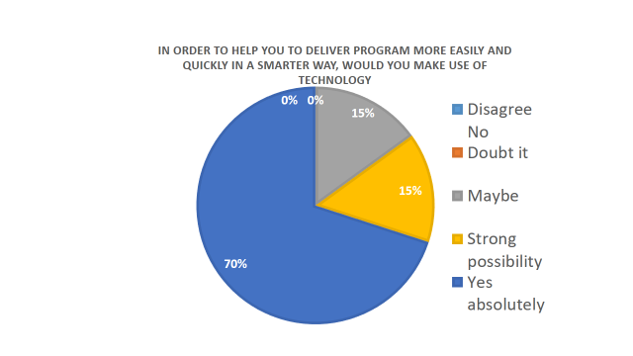
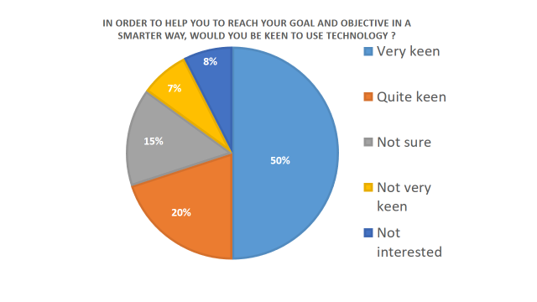
The researcher compiled two similar questions from both questionnaires to be able to make a comparison between them.
Table 1 From Guest’s questionnaire Table 1.1 From Coaches questionnaire

Table 1 and 1.1 support the fact of using technology to reach specific objectives. A large proportion of the respondents from guest questionnaires are very keen with 50% and 20 % are quite keen, both are positive responses and this shows that they are more likely to use technology. Comparing to the coaches’ questionnaire, it can be seen from

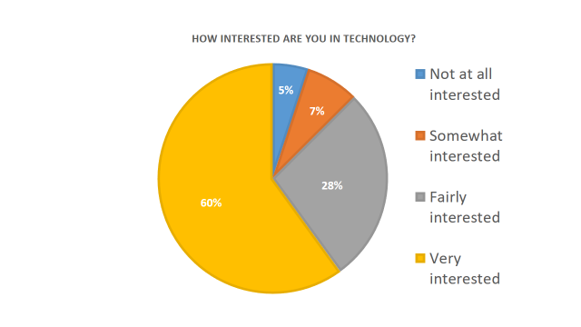
Table 1.2 From Guest questionnaire

Table 1.2 that coaches have only positive responses to the subject and want to make changes on their way of delivering coaching.

Referring to Table 1.2, which is about their interest in technology, we can see that only 5% of the guest respondents are not interested at all, 7% are undecided, however, we can clearly see 60% of the respondents that are very interested with 28% are fairly interested.
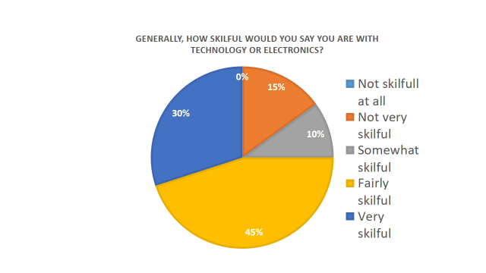
Table 1.3 From Coach questionnaire

As can be seen in table 1.3, Coaches does not have a real objection to using technology, there is an only positive response. Only 15% answered "maybe" which means that given information they are keen to go for the change.
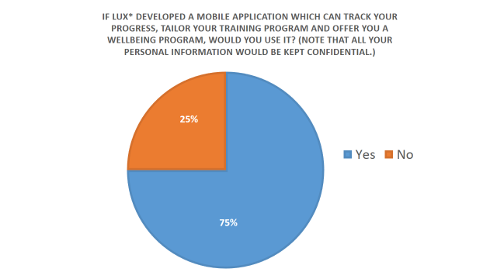

Table 1.4 From Guest questionnaire

As shown in Table 1.4, the percentage of response is surprisingly positive with 75% who wish to go ahead with technology. On the other hand, 25% believed that they did not need such a mobile application, they preferred to do without. The same question was addressed by the Coaches and the response was also positive with 90% against 10% which was negative. These figures show that coaches are ready to make the transition towards using technology at work on a daily basis.
Data analysis from guest questionnaire in appendix A

Question 1, investigated how frequently they work-out on a weekly basis and it reveals that most of the respondents practice twice a week with a percentage of 45%, followed by five times a week with 20%, 18% are those who do four times; 17% do once a week which is the lowest percentage. The researcher concluded that twice per week is the most common workout frequency.

Question 2, asked the respondents if they have any training program and 67% have one whereas 33% do not follow any training program.

Question 3, inquired about how often they change their program. Unexpectedly, 55% stated every month, followed by once a year with a percentage of 23% and only 7% every six months. The researcher was expecting a higher percentage for every six months but it was not the case.

Question 4, the survey response shows that 73% of the respondents have no tailor-made training programs and on the other hand 27% have their own tailor-made programs. The researcher found that on 40 respondents, only 11 have in their possession tailor-made program.

Question 5. Data collected was expected by the researcher. A percentage of 80% of the respondents make use of paper for their training program. The remaining percentage, 20% are participants who are already using technology and uses mobile phone applications to do their workout routine.

Question 6, talked about tracking their progression. The majority of the respondents with a number of 78% said "no" as they cannot track whereas 22% were able to do so. At some point, there are about 32 out of 40 respondents who do not track their performance or simply are ignorant of how to do it. The researcher also notes that the respondents did not complete the part opening question. They simply replied yes but were unable to communicate the instrument they used to track their performance. It could be either they did not understand the question or they did not feel comfortable to share their tracking instrument. This kind of reaction from respondents did not ease the research. Perhaps the question should have included some multiple-choice answers to encourage response.

Question 8, inquired about technology skills. Most of them categorized themselves as fairly skilful which bring a percentage of 42%, followed by 18% very skilful and 25% are keen to acquire technology skills. The lowest response was 10% for not very skilful and 5% only for not skilful at all. This proves that most of the guests have basic technology skills usage.

Data analysis from coach questionnaire in appendix B

Question 1, investigated with the coaches if they are able to tailor-made programs for their guests. As expected by the researcher, 80% of the respondent's responses were positive whereas 20% were negative. This shows that most of the coaches are able to design and deliver a coaching program.

Question 2, explored how much time a coach takes to deliver a training program. Two days had the highest percentage with 45%, 25% of the respondent took more than one day, 15% for one day, 4 to 6 hours we got only 10% and the lowest one was for the 1 to 3 hours with a percentage of 5%. Figures showed that a tailor-made program takes at least two days to be done by a coach and this could be reduced drastically by doing it more start by creating an application that would help to design programs.

Question 5, in the coach questionnaire in Appendix B, 45% of the respondents categorized themselves as fast people to learn technology, 30% of them get it instantly and 25% have some difficulties to adapt. Overall, the researcher concluded that 75% of the respondents have the potential of using mobile applications and software.

EVALUATION

The response rate from both categories was high. The researcher was astonished at the way the targeted audience wanted to participate in the survey and the quality of the responses. Respondents returned their survey with enthusiasm and quickly. The below table represents an overall view of the ten questions coming from the guest survey questionnaire and the six questions from the coach survey questionnaire. It can be seen that all answers were positive from both sides, this indicates that technology wellbeing would be well appreciated and useful.

Table 1.5 this table helps to see how the respondents are keen to direct towards technology.

CRITIQUES
In retrospect, the researcher realised that the questionnaire for coaches was not sufficient to collect consistent data. The questionnaires were comprised of only six questions and it could have included more questions; perhaps some more open questions to have more feedback on the subject. The researcher also noted there should have been a focus group with the coaches that would have been beneficial for data collection.

Another change that could have been done, instead of having only one qualitative open question in the guest questionnaire, it would have benefited to have more feedback to have several open questions.

Another change is concerning the types of questions in the surveys.
It has been noticed while distributing the survey amongst the guests, the age group was varied. When data were collected, the researcher realised that the age group on guest survey questionnaires would have been beneficial in understanding responses. This would have permitted to know the age group which gave negative responses to some questions related to their skill of using technology.

The researcher believes that survey analysis would be easier if all survey forms were available on soft-copy such as a digital sheet using an application from an IPad or any electronic device. By using such a tool, this would have been to simplify the filtering of information and the manipulation of collected data.

The last observation of the researcher was the location. It was noted that the gym was not the best place to make the guest fill the questionnaire. Despite the high score of respondents, they were not at ease to fill the questionnaire as it was not a quiet place with people passing by. It can be concluded that the location was not appropriate and perhaps a private spot with seating facilities would be much more comfortable.

CONCLUSION

Based on the conducted research, the researcher strongly believes that creating an application or merging the LUX* Experience to the My Wellness from Technogym would allow guests to record performance. For coach, it will be allowed them to be able to create a smarter and quicker training program. Regarding the business, it will give more value to the LUX* application to be also known as a fitness aid that could be used over the world.
APPENDIX A: SAMPLE SURVEY FOR GUEST

“How technology could help you to improve your workout routine”.
We need your assistance in answering questions regarding the use of technology for Wellness programmes.
Kindly circle the response you feel is most appropriate.

- How many times do you work out weekly?

- Once a week.
- Twice a week.
- Four times a week.
- Five or more

- Do you have a training program that you currently follow?

- Yes.
- No.

- How often do you change your training program?

- Every week.
- Every month.
- Every six months.
- Once a year.
- Not applicable.

- Is your training program tailor made just for you?

- Yes.
- No.
- Not applicable.

- How is you training program is stored?

  - On paper
  - On phone thought a fitness application
  - Not applicable.

- Are you able to track your progression?
- Yes.
If yes please tell us how
………………………………………………………………………………… …………………………………………………………………………………………………………………………………………………………………………………………………………………………………………………………………………………………………………………………………………………………………………
- No.
- How interested are you in Technology?

  - Not at all interested
  - Somewhat interested
  - Fairly interested
  - Very interested

- Generally, how skilful would you say you are with technology or electronics?

  - Not skilful at all
  - Not very skilful
  - Somewhat skilful
  - Fairly skilful
  - Very skilful

- In order to help you to reach your goal and objective in a smarter way, would you to use suitable?

- Very keen
- Quite keen
- Not sure
- Not very keen
- Not interested

- If LUX* developed a mobile application which can track your progress, tailor your training program and offer you a wellbeing program, would you use it? (Note that all your personal information would be kept confidential.)

- Yes.
- No.
Thank you for your assistance

APPENDIX B: SAMPLE SURVEY FOR COACH

“How technology can improve your work”.

Please assist in answering questions with regards to technology being used within the gym. While your response remain anonymous, we are keen to hear your opinions

Kindly circle your answer.

- Do you do tailor make fitness, nutrition and wellbeing programs for guests?

  - Yes
  - No

- How much time does it take you to create a program?

- 1–3 hours
- 4-6 hours
- One day
- Two days
- More than two days

- How interested are you in mobile application?

  - Not at all interested
  - Somewhat interested
  - Fairly interested
  - Very interested

- Generally, how skilful would you say you are with technology or electronics?

  - Not skilful at all
  - Not very skilful
  - Somewhat skilful
  - Fairly skilful
  - Very skilful

- How long does it take you to use new technologies, software, or applications

  - Longer than most
  - About average
  - Faster than other people
  - I catch on almost instantly

- In order to help you to deliver program more easily and quickly in a smarter way, would you make use of technology?

  - Yes, absolutely
  - Strong possibility
  - Maybe
- Doubt it
- Disagree No

- If LUX* came with a mobile application which can help you to, tailor training and wellbeing programs, would you use it?

  - Yes.
  - No.

APPENDIX C:
PRESENTATION SLIDES





