The Sutton Hoo Ship-Burial
View of ship looking aft (photo C W Phillips 1940)
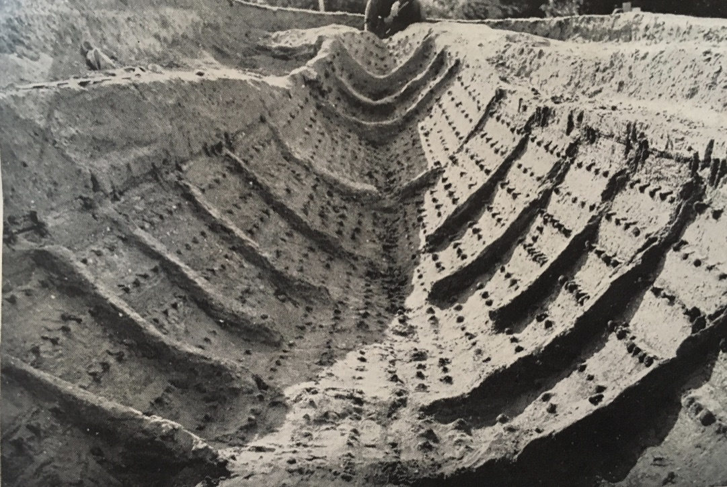
The Sutton Hoo Ship-Burial story is extraordinary and complex, commencing at a time of world uncertainty and tension at the outset of the Second World War. In this essay, the focus is on the ship itself and lessons learnt.
Discovery and Assessment
Sutton Hoo comprises a grouping of around 18 barrows situated on an escarpment overlooking the River Deben, Suffolk, on its east bank. They have aroused curiosity since at least 1600. Mrs Pretty owned Sutton Hoo and wanted to know what the barrows contained. She instructed a local amateur archaeologist, Basil Brown, to start excavating. Brown excavated three mounds in 1938, and the following year he excavated Mound 1 which was subsequently found to contain the Ship-Burial. Guy Maynard, the then Curator of Ipswich Museums, was asked to supervise and advise.
Excavation and Post-Excavation
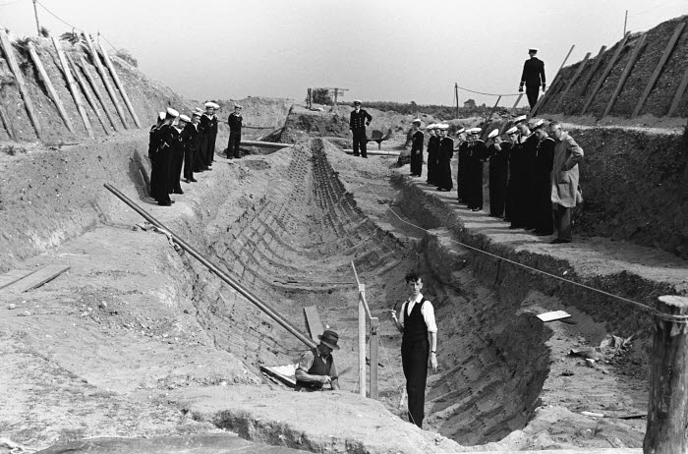
Shortly after starting the excavation, Brown found iron objects in the north side of his trench – iron clench-nails in situ – suggesting a large ship. The trench was enlarged and most of the forward part of the ship was cleared of in-filling. As they progressed along the ship, they came upon the bow end of the burial chamber with artefacts evident, and Brown and Maynard realised that the site was important (Phillips 1940). This was reported to the British Museum and the Ancient Monuments Department of the Ministry of Works. Within days, C W Phillips was asked to take over and complete the excavation, under the auspices of the Ministry of Works.
Excavation of ship 1939 (© British Museum)
The excavation became in effect an improvised rescue dig, because of the war, to be completed with no funding and in eight weeks (Carver 2004 p.11). Phillips took photographs and kept a diary. Phillips (1940) states that the ship was placed in a deep trench, tight at the stern end with only inches to spare and with space at the bow of around six feet. Bruce-Mitford (1979b) suggested the ship was hauled overland over a third of a mile from the tidal estuary of the River Deben. The supposition was that the ship was dragged up the escarpment and pushed forward on rollers until resting above the trench and then lowered slowly and carefully. Once the burial deposit was placed within the burial chamber, the ship was filled with sand. On excavation, there were no wooden remains, just a slight dark discolouration in the sand to signpost the ship’s timbers, with the sand being wet and firm enough to hold fast the nails and bolts in situ (Phillips 1940). The existence of the burial chamber was evident from thin stain-lines at right-angles to the keel-line at either end of the burial deposit amidships, these being the wooden end-walls spaced 6.75m apart. A gabled wooden roof over the chamber showed up as thin sloping lines of discolouration in the sand (Bruce-Mitford 1979b).
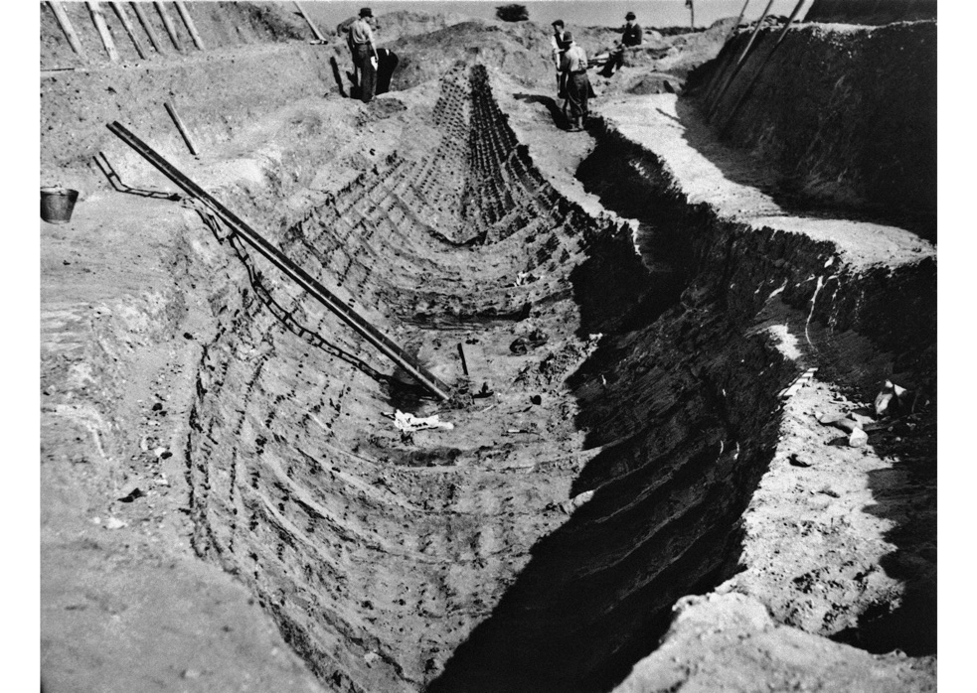
Phillips (1940) describes how he had a wide trench cut through the mound to give ample space on both sides of the ship trench, terracing the space and facing the sides with timber. The ship was then carefully emptied of its contents, starting with the burial chamber, with the contents being moved to the British Museum for emergency conservation treatment. Lieut-Commander J K D Hutchison of the Science Museum directed the excavation and study of the ship and he and Phillips continued their work. The burial deposit had rested directly on the bottom of the ship. Phillips (1940) suggested the burial chamber roof rested on the inside of the gunwale (similar to the Oseberg ship) as the gunwale appeared contorted suggesting pressure from within the ship. Phillips questioned whether this was a burial site and concluded it was more likely to be a type of cenotaph. Later sampling in subsequent excavations has identified areas of phosphate concentration which might indicate the presence of a body and the positioning of metal fixings might suggest a coffin, but the evidence is inconclusive, and a definitive answer awaits further detailed scientific research (Carver 2011).
View of ship (© British Museum)
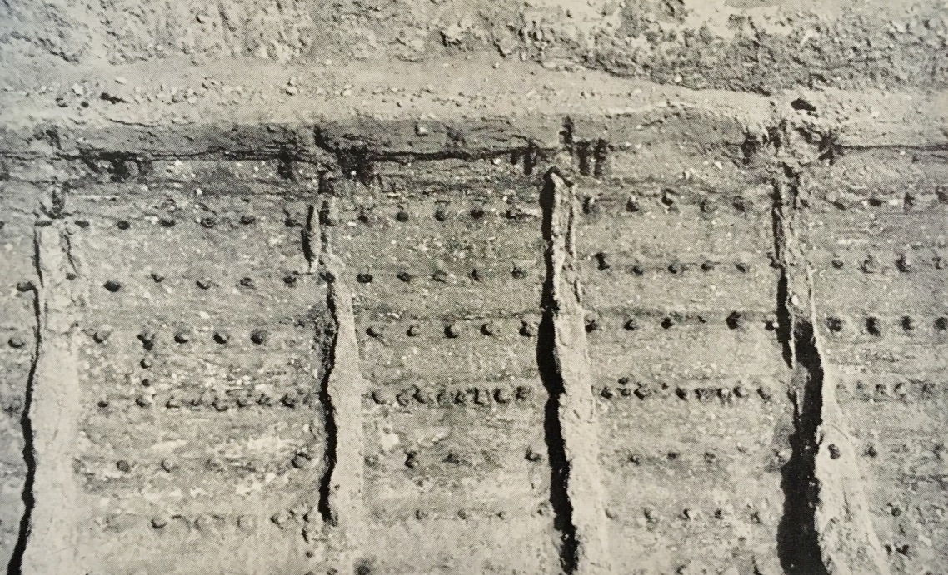
Phillips (1940) describes the ship as: a “great open rowing boat 80ft as traced in the ground”. The beam at its greatest was 14ft, depth 5ft, with a prow rising to a height of at least 12½ft above the keel plank amidships and drew 2ft of water when light. No official detailed plan was available from Hutchison in 1940. It was clinker built without permanent decking and carried no mast or other equipment. Its hull had 26 ribs. There were nine broad strakes on each side, including the gunwale. The strakes consisted of five planks each running the length of the ship and united by overlapping joints secured by clench nails (indicating a flush join). Phillips noted a similarity to the Nydam ship in Kiel Museum. He also felt it was an Anglo-Saxon ship from the details of its construction and its contents, although at the time there was a lot of Scandinavian interest and desire to claim it as a Viking ship (Bruce-Mitford 1949). Coins in the burial deposit provided a terminus post quem of 620-5AD, confirming Phillips’s hypothesis. Phillips describes the keel as being probably a keel-plank, with sections cut across giving no true keel projecting downwards. Between ribs 7 and 8 curving was seen with the scarves joining the posts to the keel fully established between ribs 3 and 4 forward and ribs 23 and 24 aft. Scarves were secured by 3 large vertical nails riveted over roves. Hutchison thought stealers were indicated fore and aft of these joints amidships. The gunwales were made of four pieces of wood, with tholes secured by pairs of long iron spikes. The thole bases were 3ft long, from the position of spikes, and abutted close, making a wale along the ship’s edge.
Port side of ship showing double nailing (photo C W Phillips 1940)
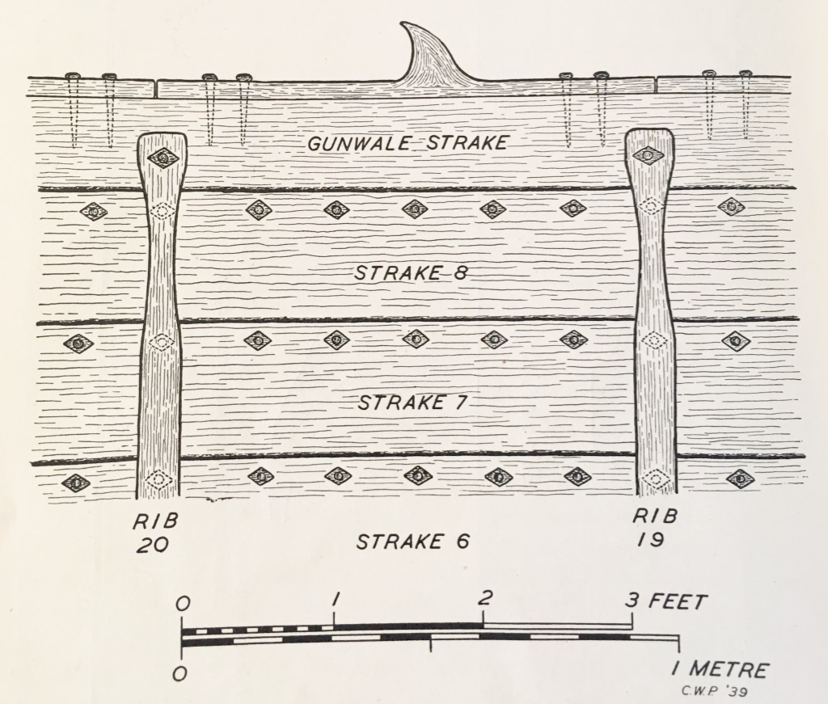
Phillips (1940) felt it was propelled by 38 oarsmen, with the actual number dependent on whether the tholes were in an unbroken sequence on each side of the boat. Angela Evans and Bruce-Mitford (1975) felt photographic evidence suggests the tholes did not run between ribs 10 and 17 (the burial chamber area) because of the lack of obvious vertical gunwale spikes. This contradicts Phillips (1940 p.187) “the spikes carried on through the burial chamber region…”. Evans and Bruce-Mitford had to rely on what photographic evidence is available because, on excavating in 1965-71, it was found that the gunwale and 7th and 8th strakes had either inwardly collapsed or been crushed. This is an interesting point and perhaps needs further investigation as replicas have been built and planned as sailing ships based on the latter interpretation.
Gunwale and strakes from inside (C W Phillips 1940)
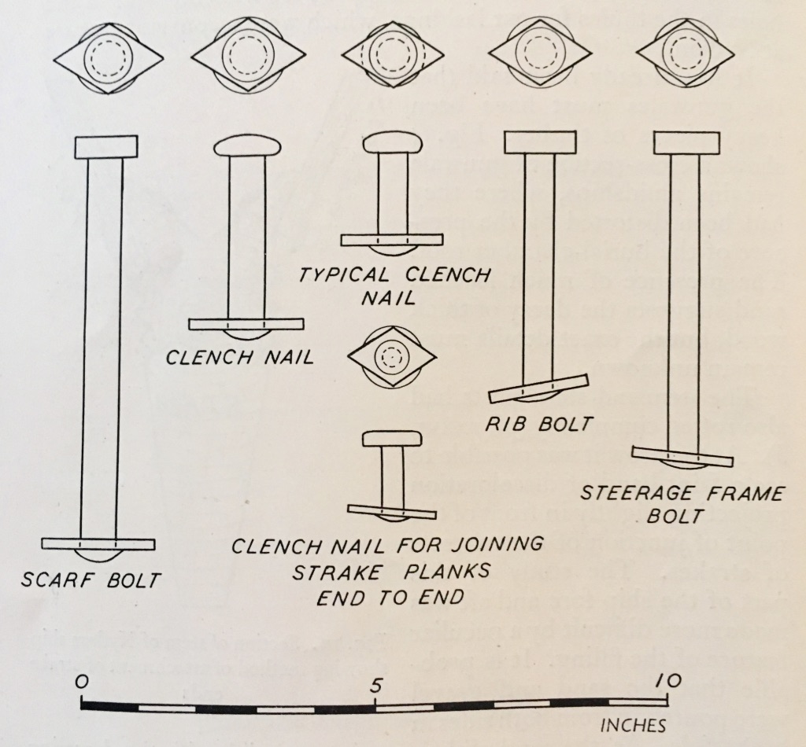
The prow showed as a faint band of discolouration projecting slightly forward of the junction of the two sets of strakes. The stern post was armoured on the outer edge with an iron strip. The clench nails were iron with domed heads. Their normal length was 2" and inside the nail was riveted over a diamond-shaped rove 2" by 1". Every rove was laid with its long axis fore and aft (Phillips 1940).
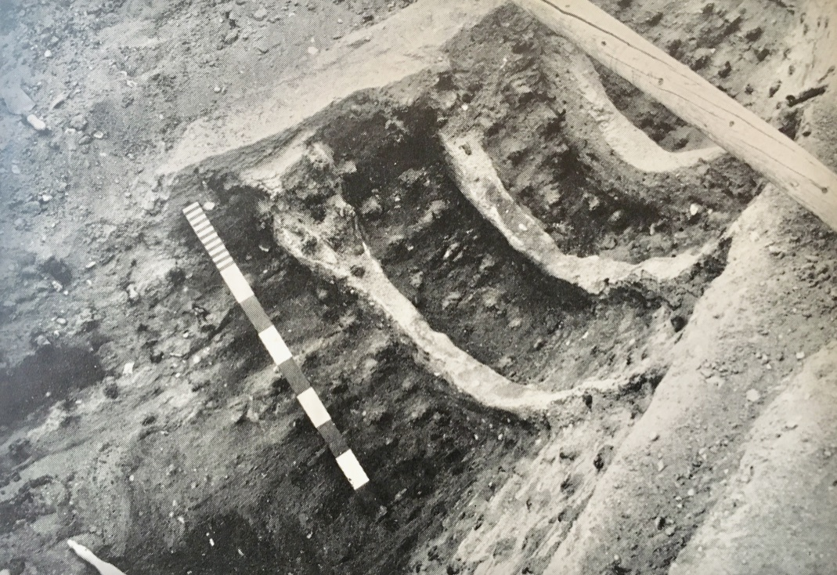
The 26 ribs were usually spaced 3ft apart, with the only marked spacing variation being in the bow and stern. They were secured at each end through the gunwales by clench nails. No trace of attachment remained between the two ends, nor was there evidence of thwarts or stanchions. Ribs 24 and 25 at the stern were closer and clubbed at the starboard side, secured to the ship by a quincunx arrangement of clench nails 5" long which infers additional strength for a steering oar arrangement, but no such steering oar was evident. The hull showed traces of repair, so the ship had been a working vessel. The stern was ploughed away but the gunwale lines of the ship show re-entrant curves fore and aft running almost parallel approaching the stern.
Sutton Hoo ship clench nails (C W Phillips 1940)
Ribs 24-26 in stern with quincunx arrangement (C W Phillips 1940)
Phillips’s (1940) assessment of the ship was that it was a beautifully designed and built vessel epitomising the peak of boat-building at the time. It bears similarities to the Nydam ship with advances in materials and design technologies, with the Sutton Hoo ship being stable and beamier with a sophisticated doubly re-entrant curve. It is evidently a high-status vessel for royal or noble patrons, built by highly-skilled shipwrights, but may well have been archaic when buried so might be evidence of an earlier tradition, and is not an example of everyday ships of its time. The excavation closed on 26 August, with no back-filling of the boat but instead filling to the gunwales with bracken and chestnut paling, sacking and throwing a broken gate on top (Bruce-Mitford 1975). The war started nine days later. In 1942, Sutton Hoo was requisitioned by the army for training purposes and tracked vehicles were driven through the boat-trench and slit trenches were dug into the mound.
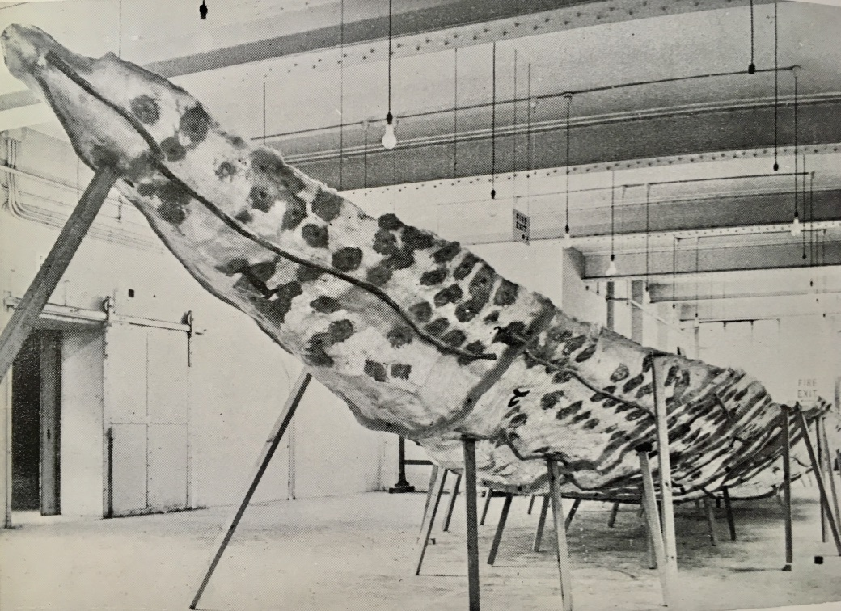
In 1946 R L S Bruce-Mitford started work at the British Museum with particular responsibility for Sutton Hoo and realised there were many questions concerning Sutton Hoo (Carver 2011). Therefore, the British Museum launched a return excavation from 1964-71. The ship was investigated using area excavation, re-recorded and a series of plaster casts were made from which a fibreglass cast was made. The excavators found the ship had been damaged by the army manoeuvres during the war which made the 1939 photographic record especially important.
Bruce-Mitford (1979a) considered important lessons were to be learnt from the 1939 excavation.
Fibreglass cast (Bruce-Mitford 1975)
New data was collected on re-excavation, and following decades of study, Bruce-Mitford (1975) published three volumes of comprehensive analysis of the Sutton Hoo burial-ship.
The 1983-2005 excavation was the first campaign to be awarded by winning a project design competition, as opposed to competitive tender or appointment of a director and subsequent planning. The applicants submitted a preliminary design, defending an outline proposal at interview – the winner named their price. This was an innovative approach with obvious benefits for the archaeology team but does not seem to have survived in today’s cash-strapped competitive market. Martin Carver won the project. He brought a systematic method to the excavation, following a series of protocols and analysing all of the data enabling a proposed programme providing a framework for the project itself (Carver 2011). The Field Reports make fascinating reading, containing historical records for all the excavations (ADS 2019). Exciting new finds from this excavation were a rich male burial and accompanying horse burial in Mound 17.
Analysis of finds continues with improved scientific techniques – an example is the identification of bitumen from the Middle East among the burial deposit, a prestige material highlighting the extensive network of links operating at the time (Burger et al 2016).

Conservation
Around 1,560 heavily oxidised iron rivets, bolts, gunwale spikes and one hull nail were found, removed to, and remain stored at the British Museum, as well as one plank-joint lifted intact in plaster in 1967 (Bruce-Mitford 1975). No other wood remained.
Publication
The first academic narrative was an account written by C W Phillips, the site director, of The Sutton Hoo Ship-Burial for The Antiquaries Journal (Vol XX No 2) appearing in April 1940. The value of this record is its immediacy to the actual excavation and the importance of having Phillips’s thoughts and impressions freshly chronicled, even if some of the conclusions were challenged following subsequent excavation. Phillips tries to give a layman’s account of the ship, pending future discussion and a full technical description written by experts. Unfortunately, this did not happen as the excavation notes and records regarding the ship itself were never found after the war.
In 1947 R L S Bruce-Mitford published The Sutton Hoo Ship-Burial – A Handbook for the British Museum which went through several impressions and editions, with the third edition being published in 1979. Bruce-Mitford published his preliminary thoughts and theories on The Sutton Hoo Ship-Burial in the proceedings of The Suffolk Institute of Archaeology (Vol 25 part I) in 1949. This was followed in 1975 by the first volume of his definitive collection of three volumes enumerating The Sutton Hoo Ship-Burial published by the British Museum. These volumes consider the evidence of the 1939 excavation, as well as taking account of new evidence and conclusions following the British Museum excavation of 1968-71 and are extremely comprehensive. However, it was felt at the time of publication that Bruce-Mitford inferred more than he should have, linking chronological evidence with Beowulf and identifying the ship with Raedwald, when the archaeological evidence was not necessarily definitive (Farrell 1977). In 1979, Bruce-Mitford wrote a monograph on The Sutton Hoo Ship-Burial – Reflections after Thirty Years published by the University of York Series 2, which was really a consideration of the ship-burial and its interpretation over a forty year period from its discovery in 1939 to its re-examination in the 1970s using new, and more refined, scientific techniques, and looking forward to the next phase of exploration.
The Archaeology Data Service website contains the excavation field reports for the 1983-2001 project directed by M Carver, and Carver produced a chapter on Sutton Hoo – An Archaeography in the 2011 edition of Great Excavations – Shaping the Archaeological Profession published by Oxbow.

Dissemination
The artefacts found in the burial deposit are displayed in the British Museum in London, to which they were very generously gifted by Mrs Pretty in 1939. Their central location means they may be viewed by many visitors and they are one of the Museum’s pre-eminent displays. The Sutton Hoo site itself is now owned by the National Trust and in 2002 a purpose-built visitor centre was opened. So, there is a disassociation between the site and the artefacts, with the site being in a relatively remote situation. Criticism has been voiced about the exhibition in the visitor centre (McAndrew 2003), with the site’s archaeology and history being of secondary value to the entertainment aspect, and reservations voiced about the interpretations presented as facts, such as showing a body in the burial chamber. The commodification of the site appears more important than presenting an accurate historical context. Disquiet has been voiced about the large amount of public lottery money spent by the National Trust on the project compared to the relatively tiny amounts available previously to the Sutton Hoo Research Trust, and about the lack of public transport and high charges, leading to less access to those of limited means to a site of such importance (McAndrew 2003).
Replica Construction
A full-size model of the ship was envisaged in the Sutton Hoo Research Trust 1992 management scheme, and, on the opening of the exhibition at Sutton Hoo, the National Trust promised to fund a sea-going replica (Kennedy 2002) but neither of these two ideas has materialised. The Woodbridge Riverside Trust (2019) has now set up The Sutton Hoo Ship’s Company to plan and build a replica ship, with the project overseen by Southampton University. A half-scale model, the Sæ Wylfing, has been built by Edwin and Joyce Gifford (1995), using shell-first construction with iron fastenings and willow treenails, based on the characteristics of the Sutton Hoo ship. Sæ Wylfing can be sailed and rowed, and the Giffords’ assessment was that the Sutton Hoo ship was a well-designed sailing boat, ideal for its purpose as a ship suited for shallow rivers and creeks and coastal waters. Although a full-size sea-going replica provides useful opportunities to test the data extrapolated and the ship’s seaworthiness, an exhibition containing a full-size replica would enhance the value of the on-site exhibition from both an educational and an experiential viewpoint.
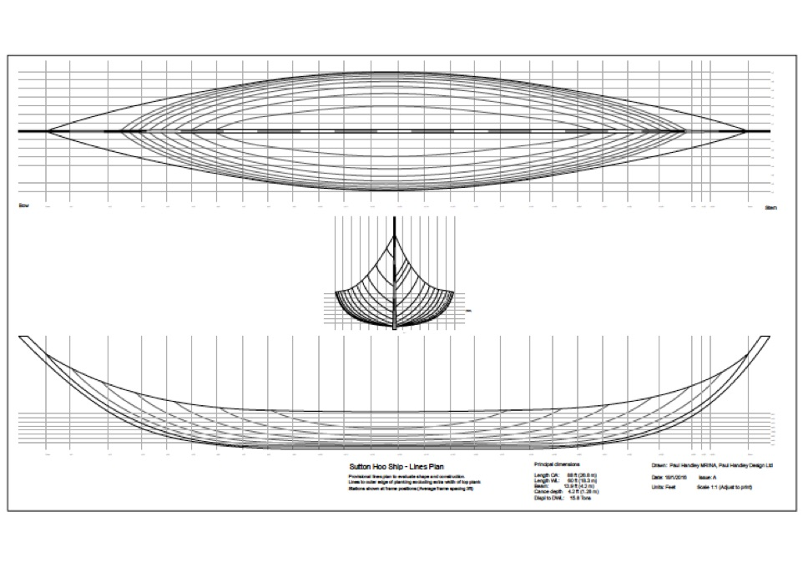
The Sutton Hoo Ship-Burial’s 1939 excavation can be seen as an example of tension between amateurs and professionals, of muddling through at a time of anxiety, of unsatisfactory record-keeping, and of mistakes made. This was the first British excavation of a ship of this size and it is easy in hindsight to criticise when the original participants were unaware of the importance of the site and its contribution to the study of Anglo-Saxon history. Many lessons have been learnt and other ship excavations have benefited from improved approaches and techniques. Sutton Hoo will continue to provoke debate and inform discussion and analysis despite the studies done in the past.
Plans for full-scale replica ship (Woodbridge Riverside Trust)

References
Archaeology Data Service 2019. The Archive of the Sutton Hoo Research Project 1983-2001 excavation. https://archaeologydataservice.ac.uk/archives/view/suttonhoo_var_2004/ [Accessed 12 February 2019]

Bruce-Mitford, R. L. S. 1949. The Sutton Hoo Ship-Burial. Proceedings of the Suffolk Institute of Archaeology 25 (Part 1).

Bruce-Mitford, R. L. S. 1975. The Sutton Hoo Ship-Burial Volume I: Excavations, Background, The Ship, Dating and Inventory. London: British Museum Publications Ltd.

Bruce-Mitford, R. L. S. 1979a. The Sutton Hoo Ship-Burial. Reflections after Thirty Years. University of York Monograph Series 2.

Bruce-Mitford, R. L. S. 1979b. The Sutton Hoo Ship Burial. A Handbook. London: British Museum Publications Ltd.

Burger, P., Stacey, P. J., Bowden, S. A., Hacke, M., Parnell, J. 2016. Identification, Geochemical Characterisation and Significance of Bitumen among the Grave Goods of the 7th Century Mound 1 Ship-Burial at Sutton Hoo (Suffolk, UK). PLoS ONE 11(12).

Carver, M. 2004. Sutton Hoo Field Reports 1983-2001. Sutton Hoo Research Project. https://archaeologydataservice.ac.uk/archives/view/suttonhoo_var_2004/ [Accessed 12 February 2019]

Carver, M. 2011. Sutton Hoo – An Archaeography. In: Schofield, J. (ed.) Great Excavations. Shaping the Archaeological Profession. Oxford: Oxbow.

Farrell, R. T. 1977. The Sutton Hoo Ship-Burial. I: Excavations, Background, The Ship, Dating and Inventory by Rupert Bruce-Mitford. Speculum 52 (No 4) (Oct 1977): 932-935.

Gifford, E. & J. 1995. The Sailing Characteristics of Saxon ships as derived from half-scale working models with special reference to the Sutton Hoo ship. The International Journal of Nautical Archaeology 24.2: 121-131.

Kennedy, M. 2002. Sutton Hoo Lays out its Treasures. The Guardian. 14 March 2002. http://www.guardian.co.uk/uk_news/story/,3604,667034,00.html [Accessed 19 February 2019]

McAndrew, D. 2003. Whose Hoo? A Review and Critique of: “Sutton Hoo”, Sutton Hoo National Trust Visitor Centre, Sutton Hoo, Suffolk. Institute of Archaeology 14: 136-143.

Phillips, C. W. 1940. The Sutton Hoo Ship-Burial. The Antiquaries Journal XX (No. 2) April 1940.

Woodbridge Riverside Trust. 2019. Website for the site including links to the half-size replica ship, the project for the full-size replica ship, and about the ship itself. https://www.woodbridgeriversidetrust.org/ [Accessed 15 February 2019]

Bibliography
Archaeology Data Service 2019. The Archive of the Sutton Hoo Research Project 1983-2001 excavation. https://archaeologydataservice.ac.uk/archives/view/suttonhoo_var_2004/ [Accessed 12 February 2019]

Bruce-Mitford, R. L. S. 1949. The Sutton Hoo Ship-Burial. Proceedings of the Suffolk Institute of Archaeology 25 (Part 1).

Bruce-Mitford, R. L. S. 1975. The Sutton Hoo Ship-Burial Volume I: Excavations, Background, The Ship, Dating and Inventory. London: British Museum Publications Ltd.

Bruce-Mitford, R. L. S. 1979a. The Sutton Hoo Ship-Burial. Reflections after Thirty Years. University of York Monograph Series 2.

Bruce-Mitford, R. L. S. 1979b. The Sutton Hoo Ship Burial. A Handbook. London: British Museum Publications Ltd.

Burger, P., Stacey, P. J., Bowden, S. A., Hacke, M., Parnell, J. 2016. Identification, Geochemical Characterisation and Significance of Bitumen among the Grave Goods of the 7th Century Mound 1 Ship-Burial at Sutton Hoo (Suffolk, UK). PLoS ONE 11(12).

Carver, M. 2004. Sutton Hoo Field Reports 1983-2001. Sutton Hoo Research Project. https://archaeologydataservice.ac.uk/archives/view/suttonhoo_var_2004/ [Accessed 12 February 2019]

Carver, M. 2011. Sutton Hoo – An Archaeography. In: Schofield, J. (ed.) Great Excavations. Shaping the Archaeological Profession. Oxford: Oxbow.

Farrell, R. T. 1977. The Sutton Hoo Ship-Burial. I: Excavations, Background, The Ship, Dating and Inventory by Rupert Bruce-Mitford. Speculum 52 (No 4) (Oct 1977): 932-935.

Gifford, E. & J. 1995. The Sailing Characteristics of Saxon ships as derived from half-scale working models with special reference to the Sutton Hoo ship. The International Journal of Nautical Archaeology 24.2: 121-131.

Kennedy, M. 2002. Sutton Hoo Lays out its Treasures. The Guardian. 14 March 2002. http://www.guardian.co.uk/uk_news/story/,3604,667034,00.html [Accessed 19 February 2019]

McAndrew, D. 2003. Whose Hoo? A Review and Critique of: “Sutton Hoo”, Sutton Hoo National Trust Visitor Centre, Sutton Hoo, Suffolk. Institute of Archaeology 14: 136-143.

Myres, J. N. L. 1977. Reviews of Books: The Sutton Hoo Ship-Burial, vol I by Rupert Bruce-Mitford. The English Historical Review XCII(CCCLXV): 847-851.

Phillips, C. W. 1940. The Sutton Hoo Ship-Burial. The Antiquaries Journal XX (No. 2) April 1940.

Van Geersdaele, P. C. 1969. Moulding the Impression of the Sutton Hoo Ship. Studies in Conservation 14(4): 177-182.

Van Geersdaele, P. C. 1970. Making the Fibre Glass Replica of the Sutton Hoo Ship Impression. Studies in Conservation 15(3): 215-220.

Woodbridge Riverside Trust. 2019. Website for the site including links to the half-size replica ship, the project for the full-size replica ship, and about the ship itself. https://www.woodbridgeriversidetrust.org/ [Accessed 15 February 2019]

