Welsh Marking During Placement.

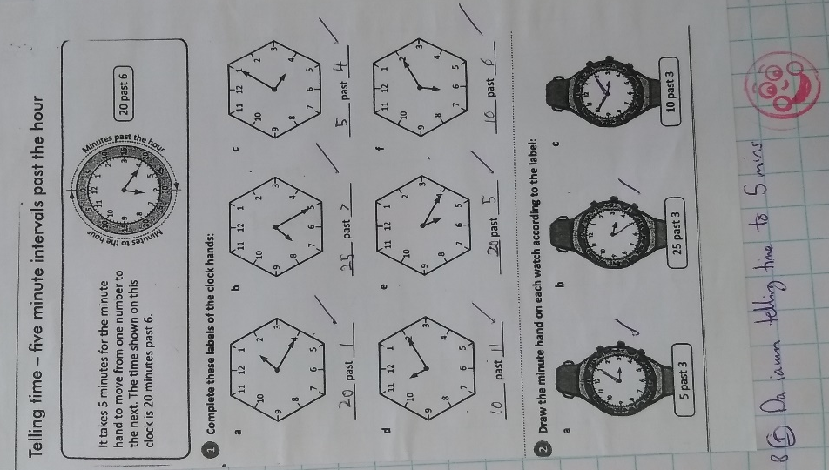
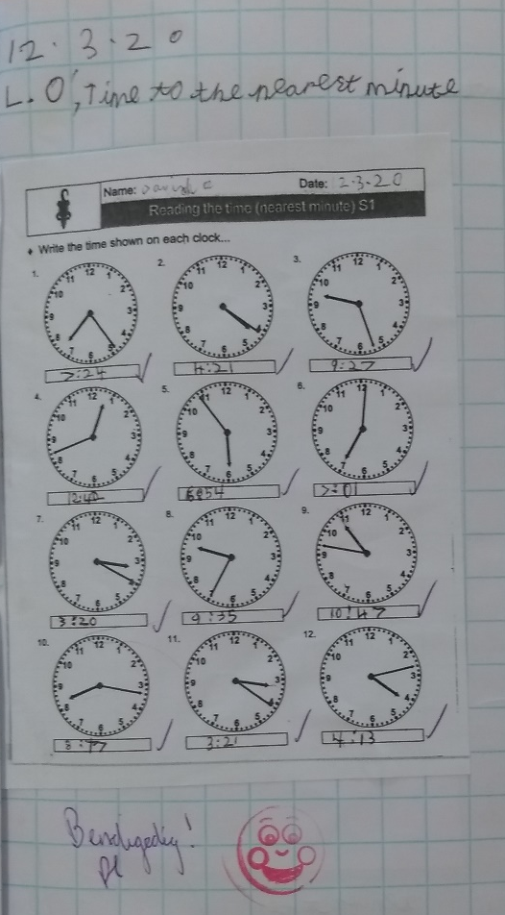
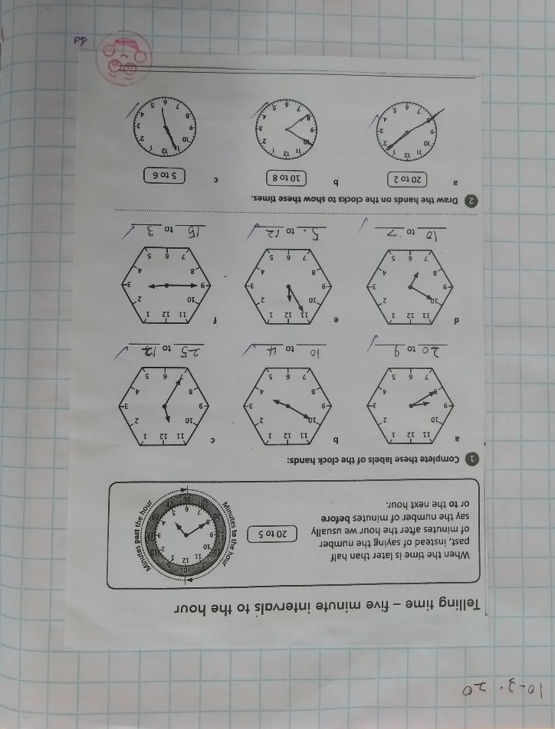
During placement I marked lots of work that I, or my class teacher planned, and throughout the four weeks I made sure to use Welsh in every work I marked. Here are some examples of the work I have marked:
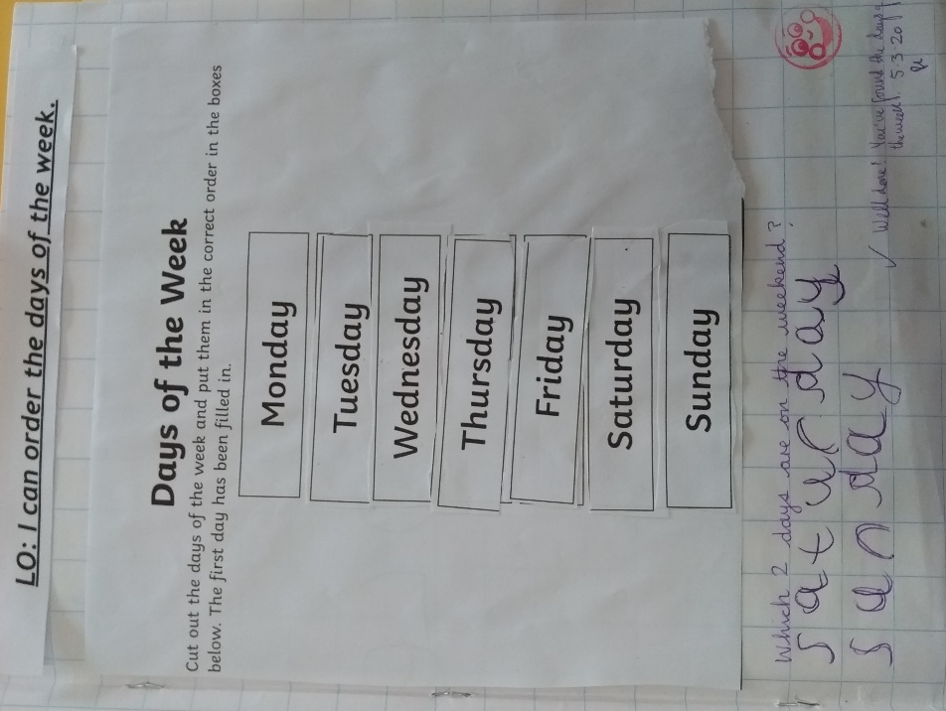

These are all during my maths lessons.
- Picture 1 – This was the first maths lesson I taught, days of the week, and first book I marked.
- Picture 2 – This was a maths lesson during week 3 about time.
- Picture 3 – This was the lesson before picture 2.

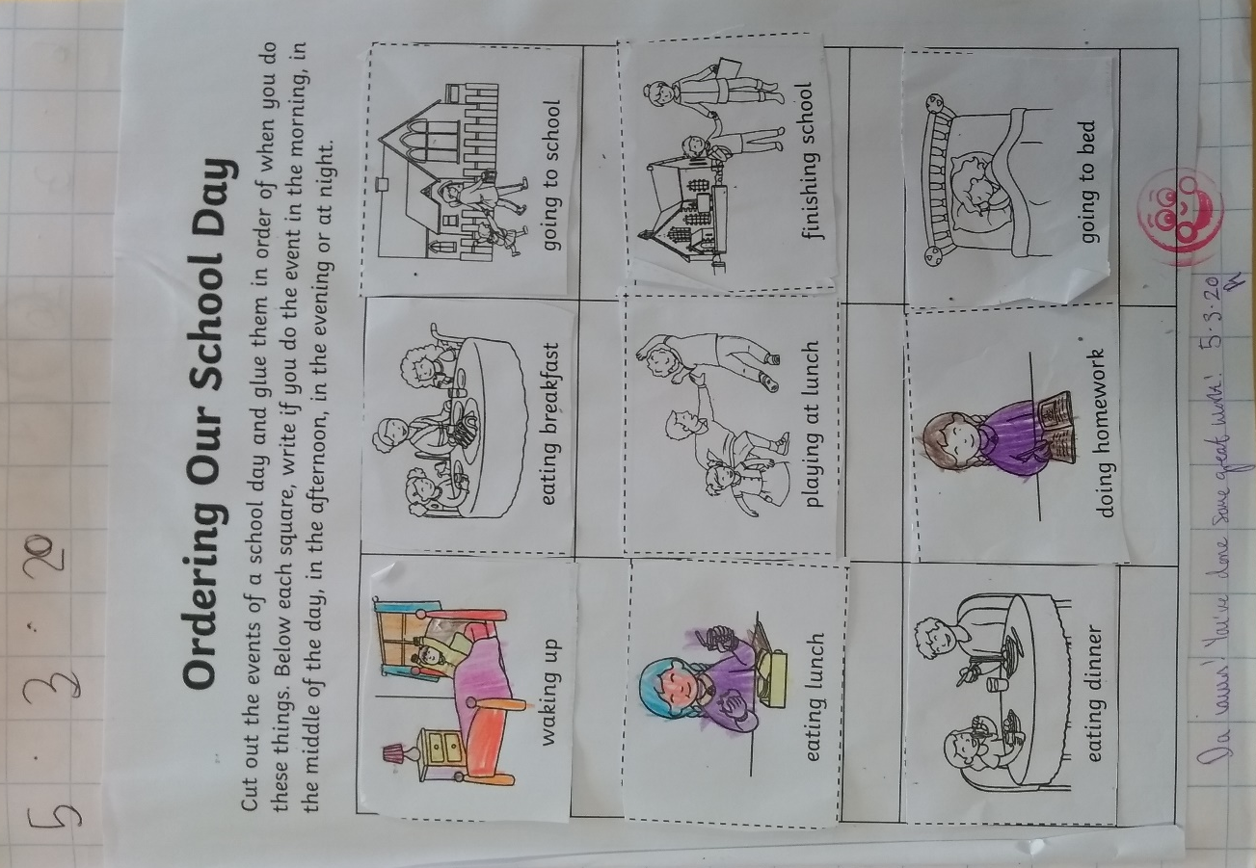

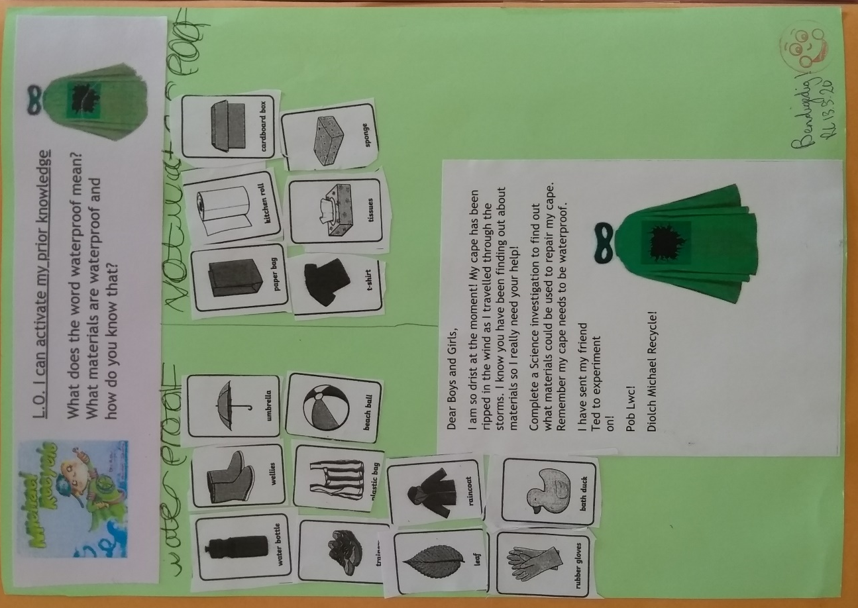

- Picture 4 – This is a maths lesson on the second week about ordering the school day.
- Picture 5 – This is a science lesson about being waterproof taught on week 3.

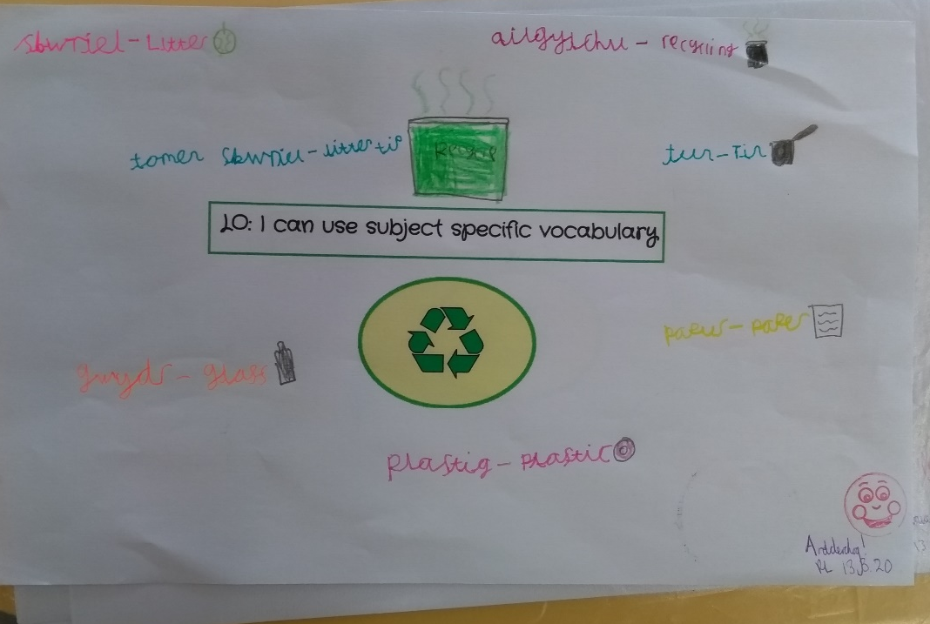

- Picture 6 – this is a topic lesson that involves finding Welsh words, translating and drawing the words.

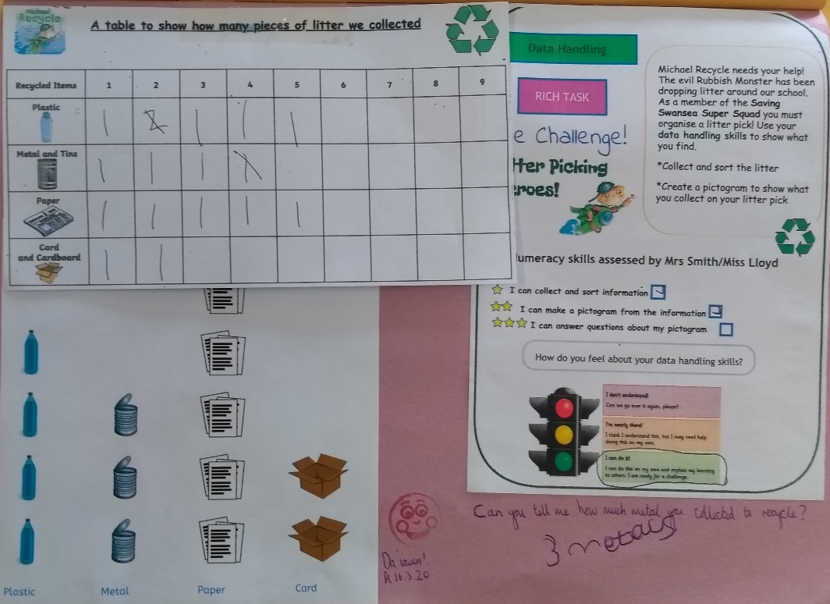

- Picture 7 – This is a maths lesson on data handling relating to the topic of recycling and sustainability.

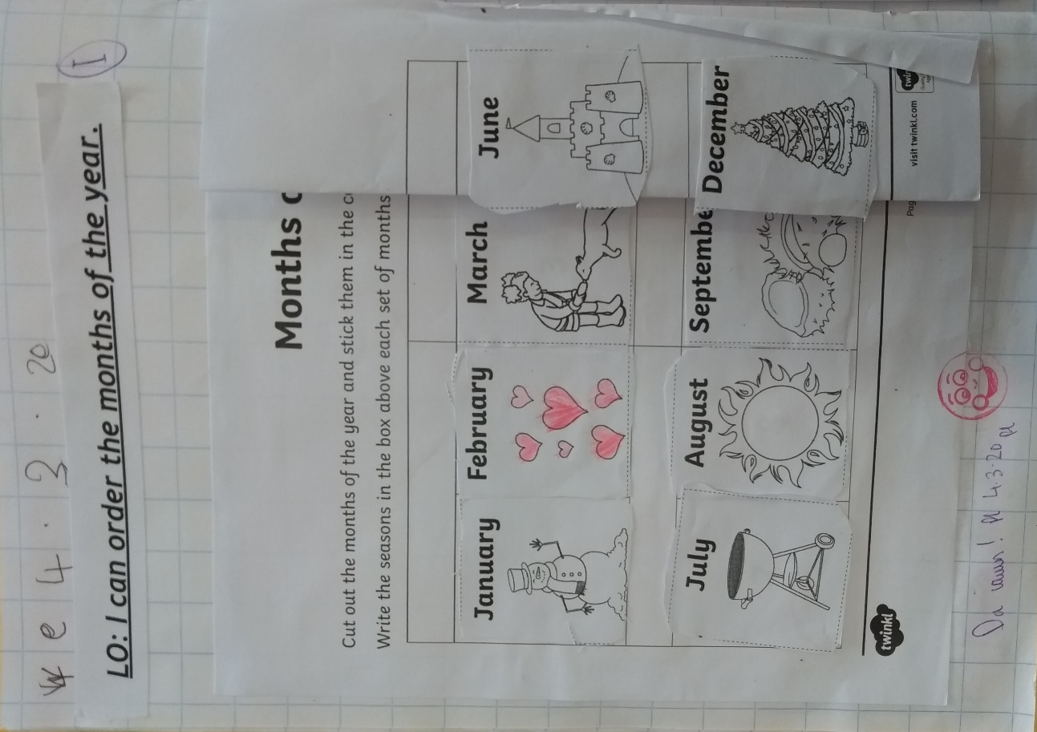
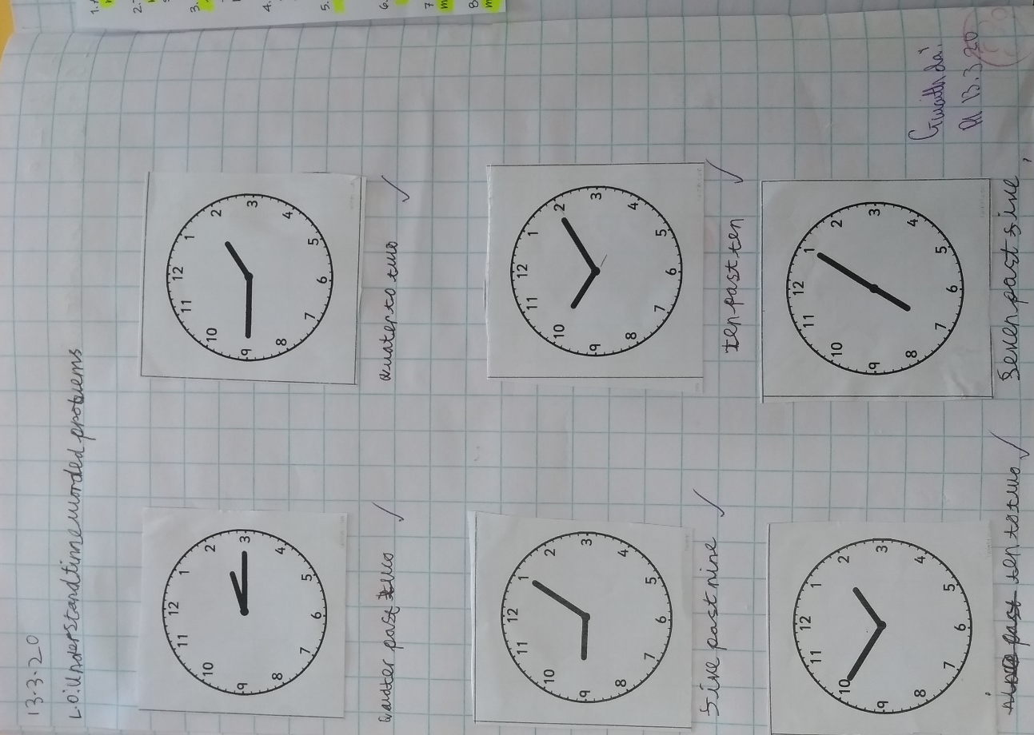
- Picture 8 – This is a maths lesson on times on an analogue clock.
- Picture 9 – This is a maths lesson from the second week about months of the year.

