How a school develops one aspect of its School Development Plan (SDP). A report that critically reflects on the actions, impact and evidence base.

Yr Athrofa – University of Wales Trinity Saint David
PGCE Secondary
1701828

Contents:

- Introduction
- Literature Review
-School development plan
- Developing Literacy: Action Point
- Developing an action point
- Reflection and Evaluation
- Conclusion
- Reference List
- Appendices

- Introduction

This reflective report will look at how a School Development Plan (SDP) is constructed whilst identifying how the school develops one aspect of the SDP. The SDP will be critically explored to address how the target/action point was addressed and the impact of the action point measured with an evidence-based framework. A critical focus on key literature and findings will be used to identify the development of the specific action. Therefore, the specific action will be a focus on additional literacy catch up sessions as part of the schools SDP target and action point. This also aligns with Donaldsons (2015) Curriculum for Wales that ensures schools SDP’s support learners to make progress whilst contributing to the four purposes of the curriculum (Welsh Government, 2022). The SDP used in this report is from a 11-18 English medium mixed comprehensive school based in South Wales, with approximately 1,121 pupils on roll, including 229 sixth form students (Estyn, 2020). The pupils come from surrounding areas of the school in a relatively affluent area with around 8.5% of pupils eligible for free school meals, which is significantly lower than national average in Wales which is 16.4%. The school also has around 9% of pupils who are on the special education needs register, which again is relatively low compared to national average of 23% and 93% of pupils are from White British ethnic background with only 3% of pupils who have English as an additional Language (Estyn, 2020).

- Literature Review

School Development Plan

A school development plan (SDP) is a school’s strategic plan set out for improvement (Welsh Government, 2014). It is a key strategy for school improvement and these plans enable the school to organise what it is already doing and what it needs to do in a more purposeful and coherent way (Davies and Ellison, 2003). The SDP’s purpose is to help schools give learners the best possible learning experiences and outcomes, whatever their background (Welsh Government ,2022). It has been found that the momentum and push for improvement as a school must come from the school’s leadership team (McAleavy et al, 2016). The leadership team will then create a development plan that is informed by regular self-evaluation of the schools’ performance and outcome which includes looking at data to identify the school improvement priorities and short-term/long-term targets (Welsh Government, 2014). Self-evaluation will entail members of staff in the school reflecting on their practice and identifying areas for improvement in pupil and professional learning (Goldstone, 2022). The SDP was recently changed from the School Development Plan Guidance (2014) to the School Improvement Plan Guidance (Welsh Government, 2022). Therefore, it is now called School Improvement Plan (SIP) and shows what the school must and should do in order to improve (Welsh Government, 2022). Whilst changes have been made to the School Improvement Guidance , it is important to note that schools are being explored as learning organisations according to Education Wales (2019) this includes a self-improving system , where schools can try out new ways of working and adapt to any changes, therefore schools will work together and improve by exploring what bests suits the school and the learning which is a co-constructed process so everyone in the organisation is involved. This suggests that the change to learning organisations allows all staff to be involved with the improvement to develop an effective improvement plan. similarly, the SIP will support the principles and practices of the Curriculum for Wales which will ensure raised standards and aspirations for all (Welsh Government, 2022).

Developing Literacy- Action Point

Literacy improvement is a key focus of the Curriculum for Wales where a Literacy Framework has been embedded into the curriculum (Donaldson, 2015). Literacy should be at heart of the curriculum and schools should plan and develop literacy skills across the school (Welsh Government, 2022). This is reinforced by Merga et al (2021) who states that Literacy development is important in schools as meeting students’ literacy needs and building literacy skills is expected to be a whole school priority. The Education Endowment Foundation (2019) state that literacy is essential for success in school and later life, if students have poor literacy skills, they will be unlikely to access the challenging academic curriculum in secondary school. Therefore, this suggests that literacy development is important in schools. Literacy has been defined as a process of using reading, writing and oral language to construct, integrate and critique meaning through interactions (Lupo et al , 2023). Therefore, literacy gaps have become more apparent through secondary school over the years, as the gap between struggling readers and capable students widens as they pupils move through the school years (Merga, 2020). Therefore, it is important for schools to support the students that are struggling with literacy ensuring there’s additional support, A tier of support approach will improve literacy skills in secondary school, this includes whole class teaching, small group tuition and 1 to 1 support depending on the literacy levels of pupils (Education Endowment Foundation, 2019). This approach allows for literacy gap to decrease. The learners that have low literacy levels need the more specific support, it has been found that adopting a more targeted, instructional approach in the educational setting, is appropriate and effective to meet the needs of the struggling learners (Duffy, 2007). However, the targeted support cannot be given without assessment, an assessment can identify the students who require additional support as well as identifying where the supported should be targeted (Education Endowment Foundation, 2019) For Example the areas could include reading, writing, oracy and communication. Therefore, it has been found that schools who focus on developing literacy and providing the support to the students who need it are the most effective for pupils learning and well-being. (Estyn,2020). However, a barrier schools face with additional literacy support is motivating the students who need that support to engage with literacy interventions or 1 to 1 support (Education Endowment Foundation ,2019). Similarly, it is difficult to get a whole school support on developing literacy across the curriculum as many teachers feel they do not have the time or capacity to engage with developing literacy in their lessons (William and Wavell, 2007). Therefore, it is important that literacy is a whole school improvement approach to allow students to have the opportunity to use the skills they are developing in interventions and additional support session within the classroom setting and across different subjects (Education Endowment Foundation ,2019).

- Developing an Action Point

To ensure a school development plan is effective and enable improvement, a robust self-evaluation by schools is fundamental (Welsh Government, 2022). Therefore, the SDP used for this report was created over a one-year time frame which allows the school to evaluate the plan after an academic year to identify any improvements to include in the next academic year’s plan. Whilst the time frame allows the school to undertake a self-evaluation, the one-year time frame is also quite limited in terms of how successful that target will be after one academic year, compared to a longer time frame with evaluations in between. The Welsh Government guidelines (2022) also suggest that a schools SDP should cover a period of 3 years to allow effective evaluation of the targets and action plans set. The target that was focused on from the SDP was learner recovery progress with the action to continue to use the RRRS grant (Recruit, Recover and Raise Standards) to support learners with additional sessions for literacy with catch up sessions and the curriculum (See appendix A). Therefore, with this one-year SDP they wanted to support learners who are struggling with literacy to improve literacy across the school. To get to this target the school used the school development planning cycle from the SDP guidance by Welsh Government (2014). Whilst there is new guidance out the cycle is still relevant for school improvement planning as it is effective to enable improvement.
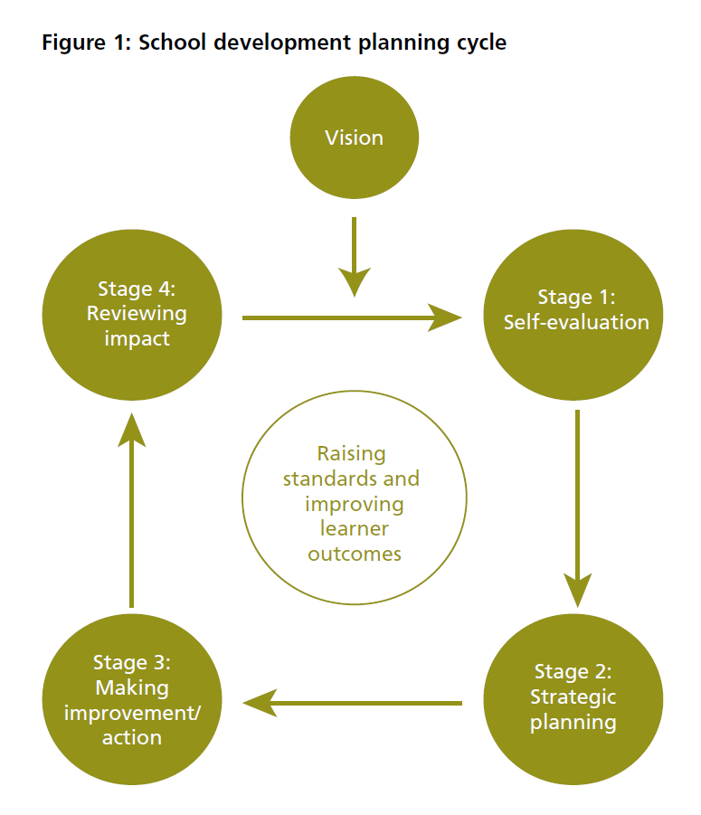

Figure 1: Welsh Government 2014

The first section of the cycle has a focus on self-evaluation where the school reflects and decides what is an area for improvement (Welsh Government, 2014). whilst an effective self-evaluation can identify areas for improvement it can also identify strengths which also allows for system-wide improvement (Welsh Government, 2022). For the specific target chosen in this report, the school used their Estyn inspection where Estyn recommended the school to reduce the variation in the quality of teaching and assessment, to focus on the development of pupils’ literacy skills across the curriculum (Estyn, 2020). Therefore, combined with Estyn’s recommendation, the school used the capped 9 scoring system to identify literacy as an area of improvement which was disputed by Teacher X (2023). The school then took on board the findings from the self-evaluation and began stage 2 of the cycle, strategic planning. Strategic planning is very important in the process of school improvement planning as it allows the organisation to identify where it wants to go , what is needed to get there and how to review if it achieves (McNamara , 2003 as cited by Fernandez, 2011). Therefore, the school had to plan effectively ensure all school partners and stakeholders were involved (Welsh Government, 2014) , this includes parents , governors and the community to allow for progress. The target to develop literacy was then used to identify different approaches that would help improve literacy across the school as part of their post inspection action plan (PIAP) as part of the requirement from Estyn (Welsh Government 2014). Therefore, the school identified two members of staff who are part of the Senior Leadership Team to oversee the target and create a strategy that will ensure success, this included looking at struggling learners first to allow improvement for the learners who’s literacy levels were low across the board as well as a whole school improvement approach , this is reinforced by Education Endowment Foundation (2019) who state that literacy skills are important in school and later life , therefore improving pupils literacy skills allows them to access the challenging curriculum successfully. Whilst this is an effective approach to improving literacy skills it is important that literacy is still developed across the school in all subjects to allow students to use the skills, they have learnt with literacy support in their lessons (Education Endowment Foundation, 2019).

Therefore, the third section of the cycle highlights the importance of making improvements and action, where the strategies from the SDP are put into action (Welsh Government, 2014). This included a tier approach for struggling students, including some 1 to 1 literacy support, group literacy sessions and general development throughout the school depending on literacy levels that were identified through capped 9 scores and begging of the year assessments. This is reinforced by Education Endowment Foundation (2019) who suggest a tiered approach will have a positive impact on literacy improvement in secondary schools. However, whilst this is an effective approach, a barrier to this approach is whether all staff were willing to improve literacy in their lessons and the cost of providing additional interventions for the students who are struggling, did there need to be someone hired to take the interventions or did it include taking someone internal off a full timetable to provide the interventions and 1 to 1 support for students. Therefore, the school used the RRRS Grant to help with any costs that the action point needed and undertook ab Cross-Curricular inset day which allowed all staff to engage with the target and prepare for improving literacy in their lessons (Teacher X, 2023). Whilst the sessions were up and running, it is also important to think about whether students who need the support will actually be motivated to engage with it, this is reinforced by Duffy (2007) who states that struggling students need the additional literacy support in order to meet their needs however Educational Endowment Education (2019) stated that some students may find it difficult to engage with the additional support , this suggests that if students are not engaging with the additional literacy support , the action point won’t be successful.

After the target and action point has been tested and put into action, the next stage is to review the impact it has had, this is because an SDP should be considered a document that is regularly monitored (Welsh Government, 2014). This allows the school to identify what has worked and what needs to be done in a more coherent and purposeful way (Davies and Ellison, 2003). For this specific action point, two reviews are included to allow for change or to see whether improvement has been made. The school will review after the academic year as the SDP is over a one-year time frame this also included a review at the middle of the academic year to see if there are any changes that needed to be done. The head teacher will sit down with appropriate stakeholders and review the action point to see whether it has been successful for learner progression. This is reinforced by Welsh Government (2014) who state that leadership team and the governing body must monitor a, review and update the school development plan annually as a minimum. Therefore, the school is effectively reviewing their SDP annually and specifically reviewing the action point twice a year by undertaking book looks to see whether literacy has improved, pupil voice and teacher voice evaluation to see whether the learners and the staff have a positive outlook on the action and tracking assessment data to see improvements across the school including the students who get the additional literacy sessions (Teacher X, 2023).

- Reflection and Evaluation

After engaging with the school development plan, it was clear that the school is successfully reviewing the SDP annually In line with Welsh Government (2014) guidelines however, the one-year time frame is not effective in successfully hitting the target as it has been found SDP’s covering a 3-year period are more effective in student progression (Welsh Government, 2022). This is something that could be considered in future practice as a target that is significantly widespread across the whole school will need time to become effective and successful. Additionally, the school development plan allowed for professional improvement as engaging with the SDP allowed for future engagement with a schools SDP more positive and successful. Similarly, the target and action point focus more on additional support for learners who are struggling rather than a whole school literacy improvement. Whilst research has suggested tiered approaches to improving literacy are important and this includes additional literacy support for students who need it (Education Endowment Foundation ,2019) , it could potentially be more successful if literacy was a key focus in subjects for pupils to be developing literacy skills that are transferable in every subject as it is important to meet every students literacy needs (Merga et al , 2021) This is also important to take forward in to future practice as literacy is an important aspect of the Curriculum for Wales (Donaldson , 2015) with a focus on a whole school cross-curricular approach. A benefit to a whole school literacy improvement focus also allows pupils to engage with literacy development which will allow the students who do receive additional literacy support to engage with literacy and use the skills learnt in lessons just like all the other students in their class. This informs future practice as literacy improvement within science will allow students to engage with their own development and use transferable skills from their support sessions in the lesson, this could include spelling scientific words correctly, using punctuation and grammar when writing a sentence in their books and arguing their point correctly in a class discussion. Therefore, in future practice literacy is important within the classroom to allows students to develop especially if it apart of the school improvement plan.

- Conclusion

To conclude, a school development plan Is important for learners’ progression and learning and without a whole school commitment and involvement from all stakeholders the improvement will not be successful (Welsh Government, 2022). similarly, Literacy is at the heart of the Curriculum for Wales and is an improvement approach for many schools (Donaldson ,2015) therefore allowing literacy to be a whole school priority rather than just a priority for specific students it ensures improvement for all learners but also ensuring the struggling students still get the additional sessions to catch up with the curriculums challenges and allow for a successful education for all abilities. Lastly, allowing evaluation annually of the school’s development plan ensures the improvement is being reviewed and changes are made if needed to keep up with societal changes and provide the best education for learners (Welsh Government ,2022).

Word Count: 2,718 Words

- .Reference List

Bubbins.M.,(2019) ‘Exploring schools as Learning Organisations’ , Education Wales. [Podcast]. Available at: https://www.spreaker.com/user/bengomedia/acew-slo-english-edit-2. (Accessed: April, 6 , 2023).

Davies, B. and Ellison, L., 2003. The new strategic direction and development of the school: Key frameworks for school improvement planning. Psychology Press.

Duffy, H., 2007. Meeting the needs of significantly struggling learners in high school: A look at approaches to tiered intervention. National High School Center.

Estyn, 2020. A report on *********************. Her Majesty’s Inspectorate for Education and Training in Wales.
Estyn, 2020. Effective school support for disadvantaged and vulnerable pupils – case studies of good practice.
Fernandez, K.E., 2011. Evaluating school improvement plans and their affect on academic performance. Educational Policy, 25(2), pp.338-367.
Goldstone, R. (2022) School self-evaluation for School Improvement: Principles of effective practice, BERA. Available at: https://www.bera.ac.uk/blog/school-self-evaluation-for-school-improvement-principles-of-effective-practice (Accessed: April 4, 2023).
Lotta Haglund and David Herron (2009) ‘Secondary School Teachers Don’t Have Time to Engage in the Most Important Aspects of Information Literacy Due to Curricular Pressures. A Review of: Williams, D. and C. Wavell. “Secondary School Teachers’ Conceptions of Student Information Literacy.” Journal of Librarianship and Information Science 39.4 (2007): 199-212’, Evidence based library and information practice, 4(1), pp. 29–31.
Lupo, S.M. et al. (2023) ‘Literacy Intervention in Secondary Schools: Exploring Educators’ Beliefs and Practices about Supporting Adolescents’ Literacy Learning’, Journal of teacher education [Preprint]. Available at: https://doi.org/10.1177/00224871231156371.
McAleavy, T., Riggall, A. and Fitzpatrick, R.,2016. Rapid School Improvement Report. Education Development Trust
Merga, M.K., 2020. “Fallen through the cracks”: Teachers’ perceptions of barriers faced by struggling literacy learners in secondary school. English in Education, 54(4), pp.371-395.
Merga, M.K., Roni, S.M. and Malpique, A., 2021. School leadership and whole-school support of struggling literacy learners in secondary schools. Educational Management Administration & Leadership, 49(3), pp.534-550.

Quigley, A. and Coleman, R., 2019. Improving Literacy in Secondary Schools. Guidance Report. Education Endowment Foundation.
Teacher X (2023) Conversation to Student Teachers. 27 March.
Welsh Government (2014). School development plans guidance

Welsh Government (2022). School Improvement Guidance. A framework for evaluation, improvement and accountability.
Welsh Government, (2022) Languages, literacy and communication: Designing your curriculum, Hwb. Available at: https://hwb.gov.wales/curriculum-for-wales/languages-literacy-and-communication/designing-your-curriculum (Accessed: April 7, 2023).

- Appendices

Appendix A
Development Priority | Action Point/Task | Lead Person/Team | Resources and Professional development | Cost | Funding Support | Time Scale for Completion | Impact Evaluation and Evidence | R  A  G
D. Learner Recovery Progress | Continue to use the RRRS grant to support learners with additional literacy sessions and whole curriculum catch up. | CAP -Deputy Head  AOB- Deputy Head  SLT Links | Time  Resources |  | RRRS Grant | September 2022 Start  August 2023- Completion | Sessions delivered to pupils  Analyse Outcomes / Pupil Voice / Staff voice.  Assessment Results.

