Economics
of
sustainability
BMSP6007

Introduction
This report will include the findings of the World Economic forum (WFE). The report will go into detail on what the world economic forum is and what it is designed for. Following this the report will look in to the future as far as the next ten years and what possible risk are included in the forum. The report will then go on to explain the importance of sustainable development.

World Risk Report
The World Economic forum release a World risk report on an annual basis. The report is not independently verified however it has been put together by sources from authors that they believe to be accurate. This report is helped by independent organisations who challenge the constant changes of the environment. This report is not to be used as facts. The content of the report is designed to make the population aware of potential unaware/new risks. The organisations taking part will not take any responsibility in reliance to this report as it is designed to show possible future risks.

Future
The outlook of the next ten years has many possible risks. Two of the main risks this report has focused on is Natural resource crisis and Biodiversity.
Natural resource crisis – This involves a rapidly growth in population. The population needs to have food, and this needs natural resources. The natural resources are being stretched to their limits as the population continues to grow rapidly. Another huge impact on natural resource is climate change. Climate change is causing the population to use up natural resources in a bid to cushion the effects of climate change. Disposal of pollutions into the natural environment are having a huge impact on this issue causing contamination of soil, air and seas. The world bank also reported that the total loss of global forest between 1990 and 2016 was 1.3 million square kilometres (R2020).
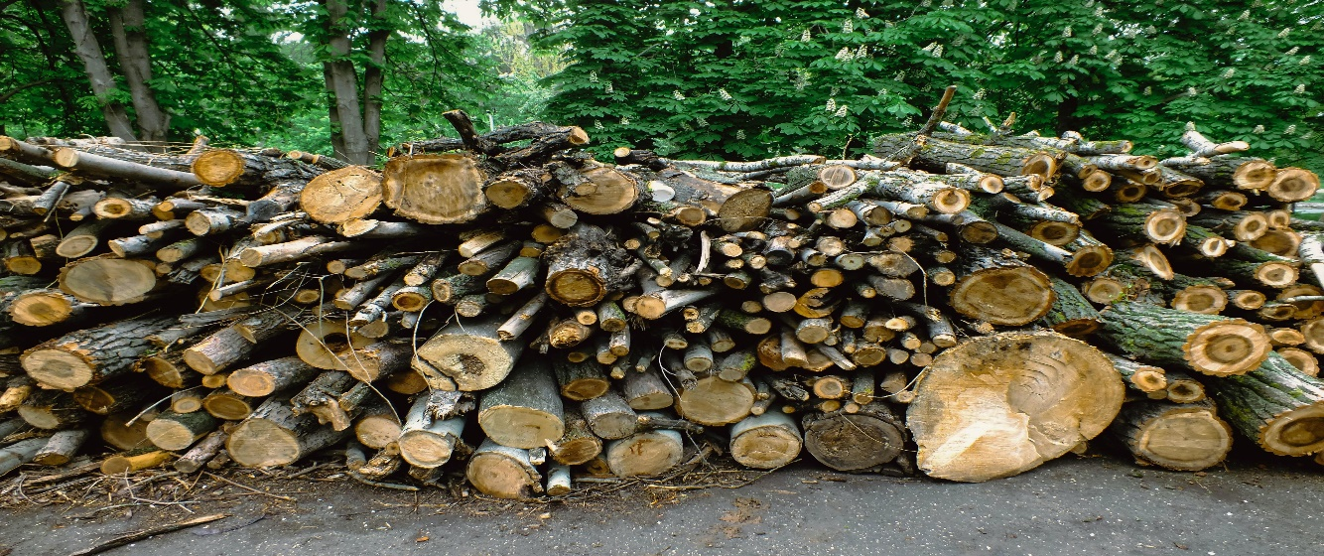
Biodiversity – Biodiversity being the variety of life on earth the risk is the loss of a wide range of animals, plants and microorganisms making a healthy ecosystem that provides us with the air we breath and the food we eat (Williams 2021). The population regretfully takes biodiversity for granted, believing that it only includes the beautiful scenery but it is by far a lot more than that. The animal and human world will not exist in the absence of biodiversity. By delaying action on biodiversity by just 10 years it will cost twice as much as acting now. The worlds governments plan to achieve forest conservation goals by 2050, taking no action for a decade will result in the issue possibly being too hard to fix. Biodiversity is currently in rapid global decline. Natural forest is not only needed to protect wild animals but also slow down the vicious climate change we are currently facing (Fernandez 2021).
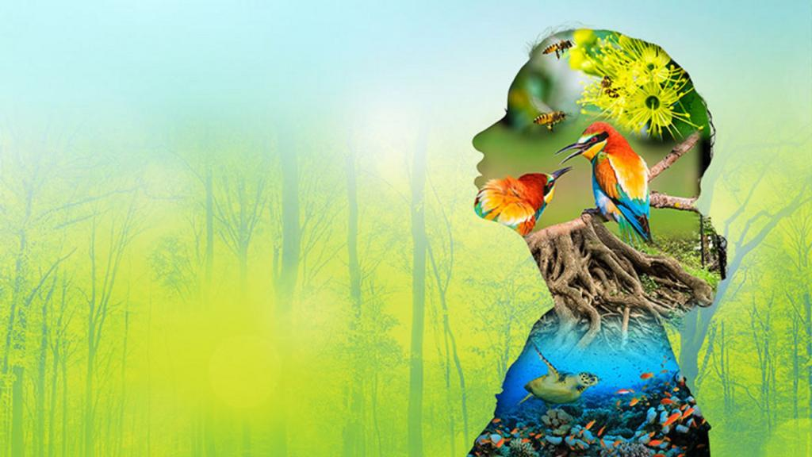

Sustainable Development
Sustainable development is a development that meets the present needs without compromising the future when meeting with their needs. Normally development is driven by need resulting in very little thought going into the impact it can make on the future. The more unsustainable development is being done the bigger the negative impact in the future needing action to take place now (Lloyd21).

Possible changes
There are many things that can be put in place to help natural resources and the issues it currently faces such as reducing the amount of oil and natural materials consumed. By exploration of renewable energy. Even though this has been taken more serious recently I believe there is a lot more to look into that can benefit this issue.
Personally I believe that the changes that can make a huge difference on Biodiversity and its current crisis are the small things that all individuals can do. I believe that these changes should inspire the future and get children involved with caring for planet. Individuals can do many things at home to help improve this, for example welcoming wildlife – this can be done by protecting wildlife when possible and providing them with a safe environment. Making a home – a family project that can include making boxes in the garden to give wildlife somewhere safe to stay. Going wild – leaving a small patch of garden grow wild benefiting insects, birds and small animals. Recycling – Keeping our waste off the streets and parks ensuring the wildlife have the best habitat.

References

Ecologia Sociale | World Natural Resource Crisis Worse Than Financial Crisis. (2021, January 1). R.Williams. Retrieved May 13, 2022, from https://www.ecologiasociale.org/world-natural-resource-crisis-worse-than-financial-crisis/#:%7E:text=According%20to%20him%2C%20the%20ecological,dominant%20forces%20of%20the%20society.

Fernandez, A. (2021, February 1). Delaying action on biodiversity by just 10 years will be twice as expensive as acting immediately, reveal Natural History Museum & Vivid Economics. Natural History Museum. Retrieved May 13, 2022, from https://www.nhm.ac.uk/press-office/press-releases/delaying-action-on-biodiversity-by-just-10-years-will-be-twice-a.html

R. (2020, May 14). Causes, Effects and Solution of Depletion of Natural Resources. Conserve Energy Future. Retrieved May 13, 2022, from https://www.conserve-energy-future.com/causes-effects-solutions-depletion-natural-resources.php

What is sustainable development · Sustainable Development Commission. (2021, March 31). Lloyd. Retrieved May 13, 2022, from https://www.sd-commission.org.uk/pages/what-is-sustainable-development.html

