University of Wales Trinity Saint David School of Engineering

Motorcycle Technology M4X00392

Vinicius Dreher

1900011

Contents
2 Introduction 1
3 Methodology 2
Analysis 4
3.1 Center of gravity 4
3.2 Honda VFR 400 5
3.3 ER6N 6
7
3.4 Maximum Velocity 7
3.4.1 Gradient 7
3.4.2 Resistance 7
4 Comparison of two modern motorcycles 9
5 References 12
6 Appendices 13
6.1 Centre of Gravity. 13
6.2 Centre of Gravity. 13
6.3 Rake and Trail. 14
6.4 Lean Angles. 14
6.4.1 Ideal Lean angle. 14
6.4.2 Actual Lean angle. 15
6.5 Minimum curve radius for given velocity. 15
6.6 Maximum Velocity Methods. 16
6.6.1 Theoretical Maximum Velocity. 16
6.6.2 Maximum Velocity using basic for and against force. 16
6.6.3 Maximum Velocity by Formula. 16
6.6.4 Maximum Velocity with all forces represented. 17
6.6.5 Combining tractive effort and resistive formulae. 18

Introduction

The following is an investigation formulated to show the understanding of;
- Motorcycle geometry and dynamic handling.
The subject is complex but not magic, however relatively simply laws of physics are always obeyed, there is no correct combination, no perfect design. Any motorcycle embodies several essential compromises. (Foale, 2002)
The characteristics discusses in this report are:
- The accurately measured geometry data from 2 different motorcycles such as trail, rake angle, wheelbase and centre of gravity.
- The gear ratios and the maximum possible speed of the motorcycle.
- Explain in detail the known handling characterises for the two machines analysed above and the differences in their attitude under dynamic situations.
- From the geometry of the Honda VFR 400 and the Yamaha YZF-R6 explain how the design of the motorcycle has been tailored to its application.

Methodology

To complete this investigation, four motorcycles were chosen to represent a variety of differing dimensions and aspects
Honda VFR 400
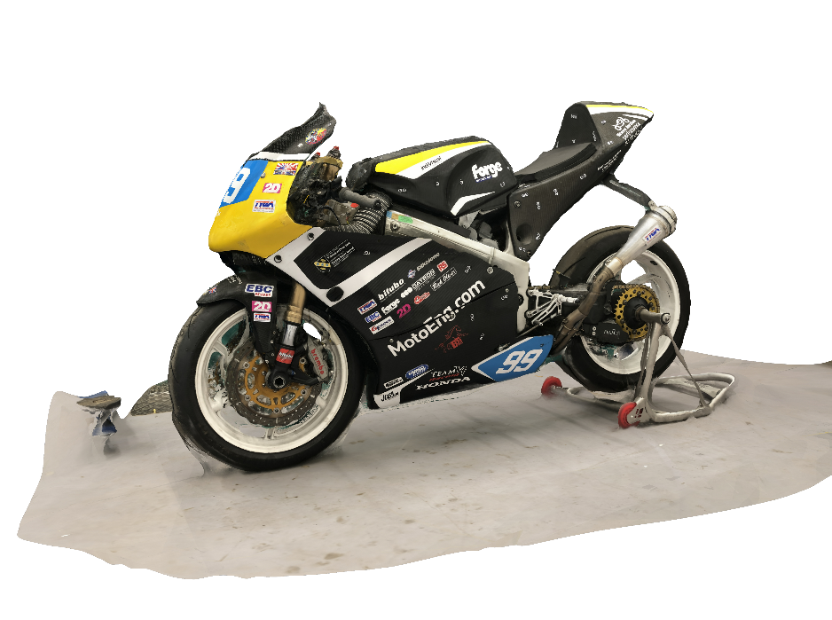
Figure 1 (AutoDesk Recap Photo, 2020)
Kawasaki ER-6N
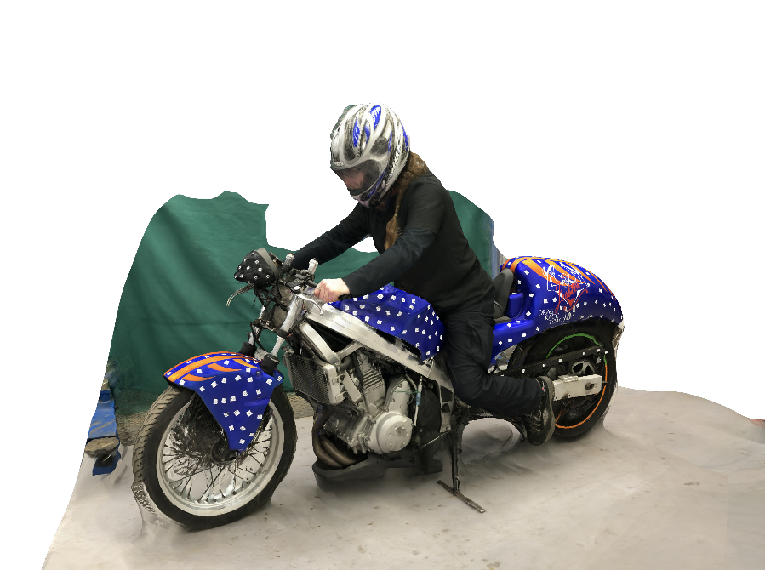
Figure 2 (AutoDesk Recap Photo, 2020)

Yamaha YZF-R6
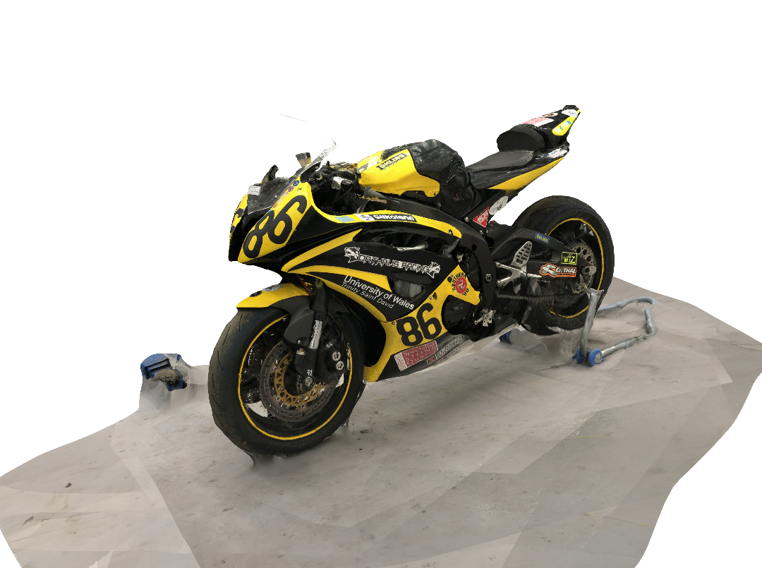
Figure 3 (AutoDesk Recap Photo, 2020)
Honda CB-600F
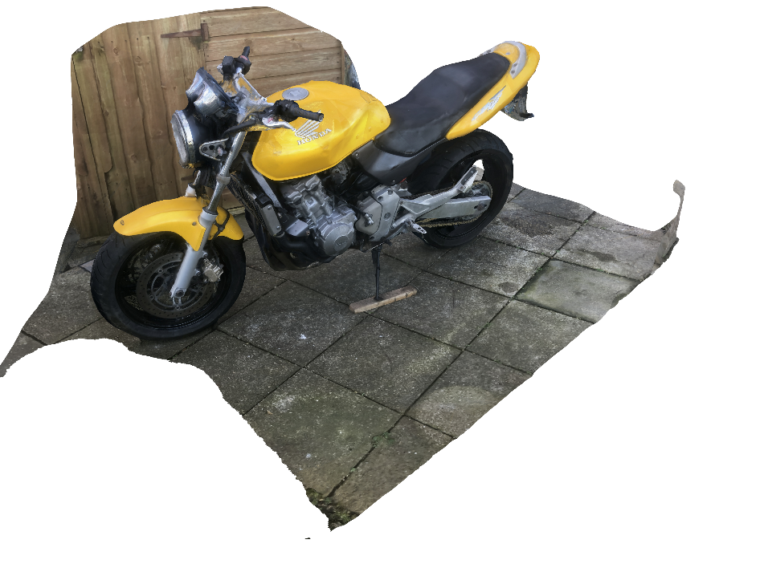
Figure 4 (AutoDesk Recap Photo, 2020)

Data were acquired using Autodesk RecapPhoto, Solidworks and Excel. The process of this data collection are included in Appendices.

Analysis

Center of gravity
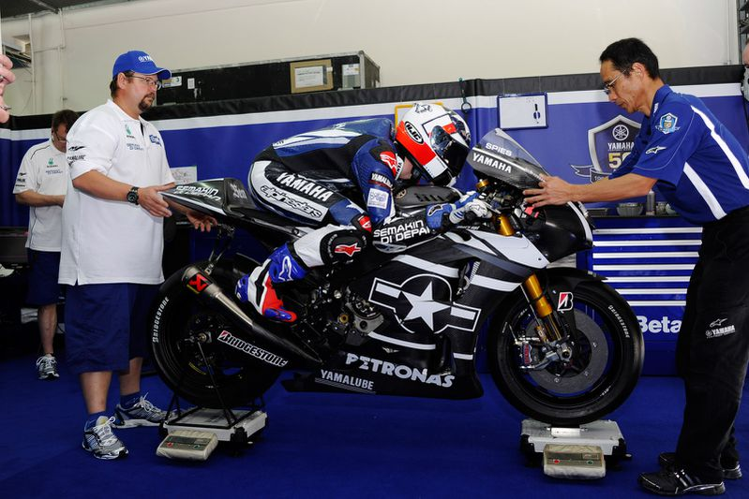
Figure 5 (Trevitt, 2016)
Weight distribution (in all three dimensions) is determined by where we choose to locate parts, particularly the very heavy ones such as thee engine, fuel tank, forks, wheels and rider. The overall result is defined by the location of something called the centre of gravity. (Bradley, 1996)
There are three basic elements that are vital in the geometry of a motorcycle: rake, trail and center of gravity.
Trail: The primary function of trail is to build in a certain amount of steering stability, and it also is of great importance to the lean-in phase when cornering. (Bradley, 1996)
Rake: The basic reason for rake is less easy to explain than that for trail because it is just possible that we don’t need it. (Foale, 2002)
Center of gravity: Another important term to understand is center of gravity (CG), or center of mass. The CG is best visualized as the point at which an object can be supported such that the object is perfectly balanced (DataMC, 2020)
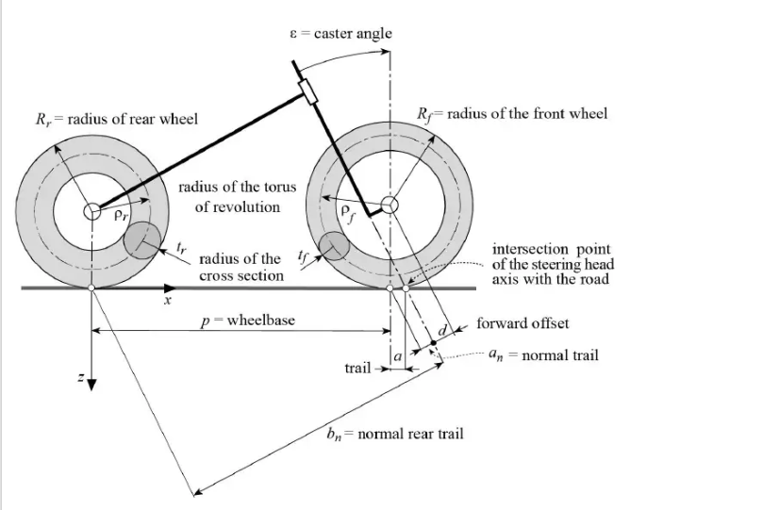
Figure 6 (Colssalter, 2006)

The CoG was found to be variable from model to model. It can be altered by altering the wheelbase or rider height however the biggest variable would be the rider.

Honda VFR 400
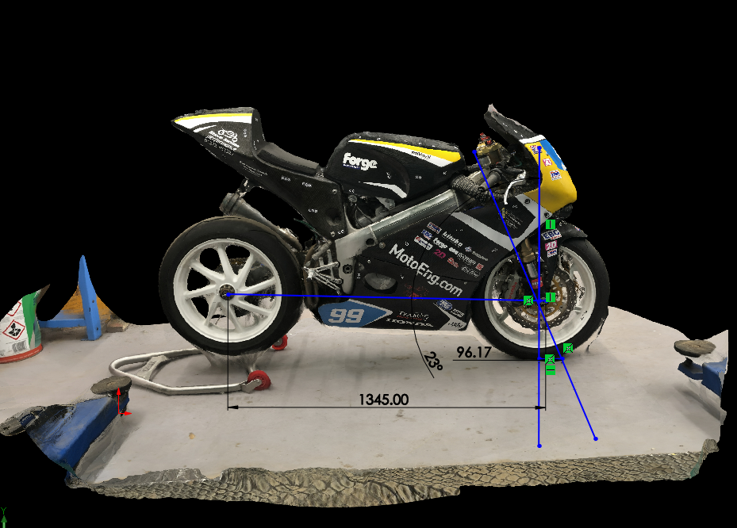
Figure 7 (SolidWorks, 2020)
The VFR400 it’s a proper racing bike, has been modified to suit a purpose. All components in this motorcycle are to make the bike even faster. As far as this investigation is concerned, modifications in relation to the length, height, power output and aerodynamics.
Race bikes usually adjust trail with adjustable triple clamps which allow the offset to be adjusted in small increments. Adjusting offset also has the effect of moving the center of gravity forwards or backwards. A reduction in trail will increase the mass on the front wheel slight. Alternatively, an increase in trail will reduce the mass on the front well too. Another point is when the offset is altered will also alter the motorcycle’s wheelbase which is directly feature of stability of the bike.

Table 1 CG with no rider VFR400

ER6N
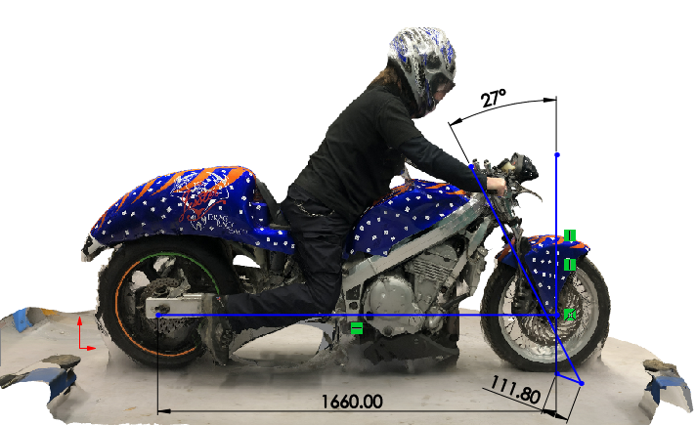
Figure 8 (SolidWorks, 2020)
This bike was built specifically for a drag racing. With a Honda VT400 Bros frame and a Kawasaki ER6N engine. The bike itself is light and suitable for rider new to the sport The CoG has been found very low. Without the rider CoG is near to axle height.
Table 2 CG with rider ER6N

Maximum Velocity
Four methods were used to calculate the maximum velocity from the Kawasaki ER6N:
- By using a single formula, the result is very similar to the formula method. The maximum velocity calculates is close to the previous calculation.
- By including torque and calculation for tractive effort, a figure for acceleration rate can be calculated.
- By using the acceleration rate a reasonable maximum velocity figure was realized. The acceleration rate gives amore realistic figure as when acceleration rate reaches zero, the tractive force driving the motorcycle is equalized by the opposing aerodynamic and frictional forces. This is the point at which the motorcycle cannot travel faster. The figure calculated by this method was close although a short of the theoretical max.
- By combining and transposing the combination of opposing forces then resolving to find maximum velocity. This method with method 3 gives the most accurate calculation of maximum velocity.

Gradient
The value of resistive force, once calculated, is simply added to the total resistance and added to the calculations, provided the gradient remains constant.

Resistance
Resistance factors include frictional, gradient and aerodynamic drag. Frictional resistances are induced by resistance between moving parts such as bearings, brakes and tire/road interaction. Gradient loses due to incline.
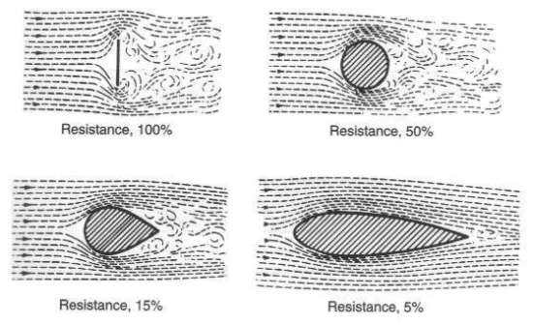
Figure 9 (Cymanski, 2020)
Aerodynamic Drag caused by the movement of a body through the air, this includes factors such as frontal area, coefficient of friction and air density of the air. The CD is in turn influenced the shape of the body, not only at the front that means along sides and to the rear of the body.

Comparison of two modern motorcycles
As already mentioned above the front forks are mounted into the triple clamp and the wheel attaches to the lower fork legs. The triple clamp is mounted to the frame at the steering stem and the angle between the steering axis with respect to a vertical line is called rake.
The distance between the fork centres and the steering stem is called fork triple clamp offset and the wheel plus tire has a certain diameter and lastly comes to the most important measure called trail.
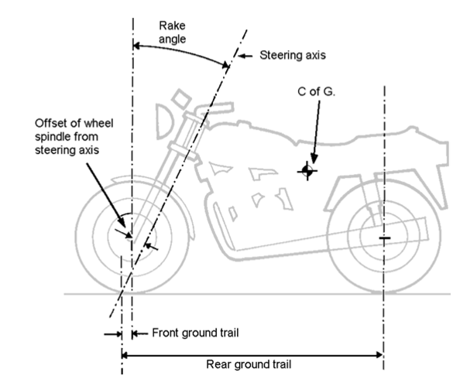
Figure 10 (Bradley, 1996)
Trail is a measurement of how far the contact patch of the front tire is behind the point where the steering axis hits the ground (Foale, 2002), in another words trail is what makes it possible to stay balanced on two wheels, because the front end to stay straight when the motorcycle is driven forward.
The effect is clearly as shows Figure 11 (Uol, 2020) going down the road in a straight line when the rider fell off.

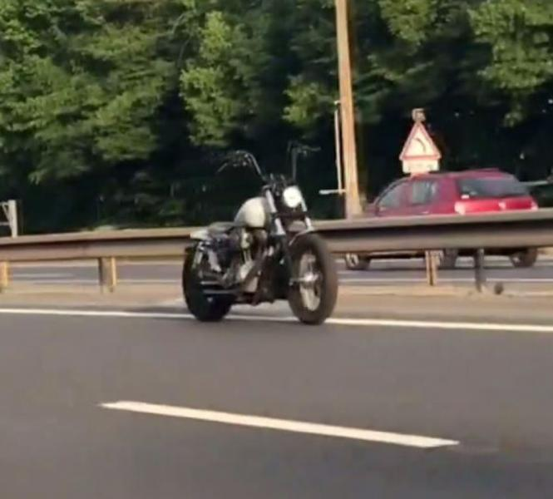
Figure 11 (Uol, 2020)
The motorcycle ‘wants’ to go in a straight line because of trail. To better visualise and understanding it will conclude this investigation showing the parameters of two different bikes.

Table 3 TECHNICAL INFORMATION YZF R6
TECHNICAL INFORMATION | R6
RAKE | 24°
WHEELBASE | 1400 mm
TRAIL | 97 mm

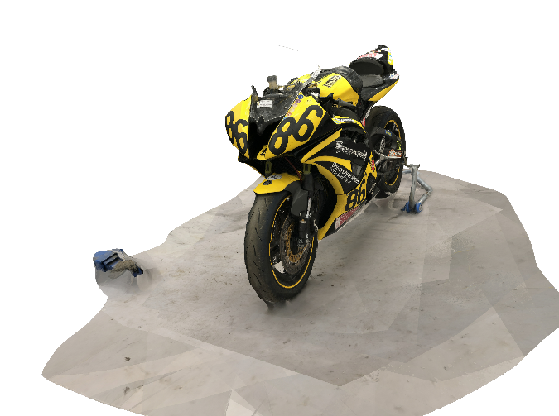

Table 4 TECHNICAL INFORMATION CB600F
TECHNICAL INFORMATION | HORNET
RAKE | 25.5°
WHEELBASE | 1420 mm
TRAIL | 99 mm
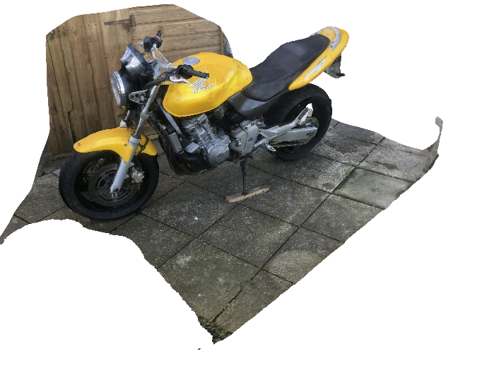
The hornet is going to turn quicker than the R6 since the CB600 has a aggressive trail compared to the R6 other crucial point is the wheelbase or simply, the distance between the front and rear axles. A long wheelbase has the effect of making the bike more stable but harder to transition and vice versa. The purpose of the CB600F is often to be used in the city which make sense when you look at the center of gravity plus the wheelbase (more wheelbase provides stable comfortable ride) whereas the R6 is more agile. An important factor to consider is that, the wheelbase changes when riding the motorcycle, the dynamics of all the components together, and how, their attributes change in different scenarios is crucial when discussing motorcycle geometry. (CoG)
The horizontal position of center of gravity is important for the acceleration and braking characteristics of the motorcycle. A motorcycle as the ER6n showed previous in chapter 3.3 with an extended swingarm, will have a center of gravity more forward, which will prevent wheelies under heavy acceleration. The vertical position of the center of gravity will have a big impact on the handling of the motorcycle. A low center of gravity makes the bike easer to steer in and provides more in corner stability however requires more lean angle for a given speed. A higher center of gravity forces the rider to use more force to lean the bike over, provides less in corner stability consequently requires less lean angle for a given speed. A bike with a higher center of gravity is also easier to flick from side to side.

References
AutoDesk Recap Photo. (2020, January 11). Swansea, U.K.
Bradley, J. (1996). The Racing motorcycle a tecjnical guide for constructors. Broadland leisure .
Colssalter, V. (2006). Motorcycle Dynamics.
Cymanski, Z. (2020, January 12). Condensed Smoke Flow around object. Retrieved from http://www.flowvis.org/wp-content/uploads/2016/11/40198-142121-Zachary-Cymanski-Nov-2-2016-1026-PM-Zack-Cymanski-First-Team.pdf
DataMC. (2020, January 13). Data for Motorcycles. Retrieved from https://www.datamc.org/data-acquisition/gps-data-analysis/mass-weight-and-center-of-gravity/
Foale, T. ( 2002). Motorcycle Handling and Chassis Design : The Art and Science. 2nd. . ed. Tony Foale Design.
SolidWorks. (2020). Motorcycles'Geometry. Swansea, U.K.
Trevitt, A. (2016, January 13). https://www.cycleworld.com/. Retrieved from CYCLE WORLD: https://www.cycleworld.com/sport-rider/all-about-geometry/
Uol. (2020, January 12). Retrieved from https://tnonline.uol.com.br/noticias/cotidiano/67,418763,15,06,moto-fantasma-em-rodovia-deixa-motoristas-perplexos-veja-video.shtml

Appendices

Centre of Gravity.
Data acquisition and formulae used in each section of the process of this investigation are as follows:

Centre of Gravity.

- Wheelbase; by measuring front axle to rear axle on both sides with front wheel straight, average of both readings to give accurate result.
- Front and rear axle height by measurement with motorcycle vertical.
- Front and rear load under level conditions; using calibrated scales at SMU workshop, weighed front and rear then repeated with rider on board.
- Centre of Gravity horizontal position. Using equilibrium/moments theory; Clockwise forces are equal to anticlockwise forces from front axle.
$$Weight on rear axle ×Wheelbase=total weight ×CoG distance$$
Transposing gives
$$CoG Distance=\frac{Weight on rear axle ×Wheelbase}{Total Weight}$$
- Centre of Gravity height; by using the wheelbase ,front axle height, and front /rear loads as set out above then repeating with the rear raised by 0.275m.
$$COG Ht=Fr axle Ht+( \frac{Fr weight Diff ×WB^{1}×WB^{2}}{Total weight ×Height raised} )$$
Where; WB₁ = Original wheelbase.
WB₂ = Horizontal wheelbase when lifted.
- Horizontal wheelbase when rear is raised was found using the Pythagoras Theorem
$Horizontal wheelbase= \sqrt{(Original}wheelbase²-height raised² )$
Then repeated with rider on board.

Rake and Trail.
(app.2)
- Conversion from radians to degrees for calculating result purposes ;
$$Radians=Angle in Degrees×(\frac{180}{Pi})$$
$$Angle in Degrees=Radians×(\frac{Pi}{180})$$

- Yoke offset is measured from headstock centerline to fork leg centerline
- Rake angle information from relevant service manuals
- Trail calculation formula;
$Trail=\left[\frac{Fr wheel radius ×\sin\left(Rake\right)- Fork offset}{\cos\left(Rake\right)}\right] ×1000$

Lean Angles.

- Corner radius measurements are representative in meters.
- Tyre thickness measurement is taken from the cross sectional profile of the tyre.
- Lateral force, being the force that pushes the motorcycle away from the centre of curvature due to centripetal force;
$$Lateral Force=\frac{Mass×Velocity^{2}}{Radius of Curve}$$
- Vertical Forces, being the force acting vertically due to gravity;
$$Vertical Force=Mass ×Gravity$$

Ideal Lean angle.

- Ideal lean angle is the maximum lean angle achievable (in Radians),taking into account lateral and vertical forces;
$Ideal lean angle=Tan^{-1}(\frac{Velocity^{2}}{(Curve radius ×Gravity)}$)

Actual Lean angle.

- Actual lean angle takes into account the cross sectional radius of the tyre which offsets the contact point to the road surface, as is the height of Centre of Gravity;
$$Actual =\left(sin^{-1}\left[\frac{\left(Tyre section radius×sin⁡(Ideal lean)\right)}{\left(Ht CoG-Tyre section Radius\right)}\right]\right)+Ideal lean$$
- Maximum velocity for a given radius of curvature;
$$Velocity=\sqrt{Curve Radius×Tyre Coeficient of Friction×Gravity}$$
- Minimum radius of curvature for given velocity
$$Curve radius=\frac{Velocity^{2}}{(Tyre Coeficient of Friction×Gravity)}$$
Resolving gives; $Lateral Force=Vertical Forces$
$$\frac{Mass×Velocity^{2}}{Radius of Curve}=$$

Minimum curve radius for given velocity.

For a given velocity there will be a minimum curve radius that can be ridden around at the lean angle found in relation to the tyre Cd.
$Minimum curve radius=\frac{Velocity^{2}}{Tyre Cd ×Gravity}$
If the curve radius is given then transposing gives;
$$Velocity=\sqrt{(Min curve radius×tyre Cd×Gravity}$$

Maximum Velocity Methods.

Theoretical Maximum Velocity.

Overall gear ratio; Top gear.
$Overall ratio=primary ×gear ×final$ drive ratio

Maximum Velocity using basic for and against force.

This is included as “basic” workings to find maximum velocities. It does not include factors such as Toque and acceleration.
- Driving Force. From, $Power=Force ×Velocity$
Transposing gives;
$$Force=\frac{Power}{Velocity}$$
- Opposing force.
= $Friction+(0.5 ×Air Density ×Drag Cd ×frontal area ×(velocity^{2})$

Maximum Velocity by Formula.

From;
$$Power at\max{v=0.5×air density×Cd ×Front area×Vmax³}$$
Transposing gives;
$$Vmax=\sqrt[3]{(\frac{\left(Max power\right)}{0.5×air density×Cd ×Front area}) }$$

Maximum Velocity with all forces represented.

- Coefficient of friction; used CdA for Suzuki Hayabusa (bodywork fitted). Divided by the frontal area gives coefficient of friction.
- Frontal area; photographed frontal aspect of motorcycle fitted with a 0.2m x 0.2m card for reference. Scaled a grid to the card over the photo then counted the grid squares covered.
- Performance figures for ZX12r; using dynamometer test from 22/4/2010.
- Transmission ratios, primary and final drive ratios from Kawasaki owner’s manual.
- By multiplying primary, gear and final ratios to get overall gear ratio;
$$Overall ratio=primary ×gear ×final$$
- Theoretical maximum velocity;
$$Max Vel=\frac{tyre circumference ×revs per second}{overall gear ratio}$$
- Rolling Friction;
$$0.01 ×Mass of motorcycle and rider ×Gravitational force(9.81ms^{2})$$
0.01 is the coefficient of friction, representing coefficient of friction of the motorcycle tyre.
- Resistive force due to gradient;

$$Mass ×Gravity ×Gradient ratio$$
- Acceleration rate in m/s²; Using Newton’s 2nd law, $F=MA.$
Transposing gives;

$$Acc= \frac{Force}{Mass}$$
- Aerodynamic drag;
$Drag=0.5 ×Air Density ×Drag Cd ×frontal area ×(velocity^{2})$

- Tractive effort. Being the force available to drive the vehicle forward at given velocity in given gear;
$$Tractive Force=\frac{\left(Torque ×Overall gear ratio ×1000\right)}{Revs per Second}$$
- Torque;
Torque = ((5252 ×Revs per Minute))/Horsepower

For “Results” Data specific to the Kawasaki ZX12R is used. However the Excel documents include the Honda C90 and Kawasaki ER6n data for comparison.

Combining tractive effort and resistive formulae.

At maximum velocity, tractive effort and resistive forces will be equal, therefore if;
$$Tractive Force=\frac{\left(Torque ×Overall gear ratio ×1000\right)}{Revs per Second}$$
And resistance;
$$Friction+[0.5 ×Air Density ×Drag Cd ×frontal area ×\left(velocity^{2}\right)]$$
Combining;
$$\frac{\left(Torque×Overall ratio×1000\right)}{Revs per Second}=Friction+[0.5 ×Air Density ×Cd ×fr area ×\left(vel²\right)]$$
Transposing for velocity;
$$Max Vel=\sqrt{[\frac{\left[\frac{\left(Torque×Overall ratio×1000\right)}{Revs per Second}+friction\right]}{0.5 ×Air Density ×Cd ×fr area }]}$$

