
Title: “Portfolio: Brand Extension.”
Program: Master of Business Administration
Module: Marketing Management
Module Code: LCMB7024
Submission Date: 27/04/2025
Submission Date: 28/04/2025
Word: 2698

Submitted To:
Dr Haoran Liu
Prof. in Marketing Management University of Wales Trinity Saint David

Submitted By:
Md Zahid Hasan Sojib
Id: 2426919
University of Wales Trinity Saint David

Introduction
Company Overview: Tesla, Inc.
Tesla, Inc. is much more than just an electric vehicle (EV) manufacturer; it's a company that has transformed entire industries and redefined what's possible in terms of sustainability, performance, and technology. Founded in 2003 by Elon Musk, JB Straubel, and Martin Eberhard, Tesla's goal was to prove that electric cars could be more than just a niche product(URBAN MOBILITY-TRENDS, NEW TECHNOLOGIES AND BUSINESS MODELS Acknowledgements, 2021). Today, the company is a household name, particularly for its luxury electric vehicles, but also for its commitment to renewable energy solutions and solar technology. Tesla has established itself as a leader in the global shift towards sustainable energy.
What sets Tesla apart from its competitors is its continuous innovation in battery technology and autonomous driving. Over the years, it has expanded its offerings, introducing not only electric cars but also energy storage systems (like Powerwall) and solar products that help people generate and store their own renewable energy.
Tesla's Mission
At the heart of Tesla's success is its mission to accelerate the world's transition to sustainable energy. Unlike many other companies that focus on short-term profits or maximizing shareholder value, Tesla is driven by a long-term vision of transforming how we use and consume energy(Metsäranta, 2018). Tesla believes that if they can make sustainable energy products more accessible, reliable, and attractive, they can make a global impact in solving climate change. This is why Tesla doesn't just stop at electric vehicles; the company is also heavily involved in solar panels, battery storage systems, and even electric semi-trucks.
Tesla's Financial Performance and Market Impact
As of 2023, Tesla's revenue was $81.46 billion—a staggering figure that shows how far the company has come in a relatively short amount of time. In fact, Tesla has become the market leader in electric vehicles, commanding more than 20% of the global market share. Despite challenges like production delays, supply chain issues, and intense competition, Tesla continues to thrive and even disrupt traditional industries. Tesla's approach to vertical integration—where it controls nearly every aspect of its product lifecycle from manufacturing to software updates(Just et al., 2024)—is a key reason behind its market dominance. Not only does Tesla manufacture its cars, but it also produces its own batteries, designs its autonomous driving software, and even manages its own charging network. This level of control ensures that Tesla is not just a car manufacturer but a tech-driven company that delivers cutting-edge solutions at scale.
1. Brand Extension Concept: Tesla E-Bike
1.1 The Idea Behind Tesla's Electric Bike
Now that Tesla has cemented its position in the electric vehicle industry, there's a growing opportunity to explore new markets and offer innovative products beyond cars. One such possibility is entering the electric bicycle (e-bike) market—a sector that's seen explosive growth in recent years, particularly in urban areas where traffic congestion, environmental concerns, and the rising costs of gasoline have driven people to look for alternative transportation solutions(Miller et al., 2020). The concept of a Tesla E-Bike is a natural extension of Tesla's core mission and existing product line. Just as Tesla revolutionized electric cars, it has the potential to redefine the e-bike experience by incorporating Tesla's world-class battery technology, autonomous features, and a premium design that aligns with its luxury brand image. Imagine a sleek, smart e-bike that not only provides an eco-friendly way to get around but also integrates seamlessly with Tesla's existing ecosystem of products and services, such as the Tesla app and Supercharger network. Tesla's entry into the e-bike market isn't just a "nice to have" for the company—it's a move that positions Tesla to take advantage of several growing trends in transportation:
Urbanization: More people are moving to cities, where cars are often impractical and expensive to own. Electric bikes provide an ideal solution for short commutes.
Eco-Friendly Transportation: There's a growing demand for clean, green transportation options(Berman et al., 2024a). People are looking for ways to reduce their carbon footprint, and e-bikes are a perfect fit.
Tech Integration: Tesla is known for its cutting-edge technology, and consumers are increasingly drawn to products that offer smart features like ride assistance, battery optimization, and app connectivity.
1.2 How Tesla's E-Bike Fits Into Its Brand
For Tesla, an e-bike fits perfectly into its broader vision for the future of sustainable transportation. Tesla's primary focus has always been to make green and high-tech products that don't compromise on performance or style. By introducing an electric bike, Tesla could provide a solution to a rapidly growing segment of urban commuters who want an affordable, sustainable, and innovative way to navigate busy city streets(Sull & Reavis, 2019). Tesla's E-Bike wouldn't just be any other e-bike—it would be a high-performance, premium product that seamlessly integrates into Tesla's existing ecosystem of electric mobility. This bike would feature the same attention to quality, innovation, and style that Tesla's cars are known for. From advanced lithium-ion batteries to AI-powered ride assistance, the Tesla E-Bike would cater to the tech-savvy, eco-conscious commuter who demands a premium product(Sull & Reavis, 2019). Imagine being able to track your ride's speed, distance, and battery health through the Tesla app while using features like Autopilot to help navigate challenging city streets. The bike would also come equipped with regenerative braking technology, a feature that's already in use in Tesla's cars, which helps to extend the bike's range by converting braking energy into stored power.
Addressing Consumer Needs: The Tesla E-Bike's Appeal
Tesla has always focused on solving real-world problems through its products. The company's cars have made a significant impact by offering performance that rivals traditional internal combustion vehicles(Just et al., 2024), all while drastically reducing emissions. Similarly, the Tesla E-Bike would aim to solve some of the pressing challenges faced by urban commuters today:
Traffic Congestion: As cities become more crowded, getting stuck in traffic has become a daily frustration. The Tesla E-Bike would provide a faster, more efficient alternative for short commutes, allowing riders to bypass traffic jams and arrive at their destination faster(Miller et al., 2020).
Environmental Impact: With growing concerns about air pollution and carbon emissions, more people are seeking green alternatives. An e-bike offers an efficient, low-emission mode of transportation that helps reduce the carbon footprint of urban travel.
Convenience: Unlike cars, e-bikes are easy to park and require little maintenance. Plus, the long-range battery technology used by Tesla would allow commuters to travel for longer distances without the need for frequent recharging.
Cost-Effective: While the upfront cost of the Tesla E-Bike may be higher than some other e-bikes on the market, it could offer superior value in terms of performance, battery life, and longevity. Given Tesla's reputation for durability and quality, consumers would likely see the investment as worthwhile. In essence, the Tesla E-Bike is more than just an idea; it represents a natural evolution of Tesla's vision to transform the way we think about transportation(Berman et al., 2024a). By entering the e-bike market, Tesla would further solidify its role as a leader in sustainable transportation and offer an innovative solution for today's urban challenges. The Tesla E-Bike would combine cutting-edge technology with eco-friendly design to meet the needs of modern commuters looking for a smarter, greener, and more efficient way to travel. This potential brand extension would allow Tesla to tap into a growing market for electric bicycles, expand its product portfolio, and continue its mission to accelerate the world's transition to sustainable energy. It aligns perfectly with the company's core values of innovation, performance, and sustainability, and it could very well become the next step in Tesla's journey toward creating a fully integrated and sustainable mobility ecosystem.
2. Market Segmentation: Understanding the Growing Demand for E-Bikes
We're seeing a huge shift in how people think about transportation, especially in cities. Traffic congestion, air pollution, and the rising costs of fuel are all pushing people to seek out cleaner, more efficient alternatives. This is where electric bikes come into play(Berman et al., 2024a). Not only are e-bikes better for the environment, but they also offer a faster and more enjoyable way to commute. The global e-bike market is expected to grow significantly in the coming years. According to Statista, it's projected to grow from $23.89 billion in

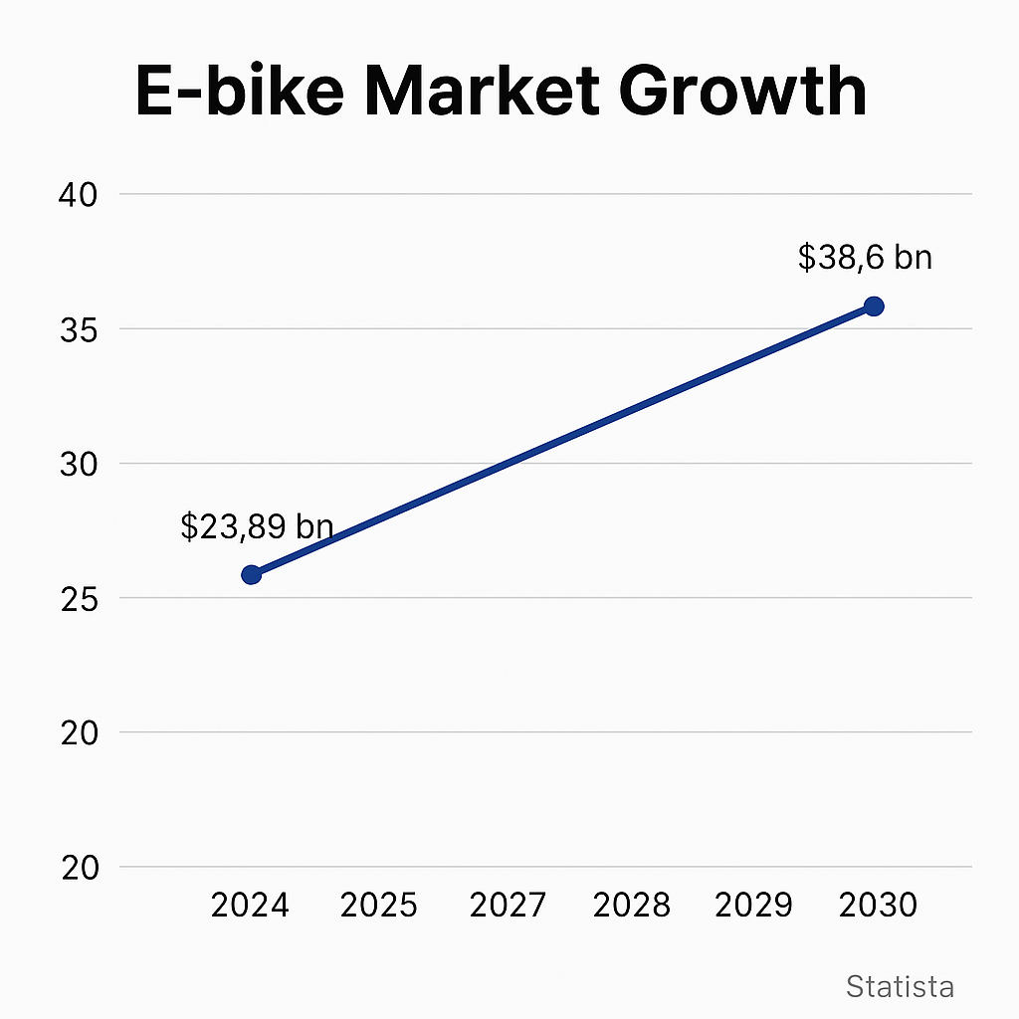
2024 to $38.6 billion by 2030, which is a massive jump. That's an annual growth rate (CAGR) of 6.9%!
This graph of the e-bike market growth represents projected market growth for the global e-bike industry. The data shown in this graph is designed to be consistent with Statista projections, which report the market size growing from $23.89 billion in 2024 to $38.6 billion by 2030 at a CAGR of 6.9%.
3.1 Challenges: The Daily Struggle
Chris's challenges are the typical urban commuter's pain points — and they're very real.
Traffic Congestion: He spends so much time in traffic that sometimes, it feels like a waste of life. What should be a 20-minute drive turns into an hour of stop-and-go. He's getting fed up.
Parking Issues: Once he finally arrives at his destination, finding a parking spot can be a whole other nightmare(Lewin, 2021). Chris has been to meetings where he had to park blocks away, making him late and frustrated.
Fuel Costs: Even though his Tesla doesn't burn gas, he knows that a lot of people still face high fuel prices, and it's a burden for the planet as well as their wallets. He's looking for alternatives, and the Tesla E-Bike feels like a logical step toward more affordable and sustainable travel.
3.2 What Chris Wants from Tesla E-Bike
When Chris thinks about a Tesla E-Bike, it's not just about the ride — it's about the entire experience. Here's what he's hoping for:
Freedom from Traffic: Imagine speeding through city streets with a light breeze on his face, avoiding the frustrating gridlock. The Tesla E-Bike would give him the ability to cruise past the long lines of cars, cutting down on his commute time significantly(Sull & Reavis, 2019).
Effortless Ride: Being someone who appreciates technology, Chris expects the Tesla E-Bike to have a smooth ride, with smart ride-assistance features (think automatic speed adjustment, smooth braking, and performance-based suggestions).
Eco-Friendly: Above all, Chris wants a product that's not just easy to use but aligns with his desire to reduce his carbon footprint. He sees riding a Tesla E-Bike as a chance to live his values while getting to work or running errands(Nicola Campagna Foglietta & Filippini, 2020).
Smart Tech: Since Chris is always on his phone, he wants the Tesla E-Bike to be integrated with the Tesla app. He imagines checking his ride stats, battery levels, and even adjusting the settings from his phone — just like he does with his car.
Style and Quality: Finally, since Chris values aesthetics and top-notch performance, he would expect the e-bike to be sleek, comfortable, and built with the same high standards as Tesla's cars. After all, when he buys something, it's not just a product; it's a reflection of who he is.
3.3 Chris's Preferences in Communication
Chris doesn't like to be bombarded with information, but he's active on social media and always finds new tech trends on Instagram or Twitter. So, when it comes to learning about products like the Tesla E-Bike, he prefers:
Visual Content: Short, engaging videos or stories on Instagram that show the bike in action — cruising through city streets, being used by other young professionals.
Targeted Ads: Chris doesn't mind receiving ads on Facebook or Google if they're relevant to his interests. He likes ads that highlight the Tesla E-Bike's performance and environmental benefits.
Email Newsletters: He also appreciates an occasional email from Tesla about new products, upcoming events, or updates, especially if there's an exclusive offer or limited-edition color for loyal Tesla owners like himself(Seyhan, 2024).
3.4 Chris's Buying Decision
When it comes time for Chris to pull the trigger on buying a Tesla E-Bike, the decision will come down to:
Brand Trust: Chris is already a loyal Tesla customer, so he's likely to trust the quality and performance of the Tesla E-Bike. He knows Tesla doesn't cut corners and expects this bike to be reliable and high-tech.
Environmental Impact: Chris doesn't just want a bike — he wants to feel like he's contributing to something bigger, something that could help the world move toward more sustainable transportation.
Long-Term Value: The price tag of $5,000-$7,000 for the Tesla E-Bike might seem high, but Chris believes that the long-term savings on fuel, parking, and stress are worth it. Plus, he's used to paying a premium for quality.

4. Marketing Mix (7Ps) for Tesla E-Bike
4.1 Product
Let's talk about the Tesla E-Bike - this is going to be a top-tier, electric bicycle designed for those who want to ride in style and sustainability. The product itself is going to blend Tesla's groundbreaking technology with the daily needs of urban commuters(Wilson et al., 2025).
Now, first off, when we talk about Tesla's battery technology, it's almost like the heart of the bike. You know how a Tesla car can go for hundreds of miles on a single charge? Well, the same high-performance lithium-ion batteries that power Tesla's vehicles will power this e-bike. These batteries are made to last a long time, recharge quickly, and most importantly, provide riders with a long range, meaning you can go for a decent distance before needing a recharge.
4.3 Place
Now, where are you going to buy this e-bike? Well, like all of Tesla's other products, the Tesla E-Bike will primarily be available on Tesla's official website. That's the main place where you can get your hands on it, just like how you buy Tesla cars. It's all about keeping things simple, streamlined, and direct from Tesla to the customer(Kumar et al., 2021). But it doesn't stop there. Tesla knows that not everyone is going to order online. For those who want to see the bike in person or test ride it before making a decision(Nicola Campagna Foglietta & Filippini, 2020), Tesla is likely going to roll it out in its showrooms. So, you'll be able to go to a physical location and get that Tesla experience - you can look at the bike, take it for a spin, and talk to knowledgeable staff about all the features.
4.4 Promotion
Now, when it comes to spreading the word about the Tesla E-Bike, we're going to see Tesla's marketing magic in full swing. Influencer marketing is going to be key here(Nicola Campagna Foglietta & Filippini, 2020). Tesla will likely partner with eco-conscious influencers, tech enthusiasts, and even celebrities who already love the brand. These people will show off the bike's features, talk about its performance(Berman et al., 2024b), and highlight how it fits into their sustainable lifestyles. Imagine seeing your favorite influencer riding a Tesla E-Bike through the city on their Instagram. It makes the product feel even cooler and more desirable.
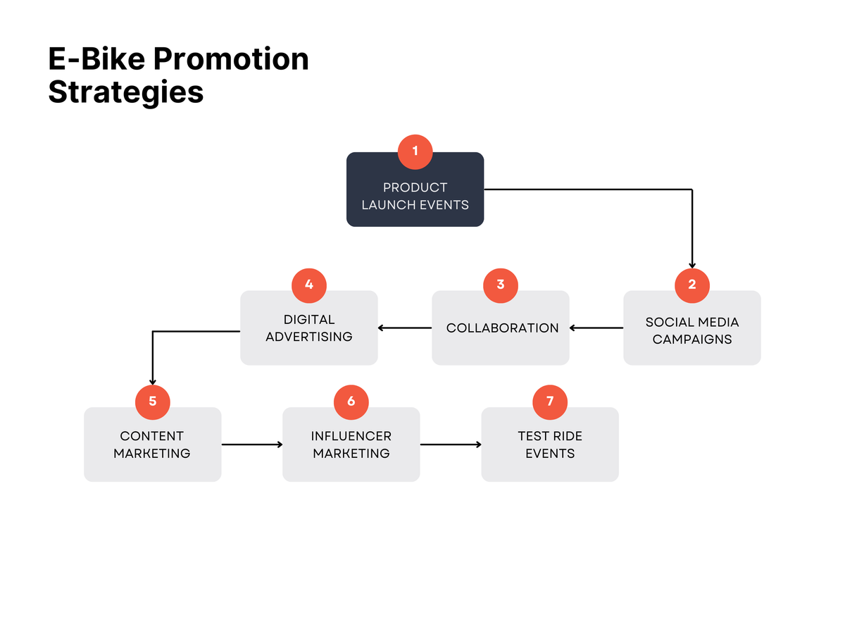
Tesla is going to sell the e-bike primarily through its website and showrooms, with a possibility of partnering with premium bike shops in key cities. To promote the bike, they'll use influencers, create engaging social media content, and organize test ride events to get people excited about the product. Overall, the Tesla E-Bike is not just about getting from point A to point B. It's about offering an experience that's as much about innovation as it is about sustainability and convenience(Julsrud & Standal, 2023). It's a product for people who want to be part of the future, and Tesla is ready to lead the way in making that future a reality for urban commuters.
Conclusion: Tesla eBike** as an extended brand aligns seamlessly with Tesla's mission to accelerate the world's transition to sustainable energy. By entering the e-bike market, Tesla leverages its strong brand equity, cutting-edge battery technology, and innovation culture to meet growing demand for eco-friendly urban transportation(Nicola Campagna Foglietta & Filippini, 2020). The Tesla eBike not only broadens the company's product portfolio but also positions the brand as a leader in **micromobility**, appealing to environmentally conscious consumers and urban commuters. In conclusion, the Tesla eBike extension represents a strategic move that enhances brand relevance, taps into a fast-growing market, and reinforces Tesla's identity as a disruptor across multiple transportation segments.

Reference:
Berman, R., Markette, N., Vera, R., & Gehle, T. (2024a). STAR, a Universal, Repeatable, Strategic Model of Corporate Innovation for Industry Domination. In IJACSA) International Journal of Advanced Computer Science and Applications (Vol. 15, Issue 9). www.ijacsa.thesai.org
Berman, R., Markette, N., Vera, R., & Gehle, T. (2024b). STAR, a Universal, Repeatable, Strategic Model of Corporate Innovation for Industry Domination. In IJACSA) International Journal of Advanced Computer Science and Applications (Vol. 15, Issue 9). www.ijacsa.thesai.org
Julsrud, T. E., & Standal, K. (2023). Developing B2B electric car sharing as a sustainable mode of work travels. A community-based affordances perspective. International Journal of Sustainable Transportation, 17(7), 815–826. https://doi.org/10.1080/15568318.2022.2103858
Just, J., Hutter, K., & Füller, J. (2024). Catching but a glimpse?—Navigating crowdsourced solution spaces with transformer-based language models. Creativity and Innovation Management. https://doi.org/10.1111/caim.12612
Kumar, R., Jha, A., Damodaran, A., Bangwal, D., & Dwivedi, A. (2021). Addressing the challenges to electric vehicle adoption via sharing economy: an Indian perspective. Management of Environmental Quality: An International Journal, 32(1), 82–99. https://doi.org/10.1108/MEQ-03-2020-0058
Lewin, W. (2021). The Sound of Silence Applying Disruptive Innovation in the Electric Motorcycle Industry. http://www.teknik.uu.se/education/
Metsäranta, V. (2018). BACHELOR’S THESIS E-bike market possibilities in Taiwan.
Miller, J. A., Panwar, R., & Medders, L. A. (2020). Understanding the Opportunities and Challenges of Alternative Sustainable Transportation.
Nicola Campagna Foglietta, by, & Filippini, T. (2020). Incumbent Brand on Purchase Intention of Disruptive Innovations A Study on the Effects of Brand Image and Sub-Brand Strategy for Electric Motorcycles.
Seyhan, E. (2024). EXPLORING TÜRKİYE’S POTENTIAL IN E-MOBILITY WITH PATENT PERSPECTIVE.
Sull, D., & Reavis, C. (2019). This case was prepared by Senior Lecturer.
URBAN MOBILITY-TRENDS, NEW TECHNOLOGIES AND BUSINESS MODELS Acknowledgements. (2021).
Wilson, C., Kerr, L., Sprei, F., Vrain, E., & Wilson, M. (2025). Annual Review of Environment and Resources Potential Climate Benefits of Digital Consumer Innovations. 38, 31. https://doi.org/10.1146/annurev-environ-012320

