Study Skills for OME
Academic Skills
Year 1 Assignment
James Steven M AWE
4-18-2019

Contents
1 Introduction 3
2 Skills evaluation 3
2.1 Skills required 3
2.2 Self-evaluation 5
2.3 Positive attributes and improvement opportunity 7
3 Application 8
3.1 Skills taken forward 8
3.2 Back up 8
3.3 Group presentation 9
4 Conclusion and evaluation 10
4.1 Summary 10
4.2 Further consideration 10
5 Bibliography 11
6 Appendices 12
6.1 Appendix A – online evaluation 12
6.2 Appendix B – presentation 15

Introduction

Study skills is a separate lesson for students whilst in education. Seen in some circles, Study Skills may not be of value to the student as the skills for learning should be developed and catered for in the individual subject [1]. The Author does not necessarily agree with all the views given by Wingate in her evaluation. Directed skills should be taught through the subject being learned, however, it is not always possible to teach the general skills required for further or higher education. Through a separate Study Skills lesson, the student can learn individual common skills that can be portrayed through all subjects being studied. It can allow the student to practice those skills in order to enhance the experiences through the education system to maximise potential for higher final scores.
This report investigates how the author has interpreted the skills needed, already obtained and discovered new skills required to gain maximum grades for the course. Study Skills has not taught the ‘science’ of the subject but has taught how to write in a new format, preserve data in the most economical way, give presentations and new methods to conduct research and reference data.

Skills evaluation

Skills required

In order to be successful in higher education many skills are required. Gaining and developing these skills is especially important for students who have returned to education after many years. Some skills may have been developed through general life skills, others must be directly learned focussing on areas of weakness that must be improved. Of the skills listed below, they may be seen as desirable and not essential as there will always be students who can complete higher education without these. However, it is the author’s opinion that it is extremely useful to try to gain these skills to maximise the learning opportunities.
Self-motivation/Time management
Higher education is not school. Students must make up their own minds whether to attend and contribute to the lectures they may receive. The student must have a desire to be at the university. If they do not want to be there, then they will most likely not put the required effort into the work.
There is an expectation that students are to spend their own time continuing work outside of the lecture/university hours in order to enhance the understanding of the subjects being taught. A lack of self-motivation may prevent students from attending a required number of lectures; it may also inhibit students from finishing assignments and handing them in on time. Most universities, including University of Wales Trinity St David, have a strict policy on marking for work which, without agreed reason, is handed in late.
“Late submission of the assessment will result in a penalty mark. Penalties for late submission: up to one week, maximum mark 40%. Over one week late, 0%. Only the extenuating circumstances panel may approve a change to submission dates” [2]
Research and referencing
Research and referencing go together well. Students must have the ability to research into the field in which they are learning. The lectures are a starting block for what additional information should be investigated further. A good student will have the ability to accumulate the information gathered ensuring its suitability for the subject. Once accumulated, the student will read through the information, picking all the relevant aspects, essentially digesting the information. Finally, the information will be interpreted, with the information interpreted it can then be presented.
“using an array of indicators of the importance and significance of published research to assess impact of published work” “has the potential to improve success for authors” [3]
To go along with research is referencing. When research has taken place, it is expected that anything useful discovered would be used in the specific assignment or report. This will show credence to the effort students have put in and also improve the outcome of the report. In order to show evidence of the research, it must be referenced accordingly. To do so not only shows the understanding of the work being undertaken, but also gives evidence to where it has come from and its validity. An equally important aspect of referencing is plagiarism. Passing someone else’s work off as ones own is not allowed and can have undesirable consequences. A simple reference acknowledges where the work is from and who it was by thus preventing the student from accusation of plagiarism.
Communications (written and oral)
The Author gives the opinion that communications are some of the most important skills required by a student. Two main forms of communication include written and oral. Written communication is generally portrayed in the form of a report or an essay. The written communication must follow the main theme of the assignment. This should be structured as taught through lectures such as study skills, or if a specific detail has been required by the assignment. It is common place for written communications to have a word limit on them. This is usually expressed in the assignment detail and is expected to be followed (often with a 10% leeway).
Oral communications can be equally as important as the written form. It is usual for the student to give more than one presentation throughout the time in education. Most presentations will be in a ‘PowerPoint’ (or other brand) type presentation. However, there may be times when the student chooses a different method to present. This will be in agreement with the lecturer. Good use of the template and a good mixture of both spoken and written words alongside relevant pictures or other media will be expected, as well as clear voice use, with the aim to avoid directly reading from the board.
Outside of the education sector the communication skill is also a very important tool, as it has been quoted:
“There’s a direct link between the quality of your communication and the quality of your life” [4]
Team working/lone working
Although much of higher education may well involve working solo, being able to work as a team is also a valuable skill that should not be taken for granted. A lot of the written communications shall be based on what the student has learned. There may be times when the student is struggling or finds it difficult to convey what is needed. Asking for assistance from another student may help rectify any problems via peer review. Working as a team is a good way to break down barriers that the student may see. There may also be times in the lab environment when the students must work together, be it for safety, ease, or general good practice that can also fall into the workplace.
“At a broad level, teamwork is the process through which team members collaborate to achieve task goals” [5]

Self-evaluation

In order to establish the best ways to progress forward both academically and professionally, the first thing that should be carried out is an evaluation of strengths and weaknesses. These analyses will show gaps where improvements can be made.

A self-evaluation has been made to study the positives and also find the areas for improvement (in the work place). To create the self-evaluation a SWOT (strengths, weaknesses, opportunities, threats) type analysis was produced using an example form CITGO Petroleum Corporation [6]. The results from the SWOT analysis are shown below.

Strengths:
- Willing to take on what needs to be done in order to deliver to schedule; both dedicated and reliable to deliver what is required of every task given.
- Commitment to excellence and pride with great integrity (company values).
- Promotes own and colleagues’ new ways of thinking.
- Committed to job and company.
- Easily approachable making others comfortable to approach/interact at any time.
- Very hands-on, practical, knowledgeable in interests, self-restraint in not responding if to do so may disadvantage you in long term (e.g. e-mail replies).
- Drive/determination, coaching/mentoring, pride/integrity.
Weaknesses:
- Taking on too much work which may eventually lead to issues with wellbeing or health.
- Can tend to focus/dwell on the past personal issues. Which can lead to negative personal feelings.
- Working exceptionally hard almost avoiding issues being faced in personal life.
- Takes everything on as determined to deliver on all fronts whilst at work and so not taking personal time showing poor work/life balance and can lead to poor time management i.e. too many hours at work over contracted hours.
- Sometimes the need to be aware of the environment should be taken into account before making comments, this can sometimes show a lack of self-restraint in a professional situation.
- Should be less willing to just say 'No' to things. (listen to ideas, not just refuse)
- Lack of writing skills - both actually doing the writing and conveying the message in an appropriate and coherent way.
- Having a very untidy desk does not work with the workplace culture ‘clear desk’ policy.
Opportunities:
- Using timely opportunities to delegate work out where appropriate. This will come as new staff become more competent.
- “Grow” an area’s capability be it in people or resources.
- Taking the opportunity to be part of the UKs first OME apprenticeship degree.
- Improve writing skills, including reading what was have written from a "fresh pair of eyes" perspective.
- Gaining the ability to see things from the bigger view-point rather than just from the coal-face and personal ideals.
- Coaching/mentoring on both a personal and professional level. This may be a of a benefit to colleagues of lower grades as they move forward in their careers.
Threats:
- Self-opinion – some things from the past cannot be changed. Acceptance and moving forward with a positive perspective.
- Taking on excessive workloads to meet demand has the possibility to end up with a self-burnout.
- Taking on additional roles to the benefit of the company may not be beneficial for personal wellbeing.
- Not taking time off in an appropriate manner leading to large blocks of time away.
- Not being immediately responsive to taking on-board constructive criticism.
- Getting bored when overworking turns into business as usual.
- Need to proactively identify projects that would benefit from one’s own interaction.
The SWOT analysis covers how the author can see positive areas and areas for improvement from a general point of view.
A second personality test was conducted, and the results are found in Appendix A. This showed that the authors main personality trait is humour, secondly fairness, with honesty and leadership third and fourth. This was a reasonably successful test to which the author agrees with. Areas such as spirituality and love of learning fell to the bottom of the list. Having been away from education for over 10 years, this course should offer a good opportunity to get back into learning
The author has also looked at the skills required and self-evaluated here.
Self-motivation/Time management
An easily self-motivated individual who is ready to accept the challenge of higher education. Finds it easy to start each piece of work but needs to concentrate on working through to completion. Time management is reasonable. Dividing up time for university well but leaving the completion of assignments to close to the last minute.
Research and referencing
Research and referencing were new to the author at the beginning of the course and are being experimented with during the early stages with practice making the final stages of the course a much more complete work. Study skills has been encouraging and from a learner view very important in this area. ‘Doing away with study skills’ would not be beneficial, especially when consideration goes to students who have been away from education for some considerable time.
It has been crucial to understand how to use the different tools for research that the university provides. Simple tools such as the library and the online library including all the journals made available contain a wealth of knowledge and information crucial to each subject. Quick guides on the use of the public internet and sites such as ‘Google Scholar’ have added to the availability of data.
A brief lesson on how to use the referencing tool in ‘Word’, has made it very easy to add the refences into the assignments without complication. Before the lesson, use of contents, headings and referencing were non-coherent. Following the lesson, they proved simple tools to use.
Communications (written and oral)
The author has written reports in the past which have had to be reworded as there is no background in report writing. This will be refined through the OME apprenticeship degree and as the author has recently gained more trust and responsibility at work to produce written reports. The author enjoys giving Oral presentations although gets anxious too easily and often loses track as the presentation progresses.
Team working/lone working
The author has experience in both team and lone working, feeling pragmatic and experienced at both. This has involved working as part of a small team for the last ten years and taking the lead in some areas in the last 2 years. The author has enjoyed teamworking and received good feedback from work colleagues on it. Sharing of information through the team and wider teams has improved the work community’s communication making the work community closer. Team working will play a part of the apprenticeship. This will be a productive way of learning how to work together.
Report or assignment writing are often lone working tasks. The author has found that this is a more efficient way of working in certain cases, for example reporting results in a written memo to the customer, before putting the data out for peer review. There are areas of work where, due to safety rules, lone working is not an option.

Positive attributes and improvement opportunity

From the self-analysis above the author has determined that areas of strength are:
Teamworking - finding it easy to work with other people and enjoying such activities makes it an easy strong point of the author. Taking the lead when needed and following instructions when requested allow for a positive working environment.
Commitment and drive – the author is very committed to all work endeavours in order to meet the company goals. Seeing the Apprenticeship degree as a goal for the company is no different and therefore the drive to complete and complete proves an exciting prospect
Oral communication – although nerves bring in anxiety, oral communications are good, even assisting other team members to improve their own oral skills.
Opportunities for improvement include but are not limited to:
Time management - although not specifically bad, improvements do need to be made. Leaving completion of projects is not ideal in either a learning or work environment.
Lack of writing skills – study skills has already shown ways to improve writing. However, until put into practice these skills cannot be evaluated.

Application

Skills taken forward

Important skills to be taken forward begin with researching and referencing. Study Skills has taught a very simple yet very important way to use the technologies available to students. This skill will provide the competence to ensure a standard set up of assignments (referencing). It has also taught students how to access a wider range of research resources. When using the sources provided by the university it also gives the student better opportunities to trust the source from which it comes. It was seen in the presentation (discussion to follow) that Wikipedia is not a reliable source. However, articles in peer-reviewed journals, articles that are cited in other respectable sources, and similar information gained from more than one independent source are examples of sources that are deemed to be reliable.
Taking into consideration the analysis of the attributes listed in 2.3, one area of positivity is oral communications. This area will be stretched both in University and at the authors place of work. This will involve taking on more presentations, requiring more knowledge and presenting to a larger audience.
Where areas of improvement have been identified these can be addressed. Gantt charts and project planning methods will assist with time management. The most important area of improvement is writing skills. A way to improve can simply be to request for honest feedback from colleagues and fellow students for what is good and where improvements can be made. There are also courses available at the work place or books in the library which can assist in improving the skills.

Back up

As technology has improved society has become more and more reliable upon the technology which is generally taken for granted, assuming that if your data is stored in one place then it is safe. According to Schofield's Second Law of Computing
“data doesn't really exist unless you have at least two copies of it” [7].
This very basic theory has become very important in the world of business and in education, if only one copy exists, it is far too easily lost.
Concentrating on education, why does the data need to be backed up? It is the responsibility of the student to back up data. Generally, data loss is not an acceptable reason for extenuating circumstance [8]. Backing up data is simple. Data has to be gathered and stored, often some form of report or assignment is to go with it. There are simple techniques and ways to back up data. (the word data for here in is assumed to the report/assignment, all encompassing)
Immediate data is usually stored on the native computer/unit. It is quite normal for this data to backed up on a memory stick/thumb drive. Based on the author’s experience, at this point backing up data becomes lacking. Possibly because now that the data is in two places, it is assumed safe?
However just because the data meets Schofield’s second law, this does not mean the data is ‘safe’. Files can still become easily corrupted. Memory sticks can become easily lost. Therefore, the following list shows just some ways of how data for higher education can be stored:
- Second memory device. This device should be kept away from the primary device i.e. kept at home while primary device is kept in a school bag. Keeping both in the same place can prove unreliable if an issue arises. For example, a car key, normally a car will come with one spare key, some people keep that key in the car. But if you lose your first key, you can’t get in the car. An example of a secondary storage device is a SanDisk SDCZ50-064G-B35 64 GB Cruzer Blade USB 2.0 Flash which costs £9.99 [9], a relatively cheap option to back up your data.
- The cloud. Most educational establishment now use cloud based environments such as ‘one drive’. These can be really effective at backing up data. As a report is written, it will automatically save data so that is always up to date. However if it is chosen to go back to an earlier version of the report, this can be time consuming.
- Email. It is very simple to email a copy of the data to one’s own email address. This will save the data in the outbox and generally also appear in the inbox. Email storage can be reasonably high, therefore lots of data can be transferred. Data sent at different time will allow the user to go back to look at past iterations easily should the latest version not be as wanted.
- My documents. Although educational establishments may be turning to cloud based facilities. It is still possible for local networks to exist be used regularly. This allows students to have access to a local network where they can access and save the data produced.
- Print a copy. Not the most economical or environmentally friendly method, it is still easy to lose, but a backup nonetheless.
This list shows how easy it is to back up data from an educational stance. Allowing for four extra backups that take no time complete.
In the industrial world data backup may appear to be more “important”. If data is lost it could possible ruin a business. Therefore, businesses may rely on more robust forms of backup systems. These systems of course come at a price. A ‘small’ business may spend up to £8230 on an ioSafe NCE405-5-EU 11513+ 20TB 5 Bay RAID Fireproof/Waterproof Network Network Attached Storage [10]. This sort of back up system will look after any data even if subjected to fire and flood. Major business including big ‘players’ in the defence industry would spend significantly more.

Group presentation

Although the author does not have a lot of confidence in giving formal presentations, a positive step is taken in each presentation given. Appendix B shows the presentation that was given by the group of four to the rest of the class. The author presented slides 1 – 16. Advice from Williams was POWER:P
“Prepare, Organise, Write, Edit, Refine and then Practice” [11]
As a team this exercise worked. Each individual went away and worked on the selected topic, before coming back to present together, in a well organised and well-rehearsed exercise.
For the author this presentation went well. It was not presented in a ‘normal’ way. A different way of passing the information using examples from the internet was used. Also included were areas of humour, as humour often helps to keep the audience’s attention and possibly remember the presentation better. Archambeault notes in a presentation about good presentations that humour should be used:
‘When appropriate to the subject matter, noting that the speaker is not a stand-up comic. You must be respectful towards the audience. It must be clean and politically correct.’ [12]
Improvements need to be made in confidence and knowing the presentation. The need for cue cards is present. Once the presentation is known well enough, cue cards may be withdrawn from use. A key factor where improvement is needed is confidence. Use of the noises ‘um’ and ‘ugh’ came up too frequently throughout the presentation when a ‘mind blank’ prevented words being used. Through time and experience these can be overcome in order to excel in oral presentation.

Conclusion and evaluation

Summary

Study skills is a useful tool for students, especially those coming back into education. The lesson has taught the author new ways of thinking about how to write assignments. It has allowed positive thoughts and thoughts for areas of where improvement may be needed based on those skills required for higher education. This has been done through Self-evaluation.
Time management and Time management and self-motivation skills have been discussed. Although not especially weak, these areas may need improvement in time to come allowing for more efficient use of time. Also, written communication in the form of assignments need to be focussed on. These two factors will have the most impact on whether the author succeeds.
Positive areas such as teamwork and oral presentations will be improved in time. As they are already in a good position, less emphasis will be placed on improvement initially, more sustaining current level of ability, whilst improving in the other areas. In the future these can be stretched to improve even further.

Further consideration

Of most concern and in need of further consideration, the areas picked up in threats during the swot analysis. By including these in the analysis the author accepts that they could be a future issue. Although based around the work place, this course is an apprenticeship which includes time at work. It is therefore important to understand where problems could potentially exist in the future. Of most note is the taking on excessive workloads and additional roles. This may lead to minimal time out of the workplace and could possibly cause physical/mental issue in the future including ‘burn out’. It is important to note that the author is self-aware of this and is actively engaging with colleagues / line manager to address these and improve the work / university balance in order to gain maximum benefit from the OME Course and contribute to it as fully as possible, while still maintaining a good professional work relationship.

Bibliography

[1] | U. Wingate, “Doing away with ‘study skills’,” Teaching in Higher Education, vol. 11, no. 4, pp. 457-469, 2006.
[2] | University of Wales Trinity Saint David, level 4 assessment specification, Appendix GA36a, Swansea, 2018.
[3] | D. U. Jette, “How Should We Determine the Importance of Research?,” Physical Therapy, vol. 98, no. 3, p. 149–152, 2018.
[4] | O. Hargie, The henadbook of communication skills, Hove: Routledge, 2006.
[5] | J. E. S. E. &. D. T. Driskell, “Foundations of teamwork and collaboration.,” American Psychologist,, Vols. 73 (4), , pp. 334-338, 2018.
[6] | CITGO Petroleum, CITGO Petroleum Corporation SWOT Analysis (2005-2013), Houston. TX: MARKETLINE, 2013.
[7] | J. Schofield, “What is the best way to back up data?,” The Guardian online, 28 August 2014.
[8] | G. A. (. b. D. Williams), Backing up data (presentation), Swansea: Swansea Metropolitan University, not known.
[9] | Amazon, “Amazon.co.uk,” Amazon, [Online]. Available: https://www.amazon.co.uk/SanDisk-SDCZ50-064G-B35-Cruzer-Blade-Flash/dp/B00BX5FOCK/ref=sr_1_5?crid=3ICQWD274VAOV&keywords=memory+stick&qid=1555430891&s=gateway&sprefix=memeo%2Caps%2C166&sr=8-5. [Accessed 16 April 2019].
[10] | Amazon, “Amazon,” Amazon, [Online]. Available: https://www.amazon.co.uk/NCE405-5-EU-Fireproof-Waterproof-Network-Attached/dp/B00N1YCAZA/ref=sr_1_1?crid=1Z8OG5UIOQOPE&keywords=nas+data+storage&qid=1555431236&s=gateway&sprefix=nas+data%2Caps%2C130&sr=8-1. [Accessed 16 april 2019].
[11] | D. W. (. presented), Presenting (class presentation), Swansea: University of Wales Trinity Saint David, 2018.
[12] | H. t. G. E. P. FR-AM-2b, “How to Give Effective Presentations FR-AM-2b,” in 2018 IEEE Symposium on Electromagnetic Compatibility, Signal Integrity and Power Integrity (EMC, SI & PI) , Long Beach, CA, , 2018.
[13] | K. Stier, “DATA Backup in the age of the cloud,” University Business, no. September 2015, pp. 49-51, 2015.

Appendices

Appendix A – online evaluation
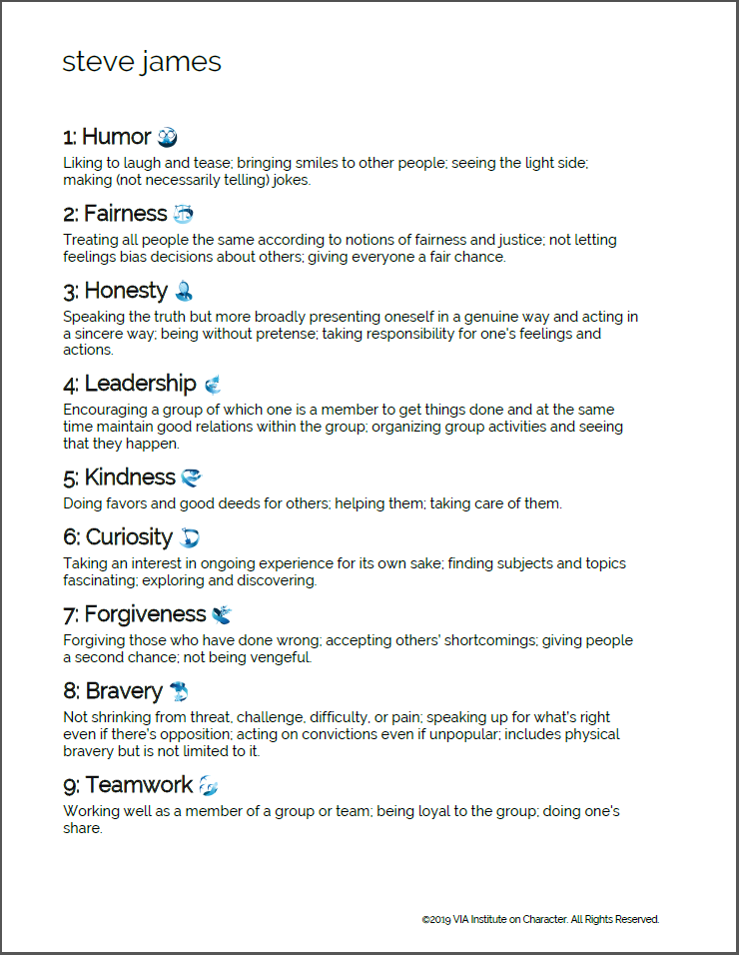
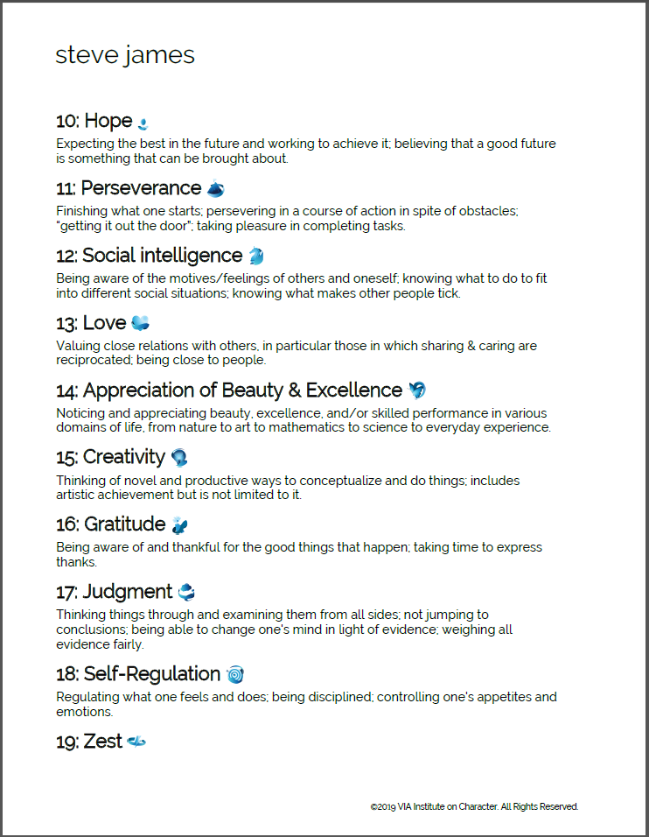
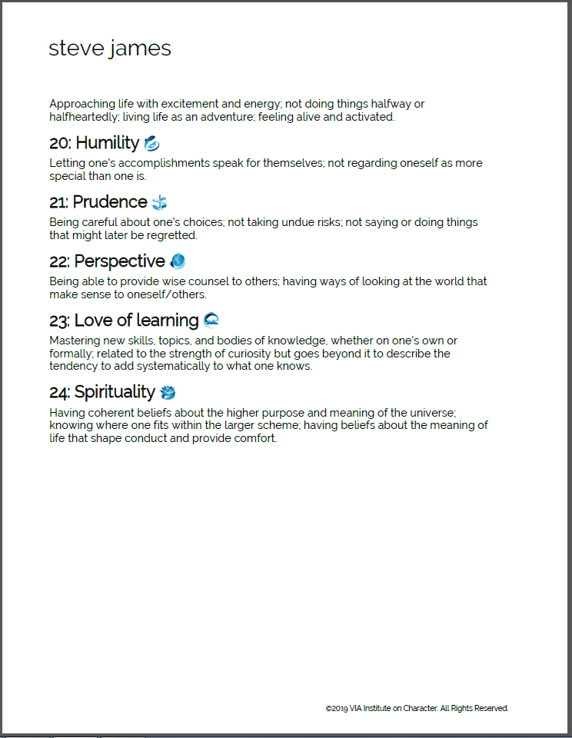

Appendix B – presentation



