I chose questions 2, 3 and 4 to answer.
NAME: Xi Wang
STUDENT NUMBER: 2212532

QUESTION TWO
- Explain the difference between static memory allocation and dynamic memory allocation in the context of data structures.
The answer is:
Static Memory Allocation:
Fixed memory size allocated at compile time.
Used for arrays and structs.
Can waste memory if overestimated.

Dynamic Memory Allocation:
Memory is allocated during runtime as needed.
Used for data structures like linked lists and trees.
More efficient but requires careful management to prevent issues like memory leaks.
[4 marks]
- Explain with the aid of a diagram the term “node based linked list.” Identify and essential operations required manage this data structure. Provide reasons for your choices in your answer.
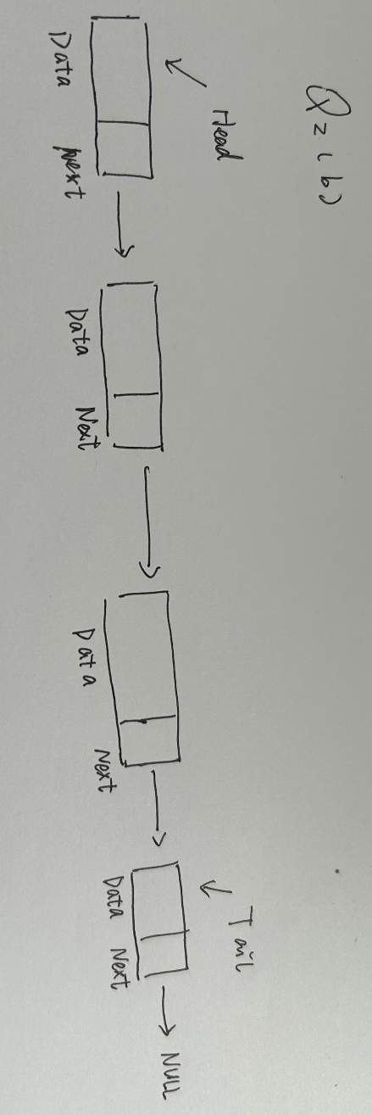
A Node-based Linked List is a data structure that consists of a sequence of nodes, where each node contains a value and a reference (link) to the next node in the sequence.
Insertion: Inserting a new node at the beginning, end, or at a specific position in the linked list.
Deletion: Removing a node from the linked list, either from the beginning, end, or a specific position.
Update: Modifying the data stored in a specific node.
Length: Determining the length or size of the linked list.
Searching: Finding a specific value or node within the linked list.
Traversal: Iterating through the linked list to access and process each node's data.

[7 marks]
- Using the ideas of dynamic memory allocation and the concept of a list node, describe using pseudo-code a detailed algorithm for a function that will delete an item from a double linked list. In your answer comment on any potential problems associated with your implementation.
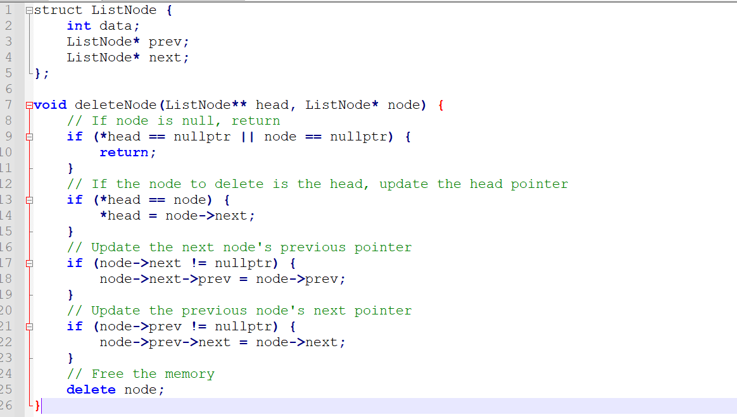
[10 marks]
- Given a dynamic linearly linked list explain how it can be modified to implement a circular data structure.
The answer is:
step 1: Traverse to the last node of the list.
step 2: Modify the last node's pointer to point to the first node instead of NULL.
[4 marks]
QUESTION THREE
- Describe the stack and queue data structures including, with arguments for their inclusion, essential operations that are performed on each structure.
The answer is:
Stack: A Last-In-First-Out (LIFO) data structure. Key operations include:
Push: Add the element to the top.
Pop: Remove the element from the top.
Peek/Top: View the top element.
isEmpty: Check if the stack is empty.

Queue: A First-In-First-Out (FIFO) data structure. Key operations include:
Enqueue: Add the element to the end.
Dequeue: Remove the element from the front.
Front: View the first element.
Rear: View the last element.
isEmpty: Check if the queue is empty.
isFull: Check if the queue is full.
- Provide an algorithm that implements an iterative depth first search using a stack data structure. Analyse this algorithm and hence state its space and time complexity.
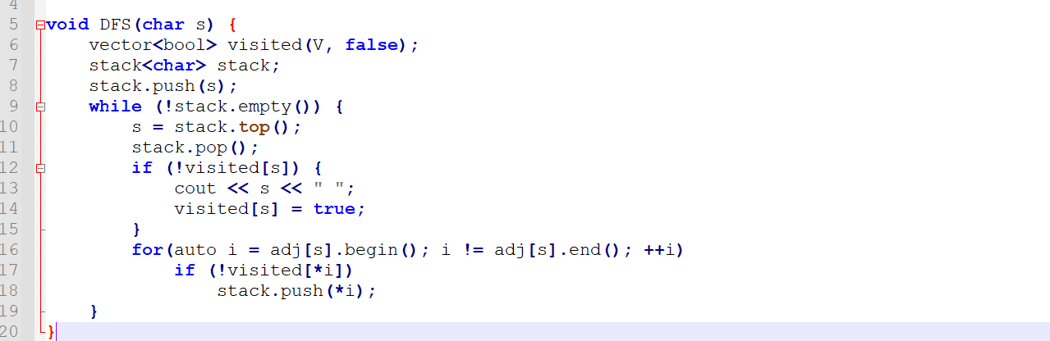
[8marks]
- Apply your algorithm to the graph of figure Q3c, showing the contents of the stack after each iteration of the loop. Explain how your depth first search algorithm might be modified to perform, instead, a breadth first search
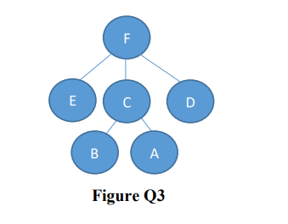
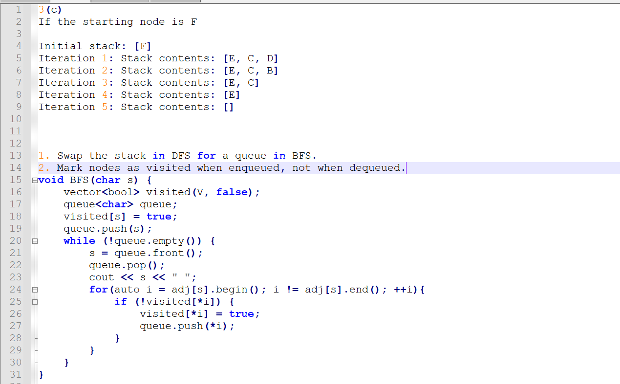 [7marks]

QUESTION FOUR
- Show by means of a diagram how a binary search tree would be constructed given the following list of unordered numbers: 50, 25, 15, 30, 18, 75, 80, 2 Give you reasons for the placement of each value.
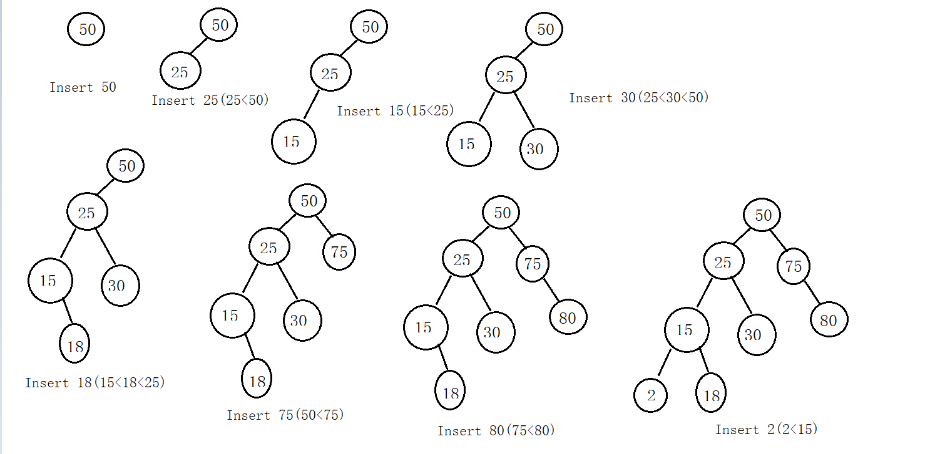
[6 marks]
- Using the binary tree generated in part a), perform a post-order traversal of the tree writing down the data read in the order in which the nodes are visited (ensure you indicate which is the first node visited in your answer). Repeat this process using an inorder and pre-order traversal.
The answer is:
pre-order traversal: 50, 25, 15, 2, 18, 30, 75, 80
in-order traversal: 2, 15, 18, 25, 30, 50, 75, 80
post-order traversal: 2, 18, 15, 30, 25, 80, 75, 50
[12 marks]
- Demonstrate with the aid of program code or pseudo code the process required to delete the number 2 from the binary tree.
The answer is:
Suppose we don't know whether 2 is at the leaf node or the root node. The pseudocode is as follows:
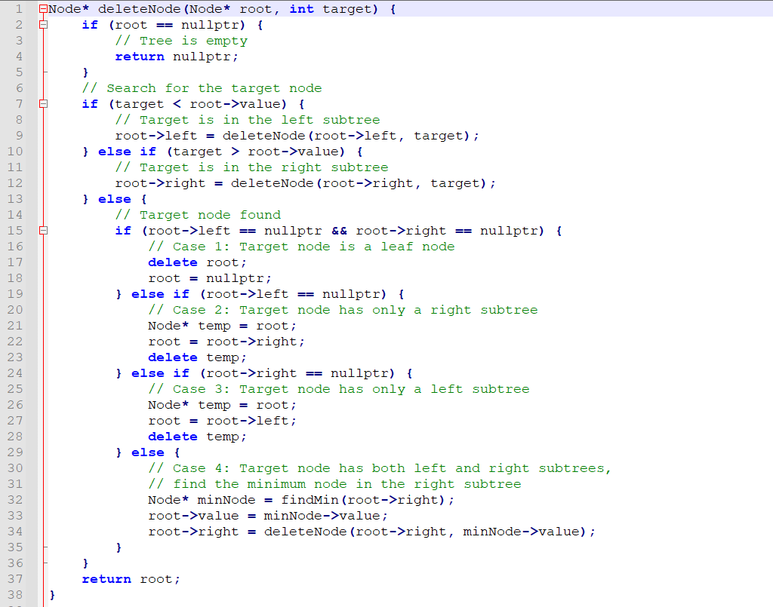
[7 Marks]

