MARKETING MANAGEMENT

Assignment 2

Student name: Nathaniel Odoi

Student Number: 1810442

Module: BMMB7012D

Date: 15th September 2019



Table of Contents
Introduction ………………………………………………………………………..3

- Marketing Function …………………………………………………………....4

  - Structure of Marketing Department …………………………………………...5

  - Activities and role of Marketing ………………………………………………5

  - Marketing Strategy …………………………………………………………….7

  - KPI’s …………………………………………………………………………...8

- Marketing Frameworks ..……………………………………………….………9

2.1 Marketing Mix ……………………………………………………………….10

2.2 7 Ps …………………………………………………………………………...10

2.3 STP …………………………………………………………………………...13

- Current and Future Issues……………………………………………………...14

3.1 Cross Departmental collaboration ……………………………………………14

3.2 CSR …………………………………………………………………………....15

- Recommendation ……………………………………………………………...16

- Conclusion …………………………………………………………………….16

- References ……………………………………………………………………..17

INTRODUCTION

Marketing is defined as any activity that an organisation undertakes to promote the selling or buying of product or services. It also includes the delivering of products to consumers or other businesses, advertising and selling (Twin, 2019).
Marketing is the backbone behind every organisation. For every organisation to withstand the competition their rivals pose and also to gain grounds and become a force to reckon with in their field of operation, the Marketing department must be on top of their game. This in tend maximise the company’s profit and also able to retain their talented employees.
Samsung was founded by Lee Byung-Chul as a trading company in 1938. The company was into insurance, food processing, textiles, securities and retail (Research-Methodology, 2019). Samsung entered into the electronic industry in the late 1960’s and into construction and shipbuilding in the mid 1970’s. after the death of Lee in 1987, the company got divided into 4 business groups which are Samsung group, CJ group, Shinsegae group and Hansol group. Samsung Electronic an affiliate of Samsung group has increasingly globalised its activities and electronics particularly mobile phones and appliances in the 1990’s (Bondarenko, 2019). In spite of all the success, those years also brought some corporate scandals that afflicted the company as the company was faced with several bribery issues and suits. The company remained focus and expanded in their technology and product quality front raging from semiconductors, computer-monitor and LCD screens climbing into top five place in global market share.
Samsung was not too popular some few years ago but Samsung currently is rated number one in technology business in terms of revenue and seventh most valuable brand. Samsung struggle to keep up in the smartphone world but now very popular with Apple Inc as the main
competitor (White, 2019).
Marketing has played an immense role in the success and achievements of Samsung. The Marketing strategy of the company was one of the best ever created because it has helped Samsung to change its structure from a cost-driven to becoming authority manufacturer (White, 2019).
Because the taste of consumers in the technology world changes all the time, Samsung had to change in order to gain upper hand and their marketing strategy was the key to evolution. Pertinent issues on how the company uses Segmentation, Targeting and Positioning (STP), Marketing mix and the purchasing behaviour of customers will be discussed and analysed. Also, the presence and absence of Corporate Social Responsibility as a marketing tool will be analysed.

- Marketing Function
Marketing role is an important part of an organisation but is mostly misunderstood. Talk about Marketing and everyone unconsciously focus on advertising which is just one form of how marketing is communicated (B2B-Club, 2019). Marketing and Advertising are mostly used interchangeably but there is a clear difference. Marketing terminology is very broad which involves advertisement Anon (Rasmussen.edu, 2019). Marketing is the whole process which determines what is known as the 4 Ps; product, placement, promotion and pricing but advertising is mainly go to do with promotion (Hanson, 2017).
Every department in an organisation knowingly or unknowingly is part of marketing by definition. Chartered Institute of Marketing defines Marketing as the process in which management is responsible to identify, anticipate and the satisfaction of customer requirement in a profitable manner. Therefore, the interplay of all departments in an organisation to maximise profit and to showcase the company’s brand is marketing. This can be explained very well in the organisational structure of Samsung.

  - Organisational structure of Samsung
Samsung organisational structure is the product type divisional structure which categorises products in determining which resources and business activities needs to go to which divisions. The entire corporate structure is unified through the Headquarters based in Seoul. The structure is designed to promote technological innovation and this is done through the collaborative effort of all divisions (Evans, 2019)
Fig 1.1 shows Organisational structure of Samsung
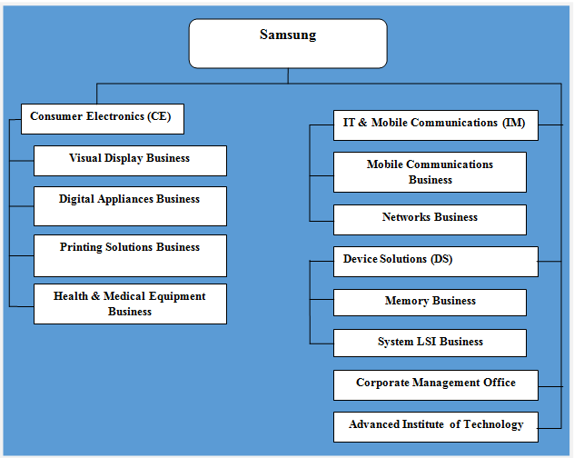
Source: research methodology.net (2019)

  - Activities and role of marketing
We need to diagnose and evaluate the roles and activities of marketing in an organisation, to understand this, the American Marketing Association (AMA) defines marketing in detail. It’s a function of the company and a set of procedures for creating, communication and delivering value to the consumer. It also manages consumer relationship in such a way that is beneficial to both the consumers and shareholders (AMA, 2013). The definition clearly implies that marketing aides in creating an idea, service or product and then reaches all customers through marketing communication (mostly advertising) with the intent of delivering value to the consumer. This intend generate revenue for the company through the purchase of their products and services or ideas.
The activities and roles of marketing differs from every organisation and Samsung is no different, Thehartford.com, (2019) has pointed out 9 different roles and activities of Marketing department which are also followed by Samsung Electronics:
Defining and managing the Brand: This refers to the way an organisation portrays themselves to the public and also what they stand for it also involves how the company present their product to customers Anon (Thehartford.com, 2019).
Samsung creates the need for people and not just satisfy customers (White, 2018)
Conducting campaign management for marketing initiatives: Over the period, Marketing department looks at a particular product or services they need to focus in a particular sales cycle Anon (Thehartford.com, 2019).
. Currently there is Promotion going on for Galaxy note 10 and its own kit as well even though the product is not yet out.
Producing marketing and promotional materials: Samsung Marketing department provides an up to date materials for promoting the product and services.
Creating content providing search engine for their website: Samsung marketing department ensures that their website is updated and also quick when people search for products and information as this is the place where first-hand information is assessed (Samsung UK, 2019).
Monitoring and managing social media: The world is seen as a global village now so constantly Samsung Marketing department makes sure they monitor what is been posted about their services online so they can react swiftly if its negative, a typical example is about batteries catching fire where they recalled all their products
Producing internal communication: It is proper for the employees of every organisation to understand the goals and what the company stand for and it is the duty of marketing department to communicate this through newsletter or the intranet.
Serving as media liaison: When a company is cited in the media, a member of the marketing departments acts on behalf of the company or guide executives on what to say and how to go about it. Not until March 2019, Mr Marc Mathieu chief Marketing Officer helped Samsung company when they went through the battery crises (Bruell, 2019).
Conducting customer and market research: Samsung has a research team that conducts research about their customers and also about their products to analysed how they are doing.
Overseeing outside vendors and agencies: Samsung manages the distribution making sure it falls within ethical means and also the Samsung supplier code of practice. The Marketing department also ensures the right adverts goes a long way for promoting the product.

  - Marketing Strategy
Consumers do not get attached to particular technology but rather they go for the best which is more advanced or user friendly. These behaviours of consumers have made technology manufacturers always made new gadgets that would meet the desire of consumers and also their satisfaction (White, 2019). Samsung has never failed in this area for several years. Samsung has huge product selection ranging from laptops, smartphones, tablets, refrigerators, TVs and cameras (Samsung.com, 2019). The Samsung marketing strategy has proactively built trust in every product they make. Samsung is not just product centred but in addition they are famous for good customer services. The well praised marketing strategy of Samsung is furtherly analysed below using the Samsung Marketing mix, their Key Performance Indicators and their Marketing Frameworks.

  - Key Performance Indicators
This is Organisation’s way of measuring success according to Kaplan and Norton (1993) in an article published in Harvard Business Review. Different organisations have their own way of measuring their marketing performance. Return on Investment (ROI) is the main method Samsung and most companies use. This is basically checking if profits are earned from our investments (Morello, 2016). Samsung uses the Marketing Evaluation Metrics, Customer profile, Financial, Behavioural Metrics and many others too. The main Marketing plan of the company is taking into account Behavioural of consumers about the Brand Image. The company has a team called the Global Marketing Team which is sub divided into three groups dealing with ROI: product strategy team, Marketing strategy team and customer perspectives.
Fig 1.4 Some Key Performance Indicators Samsung uses to measure marketing Performance.

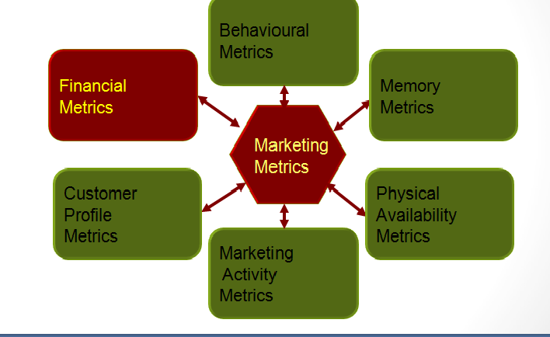
Evaluating Marketing Performance Source: Wordpress.com (2016).

- Marketing Frameworks
Marketing analysis framework gives the company tools and guide that assist to embark on analysis and to make decisions (WFP, 2011, p 1). Some common ones are 7Ps of marketing mix (Chaffy, 2018), Unique Selling Position, Segmentation, Targeting and Positioning. Boston Consulting Group Matrix, PESTLE, Porter’s 5 Forces and Growth Strategy mix. Organisation can base on these models as a guide to design and set a marketing plan. Each of these has their own advantages and limitations but most organisation may prefer to stick to one of them. According to Kotler (2000) a combination will be used usually. Clearly Samsung uses more than one as their Marketing strategy.

  - Marketing mix
Kotler (2009, p.9) defined Marketing mix as the set of marketing tools that an organisation uses to pursue its marketing goals. A popular example is the 4Ps that came up first which are product, price, place and promotion created by Edmund McCarthy in the 1940s (Needham, 1996). This development was made when there was not a lot of attention on the service
industry but since Samsung deals in both products and services then the need for the 7Ps which account for both (Dudovskiy, 2019).

  - 7Ps
The original 4Ps were expanded by adding 3 extra Ps so that the service industry will be accounted for by Booms and Bitner (1981). And these are known as the 7 Ps. Below is how Samsung uses the 7 Ps;
- Product: This basically means what customers are been provided with which could be items and services (Farrall and Lindsley, 2008). Samsung company is noted for one of the fastest product services giving its customer vast range of product variations. Refrigerators, washing machines, Tablets, IT (Laptops, printers and accessories), Televisions and Mobile phones (smart phones and normal phones). All these products have won trust from customers and are well accepted worldwide due to their quality and user friendly (Dudovyskiy, 2019).
- Price: This refers to the amount of money consumers pay for a product or services (Kotler and Armstrong, 2011). Samsung uses two pricing strategies which are Competitive pricing and Skimming pricing (Bhasin, 2019).
Competitive pricing – This means setting your price at the same level as the competitors have (Grasset, 2015). Samsung uses this type of pricing in order to be able to withstand the fierce competition in the market because unlike smartphones where they dominate, other brands like LG in other gadgets and in cameras Nikon and Cannon also are very good brands too.
Skimming pricing: Setting up the highest price for a new product and reduces it over a period of time Anon (BusinessDictionary.com, 2019). This pricing technique is also used by the company’s major competitor Apple. Samsung uses skimming pricing to gain upper hand over their competitors. A typical example Galaxy S9 Plus will cost £700.00 across the globe with smart features what happens next is competitors will launch a similar product with same features, then Samsung will reduce the price and steal customers from their competitor.
- Place: This links to where and how products are made to reach consumers (Farrall and Lindsley cited in Frazzer-Morris, 2018). Channel marketing is what Samsung uses in its industry and this is where only service dealers are used in corporate sales. The distribution is a powerfully irresistible part of the company’s marketing strategy. Retailers are bound to involve Samsung in their list because of the fame the firm has worldwide so it can also serve as an option for customers. In Mumbai, the company distributes its product through a single company and this helps in paying a lot to distribution channels (Bhasin, 2019).
- Promotion: Samsung uses diverse forms of promotion; the company believes in engaging consumers therefore advertising is one of their promotional tools (White, 2019). Samsung also gives discounts, embarks on national and worldwide festivals and also sponsors events. Their Marketing strategy concurrently helps the organisation progress in different aspects. Samsung is actively involved in various sponsorship as well, the Australian Olympic Team, Sydney Opera House and Oceania Foundation are all sponsored by Samsung. Marvel’s Avengers starring Lionel Messi, Eddie Lacy, John Florence etc in Assemble Part 1 and 2 is a huge success of the company’s Marketing Department as this advert got over 51 million views and the mobile advert is also awesome which increased the public image of the company (White, 2019).
- Process: This is how they manufacture and deliver their product (Farrall and Lindsley, 2008). Samsung managed their supply chain based on a principle known as Ethical Distribution process making sure their suppliers are held at a higher standard. Samsung also conduct thorough examination on the minerals used for their products (Samsung Electronics America, 2019).
- People: This refers to whoever has interaction with the product or service and this could be employees who engages in selling, advertising, public relations and the consumers who are the main target. Samsung is noted for quality service in terms of relating to customers. The company gives equal opportunities to all employees and also train then to acquire talent to fit each job role (Samsungsem.com, 2019).
- Physical Evidence: Frazzer-Morris, (2019) refers to it as what every business can do to shape how their product and services can be perceived by the customer. Some will argue that this is part of branding, it refers to the part of it that is visual. It could even be a store design or brochure (Farrall and Lindsley, 2008). A typical example of how Samsung design their store as shown in fig 2.2 below.
It is design in such a way that the various product will be exhibited so that customers can try hands on.

Fig 2.2
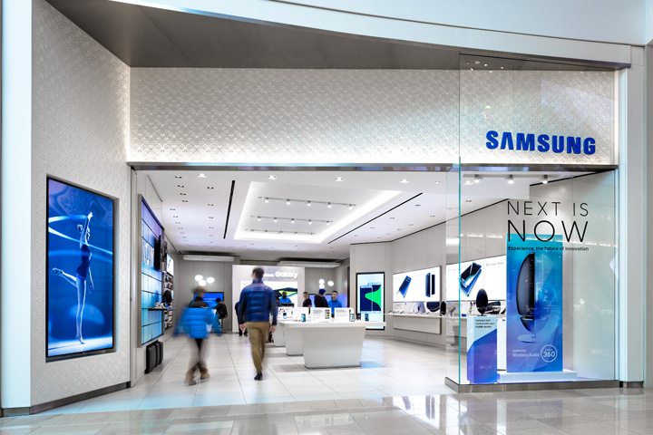
Samsung store at Sherway Gardens, Toronto by Cutler.
Source: Retaildesignblog.net (2019)

  - Segmentation, Targeting and Positioning (STP)
This is basically putting the population into groups based on certain characteristics (Dudovskiy, 2017). Behavioural and Psycho-graphic can be said to be those that are been used by Samsung in terms of segmentation.
Geographically, the company made Galaxy segment for urban and Samsung Guru segment for remote areas. Making it look like there is something for everyone wherever you are located. For Demographic, the youth between the ages of 16 and 29 have got the smartphone whereas Samsung Guru is made for middle and lower class for easily affordability. The company looks after its customers in terms of budget, need and requirement.
Psychologically, Samsung has product to suit the lifestyle of their customers example the Galaxy is made in different colours to suit particular sex type.
Targeting is based on selecting a particular group as consumers of product or service (Dudovskiy, 2017). And positioning is the selection of a marketing mix which is most suitable for target customer segment.

- Current and Future Issues
By revenue Samsung is the largest tech business. Notwithstanding this fact, there is a brand damaging when passengers on an aircraft get told to turn off their Samsung devices. Obviously, that sends a negative signal meaning the airline has lack of faith in the product in terms of safety (Cellan-Jones, 2016). Even though Samsung acted swiftly to react to that but that is still an issue where their competitors can highlight more to tarnish the company’s brand and image.
In the second quarter of 2017 Samsung recorded 12.6 billion USD which was over 70% of the previous year’s profit, however how long is this going to continue as they face heavy competition from their Chinese rivals in semiconductors and also having an untested boss (Sunghee, 2017). Samsung Marketing department needs to be on it toes as their Chinese rivals emerge as that could be a massive competition for the company in the future. In my honest opinion, these are issues which Samsung can combat in a more effective way to see Samsung still flourish at the top.

  - Cross- departmental collaboration
Marketing department alone by its definition cannot tackle the above issue highlighted alone. This is where all department will have to work hand in hand together to the good and benefit of the Company. Department like Production will have to scrutinise and supervise well with what they design and manufacture as well as Human Resource will have to ensure the right talent is employed to exhibit the right skill (FitzHugh and Piercy, 2007). Not placing square peg in a round hole. Marketing department can however collaborate very well and partner all these department to make sure these issues are resolved.

  - Corporate Social Responsibility (CSR)
Samsung is keen on providing variety of quality products which are the perfect choice for its customers and also competitive for its rivals. This has been well executed. But customers more especially millennials prefer to buy from companies who are considered to be responsible socially (Europeanceo, 2018). Samsung CSR committee manages this aspect of the company, every year a report is released by the company enumerating all the programmes the company has initiated (Dudovskiy, 2019). Samsung addresses this aspect in four different ways: green management, social contributions, health and safety and sharing growth. Samsung Solve for Tomorrow is a programme that engages NGO’s and students to tackles social issues (Dudovskiy, 2019). Through CSR, the company gains some good will which is a form of marketing.
A research conducted by Belinda McLaughlin in 2017 on how CSR improve marketing and financial performance of a company, in her findings, it was deduced that CSR raises the company’s bar in competition against their rivals and also increase profit margin of the company (McLaughlin, 2019).

- Recommendation
Notwithstanding the current position of Samsung in terms of revenue and also technology, there are still some few areas they need to look into as failure to do so could possibly have a long-term effect on the company which may lead to the rise of their main rival Apple hence losing customers.
- Samsung should strategically partner external software developers; this is because their sole reliance on android OS is not the best as it limits business capabilities because of Google’s influence on the software (Martin, 2019).
- Competition especially imitation of products; one of the major threats the company could face is the imitation of Samsung product which could be sold at lower prices in the market (Martin, 2019). My recommendation is that Samsung should restrict non distributers from getting access to their product in that case they can advertise the sole distributers and bring counterfeit marketers to book.

- Conclusion
The Marketing strategy of Samsung is second to none and a very good example for marketers to progress and evolve. As we can see having variety of products helps the company to satisfy the larger consumers and that sells the company globally. The marketing department is also doing remarkably well by sponsoring a lot of events to make the brand a global giant as it is today. Another area that has contributed remarkably to the success of the company is their commitment in CSR as this has impact on their financial performance by maximising profit (McLaughlin, 2017). With Marketing serving as the core competency of the development of the business, time and money should not be spared on the Marketing department (White, 2019). The Marketing Department of Samsung also work hand in hand with other department within the organisation and that has also contributed to the success of the company.

References

American Marketing Association. (2019). What is Marketing? — The Definition of Marketing — AMA. [online] Available at: https://www.ama.org/the-definition-of-marketing/ [Accessed 5 Sep. 2019].

Bhasin, H. (2019). Marketing mix of Samsung - Samsung marketing mix & 4p's of Samsung. [online] Marketing91. Available at: https://www.marketing91.com/marketing-mix-of-samsung/ [Accessed 25 Aug. 2019].

Bondarenko, P. (2019). Samsung | History & Facts. [online] Encyclopedia Britannica. Available at: https://www.britannica.com/topic/Samsung-Electronics [Accessed 24 Aug. 2019].

Bruell, A. (2019). Samsung America Marketing Head Marc Mathieu Departs Company. [online] WSJ. Available at: https://www.wsj.com/articles/samsung-america-marketing-head-marc-mathieu-departs-company-11552501113 [Accessed 4 Sep. 2019].

BusinessDictionary.com. (2019). What is market skimming pricing? definition and meaning. [online] Available at: http://www.businessdictionary.com/definition/market-skimming-pricing.html [Accessed 24 Aug. 2019].

Cellan-Jones, R. (2019). Samsung's burning issue. [online] BBC News. Available at: https://www.bbc.com/news/technology-37605948 [Accessed 27 Aug. 2019].

Chaffey, D. (2019). Marketing models that have stood the test of time | Smart Insights. [online] Smart Insights. Available at: https://www.smartinsights.com/digital-marketing-strategy/online-business-revenue-models/marketing-models/ [Accessed 04 Sep. 2019].

CIM, J. C. and Porras J. (1994). Built to last: Successful habits of visionary companies. Harper Business.1994

Dudovskiy, J. (2019). Samsung Corporate Social Responsibility - Research-Methodology. [online] Research-Methodology. Available at: https://research-methodology.net/samsung-corporate-social-responsibility/ [Accessed 31 Aug. 2019].

Grasset, G. (2015). Competitive Pricing Definition - Lokad. [online] Lokad.com. Available at: https://www.lokad.com/competitive-pricing-definition [Accessed 24 Aug. 2019].

Kotler, P. (2000). Marketing Management, (Millenium Edition), Custom Edition for University of Phoenix, Prentice Hall

Kotler, P. and Armstrong, G. (2011). Principles of marketing. 14th ed. Boston: Pearson Prentice Hall, p.52.
Martin, V. (2019). Samsung SWOT Analysis & Recommendations - Panmore Institute. [online] Panmore Institute. Available at: http://panmore.com/samsung-swot-analysis-internal-external-factors-recommendations [Accessed 7 Sep. 2019].

McLaughlin, B. (2019). Corporate Social Responsibility Factors in Market Share and Financial Performance Improvement. [online] Semanticscholar.org. Available at: https://www.semanticscholar.org/paper/Corporate-Social-Responsibility-Factors-in-Market-McLaughlin/a967742f4d1c690e664a24f901c7ec56d3e40bc7 [Accessed 31 Aug. 2019].

Norton, D. and Kaplan, R. (2019). Putting the Balanced Scorecard to Work. [online] Harvard Business Review. Available at: https://hbr.org/1993/09/putting-the-balanced-scorecard-to-work [Accessed 5 Sep. 2019].

Research-Methodology. (2019). Samsung Group - Research-Methodology. [online] Available at: https://research-methodology.net/samsung-electronics-report-3/ [Accessed 7 Sep. 2019].

Rasmussen.edu. (2019). Advertising vs. Marketing: Comparing Commonly Confused Business Careers | Rasmussen College. [online] Available at: https://www.rasmussen.edu/degrees/business/blog/advertising-vs-marketing/ [Accessed 5 Sep. 2019].

Samsung uk. (2019). Find a Samsung Support Centre | Samsung Support UK. [online] Available at: https://www.samsung.com/uk/support/service-centre/ [Accessed 7 Sep. 2019].

Samsung Electronics America. (2019). Supply Chain | Sustainability | Samsung US. [online] Available at: https://www.samsung.com/us/aboutsamsung/sustainability/supply-chain/ [Accessed 26 Aug. 2019].

Samsungsem.com. (2019). SAMSUNG ELECTRO-MECHANICS. [online] Available at: http://www.samsungsem.com/global/sustainability/executive-n-staff/index.jsp [Accessed 26 Aug. 2019].

Smallbusiness.chron.com. (2019). What Is the Difference Between Marketing and Advertising?. [online] Available at: https://smallbusiness.chron.com/difference-between-marketing-advertising-25047.html [Accessed 5 Sep. 2019].

Sunghee, H. (2019). Samsung facing growing threats despite record profits. [online] Phys.org. Available at: https://phys.org/news/2017-07-samsung-threats-profits.html [Accessed 27 Aug. 2019].

Thensmc.com. (2019). [online] Available at: https://www.thensmc.com/sites/default/files/CIM%207Ps%20Resource.PDF [Accessed 24 Aug. 2019].

Thehartford.com. (2019). The Role of a Marketing Department in a Business | The Hartford. [online] Available at: https://www.thehartford.com/business-insurance/strategy/creating-marketing-department/role [Accessed 4 Sep. 2019].

Twin, A. (2019). Everything Marketing Entails. [online] Investopedia. Available at: https://www.investopedia.com/terms/m/marketing.asp [Accessed 19 Aug. 2019].

White, W. (2019). Samsung Marketing Strategy: The Master Brand · Inevitable Steps. [online] Inevitable Steps. Available at: http://inevitablesteps.com/marketing/samsung-marketing-strategy/ [Accessed 19 Aug. 2019].

WFP, (2011). Market analysis frameworks. [online] Available at: https://documents.wfp.org/stellent/groups/public/documents/manual_guide_proced/wfp243856.pdf [Accessed 04 Sep. 2019].

