

Module Name- Contemporary Themes in the Hotel and Hospitality Sector
Module code: BMIH6001

Research title: The importance of sustainability in terms of Food waste and its efficacy through smart inventory management of the hospitality sector- A case study of Marriott International

Student Name - Mariana Mironov
Student ID-2232725
Lecture name: Lola Villard-Coles

AI Acknowledgement Statement

I declare that I have not incorporated any AI tools in executing and writing this assignment. I did not submit any materials that have been generated by artificial intelligence as my own work.
I acknowledge that I have copies of my drafts, notes, other referenced resources used by me.

Abstract
The following research has been conducted on the understanding of the importance of sustainability in reducing food waste within the hotel and hospitality sector through smart inventory management. Marriott International has been selected as a case study organisation in this research for further discussion on the topic. An introductory chapter has been placed to highlight the direction of the research through formulating aims and objectives. The literature review chapter has discussed existing infiltration available on the research topic. The research methods section has highlighted that a secondary qualitative method has been applied, and information has been interpreted by using a thematic analysis process. This observation has conducted a qualitative analysis to generate a proper outcome from the topic. Google Scholar has played a core role in offering a wide range of sources for the subject. The discussion part has linked the literature review with the evaluation part to substantiate the plan. An overall summary of all outcomes has been presented in the conclusion section of the study.

Table of Contents
Introduction 6
Background and importance of the theme 6
Aim 6
Objectives 6
Overview of the hotel and hospitality sector and its relevance to the theme 6
Literature Review 7
Application of smart inventory management organisations within the hotel and hospitality sector to reduce Food waste and promote sustainability 7
Issues experienced by firms in the hotel and hospitality sector while utilising smart inventory management to reduce food waste and improve sustainability 7
Potential strategies that can help in mitigating the challenges and enhance smart inventory management within the hotel and hospitality sector to promote sustainability in terms of Food waste and its efficacy 8
Literature Gap 8
Methods 9
Research data collection procedures 9
Data analytical techniques 9
Data collection tools 9
Theme impact analysis 10
Qualitative analysis 10
Discussion 14
Conclusion 15
Recommendations 16
References 17
Appendix 19
Gantt chart 19

Introduction

Background and importance of the theme
Sustainability in relation to food waste and efficacy involves the responsible use of food resources for decreasing food waste generation. Reports have suggested that nearly 79 thousand tonnes of food waste are generated by the hotel and hospitality industry annually (Shapiroe, 2024). Hence, exploring this topic is important to find reliable solutions to reduce food waste and promote sustainability within this industry.

Aim
To understand the importance of sustainability in terms of Food waste and its efficacy through smart inventory management at Marriott International.

Objectives
To identify the ways Marriott International employs smart inventory management to promote sustainability in terms of Food waste and its efficacy
To analyse the challenges faced by Marriott International while practising smart inventory management to promote sustainability in terms of Food waste and its efficacy
To evaluate the potential strategies that can help Marriott International to mitigate the challenges and enhance smart inventory management to promote sustainability in terms of Food waste and its efficacy

Overview of the hotel and hospitality sector and its relevance to the theme
The hotel and hospitality sector includes accommodation and food and beverage services to meet the needs and demands of travellers and tourists. Marriott International is a global and one of the biggest hotel companies, having more than 9 thousand properties in 134 different countries (Mariott International, 2025). According to statistics, this sector is expected to grow by 7% by the year 2030 (Statista, 2025). Sustainability is highly important in the hotel and hospitality sector for ensuring its long-term economic growth by reducing its negative effects on society and the environment. Hence, a deep understanding to mitigate the issues preventing organisations from reducing food waste and becoming sustainable is required.

Literature Review

Application of smart inventory management organisations within the hotel and hospitality sector to reduce Food waste and promote sustainability
Artificial intelligence-based inventory management
According to Vukolić et al. (2025), the utilisation of AI within organisations in the hotel and hospitality sector was included for smart inventory management practice to reduce the waste of food items. It has been identified that AI technology has helped in analysing the need and demand for food items among guests. Hence, accurate orders can be placed by organisations to their food suppliers, which has helped in managing stock levels. Enhanced control on inventory has been achieved by firms that have helped them improve the sustainability of their business.
Automation of waste material monitoring
As per Gómez-Talal et al. (2024), the smart inventory management system includes the automation of waste material monitoring in the hotel and hospitality sector to enhance sustainability. These have aided in identifying the generation of waste materials in an automated manner. The need for manual efforts has been eliminated by the automation of waste material monitoring. It has saved the time of supply chain workers and increased their contribution to strategic planning regarding sustainability.

Issues experienced by firms in the hotel and hospitality sector while utilising smart inventory management to reduce food waste and improve sustainability
Insufficient awareness
As stated by Perera (2024), insufficient awareness among different stakeholders has been identified as a critical issue while implementing smart inventory management in the hotel and hospitality sector. Many organisations have reported that due to a lack of awareness, the effectiveness of smart inventory management in tracking food waste has been compromised. Other than that, the lack of awareness among suppliers often resulted in the replenishment of sticks or overstocking-related issues.
Increased food costs
As noted by Bux (2025), organisations often face issues related to the increasing food costs while employing food waste reduction solutions that have made it difficult to promote sustainability. Various organisations have reported that implementing smart inventory management systems and adopting waste reduction practices has created challenges in maintaining the affordability of their products and services. It has increased the risk of reduced customer satisfaction levels and loyalty and caused disruptions in their sustainable efforts.

Potential strategies that can help in mitigating the challenges and enhance smart inventory management within the hotel and hospitality sector to promote sustainability in terms of Food waste and its efficacy
Real-time AI-based predictive analytics
As suggested by Nguyen (2022), the organisation has found the real-time AI-based predictive analytical tools to be a cost-effective way for smart inventory management within the hotel and hospitality sector. It has been reported that the easy availability of these tools and low financial requirements have increased their adoption among hoteliers for promoting their sustainability through reducing food waste. This strategy has helped them to control the food costs while promoting sustainability to safeguard their customer satisfaction levels.
Increasing awareness about AI-based solutions
As stated by Clark et al. (2025), organisations have prioritised increasing awareness among their stakeholders about the use of advanced technologies like AI for smart inventory management to successfully cut down food waste. Various awareness initiatives and programmes have been launched for employees and suppliers to educate them about smart inventory management. On the other hand, organisations have also included their smart inventory management initiatives within their sustainability reports to educate their customers about their commitment to reducing food waste.

Literature Gap
The previous literature has provided basic insights and understanding about the role of smart inventory management in reducing food waste and promoting sustainability within the hotel and hospitality sector. Specific insights on particular hotels or hospitality-based organisations were missing, which has restricted an accurate understanding of the issue. Apart from that, many previous studies have been conducted on sustainability in terms of reducing food waste without focusing on a specific area like smart inventory management, which has widened their scope.

Methods

Research data collection procedures
The data collection procedure for the research has been mentioned to be based on secondary sources. The secondary sources of data help to provide qualitative and quantitative forms of data to be utilised in the research. Through the research process, only the qualitative form of data collection has been selected. This helps to provide more effective access to information available on the internet while highlighting different sectors of value which have already been researched and formulated (Nii Laryeafio and Ogbewe, 2023).

Data analytical techniques
The data analytical techniques focus on the availability of the data and analysing the data for reaching a better outcome. The research process mentions collecting qualitative data from a secondary source of data, which directly influences the data analysis process. A thematic analysis will be carried out in the research to understand and follow through the collected qualitative form of data. This will help to gather a number of data while focusing on the information through different themes. The practice also highlights their strengths and limitations properly (Squires, 2023).

Data collection tools
Data collection tools refer to tools to gather and interpret information from wider sources. The technique is Google Scholar, which is used to gather secondary source data through different journals and books. This makes the resources more relevant and authentic, as it also uses available articles on the internet using the search engine method. The collection process helps to maintain authenticity and a level of trust in the collected information, enhancing the research quality (Fornaro et al., 2021).

Theme impact analysis

Qualitative analysis
Identifying the approaches Marriott International is undertaking with smart inventory management to engage in sustainability practices involving food waste and their effectiveness
1st theme: Various procedures of smart inventory management in the hotel sector for the encouragement of green initiatives in the reduction of food waste
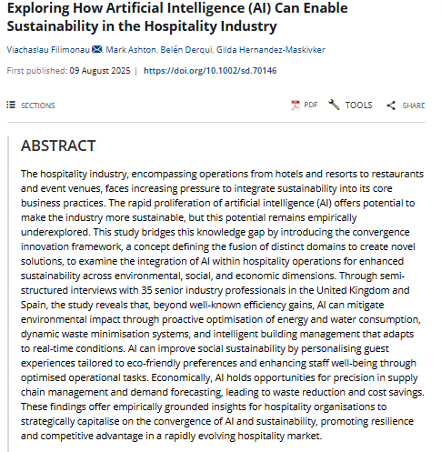
Figure: Significance of artificial intelligence in the hospitality industry for smart inventory management to maintain sustainability
Source: (Filimonau et al., 2025)
This theme of the process is useful in exploring various applications of smart inventory management to initiate sustainability in version to the hospitality industry. Artificial intelligence has been discussed within this theme to support companies in their plans within the market. The hotel industry is now increasingly utilising predictive analytics to gauge upcoming guest demand. This process and its application will enable organisations to control or manipulate the overall purchasing rate of their consumers. It can be effective in order to reduce overall food waste in this particular industry. The effective application of smart sensors as a means of implementation of an IoT-enabled storage system is also a necessary action in terms of monitoring of expiry dates of the resources. That notification in a timely manner will significantly reduce a substantial amount of waste from companies in the hospitality industry. Organisations application of AI in this particular field has been expressed in this analysis.
Theme 2: Several challenges encountered by the hotel and hospitality sector during the incorporation of smart inventory management regarding green initiatives
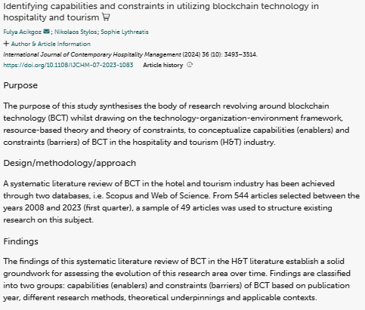
Figure: Various challenges during the application of smart inventory management systems, such as Blockchain, in the Hospitality sector
Source: (Acikgoz et al., 2024)
This theme is the portrayal of various issues of the hospitality sector in maintaining green initiatives through the utilisation of smart inventory management practices. An effective application of advanced technology, such as blockchain, comes with some barriers. Various complexities in this section hinder its adoption during operations in the workplace. A lack of effective infrastructure in organisations intensifies the issue significantly. Additionally, data fragmentation and real-time tracking restrictions are some other barriers in this section. Employees also show their scepticism towards the change regarding the new technology. The chance of job cuts is a main reason behind the issue. Regulatory uncertainty in sustainability metrics across regions is one of the main issues in the entire process.
Significant approaches that can assist Marriott International in reducing the issues and improve smart inventory management for the promotion of sustainability
Third theme: Suitable strategies that establishments can use to minimise challenges and enhance smart inventory management for increasing viability
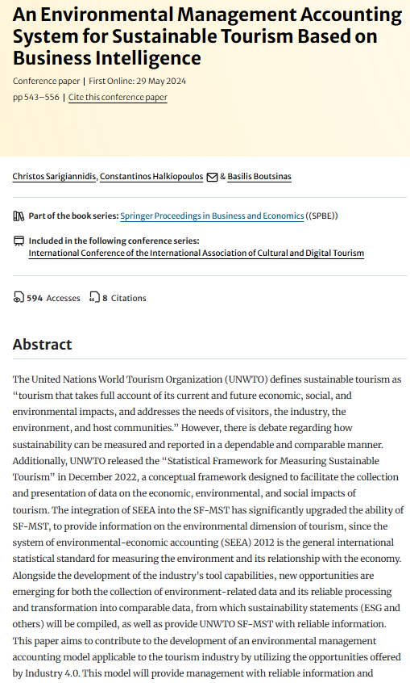
Figure: Environmental management mechanism for tourism firms
Source: (Sarigiannidis et al., 2023)

Analysis
Environmental Management Accounting mechanism is incorporated with Business Intelligence to upgrade viable travel procedures. The primary strength of this article is the encouragement of data-navigated viability, however it has low flexibility across assorted operational terms. Travel establishments can encompass this framework to foster food waste or enhance smart inventory handling through the utilisation of practical analytics. Supervision of consumption patterns and forecasting of trends leverages the effectiveness. Effective incorporation of an IoT-allowed tracking mechanism or RFID technology enables mechanised stock observation. Professional alerts and the waste aspect improve operational control. AI-navigated menu engineering can additionally enhance offerings dependent on customer preferences. EMA endorses price lucidity by increasing ecological influences. Allowance of the establishment helps to adhere viability efforts with financial efficiency. Significant partnerships with regional distributors for precise delivery minimise storage requirements or carbon footprint. Whereas, employee development or customer involvement efforts cater an environment of viability. The approaches efficiently increase adaptive, data-driven client anticipations. Offering a flexible or responsible strategy helps to improve sustainability in the hospitality industry.

Discussion
According to Vukolić et al. (2025), establishments in the hospitality sector utilise AI-dependent demand forecasting and mechanised waste tracking to improve inventory. Optimisation of supplier precision, operational performance is gained through practical insights or data-navigated approaches. The hospitality industry utilises AI-navigated predictive assessment or IoT-permitted storage to predict requirements. Improvement of viability and operational performance assists in various hotel activities. The literature review and information from the findings are not similar here. Bux (2025) stated that Hotel organisations encounter issues due to stakeholder consciousness gaps or increased food prices. Potential waste tracking, budget-friendliness, and client satisfaction are the key issues. Companies in the analysis part encounter issues in smart inventory encompassing due to system gaps, staff hindrance that restrict potentially foodwaste decrement. Significant findings or literature review are nor identical here in this. As stated by Clark et al. (2025), organisations utilise actual-time AI analytics or stakeholder awareness campaigns to improve viability. Retention of client experience or operational performance is received through this. Incorporation of EMA with business intelligence permits firms to decrease food waste and improve inventory through IoT or AI tools. Hence, the information stated in these two parts are not similar in nature.

Conclusion
This assessment has presented an analysis part to evaluate all objectives properly with the help of various themes. The application of AI in the smart inventory system has been prioritised for the hospitality sector. Marriott International should use this technique to achieve its goals properly. However, it comes with some challenges, such as a lack of infrastructure and standardised regulations. This assessment helps the company to take some actionable steps to mitigate these types of issues. Additionally, the firm should prioritise IoT technology in its operations to boost its efficiency in the market. The entire assessment has highlighted these approaches to maintain green initiatives in the workplace of Marriott International.

Recommendations
Blockchain-permitted traceability system
Effective incorporation of blockchain into smart inventory management is recommended for the company to assure lucid or tamper-resistance tracking. Establishments can improve responsibility across the distribution chain, which decrease the flaws. Potential blockchain also increases practical data sharing among distributors by allowing accurate inventory decisions (Drljevic et al., 2022). Blending of AI or IoT also empowers operational control and endorse company’s ESG commitments.
Apply AI-powered predictive analytics to demand forecasting
Marriott International is suggested to invest in AI-powered predictive analytics for effectively managing its food inventory and reducing wastage. These software applications consider historical guest behaviour, booking habits, seasonal trends, and local events to make more detailed estimates regarding food demand (Amori, 2025). This allows significant menu planning and procurement decisions, decreasing overproduction and spoilage. Considering solutions such as using Winnow or Leanpath, particularly designed for the hospitality sector, can help to monitor food waste in real time, gaining an understanding of the food that is being thrown away and its reasons. This can relatively inform chefs and managers regarding the ways they can change portion sizes, streamline procurement, and apply best practices across hotels, ultimately making operations more sustainable and cost-effective.
Create a real-time smart inventory tracking process
Marriott is also recommended to consider an inventory control approach that contains potential technological considerations, such as RFID or IoT devices (Muynck, 2023). This technology can offer real-time updates on stocks, expiration dates, and consumption levels, leading to informed planning and usage of ingredients. For example, the ingredients that are going to expire soon can be used in meal preparations first, to avoid wastage due to spoilage. The approach of combining with procurement systems, the platform will be able to automate reordering based on current demand, which will maintain the optimal stock levels. Apart from that, tracking data among properties can guide the association to identify high-waste locations, comparison of performance, and application of targeted interventions. This consideration will develop both sustainability and operational efficiency at scale.

References
Acikgoz, F., Stylos, N. and Lythreatis, S., (2024). Identifying capabilities and constraints in utilizing blockchain technology in hospitality and tourism. International Journal of Contemporary Hospitality Management, 36(10), pp.3493-3514.
Amori, M., (2025). How AI Powers Manufacturing And Maintenance Demand Forecasting. [Online] Available at: https://www.forbes.com/councils/forbestechcouncil/2025/01/24/how-ai-powers-manufacturing-and-maintenance-demand-forecasting/ [Accessed 11 October 2025].
Bux, C., (2025). Sustainable Healthcare and Food Waste Minimization Through a Data-Driven Hospitality Management. In Strategies for a Sustainable and Environmentally Friendly Hospital Foodservice Management (pp. 89-110). Cham: Springer Nature Switzerland.
Clark, Q.M., Kanavikar, D.B., Clark, J. and Donnelly, P.J., (2025). Exploring the potential of AI-driven food waste management strategies used in the hospitality industry for application in household settings. Frontiers in Artificial Intelligence, 7, p.1429477.
Drljevic, N., Aranda, D.A. and Stantchev, V., (2022). An integrated adoption model to manage blockchain-driven business innovation in a sustainable way. Sustainability, 14(5), p.2873.
Filimonau, V., Ashton, M., Derqui, B. and Hernandez‐Maskivker, G., (2025). Exploring How Artificial Intelligence (AI) Can Enable Sustainability in the Hospitality Industry. Sustainable Development.
Fornaro, C.J., Sterin, K. and Struloeff, K.L., (2021). Qualitative data collection tools: Design, development, and applications by Felice D. Billups. Current Issues in Comparative Education, 23(1).
Gómez-Talal, I., González-Serrano, L., Rojo-Álvarez, J.L. and Talón-Ballestero, P., (2024). Avoiding food waste from restaurant tickets: a big data management tool. Journal of Hospitality and Tourism Technology, 15(2), pp.232-253.
Mariott International, (2025). Our Story. [Online] Available at: https://www.hotel-development.marriott.com/power-of-marriott/our-story [Accessed 2 October 2025].
Muynck, B. D., (2023). How Real-Time Inventory-Level Visibility Drives Retail To Efficiency. [Online] Available at: https://www.forbes.com/councils/forbestechcouncil/2023/11/07/how-real-time-inventory-level-visibility-drives-retail-to-efficiency/ [Accessed 11 October 2025].
Nguyen, T.H., (2022). Guideline for food waste reduction in Hospitality Industry-Study Case: Hotel F6, Helsinki.
Nii Laryeafio, M. and Ogbewe, O.C., (2023). Ethical consideration dilemma: systematic review of ethics in qualitative data collection through interviews. Journal of Ethics in Entrepreneurship and Technology, 3(2), pp.94-110.
Perera, M., (2024). Exploring the role of AI in enhancing sustainability within New Zealand's hospitality industry: A study on knowledge, applicability, and perception in reducing food waste.
Sarigiannidis, C., Halkiopoulos, C. and Boutsinas, B., (2023), (August). An environmental management accounting system for sustainable tourism based on business intelligence. In International Conference of the International Association of Cultural and Digital Tourism (pp. 543-556). Cham: Springer Nature Switzerland.
Shapiroe, (2024). Addressing Food Waste in the Hospitality Industry. [Online] Available at: https://shapiroe.com/blog/food-waste-hospitality-industry/ [Accessed 2 October 2025].
Squires, V., (2023). Thematic analysis. In Varieties of qualitative research methods: Selected contextual perspectives (pp. 463-468). Cham: Springer International Publishing.
Statista, (2025). Hotels - Worldwide. [Online] Available at: https://www.statista.com/outlook/mmo/travel-tourism/hotels/worldwide?srsltid=AfmBOoqJv4Ls2XwKWtkXfwGZAYBZsC8v3xW5QoYczNuwMGiCkBTqb4ZT [Accessed 2 October 2025].
Vukolić, D., Gajić, T., Cabral, Ó., Veljović, S. and Knežević, S., (2025). Revolutionizing the hospitality industry: the impact of AI technologies on efficient food management and reduction of food waste. Journal of Tourism Futures, pp.1-29.

Appendix

Gantt chart
Features | 1 Week | 2 Week | 3 Week | 4 Week | 5 Week | 6 Week | 7 Week | 8 Week | 9 Week | 10 Week | 11 Week | 12 Week
Choosing research topics
Objectives and Aim
Literature Review
Methodology
Data Collection and Analysis
Discussion
Conclusion and Recommendations
Submission

