Breakfast Board

Module: Foreign Languages & Cultural Awareness
Module code: BMIH5003

Student Name: AKM Baizidur Rahman Khan
Student ID: 2013237

Lecturer: Rodrigo Aguilera

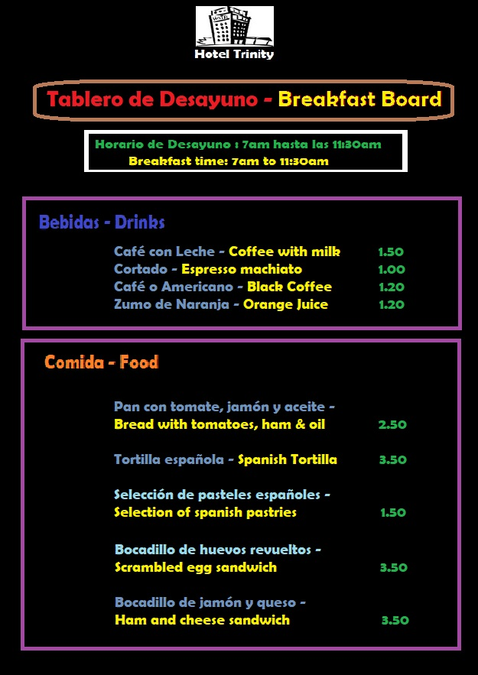
Breakfast Board ______________

