QP Wines Ltd

Business and Marketing Strategy

Business Plan

QPwines.com
Chapman Street Warehouse
Llanelli
Carmarthenshire
SA15 1DD

Prepared by
Enrique Quevedo Diaz
University of Wales Trinity Saint David
Student number 1917750

Executive Summary

Background and Context to the Business Strategy……………………………………………………3

The Current Structure of the UK Market Place………………………………………………………….4

Target Market and Financial Target for QP Wines…………………………………………………….4

Commentary of Industry Structure…………………………………………………………………………..5

QP Wines Business Proposition………………………………………………………………………………..6

Competition…………………………………………………………………………………………………………….7

The QP Group Wine Cost Model………………………………………………………………………………7

Principles………………………………………………………………………………………………………………….8

Marketing Promotions…………………………………………………………………………………………….8

Operational Costs – 12 months………………………………………………………………………………..8-9

Sensitivity/ Risk Analysis……………………………………………………………………………………….…10

Income Generation………………………………………………………………………………………………….11

Reference…………………………………………………………………………………………………………………12

Appendix…………………………………………………………………………………………………………………13

Background and Context to the Business Strategy

Chile is a developing wine country/exporter. Over the last 10 years the country has focused on wine sales as a key export market and total wine growing now exceeds 112,000 hectares.

According to the British entrepreneur, Robin Cammish, “The UK is Chile’s single largest export market and is growing in both volume (25%) and per bottle, average price per unit (8%) in the 12 months to September 2019. The UK represents 20% of all Chilean wine exports”.

Cammish mentioned that “the total UK market value 12 months to September 2019 of Chilean wine was USD $193 million (£94 million) of this the value of UK retail sales above £5 per bottle is £50 million”.

Both on-trade and off-trade UK market share is growing:
Off-trade = 7.5%
On-trade = 8.3%

The commercial director of Wines of Chile, Angelica Valenzuela proposed that “There is a consistent trend to move Chilean wine up market from the Supermarket £4 - £6 per bottle – Concha y Toro type, into the +£7 to £10 per bottle arena” Making a move up in the market to Premium wines.

According to the thoughts of the entrepreneur Cammish, “The good news is that the quality of wines available in this mid-market segment are outstanding and are comparable with Australian/New Zealand/France, but with significantly lower costs of production due to low labour rates”.

In Summary

A rapidly growing market in terms of:

- Volume
- Selling price
- Quality of product

The Current Structure of the UK Market Place

The UK market for Chilean wine has the same for all wines sold in the UK. According to Wine Searcher, the way wine is distributed is the following one:

Off-trade – Supermarkets

The big chains buy direct from the countries. And the big independents, copy the supermarket model (for example, Majestic wines). The smaller business and specialists buy through importers.

A number are attempting e-selling, direct to customers. This is usually in parallel with a traditional retail operation eg Tesco + Majestic. There is no established specialist Chilean wine seller direct to the public in the UK.

On-trade

The on–trade is Hotels, Restaurants, Pubs and Hospitality venues.

The on-trade usually buy from wholesalers, who themselves buy from importers. The wines here vary in quality, bought at £4 - £5 per bottle and sold for £12 - £20 per bottle. On-trade mark ups are typically +300%.

Value of UK market On-trade vs Off-trade (TBA) for the purposes of this plan we have assumed at 80/20 split.
80% off trade = £80 million pa
20% on trade = £20 million pa

Target Market and Financial Target for QP Wines

We are setting a range of targets from conservative to aggressive. The aggressive target for QP Wines is to achieve £1 million full first year sales. Selling through e-marketing direct to the UK public.

This aggressive target represents 1% of total UK sales of Chilean wine by value, or 2% of the +£5 per bottle market. In terms of volume, this equates to:
160,000 bottles per annum or
500 bottles per day or
28,000 6 bottle cases per annum or
500 per week (100 per day)

The implications are:
- Order management and delivery to customers needs to be very efficient
- We need to be very good at doing the basics well. Such as admin, stock control, pick and pack, re-order.

The Conservative first full year target is to achieve £250k pa sales. This equates to:
42,000 bottles or
7000 6 case sets
In the first year

Translated into weekly volume, this is 140 case orders per week.

Stock turns would be 2 x pa.

Commentary of Industry Structure

We attended a wine tasting in London, before the Covid-19 Lockdown, and we spoke to Anita Jackson, who is Wines of Chile UK Director, and we came up with the conclusion that leaving aside 6 supermarket chains and 4-5 large independents, the industry structure is still very traditional with lots of small importers and intermediary agencies bringing wine into the UK. This is a very fragmented, amateur, and disorganised supply chain containing lots of hobbyists/traditionalists.

We would characterise the typical wine importer or seller as a middle aged upper middle class who is a genial friendly person who drinks too much of their own product.

This is a marketplace which is ripe for both a professional business approach, and consolidation

QP Wines Business Proposition

The Business Proposition is to buy good quality Chilean wines from importers ( low QP stock costs) and retail these direct to the public with a 100% on-line business model.

The QP Wines Business Proposition is to:

- Focus exclusively on Chilean wines
- Target wines in the £5 - £10 retail value segment
- Buy from importers wines currently going into on-trade
- Sell solely ‘on-line’ to direct to the customer (DTC)
- QP pick and pack to order and ship direct to the consumer using a delivery company.

Positives

Chile only | = | Focus
£5 - £10/bottle | = | high margin, but low price than on-trade consumer sales, steers away from supermarket wines or segment
Buy from Importers | =  = | Expansion of the business with new channels to market (DTC)  Minimises stock holding to QP Wines
On-line DTC  e-marketing | = | Modern business model, beats the traditionalists
Pick and Pack to order | = | 2-3 day order to consumer receipt
Consumer | = | Able to buy the next day wines that have been enjoyed in a restaurant on an evening

Keys to Success

Wine is good quality | = | Yes, Chile can now supply +60 wineries plus150 varieties of quality
Great e-catalogue  Simple to order | = | Copy the best of what is already out there but focus on Chile content
e-marketing | = | QP Wines aim is to be at the top of any search engine for Google, and social media. Costs are max £1000 month.
Fast delivery | = | 2-3 day order turnaround
High margin  Good value | = | 100% QPW mark-up still leaves wines at 50% of on-trade consumer price/restaurant price

Competition

At the time of writing, there is no established direct competition to this proposed business model for Chilean wines. There is one start up which began trading in October 2017. This is Mark Hughes trading as Chilean wine club, he operates out of a house in the UK

There is one parallel organisation in existence – South African wines, SAWines.co.uk is a trading arm of Windsor Wines Ltd (01753 8622111) and was established in 2002. The registered office is 8, The Fairway, Cox Green, Maidenhead, SL6 3AR – company number 04559580.

There are no other country specific wine retailers, all are generalists.

This is a key to success of QP Wines – we will focus exclusively on Chilean Wines of good quality.

The QP Group Wine Cost Model

A: Start-up Costs

1 | Wine Stock  Buy from Importers, say 40 wineries @ 25 cases and £5/bottle Duty paid (DPD) |  | £60,000
2. | Warehouse  1500 sq ft – Burry Port  £3.50 sq ft = rates 12 months  Initial fit-out | £8250  £1750 | £10,000
3. | Web  - Software  - Design  - Hosting  - Equipment/telecoms | £2000  £5000  £5000  £3000 | £15,000
4. | Initial Packaging stock |  | £1,000
5. | Marketing start-up  - Brochures/inserts  - E-marketing | £1,000  £5,000 | £6,000
 | Sub-Total |  | £92,000
 | Contingency |  | £8,000
 | Total |  | £100,000

Proposal

Fund start-up costs from Directors Loan, charged at commercial rates (8%) with deferred repayment.

B. The Wine Cost Model (to be built)

 |  | £ / B
1 | FOB Santiago | £2 - £8
2 | Duty (UK + EEC) | £2.23
3 | Duty paid delivered QP | £4-5/B
4 | Retail DTC | £8-£10 per bottle (+VAT)
5 | Pack and Shipping Cost/B | £9

Principles

- Buy from Importers
- Mark-up by 100% (need to check VAT in or out)
- Pack and Ship at cost
- use e-engine for payment management (Pay Pal or equivalent)

Marketing Promotions

- Discount mixed cases of 6/12 wines

C Operational Costs – 12 months

The principals will operate a low cost eg minimum wage start-up until we know that we have a going concern

 |  | £
1 | Staff costs  - catalogue  - warehouse  - admin | £40.000
2 | Utilities | £6.000
3 | Telecoms | £600
4 | IT | £1.200
5 | Audit fees | £1000
6 | Insurances | £1000
7 | Licences | £500
8 | Marketing | £5000
9 | Transport | £5000
10 | Materials | £2000
11 | Travel Costs | £2000
12 | Postage | £3000

Operational actions – July 2020

1. Check on premise’s availability
2. Appoint lawyer (local) apply for licence
3. Set up QP Wines Ltd with Companies House
4. Confirm company structure
5. Set up bank details
6 Set up supply chain (bonded warehouse, and delivery mechanisms to customers
7. Apply for VAT registration
8. Source catalogue software
9. Select initial offering of wines – write up profile
10. Negotiate pricing with importers

D Sensitivity/ Risk Analysis

- Logistics and Order Processing – Aggressive target

Based on a UK market size of £50 million (which is currently expanding at 15-25% pa) for Chilean wines retailing above £5 per bottle.

- Assume that there is a 80/20 split on-trade vs off-trade

- The QP Wines UK market size is £80 million
1% penetration = £800k pa

- £1000k = 160,000 bottles PA
or 28,000 cases
or 500 single bottle orders per day
or 500 6-pack cases per week

- The initial planned stock of QP Wine is ±20,000 bottles, this will turn 8 x times PA on average.

Implications of the above:

- To be successful as QP Wines we need an efficient and effective set of systems and procedures to handle
  - Warehouse stock control
  - Order processing
  - Picking and packing
  - Wine re-ordering
  - Despatch to customer

- To achieve 1% market share requires the ability to process up to 100 case orders per day

- Margin and contribution Generation

a) The initial assumption is that we should set mark-ups at 100% to bought-on cost.
Buy wine DDP at £4.00 per bottle, retail at £8.00
Gross margin = £4.00 or 100% + VAT £1.40
Retail = £9.40 each

b) The alternative model would be to absorb VAT into the Retail Price
eg.. Buy wine DDP @ £4.00 per bottle, retail at £8.00
Gross margin = £2.80 or 70%
VAT = £1.19

This alternative model b, is the one currently used by Independent/Specialists who run a traditional retail shop-based business model.

To cover the costs of start-up, we will aim for a high margin initial model a.

Income Generation

Based on the target initial market penetration of 1% and a conservative sales model (70% mark-up).
Year end gross margin before costs would be 180,000 x £2.8/b = £448K

Based on conservative sales model
Year end gross income could be 40,000 x £2.8/b = £112k

- Operating Costs – Conservative target

Year one cost model amatising costs over 40,000 bottle sales (to be validated)

 | £ Total | £ per bottle
Warehouse Operations costs | £10,000 | .30
Packaging |  | .30
Dispatch / delivery |  | 1.00
Marketing |  | .25
Finance charges |  | .25
Software/equipment |  | .20
 |  | £2.30 per bottle

This leaves £0.50/B to £1.70/B to cover direct labour costs, general overheads, and profit, depending upon the pricing model adopted.

Implications: Aim should be to target 100% mark-up plus VAT model, especially during a start-up phase.

References

Cammish, R. (2020) Dialogue with a successful entrepreneur at the The London Wine Fair

Catchpole, A. (2018) Q&A: Anita Jackson, Wines of Chile. [online] Available at https://harpers.co.uk/news/fullstory.php/aid/23129/Q_A:_Anita_Jackson,_Wines_of_Chile.html Accessed: 02/07/2020

Fernandez, I. (2016) The wine market in the UK (Spanish). [online] Available at https://www.prochile.gob.cl/wp-content/uploads/2016/12/FMP_RUnido_Vino_2016.pdf Accessed 05/07/2020

Kirschenmann, E. (2018) Case Studies: Turning a Winery Website into a Sales Driver. [online] Available at https://www.winebusiness.com/wbm/?go=getArticleSignIn&dataId=205368 Accessed 08/07/2020

Le Cordon Bleu (2020) How to Start a Winery or Wine Business. [online] Available at https://www.cordonbleu.edu/london/how-to-start-a-winery-or-wine-business/en Accessed 02/07/2020

Moore, V. (2020) Why you should be drinking Chilean wine. [online] Available at https://www.bbcgoodfood.com/howto/guide/why-you-should-be-drinking-chilean-wine Accessed: 04/07/2020

Oz Clarke (2020) About the Best Chilean Wine. [online] Available at https://www.wine-searcher.com/regions-chile?tab_F=best Accessed 04/07/2020

Reeve, J. (2020) Chilean Wine. [online] Available at https://www.wine-searcher.com/regions-chile?tab_F=mostpopular#winesortlist Accessed 09/07/2020

Schmitt, P. (2018) Wines of Chile Unveils £10 Plus Promo Plan. [online] Available at https://www.thedrinksbusiness.com/2018/03/wines-of-chile-unveils-10-plus-promo-plan/
Accessed 04/07/2020

Simone, P. (2008) Winning with Wine. [online] Available at https://www.entrepreneur.com/article/195112 Accessed 03/07/2020

Appendix
Wine Budget
Balance Sheet

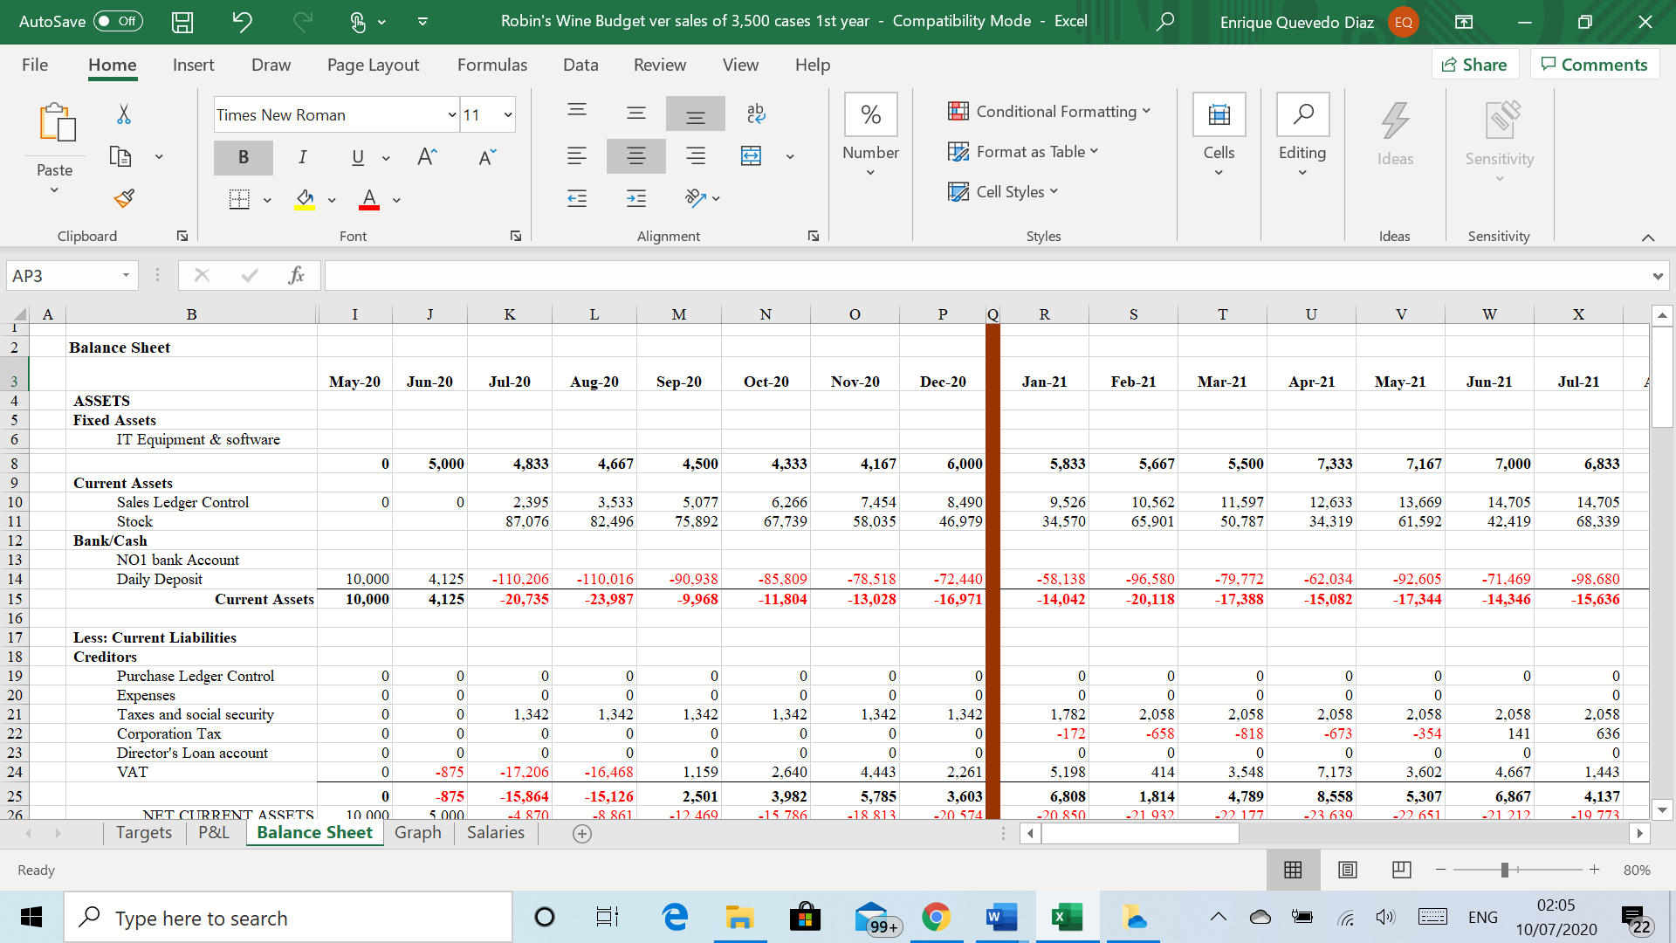

Target

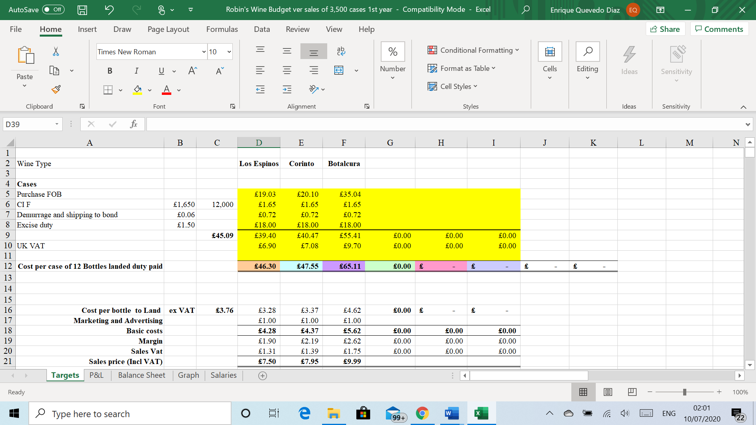

Graph



