Digital Skills and Research Methods
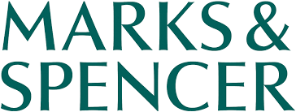


BMSW4003_LON

Lecturer: Fernando Suneth

Student name | Student id | Topic
Ioana Irina Dinu  Mirela Olaru  Alda D.S. Coelho  Edit Tingyela  Theresa O. Onuorah | 1914863  1914862  1914109  1917242  1914863 | Background and History of Marks & Spencer  Aim & Objectives of Marks & Spencer  Scope/Purpose of the organization at Marks & Spencer  Mission and vision of the organization  Current status and services of M&S  Challenges before introducing modern technology  Insights of modern technology Introduced at M&S  Impacts of modern technology at M&S  Positive and Negative impact of M&S introduction to modern technology

Table of Contents
Topic: Background and history of Marks & Spencer 4
Slide no:1 5
Speaker notes: 5
Topic: Aim and objectives of Marks and Spencer 6
Slide no: 2 6
Speaker notes: 6
Topic: Scope/Purpose of the organization at M&S 7
Slide no: 1 7
Speaker notes: 7
8
Topic: Mission and vision of the organization 8
Slide no: 2 8
Speaker notes: 8
Topic: Current status and services of Marks and Spencer 9
Slide no: 1 10
Speaker notes: 10
Topic: Challenges before introducing modern technology 11
Slide no: 2 11
Speaker notes: 11
Topic: Insights of the Modern Technology Introduced at M&S 12
Slide no: 1 12
Speaker notes: 12
Topic: Impacts of the Modern Technology at M&S 14
Slides no: 2 14
Speaker notes: 14
Topic: Positive and negative impact of Marks & Spencer introduction to modern technology 15
Slide no: 1 & 2 16
Speaker notes: 16
References 18
References 19

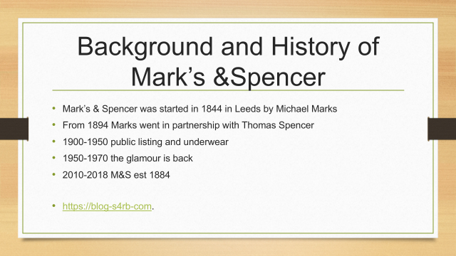

Topic: Background and history of Marks & Spencer
Group leader: Ioana Irina Dinu

Slide no:1

Speaker notes:
Marks & Spencer is one of the largest British retail nourishment and wardrobe company. M&S was initiated in 1884 by Michael Marks, a polish refugee and he started to open a market stall in Leeds with the banner “don't ask the price, it’s a penny”. In 1894 Marks went into alliance with Thomas Spencer and 1904 is open the first shop Marks & Spencer and achieve to a public company. M&S continued to develop and in 1920 is starting selling the underwear bra. From 1930 M&S is beginning with food and clothing departments and in 1957 are selling clothes such as nylon stockings. By the 1960, M&S go ahead with selling dairy products, meat and in 1972 are introducing the frozen ready meals. In 1999 M&S has opened the online store on website and in 2001 the first food online stores have been opened (Called Simply Food). In present, between 2010-2018 M&S has extended above 979 stores,450 international stores, 134 years commerce with 84,939 employees and it is shown new device introduced in 2015 Est 1884.(Blog-S4rb-com, [Online], Accesed:04 May 2020)
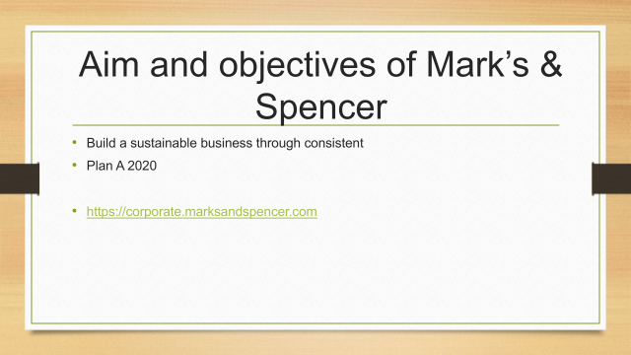

Topic: Aim and objectives of Marks and Spencer
Group leader: Ioana Irina Dinu

Slide no: 2

Speaker notes:
It is named Plan A because Plan B doesn't exist. M&S are redacted in 2014 the Plan A report and is trying different ways in order to obtain a impenetrably and continual business and this project are extending the Plan A over M&S international employment in the following 6 years. Called Plan A 2020, the 100 obligation plan maintains and building a M&S 2015 eco and moral commitments that implemented today's and tomorrow's livability market summons. Project A 2020 are including M&S operations global, not just in the UK. The marketer M&S decided to have “Launch of a Global Community Programme” to intensify the number of the social and the project “Make your Mark” decided to aid 5000 people out of work by 2016 in order to achieve the employability program. This scheme is concentrating on energy to enlarge the target from 35% till 50% by 2020 and to contribute with £1 million every year for local charities including £20 millions for health.
According with Mike Barry, the director of Plan A 2020 is described this project as a supportable business idea fixed on customers, employees and supplier’s engagement. (Marksandspencer.com, [Online], Accessed: 04 May 2020)

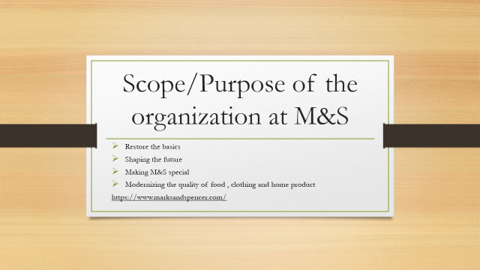

Topic: Scope/Purpose of the organization at M&S
Member of the group: Mirela Olaru

Slide no: 1

Speaker notes:

M&S is a leading British retail who sales healthy food, clothing and homeware to millions of customers all around the word.
The scope of M&S is to offer good quality for all the customers; fresh fruit and meet, organic food, to discover the lattes news and the best offers on food plus tips and recipes at an amazing quality and price.
M&S provide a huge rage of clothing, home and beauty products at a high quality and service. The success of M&S is in large part due to principle guiding like inspiration, to create new ideas to excite the customers, focusing on continuous improvement, doing the right thing having trust in their employees and customers. (Marksandspencer.com 24 April).
M&S is always trying to implement new strategies to increase the profit of the business.
Marks and Spencer try to make each minute special. Every client partner is told to undertake and go out of their way to inspire the client and make their involvement special.
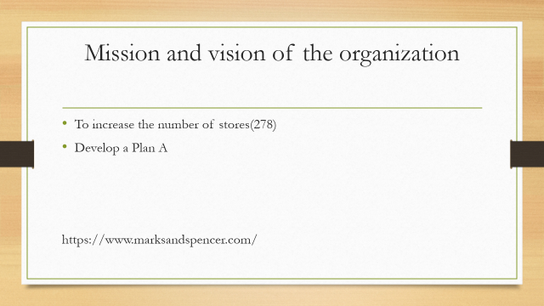

Topic: Mission and vision of the organization
Member of the group: Mirela Olaru

Slide no: 2

Speaker notes:
M &S vision is to increase the number of stores. The organization has developed a Plan A, until 2025 they expect to become a sustainable business.
The company M&S is involved in several activity’s-like charities, to reduce population, transforming lives and communities, increase collaboration, partnership and advocacy, to ensure that M&S voice is heard more clearly. M& S mission is to make inspirational qualities accessible to others, to reduce the risk and to increase productivity, to attract new customers. Mark and Spencer accord a huge importance to the employees by inspire them, providing training and rewords. (writepass.com 24 April). (Druker, 1974).M&S launched a Plan A in 2007 and extended until 2025.
They committed to making a difference to construct a feasible future by being a trade that empowers their clients to have a positive aspect of prosperity, communities and the planet to though all they do.
Through Plan A, M&S, it is working with its clients and provider to combat climate alter, diminish squander, utilize feasible crude materials, exchange morally and offer assistance clients to lead more advantageous ways of live.
The 3 Pillars of Plan A 2025 of M&S are to help 10 million people live happily and healthier lives, to transform 1000 communities and to become a zero-waste business.
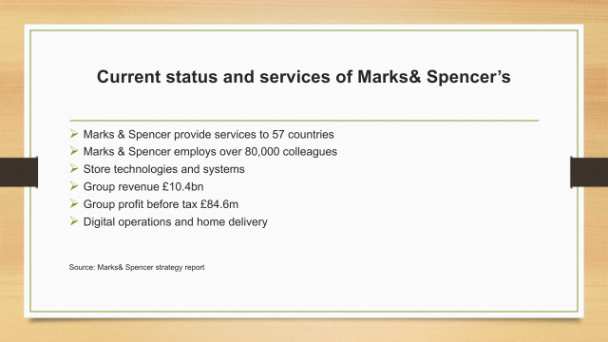

Topic: Current status and services of Marks and Spencer
Member of the group: Alda Dos Santos Coelho

Slide no: 1

Speaker notes:
The current status of Marks & Spencer’s now is that they provide to more than 57 countries and employ over 80,000 colleagues (Spencer, 2016) The most common communities they do their operations are families and accountable business, they have a great value and profitable growth. New strategies have been implemented in marks and Spencer’s technology advantages such as Digital operations, home delivery, store technologies and systems, Wi-Fi, Easy access like car park and all these new strategies available stores become more profitable. Although their Group (Spencer, 2016) revenue has increased to £10.4 bn, profit before tax also increased to £84.6m, as well as home delivery and clothing had a slightly increased of 22%, their value for money has gone up by 59%, as well as good results for their net debt only reaches the minimum of 1.55bn and the score net has achieved marks of 68 for their score. Over all Marks & spencer strategies of changing markets, organizing the way the work and implement new store base they are just contributing for better business for themselves as well as give more quality and choice to their communities.

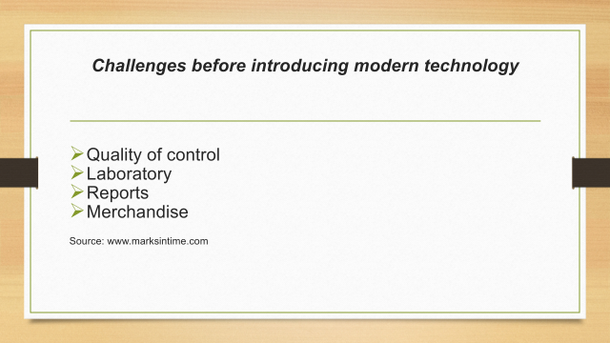
Topic: Challenges before introducing modern technology
Member of the group: Alda Dos Santos Coelho

Slide no: 2

Speaker notes:
Marks & spencer has a history since 1884 when they first come to the market. Marks & spencer back on time has first introduce modern technology in 1938. They had invested on their quality of control as their central purpose and do their reports daily back to the laboratory in order to make improvements by the staff in factory floor. Two years before in 1936 Marks & spencer also introduce in merchandise development department by (DR Eric Kann) the whole process was running by the Germans to test the color fastness and shrinkers. Marks & spencer has opened their first store in Leeds in 1904, few years later they adopted a revolutionary policy that they just buy directly from the suppliers as well as other technologies has appeared such as charge cards 1985, shop online 1999 an the 3D digital fit company, the 3D is the Texel technology that measured people in shapes and sizes which was created by digital avatar, the Texel is a design to enrich the offline and online shop experience as it states the co- founder(Sergey Kimemtley). In addiction these investments are strategic in partnership with Microsoft, which is testing the capacity of technology and artificial intelligence in a retail environment.

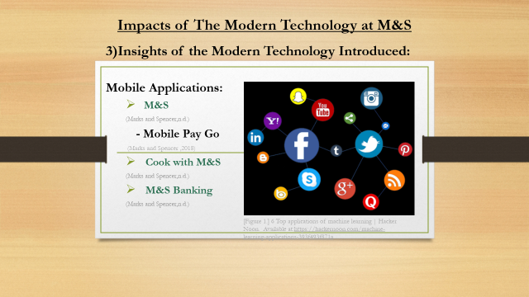

Topic: Insights of the Modern Technology Introduced at M&S
Member of the group: Edith Tingyela

Slide no: 1

Speaker notes:
M&S has started five -year transformation plan since 2018, the new Technology Transformation Programme is part of this. The plan will allow M&S to become a digital-first Business. Current technologies used in M&S:
(Marks and Spencer, 2018)
Mobile applications:
M&S
This application enables the users to bay online easily and fast from home. (Marks and Spencer,n.d.)
Mobile, Pay, Go
The costumers can pay for items without to use a till. Just open the M&S app, select the products, scan them then you pay straight from your phone. It is the simple way to do very fast shopping up to the value £30. The service allows customers to purchase less than 1 minute. It is the best way for the very busy London customers to buy food in the lunch time. It changed the shopping experience, which is the huge benefit for them. (Marks and Spencer,2018)
Cook with M&S
Free recipe app, personalised shopping list, lots of advice, ideas. Clear step-by-step cooking instructions. (Marks and Spencer,n.d.)
M&S banking
You can manage your banking on the go with your phone. With your new Digital M&S PASS you can access Internet Banking quicker than ever before. (Marks and Spencer,n.d.)
Mobile pay:
Easy and safe ways to purchase using your smartphone, just download the relevant app, add your M&S Debit or Credit Card and you can pay with your phone. Without your card or PIN. (Marks and Spencer,n.d.)

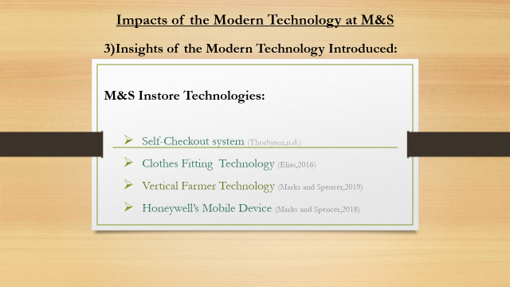

Topic: Impacts of the Modern Technology at M&S
Member of the group: Edith Tingyela

Slides no: 2

Speaker notes:
M&S in store technologies:
Self-Checkout system:
The customer uses a machine to scan items and puts them in a bag. It can optimize the checkout process. (Thorbjørn,n.d.)
Clothes fitting technology:
M&S partners with Texel, who developed the 3D scanning Technology. It can help for the customers to choose the best suits clothes their shape and size. The benefit with this technology, M&S can cut down returns and support sales. The fitting technology can be used in-store with a single sensor or the customers can download the app to the smartphone. (Elias,2016)
Vertical farmer technology:
In the farm can grow varieties of fresh herbs, which have exceptional taste and their quality is excellent. It uses a cloud-based platform and the farmers go to the shops every twice a week to harvest and transplanting. (Marks and Spencer,2019)
Honeywell's mobile device
This is used by workers.
M&S combined the retailer’s three key pillars, which are service, sales, and task performance into one device. This has significantly improved its operational efficiency. It helps both the customers and the managers to have a quicker experience. (Marks and Spencer, 2019)
The result of the new Technology transformation programme the M&S business will achieve a seamless customer experience, making M&S special. (Marks and Spencer,2018)

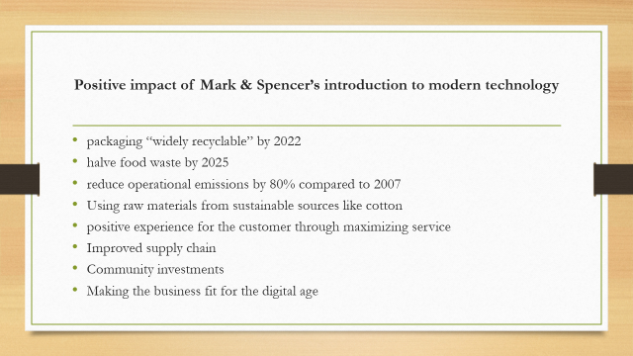

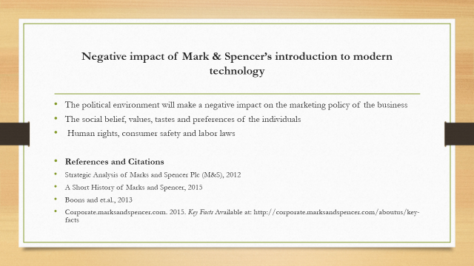
Topic: Positive and negative impact of Marks & Spencer introduction to modern technology
Member of the group: Theresa Okonkwo Onuorah

Slide no: 1 & 2

Speaker notes:
The technology transformation program includes making packaging “widely recyclable” by 2022, halve food waste by 2025 and reduce operational emissions by 80% compared to 2007. It will also show clearer accountabilities by focusing on creating a positive experience for the customer through maximizing service.
This transformation will go a long way in improving the living wage, supply chain and community investments on the part of Marks and Spencer and above all, making the business fit for the digital age.
FACTORS:
The political environment will influence the functioning of Marks and Spencer. The environment will make a negative impact on the marketing policy of the business (Boons and et.al., 2013). It will also create a negative impact in the expansion of the business within the country. Stronger rules and regulation will cause difficulties in establishing the business.
Marcus Sieff once said “a business is only as good as its people”, with this in mind, the social environment where the choices, tastes and preferences of every individual must be considered. it is necessary to point out that in order to establish any business, it is important for the firm to works as per the social belief, values, tastes and preferences of the individuals of that country. The functioning of the business against the social environment will lead to a negative effect on the organization, for example, if the Chinese like hot drinks like teas and coffee, Marks and Spencer must focus on the sales of hot drinks in the store rather than soft drinks which will help to increase the sale of the Marks and Spencer store so if Marks and spencer hopes to improve customer experience, great attention must be paid to the social environment.
The legal environment is related to laws formed by the government for the functioning of the organization, these laws include human rights, consumer safety laws and labor laws. These laws in one way or the other affect the working of the organization and the organization has to follow all the rules and laws mentioned by the authorities. The labor law has some benefits and on the other hand, it has some negative points. The good labor law will help to generate more labor which is in turn beneficial to the organization in maintaining human resource and this must be considered when simplifying and consolidating the Marks and Spencer’s technology supplier base.

References
The history of M&S |this is not just a store, it’s M&S store since 1884 (2020), [Online] Available at: https://blog.s4rb.com/the-history-of-marks-and-spencer ,Accessed: 04 May 2020.
Plan A Report Launches New 2020 Eco And Ethical Plan For M&S(2014), [Online], Available at: https://corporate.marksandspencer.com/media/press-releases/2014/plan-a-report-launches-new-2020-eco-and-ethical-plan-for-mands), Accessed:04 May 2020.
Druker, P., 1974. [Online]
[Accessed 04 2020].
Druker, P., 1974. Management.Tasks.Responsabilities Practices. London: Heinnemman.
M&S, 2019. [Online]
Available at: https://corporate.marksandspencer.com/documents/msar-2019/strategic-report.pdf
[Accessed 26 April 2020].
Spencer, M. a., 2020. sustainability. [Online]
Available at: https://corporate.marksandspencer.com/sustainability
[Accessed 25 april 2020].

Elias, J. (2016) M&S invests in clothes fitting technology to reduce returns’,
The Retailgazette,14 May. Available at:
https://www.retailgazette.co.uk/blog/2019/05/ms-invests-in-online-clothes-fitting-technology-to-combat-returns/ (Accessed: 14 April 2020).

Marks and Spencer (2018) Marks and Spencer Announces Technology Transformation Programme. Available at:
https://corporate.marksandspencer.com/media/press-releases/2018/marks-and-spencer-announces-technology-transformation-programme (Accessed: 14 April 2020)

References
(Accessed: 17 April 2020)
https://corporate.marksandspencer.com/media/press-releases/2018/m-and-s-rolls-out-checkout-free-checkout-as-part-of-digital-first-strategy (Accessed: 13 April 2020)
Marks and Spencer Mobile Pay. Available at: https://bank.marksandspencer.com/mobile-pay/ (Accessed: 15 April 2020)

Marks and Spencer (2018) M&S Rolls out checkout free checkout as part of digital first strategy. Available at:
Marks and Spencer (2019) M&S Partners with six start-us in first year of founder’s factory retail joint venture. Available at: https://corporate.marksandspencer.com/media/press-releases/5c2f8d617880b21084450f5e/m-and-s-partners-with-six-start-ups-in-first-year-of-founders-factory-retail-joint-venture https://www.edie.net/news/8/M-S-showcases-vertical-farming-at-London-store/ (Accessed : 13April 2020)
Marks and Spencer (2019) M&S Transformation Update. P.150 Available at: https://corporate.marksandspencer.com/documents/m-and-s-investor-day-oct-1st-2019.pdf
Marks and Spencer M&S Mobile Apps. Available at: https://www.marksandspencer.com/c/mobile-apps?OmnitureRedirect=mobile%20app(Accessed : 17April 2020)
Systems , Sprinting Software, Available at: https://sprintingsoftware.com/blog/retail-self-checkout-systems/ (Accessed : 16 April 2020)
Thorbjørn, S.J, (n.d.) Advantages and Disadvantages of 6 Retail Self-Checkout
Anon,2020. A history of Marks &Spencer M&S company archive. [Online]. Available at: https//marksintim.marksandspencer.com/download=996

