

Assessment 1 – Reading Task Template
PART 1: Upload your photo of your A3 in-class notes here:
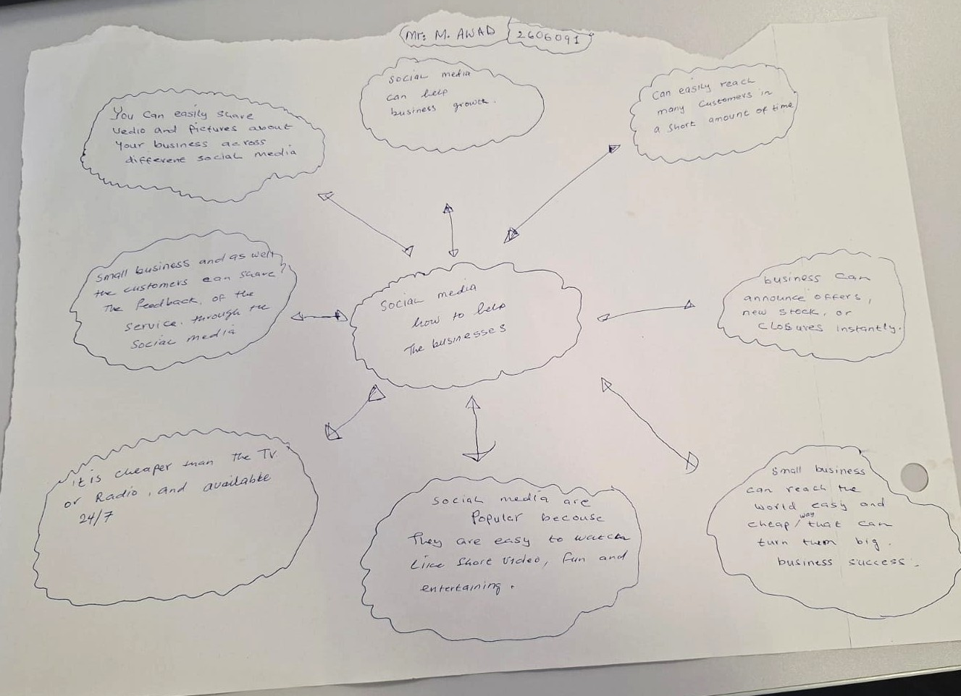

PART 2:
- Answer every question below in 1-3 full sentences.
- Use your own words. Do not use generative AI to answer these questions.
- Include a specific detail from the text when asked.
REMINDER
- The main idea is the overall message of the whole text.
- A key point helps to explain the main idea.
- A specific detail or example from the text shows that the key point is true.

- What is the main idea of the whole text?
Social media is powerfull

- What is one key point that supports the main idea, and which specific example from the text shows this?
Social media help helps the small business, for the cheaper way then the old traditional tv and radio

- What is a different key point that supports the main idea, and which specific example from the text shows this?
Small business can easy react to many customers in a short time, and also hear what the customers saying about their business

- Which part of the text do you think is most important, and why?
Availability 24/7 and affordability , small business can reach their customer for quick and less spend

Reflection:
- What did you find difficult in this task (including in-class components), and why was it difficult? I found difficult for drawing the main map as I am not good for drawing

- What helped you with this difficulty, and how did it help you?
Finding how to draw main maps for quiz online then done this at the end

