  Component One:  What are the key skills required when working in the housekeeping team? 750 words (+/- 10%)  Contribution to Overall Module Assessment: 25% | Student No: | 2206963
 | Module Title: | Operating Hotel Facilities
 | Module Code: | BMIH4006
 | Lecturer: | Kathryn Flynn

Introduction
The hotel industry is solely dependent on the implementation of various skills among individuals such as time management, communication and interpersonal and others. the following self-reflection essay will be described various skills required for working on the housekeeping staff of a hotel. A brief personal reflection on the impact of all these skills in the hotel industry of the UK will also be elaborated. lastly, the importance of housekeeping staff in the hospitality industry will be highlighted in these reflective essays.

Discussion
Employment within a housekeeping team at a hotel necessitates a fusion of technical competencies, interpersonal aptitudes, and individual attributes. Intellectual skills is the primary requirement in the field of housekeeping that individuals must have. This is essential for staff members to possess a thorough comprehension of various understanding regarding techniques, and equipment. On the other hand, effective time management is extremely important for housekeeping staff as they face the challenge of meeting stringent deadlines (Doyle, 2021). The ability to effectively prioritise tasks and execute them in accordance with predetermined temporal parameters is deemed essential. Moreover, Communication is the primary requirement in the field of housekeeping. Proper and effective transmission of knowledge always increases the communication bridge between the team members and higher authorities (Krizanova et al., 2019). Therefore, It is essential for employees to possess the capability to comprehend requests made by patrons and effectively communicate them to fellow staff members. The effective functioning of a team is crucial for housekeeping personnel to satisfactorily perform their duties. It is imperative that they possess the ability to collaborate and work in conjunction with other members of staff to guarantee the state of all accommodations (Chon and Zoltan, 2019).

After gaining a handful of experience during my course I have achieved communication, time management and intellectual skills. This is extremely important to reflect on my own experience that can help me to assess my own experience. I have also done an internship at the Imperial London situated in UK (imperialhotels.co.uk, 2023). I was appointed to the housekeeping team and had to operate various operational management associated with the hotel. During my course, I was unable to communicate with my peers and educators. Due to this fact, my overall performance also decreased in the first two semesters. Over the years, I have developed my knowledge regarding these attributes with the use of videos and other facts. I have also taken part in various courses to increase my efficiency in communication skills. Therefore, this has helped me a lot to communicate with the customer and management team (Mbaye, 2022). My time management skills have also helped me a lot during my internship in the Imperial Hotels. I have successfully delivered each of my assigned work within the time frame. Along with that, these skills increased my productivity from every perspective. Apart from the housekeeping work, I have also taken part in other work to increase my knowledge of the hotel industry (Baum, 2019). All of these skills have helped a lot to reduce job stress and increased confidence. Additionally, I have gained knowledge about the importance of safety and hygiene in maintaining the brand image among customers.
The housekeeping team acts as an important role in the hospital industry and sometimes all of their activities are often neglected. All individuals associated with this work are solely responsible for maintaining the hospitality industry safe. They primarily ensure hazard free environment and remove clutter from the customer areas (revfine, 2023). Guest always wants comfortable and pleasant stay and therefore clean and well-maintained room and amenities always help to increase customer satisfaction rate. Understanding all these facts can improved the career growth in this field. Above all, the image and reputation of the hotel depend on the type of service they are providing. Housekeeping staff can enhance the brand reputation and attract new customers by improvising their management skills (slack, 2021). They are also responsible for getting good reviews that can automatically increase customer engagement. Cost control within the hotel is also dependent on the house management staff as they help to prevent property damage, maintain equipment and others. Furthermore, their work is extremely essential in maintaining the overall reputation of any hotel industry.

Conclusion
The above reflective essay has described the various skills required for working in the housekeeping team of Imperial Hotels. All these skills are associated with communication, time management, and intellectual that mainly act as primary requirements in the field hotel industry. A proper reflection on the impact of all these attributes during the course of my job in the hotel has also been described. According to my analysis, my academic knowledge has helped me a lot to mitigate all the issues I have faced during the accomplishment of the course. The importance of the housekeeping team in the hospitality industry have elaborated in the last part of this reflective essay.

Word Count | 811

Component Two:
Contribution to Overall Module Assessment: 25%
In this scenario – You have just been promoted to team leader for a floor within the hotel. A guest complains that on their arrival, their room had not been properly cleaned. Create an action plan and answer the following questions.

Problem | Why did it happen? | What are you going to do? | How will you prevent this from happening in the future? | What measures would you introduce to improve team effectiveness?
Broken Lights | Not having clear instruction | I will tell the maintenance team to change the bulb as early as possible. I will also instruct them to carry out weekly checks to confirm that all electrical systems are functioning properly. I will also check the other equipment in that room as well as other rooms personally (HotelFriend, 2020). There can be instances when visitors detect a bulb that needs to be changed, but regular checks may reduce the possibility of guests experiencing an inconvenience. | A dependable provider will be responsible for maintaining the electrical stocks. Low-quality, inefficient lights and electrical equipment may save money initially, but they will bring greater financial troubles in the long run (Nkwnayane, 2021). As a result, in the future, to avoid any problems with electrical equipment, bulb, and equipment will be carefully maintained, and only high-quality equipment will be used in the hotel rooms. | I am going to give a list of chores that need attention, which is always beneficial to the team. Because large lists might slow down or even mislead housekeepers, I will keep instructions brief and simple.
Damp Patches | Ignored by the housekeeping staff | I will tell the team to use wall washing mops, dip them in cleaning solution, and ring them out. I will also instruct them to begin washing from the bottom to the top of the wall. I will give the team a graffiti remover to get rid of any persistent dirt or stains (HotelFriend, 2020). I will make certain that no abrasives are used on the wall since this would harm the finish and result in spotted walls that cannot be fixed. | As a team leader, I will tell team members that any moist patches or cracks must be documented and repaired as quickly as possible. If a guest's room is deemed unsuitable, they may be relocated to another (Nkwnayane, 2021). | I will arrange special training for housekeepers to help them learn how to remove patches and stains effectively (Simmons, 2021).
Dust | Not Having a Good Vacuum cleaner | I will delegate the task of dusting bookcases, televisions, and other surfaces to a team member. Because this involves ceilings and hard-to-reach areas, I will instruct them to utilise the extended duster (Nkwnayane, 2021). Dust and cobwebs tend to accumulate on ceilings and high surfaces, so I will instruct them to begin at the top and work their way down. | I will instruct the crew to use both vacuum cleaners and microfiber cloths. Venetian blinds should be dust mopped or vacuumed on a regular basis. Dusting should be done on a regular basis to ensure that all furniture is fully dusted in the shortest amount of time feasible (Sanarp, 2020). | At first, I will request the hotel manager to buy a high-quality vacuum cleaner Then I will help the team members to learn how to operate it properly.
Dirty windows glasses and mirrors | Insufficiently cleaned by the team | I will scrub the mirror with a moist sponge then dry and shine it with a dry towel. I will wipe away any smudges and leave the mirror spotlessly clean and glossy (Sanarp, 2020). | Fingerprints, stains of makeup, or any form of debris on window glasses or mirrors are unsanitary, and guests should not feel obligated to clean their own rooms. As a result, I shall inspect the window glasses and mirrors frequently. | I will ask the team members to report any kind of dirt on the windows glasses and mirrors (Simmons, 2021).
Hair on the floor of the bathroom | Housekeeping employees take shortcuts by not sweeping up the bathroom | I will tell a team member to brush the hair from the floor using a rubber squeegee broom. Then sweep everything into a dustpan and throw it away (Sanarp, 2020). After each usage, rinse the broom's head under running water to clean it. | To avoid a repeat of this situation, I will instruct the team to clean and inspect the bathroom regular basis (HotelFriend, 2020). They also need to be aware of special surfaces, clean toilets with care, wear protective gloves, clean the shower, bath, sink, mirrors, and drains, wipe under and across all surfaces, dust, vacuum/Hoover, mop, and air the room. | I will make a clear and realistic schedule for the team members to help them to get enough time to clean a room (Simmons, 2021).

Component Three:
Contribution to Overall Module Assessment: 50%
Your task is to create and prepare a presentation following the detailed scenario provided below.

As the floor housekeeping manager and given the recent guest complaints you need to put together a basic training presentation for your colleagues within the housekeeping team to get the best out of them, ensure that brand standard is being achieved and that Health and Safety procedures are also being followed.

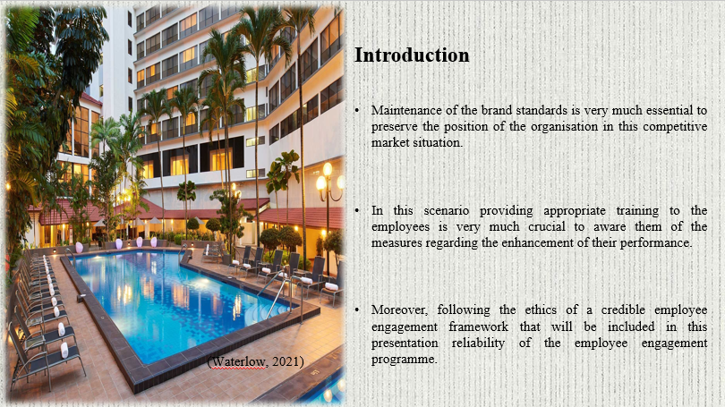

Training Notes:

Introduction
Maintenance of the brand standards is very much essential to preserve the position of the organisation in this competitive market situation. Apart from that lack of conserving the working ethics of the hospitality service provider can bring various complexities regarding their respective working process. In this scenario providing appropriate training to the employees is very much crucial to aware them of the measures regarding the enhancement of their performance. By following this aspect, the organisation is also able to preserve its brand image for a long time. This presentation will discuss the process through which appropriate training can be provided to the workers for the development of organisational performance. Moreover, following the ethics of a credible employee engagement framework that will be included in this presentation reliability of the employee engagement programme.

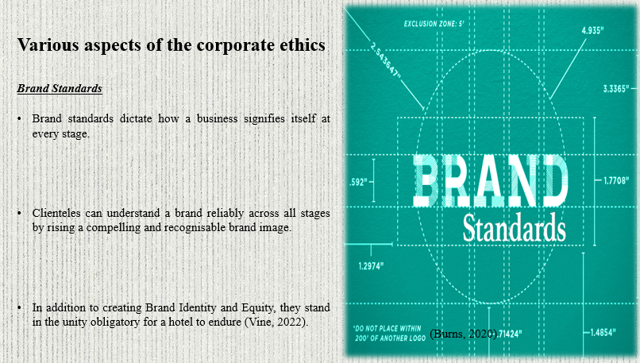

Training Notes:

Various aspects of the corporate ethics

Brand Standards
Brand standards dictate how a business signifies itself at every stage. Brand reliability transversely promotion channels are formed by having strong and easily obtainable brand standards guidelines. Clienteles can understand a brand reliably across all stages by rising a compelling and recognisable brand image. Or, to put it another way, brand standards help as a guest's minimal bar for what they may do in advance from a product and a provision. In addition to creating Brand Identity and Equity, they stand in the unity obligatory for a hotel to endure (Vine, 2022). Aware the employees of the brand standards of the organisation, the appropriate training programme is very much crucial in this context.

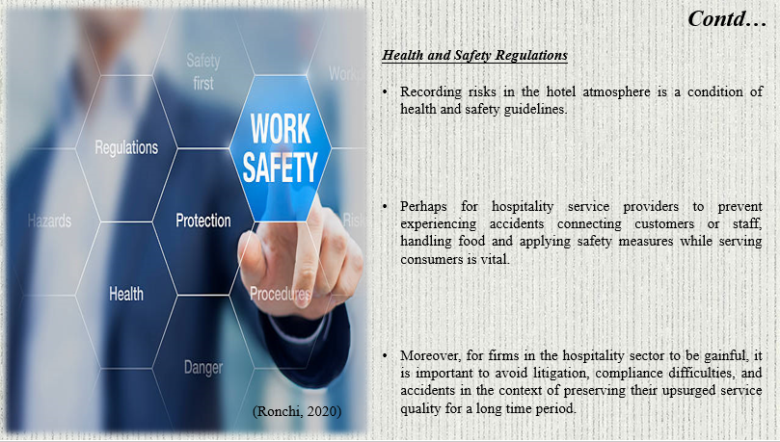

Training Notes:

Health and Safety Regulations
Recording risks in the hotel atmosphere is a condition of health and safety guidelines. Another key component of these health and safety rules is letting all applicable parties know about possible hazards and putting training procedures into place to decrease risks. Perhaps for hospitality service providers to prevent experiencing accidents connecting customers or staff, handling food and applying safety measures while serving consumers is vital. Moreover, for firms in the hospitality sector to be gainful, it is important to avoid litigation, compliance difficulties, and accidents in the context of preserving their upsurged service quality for a long time period.

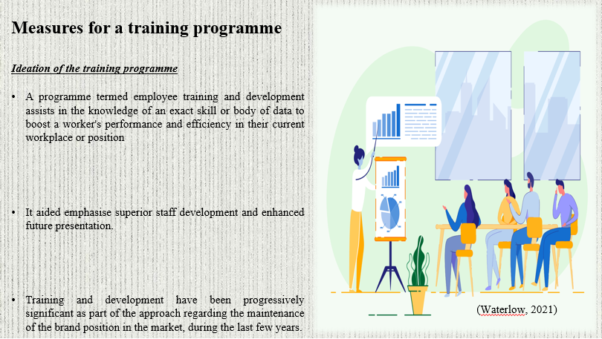

Training Notes:

Measures for a training programme

Ideation of the training programme
A programme termed employee training and development assists in the knowledge of an exact skill or body of data to boost a worker's performance and efficiency in their current workplace or position. It aided emphasise superior staff development and enhanced future presentation. Managers use a variety of educational methods and programmes in an exertion to communicate and develop their employees. Training and development have been progressively significant as part of the approach regarding the maintenance of the brand position in the market, during the last few years.
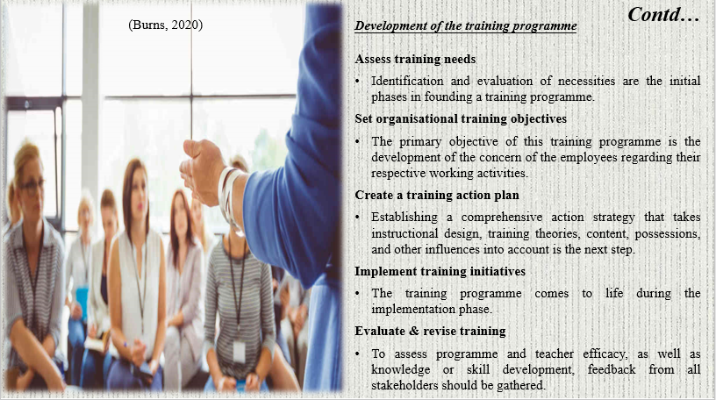

Training Notes:

Development of the training programme
Assess training needs
Identification and evaluation of necessities are the initial phases in founding a training programme. The organisation's strategic, human resource, or individual development goals need to include employee training. Due to the lack of communication establishment of an effective communication network within the organisation is important to uplift the credibility of the training programme (Futurelearn, 2023).
Set organisational training objectives
The primary objective of this training programme is the development of the concern of the employees regarding their respective working activities. Apart from that Bing the collaboration among the stakeholders is another core aim of this training programme as well. Further, the ways through which the brand standards and the health and safety regulations can be maintained appropriately will also be delivered through this training project.
Create a training action plan
Establishing a comprehensive action strategy that takes instructional design, training theories, content, possessions, and other influences into account is the next step. A summary of the tools and methods for delivering the training should also be given. Both the participants' chosen learning styles and the program's degree of teaching should be taken into consideration.
Implement training initiatives
The training programme comes to life during the implementation phase. At the time of implementing a programme, it is important to carefully arrange the timing of training activities and the allocation of any necessary resources in addition to taking employee engagement and learning KPI targets into account. The training progression is then advertised, conducted, and formally launched. To make sure the curriculum is effective, participant development should be followed during training (Page, 2023).
Evaluate & revise training
To assess programme and teacher efficacy, as well as knowledge or skill development, feedback from all stakeholders should be gathered. The company will be able to identify any programme shortcomings and develop a more effective People Insights strategy by reviewing this feedback in conjunction with an employee performance evaluation. If goals are not being fulfilled, the training programme or action plan can now be amended or reevaluated.

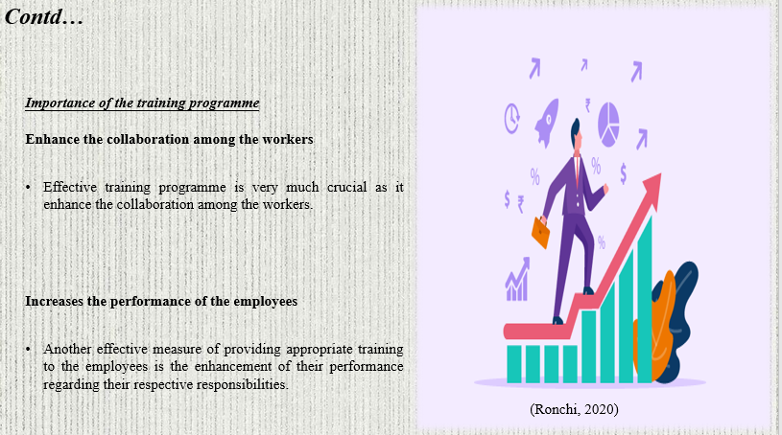

Training Notes:

Importance of the training programme
Enhance the collaboration among the workers
Effective training programme is very much crucial as it enhance the collaboration among the workers. With this measure, a strong understanding among the organisation and its employees can be established that assists the individuals to understand the working process of hospitality service. In addition, communication among the workers becomes also enhanced which is very much helpful for the maintenance of corporate ethics. Perhaps the leaders of the organisation are also able to guide the employees according to the respective brand standards of the business that enhance the hospitality service as well (Clayton, 2022).
Increases the performance of the employees
Another effective measure of providing appropriate training to the employees is the enhancement of their performance regarding their respective responsibilities. Besides it also improved their concern in the context of maintaining their working procedures as well. Tentatively the productivity of the hospitality service also becomes increased along with the uplifted performance of its workers. Along with this, the organisation is also able to provide appropriate guest service to its customers more effectively which enhances its brand image. Moreover, it is also beneficial for the organisation for the maintenance of their health and safety regulations within their working procedures (Avature, 2023).

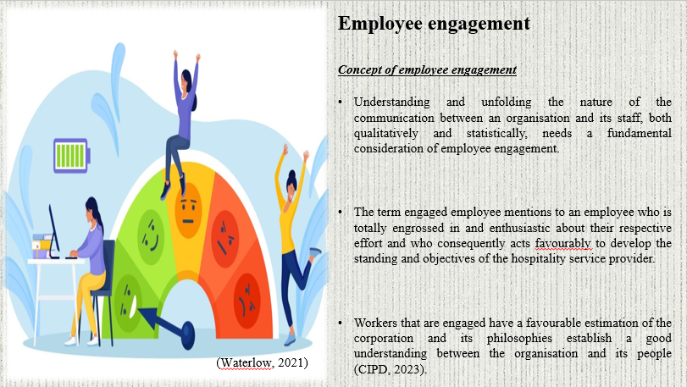

Training Notes:

Employee engagement

Concept of employee engagement
Understanding and unfolding the nature of the communication between an organisation and its staff, both qualitatively and statistically, needs a fundamental consideration of employee engagement. The term engaged employee mentions to an employee who is totally engrossed in and enthusiastic about their respective effort and who consequently acts favourably to develop the standing and objectives of the hospitality service provider. Workers that are engaged have a favourable estimation of the corporation and its philosophies establish a good understanding between the organisation and its people (CIPD, 2023).

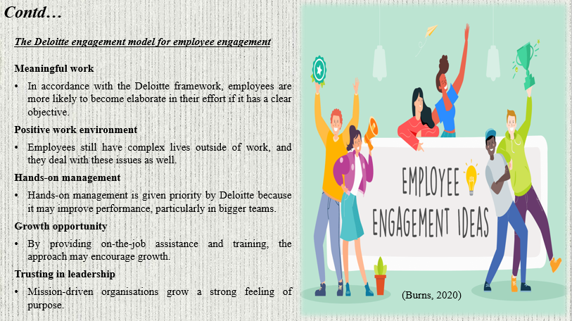

Training Notes:

The Deloitte engagement model for employee engagement
According to the Deloitte model, companies are contending with one another to recollect highly trained workforces and employees having more transferring leverage. This idea emphasises the business culture as an entire and offers compensation in many expanses, not simply the demonstrative one (Tan, and Yeap, 2022).
Meaningful work
In accordance with the Deloitte framework, employees are more likely to become elaborate in their effort if it has a clear objective. The Deloitte method gives supervise members a feeling of independence to support this constituent. Assuming accountability for their job gives people the elasticity to express their originality and infuse connotation into their exertion. In this context sharing the goals of the organisation with the employees is very much effective to enhance their performance in their respective fields.
Positive work environment
Employees still have complex lives outside of work, and they deal with these issues as well. By establishing a secure and adaptable environment inside the company to promote worker welfare, Deloitte makes sure to engage them. Companies under a lot of strain spend money on benefits to keep staff. Providing appropriate rewards and facilities to the workers is very much effective in the context of developing a positive work environment that enhanced their engagement as well (Burns, 2020).
Hands-on management
Hands-on management is given priority by Deloitte because it may improve performance, particularly in bigger teams. In addition, the business invests in management training and uses contemporary performance management to demonstrate its dedication to its employees. the managers are more likely to adhere to the targets if the goals are clear. Putting into practice goals and important outcomes is one approach to achieving this. When managers begin mentoring employees, hands-on management also gets better. In this approach, workers will start to feel appreciated and perform better.
Growth opportunity
If they feel that the company offers them prospects for advancement, employees are more likely to be engaged in their job. Everyone knows that they would not want to work hard for something that has little chance of success. By providing on-the-job assistance and training, the approach may encourage growth. The corporation also gains from this expansion in addition to the employee (Petrongolo and Ronchi, 2020).
Trusting in leadership
Mission-driven organisations grow a strong feeling of purpose. When defining success, they also take into consideration all stakeholders. People within the company are happier as a consequence. Businesses that make investments in their employees profit more. Employees that are more engaged not only perform better at work but also increase their levels of commitment. By doing this, they lower their turnover rates. Transparency and honesty are important components in creating trust. When workers are often polled and heard, they will feel engaged (Waterlow, 2021).

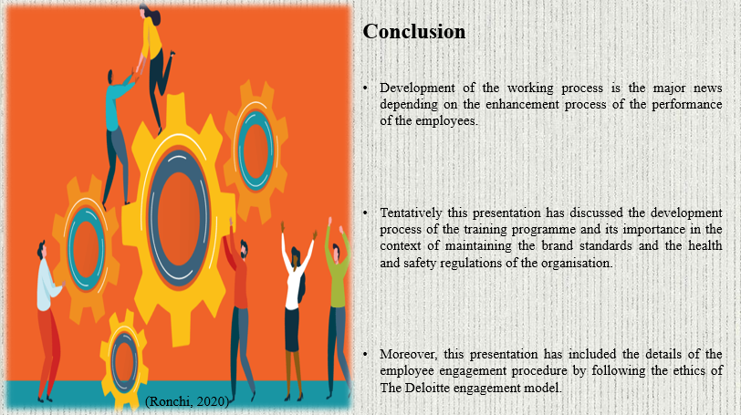

Training Notes:

Conclusion
Development of the working process is the major news depending on the enhancement process of the performance of the employees. For this reason, this presentation has described the details of the employee training programme in the context of uplifting their productivity. Along with this, the concept of brand standards and health and safety regulations of the hospitality service provider is another cold aspect of this presentation as well. Tentatively this presentation has discussed the development process of the training programme and its importance in the context of maintaining the brand standards and the health and safety regulations of the organisation. Moreover, this presentation has included the details of the employee engagement procedure by following the ethics of The Deloitte engagement model.

References

Baum, T., (2019). Does the hospitality industry need or deserve talent?. International Journal of Contemporary Hospitality Management.
Chon, K.K.S. and Zoltan, J., (2019). Role of servant leadership in contemporary hospitality. International Journal of Contemporary Hospitality Management.
Doyle, A., (2021). Important Time Management Skills For Workplace Success. [Online] Available at: https://www.thebalancemoney.com/time-management-skills-2063776 [Accessed 9 May 2023].
Imperialhotels.co.uk, (2023). About Us. [Online] Available at: https://www.imperialhotels.co.uk/?campaign=googleads&gclid=CjwKCAjw6vyiBhB_EiwAQJRopvM0gtuRjapW6xaYMLsfgOJLk_QabuJDtDzLtkuKGaNfynECozxNxoCPrYQAvD_BwE [Accessed 9 May 2023].
Krizanova, A., Lazaroiu, G., Gajanova, L., Kliestikova, J., Nadanyiova, M. and Moravcikova, D., (2019). The effectiveness of marketing communication and importance of its evaluation in an online environment. Sustainability, 11(24), p.7016.
Mbaye, E., (2022). TIME MANAGEMENT FOR HOUSEKEEPERS. [Online] Available at: https://www.progisap.fr/en/gestion-du-temps-femme-de-menage/ [Accessed 9 May 2023].
Revfine, (2023). The Significance of Hotel Housekeeping. [Online] Available at: https://www.revfine.com/housekeeping-responsibilities/ [Accessed 9 May 2023].
Slack, (2021). 10 tips for mastering time management at work. [Online] Available at: https://slack.com/intl/en-in/blog/collaboration/mastering-time-management-at-work [Accessed 9 May 2023].
HotelFriend (2020). Hotel housekeeping - cleaning tips and tricks from HotelFriend. [online] hotelfriend.com. Available at: https://hotelfriend.com/blogpost/how-to-avoid-chaos-in-your-housekeeping-department [Accessed 31 May 2023].
Nkwnayane, S. (2021). Room Cleaning Procedures in Hotel Housekeeping. [online] www.hospitalitycourses.co.za. Available at: https://www.hospitalitycourses.co.za/blog/room-cleaning-procedures-in-hotel-housekeeping [Accessed 31 May 2023].
Sanarp (2020). Cleaning bedroom surfaces, mirrors, and walls. [online] sanarp.com. Available at: https://sanarp.com/Learning/learn/MTg3 [Accessed 31 May 2023].
Simmons, T. (2021). Housekeeping Challenges and Strategy. [online] www.theelitemaids.com. Available at: https://www.theelitemaids.com/blog/top-housekeeping-challenges-and-strategy [Accessed 31 May 2023].
Vine, M., (2022). What are brand guidelines?. [Online] Available at: https://www.tomango.co.uk/blog/what-are-brand-guidelines/[Accessed 01 05 2023].
Futurelearn, (2023). What is the purpose of training and development?. [Online] Available at: https://www.futurelearn.com/info/courses/training-development-work/0/steps/88512[Accessed 01 05 2023].
Page, M., (2023). The importance of training and development. [Online] Available at: https://www.michaelpage.co.uk/advice/management-advice/development-and-retention/importance-training-development[Accessed 01 05 2023].
Clayton, S., (2022). Collaboration Among Employees: 8 Ways You Can Improve It. [Online] Available at: https://www.ringcentral.com/gb/en/blog/collaboration-among-employees/[Accessed 01 05 2023].
Avature, (2023). Performance Management in The UK: Challenges and Best Practices. [Online] Available at: https://www.avature.net/blogs/performance-management-in-the-uk-challenges-and-best-practices/[Accessed 01 05 2023].
CIPD, (2023). Employee engagement and motivation. [Online] Available at: https://www.cipd.org/uk/knowledge/factsheets/engagement-factsheet/#:~:text=Treat%20employee%20engagement%20as%20a,alongside%20precision%20on%20priority%20concerns.[Accessed 01 05 2023].
Tan, K.L. and Yeap, P.F., (2022). The impact of work engagement and meaningful work to alleviate job burnout among social workers in New Zealand. Management Decision, 60(11).
Burns, D., Dagnall, N. and Holt, M., (2020), October. Assessing the impact of the COVID-19 pandemic on student wellbeing at universities in the United Kingdom: A conceptual analysis. In Frontiers in Education (Vol. 5, p. 582882). Frontiers Media SA.
Petrongolo, B. and Ronchi, M., (2020). Gender gaps and the structure of local labor markets. Labour Economics, 64, p.101819.
Enria, L., Waterlow, N., Rogers, N.T., Brindle, H., Lal, S., Eggo, R.M., Lees, S. and Roberts, C.H., (2021). Trust and transparency in times of crisis: Results from an online survey during the first wave (April 2020) of the COVID-19 epidemic in the UK. PloS one, 16(2), p.e0239247.

