Student Name: Danielle Blake
P Number: 1700391
Programme of Study: Illustration
Module: M4X01559

Curatorial Text - 1180 words

Richard Dawkins' book, The Selfish Gene (1976) coined the term 'meme'. He discussed how specific behaviours could be adaptive using a gene-centred view of evolution. Dawkin states 'It was Darwin who first put together a coherent and tenable account of why we exist' (1976:1).

The theory of Evolution and 'survival of the fittest' has been compared to the activity of viral internet memes. 'A 'survival machine', once built, is free to behave as it will and 'rebel' against its genes should it so wish' (Harding and Crawshaw, 2017:244). The rise of technology has enabled globalisation and people of different cultures can now view new information. Memes come in different formats such as videos, images, text or song et cetera. Generally humorous they are duplicated or reproduced to be spread promptly each having a slight variation similarly to how Charles Darwin explained gene mutation in his Theory of Evolution.

The human body is made of 23 pairs of chromosomes. Every chromosome contains multiple genes and within these they contain deoxyribonucleic acid, known as 'DNA'. These genes will mutate to accommodate our needs, for example our brain size increasing throughout the evolution of our species. Once this change has occurred those without the mutation won't pass the genes needed and theoretically would become extinct. This can applied to memes. When shared if they aren't updated the older versions become irrelevant.


Joseph Ducreux, Self Portrait, c.1793

Before the creation of modern technology, it's questioned how cultures shared their heritage. How did artwork become famous? How did it become viral?

Ducreux's self portrait is known as one of the first memes to be created, the way it has evolved into one shows how Darwin's theory can be applied. Passionate about physiognomy, Decreux wanted to expand the range of facial expressions beyond those used in official portraiture. He is seen to be grinning and pointing towards the viewer.

After 2 centuries it became a meme in 2009. Due to the nature of the painting captions were added, the most famous being 'Disregard Females, Acquire Currency'. This archaic reinterpretation of lyrics from Notorious B.I.G's single 'Get Money' started a trend. 'Certain memes, will be more successful than others because they fulfil a cultural need' (Marwick, 2013:12).

As the meme became viral the task of translating Olde English back into their original verses gave the viewer a sense of accomplishment. The evolution of new Olde English phrases being added increased the memes popularity however as time has passed this meme has become irrelevant, extinct even.

So what does a meme need in order to stay relevant?

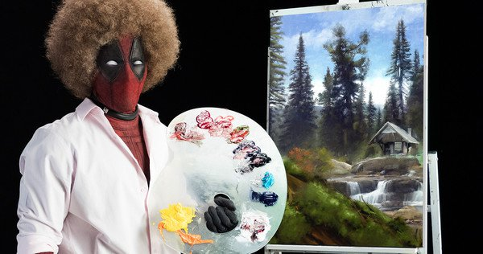

Deadpool 2 Movie Trailer, Marvel, 2017
Memes often parody previous cultural phenomenon's. Marvel produced a trailer for Deadpool 2, with Ryan Reynolds portraying Bob Ross while acting as Deadpool. It's name 'Wet on Wet' immediately sets the tone of the video referencing Bob Ross' wet on wet oil painting technique.

Over recent years Bob Ross has gained a cult following because of his show 'The Joy of Painting'. In the trailer catchphrases from the show are used, however in the form of innuendos. By referencing the original phrases in a comedic tone gives the meme the qualities it needs in order to stay relevant. This in a sense is the evolution stage of a meme, it's taking previous qualities and adapting them in order to survive with other competition.

'The visceral emotional reaction created by the images, music, message, and people in the video increased viewer interest and led them to forward it to friends and acquaintances' (Guadagno et al, 2013:2312). Goes to prove that there needs to be an emotional connection for a meme to survive. Ross is nostalgic for many viewers, therefore by recycling his material to reincarnate those feelings; that connection will encourage viewers to share the new meme and make it go viral.

However, how much do emotions really affect the virality of a meme? What triggers the viewer to share it?

The third piece to be included in this exhibition is from K.C. Green's Gunshow comic #648. This image to known as 'This Is Fine'. This meme is about a dog attempting to reassure himself that everything is fine even though he's sat in a burning room. It's used as a reaction image to convey a sense of self-denial or acceptance when faced with a hopeless situation. This meme is an example of how the viewer can relate to an artwork and know that they're not alone in how they are feeling, because of this the viewer may feel an urge to share this with their peers as they're likely to relate to it too.

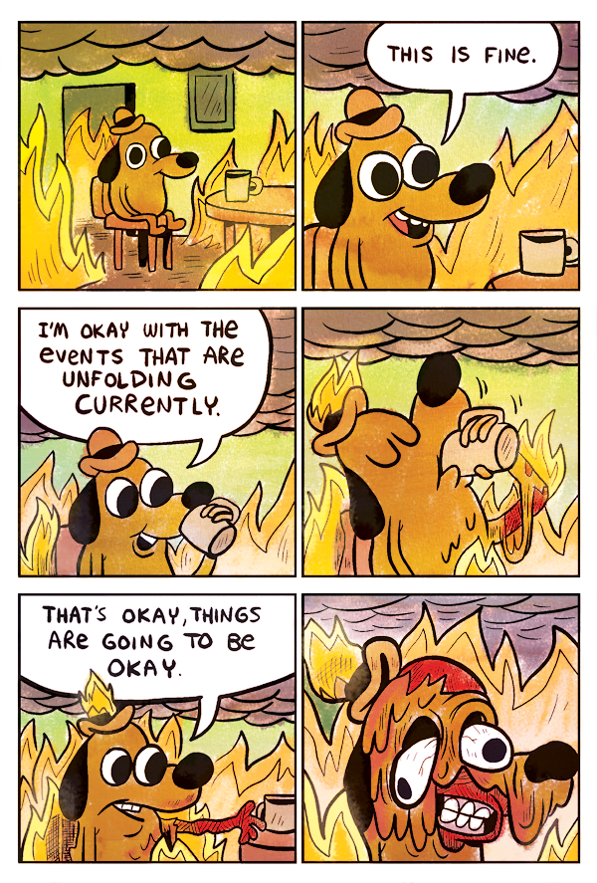

Gunshow comic #648, K.C. Green, 2013

'Social networks distribute internet memes without cessation every moment of everyday. Most Facebook users likely encounter a meme and/or distribute a meme daily' (Wiggins and Bowers, 2015: 1890). Social media is another reason why memes stay relevant. You could even go as far to say that social media is the human body and memes are the genes found inside it.

There are multiple social media platforms, one of the most popular for memes is YouTube. Social networking sites such as YouTube allow communities to form, these communities have different types of humour attached to them. This could be compared to different types of species and how there are different genus groups within in them.

'Memetics is the counterpart of genetics in the cultural arena. In its application to science, it deals with the manner in which memes/ideas spread in the scientific communities' (Kantorovich, 2014: 363). There are many meme communities, each will have solidarity within them. An example of this is from Lazy Town's Stefan Karl Stefansson who played Robbie Rotten. He performed a song on the show called 'We Are Number One'. This video rose to popularity after people created responses that imitated the video format. They made their own versions to help crowd fund for Stefansson's cancer treatment.

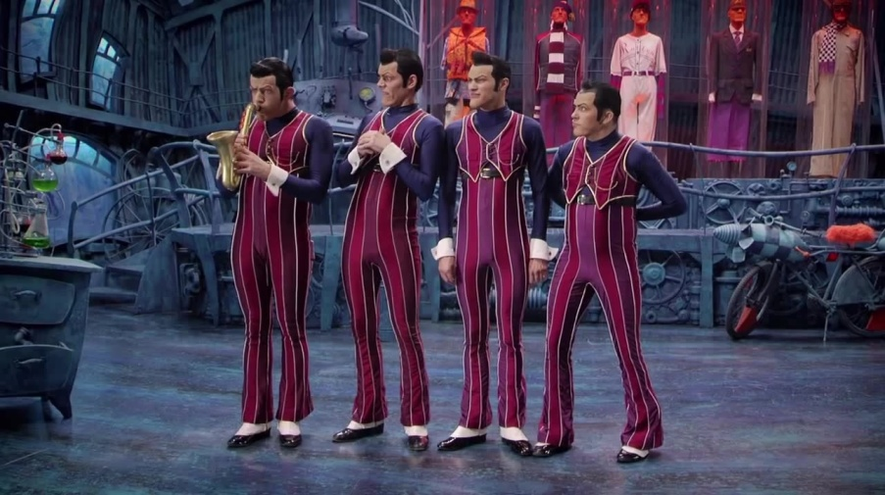

We Are Number One, Lazy Town, 2014

The responses that were made are a direct example of how memes are linked to Darwin's theory. They were passed as a gene would and mutated into something else but still sharing similar characteristics from previous generations, the difference being that there were improvements. In this case it was the videos topic that would change, such as 'We Are Number One but it's in Japanese'.

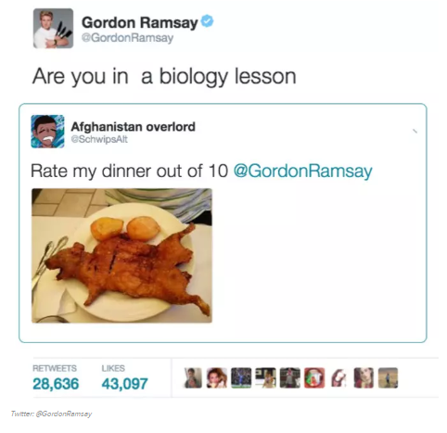
Most memes display fictional characters however in modern society more people can become a meme or create one using their persona. An example of this is chef Gordon Ramsay. Known for his explosive temper Ramsay is often shown venting his frustration over undercooked meals. Recently on twitter Gordon started to get sent images of meals made by the public to critique, although what Gordon does instead is use his critiques comically and therefore 'roast' the person who made the dish.
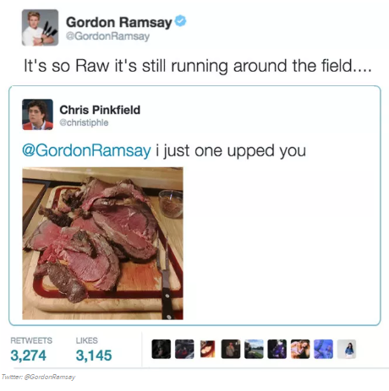
Tweets From @GordonRamsay, 2017

This type of meme requires public participation as without people sending in pictures the meme wouldn't be able to continue just as humans need to reproduce in order to keep life going and keep the process of evolution running.
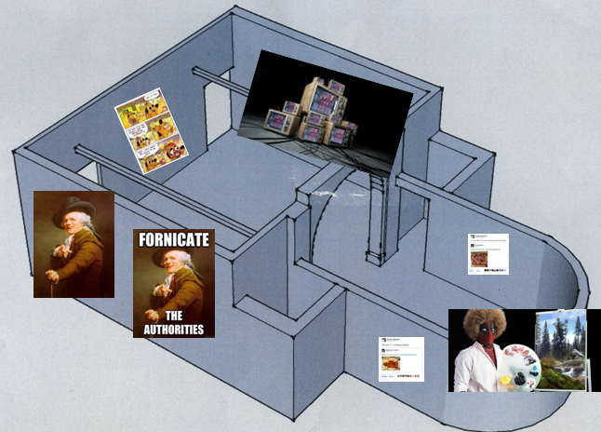

Bibliography

Dawkins. R. (1976) The Selfish Gene. Oxford; New York: Oxford University Press.
Harding, K. and Crawshaw, A (2017) 'The Selfish Gene', Practical Neurology, 17 (3) : 244.
Marwick. A (2013) 'Memes', Contexts, 12 (4) : 12-13.
Guadagno, R, E, Rempala, D, M, Murphy, S. and Okdie, B, M (2013) 'What Makes a Video Go Viral? An Analysis of Emotional Contagion and Internet Memes', Computers In Human Behaviour, 29 (6) : 2312-2319.
Wiggins, B, E. and Bowers, G, B (2015) 'Memes as a Genre: A Structional Analysis of the Memescape', New Media & Society, 17 (11) : 1886-1906.
Kantorovich, A (2014) 'An Evolutionary View of Science: Imitation and Memetics', Social Science Information, 53 (3) : 363-373.

Additional Reading List
Websites:

BBC. (2014) BBC Bitesize.
Available at: http://www.bbc.co.uk/bitesize/higher/biology/genetics_adaptation/mutations/revision/2/
(Accessed:20 April 2018 )
David, T, Mitchell. (2013) Encyclopedia Britannica.
Available at: https://www.britannica.com/science/mutation-theory (Accessed:20 April 2018 )
Hellfire Gamer. (2014) Know Your Meme.
Available at: http://knowyourmeme.com/memes/people/richard-dawkins (Accessed: 20 April 2018)
NIH U.S National Library of Medicine. (2018) Genetics Home Reference.
Available at: https://ghr.nlm.nih.gov/primer/basics/gene (Accessed:20 April 2018)

