Task 1

Academic Poster with Annotated bibliography

Student Name: Maninder Kaur Chander
Student no: 2009648
Module Title: Psychology for Health and Social Care
Module Code: BMHP4003

Lecturer Name: Rebecca Kavanagh

Understanding psychological development across the lifespan”
Psychological development
(Denise Boyd, 2019) Developmental psychology is increasingly becoming a life psychology instead of being limited to childhood and adolescent psychology. The aim of this Academic poster to help a local community hospital staff to understand psychological development across the life span. This poster will help staff to better deal with, communicate with and understand the need of the patients.
Here I am using Erikson’s Model
Erikson’s psychological theory Sigmund Psychological theory
Sigmund Freud is a father of psychology. He observed that the child's behaviour in the predictable phases of early childhood development is geared towards certain parts of the body, for example the mouth when breastfeeding, the anus during toilet training. He argued that adult neurosis (functional mental disorder) is often rooted in child sexuality, so he suggested that adult neurotic behaviours are manifestations of sexual fantasies and cravings for sex.
(Wikipedia contributors, 2021)

. (Wikipedia contributors, 2021)
Erik Erikson was born in 15 June 1902. He was a German-American Phycologist who developed one of the most popular and important theory on development. Erikson believed personality developed in 8 stages. (Cherry, 2020)

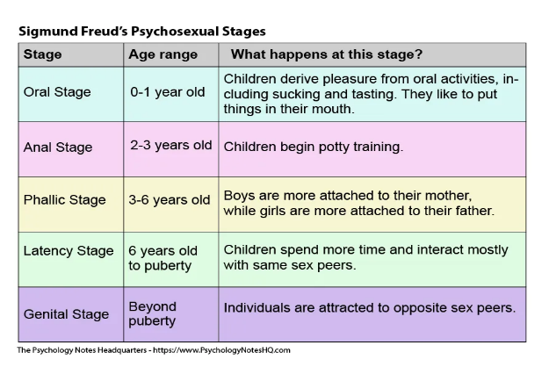
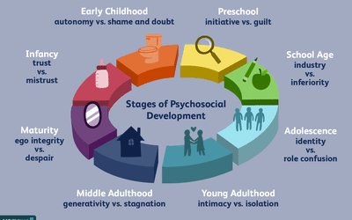
(Seong, 2020)
(PsychologynotesHQ, 2021)

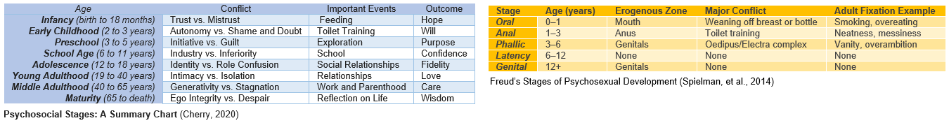
Erikson follows a Freud’s concept and many of his ideas. This is the reason, both theories have similarities. They both identified the importance of the unconscious development. They separated development into stages of a person’s life and also use similar age classifications for these stages’ development
Both Freud and Erikson agreed on childhood playing a vital role in shaping a person’s personality in adult life. Freud focussed on early childhood and said that a person’s personality is usually determined by childhood. Erikson believed that personality is determined more by external factors such as how caregivers (parents/guardians) meet the needs of a child.
Freud and Erikson understand the significance of the unconscious mind in the development of personality. Both theorists base their theories on some type of conflict. When a conflict is not properly handled, it causes emotional pain, which can lead to mental disease. Childhood is vital for personality development, and both theories believe that childhood trauma can influence personality development (Martha Lally, 2017)
The nature of conflict differs between Freud and Erikson. Freud's argument is around sex. Erikson's theory adopts a psychosocial perspective, which indicates that people are moulded by society and want to belong to a community. According to Erikson's thesis, conflict is resolved when a person learns to love and care for others. According to Freud's, conflict is resolved when a person obtains sufficient pleasure throughout the early stages of development (Carrey, 2010).
Erikson suggested that how we interact with others is what affects our sense of self, or what he called ego identity. He proposed that at each of the eight stages of development there is a conflict, or task that needs to be resolved (Spielman, et al., 2014).
Sigmund Freud says the first six years of life are most crucial for personality development. He lists three stages: oral, anal and phallic stage. The stages revolve around pleasure centres -- the mouth, anal release and genitals. But Erikson’s stages cover lifespan development. These stages are based on the study of psychosocial challenges. The first 3 stages cover childhood and adolescence. These stages cover the conflicts of creating trust, independence and purpose. Stages 4 and 5 cover school ages and adulthood. The next stages cover adolescence, middle age, and old age (Clayton, 1975).
Examples of how staff can support older adults in stage 8 of lifespan
Stage 8 is a wisdom stage. In this stage people start to evaluate life and those who look back with regret are fearful of death. In this stage, some of us suffer with chronic disease and many more health issue. We all need extra care and support. So, community hospital staff need to understand their needs and support them physically and mentally. They should care and support older adults emotionally and patiently. Although they will need extra care and support, they should be treated with respect and never made to feel humiliated for needing this extra support.
Conclusion
In conclusion Erikson agreed with Freud’s development theory up to a point, but he himself believed that personality is shaped by the conflicts people face over the 8 stages of their lifespan. He also believed that social factors played more of a role than the psychosexual factors in Freud’s development theory. Erikson believes all 8 stages play a vital role in lifespan development but In Wisdom (stage 8) people start to evaluate their life. Some look back with satisfaction, wisdom and few regrets but some feel unsuccessful at this stage.

Bibliography

Carrey, N., 2010. “The Two Ericksons: Forgotten Concepts and what Constitutes an Appropriate Professional Knowledge Base in Psychiatry.”. Journal of the Canadian Academy of Child and Adolescent PsychiatryJournal de l'Academie canadienne de psychiatrie de l'enfant et de l'adolescent, 19(4), p. 248.
Cherry, K., 2020. very well mind. [Online]
Available at: https://www.verywellmind.com/erik-eriksons-stages-of-psychosocial-development-2795740
[Accessed 11 June 2021].
Freud's Psychosexual Developmental Theory
This article was written by Kendra Cherry on November 19, 2020. this article reviewed by Steven Gans MD. In this article Kendra Cherry discussed about Freud's Psychosexual stages. his theory described how personality developed over the course of childhood.
Clayton, V., 1975. Human deveopment. Erikson’s Theory of Human Development as it Applies to the Aged: Wisdom as Contradictive Cognition, 18(2), pp. 119-128.
In this article Vivian Clayton talked about Erikson's theory on Human development and stages of lifespan from birth to wisdom age. also he discussed how each stage impact on human development.
Denise Boyd, H. B., 2019. Lifespan Development. Global Edition ed. s.l.:Pearson Education, Limited.
This book explaining the lifespan development from psychological aspects. it also covers the psychological science of young children into their late adulthood. Writer summaries each development cycle very well
Martha Lally, S. V.-F., 2017. Lifespan Development: A Psychological Perspective - Second Edition. 2nd ed. Illinois: Goodheart-WillcoxCompany,Inc..
In this book writers discussed both Erikson's and Freud theories. she also discussed idea of lifespan development from birth to mid and late childhood. also from late adulthood to wisdom age ( death ).
https://www.proquest.com/openview/c078ed89ca25a431e114e6c8478b4755/1?pq-origsite=gscholar&cbl=1819054
Piaget, Kohlberg, and Erikson: Developmental Implications for Secondary Education
Miller, John P.Adolescence; Roslyn Heights, N.Y. Vol. 13, Iss. 50, (Summer 1978): 237.
in this article John P. Miller examines the theories of Piaget, Kohlberg and Erikson in relation to education and adolescences. they all had similar views concerning the individual and his/her relationship to the environment.

McLeod, S. A. (2008).
Erik Erikson | Psychosocial Stages - Simply Psychology.
Retrieved from
http://www.simplypsychology.org
/Erik-Erikson.html

Dr Saul McLeod explains how Erikson’s theory involved the person experiencing a psychosocial crisis during each of the 8 stages. These crisis could have a positive or negative outcome for personality development.

Wallerstein, R. S. (1998). Erikson’s Concept of Ego Identity Reconsidered. Journal of the American Psychoanalytic Association, 46(1), 229–248. https://doi.org/10.1177/000306519804600112

Robert S Wallerstein attempts to explain Erikson’s concept of ego identity. In this article again, there is emphasis on the crisis people have to overcome in order to progress positively through the stages.

PsychologynotesHQ, 2021. the psychology notes HQ. [Online]
Available at: https://www.psychologynoteshq.com/freud-psychosexual-development/
[Accessed 13 June 2021].

Seong, J., 2020. Very Well. [Online]
Available at: https://www.verywellmind.com/erik-eriksons-stages-of-psychosocial-development-2795740
[Accessed 11 June 2021].

Spielman, R. M. et al., 2014. 9.2 Lifespan Theories. In: Psychology. Houston: OpenStax.

Wikipedia contributors, 2021. Psychosexual development. [Online]
Available at: https://en.wikipedia.org/w/index.php?title=Psychosexual_development&oldid=1027194761
[Accessed 12 June 2021].

Bibliography
Cherry, K., 2020. very well mind. [Online] Available at: https://www.verywellmind.com/erik-eriksons-stages-of-psychosocial-development-2795740 [Accessed 11 June 2021].
Denise Boyd, H. B., 2019. Lifespan Development. Global Edition ed. s.l.:Pearson Education, Limited.
PsychologynotesHQ, 2021. the psychology notes HQ. [Online] Available at: https://www.psychologynoteshq.com/freud-psychosexual-development/ [Accessed 13 June 2021].
Seong, J., 2020. Very Well. [Online] Available at: https://www.verywellmind.com/erik-eriksons-stages-of-psychosocial-development-2795740 [Accessed 11 June 2021].
Wikipedia contributors, 2021. Psychosexual development. [Online] Available at: https://en.wikipedia.org/w/index.php?title=Psychosexual_development&oldid=1027194761 [Accessed 12 June 2021].
https://www.proquest.com/openview/c078ed89ca25a431e114e6c8478b4755/1?pq-origsite=gscholar&cbl=1819054
Piaget, Kohlberg, and Erikson: Developmental Implications for Secondary Education
Miller, John P.Adolescence; Roslyn Heights, N.Y. Vol. 13, Iss. 50, (Summer 1978): 237.
In this article John P. Miller examines the theories of Piaget, Kohlberg and Erikson in relation to education and adolences. they all had similar views concerning the idvidual and his/her relationship to the enviorment.
2. https://www.verywellmind.com/child-development-theories-2795068
Freud's Psychosexual Developmental Theory
This article written by Kendra Cherry on November 19, 2020. this article reviewed by Steven Gans MD. In this article Kendra Cherry discussed about Freud's Psychosexual stages. his theory described how personality developed over the course of childhood.

