Con-rod accelerations, forces & Displacements
Advanced Engine Design (M6X00410)

University of Wales Trinity Saint David, School of Engineering
BEng Motorcycle Engineering (4 Year Course)
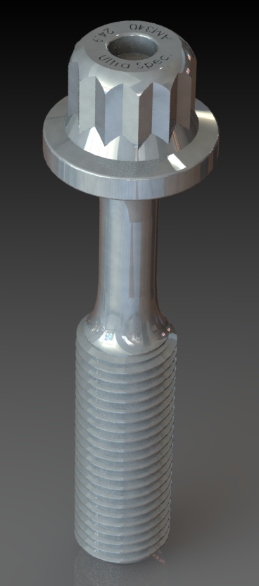
Table of Contents
1 General Values and Introductory Remarks 5
2 Gudgeon Pin Case Study (basic overview of methodology for fatigue analysis) 6
3 Connecting Rod Case Study 9
4 Connecting Rod Bolt Case Study 13
5 Crankshaft Case Study 21
6 References 23

Table of Figures and Tables
Table 1: Table of general measurements pertinent to work throughout the report 4
Table 2: Table of values relating to the calculation in Gudgeon Pin Case Study 5
Table 3: Material specifications table relating to Gudgeon Pin Case Study 5
Table 4: Table of values relating to the calculations seen in the Connecting Rod Case Study 8
Table 5: Table of Material values relating to the Connecting Rod Case Study 8
Table 6: Table of Masses and Areas considered for the Connecting Rod Case Study 9
Table 7:Table of Forces and Stresses seen in the Connecting rod 9
Table 8: Table of Range and Mean Stresses Seen in the Connecting Rod 9
Table 9: Table of Fatigue Analysis Values for Connecting Rod 11
Table 10: Table of General Values related to the calculations undertaken in the Connecting Rod Bolt Case Study 12
Table 11: Table of Material Specifications of the STANDARD Rod Bolt 12
Table 12: Table of Material Specifications for the MODIFIED Rod Bolt 12
Table 13: Comparison of Ratio of Stiffnesses bolt to cap 13
Table 14: Table of comparison relating to Axial forces and stresses 13
Table 15: Fatigue analysis of the standard bolt at 6000RPM 15
Table 17: Fatigue Analysis of the modified bolt at 6000RPM 16
Table 18: Fatigue Analysis of the standard bolt at 9000RPM 17
Table 19: Fatigue analysis of the modified bolt at 9000RPM 18
Table 20: Table of General Values used in the Calculation of the Crankshaft Case Study 20
Table 21: Table of Material values relating to the Crankshaft Case Study 20
Table 22: Table of Stresses seen at Firing and Exhausting 21
Table 23: Table of "Goodman" Diagram Stresses and FSF 21

Figure 1: Goodman Diagram for Gudgeon Pin Fatigue Analysis (plotted using SOLIDWORKS) 6
Figure 2: Cutaway of Small-End and Pin 7
Figure 3: Demonstration of change in points with rod angle 7
Figure 4: Diagram of cases considered for Connecting Rod Fatigue Analysis 9
Figure 5: Roark's Interpolation method for Kt value estimation 10
Figure 6: The authors interpolation method utilising SOLIDWORKS and Excel tools 10
Figure 7: Goodman Diagrams for Point A, B & C 11
Figure 8: Goodman Diagram of standard bolt at 6000RPM 15
Figure 9: Goodman Diagram of Modified bolt at 6000RPM 16
Figure 10: Goodman Diagram of Standard Bolt at 9000RPM 17
Figure 11: Goodman Diagram of Modified Bolt at 9000RPM 18
Figure 12:Comparison between Standard and Modified Bolts 19
Figure 13: Application of Grodzinskis Template for Streamline fillets and the template as seen below 19
Figure 14: Goodman Diagram for the Crankshaft Case Study 21

General Values and Introductory Remarks
The primary aim of this report is to investigate the stresses, loading cases and geometric conditions (along with their influencing/effecting factors) found in the internal combustion engine. As with previous work the system considered is the Forced-Induction SI 4-stroke Ford 1.6GDI “Sigma” platform. Materials and geometry/mass have been measured, researched or approximated for the purposes of calculating approximate “standard” fatigue safety and stress values seen in different components throughout the system to better understand the reasoning and areas for improvement seen in a modern engine platform of this kind.
The areas under study will be: the pin joint connection between the piston and the connecting rod (Gudgeon Pin Case Study), several key stress areas of the connecting rod (Connecting Rod Case Study), the bolted connections securing the connecting rod to the crankshaft (Connecting Rod Bolt Case Study) and finally a brief study of the critical stress areas in the crankshaft itself (Crankshaft Case Study).
In the interest of simplicity this report will provide a brief overview of methodology and results with areas of interest highlighted and investigated further as-opposed to a step-by-step walkthrough of methodology for each small element of study.
Additionally, due to the lengthy nature of the work within this report the author has opted to display a range of values and measurements that are used through out the work at this early stage to alleviate repetitions later in this work.
Table 1: Table of general measurements pertinent to work throughout the report
Values Considered | Measurement or Calculation | Units
Conrod Length | 134.000 | mm
Crank Radius (Stroke) | 40.700 | mm
Piston Assembly Mass (Piston, All rings and Circlips) | 268.200 | grams
Connecting Rod Bolt Mass | 18.000 | grams
Gudgeon Pin Mass | 75.900 | grams
Connecting Rod Mass (including bolts) | 407.120 | grams
Connecting Rod Cap | 116.500 | grams
Considered Reciprocating Mass (1/3 of Con-rod, Piston Assy. And Gudgeon Pin) | 479.767 | grams
Considered Rotating Mass (2/3 of Con-rod minus the Con-rod “Cap”) | 154.834 | grams
Length of Con-Rod bolt considered (2nd engaged thread to underside of bolt head) | 34.850 | mm

Gudgeon Pin Case Study (basic overview of methodology for fatigue analysis)
Table 2: Table of values relating to the calculation in Gudgeon Pin Case Study
Values Considered | Measurement or Calculation | Units
Piston Mass | 268.200 | grams
Gudgeon Pin Mass (Extruding from Point A) | 26.170 | grams
Pin Inner Diameter | 17.000 | mm
Pin Outer Diameter | 21.000 | mm
Cross Sectional Area | 119.381 | mm²
Neutral Axis | 10.500 | mm
Point A → Piston Effort on Pin | 11.130 | mm
Point A → Centre of Mass of extruding section of pin | 6.250 | mm
Table 3: Material specifications table relating to Gudgeon Pin Case Study
Material Considered as AISI 4340 Steel Alloy (Normalized @ 870°C) | Value taken from Solidworks Materials Database | Units
Ultimate Tensile Stress | 1110.000 | N/mm²
Endurance Limit when mean is considered to be zero | 394.980 | N/mm²
The methodology (calculation pathway) relating to the determination of stresses and fatigue safety factors for this case study is as follows:
Definition of the second moment of inertia for the pin using: $\frac{{πd}^{4}}{64}$ This returned the value of 5446.736 mm⁴ when considering the hollowed geometry of the pin (internal geometry disregarded and treated as a uniform tube).
Calculation of the Inertial and Net forces seen in the case study using:
Inertia = $Mass of pin Extruding from connecting rod ×Rω^{2}\cos\left(θ\right)+\frac{R}{L}Rω^{2}cos⁡(2θ)$
Net Force = $\frac{Gas Force+ Inertia}{2}$ for Firing, $\frac{Gas Force- Inertia}{2}$ for Exhausting. The Net Force values returned were 26976.822N for Firing and -2674.240N for Exhausting.
Calculation of Net bending moments about Point A for both Firing and Exhausting:
$Force ×Distance$ The results returned were 291505.774Nmm for Firing and -27091.800Nmm for Exhausting
Once net bending moments have been calculated shear and bending stresses are determined using the following equations:
$Bending Stress=\frac{Moment×Neutral Axis}{Moment of Inertia}$ $Shear Stress=\frac{Force}{Cross-sectional area}$
To return values of bending stress of 561.953 N/mm² for Firing and -52.227 N/mm² for Exhausting
And, for the shear case, 225.973N/mm² for Firing and -22.401N/mm² for Exhausting
These values can then be combined using $\sqrt{Bending Stress^{2}+{\left(2×Shear Stress\right)}^{2}}$ to provide a combined stress for both the TENSILE Firing event of 721.143N/mm² and -68.810N/mm² for the COMPRESSIVE Exhausting event.
Once these values have been determined the fatigue analysis can begin:
To carry out a fatigue analysis a range and mean average of the two previously mentioned values must be taken. The values returned for this were 789.950N/mm² for the range of stresses seen and 394.980N/mm².
From these four values a “Goodman Diagram” can be plotted to allow trigonometric assumption of further fatigue analysis values.
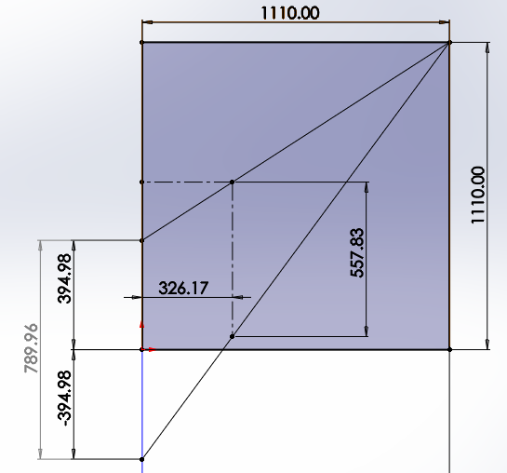
Figure 1: Goodman Diagram for Gudgeon Pin Fatigue Analysis (plotted using SOLIDWORKS)
As can be seen above, if the range of stresses is split evenly about the x-axis and points are plotted to a bounding box of the UTS value, then a vertical line about the y-axis at the distance of the mean average along the x-axis will (when intersected with the y-axis) return the value of “Actual” range of stresses seen during the fatigue event.
This Actual range can be then compared to the previously calculated “Allowable” Range to provide a “Fatigue Safety Factor”. In the case of this particular study the factor returned was 1.42.
In the case of these studies an FSF of 1 means a fatigue life of 10⁷ fatigue cycles, if the part reaches this threshold it is considered that it has an “infinite fatigue life”, as the value returned here is greater than 1 it can be surmised that Ford have a designed a part that is fit-for-purpose in relation to fatigue life at 6000RPM engine speed under normal conditions.
A few points of note for this case study are that for the purposes of this work the connecting rod “small-end” has been considered as a uniform shape, providing an equal moment length in both Firing and Exhausting, the reality of the real-world geometry is that the “small-end” is tapered (see images below). This presents an interesting query which (for the sake of time and expediency) which was not addressed.
Firstly, if the Firing and Exhausting events are considered to act directly along the connecting rod there are two points about which a moment can occur the top point (T) (circled in YELLOW in Fig 2.) and the bottom point (B) (circled in RED in Fig 2.), this, in theory, will provide a different loading/stress event in different directions.
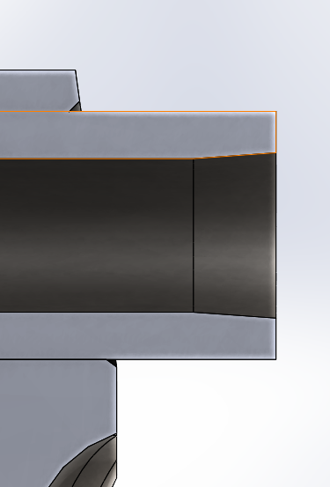
Figure 2: Cutaway of Small-End and Pin
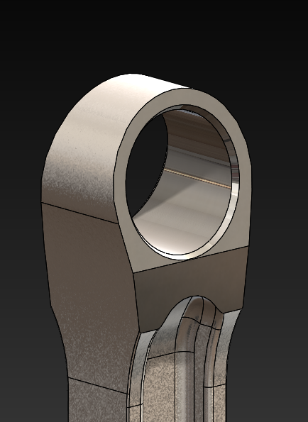
Figure 3: Demonstration of change in points with rod angle
Also with the change of rod angle due to extreme events not occurring exactly at TDC each time will mean a change of points each case at each angle, points about the red line for instance will be different to those about the yellow line meaning a completely different pair of moments between Firing and Exhausting.

Connecting Rod Case Study
Table 4: Table of values relating to the calculations seen in the Connecting Rod Case Study
Values Considered | Measurement or Calculation | Units
Angular Velocity at 6000RPM Engine Speed ($2π\frac{Engine Speed}{60})$ | 628.319 | rad/s
Crank Angle at Exhausting Event | -6.248 | rad (BTDC-Firing)
Connecting Rod Angle at Exhausting Event | 0.011 | rad (BTDC-Firing)
Gas Force seen at Exhausting Event | 1359.233 | Newtons
Crank Angle at Firing Event | 0.314 | rad (ATDC-Firing)
Connecting Rod Angle at Firing Event | 0.094 | rad (ATDC-Firing)
Gas Force seen at Firing Event | 47789.811 | Newtons
Table 5: Table of Material values relating to the Connecting Rod Case Study
Material Considered as AISI 4140 Steel Alloy (Normalized @ 870°C) | Values taken from Smith Metal Datasheet and Engineering Toolbox (Smiths Metals Centres, 2018) (Engineering Toolbox, 2011) | Units
Ultimate Tensile Stress | 1000 | N/mm²
Polished Endurance Limit | 480 | N/mm²
Endurance Limit/UTS Ratio | 0.480 | -

As the basic methodology of the “Goodman Diagram” style of fatigue analysis has been explained in the previous chapter only the key points relating to this particular case study will be explained.
The study is broken into three areas of scrutiny, points A though C, each area is at the cross section of a geometry that can be considered a stress raiser (shoulder fillets seen at the small-end, transition to big-end and on the tip of the cap), ideally a full 3 dimensional Finite Element Analysis would be carried out (but once again for the sake of expediency this has not been undertaken) in tandem with real world testing to determine accurate results, but, in lieu of this a series of “stress concentration” factors have been considered.
This study considers the connecting rod in a single-plane with forces resolved about the rod angle to provide realist loading.
For each “point” case the mass of connecting rod considered (combined with the piston assembly and Pin) changes and the cross-sectional area along with it to provide an accurate representation of the loading seen in the real-world application, these values can be found in Table 6 overleaf.
Table 6: Table of Masses and Areas considered for the Connecting Rod Case Study
Location | Mass Considered | Cross-sectional Area Considered
Point A | 394.550g (Con-rod material above Point A) | 392.820mm²
Point B | 514.700g (Con-rod material above Point B | 346.58mm²
Point C | 669.370g (Con-rod minus cap) | 157.66mm²
The values calculated from these points for forces and loading as a component of rod angle are shown in the table below:
Table 7:Table of Forces and Stresses seen in the Connecting rod
Location | Force and Nominal Stress in Firing | Force and Nominal Stress in Exhausting
Point A | -55622.362N & -141.59N/mm² | 6897.630N & 17.559N/mm²
Point B | -57943.034N & -167.185N/mm² | 9412.067N & 27.157N/mm²
Point C | 0N & 0N/mm² (shielded by crank journal) | 6324.460N & 40.115N/mm²
Additionally, below can be seen a visual representation of the areas considered for each point case taken from a cross section of the connecting rod geometry. Point A represented in YELLOW, Point B represented in ORANGE and Point C represented in GREEN.
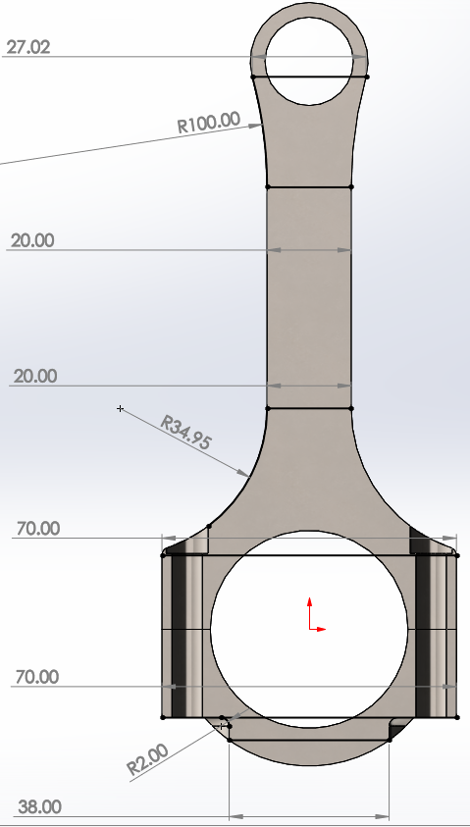
Figure 4: Diagram of cases considered for Connecting Rod Fatigue Analysis
As seen previously once the forces in both tension and compression have been calculated the “allowable” range and average mean can be calculated in the usual way. The values for these parameters are:
Table 8: Table of Range and Mean Stresses Seen in the Connecting Rod
Location | Allowable Range of Stresses | Mean Average Stress
Point A | 159.157N/mm² | -62.0192N/mm²
Point B | 194.342N/mm² | -70.014N/mm²
Point C | 40.115N/mm² | 20.057N/mm²
In contrast to the methodology shown in the Gudgeon Pin Case Study, the geometry at each “point” shows a stress raiser in the form of a “Shoulder Fillet”, this calls for a compensation factor in the form of a “stress concentration factor” which, through empirical experimentation, values can be approximated based on relationships of dimensions in the geometry itself.
For points A and B the method found in “Roark’s Formulas for Stress and Strain” (W Young, 1989) can be used, this method has the user meet a set of criteria before allowing the use of an interpolation technique to provide a Stress Concentration Value (Kt) based on existing datasets (Shown below Fig 5). Unfortunately, Point C did not meet the required criteria for this method and a much more rudimentary method had to be employed by the author to produce a Kt value using the graph shown below in Fig .
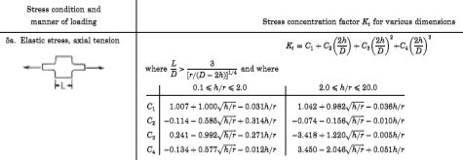
Figure 5: Roark's Interpolation method for Kt value estimation
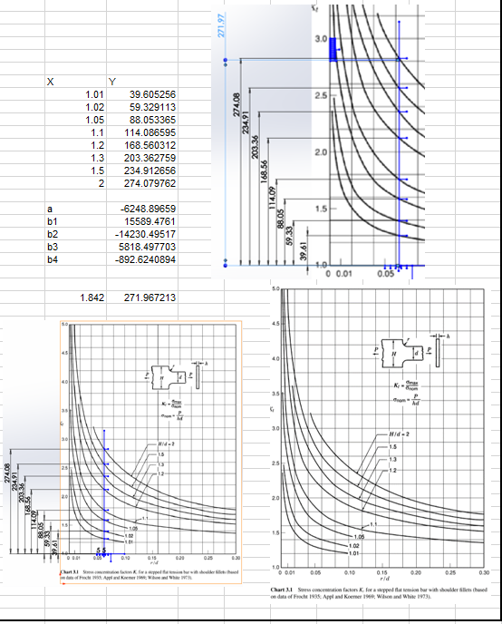
Figure 6: The authors interpolation method utilising SOLIDWORKS and Excel tools
Once stress compensation has been accounted for the “Goodman Diagram” process can begin again, unlike previously this material has an endurance limit provided, this means that to get the endurance limit used in the diagram the provided value must be divided by the Kt value for each respective “Point”.
Table 9: Table of Fatigue Analysis Values for Connecting Rod
Location | Stress Concentration Value | Endurance limit accounting for Kt | “Actual” range | Fatigue Safety Factor
Point A | 1.141 | 420.817N/mm² | 893.832N/mm² | 5.616
Point B | 1.278 | 375.562N/mm² | 803.712N/mm² | 4.136
Point C | 2.81 | 170.819N/mm² | 334.785N/mm² | 8.346

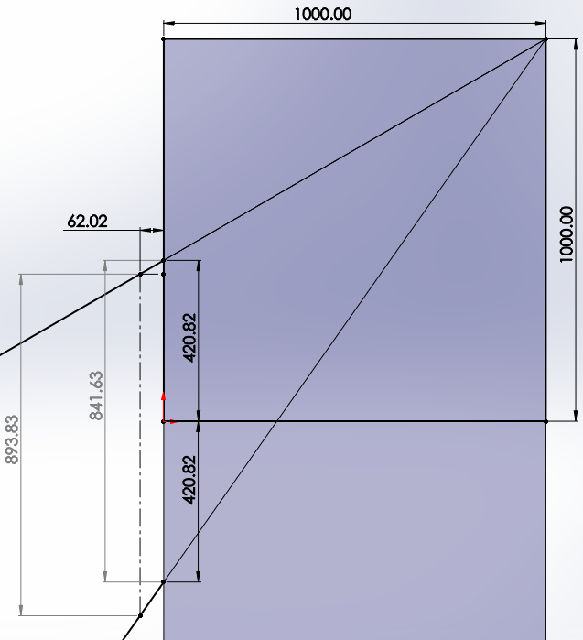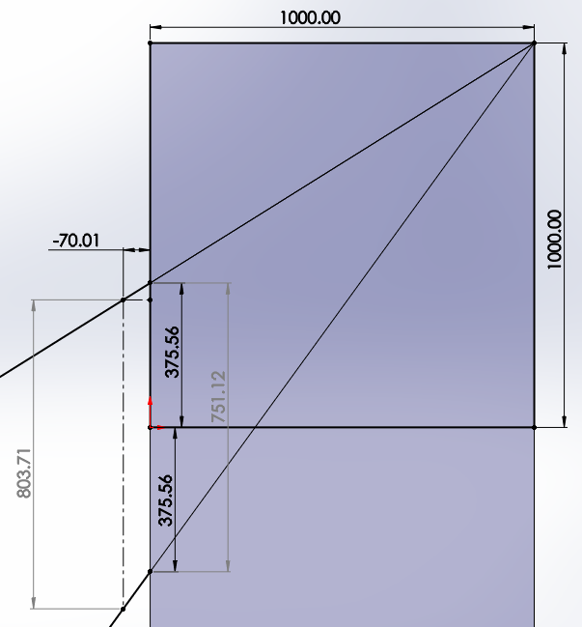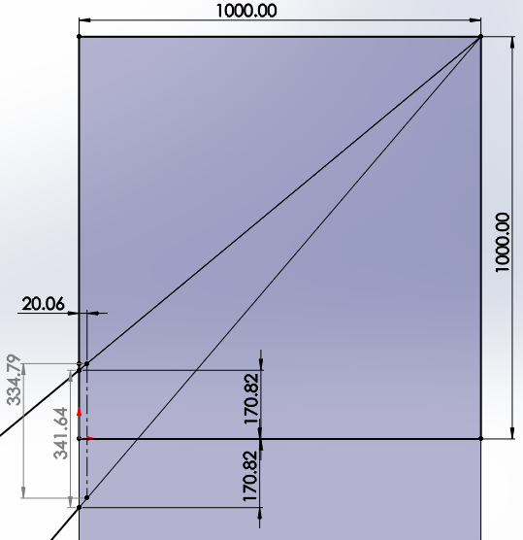
C
B
A
Figure 7: Goodman Diagrams for Point A, B & C

Connecting Rod Bolt Case Study
Table 10: Table of General Values related to the calculations undertaken in the Connecting Rod Bolt Case Study
Values Considered | Measurement or Calculation | Units
Angular Velocity seen @9000 RPM ($2π\frac{Engine Speed}{60})$ | 942.478 | rad/s
Seating Face Outer Diameter | 12.220 | mm
Seating Face Inner Diameter | 8.300 | mm
Average Seating Face Diameter | 10.260 | mm
Thread Diameter (Newman Tools Inc., 2009) | 7.940 | mm
Thread Core Diameter (Newman Tools Inc., 2009) | 6.773 | mm
Average Diameter of Threaded Section | 7.357 | mm
Area of bolt considered | 42.504 | mm
Thread Stress Concentration Factor (H F. Moore, 1934) | 2.150 | -
Bolt Head Stress Concentration Factor (Un-used) (Pilkey, 1997) | 2.147 | -

Table 11: Table of Material Specifications of the STANDARD Rod Bolt
Material Considered as AISI 4135 Steel Alloy | Values taken from MatWeb Datasheet (MatWeb, 2020) | Units
Ultimate Tensile Stress | 1100.000 | N/mm²
Polished Endurance Limit | 528.000 | N/mm²
Elastic Modulus | 205000.000 | N/mm²
Yield Point | 800.250 | N/mm²
Endurance Limit/UTS Ratio | 0.48 | -
Yield Point/UTS Ratio | 0.728 | -

Table 12: Table of Material Specifications for the MODIFIED Rod Bolt
Material Considered as AerMet 340 Steel/Titanium Alloy | Values taken from CarTech & MatWeb Datasheets (Carpenter Technology Corp., 2007) (MatWeb, 2020) (CarTech, 2007) | Units
Ultimate Tensile Stress | 2430.000 | N/mm²
Elastic Modulus | 192000.000 | N/mm²
Polished Endurance Limit | 986.000 | N/mm²
Yield Point | 2160.000 | N/mm²
Endurance Limit/UTS Ratio | 0.406 | -
Yield Point/UTS Ratio | 0.889 | -
For the purposes of this section the work will adhere to the guidance notes of the task showing the method of calculation and a comparison between the standard bolt design/material specification and the modified design/material specification chosen by the author.
Firstly, the ratio of stiffnesses between the Connecting Rod cap and the Bolt itself. This is done using the derivation of the stiffness found in Hooke’s Law: $Spring Rate of material=\frac{Youngs Modulus ×Cross-sectional Area}{Length}$
As the calculation being considered is a ratio like terms can be cancelled, in this particular case as the length of the considered material area is unknown it is disregarded leaving the equation:
$\frac{Ecap ×Acap}{Ebolt ×Abolt }$ Equation 1: Truncated Equation for determination of Cap-Bolt Stiffness Ratio
E denoting the Youngs Modulus (or Modulus of Elasticity) of the material in question and A denoting the cross-sectional area considered (taken by calculating the average diameter of the threaded section for the bolt in the case of the standard bolt, and by taking the thinnest cross section of the modified bolt).
The values returned for the standard and modified material are shown below:
Table 13: Comparison of Ratio of Stiffnesses bolt to cap
Material | Youngs Modulus | Cross Sectional Area | Ratio of Stiffnesses
AISI 4135 (Standard) | 205000N/mm² | 42.504mm² | 3.589
AerMet 340 (Modified) | 192000N/mm² | 15.711mm² | 6.882

As can be seen above the modified material has a vastly reduced Cross-sectional Area in comparison to the standard material, this is due to the need for the static axial loading (seen when tightening) needing to remain the same between the modified and standard designs as to not compromise the “roundness” value seen in the standard connecting rod using the standard bolting system. The calculations for this can be seen below:
Axial Stress can be calculated as 90% of the yield point of the material.
Axial Force therefore is the Axial Stress of the material multiplied by the smallest effective cross-section in the part, for the standard bolt that is in the threaded section, in the case of the modified bolt the axial force/stress value seen if the bolt is kept to the standard geometry will massively compromise the “roundness” due to the new materials superior properties, thus, a “waist” or reduction in diameter must be applied to achieve the same relationship.
Table 14: Table of comparison relating to Axial forces and stresses
Bolt Spec | Axial Stress | Axial Force | Cross Sectional Area
Standard | 720.225N/mm² | 30216.624N | 42.504mm²
Modified | 1944.000N/mm² | 30216.613N | 15.747mm²

Next the stiffness of the bolts in the considered “stretch region” must be considered, this can be described visually as the “uniform gradient” section of a stress/strain graph denoting the section of the materials deformation that is “obeying” Hooke’s Law $F=kx$ up to the elastic limit of the material (in an idealised case, in reality materials tend to disobey the law before their perceived elastic limit).
This calculation uses the full version of the derivation shown previously:
$k= \frac{E×A}{L}$ Equation 2: Full usage of derived equation from Hooke's Law
 | Standard | Modified
Stiffness | 250025.002Nmm | 128555.6512Nmm

Again, as can be seen above the modified material bolt exhibits strange results, this is due to the theory of springs in series, $Ktotal=\frac{1}{K1}+\frac{1}{K2}+\frac{1}{K3} etc.$this means that due to the “waisting” explained previously although the yield point of the material is well above the standard material due to the reduced area overall value of the “stretch” area stiffness is lower than the standard system.
Next the tightening torque required for the standard bolt will be considered, this is a simple force and friction problem with an axial component and a torsional component, using the axial force seen prior an estimation of the frictional force (opposing torsional input) at both the threads and the bolt head can be made by utilising coefficients of friction considering; the use of a Molybdenum Disulphide based assembly lubricant on the threads and a bright finished delivery state (lightly oiled) condition for the underside of the head. (AmesWeb, 2020)
Thread Friction Coefficient | 0.1
Head Friction Coefficient | 0.14
Frictional Force on threads | 3061.262N
Resisting Torque on threads | 11260.088Nmm
Frictional Torque on Head | 4285.767N
Resisting Torque on Head | 21985.986Nmm

This provides an overall tightening torque to overcome frictional resistance and meet 90% of yield of 33.246Nm
Once these parameters have been understood a “Goodman Diagram” style of tensile fatigue analysis can be undertaken as seen previously.
The values seen for this series of calculations have been shown overleaf:

Table 15: Fatigue analysis of the standard bolt at 6000RPM
Forces on Bolt STD @6k
Force seen by one bolt-cap area @ TDC Exhausting | 5589.364923 | N
Extra Force | 1231.42822 | N
Extra Stress | 28.97188429 | N/mm2
Min | 720.225 | N/mm2
Nom | 749.1968843 | N/mm2
Max | 778.1687686 | N/mm2
Range | 57.94376858 | N/mm2
Mean | 749.1968843 | N/mm2
Endurance Limit Accounting for Kt Value | 245.5813953
Allowable Range | 156.6376703
Safety Factor | 2.703270327
Static Safety Factor | 1.413575107
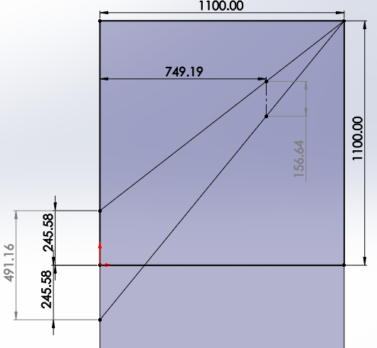
Figure 8: Goodman Diagram of standard bolt at 6000RPM

Table 17: Fatigue Analysis of the modified bolt at 6000RPM
Forces on Bolt Modified @6k
Force seen by one bolt-cap area @ TDC Exhausting | 5589.364923 | N
Extra Force | 709.0598422 | N
Extra Stress | 16.68209268 | N/mm2
Min | 1944 | N/mm2
Nom | 1960.682093 | N/mm2
Max | 1977.364185 | N/mm2
Range | 33.36418536 | N/mm2
Mean | 1960.682093 | N/mm2
Endurance Limit Accounting for Kt Value | 458.6046512
Allowable Range | 177.1451647
Safety Factor | 5.309440732
Static Safety Factor | 1.228908674
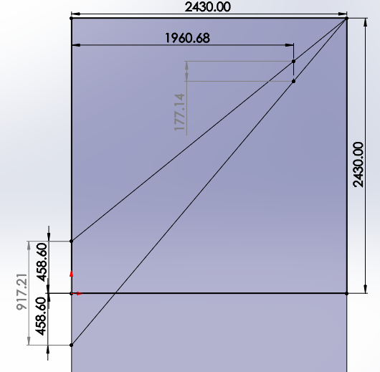
Figure 9: Goodman Diagram of Modified bolt at 6000RPM

This case then was repeated for a case at 9000RPM to simulate a “race” version of the same engine, values shown below:
Table 18: Fatigue Analysis of the standard bolt at 9000RPM
Forces on Bolt STD@9k
Force seen by one bolt-cap area @ TDC Exhausting | 26637.16657 | N
Extra Force | 5868.602082 | N
Extra Stress | 138.0709469 | N/mm2
Min | 720.225 | N/mm2
Nom | 858.2959469 | N/mm2
Max | 996.3668939 | N/mm2
Range | 276.1418939 | N/mm2
Mean | 858.2959469 | N/mm2
Endurance Limit Accounting for Kt Value | 245.5813953
Allowable Range | 107.9236702
Fatigue Safety Factor | 0.390826863
Static Safety Factor | 1.104010989
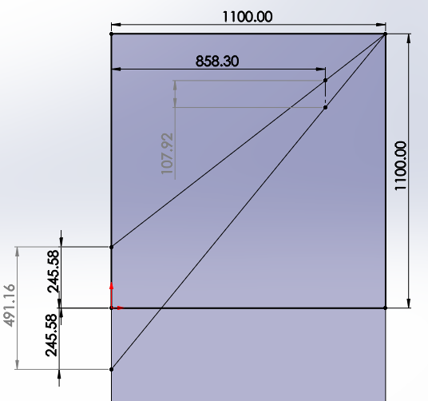
Figure 10: Goodman Diagram of Standard Bolt at 9000RPM

Table 19: Fatigue analysis of the modified bolt at 9000RPM
Forces on Bolt Modified @9k
Force seen by one bolt-cap area @ TDC Exhausting | 26637.16657 | N
Extra Force | 3379.15763 | N
Extra Stress | 79.50164064 | N/mm2
Min | 1944 | N/mm2
Nom | 2023.501641 | N/mm2
Max | 2103.003281 | N/mm2
Range | 159.0032813 | N/mm2
Mean | 2023.501641 | N/mm2
Endurance Limit Accounting for Kt Value | 458.6046512
Allowable Range | 153.4337764
Fatigue Safety Factor | 0.96497239
Static Safety Factor | 1.155490351
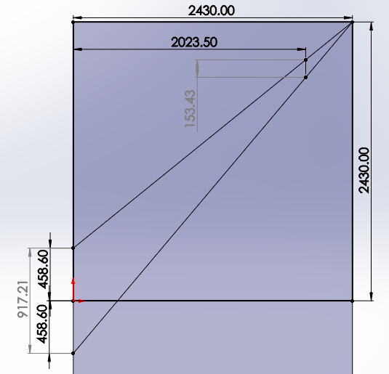
Figure 11: Goodman Diagram of Modified Bolt at 9000RPM

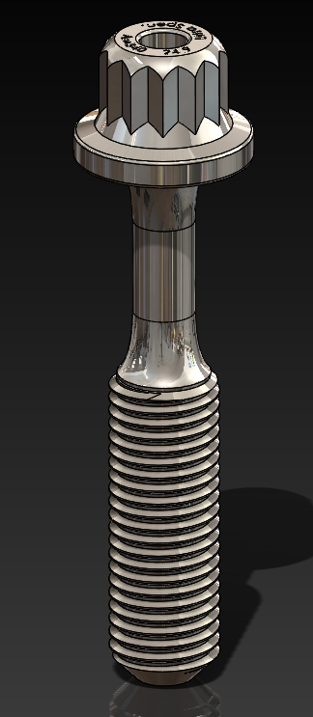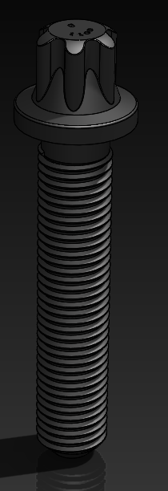
Figure 12:Comparison between Standard and Modified Bolts
A comparison of the standard and modified bolt designs can be seen above with the waisted geometry and filleted transitions seen on the modified bolt to the left. The profile used of these fillets is based off a construction of special fillets design shown in the Peterson’s book carried out by Grodzinski (1941), the theory of special radius fillets of this kind stems from the work by Baud on the laminar frictionless flow of liquid through an opening dictating that the liquid at the boundary of this phenomena has a constant velocity and thus reason dictates that fillet of the same boundary may posses a contour of constant stress for members in tension. Essentially saying that there are no appreciable stress concentrations seen in a fillet of this streamline form. To this end the stress concentrations considered for the modified bolt have been taken about the threads as with the standard bolt
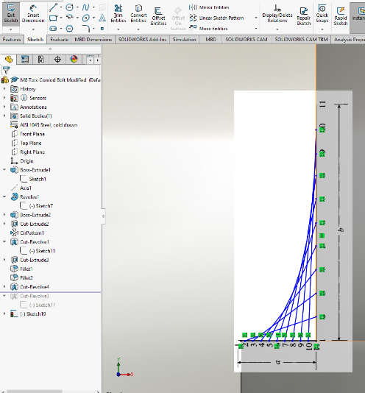
Figure 13: Application of Grodzinskis Template for Streamline fillets and the template as seen below
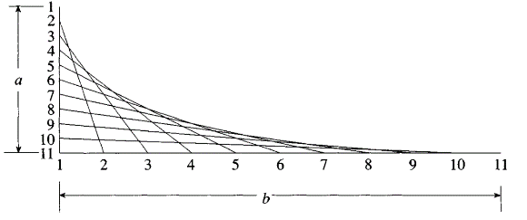

Crankshaft Case Study
Table 20: Table of General Values used in the Calculation of the Crankshaft Case Study
Values Considered | Measurement or Calculation | Units
Main Bearing Journal Diameter | 47.989 | mm
Main Bearing Journal Length | 16.002 | mm
Connecting Rod Journal Diameter | 44.200 | mm
Depth of Fillet Undercut | 0.500 | mm
Radius of Crankpin Fillet | 1.500 | mm
Distance Point A → Point B | 22.640 | mm
Distance Point A → Centre of Main Bearing Journal | 12.050 | mm
Distance Point B → Centre of Main Bearing Journal | 32.500 | mm
Main Bearing Contact Area | 767.680 | mm
Stress Concentration Factor @ Fillet Undercut | 2 | -
Table 21: Table of Material values relating to the Crankshaft Case Study
Material Considered as Ductile Cast Iron | Values taken from Report on Crankshaft Fatigue Performance (J Williams, 2007) | Units
Ultimate Tensile Stress | 658.000 | N/mm²
Elastic Modulus | 178000.000 | N/mm²
Polished Endurance Limit | 263.000 | N/mm²
Yield Point | 412.000 | N/mm²
Once again as the basic methodology has been explained prior what follows is an overview of key points during the fatigue analysis of the crankshaft.
Firstly, the force seen at each bearing surface of the main bearings must be established during Firing and Exhausting, this is done by dividing the Net Force evenly between the two bearings supporting each instance of the crankshaft. Force on Bearings during Firing = -17562.180N and 5586.179N when Exhausting. These values can then be equivalated to a “pressure” mathematically distributing them over the bearing area. Pressure at Firing on a single Main Bearing = -22.877N/mm² and 7.277 at Exhausting
As seen with the Gudgeon Pin Case Study the Crankshaft is a bending scenario and thus must consider moments about a point and a combination stress. For the calculation of moments two distances must be considered; the dimension from the “Point A” fillet/undercut to the centre of the main bearing journal and the dimension from the “Point B” fillet/undercut to the centre of the main bearing journal.
Bending Moment @ A Firing | Bending Moment @ B Firing | Bending Moment @ A Exhausting | Bending Moment @ B Exhausting
-211624.300Nmm | -570771.000Nmm | 67313.460Nmm | 181550.800Nmm

Once the bending moments have been considered the Bending and Shear Stresses seen at B can be considered in the manner as seen previously (Gudgeon Pin Case Study) accounting for second moment of area (44571.241mm⁴) calculated using the “effective beam length” (calculated by taking a mean average of the Crank Journal and the Connecting Rod Journal diameters) (46.09mm).
The values obtained can be seen below:
Table 22: Table of Stresses seen at Firing and Exhausting
Event Considered | Bending | Shear | Resultant
Firing | -144.962N/mm² | -21.170N/mm² | 151.019N/mm²(max)
Exhausting | 46.109N/mm² | 6.734N/mm² | 48.036N/mm²(min)

Now considering an assumed Kt value of 3.5 (an approximation based on data found in “Peterson’s”) the usual “Goodman Diagram” process can be carried out:
Table 23: Table of "Goodman" Diagram Stresses and FSF
Endurance limit (after Kt) | Allowable Range | Mean Stress | Actual Range | Fatigue Safety Factor
75.143N/mm² | 102.983N/mm² | 99.527N/mm² | 127.554N/mm² | 1.239

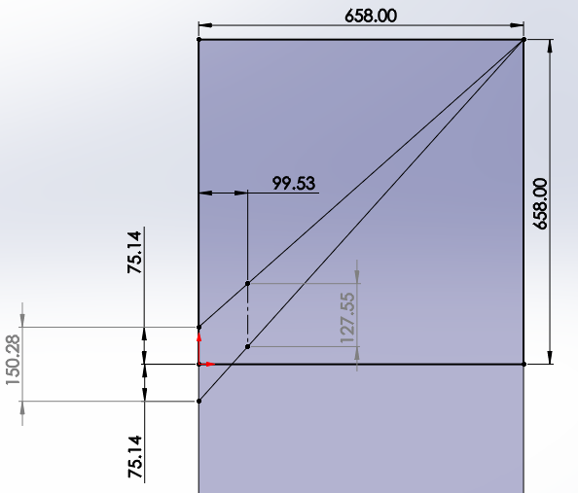
Figure 14: Goodman Diagram for the Crankshaft Case Study

References
AmesWeb, 2020. Friction Coefficient Guide Values for different materials aqnd lubrication ststes in bolted connections. [Online]
Available at: https://amesweb.info/Screws/Tables/Friction-Coefficient-Values-Bolted-Joints.aspx
[Accessed Feburary 2020].
Bolton, W., 1990. Torque and Work Done. In: Engineering Science. Abingdon: Elsevier, pp. 76-77.
Carpenter Technology Corp., 2007. Ultra-High Strength Steels VS Titanium Alloys. Advanced Materials & Processes, November, pp. 37-40.
CarTech, 2007. CarTech AerMet 340 Alloy Technical Datasheet. s.l.:Carpenter Technology Corporation.
Engineering Toolbox, 2011. Steels - Endurance Limits and Fatigue Stress. [Online]
Available at: https://www.engineeringtoolbox.com/steel-endurance-limit-d_1781.html
[Accessed 28 January 2020].
H F. Moore, P. E. H., 1934. THE STRENGTH OF SCREW THREADS UNDER REPEATED TENSION. University of Illinois Bulletin, 13 March, pp. 11-14.
Heisler, H., 1995. Engine Balance and Vibration. In: Advanced engine technology. London: Elsevier, pp. 79-85.
J Williams, A. F., 2007. Fatigue Performance of Forged Steel and Ductile Cast Iron Crankshafts, Toledo: SAE International.
Macdonald, M., 2019. Lectures on Modelling In-cylinder forces on Connecting Rods and Reciprocating Assembly [Interview] (October 2019).
MatWeb, 2020. AISI 4135 Datasheet. [Online]
Available at: http://www.matweb.com/search/datasheet.aspx?matguid=58c8ecbfbbb74e208ef745ab062e47a2&ckck=1
[Accessed January 2020].
MatWeb, 2020. Carpenter AerMet 340 Datasheet. [Online]
Available at: http://www.matweb.com/search/datasheet.aspx?matguid=64583c8ce6724989a11e1ef598d3273d&ckck=1
[Accessed January 2020].
Newman Tools Inc., 2009. Thread Data - Metric Fine -- Fine Pitch -- M(1mm-28mm). [Online]
Available at: https://www.newmantools.com/tech/threadmf.htm
[Accessed January 2020].
Pilkey, W. D., 1997. Stress Concentration Factor in Tension (Axial Loading). In: Petersons Stress Concentration Factors. s.l.:John Wiley & Sons Inc, pp. 137-143,156.
Smiths Metals Centres, 2018. EN19 Technical Datasheet. s.l.:Smiths Metals Centres.
W Young, R. B., 1989. Stress Concentrations. In: Roark's Formulas for Stress and Strain. s.l.:McGraw-Hill, pp. 771-799.

For Firing the forces are combined as the event occurs after TDC when the forces are both applied downwards on the pin, in the Exhausting case (seen during the “dwell” or the few degrees of crank rotation where the piston undergoes the least movement in the vertical plane during transition from BTDC to ATDC) the event occurs just prior to TDC where the force exerted by gas pressure is opposing the inertial force.
The sign notation for these values (and subsequent sections of stresses) indicate the condition the forces put “Point A” into, in the case of the Firing event point A is put into TENSION due to its downward bending moment and therefore is considered a positive value, the reverse is true of COMPRESSION at the Exhausting event.

