

Postgraduate/Distance Learning
Assignment coversheet & feedback form

THIS SHEET MUST BE THE FIRST PAGE OF THE ASSIGNMENT YOU ARE SUBMITTING (DO NOT SEND AS A SEPARATE FILE)

For completion by the student:
Student Name: Maria Meier

Student University Email: 2309714@uwtsd.ac.uk
Module code: HPCA7015  Module title: Foundations in Cultural Astronomy and Astrology | Student ID number:  2309714 |  |  | Educational support needs:  Yes/No
Assignment title: Essay Comparing and Contrasting Two Sky Myths

Assignment due date: 4 January, 2024
This assignment is for the 1st X 2nd 3rd 4th 5th 6th module of the degree
I confirm that this is my original work and that I have adhered to the University policy on plagiarism.
Signed ……………………………………………………………
Email submission: if you are submitting this form via email, please tick this box X
(as a substitute for your signature) to confirm that you agree to the above declaration.
Assignment Mark
1st Marker’s Provisional mark
2nd Marker’s/Moderator’s provisional mark
External Examiner’s mark (if relevant)
Final Mark

NB. All marks are provisional until confirmed by the Final Examination Board.

For completion by Marker 1 :
Comments:

Marker’s signature: |  |  | Date:
For completion by Marker 2/Moderator:

Comments:

Marker’s Signature: |  | Date:
External Examiner’s comments (if relevant)

External Examiner’s Signature: |  | Date:

Maria Meier 2309714 Page 1 of 9

Essay Comparing and Contrasting Two Sky Myths from Two Different Cultures:
From East to West and Many to One - An Examination of the Ten Suns Myth of China
and the Aztec Fifth Sun Myth
Word Count: 3580
This essay delves into the exploration of two sun myths: the Chinese myth of the Ten Suns and the Aztec Myth of the Fifth Sun, drawing comparisons and contrasts between them. The primary focus is on analyzing these myths through the lens of structuralist theory, a framework introduced by Lévi-Strauss. This approach aims to unveil common elements in stories originating from diverse cultures. To facilitate a comprehensive examination of the myths, the essay employs three fundamental questions, as suggested by Robert A. Segal, to frame specific aspects and complement the structural theory of Lévi-Strauss. Segal contends that these questions, among others, offer valuable insights into myth analysis. The specific inquiries addressed are the myth's origin, its subject matter, and its function. By utilizing Segal's framework, this essay seeks to navigate the inherent challenges of understanding the complete cultural context surrounding these myths.
A Theory of Myth
Attempting to describe myth, the American humanistic psychologist, Rollo May, used the analogy of 'beams in a house' to illustrate his point. He explained that these beams, though not exposed to outside view, form the structural foundation holding the house together for people to inhabit. This notion of applying structuralism to myth was first proposed by Lévi-Strauss, who argued for the existence of universal mental structures beneath the diverse surface of myths from different cultures. According to him, the focus should not be on individual myth components but on the 'way the elements are combined,' emphasizing structural analysis applicable to both collective traditions and individual-authored works. Lévi-Strauss's structuralist approach aimed at identifying underlying binary oppositions and structural patterns common to myths across societies seeking to uncover deep structures of human thought and cognition influencing cultural expressions like myths. He acknowledged that there may seem to be a paradox one is faced with when examining myths, proposing that if one studies the elements a myth is contingent on - the culture, environment, timeframe - then how does one account for common elements that exist in myths from vastly different parts of the world? It is through this that he analyzes universal patterns and structures underlying global mythologies that Lévi-Strauss answers this question. As illustrated in this essay which looks at myths from the Shang culture of China and the Aztecs of Mexico, a structuralist approach can identify common patterns from these disparate regions and cultures. While Segal embraces the notion of structure, he seeks to create a framework through the questions he puts forward as a means of contextualizing the myths at a personal level and how they may contribute to a sense of identity. Despite differences in emphasis and methodology, both scholars seek to understand the underlying structures and meanings of myths. Segal's psychological approach and Lévi-Strauss's structuralist perspective address different aspects of the complex phenomenon of myth. While Segal doesn't strictly adhere to a set of questions for analyzing myths, his work often involves examining key aspects, including origin, subject matter, and function. He explores how myths come into existence, their content and themes, and their purpose and function within a society. Segal investigates the sources, influences, and cultural contexts contributing to myth creation, the symbolic elements within myths, and

Maria Meier 2309714 Page 2 of 9
the multiple functions they serve. In essence, Lévi-Strauss's structuralist approach and Segal's inquiries collectively contribute to a comprehensive understanding of myths, addressing both their universal structures and their psychological, cultural, and functional dimensions. To understand the myths more fully, this essay utilizes these questions to enhance the understanding of what could otherwise be an abstract examination of myth that could lose the nuance of the myth.
The origin, subject and function of the Chinese myth of the Ten Suns
Segal's questions about the origin, subject matter, and function add context for the examination of myth, while at the same highlighting how modern interpretation and understanding may be limited by that which is lost to history. The setting of the Ten Myths comes from a culture that had or was developing what Campion describes as one of the three major technically complex and philosophically sophisticated astrological systems. While for the Chinese, their sophisticated astrology became an official function of the state, it could be expected that myths and myths addressing celestial events existed to provide explanations and guidance beyond the formal process of the ruling class. As is common with ancient texts, nuances and original meanings may be obscured by the passage of time. However, certain themes exhibit clarity and consistency, supporting a structural theory for interpretation. In the case of the Chinese myth of the Ten Suns, Sarah Allan notes that few Chinese texts predate the fifth or sixth centuries B.C. She suggests that the explanation for this myth may be rooted in Chinese religious beliefs. In the Chinese worldview, gods, ancestors, and ghosts were perceived as spirits of deceased individuals who had inhabited specific places and times. Unlike many other cultures, where myths often depict human interactions with deities, Chinese mythology emphasizes ritual offerings to appease these spirits. Historical records link the myth of multiple suns to the Shang Dynasty, which thrived in China during the first millennium BCE. While neither Lévi-Strauss nor Segal addresses this issue in their discussion of myth theory, myth, like culture, is not immune to the political realities of society. As the Zhou conquered the Shang, solar beliefs shifted. As Alan explained, 'the Zhou's belief in a singular sun, led to a reinterpretation of the myth, and while the original meaning was lost, the motifs persisted in different contexts. At a popular level, the belief in ten suns rising sequentially from the Mulberry Tree endured, even as the belief in ten suns had waned. Besides an instructional tool for explaining the
The Myth of the Ten Suns

The following synopsis of the Chinese myth is derived from a direct translation by Allan. In addition to adding some historical context, she provides the Chinese language glyphs for certain passages explaining why chose certain words.

According to the ancient book, the Shan hai Jing (which can be translated as 'Classic of Mountains and Sea' ) the following story is told:

Maria Meier 2309714 Page 3 of 9
'Above the Tang Valley is the Fu Sang (mulberry tree) and a pool wherein the ten suns bathe.
In the swirling water is a great tree. Nine suns dwell on its lower branches; one sun on its uppermost branch. When one sun reaches the tree, another sun goes out; all of them carried by birds.’

The ten suns were said to be the sons of the Heavenly Emperor Degen who also had twelve daughter moons. But as time went by the suns grew restless and curious. One day the ten suns decided to appear in the sky all at once as dawn broke, nearly burning the world to ashes. This caused the death of many creatures and rivers and lakes dried up the few surviving humans and animals were thrown into chaos searching desperately for shelter and water in the extreme heat.

Heeding the people's plea Degen granted the god, Ye the Archer, a bow and arrows, who one by one, shot each sun from the sky. As the suns fell, they transformed into a golden three-legged bird before crashing to the Earth Yao (the wife of Degen) pleaded for the last sun to be spared. Fearing Ye, the sun obediently rose from the east and set in the west every day warming the Earth and nurturing life.

Structuralism in the Ten Suns Myth

As introduced earlier in this essay, the work of Lévi-Strauss led to his theory of structuralism which he then applied to examinations of myth. Part of his theory proposes that certain patterns and structures exist within those stories that can be called myths regardless of the particulars of their cultural setting. When examining the Ten Suns myth using this framework certain themes can be identified such as order from chaos, balancing the forces of life and death or destruction, and the need for obedience to the process. Additionally, the themes of the elements are foundational to this story, specifically fire and water which also manifest as the sun and moon, light and dark. This binary force is a main aspect of Lévi-Strauss' theory as he speaks to a common theme of opposites balancing each other that can be found in myths throughout the world. The overarching theme of the myth, which could be described as creating order out of chaos, is itself a binary element. When the ten suns break the ordered process of when they can rise into the sky and all appear at once, destruction ensues both for the people on earth as well as for themselves, with the exception of the one who is allowed to remain, again to ensure that the balance can exist.
The archer Ye is an example of a hero figure who also illustrates a figure that is a blur between humans and deities. As is seen in other mythical pantheons, the gods perform very human-like functions, but there is also a hierarchy amongst them. In this case, the Heavenly Emperor Degen gives the assignment of restoring order to Ye, who is described as a god. It is through this heavenly intervention that transformation comes about which can be viewed as another form of the structures Lévi-Strauss ascribes to myth. That deified intervention is necessary to keep structured order in the world and ensure humans' existence.
The questions posed by Segal and addressed previously are useful for setting context, especially in light of modern understanding of history, culture, and ongoing academic discoveries, they also show the difficulty in examining ancient myth devoid of a truly comprehensive understanding of its original setting. The translator of the Ten Suns myth, Allan, argues this point by saying that myths 'exist within a social and intellectual structure, outside which they appear as irrational or incomprehensible,' going on to say that ' myths are not isolated phenomena,'7 and, thus, whatever theory is used, a message of the need for an orderly world seems to be the dominate theme.

Maria Meier 2309714 Page 4 of 9

The context of the Fifth Sun myth - addressing its origin, subject matter and function

The Mexica people, who were to become known as the Aztec, were relative newcomers to the Valley of Mexico, arriving, as Leon-Portillo explains, to sometime in the mid-thirteenth century. There they found already existing flourishing city-states but were rebuffed in their attempts to settle in them. Eventually, through force, they would build their own empire and it is reasonable to assume that they incorporated and adapted others' stories and myths. The sources that today provide the origins of modern understanding of this culture and its cosmology are drawn from codices that record the flourishing of the Aztec Empire up to the time of conquest by the Spaniards in 1521.
One of the greatest challenges for an academic examination of the myth and culture of the early Americas is the lack of primary sources. In Mexico, where complex written documents existed, the systematic destruction of these cultural records occurred within the first decade of colonisation. As Campion states, 'source problems are also considerable.' What does exist is believed to have been reconstructed under the eye of the Catholic Church.
The Aztecs believed in a cyclical view of time, where the world goes through a series of ages described as suns that were associated with a specific deity and a particular element. The myth examined in this essay, the Fifth Sun, serves as a record of Aztec cosmology recording the birth and destruction of the world. It further prescribes the obligation of humans in the form of offering sacrifice that is required to maintain order in the universe. Finally, the myth can be seen as a nationalistic statement, reinforcing the history and role of the Aztec Empire by establishing its connections to the gods.

The Aztec Myth of the Fifth Sun

The following is a direct English translation of the Nahuatl language codex, Chimalpopoca, which is considered to be a transcription of earlier pictograph records of Aztec (Mexica) cosmology including the following myth of the Fifth Sun.

‘Here are the wisdom tales made long ago, of how the earth was established, how everything was established, how whatever is known started, how all the suns that there were began.

It is said that life had been created four times. So the old ones knew that in the fifth age, in the time of
1 Rabbit, earth, and sky were established, and they knew that when earth and sky were established, people had existed four times. So they knew how each of the suns had been.'
At the end of the fourth sun, the gods gathered to decide who had to sacrifice themself for the new world to begin, but none of the most important gods wanted to jump into the flames. The rich and proud god Tecuciztecatl hesitated, and during that hesitation, the humble and poor Nanahuatzin leaped into the flames and became the new sun.
Tecuciztecatl jumped in after him to become a second sun. However, the gods realized that two suns would overwhelm the world, so they threw a rabbit at Tecuciztecal and he became the moon. The two

Maria Meier 2309714 Page 5 of 9
celestial bodies were set in motion by Ehecatl, the god of the wind, who fiercely and violently blew the sun into motion.
'Thus it was that as the Sun was falling into the Earth again, the Moon arose from the ashes into which He had fallen. They detained Him and dressed Him in rags. He who would have been the Sun, who would have been clothed in splendor. The Earth and all its inhabitants were filled with tonalli, with energy and warmth. Night and day, cold and heat, and the eternal cycles of time and the seasons came into being, and the deaths of the Teteo (god/divine one) established the covenant of sacrifice with humanity.'
The Fifth Sun within the Structuralist Definition of Myth

The well-established myths that define their cosmology can be examined by applying Lévi-Strauss' theory of structuralism, in two regards. Firstly, as addressed in the previous discussion of the Ten Suns myth, one of the principal arguments of Lévi-Strauss' structuralism theory is that elements or themes within myth are not limited or confined by culture, but rather they can be found universally. He describes the 'operative value of myth,' as being related to its 'specific pattern.'
The Fifth Sun myth follows this model as pointed out by Campion when he describes Aztec cosmology as utilizing such a pattern; in this case, it is one of 'fourness written into the pattern of existence.' going on to note, is a pattern found in other distinct and distant cultures including Greek, Indian, and Mesopotamian.' The distinction of the Fifth Sun myth is that the Aztecs built on to the existing structure by adding a new dimension, the Fifth. This, according to the myth, symbolized the current era and was to be uniquely identified with them and their reign.
Once again, another point of similarity with the Chinese myth is another of Lévi-Straus's tenets that can be clearly identified in this Fifth Sun myth - the existence of binary oppositions. While more recent though in this area may question the limitations of binary thinking, it does apply in this case throughout the myth as a way for forces to counterbalance each other. The repeating cycles of the previous four suns representing birth and destruction is an example of these binary forces he ascribes to myth. Even the primary Aztec god, Quetzalcoatl, the winged serpent is an embodiment of this dualistic vision of existence. Even using Segal's questions to put a more nuanced context of the myth, the Aztec Myth of the Fifth Sun exemplifies the theory of structuralism in myth.

Common Themes and Differences in the Myths

The most obvious common theme of the two myths examined is the central role of multiple suns in each with them existing simultaneously in the Chinese myth, and in the Aztec myth, they appear in a successive order to indicate different eras or times. The sun as a central god figure with either male or female qualities is found in many parts of the world. However, the appearance of multiple suns may have an astronomical tie per a theory proposed by Peter Metevelis. He suggests that 'archaic multiple suns myths recounted how primal people once suffered having a sudden abundance of suns in the sky, parching or combusting the land.' He connects this to the annual conjunction of the star, Sirius, whose name could be interpreted as 'scorching' and the sun, noting that two thousand years ago the conjunction

Maria Meier 2309714 Page 6 of 9

happened closer to the date of the summer solstice than it does now and that this would be more pronounced at more southern latitudes.
As discussed previously in the context of Lévi-Strauss' contention that myth must include binary opposition and examples of these are found throughout in the forms of chaos and order, birth and destruction, even sun and moon throughout these myths. And while these binary forces have very real impacts on humans, in both cases, there is the destruction of human life, they do not play a central role in the myths. The gods in their own ordered universe assume human-like qualities and actions including producing offspring.
The differences in the two myths may lie in how they deal with the concept of time. In the Chinese myth, once order is restored in a world of only one sun, the implication is that time continues infinitely. By contrast, the Aztec myth is very specific about endings and beginnings - eras and time frames. They use such specific numbers, that the Codex Chimalpopoca assigns years according to the modern calendar to indicate which period of history the story is likely referring to. Although not a topic addressed within the study of myth theory, it must be noted that myth is not created in nor exists in a sanitary vacuum but is a reflection of the politics of the society.
As mentioned in the analysis of the Ten Suns, Allan states that the original myth of multiple suns evolved from ten (and sometimes six) to one with the change of the ruling dynasty. Since order was restored under one sun, there may be no need or desire to develop a narrative that this time would end. In a very different setting, also addressed previously, the Aztecs were a new conquering empire. A central story that was specific about previous eras ending, might be seen as necessary to legitimize their rule. Also included in the Aztec myth but not the Chinese is the call for sacrifice on the part of humans, which can be interpreted both literally and metaphorically.

Conclusion

Lévi-Strauss provided one additional element of a myth's structure that was not yet addressed in this essay but applies in both cases. He stated that myth always refers to events alleged to have taken place in a time before the world was created, or during its first stages creating a distance or sense of the unknown between the events in the myth and the everyday life of the people hearing the story. The opening lines of the myths cited do just that:
' According to the ancient book'
‘Here are the wisdom tales made long ago'

The paradox of course is that myth, while it may be developed around a distant unachievable place and time, very much relates to everyday lives. It is hard to see how else, these and so many other tales continue in some form to be told. Brought to the present day, we understand that 'once upon a time' will likely impart a values-based lesson, and even if the story takes place 'a long time ago, in a galaxy far, far away,' the pattern of struggle and victory over adversity is meant to inspire our much more mundane lives.
One of the great challenges of determining and applying myth theory is that any analysis requires a fixed set of data to draw on as well as an agreed upon set of definitions and criteria. That, in turn, assumes the myths are static objects. Ongoing research, especially in regions of the world and in cultures that have not been studied as fully as others, regularly yields new insight and understanding that cultures, even those that the philosopher, Lévy-Bruhl, may have labeled as primitive continue to evolve their

Maria Meier 2309714 Page 7 of 9

cultures, and with them their myths. While not an element of existing myth theory, perhaps the adaptability of a story to still have resonance after millennia should be included as a criterion for identifying myth.

Maria Meier 2309714 Page 8 of 9

Illustrations of the two myths cited adapted for contemporary use

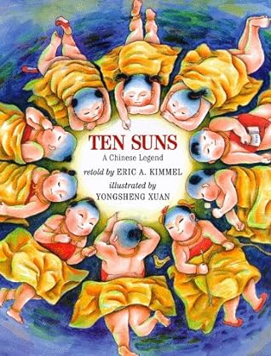
Figure 1: The cover of Ten Suns, an English-
language adaptation of the Chinese myth written for children.
Published 1998.

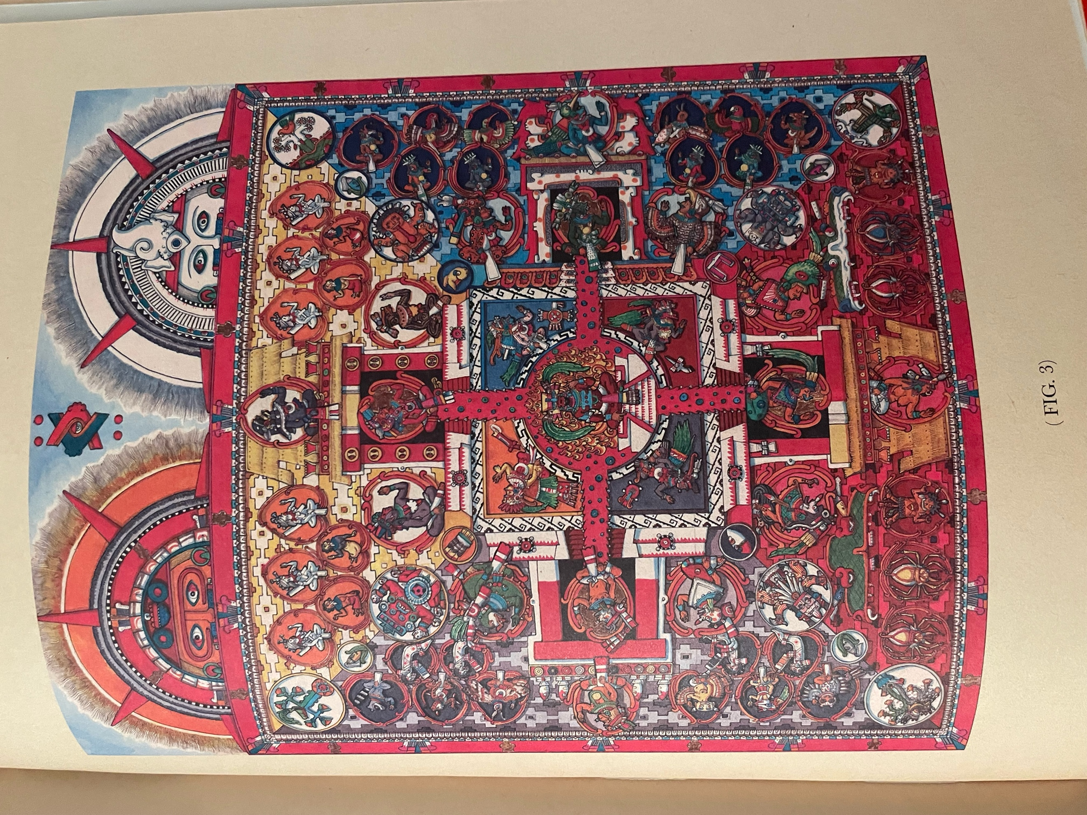
Figure 2: an illustration from the graphic book, The Birth of the Fifth Sun,
a retelling of the Aztec myth with trilingual (Nahuatl, Spanish and English)
captions by Mexican-American writer and artist
Chicome Amatlapalli. Published 2023.

Maria Meier 2309714 Page 9 of 9

Bibliography

Allan, Sarah, "Son of Suns: Myth and Totemism in Early China." Bulletin of the School of Oriental and African Studies, University of London, 1981, Vol. 44 No. 2 (1981), pp. 290-326. https://www.jstor.org/stable/616397

Amatlapalli, Chicome Itzcuintli, Inic Maculli Tonatiuh Itlacatiliz/El Nacimiento del Quinto Sol/The Birth of the Fifth Sun (Mexico City: Papalota Negra, 2023).

Aveni, Anthony, Conversing with the Planets: How Science and Myth Invented the Cosmos (Boulder: The University Press of Colorado, 2002).

Campion, Nicholas, Astrology and Cosmology in the World's Religions (New York and London: New York University Press, 2012).

History and Mythology of the Aztecs: The Codex Chimalpopoca, tr. by John Bierhorst (Tucson: University of Arizona Press, 1992).

Lévi-Strauss, Claude, "The Structural Study of Myth." The Journal of American Folklore, Oct. - Dec., 1955, Vol 68, No. 270, Myth: A Symposium (Oct. - Dec., 1955), pp. 428-444.
https://jstor.org/stable/536768.

Lévi-Strauss, Claude, "Structuralism and Myth." The Kenyon Review, Spring 1981, New Series, Vol. 3, No. 2 (Spring, 1981), pp. 64-88.
https://www.jstor.org/stable.4335186.

Metevelis, Peter, “The Dog Star and the Multiple Suns Motif: An Asian Contribution to European Mythology.” Asian Folklore Studies, 2005, Vol. 64, No. 1 (2005), pp. 133-137. https://www.jstor.org/stable/30030361.

Segal, Robert A., "Commentary on Mills' 'toward a theory of myth'." Journal for The Theory of Social Behaviour, 2020, Vol. 50, Issue 4 (2020), pp. 425-428.
https://doi.org/10.1111/jtsb.12256.

Taube, Karl, Aztec and Maya Myths (Austin: University of Texas Press, 1993).

Claude Lévi-Strauss, "The Structural Study of Myth." The Journal of American Folklore, Oct. - Dec., 1955, Vol 68, No. 270, Myth: A Symposium (Oct. - Dec., 1955), https://jstor.org/stable/536768, p. 430.
Lévi-Strauss, p 429.
Nicholas Campion, Astrology and Cosmology in the World's Religions (New York and London: New York University Press, 2012), p. 94.
Sarah Allan, "Son of Suns: Myth and Totemism in Early China." Bulletin of the School of Oriental and African Studies, University of London, 1981, Vol. 44 No. 2 (1981), https://www.jstor.org/stable/616397, pp. 290.
Allan, p. 293.
Sarah Allan, p. 293
Sarah Allan, p. 294
The Codex Chimalpopoca, tr. by John Bierhorst (Tucson: University of Arizona Press, 1992), p. 1.
Campion, p. 56
Chimalpopoca, p. 142, 75:1.
Karle Taube, Aztec and Maya Myths (Austin: University of Texas Press, 1993), p. 13.
Chicome Itzcuintli Amatlapalli, The Birth of the Fifth Sun (Mexico City: Papalota Negra, 2023), p. 60.
Lévi-Strauss, p 429.
Campion p. 94.
Peter Metevelis, “The Dog Star and the Multiple Suns Motif: An Asian Contribution to European Mythology.” Asian Folklore Studies, 2005, Vol. 64, No. 1 (2005), https://www.jstor.org/stable/30030361, pp. 134-135.
Allan, p. 135.
Lévi-Strauss, p 430.

