Reshaping the Strategic Direction of Nike by Delivering Innovative Customer Care

Module: Strategic Management (BMMB7013)
Course: Master of Business Administration

Report By: Syed Asad Husain Zaidi (2213561)
Lecturers: Gareth Hughes and Arpu Kumar

Table of Contents

1. Executive Summary 1
2. Introduction 2
2.1. Report Remit 2
2.2. Background of the Organization 2
2.3. Definition of Major Concepts and the Strategy of Nike 4
3. Main Findings - Nike’s Strategic Analysis (External & Internal) 6
3.1. External Analysis 6
3.2. Internal Analysis 16
3.3. Wider Implications of the proposed strategies on different areas of Nike 16
4. Strategic options for Personalized Customer Care – Conclusions from Analysis 17
5. Conclusions & Recommendations 18
6. References 20

List of Figures
Figure 1: Nike Business Infographics; Source: Business Strategy Hub 3
Figure 2: Business Strategy Model Canvas of Nike (Pereira, 2023) 4
Figure 3: Nike's Cost Structure (Shastri, 2021) 5
Figure 4: Nike's Income Statements (Source: Nike Annual Report 2021) 5
Figure 5: Nike Vs Major Retailers (Salpini, 2021) Source: Retail Dive 6
Figure 6: Distribution of Nike's sale worldwide (Source: Statista 2023) 14

Executive Summary
This business report critically evaluates the feasibility of reshaping the strategic direction of Nike, by delivering an innovative and world class customer service. Nike was born in January 1964. Initially known as Blue Ribbon Sports (BRS), it was the mastermind of the Phillip Knight and his coach Bill Bowerman from the University of Oregon.
Nike's customer care strategy is based on Customer focus, Innovation and Collaboration. Nike puts the customer at the locus of every operation. Nike's customer care team is dedicated to providing excellent service to customers, and it is constantly innovating for ways to improve the customer experience. Nike works closely with its customers to understand their needs and preferences. It also works with its strategic partners to provide a seamless customer experience.
The broad external analysis shows that Nike is facing some challenges post covid-19, which has led to decline in sales and profits. Also, there is stiff competition from other athletic and footwear brands, with significant legal challenges and issues in supply chain management. Despite these challenges, Nike is also well-positioned for future growth. Nike has a strong brand reputation, a global reach, and a focus on innovation. It is also well-positioned to benefit from the growing demand for sustainable products.
Nike's strong brand value and large customer base, along with its sustainability efforts, have enhanced brand loyalty. However, challenges such as counterfeiting and network thefts, as well as the impact of the COVID-19 pandemic, complaints about labour conditions and over-reliance on the North American markets, require strategic adjustments. Nike can improve its customer service by personalizing its products, using data analytics and AI, and providing an omni-channel experience. It can also enhance its loyalty programs, engage more on social media, and regularly monitor customer feedback.
This report recommends that Nike should aggressively embrace the latest technologies, adopt a customized and personalized approach, invest in technology, integrate online and offline channels, focus on sustainability and community engagement, continuously invest in customer insights, and foster a culture of innovation. These strategic initiatives aim to enhance customer satisfaction, loyalty, and brand reputation of Nike and its long-term success.

Introduction

Report Remit
The purpose of this report is to assess the current state of Nike's customer care and to recommend strategic ways to improve it, in order to reshape the company's strategic direction. The report will broadly cover the current state of Nike's customer care, factors that are driving the need for innovative customer care, opportunities for Nike to improve its customer care and recommendations for how Nike can reshape its strategic direction by delivering innovative customer care.

Background of the Organization
Initially known as Blue Ribbon Sports (BRS), Nike was founded by the athlete Philip Knight from the University of Oregon and his coach Bill Bowerman in January 1964. (Companies History, 2013). Initially the Blue Ribbon Sports was developed to be importing shoes from Japan, which were meant to be high quality and low cost for the American Market (UȚĂ, 2020).
The company in 1971, grew to fifty employees. In the meantime, the collaboration with the Japanese came to an end and Phil decided to manufacture his shoes in a factory in Mexico, which was also endorsed by the brand Adidas. At this time also, he was looking to christen his brand and was searching for a new name for the first lot of order for leather soccer shoes, which he sold as football shoes. He took suggestions from his employees for the new name, and they came up with “Dimension Six”. It was outrightly rejected for being ‘unspeakably bad’. Jeff Johnson, his company’s first employee, told him that he had a dream last night about the name ‘Nike’ which translated to ‘the Greek winged Goddess of Victory’. This name sounded so pleasant to Phil due to the letter ‘K’, that he immediately changed the name of Blue Ribbon Sports (BRS) to Nike in 1978 (UȚĂ, 2020)
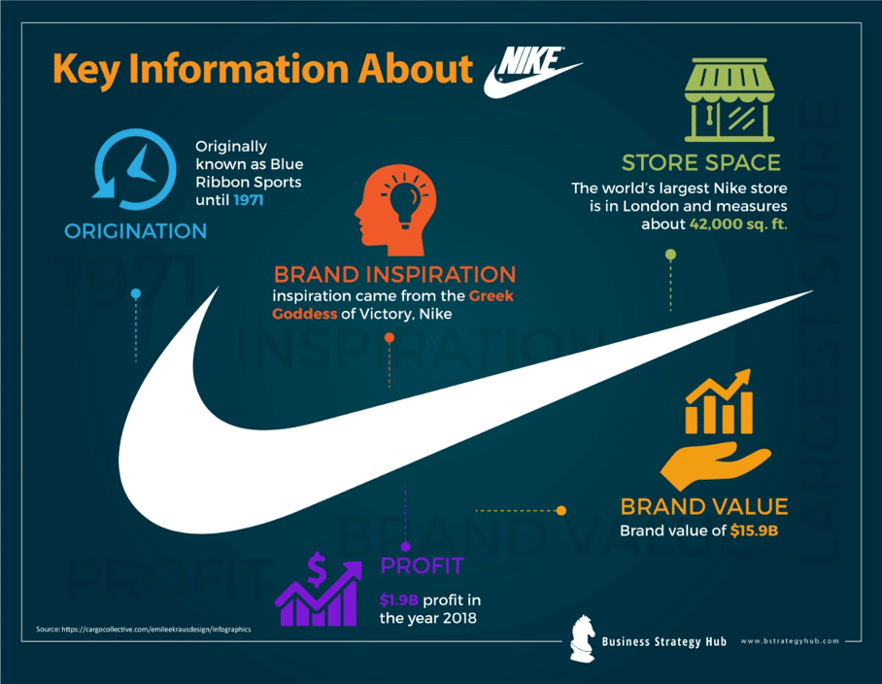
Figure 1: Nike Business Infographics; Source: Business Strategy Hub
Nike was generating $1 Billion in revenues from the sales of its athletic shoes worldwide in 1988. The United States, alone contributed around 63% of the total sales to the tune of $757 Million. Around 40 million athletic shoes which were sold in US, were not manufactured there. The manufacturing usually took off shore, as it was a labour-intensive industry, which required too much manpower (Donaghu and Barff, 1990).
Nike is now a team comprising of brands such as Nike, Converse and Jordan brands, with its Global Headquarters in Beaverton, USA, with 43% of its leadership positions being filled by women (Nike, 2022). The current top leadership positions holders of Nike are Phil Knight (Chairman Emeritus), Mark Parker (Executive Chairman) and John Donahoe (President & CEO). The leading shareholders of Nike Inc. (NKE) are Phil Knight, Mark Parker, Andrew Campion, Swoosh LLC, Blackrock LLC and Vanguard Group Inc. The first three make the largest individual shareholder club of Nike and the last three make the top three institutional shareholders cohort of Nike (Reiff, 2020).

Definition of Major Concepts and the Strategy of Nike

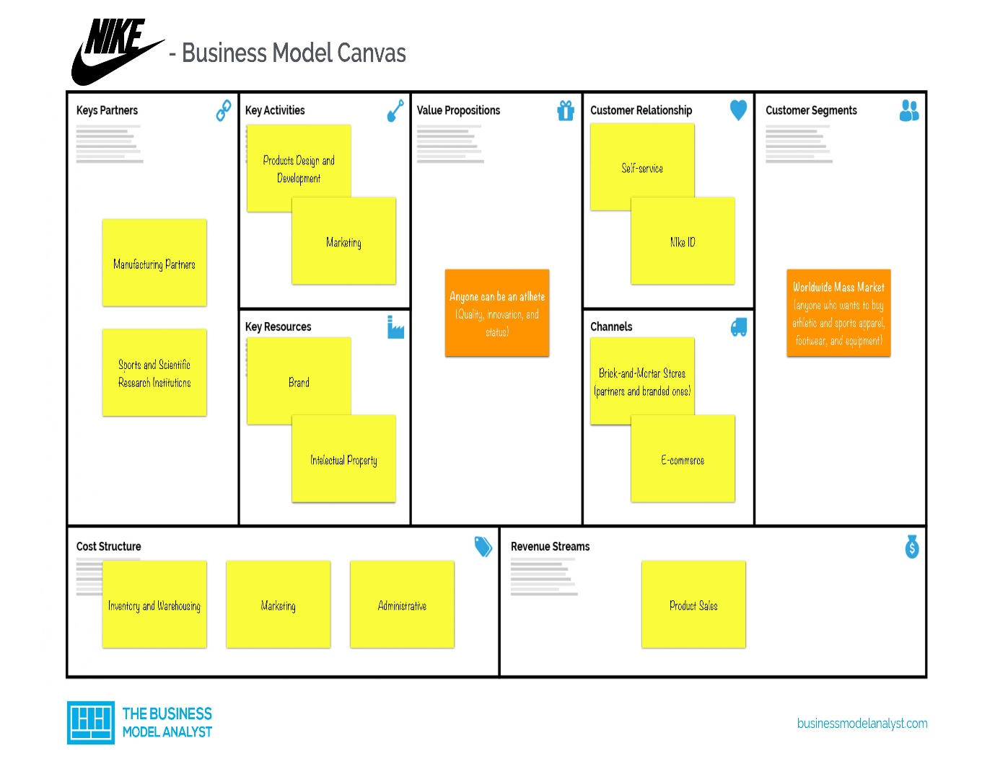
Figure 2: Business Strategy Model Canvas of Nike (Pereira, 2023)
Nike has the following customer segments markets across the world (Pereira, 2021):
- North American Markets
- Europe, Middle East & Africa
- The Asia Pacific & Latin America
- Greater China
Nike’s cost structure consists of three components. The first component, which is the massive cost chunk of the Nike - Cost of Goods Sold (COGS), which includes Inventory costs and the warehousing costs, which constitutes about $21 Billion of costs per year. The second component is the marketing costs which includes the advertising, media, PR, sponsorship, events etc. accounting to $3 Billion in total costs and the last component includes the administrative and general expenses clocking to $500 Million per year (Shastri, 2021).

The cost structure of Nike can be infographically represented by the following figure:
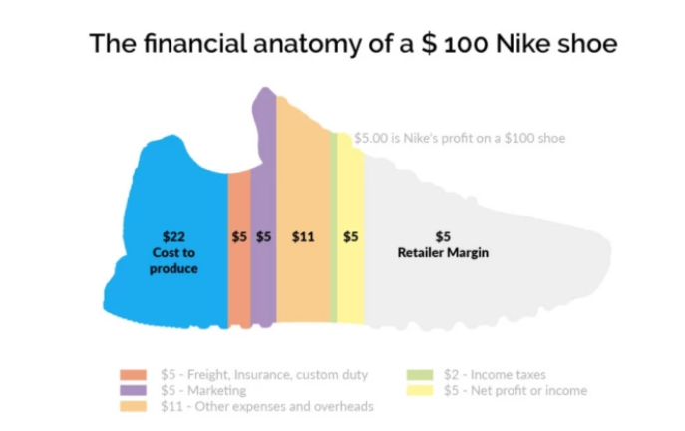
Figure 3: Nike's Cost Structure (Shastri, 2021)
In the pre-covid scenario, in 2019 the Net Income of Nike was $4,029 Million. This figure gradually dipped to $2,539 Million in 2020, when covid happened, due to decrease in sales, closure of stores etc. But there was a significant increase in the Net Income/Sales of the Nike in 2021, clocking to the tune of $5,727 Million, which significantly highlights the efforts made by Nike in all the spheres to revamp its sales (Nike, 2021)
Below is a screen grab from the Nike’s Annual Report 2021:
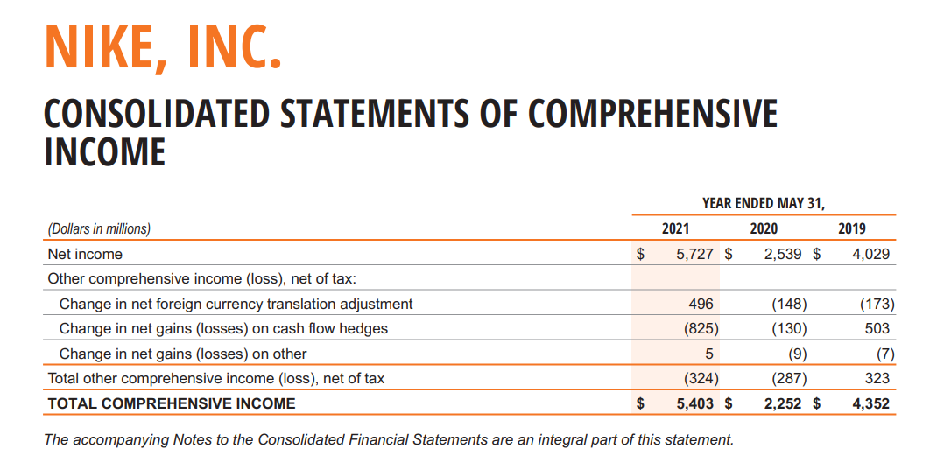
Figure 4: Nike's Income Statements (Source: Nike Annual Report 2021)
As of 2021, in a 10-year-old span, Nike has already doubled its revenue and is projecting to hit $50 Billion annual sales in its next Annual Report. It all has happened due to the innovation, research and development of Nike (Salpini, 2021).
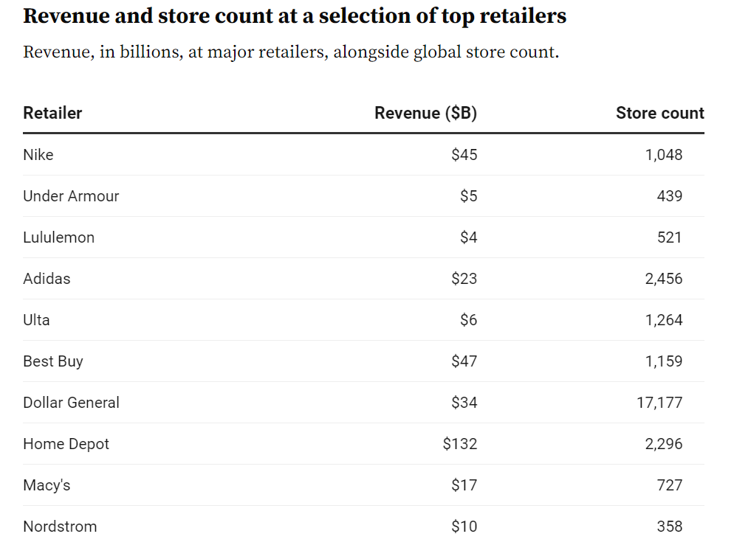
Figure 5: Nike Vs Major Retailers (Salpini, 2021) Source: Retail Dive

Main Findings - Nike’s Strategic Analysis (External & Internal)
Before the covid Nike’s strategic policy concerning its customer, care was having almost all the components which were needed to keep it in the top-notch companies worldwide, supporting customer friendly return and refund policies. One of the policies which Nike follows is the continuous and deep emphasis on innovation, research and development. This heavy-duty emphasis on the research and creativity has led to the production of footwear, apparels and athletic instruments which are mostly injury free, have maximum comfort (Pro Direct Running, 2021).

External Analysis
There are various techniques for External Strategic Analysis of Nike. The strategic analysis of Nike is being performed as a part of project which is entrusted on me by the senior management, to participate in a sudden onset emergency project team. The team is responsible for the reshaping the strategic direction of the Nike, to deliver innovative customer care ensuring future resilience and sustainable competitive advantage, keeping pandemic as the reference point, not to mention that the condition as of now is improving. As part of the external strategic analysis, we as team will be using the following techniques to analyse Nike’s strategic environment against the backdrop of pandemic:
PESTEL Analysis
Political Factors: A conducive political environment is conclusively essential for expansion and streamlined working of Nike.
- The Governmental policies, trade regulations, manufacturing laws and tax regulations can change in the nick of time. These changes ought to affect the growth of Nike.
- American Trade Tariffs foster friendly international trade agreements between various countries, thus enhancing the business of Nike and boosting its prospects especially in the America.
- Nike’s major production is outsourced to almost 41 countries worldwide (Pino, 2020), due to the cheap labour available in these countries, hence there is a continuous import and export of goods for normal trade market of Nike. The political environment in each of these countries wherever the goods of Nike flow, hugely impacts its supply chain operations and this affecting its overall growth.
- There is a trade war happening all the times between various countries especially after the pandemic like the China and the US (BBC News, 2020), which has hampered the flow of goods from the China to the US and vice versa. More than $360 billion (£268 billion) worth of Chinese imports have been hit with tariffs by the US, and more than $110 billion worth of US goods have been hit in return (BBC News, 2020). Not to forget, there are factories producing goods for Nike in China which count to 146, employing 189,000 workers (BBC, 2023).
- Significant political impact due to the Russia-Ukraine war, as Nike has closed all the business in Russia (BBC, 2022).
Economic Factors: These factors are directly proportional to the revenue and profitability of Nike. The pandemic laid a significant effect on the sales of Nike, which dropped to $2,539 in 2020 from $4,029 in 2019 (Nike, 2021).
- Due to the onset of Pandemic the sales of Nike Crippled. Nike posted an YoY loss of 38% to the tune of $6.3 Billion forcing Nike to close its most of the stores across North America and Europe (Santana, 2020). This economic shrinking was out of bounds for Nike and they tried to focus on Digital sales, due to the changing buying pattern in consumer behaviour. As a result, they were able to increase the sales by 75%, with digital sales contributing to 30% of overall revenue during the course of Pandemic (24/7 Wall Street, 2020).
- Foreign exchange currency fluctuations and volatile exchange rates, due to unstable economic conditions can badly trigger Nike’s revenue making capacity in the global markets (Guyot, 2015).
- Rising cost of living has placed logger heads on Nike, as the consumer spending power has gradually decline, resulting in the overall revenue dip for Nike (Bedi, 2022).
- Nike face substantial disruptions in supply chains due to factory closures owing to covid restrictions have substantially impacted the movement of goods to the retail stores, fulfilment centers and partner warehouses, eventually destabilizing the profits (Kohan, 2021).
Socio-Cultural Factors: Social and Cultural factors are ought to affect the sales of the company.
- After the pandemic, the consumers have a greater biasness towards a responsible, healthy and conscious living. There has been a greater emphasis on athleisure and home-based training and workout schedules, as the consumer prefers athleisure because of its comfort and its mix and match with day-to-day casual clothing. This shift has created a separate market for Nike especially after the Covid (Tandon, 2023).
- Changing consumer behaviour after the pandemic, has hugely impacted the design, innovation, creativity and more importantly the production of Nike. It can be seen as an opportunity for the development of another niche area for the company and clock its revenue, beating the competition (Arzhanova, Beregovskaya and Silina, 2020).
- Various social movements focussing on inclusion, diversity and most recently LGBTQ+ revolution has revolutionized the way Nike had prioritised its production and design content. In recent times after covid, there has been an emphasis on the engagement of women in the workforce and due to which Nike had 50.4% concentration of women engagement in its workforce. There was a 15% representation of Asian people in its employee clutter in the US, emphasizing inclusion and diversity. Nike has already made a target of 35% representation of ethnic and racial minorities in its US manpower cohort by 2025 (Global Data, 2022).
Technological Factors: Nike has adopted and used technology, digital transformation to greatly catalyse its productivity as well as sales.
- Nike has used the generative AI, Machine Learning, Wearable technology and Data Analytics techniques after pandemic, especially when it saw a plunge in its digital sales, after its stores closed. These machine learning techniques have helped Nike to predict consumer behaviour, suggest products for them, make faster deliveries, adopting last mile delivery approach, driving sales and more importantly fostering data driven accurate sales forecasting. Nike has deployed about 1000 Cobots, which are used as robots to pick and pack its products at the fulfilment centers (Rowsell, 2022).
- The pandemic had hugely impacted the offline the sales, henceforth the adoption of e-commerce, digital marketing, virtual chatbots and customer service experiences was evident for a global footwear giant to adopt with (Dhesi, 2021).
- Global partnerships with tech firms like Foot Locker Inc. and Nordstorm Inc. to drive the digital sales of the Nike was immediately taken to thrive the competition as the pandemic was deteriorating the future revenue prospects. As a result of this swift technological change adoption, although there was a dip pf 38% in overall sales of Nike, but the Digital Sales rocketed to 75% (Arcieri, 2020).
Ecological Factors: These factors have significantly become more relevant due to growing concerns for sustainability, reducing carbon footprint and environmental concerns.
- Consumers are becoming increasingly aware of more responsible and sustained clothing, which is affecting their choices and preferences. Adopting to this changing ordeal, Nike has developed a concept “Nike Forward” which is the most ground breaking and new approach towards material design. The clothes are not traditionally not knitted or woven, but instead they are made by joining incredibly thin layers with a needle-punching technique, which greatly decreases carbon emissions and can be customised to the particular item (Nast, 2022).
- Increased focus on sustainable clothing material from 41% to 59% during pandemic in 2020. Nike products which are marked as ‘made with sustainable material’ have at least 50% recyclable component in them (Weavabel, 2023).
- Nike’s ‘Move to Zero’ initiative is a step towards Zero Carbon Emission, catalysed by the changing environmental concerns after pandemic (Nike, 2023b)
Legal Factors:
- Nike was trapped in a hefty legal suit of $5 Million by Monika Taylor, alleging that Nike is trying to attract customers by misrepresentation or false representation of prices. These type of legal glitches cripples the media voraciously and created a bad impression of the brand in eyes of its customers and thereby posing huge pressure on its customer service and the needs to rectify its image (Sneaker Freaker, 2016).
- Lawsuits running by the employees of Nike in the recent past have also created concerns of trust and representation of women and addressing their issues by the senior management. More than 5,000 pages of documents, including surveys of female employees alleging sexist attitudes and behaviour at the sportswear company along with corporate bullying and fears of retaliation, have been submitted in a long-running sexual harassment and gender discrimination lawsuit against Nike (Helmore, 2022).
- Nike has been accused of evading taxes, by initially shifting its large sums of money from Netherlands to Bermuda, which is an offshore tax haven with zero tax in 2014. After 2014, Nike again started using the controversial ‘CV’ with the agreement of Dutch authorities via its subsidiary Nike Innovate CV, which is technically not registered under any tax regime in the world, thus avoiding major chunk of taxes from the Dutch and the US tax watchdogs. This tax evasion issue is of concern to Nike, maligning its image among investors (Hopkins and Bowers, 2017).
Michael Porter’s Five Force Analysis
Porter’s 5 force analysis, help us is getting answers to questions such as, that what forces beyond a direct competitor shape the industry, factors making the industry profitable and where can company find a good an strategic position, which is profitable and difficult to attack (Porter, 2008). We will use the framework in this instance to analyse Nike's strategic course and its capacity to provide creative customer service in the face of the pandemic.
Threat of New Entrants (Moderate to Weak Force): This step/element of the analysis, measures the extent of competition given by the new entrants, who might or already have entered the sportwear industry (Sports Shoes, Sports Apparels & Fitness Equipment’s) for Nike. Since, sportwear is a tough sector to get through so the following factors show that moderate to low threat of new entrants for Nike (Barney, 1991):
- Nike’s brand Image is difficult to develop, robust economies of scale and efficient distribution and fulfilment network, serves as a strong deterring factor for new entrants and acts as a weak force for new entrants.
- High Cost of brand development in sportswear industry is again a weak force.
- Easy access to fulfilment, advertising and distribution channels like the Amazon, eBay, Walmart etc. which can be accessed by any of the new entrants, can serve as a moderate force acting in favour of new entrants and posing any risk to the Nike’s existence.
The digital age, have lowered the entry barriers. Nike should be operating on latest cutting-edge technologies to mitigate this risk. Nike can also control the entry of new entrants by increasing the economies of scale, spending more on Research & Development which will result in defining new sets and strategies (Fern Fort University, 2019).
Bargaining Power of Suppliers of Nike (Weak Force): This force, measures the impact of suppliers on the Nike operations, which is again a weak force.
- Nike’s scale of operations and global outreach is pretty huge and its gives Nike as smart leverage and level to bargain with its suppliers on terms of prices and quantities, thereby keeping the economies of scale on Nike’s side, which is a weak force.
- There is ample availability of suppliers in the sporting goods sector, thus again making this a weak force.
- Moderate to Low size of suppliers in comparison to mammoth supply chain structure of Nike, which in one hand means that the suppliers are small in size compared to the structure of Nike, which again makes them weak force to have an impact on the operations of Nike, with their bargaining power.
Nike can deal with the bargaining power of suppliers, by building a robust supply chain structure, to give juggernauts to the suppliers, by continuous innovation on design so that if the suppliers increase the prices, Nike can immediately shift to a different product. Also, Nike could work on developing third party suppliers, whose business should solely depend on Nike likewise in the case of Walmart (Krunchbox, 2022).
Bargaining Power of Buyers/Customers of Nike (Moderate): The bargaining power of the customers of Nike and in the sportwear industry ranges from moderate to high levels as there might be other available options.
- Switching costs to other brands similar to Nike is a Low to Moderate force.
- Availability of substitutes is again a Moderate force, as the customers who buy Nike, will typically switch to high end sportwear brand like Adidas or Reebok. So, the number of substitutes, which match the quality and standards of Nike is relatively low.
- Low number of buyer concentration, whose exclusive preference to go for sportswear related apparels only, makes the buyers are weak force.
Nike can eventually, handle the buying power of its buyer’s issue by trying to increase its customer base, probably by lowering its costs on some of its flagship products, which will reduce the bargaining power of the Nike’s customers and of course innovation will keep a sense of variety at Nike and keep the customers involved.
Threat of Substitutes (Moderate Force): The availability of substitutes, may weaken the market share of Nike. But in reality, the strong Brand Equity and culture of Nike, makes it difficult to the competitors to create product matching the brand values of Nike, hence this factor is counted as a moderate force.
- Counterfeiting is the biggest threat to Nike, as in the recent past the Nike products are imitated and the imitators are continuously enhancing the quality to match the fake products with the Nike. Nike is one of the most counterfeited brands in the world (Gupta, 2017). Hence, Nike has urged the consumers to report the fake replicas on its website (Nike, 2023a).
- Availability of substitutes similar to Nike’s standards is a Moderate threat.
- Switching costs between the products is again a Low to Moderate threat.
Nike can easily minimize the threat of substitute, by increasing the switching costs, providing after sales and being more service oriented and analysing the demand gaps.
Competitive Rivalry (Strong Force): Competitive rivalry in the sportswear industry is high. Nike faces stiff competition from stalwarts like Adidas, Reebok, Puma etc. Competition among the companies in the sportswear sector determines the market share.
- Aggressive marketing and advertising strategy of the competitors like Adidas, Reebok, Puma etc. which is a strong force.
- The count of companies in sportswear, apparels and fitness equipment’s is a strong force in context to the competitive rivalry given to Nike.
- The rate of growth of sportwear market is relatively slow with a projected CAGR of 6.6% (Fortune Business Insights, 2021), which is not very rapid as compared to other sectors. Hence making it’s a strong force for competitive rivalry
Nike can offset the effects of competitive rivalry by high degree of product differentiation, doing more sustainable business reducing the carbon footprint and collaborating or taking over its competitors, to increase its market share and book value.

SWOT Analysis of Nike for reshaping its Strategy for a World Class Customer Service:
Strengths of Nike (Internal Strategic Context):
- Strong Brand Image & Positioning: Nike is a signature sportwear brand, with easy recognition and the swoosh symbol is its face. People love Nike all over the world. As of 2022, the brand value of Nike was $33 Billion (Sabanoglu, 2022).
- Mammoth Customer Base: Nike has a customer base all around the world. People follow Nike’s style trends and it defines the standards in the sportswear industry. This Is the reason the market capitalisation of Nike as of June 2023 in $162.70B (Yahoo Finance, 2023).
- Continuously Striving for Sustainability and Zero Carbon Footprint: “Move to Zero” is an initiative by Nike to reduce the Net Carbon footprint to zero and zero waste. Nike used more than 59% sustainable materials after 2020 (TheSportsEdit, 2023).
- Power of Partnership: Nike has iconic partnerships with people like Michael Jordon, the greatest basketball player. This resulted in formation of Air Jordon, and the rest became history (Ali, 2020).
- Substantially Low Production Cost: Best example of outsourced contract manufacturing in low-cost concentrated areas such as Vietnam, China and Indonesia contributing to about 49%, 23% & 21% of its footwear business (Singh, 2019).
Weakness of Nike (Internal Strategic Context):
- Complaints of inhumane labour conditions in the outsourced countries: There has been complains by various agencies, that forced labours, especially Uyghurs in China are forced to make Nike shoes by the Chinese Government and in South Korea, that are linked to crimes against humanity (Pang, 2022) which questions credibility of Nike’ brand.
- Huge Debt Proportion in total capital Structure: Nike’s total debt as of Nov 22, $9.43B. Total liabilities of $8.32B more than its cash in hand and near-term receivables (Simply Wall St, 2023).

- Maximum dependence on North America Markets, primarily USA:
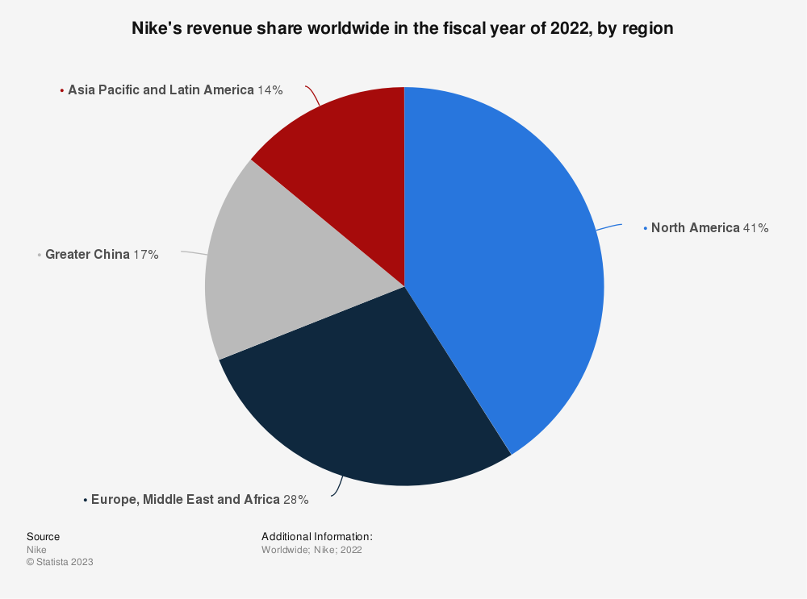
Figure 6: Distribution of Nike's sale worldwide (Source: Statista 2023)
- Issue of frequent Lawsuits: In 2018, former female employees of Nike, filed a lawsuit alleging Nike of Gender Discrimination in the wake of #MeToo movement, and various other lawsuits bringing a bad name to Nike (Kish, 2022)
Opportunities for Nike (External Strategic Context):
- Expansion Opportunities for Nike: It is projected that over the next 5 years 70% of the Nike’s revenue can come outside of its core US Markets (Rodriguez, 2023).
- Severing of Ties with Big Retailers: Nike has announced that they are aborting their retailing operations with big shots like Urban Outfitter, Olympia Sports etc. for enhancing the spotlight on its brand, although this has led to other brand taking the shelve space, but it’s a step towards a pleasant customer experience (Monteros, 2022).
- Scopes in AI and digital world: In the 2021, Nike has acquired RTFKT a brand that clubs cutting edge innovation with culture and gaming. RTFKT combines NFT, gaming engines, augmented reality, blockchain etc. to create virtual products and experiences (Nike, 2021).
- Moving away from wholesale distribution networks for increasing profits: Nike has closed its wholesale distribution with various big wholesalers including Zappos, Big Five, Dunham’s and is increasing its focus on Direct to Consumer (DTC) markets such as its Retail Stores, Website etc. (Ryan, 2021).
Threats for Nike (External Strategic Context):
- Counterfeiting: Nike is the one of the most counterfeited brands in the world. Recently Nike has filed lawsuits against hundreds of websites and social media accounts. This posse’s huge threat to Nike tarnishing its image (Osei, 2021).
- Surmounting pressure for thriving competition and marketing budgets: Rival sportswear companies like Adidas, Under Armour, Asics etc. are massively increasing a burden of marketing budget which is going out of bounds for Nike (Barrabi, 2016). The only way out of this competition is to be as much as innovative and creative customizing the needs of its customers and athletes.
- Negative Impacts of Foreign Exchange: Since Nike is a Global brand operating all over the world, hence it is severely affected by foreign exchange regulations. Nike’s foreign exchange regulations hit a 5-year low of -$143M in May 2022 (Finbox, 2023).
- Huge concerns over Warehouse and Retail level thefts: Nike is battling a staggering number of thefts in warehouse and retail stores, with retail theft alone to a whooping amount of $95B annually. Recently a store in Portland, Oregon was closed due to theft (Kish, 2023).
- Accusations of driving Kangaroo Population towards extinction: Animal right activists have said that Nike is using Kangaroo Skin to make its leather football shoes, accusing Nike of threatening Kangaroo population towards extinction (Webber, 2021).

Internal Analysis
Capabilities & Resources: Nike’s strong brand value, strong global supply chain network, innovation in product design and focus towards sustainability and reducing its carbon footprint are its key components of internal strengths. Nike’s continuous investment in research and development and athlete endorsements have hugely paved the way for its success.
Organisation Culture & Hierarchy: The organisational structure of Nike encourages functional specialisation and speeds up decision-making. The business encourages a culture of innovation, teamwork, and performance, which encourages employee collaboration and creativity.
Overall Financial Performance of Nike: Analysis of the financial statements of Nike clearly shows a net income of $1439 M, for the financial year ending 2022, showing its ability to invest in more strategic initiatives (Nike, Inc., 2022).

Wider Implications of the proposed strategies on different areas of Nike
Operations & Supply Chain  Customization and personalization necessitate changes to manufacturing, inventory control, and logistics of the supply chain.  It might be necessary to make investments in IT infrastructure and data management capabilities to support improved data analytics and AI-driven customer service. | Marketing  The implementation of personalized customer service experience requires an overhauling of the marketing resources.  Collaboration and tuning between marketing and customer care is essential for coherence across Nike’s online and offline touchpoints.
Technology  Adoption of Technologies such Artificial Intelligence, Data Analytics, Omni Channel Experience etc. calls for a robust investment in IT infrastructure.  Adherence to Data and Security laws is another crucial factor for safeguarding customer data and compliance to regulatory framework. | Finance  Investment in technology for innovative customer service, involves huge financial investment. Nike should evaluate the financial feasibility of such investments and its impact on profitability.  Impact on Pricing should also be evaluated.
Human Resources  Moving towards an innovative and personalized customer care, will involve in hiring additional staff or training the existing staff for increased customer queries and handling the AI systems.  Manpower should be provided with periodical trainings about changes in technology and trends to keep pace with the innovation for providing personalized customer service and handling customer data sensitively. | Organisation Culture & Change Management  Introducing a personalized customer care strategy involves a strategic shift and change in the whole Nike. The change management efforts should be communicated effectively, duly explaining the strategic rationale and long-term benefits encouraging overall involvement and fostering a customer centric culture in the whole organisation.

Strategic options for Personalized Customer Care – Conclusions from Analysis
After analysing Nike, Externally & Internally, the following can be concluded as feasible strategic options for moving towards a personalized and innovative customer service:
- Personalization & Customization of products according to preferences of individuals.
- Use of enhanced Data Analytics/AI for gaining insights into customer tastes and preferences, which will help in developing targeted marketing campaigns and deliver personalized recommendations.
- Omni-Channel Experience, should be there, by integration of its physical and online stores to provide seamless and personalized shopping experience, like Virtual Try-On, in-store customer assistance etc.
- AI-driven Customer Service, with the help of virtual assistants and chatbots to provide assistance to customers in finding right products and answering questions in a timely fashion.
- Use of enhances Loyalty Programs: his can include, custom discounts, early access to new product launches etc.
- More Engagement on social media: More interaction with customers on social media on to provide a personal touch.
- Regular Monitoring & Evaluation of Customer Feedback will help Nike to create a unique customer service experience and throttle through the competition.

Conclusions & Recommendations
- Strong Brand Value & Mammoth Customer Base: Nike enjoys a string brand value of $33B as of 2022 (Sabanoglu, 2022) and a massive customer base of its loyal customers around the world.
- Nike’s ‘Move to Zero’, for reducing Carbon Footprint through circular designing, have resulted in 30% reduction in midsole defect rate, making Nike more sustainable in the eyes of its customers and thus enhancing brand loyalty. Also, it has helped Nike to achieve high standards of Customer Service (CFA, 2023).
- Elimination of distributors and wholesalers like Zappos, Dillards to focus more on its customers directly and to implement D2C (Direct to Customer) Models, for a more enhanced and personalized touch with the customers.
- Counterfeiting & Network (Retail & Wholesale) thefts, have costed Nike a staggering $95B annually, forcing it to close its various stores in US (Colton, 2023).
- To address the issues brought on by Covid-19, Nike expedited Automation and Digital transformation for an enhanced geographical diversity within its supply chains to power long term growth.
- The Covid-19 Pandemic catalysed Nike’s focus on e-commerce, Digital sales for Nike increased by 75%. The outcomes prompted a leadership change at Nike and prompted a larger investment for a direct-to-consumer (D2C) strategy (Renaldi, 2020).
Recommendations for reshaping the strategic direction of Nike for an Innovative Customer Service Experience:

- Embracement of Latest Technologies: Nike should make more use of data analytics, digital platforms and AI-backed technologies for delivering personalized content and innovative customer service experience.
- Adopting a more customized and personalized approach: Enhanced customer satisfaction and loyalty can be achieved by adjusting manufacturing procedures and logistics in the supply chain to accommodate personalised products.
- Investment in Technology: Nike should be investing robustly and aggressively in latest technologies such as generative AI, Data Analytics and AI-driven customer service.
- Integration of Online and Offline Channels: Proving an omnichannel experience, will create a unified and seamless platform for customers, who are seeking help in finding suitable products and increase convenience and engagement for customers.
- More Focus on being Sustainable and engaging the community: Inculcating sustainability in its customer service experience and fostering a feeling of community engagement, will greatly enhance the overall customer satisfaction and Nike can achieve enhances brand loyalty and reputation.
- Continuous investment in Customer Insights and Preferences: Nike's abilities to gather, analyse, and use customer data to learn more about preferences, behaviours, and trends can be enhanced. Nike can create products, marketing strategies, and customer service strategies that are highly personalised and match the preferences of its customers.
- Foster a Culture of Innovation: Nike should foster a culture that values experimentation, innovation, and prompt response to shifting consumer demands and market conditions. This includes clubbing cross-functional teams, setting up innovation hubs, and giving staff members the tools, they need to experiment with latest technologies and swiftly put customer-centric initiatives into action.

References
24/7 Wall Street (2020). Nike’s Incredible Digital Sales Fail to Offset Store Closures. markets.businessinsider.com. Available at: https://markets.businessinsider.com/news/stocks/nike-s-incredible-digital-sales-fail-to-offset-store-closures-1029346164 (Accessed: 4 June 2023)
Ali, Z. (2020). The Power of Partnerships - Nike & Michael Jordan. [online] www.centuroglobal.com. Available at: https://www.centuroglobal.com/article/the_power_of_partnerships_nike_michael_jordan. (Accessed: 10 June 2023)
Arcieri, K. (2020). Nike levels up digital game in wake of coronavirus hit. [online] S&P Global. Available at: https://www.spglobal.com/marketintelligence/en/news-insights/latest-news-headlines/nike-levels-up-digital-game-in-wake-of-coronavirus-hit-59265634. (Accessed: 5 Jun. 2023)
Arzhanova, K.A., Beregovskaya, T.A. and Silina, S.A. (2020). ‘The Impact of the COVID-19 Pandemic on Consumer Behaviour and Companies’ Internet Communication Strategies’. [online] www.atlantis-press.com. doi: https://doi.org/10.2991/assehr.k.201105.010. Available at: https://www.atlantis-press.com/proceedings/rtcov-20/125945739 (Accessed: 5 Jun. 2023)
Barney, J. (1991). ‘Firm resources and sustained competitive advantage’. Journal of Management, [online] 17(1), pp.99–120. doi: https://doi.org/10.1177/014920639101700108. (Accessed: 8 June 2023)
Barrabi, T. (2016). Nike Under Pressure From Surging Competitors. [online] FOXBusiness. Available at: https://www.foxbusiness.com/features/nike-under-pressure-from-surging-competitors. (Accessed: 10 June 2023).
BBC (2022). Nike latest brand to leave Russia permanently. BBC News. [online] 23 Jun. Available at: https://www.bbc.co.uk/news/business-61914165. (Accessed: 4th June 2023)
BBC (2023). Case study: Nike production in China - Globalisation - CCEA - GCSE Geography Revision - CCEA. [online] BBC Bitesize. Available at: https://www.bbc.co.uk/bitesize/guides/zxm3srd/revision/4#:~:text=Nike%20has%20been%20working%20in. (Accessed: 4th June 2023)
BBC News (2020). A quick guide to the US-China trade war. BBC News. 16 Jan. Available at: https://www.bbc.co.uk/news/business-45899310 (Accessed: 4th June 2023)
Bedi, M. (2022). Nike sales likely to suffer as inflation hits sneakerheads. Reuters. [online] 28 Sep. Available at: https://www.reuters.com/business/retail-consumer/nike-sales-likely-suffer-inflation-hits-sneakerheads-2022-09-28/. (Accessed: 4 Jun. 2023)
CFA (2023). Nike’s pursuit of a Zero Carbon and Zero Waste Future through Circular Design. [online] Global Fashion Agenda. Available at: https://globalfashionagenda.org/case-study/nikes-pursuit-of-a-zero-carbon-and-zero-waste-future-through-circular-design/ (Accessed 23 Jun. 2023).
Colton, E. (2023). Nike faces onslaught of thefts from the warehouse to retail shelves. [online] FOXBusiness. Available at: https://www.foxbusiness.com/retail/nike-faces-onslaught-thefts-from-warehouse-retail-shelves. (Accessed 23 Jun. 2023).
Companies History (2013). Nike. [online] Companies History - The biggest companies in the world. Available at: https://www.companieshistory.com/nike/. (Accessed: 2nd June 2023)
Dhesi, A. (2021). Sustaining Digital Transformation in the Post-COVID Era: Nike Case Study. Available at: https://dspace.mit.edu/bitstream/handle/1721.1/139396/Dhesi-adhesi-MSMS-mgt-2021-thesis.pdf. (Accessed: 5 Jun. 2023)
Donaghu, M.T. and Barff, R. (1990). Nike just did it: International Subcontracting and Flexibility in Athletic Footwear Production. Regional Studies, 24(6), pp.537–552. doi:https://doi.org/10.1080/00343409012331346204. (Accessed: 2nd June 2023)
Fern Fort University (2019). NIKE, Inc. Porter Five (5) Forces & Industry Analysis [Strategy]. Fern Fort University. Available at: http://fernfortuniversity.com/term-papers/porter5/analysis/765-nike--inc-.php. (Accessed: 8 June 2023)
Finbox (2023). The Complete Toolbox For Investors | finbox.com. [online] Finbox.com. Available at: https://finbox.com/NYSE:NKE/explorer/fx/#:~:text=NIKE. (Accessed: 10 June 2023).
Fortune Business Insights (2021). Sportswear Market Size, Share, Industry Forecast 2028. www.fortunebusinessinsights.com. Available at: https://www.fortunebusinessinsights.com/sportswear-market-102571. (Accessed: 8 June 2023)
Global Data (2022). ShieldSquare Captcha. [online] www.globaldata.com. Available at: https://www.globaldata.com/data-insights/consumer/nike-diversity-in-workforce-2095670/ (Accessed: 5 Jun. 2023)
Gupta (2017). The Rise of Counterfeiting and Its Effects on Nike. [online] Soapboxie. Available at: https://soapboxie.com/economy/The-Rise-of-Counterfeiting-and-Its-Effects-on-Nike. (Accessed: 8 June 2023)
Guyot, O. (2015). How Nike has adapted to exchange rate fluctuations. [online] FashionNetwork.com. Available at: https://shorturl.at/yOS08 (Accessed: 4 Jun. 2023)
Helmore, E. (2022). Nike lawsuit records allege culture of sexism, bullying and fear of retaliation. [online] the Guardian. Available at: https://www.theguardian.com/business/2022/dec/20/nike-lawsuit-records-sexual-abuse-toxic-workplace-claim. (Accessed: 5 Jun. 2023)
Hopkins, N. and Bowers, S. (2017). Revealed: how Nike stays one step ahead of the taxman. The Guardian. 6 Nov. Available at: https://www.theguardian.com/news/2017/nov/06/nike-tax-paradise-papers#:~:text=They%20pay%20some%20tax%20on (Accessed 5 Jun. 2023)
Kish, M. (2022). Inside Nike’s high-profile gender discrimination lawsuit, where plaintiffs claim unequal pay and more thanks to a ‘boys’ club’ culture. [online] Business Insider. Available at: https://www.businessinsider.com/inside-nike-gender-discrimination-lawsuit-citing-unequal-pay-2022-5?r=US&IR=T. (Accessed: 10 June 2023).
Kish, M. (2023). Nike is battling theft in stores, warehouses, and even trains. [online] Business Insider. Available at: https://www.businessinsider.com/nike-facing-a-wave-of-retail-crime-across-the-country-2023-2?r=US&IR=T. (Accessed: 10 June 2023).
Kohan, S.E. (2021). Nike Prices To Rise Amid Supply Chain Issues While Profits Increase 23%. [online] Forbes. Available at: https://www.forbes.com/sites/shelleykohan/2021/09/23/nike-prices-to-rise-amid-supply-chain-issues-while-profits-increase-23/?sh=4d69947247fd (Accessed: 4 Jun. 2023).
Krunchbox (2022). How Walmart Collaborates With Its Vendors. [online] Krunchbox. Available at: https://krunchbox.com/how-walmart-collaborates-with-its-vendors/. (Accessed: 8 June 2023)
Monteros, M. (2022). As Nike cuts ties with retailers, competitors look to take its place in wholesale. [online] Modern Retail. Available at: https://www.modernretail.co/retailers/as-nike-cuts-ties-with-retailers-competitors-look-to-take-its-place-in-wholesale/#:~:text=Last%20year%2C%20Nike%20announced%20it. (Accessed: 10 June 2023).
Nast, C. (2022). Nike Has Unveiled Its Most Sustainable Sportswear To Date. British Vogue. Available at: https://www.vogue.co.uk/fashion/bc/innovating-the-future-with-nike. (Accessed: 5 Jun. 2023)
Nike (2021). Nike Acquires RTFKT. [online] Nike.com. Available at: https://about.nike.com/en/newsroom/releases/nike-acquires-rtfkt. (Accessed: 10 June 2023).
Nike (2021). NIKE, Inc. - Investor Relations - Investors - News, Events and Reports. [online] Nike.com. Available at: https://investors.nike.com/investors/news-events-and-reports/?toggle=reports. (Accessed: 3rd June 2023)
Nike (2022). WELCOME TO NIKE, INC. Nike.com. Available at: https://about.nike.com/en/company (Accessed: 3rd June 2023)
Nike (2023a). Have I Bought Fake Nikes? | Nike Help. [online] www.nike.com. Available at: https://www.nike.com/gb/help/a/nike-product-authenticity. (Accessed: 8 June 2023)
Nike (2023b). Nike Sustainability. Move to Zero. Nike.com. Available at: https://www.nike.com/sustainability. (Accessed: 5 Jun. 2023)
Nike, Inc. (2022). NIKE, Inc. Reports Fiscal 2022 Fourth Quarter and Full Year Results. [online] investors.nike.com. Available at: https://investors.nike.com/investors/news-events-and-reports/investor-news/investor-news-details/2022/NIKE-Inc.-Reports-Fiscal-2022-Fourth-Quarter-and-Full-Year-Results/default.aspx. (Accessed: 23 June 2023).
Osei, S. (2021). Nike’s War on Fakes Is Only Just Getting Started. [online] Highsnobiety. Available at: https://www.highsnobiety.com/p/nike-counterfeit-sneakers-lawsuits/. (Accessed: 10 June 2023).
Pang, A. (2022). The China Challenge: The Stain of Forced Labor on Nike Shoes. [online] Discourse. Available at: https://www.discoursemagazine.com/economics/2022/01/05/the-china-challenge-the-stain-of-forced-labor-on-nike-shoes/. (Accessed: 10 June 2023)
Pereira, D. (2021). Nike business model. The Business Model Analyst. Available at: https://businessmodelanalyst.com/nike-business-model/. (Accessed: 2nd June 2023)
Pereira, D. (2023). Nike Business Model Canvas. Business Model Analyst. Available at: https://businessmodelanalyst.com/downloads/nike-business-model-canvas/ (Accessed 3 Jun. 2023).
Pino, G. (2020). Nike Products Are Manufactured in Over 41 Countries | Sourci. Available at: https://sourci.com.au/blog/nike-products-are-manufactured-in-over-41-countries/. (Accessed: 4th June 2023)
Porter, M.E. (2008). The Five Competitive Forces That Shape Strategy. Hbs.edu. Available at: https://www.hbs.edu/faculty/Pages/item.aspx?num=34522. (Accessed: 8 June 2023)
Pro Direct Running (2021). Best Nike Running Shoes for Injury Prevention – Project: Run Fearless. [online] Pro: Direct Running. Available at: https://www.prodirectsport.com/running/articles/kit-and-gear/reviews/nike-project-run-fearless/ (Accessed: 3rd June 2023)
Reiff, N. (2020). Top Nike Shareholders. Investopedia. Available at: https://www.investopedia.com/articles/insights/052516/top-4-nike-shareholders-nke.asp#:~:text=4%EF%BB%BF%20The%20co%2Dfounder. (Accessed: 3rd June 2023)
Renaldi, M. (2020). The COVID-19 Pandemic Accelerates Nike’s Ecommerce Focus. [online] Vaimo. Available at: https://www.vaimo.com/blog/covid-accelerates-nike-ecommerce-focus/. (Accessed 23 Jun. 2023).
Rodriguez, M. (2023). Nike: Turning Cautiously Positive In The Long Term (NYSE:NKE) | Seeking Alpha. [online] seekingalpha.com. Available at: https://seekingalpha.com/article/4571788-nike-stock-turning-cautiously-positive-long-term-buy. (Accessed: 10 June 2023).
Rowsell, J. (2022). How Nike transformed supply chains to survive Covid. Supply Management. Available at: https://www.cips.org/supply-management/news/2022/january/how-nike-transformed-supply-chains-to-survive-covid/#:~:text=Nike%20has%20used%20AI%20and. (Accessed: 5 Jun. 2023)
Ryan, T. (2021). Nike says goodbye to more longtime wholesale partners – RetailWire. [online] Retailwire. Available at: https://retailwire.com/discussion/nike-says-goodbye-to-more-longtime-wholesale-partners/. (Accessed: 10 June 2023).
Sabanoglu, T. (2022). Nike: Brand Value Worldwide 2016-2019 | Statistic. [online] Statista. Available at: https://www.statista.com/statistics/632210/nike-brand-value/. (Accessed: 10 Jun 2023)
Salpini, C. (2021). Nike is on track to make $50 billion this year. How much is that, really? Retail Dive. [online] 4 Nov. Available at: https://www.retaildive.com/news/nike-is-on-track-to-make-50-billion-this-year-how-much-is-that-really/608511/. (Accessed: 3rd June 2023)
Santana, D. (2020). Nike Sales Slump Over Store Closures Resulting From COVID-19. [online] Front Office Sports. Available at: https://frontofficesports.com/nike-sales-slump-over-covid19/. (Accessed: 4th June 2023)
Shastri, A. (2021). Complete Business Model of Nike | IIDE. Available at: https://iide.co/case-studies/business-model-of-nike/. (Accessed: 3rd June 2023)
Simply Wall St (2023). Is NIKE (NYSE:NKE) Using Too Much Debt? [online] simplywall.st. Available at: https://simplywall.st/stocks/us/consumer-durables/nyse-nke/nike/news/is-nike-nysenke-using-too-much-debt-3. (Accessed: 10 June 2023).
Singh, A. (2019). Nike Manufacturing and Supply Chain Strategies - Market Realist. [online] Market Realist. Available at: https://marketrealist.com/2019/10/nike-manufacturing-and-supply-chain-strategies/. (Accessed: 10 June 2023)
Sneaker Freaker (2016). Nike Is Being Sued $5m For Fraudulent In-Store Pricing. Sneaker Freaker. Available at: https://www.sneakerfreaker.com/news/nike-is-being-sued-5m-fraudulent-store-pricing. (Accessed: 5 Jun. 2023)
Tandon, S. (2023). Athleisure, casual wear stay robust in post-covid world. mint. Available at: https://www.livemint.com/companies/people/athleisure-casual-wear-stay-robust-in-post-covid-world-11674843232007.html (Accessed: 5 June 2023)
TheSportsEdit (2023). Nike Sustainability. [online] The Sports Edit. Available at: https://thesportsedit.com/pages/nike-sustainability. (Accessed: 10 June 2023)
UȚĂ, I.-C. (2020). The story behind the brand: NIKE – Brand Minds. [online] brandminds.com. Available at: https://brandminds.com/the-story-behind-the-brand-nike/. (Accessed: 2nd June 2023)
Weavabel (2023). Is Nike Sustainable? Focusing on a Brighter Future. www.weavabel.com. Available at: https://www.weavabel.com/blog/is-nike-sustainable-focusing-on-a-brighter-future#:~:text=Nike. (Accessed: 5 Jun. 2023)
Webber, J. (2021). Nike Accused Of Driving Kangaroos To Extinction To Make Leather Football Shoes. [online] Plant Based News. Available at: https://plantbasednews.org/culture/ethics/nike-kangaroos-leather-football-shoes/. (Accessed: 10 June 2023).
Yahoo Finance (2023). Nike, Inc. (NKE) Stock Price, Quote, History & News. @YahooFinance. Available at: https://finance.yahoo.com/quote/NKE/. (Accessed: 10 June 2023).

