How will consumers of the future interact with advertising?

Submitted in partial fulfilment of the requirements for the degree of
BA (Hons) University of Wales Trinity Saint David, Swansea
13th December 2017

Advertising and Brand Design

Supervisor: Martin Bush

Word Count: 5021

Francesca Murray–Shelley (P144524)

Summary of Topic
This dissertation will explore the way in which consumers will interact with advertising in the future and how technological advances enhance consumer interactivity with a brand. I will also explore recent industry campaigns which will be included within the traditional, data driven and experiential chapters.

Table of Contents

How will consumers of the future interact with advertising? 1
Summary of Topic 2
Chapter One Traditional Advertising 5
Chapter Two- Data Driven Advertisement 15
Chapter Three – Experiential Advertising 22
Conclusion 27
Bibliography 30

Illustrations
(Figure 1, Volkswagen 'Think Small') 6
Figure 2 Clear Channel 7
Figure 3 John Lewis Moz the Monster 10
Figure 4 Piccadilly Surveillance Technology) 17
Figure 5 Play Station four OXO Tower 23
Figure 6 London Live bus 25
Figure 7 London Live Count Down 26

Introduction

This dissertation will explore the way in which consumers will interact with advertising in the future. The subject of what the future will encompass is unknown however I find technological advances within the advertising industry intriguing. Exploring and keeping up to date with industry changes has allowed me to develop a further understanding of advertising and the endless possibilities of the future. The campaigns and advertisements included within this dissertation will form an interpretation of what the future of advertising could entail. The chapters will progress from traditional advertising to the technology driven possibilities of the future. Chapter one will focus on influential adverts such as Volkswagen, the most recent John Lewis adverts, billboard campaigns and the ongoing benefits of digital print within the last half a century and the way in which consumers and advertisers have previously interacted with them. The relation between the advertising campaigns and the emotion of the consumers interaction will be evident within this first chapter. The exploration and research of the traditional format for advertising will create the foundations for the following chapters.
Chapter two will explore the notions of data driven advertising and expand on recent technological advances such as surveillance technology, content consumption and big data. This chapter will also analyse how the progression of digital and data driven advertising can create a further interaction with the end consumer. Research in this chapter will encapsulate the thoughts and suggestions from industry experts such as Dave Trott and Sir John Heggarty. This chapter will also demonstrate how consumers will adapt as a result of the new technologies within data driven advertisements.
Chapter three will explore recent experiential advertising campaigns. Technological change will be the basis of this chapter and we will explore recent campaigns which demonstrate the potential for the future of experiential advertising. Campaigns such as the PS4 launch and the London Live bus are two campaigns included within chapter three. The chosen campaigns will provide examples of recent industry developments and the effects these changes have currently and will have in the future. The aim for chapter three is also to develop the idea of the emotional connection between brand and consumer. Throughout the research and development stages, find relevant content with the use of books was proven difficult. However, the use of online sources did provide relevant content due to this thesis focusing on the future of advertisement.

Chapter One Traditional Advertising
Traditional platforms within advertising were able to deliver information to the consumer in a relevant and practical manner. Since the early days of advertisements, newspaper publications can be traced as far back as the sixteenth century. “At the beginning of the nineteenth century most advertisements in Britain were used for sailing departures and arrivals, books, plays, patent medicines and also for the slave trade” (Dyer 1982: 32). Traditional advertising has progressed a great deal throughout the last century.
People became increasingly reliant on magazines and newspapers due to their credible information. There have been many creative and evoking traditional advertising campaigns within printed media. Volkswagen’s “Think Small” campaign became known for its iconic design and creative marketing strategy. “The Volkswagen Beetle was a small, slow, ugly, foreign car that the folks at DDB turned into an iconic piece of American pride”. David Gianatasio (Adweek: 2016). The concept for this campaign remains simple yet effective known as ‘the advert that changed advertising’.

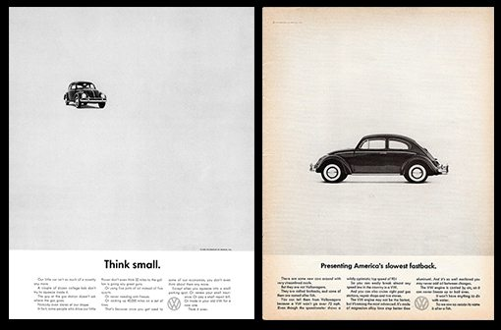
(Figure 1, Volkswagen 'Think Small')

“A picture is used to lead the eye to the written copy in magazine adverts and in commercials; language is often used merely to reinforce a photograph or filmed sequence” (Dyer 1982: 86). The adverts created by Carl Hahn the creative director of Volkswagen and copy writer Julian Koenig did not “try to turn the Beetle into something that it wasn’t. They simply emphasised the practical advantages of owning one” (Campaign: 2013). Carl Hahn’s aim to change the consumers opinion in the late fifties from a small ugly German car to an honest necessity proved a success. This campaign encapsulates the authenticity towards traditional advertising. Also suggesting how successful an uncluttered simplistic idea can engage with the consumer and become iconic.

It is sometimes said that traditional advertising – or at least some important parts of it are dead (Forbes 2016). This criticism is usually directed at classic billboards, the sort of large panel boards found on the sides of buildings and similar structures. Clear Channel is “one of the UK’ leading Out of Home media owners. They find innovative ways for brands to meet and engage people while they are out and about” (Clear Channel: 2017). One of the leading exponents of the use of this type of media, recently sent shock waves through the industry by announcing that it was cancelling contracts to rent space for the boards. It argues that the revenue available from these sites no longer exceed the rents that have to be paid. The company indicated that some sites would be abandoned where it was not felt desirable, or possible, to replace them with digital screens.

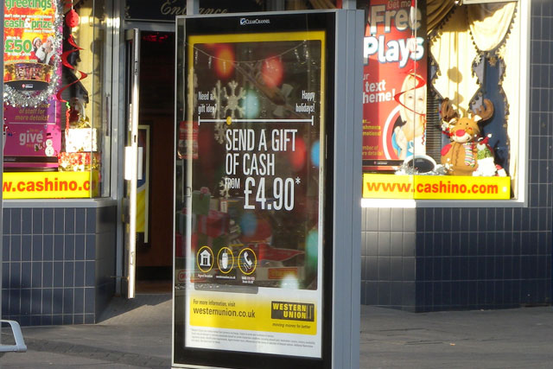
Figure 2 Clear Channel
In fact there remain many billboards in regular use. “There are still 15,000 in the UK but this figure is down by 17% over the last five years” (Daniel Farey – Jones: 2016). However, whilst this ‘outdoor analogue media market’ is still growing at around 2-3% per year, the annual growth of digital outdoor screens is over 30%. Glen Wilson, the Managing Director of Posterscope, argues that “billboards work because ‘out-of-home’ is still very much in the business of big, bright and broadcast” (Gideon Spanier: 2016). It is also true that the relative simplicity of messages presented on billboards makes them provide information to the consumer in a short space of time. This is important since, as will be discussed later, getting a marketing message over within the viewer’ attention span is very important.
Despite the historic and continuing importance of billboards, progress in advertising has and is still switching to the use of digital techniques. Here the emphasis is tending to shift to displaying messages on computers and smartphones making intensive use of the internet. Television advertising brings marketing messages into consumers’ homes. Advertisements on television and on mobile devices are often seen as being intrusive and undesirable, particularly if the perceived volume level increases during adverts as the result of volume compression.
It is said that the most used button on many television controllers is the “mute” switch (Daniel Engna: 2012). It is certainly true that, even now, many adverts on this medium can only be described as boring.
The Daily Mail recently reported that the average UK adult spends 24 hours every week in front of the TV. This ‘captive audience’ will only respond to advertisements that are not seen as boring but are so interesting that people are prepared to tolerate them for longer periods than their basic attention spans. A recent Microsoft consumer study claims that the “human attention span today is 8 seconds, down from 12 seconds in 2000” (Jaja Liao: 2016). It is perhaps unfortunate that many column inches in the press seem be the concerned with the fact that goldfishes also seem to have the same basic attention span. Clearly a way to attempt to solve this problem is somehow to increase the advert’s initial impact or to make it something that the viewer actually wants to see – that is make it actually entertaining.

Consumers today communicate and interact differently to commercial television adverts. Emotional connections contrived by brands such as John Lewis are evident, especially at seasonal times of the year. This emotional bond between brand and consumer is changing the way in which we view commercials today. John Lewis has created a simple yet effective approach within their television adverts each year which is to encourage the consumer to give presents rather than receive them. The most recent John Lewis Christmas advert named Moz the Monster follows the same narrative as previous years however journalist for the independent Yas Necati describes this years narrative as:
“Not heart-wrenching like the man on the moon, not heart-warming like the one with the snowmen, not even cute like Monty the penguin or funny like the dog on the trampoline. The monster under the bed is unremarkable and unrelatable”. (Necati 2017).


Figure 3 John Lewis Moz the Monster

This singular opinion of the unremarkable advert this year is also the reaction of many consumers, however the underlying narrative to give is still evident. Adverts such as this “add emotion a humour to everyday situations” (Zlata Rodionova 2016). Factors such as particular song choices which trigger memories with the consumer and create positive feelings each contributing to the success of John Lewis adverts.

Other traditional mediums such as the billboard still deliver powerful messaging and emotional connections with the consumer. The traditional billboard can be traced to an invention of the late 1790’s. Lithography allowed for mass production of posters for business to display their product or announcements. Billboards from the past are described as
“intrusive, inflexible and mute billboards. They feel like throwbacks to the old way of doing things. A flat image with an unyielding rule that the consumer can take in no more than eight words” (Nadja Lossgott, Creative Director at AMV BBDO: 2015).
This definitive view of past billboards can be related to however the success of ambient digital billboard advertising and interactive outdoor experiences relies heavily on past billboard ad campaigns and the increasing progression of technology. This rise in success of out of home advertising perhaps is a result of the billboards creating and immersive experience in which the consumer can relate too. The possibilities of how consumers will interact with billboards in the future are unlimited and will most likely progress predominantly throughout the next decade. “Smart billboards will create responsive abilities” (Ariella Brown :2017).
Advanced research projects agency (ARPA) created the first computer network in the 1960’s. “It used revolutionary concepts that still form the basis of the internet today” (Godfrey Parking (2009:17). As advertising emerged into the twentieth century new media materialised conveying adverts to consumers. As advertising is becoming more sophisticated and less interruptive the aim is to not produce irrelevant information and try to manipulate the consumer into buying unwanted products. This became the popular approach to advertising before the internet. Basic internet advertising also encapsulates traditional approaches however “Online advertising technology is becoming even more sophisticated. Advertisers are using cookies that allow brands to ‘retarget’ particular users” (Appnova: 2017). This quote suggests that before the internet targeting the relevant consumer proved difficult however improving technology within the internet is continuing to provide personalised data to determine where ad load should be distributed and targeted. Internet in the future may allow for increased access to personal data aiding advertising however this infringement on personal data could increase the risk of privacy. “Eventually, connectivity will be constant and streamlined to the point where no individual “connection” is really necessary” (Baraniuk: 2016). A world without WiFi codes could evolve by 2020 and endless possibilities such as the internet on Mars in the next decade with the use of satellites orbiting the planet. These are possibilities along with increasing adaptation of technology these idealisms could and most likely will be reality.
Lee Rainie, director of Internet, Science and Technology Research suggests that “the internet will become like electricity- less visible, yet more deeply embedded in people’s lives for good” (Rainie: 2017). The future of internet advertising according to Google will be as a result of brands and advertisers gaining intelligence of the users journey online. This findings from this chapter introduce examples of emotional connections between brand and consumer and definitive views of past billboards.

The future of traditional digital print advertising is strong. The continual huge advances with digital print techniques provide very focussed advertising media with print runs being very specific provide much confidence with print companies to keep making investments for shorter runs. An example of this is a local company, Stephens and George Printers in Merthyr. These printers go against the trend of print reduction they have invested heavily to make cost effective digital print runs for very specific market demographics. Large investment in small run digital printing which allows the advertisers to retain confidence that traditional marketing can still work but using the latest printing technology to maximise advertising revenue. This example shows how people will interact in the future with advertising, from my research I can see that it is far from a form of advertising that will disappear. It will grow by using cutting edge print technology. With much of traditional marketing being paid for it can still be very targeted with far more specialist journals in smaller print runs reaching a very targeted market place.
“All of our research shows that this core audience is turning to print for a long-term escape away from the never-ending madness of digital and 140 characters”. (Thomas Hobbs 2016)
People are returning to print much like the vinyl effect, companies such as Stephens and George Printers can provide something more accurate and versatile when it comes to big news, brands are waking up to that reality too. I found the above statement reinforced just how the future of traditional advertising will be but using technology to allow people to interact with local adverts and local news in a far more reactive way.

Chapter Two- Data Driven Advertisement
“New technology is always evolving we do not know yet where it will go however the end user will always adapt” (Dave Trott: 2011). Dave Trott industry expert suggests that the consumers will accept new technology however they will adapt it into their lifestyle. The consumers acceptance of new technology is important especially within data and digital driven advertising. Digital advertising allows for marketing media to be digitally displayed. It also allows advertisers to reach and address their main audiences with precision using new techniques. As technology is evolving consumers are now able to access content which is more relevant to their interests (also known as content consumption). Advertising creatives need to include key factors to attract their target audience as (Dave Trott: 2011) suggests “impact, communication and persuasion if you don’t have this nothing will happen”. Information, interactivity and entertainment are now the key components for a successful advert.

The progression of digital and data driven advertising allows consumers to choose content that interests them and which advertising platforms they view this content on. This form of interaction on platforms is called cross channel advertising and is emerging rapidly. As this interaction is increasing and more media channels are being used, tracking what audiences are viewing is becoming increasingly difficult. However data collated from the channels and platforms the consumer is viewing is important. The more that is known about the consumer and what content they are viewing allows advertisers to create relevant targeted content that includes their products for the end user. This is key to the progression and success of digital advertising.

Sir John Hegarty, fifty years veteran of the advertising industry talks about the evolution and the future of advertising. In an interview for (Campaign TV: 2013) Hegarty explains that “the industry hasn’t changed hugely the opportunity has changed”. The use and progression of certain technologies such as data driven advertising and surveillance technology has developed these opportunities further. However Hegarty also suggests that “marketing’s future lies in a return to the old basics of persuasion and promotion” (Hegarty: 2017). This quote emphasises that a return to the traditional advertising techniques is key.

Surveillance Technology is a new way of collecting specific data and allows brands to create commercials which are personalised to each individual consumer. An example of surveillance technology was reported in The Times newspaper “A billboard installed at Piccadilly Circus in central London will use surveillance technology to broadcast adverts based on peoples age, gender and mood” (Matthew Moore: 2017). This article explains the surveillance capabilities of cameras within the billboard, that are able to determine the demographic of the people surrounding the billboard. Piccadilly Circus “is considered the world’s most lucrative advertising spot with an estimated one hundred million passing through each year” (Moore: 2017). This technology is revolutionary allowing the billboard to interact personally with the surrounding consumers. The technology also includes location-tracking technologies, communications and improved imagery devices. “The suggestion that Piccadilly Circus will become a wall of personalised ads based on monitoring and tracking people, vehicles and WiFi connections crosses the creepy line by a clear mile” Media correspondent (The Times: 2017)

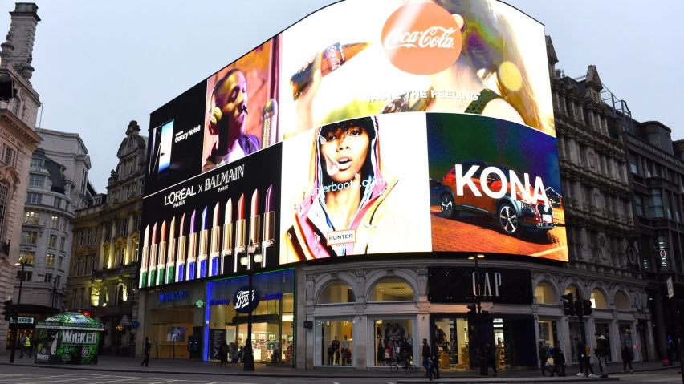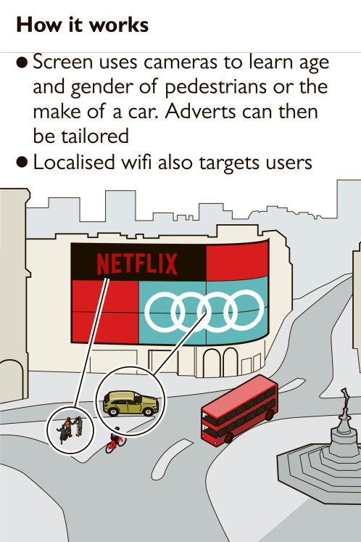
Figure 4 Piccadilly Surveillance Technology)

This quote suggests that there could be impending privacy factors that passers-by might be subjected to due to this new technology and data driven advertising. However when in the proximity of the billboard it does not collate and retain any information. “Technology is constantly moving forward through a series of spectacular advances or breakthroughs, to give us a stream of ever more ingenious products and services” (David Smith: 2006).

Data driven company Amazon who have flourished as a digitally based company did not suffer from the difficulties encountered by traditional retailers who had to adapt to using digital techniques. The company makes extensive use of what it calls “predictive analytics” (Jennifer Wills: 2017) for targeted marketing. This, it believes, increases customer satisfaction and builds company loyalty.
Amazon leads the pack in using CFE. This is a Collaborative Filtering Engine which analyses the items you purchased previously, what is in your cart at the moment, which products you have reviewed or rated and what you search for most. Done in real time the software can then recommend additional products that other customers purchased when they bought the same items as you. This is a powerful psychological tool which encourages impulse buying, supposedly increases your customer satisfaction and, importantly for the company, increases its annual revenue by up to 30%. Another tool which appears to be boosting sales is the concept of “Prime” whereby customers receive special treatment such as fast delivery and specially targeted promotions. This is not free but customers who use it seem to regard it highly. This type of consumer analysis has proven successful and changes the way in which the consumer is interacting with digital based companies.

Another example of data driven advertising is the brand Tesco, the largest food retailer in the UK and still enjoys the biggest market share, albeit its dominance is under constant pressure from rivals, many of whom have adopted its marketing techniques. The terminology for companies who analyse human behaviour with trends and buying patterns is known as (Big Data). For many years this company has appreciated the value of big data and has tracked customer activity through its loyalty or Club Card scheme. The very phrase implies that the individual customer is a member of a club to which they can feel privileged. By presenting a club card at the till the customer gains loyalty points which can be accumulated and used against future grocery purchases and, indeed, against a variety of other services available from 400 partners who include Hotels.com and Uber. Tesco itself gains enormous volumes of data about individuals gained from analysing their till receipts. The use of cameras to record facial characteristics has also been tried allowing factors such as age, gender and ethnicity to be determined. “Real time data analytics” or “dynamic analysis” are phrases used to describe how this sort of data can be processed as soon as it becomes available to help with stock control, waste management and to track how popular some products are.
The Club Card itself has recently been updated into a contactless version which the company feels will be easier to use. Tesco’s Chief Customer Officer, Alessandra Bellini, said “Tesco Club card is one of the most uniquely helpful things we do and it’s our way of saying thank you to our customers for shopping with us. “Tesco moved into online marketing early and it is here that the benefits of its big data may well be felt most of all. A customer signing in to its website is identified the system and the algorithm identifies their spending history, their likes and dislikes and is thus able to tailor the pages they receive to best suit their preferences and their ability to pay. The former CEO, Phil Clarke, once said in a five step guide article for Campaign magazine “that its website was intended to recreate the personal service that shoppers once used to enjoy on the High Street”

At the start of this chapter a quotation from Trott emphasised that, customers will always adapt to digital marketing techniques. It can be argued that such adaption is by no means certain – a fact that the industry would be well advised to take into consideration.
A number of surveys have been conducted into consumers’ attitudes to data collection about their buying habits and about their lifestyles in general. The results do not meet with overall approval. For example, two thirds of respondents would like to be better informed about how their data is used. Surveys by TRUSTE (a data privacy management company) and others found that as many as 87% are hesitant about data being stored at all. The new
Data Protection Acts of 1998 allows the consumer to ask companies what data they currently have collated on them as the safety of personal data, both within the home environment and outside, is considered important. Reports of data loss by a company can result in up to 70% of those individuals potentially affected deciding to no longer deal with them – potentially a catastrophic situation for the business. It would seem, therefore, that transparency and honesty from business to consumer is vitally important given the increase in digital marketing and its growth in the future.

Chapter Three – Experiential Advertising
Advances and breakthroughs within technology, also known as technological change, is constantly advancing and leaning to new innovation within the advertising industry. Surveillance technology is currently at the forefront of new technology innovation. However, the future for advertising messages placed on smartphones are not always successful. The generation of ad blockers which is a piece of software which prevents adverts showing on a web page and similar software designed to minimise intrusive messages means that it is often difficult to see how effective campaigns actually are. This means there is a constant drive within the industry to develop new mechanisms to ‘get the advertising word across’. One of the more promising factors is what has come to the known as ‘Experiential Advertising’. Experiential advertising directly involves the consumer and allows them to interact with the brand being advertised. There are names for what is essentially the same idea it is also termed as “Engagement Marketing”, “Participation Marketing”, “Live Marketing”, “Event Marketing” and others are also used within the industry.
These phrases mean a marketing strategy which directly involves individuals or small groups and usually encourages them to participate in the evolution of a brand. They are subjected to a brand experience which allows each individual to become connected with the brand. Some examples will be described below. Many of these advertising agencies use mobile phones as part of the campaign to strengthen the message they are aiming to get across. Many advertising agencies have developed their own technology to run alongside these campaigns. This technology further subjects the consumer to a “brand experience” which should allow each individual to become connected with the brand. We will consider two examples of what are award winning campaigns to promote a brand through experiential work. The first example is (PlayStation Four Launch of the new console in November 2013)
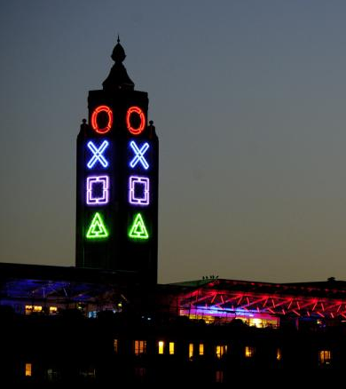
Figure 5 Play Station four OXO Tower

A glimpse of the future of interaction from this project was seen initially on Twitter. “Fever claimed the activity has generated 14.3 million impressions on Twitter since pictures were released online at 11.30am yesterday. It claimed that “600,000 people saw the UK PS4 launch messaging every hour at its peak” (Jonathen Tilley: 2013). The campaign was one of the of most cost effective experiential models in direct competition to the XBOX One Leicester Square traditional launch in the same week. The PS4 was true experiential campaign verses a traditional launch. The iconic OXO tower on the Southbank of the river Themes in London symbols were transformed into PlayStations controller symbols. This campaign illustrates the power of how marketing can drive technology in itself.

This was and still is in cases a way to grab and send very high speed local information. In this campaign “the PS4 project would have had local points on the banks of the Thames close to the OXO tower” PR Week, (Jonathan Tilley: 2017). The localised data points main objective is to send the consumer information and to also to grab data. The evolution of the PS4 brand by using experiential over traditional techniques in this instant was massively self-evident and successful.

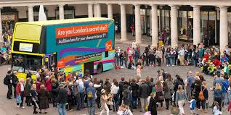
Figure 6 London Live bus

Another experiential campaign “London Live used a bus with a large interactive screen to help with launch of the Television station through London” (Samantha Edwards, Campaign: 2014). The campaign supports the effectiveness of experiential campaigns. The image shows how the bus can even become invisible. The bus had a call to action using the screen of events being done inside the bus. The above image, the media bus on location in convent Garden partnered with L’Oréal who became the launch bus main sponsor. The start of the Broadcasting from London Live was done from the upper floor of the bus in Leicester square.
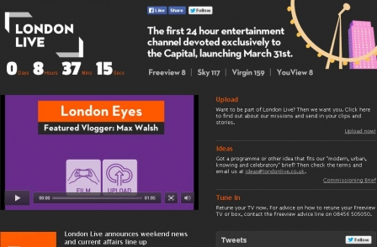
Figure 7 London Live Count Down

The above images indicates that countdown to the station launch used the Media Bus in London to create awareness through it being used as the focal point of the experiential marketing. From this campaign, not only does the bus provide the key experiential part, but it also provides internal space for amplifying a campaign. These projects show how important experiential campaigns will be with the merging of established and cutting-edge technology into the future of advertising.

Conclusion
To conclude this dissertation, I have established the progression of technological advances through particular campaigns in relation to each chapter title. The traditional chosen advertisements in chapter one describe the emotion between consumer and advert. The Volkswagen ‘Think Small’ campaign represents the importance of the chosen imagery and copy. John Lewis advertisements are a definitive example of this emotion between brand and consumer. I have also concluded after research into the future of technological advances how the constant change and improvement within the technology industry is aiding the future of advertising especially within the internet. I also established through thorough research the infringement of privacy from brand to consumer. ‘Brands and advertisers are constantly gaining intelligence of the users journey online’. This particular point I found important to explain further within the first chapter as the impending privacy breaches with the use of data collation from particular brands can become an infringement of privacy to the consumer and unpleasant. The first chapter also explains the benefits of personalised data which is a key component within the future of advertising and the way in which the consumer currently interacts with traditional advertising methods and changing elements including the use of personalised data. Each of the methods and platforms explained in chapter one provides the basis and example of a few traditional marketing methods within advertising. These chosen campaigns also provide a background in traditional methods with the use of new technology within the advertising industry.

Chapter two suggests the idealisms and thoughts of industry experts such as David Trott. The evolution of new technology and its effects are an essential element within this chapter. The explanations of data and digital driven advertising with examples such as surveillance technology with an aim to provide a clear and definitive understanding of the outcomes of using this form of new technology. The aim to describe the importance of the accessibility of new content for the consumer within chapter two is evident however to argue the point of what adverts the consumer is subjected to and what they would like to be advertised would be a point I would have liked to argue further. Including data driven companies such as Amazon within this chapter I found relevant to the chapter heading as companies such as this are huge components within the future interactions between the consumer and brand. An unlikely source however a relevant one that I thought to include was the Tesco club card scheme the reason for this choice in brand was due to the appreciation and the value Tesco has for the use of big data by introducing a scheme such as the Tesco Club card. This scheme encapsulates the idea of tracking customer activity and encouraging the customer to be a part of something in this case a club. This point again relates back to the brand John Lewis by encouraging the consumer to be emotionally apart of the brand itself.

My aim within this essay has been to enhance the possibilities showing examples of the relevant campaigns to each chapter. Chapter three demonstrates the most recent advances and breakthroughs within technology. Experiential advertising is a relevant example of how far powerful the emotional connection can be between brand and consumer. An example of good marketing strategy can be described within the PlayStation Four campaign which illustrates the power of how marketing can drive technology in itself. Another campaign I found relevant to include within this chapter to again highlight the importance of technology which is the key to the success of the future of advertising is the London Live bus. By using the experiential bus as a platform to broadcast London Live a new dimension and focal talking point was created for London Live. These campaigns provide an insight to examples of traditional advertising, data driven advertising and experiential advertising. The future is unknown however campaigns such as these provide a small insight and possibilities of what the future of the interaction between brand and consumer will entail.

Bibliography
Reference List:

Articles in Online Collections

Google Cloud Tech Summit (2017) Smart technology gives a real helping hand to business Available at: https://www.thetimes.co.uk/static/tech-summit/artificial-intelligence-gives-a-real-helping-hand-to-business/?mvt=i.[19.11.2017]

Sir John Hegarty (2017) ‘The future of marketing’ interviewed by Web Summit, (November 8th 2017),[16.11.2017]

Stephen Lepitek (2014) ‘The Drum Age of Disruption’, Sir Martin Sorrell on how technology is changing the marketing agency landscape,The Drum. Available at: http://www.thedrum.com/news/2014/06/26/age-disruption-wpp-boss-sir-martin-sorrell-how-technology-changing-marketing-agency.[19.11.2017]

Violet Blue (2017) The future of surveillance is hidden in airport ads by Engaget UK (October 13th 2017),[09.11.2017]

Books:

Dyer Gillian (1982) Advertising as Communication. London: Methuen & Co.Ltd

Hoffman Barry (2002) The Fine Art of Advertising. New YoRk: Stewart, Tabori & Chang

Ingles Fred (1972) The Imagery of Power. London: Heinemann

Mathewson James (2010) Audience, Relevance and Search. Unites States:IBM Press

Sewloll, Omesh. “Internet Advertising: An Emerging Model for the Future of Advertising [Thesis].” Thesis (MBA Marketing) - University of Wales Trinity Saint David / CTL, London . 2011, 2011.

Smith David (2006) Exploring innovation. New York: The McGraw-Hill Education

Wojdynski, Bartosz W. “Native Advertising and the Future of Mass Communication.” American Behavioral Scientist, vol. 60, no. 12, 2016, pp. 1403–1408., doi:10.1177/0002764216660134.

Illustrations:

[Figure 2, Clear Channel]. Campaign, 2016. Skips rent on 800 billboards[Image]Available at: https://www.campaignlive.co.uk/article/clear-channel-skips-rent-800-billboards/1412367 [04.11.2017]

[Figure 3, John Lewis].Independent,2017. Hope of the last John Lewis Advert.[Image] Available at: http://www.independent.co.uk/voices/john-lewis-christmas-advert-2017-moz-the-monster-what-is-it-money-preparation-a8046786.html [05.11.2017]

[Figure 6, London Live bus]. London Live Bus. 2017.The Graph. [Image] Available at: https://www.graph.uk/case-studies/london-live-digital-platform-development. [24.11.2017]

Figure 7, London Live Count Down.2017. RT Question more. [Image] Available at: https://www.rt.com/business/lebedev-london-tv-channel-321/ [27.11.2017]

[Figure 4, Piccadilly billboard]. The Times.2017.The billboard that has its eye on you[Image] Available at: https://www.thetimes.co.uk/article/personalised-ads-delivered-by-the-billboard-that-s-got-its-eye-on-you-hrxwrrb3z[10.11.2017]

[Figure 5, Play Station four].The telegraph. 2017. Play station make over[image] Available at: http://www.telegraph.co.uk/technology/video-games/10451558/PS4-launch-Londons-OXO-Tower-gets-PlayStation-makeover.html[23,11.2017]

[Figure 1 Volkswagen]. Volkswagen, 1959.Think Small[Image]Available at: https://designshack.net/articles/graphics/the-greatest-print-campaigns-of-all-time-volkswagen-think-small/ [02.11.2017]

Interviews

Dave Trott (2011) interviewed by Dave Birss for Additive,2011(online). (Available at: https://vimeo.com/32202639)

Sir John Hegarty (2013) ‘John Hegarty on Industry Changes’ interviewed by Campaign TV, (October 4th 2013)

Steven Hawkin (2017) ‘Artificial Intellegence’ interviewed by Joao Medeiros Wired, (November 28th 2017)

Journals:

Curb media 2016 Available at: http://www.curbmedia.com/portfolio-item/ps4/ [13/12/2017]

The Dose (2017) Available at: http://www.digitasdose.com/2017/05/google-marketing-next-2017-showcasing-future-advertising/ [04/12/2017]

Graph (2017) Available: https://www.graph.uk/case-studies/london-live-digital-platform-development [06/12/2017]

The Insider (2017) Available at: https://thenextweb.com/insider/2017/03/06/the-incredible-growth-of-the-internet-over-the-past-five-years-explained-in-detail/ [10/11/2017]

PR Week, Jonathan Tilley (2013) PlayStation's redecoration of the Oxo Tower. Available at http://www.telegraph.co.uk/technology/video-games/10451558/PS4-launch-Londons-OXO-Tower-gets-PlayStation-makeover.html [05/12/2017]

Websites

Adage 2017. Available at” http://adage.com/article/media/future-tv-advertising/303565/ [09/11/2017]

Daniel Farey Jones, Campaign. (2016) Clear Channel skips rent on eight hundred billboards. Available at: https://www.campaignlive.co.uk/article/clear-channel-skips-rent-800-billboards/1412367#soj1rBKIRRB9L4fE.9927.[27.10.2017]

Nadja Lossgott (2017) Available at: https://www.dandad.org/en/d-ad-outdoor-advertising-features-opinions/[10/11/2017]

National Science and media museum. (2011). Available at https://blog.scienceandmediamuseum.org.uk/short-history-british-television-advertising/. [02/11/2017]

Padtronics 2017. Available at: https://www.padtronics.com/how-a-smart-billboard-is-changing-how-consumers-interact-with-products/[02/11/2017]

Robert Klara.(2017). How the Hollywood sign went from temporary billboards to a symbol of Americas showbiz capital. Available at:http://www.adweek.com/brand-marketing/the-hollywood-sign-is-king-of-the-hill/ . (2017) By Robert Klara [01/11/2017]

Hobbs Thomas. (2016)https://www.marketingweek.com/2016/07/28/how-newspapers-can-convince-advertisers-to-return-to-print/ [02/11/2017]

Additional Reading List:

Cury, Ivan. TV Commercials : How to Make Them or, How Big Is the Boat? Oxford, Oxford : Focal, 2005.

Dahlen, Micael. “If Advertising Won't Die, What Will It Be? Toward a Working Definition of Advertising.” Journal of Advertising, vol. 45, no. 3, 2016, pp. 334–346., doi:10.1080/00913367.2016.1172387.

Newth, Tom von Logue. The Ad-Makers : How the Best TV Commercials Are Produced. New York : Focal Press, Taylor & Francis Group, 2013.

Richins, Marsha L. “An Analysis of Consumer Interaction Styles in the Marketplace.” Journal of Consumer Research, vol. 10, no. 1, 1983, pp. 73–83.

Wojdynski, Bartosz W. “Native Advertising and the Future of Mass Communication.” American Behavioral Scientist, vol. 60, no. 12, 2016, pp. 1403–1408., doi:10.1177/0002764216660134.

