
Module Title: Marketing Management
Module Code: LCMB7024
Assessment Component 2: Marketing Portfolio

Student ID:2510655
Student Name: Divyesh Desai

Table of Contents
Introduction 3
Element 1: STDP analysis 4
Element 2: Marketing Mix: 4Ps 8
Element 3: Marketing strategy pitch 11
Element 4: Reflection 13
Conclusion 15
References 16
Appendix 17

Introduction
The aim of the report is to introduce a new sub-brand of Samsung that is HomeChef, which is designed for improving the position in the category of smart kitchen. Samsung is a leading global technology company that is known for its capabilities in digital innovation, smart devices, and consumer electronics (Samsung, 2025).

Figure 1: Logo of Samsung
(Source: Samsung, 2025)
The brand has developed an effective presence in home appliances, televisions, and smartphones. Samsung is expanding its business in intelligent automation to improve everyday living. The new brand, Samsung HomeChef, will focus on AI cooking companion devices that include an AI cooking assistant with gesture and voice control, which is an auto recipe generator that recommends meals based on advanced kitchen sensors and available ingredients. The new concepts aim for making home cooking safe, effective, and personalised. Samsung HomeChef directly responds to the emerging trends in which consumers look for convenience and healthier meal solutions. In the report, the marketing of the new brand has been analysed by focusing on STDP analysis, marketing mix, and marketing strategy pitch.

Element 1: STDP analysis
Segmentation
Effective segmentation is important for allowing Samsung HomeChef to reach the consumers who are likely for valuing AI-enabled technology in the Kitchen. The market for smart devices in the kitchen could be divided by using “demographic, psychographic, behavioural, and geographic” variables.
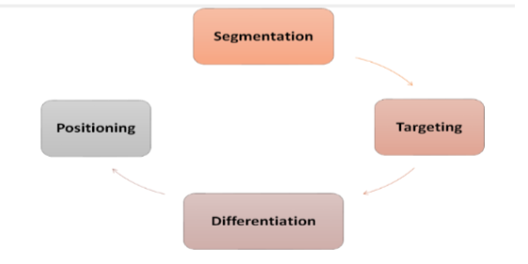
Figure 2: STDP market model
(Source: Fripp, 2025)
- Demographic segmentation: This highlights that the primary users of the new brand could be adults from the age group 25-55 because this age group is responsible for household technology purchases and meal preparation. In this age category, several are dual-income households that have higher disposable income. This group involve technology adopters that are familiar with IoT connectivity, AI-powered features, and digital interfaces (Theocharis, et al., 2025). These consumers are open to implementing several devices with the help of ecopsystem, such as Samsung SmartThings.
- Psychographic segmentation: This focuses on attitudes, values, and lifestyles of the consumer. Samsung HomeChef highly appeals to convenience seekers who prefer automated, fast, and simple cooking processes due to a busy schedule. It also targets health-conscious consumer who values healthier cooking methods, better ingredient management, and personalised meal recommendations. The third group of psychographics includes smart-home enthusiasts individuals that enjoy experimenting with new technologies as well as optimising their living standards by utilising interconnected devices.
- Behavioural segmentation: This type of segmentation examines consumers' readiness and habits for adopting new technologies. The brand is important for users who effectively engage with kitchen tutorials, recipe platforms, and cooking apps. These individuals use technology for supporting meal preparation and are willing to upgrade to devices which are AI-enabled (Dakhia, et al., 2025). It also includes consumers with high choices for adopting AI devices, mainly that who already use smart appliances such as smart sensors, smart ovens, and AI refrigerators.
- Geographical segmentation: This shows that the demand for Samsung HomeChef could be strongest in urban markets with high integration rates of digital infrastructure and smart appliances. These urban locations have higher technology exposure, familiarity with interconnected systems of home, and high income levels. Regions in Japan, South Korea, Europe, and North America show opportunities for the new brand.
Targeting
Based on the analysis of segmentation, Samsung Homechef could integrate a differentiated targeting strategy by selecting multiple segments with product benefits and tailored messaging. This strategy aligns with the overall marketing strategy of Samsung that targets consumers with the help of several technology solutions designed for different lifestyles. The primary target market of the new category consists of urban families and professionals who already value convenience and utilise smart devices. Furthermore, these consumers face limited time for cooking and depend on rapid meal solutions. Samsung HomeChef offers them real-time monitoring, automated guidance, and personalised recipes by reducing the effort and stress associated with the preparation of daily meals. Families also appreciate the sensors of safety that detect gas leakage, food spoilage, and overheating, which make the kitchen safe for older adults and children.
The secondary target market involves young tech-savvy individuals such as early-career professionals, fitness-focused individuals, and students who regularly utilise meal-prep routines and cooking apps. This group is highly comfortable with AI services, IoT systems, and mobile apps. For them, Samsung HomeChek offers an enjoyable and innovative experience of cooking by providing help for maintaining healthier eating habits and new recipes. Meal preparation also attains benefits from ingredient-based recipe suggestions that support planned weekly meals and reduce food waste. Targeting allows the company for reaching younger digital adopters and premium users by allowing wider penetration of the market and maintaining strong value propositions (Bakashaba and Bindeeba, 2025).
Differentiation
It has been analysed that for attaining success in the competitive market of smart kitchens, Samsung HomeChef could effectively differentiate itself from AI-based cooking competitors and existing smart appliances. Moreover, the brand also offers various distinctive strengths that are different from others. An AI-driven personalised cooking system is the major differentiator that adapts cooking times, techniques, and recipes to the dietary needs and individual preferences. Samsung HomeChef utilises real-time data as well as the history of users for providing customised recommendations by making the cooking enjoyable and efficient. Implementation with the Samsung SmartThings ecosystem is also a major advantage. The devices of HomeChef connect with tablets, smartphones, ovens, and refrigerators by allowing cross-device synchronisation. The brand also stands out with the automated recipe generation that utilises AI for analysing user preferences, nutritional needs, and ingredients. This reduces the time of decision-making and helps the users in avoiding repetitive meals.
In addition, the inclusion of smart safety sensors, such as food freshness notifications, gas monitoring, and heat detection by adding significant value. These features allow a safe cooking environment, mainly for families.
Positioning
Samsung HomeChef could be positioned as a health-supportive, intelligent, and premium AI cooking companion that is designed for simplifying and increasing everyday experiences of cooking. The positioning shows three main pillars that are well-being, personalisation, and innovation. The positioning statement of the company for the new category is “For busy households and tech-savvy individuals, Samsung HomeChef is a smart, AI-powered kitchen companion that delivers personalised recipes, safer cooking, and seamless device integration by offering a modern and healthier cooking experience that traditional appliances cannot provide”.

Element 2: Marketing Mix: 4Ps
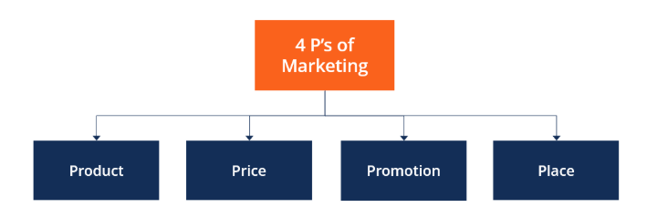
Figure 3: 4 Ps of marketing
(Source: CFI, 2025)
Product
Samsung HomeChef is a solid range of AI-powered devices of cooking devices that are designed for making everyday cooking safer and easier. The main products involve the auto-recipe generator, smart kitchen sensors, food freshness monitoring, and an AI cooking assistant. These devices provide step-by-step cooking automation, real-time alerts, and AI-based recommendations by helping users for cooking meals with less effort. The design of the product focuses on usability, elegance, and simplicity. The devices follow the modern aesthetic of Samsung by using metallic finishes, easy-to-read digital displays, and smooth surfaces. The interface is user-friendly with seamless transitions between screens, intuitive navigation, and clear icons. The logo of the HomeChef brand features a modern and clear design. However, packaging uses recyclable materials for reflecting the values of sustainability. QR codes on the link of packaging link users to the digital manuals by reducing the waste of paper (Ozturkcan and Kitapci, 2025). The brand is also designed to fit effectively with the overall image of Samsung of smart-home integration and intelligent living. The main advantage is integration with the SmartThings app of Samsung that allows users for receiving alerts, synchronising recipes, controlling devices remotely, and link the product with other appliances of Samsung appliances, such as refrigerators and smart ovens.
Price
Samsung Homechef could use a premium strategy of pricing by showing its advanced features of AI, close integration with the SmartThings ecosystem, and high-quality materials. Furthermore, cooking devices of AI show a growing but premium pricing shows advanced performance, durability, and reliability. Consumer who values automation, safety, and convenience are more likely for accepting a higher point of pricing (Wang, et al., 2021). The structure of pricing could involve versioned models for catering to different budgets and needs.
- The standard model could involve important features such as basic safety alerts and AI recipes.
- The pro model could offer improved sensor precision and sophisticated automation.
- The elite model could provide advanced AI processing, premium design features, and full ecosystem integration.
Samsung could also offer bundle options, such as pairing the AI assistant for cooking with gas sensors. Bundled pricing encourages multi-product adoption as well as enhances the loyalty of consumers in the ecosystem of Samsung. Additionally, Samsung could introduce an optional service of subscription service for users who want access to an expanded database of recipes, regular software updates, and AI-driven diet plans. This model of subscription develops recurring revenue and supports long-term engagement by allowing basic functionality of the product for non-subscribers.
Place
Samsung HomeChef could use an omnichannel distribution strategy for reaching a wide range of consumers with the help of digital and physical touchpoints. This approach improves accessibility as well as supports different preferences of shopping preferences (Černikovaitė, et al., 2021). This product could be shown in the retail stores of Samsung, where consumers could interact with the experience, live demonstration and devices. These stores act as an essential space of education by allowing consumers for seeing the way that AI features work and how devices connect with other products of Samsung products. Online sales could be an important part of the distribution strategy (Zhang, et al., 2023). HomeChef devices could be available on Samsung.com by allowing consumers for comparing models, accessing exclusive bundles, and exploring detailed product information. In addition, the product could be sold on major platforms of e-commerce platforms such as Amazon by offering convenience and increasing reach to consumers who prefer fast online shopping. Moreover, Samsung could also place Homeche in kitchen showrooms and premium electronics such as smart-home design studios, home-improvement centres, and appliance retailers. These showrooms attract consumer who are upgrading their kitchens to advanced cooking technology. Well-trained staff of sales staff in this environment could explain the benefits of the product and provide demonstrations.
Promotion
The promotional strategy could focus on showing product value, motivating purchase intention among target consumers, and building awareness (Luo, et al., 2022). Samsung HomeChef could be promoted by using a combination of experiential and digital marketing activities. Key activities of promotion involve educating consumers about the benefits of AI cooking by showing convenience and safety features, and positioning HomeChef as a premium solution for the smart kitchen. The promotional mix could start with digital advertising on platforms such as Facebook, Instagram, YouTube, and Google. Advertisements could show the way that HomeChef integrates with smart things and simplifies meal preparation. Short videos show real-time guidance of AI, and recipe suggestions could help potential users in understanding the value of the product. Influencer collaboration could play an important role in enhancing the sales of Samsung HomeChef products. The firm could make partnerships with lifestyle influencers, home cooks, and chefs who could show the product with the help of live sessions and videos (Sokolova, et al., 2024). Social media campaigns that majorly use YouTube cooking influencers could help in attracting tech-savvy and younger audiences.
With the help of a combination of influencer engagement, experiential marketing, and digital promotion, Samsung HomeChef could build strong wareness of brand awareness and encourage the adoption in the market of smart-kitchen.

Element 3: Marketing strategy pitch
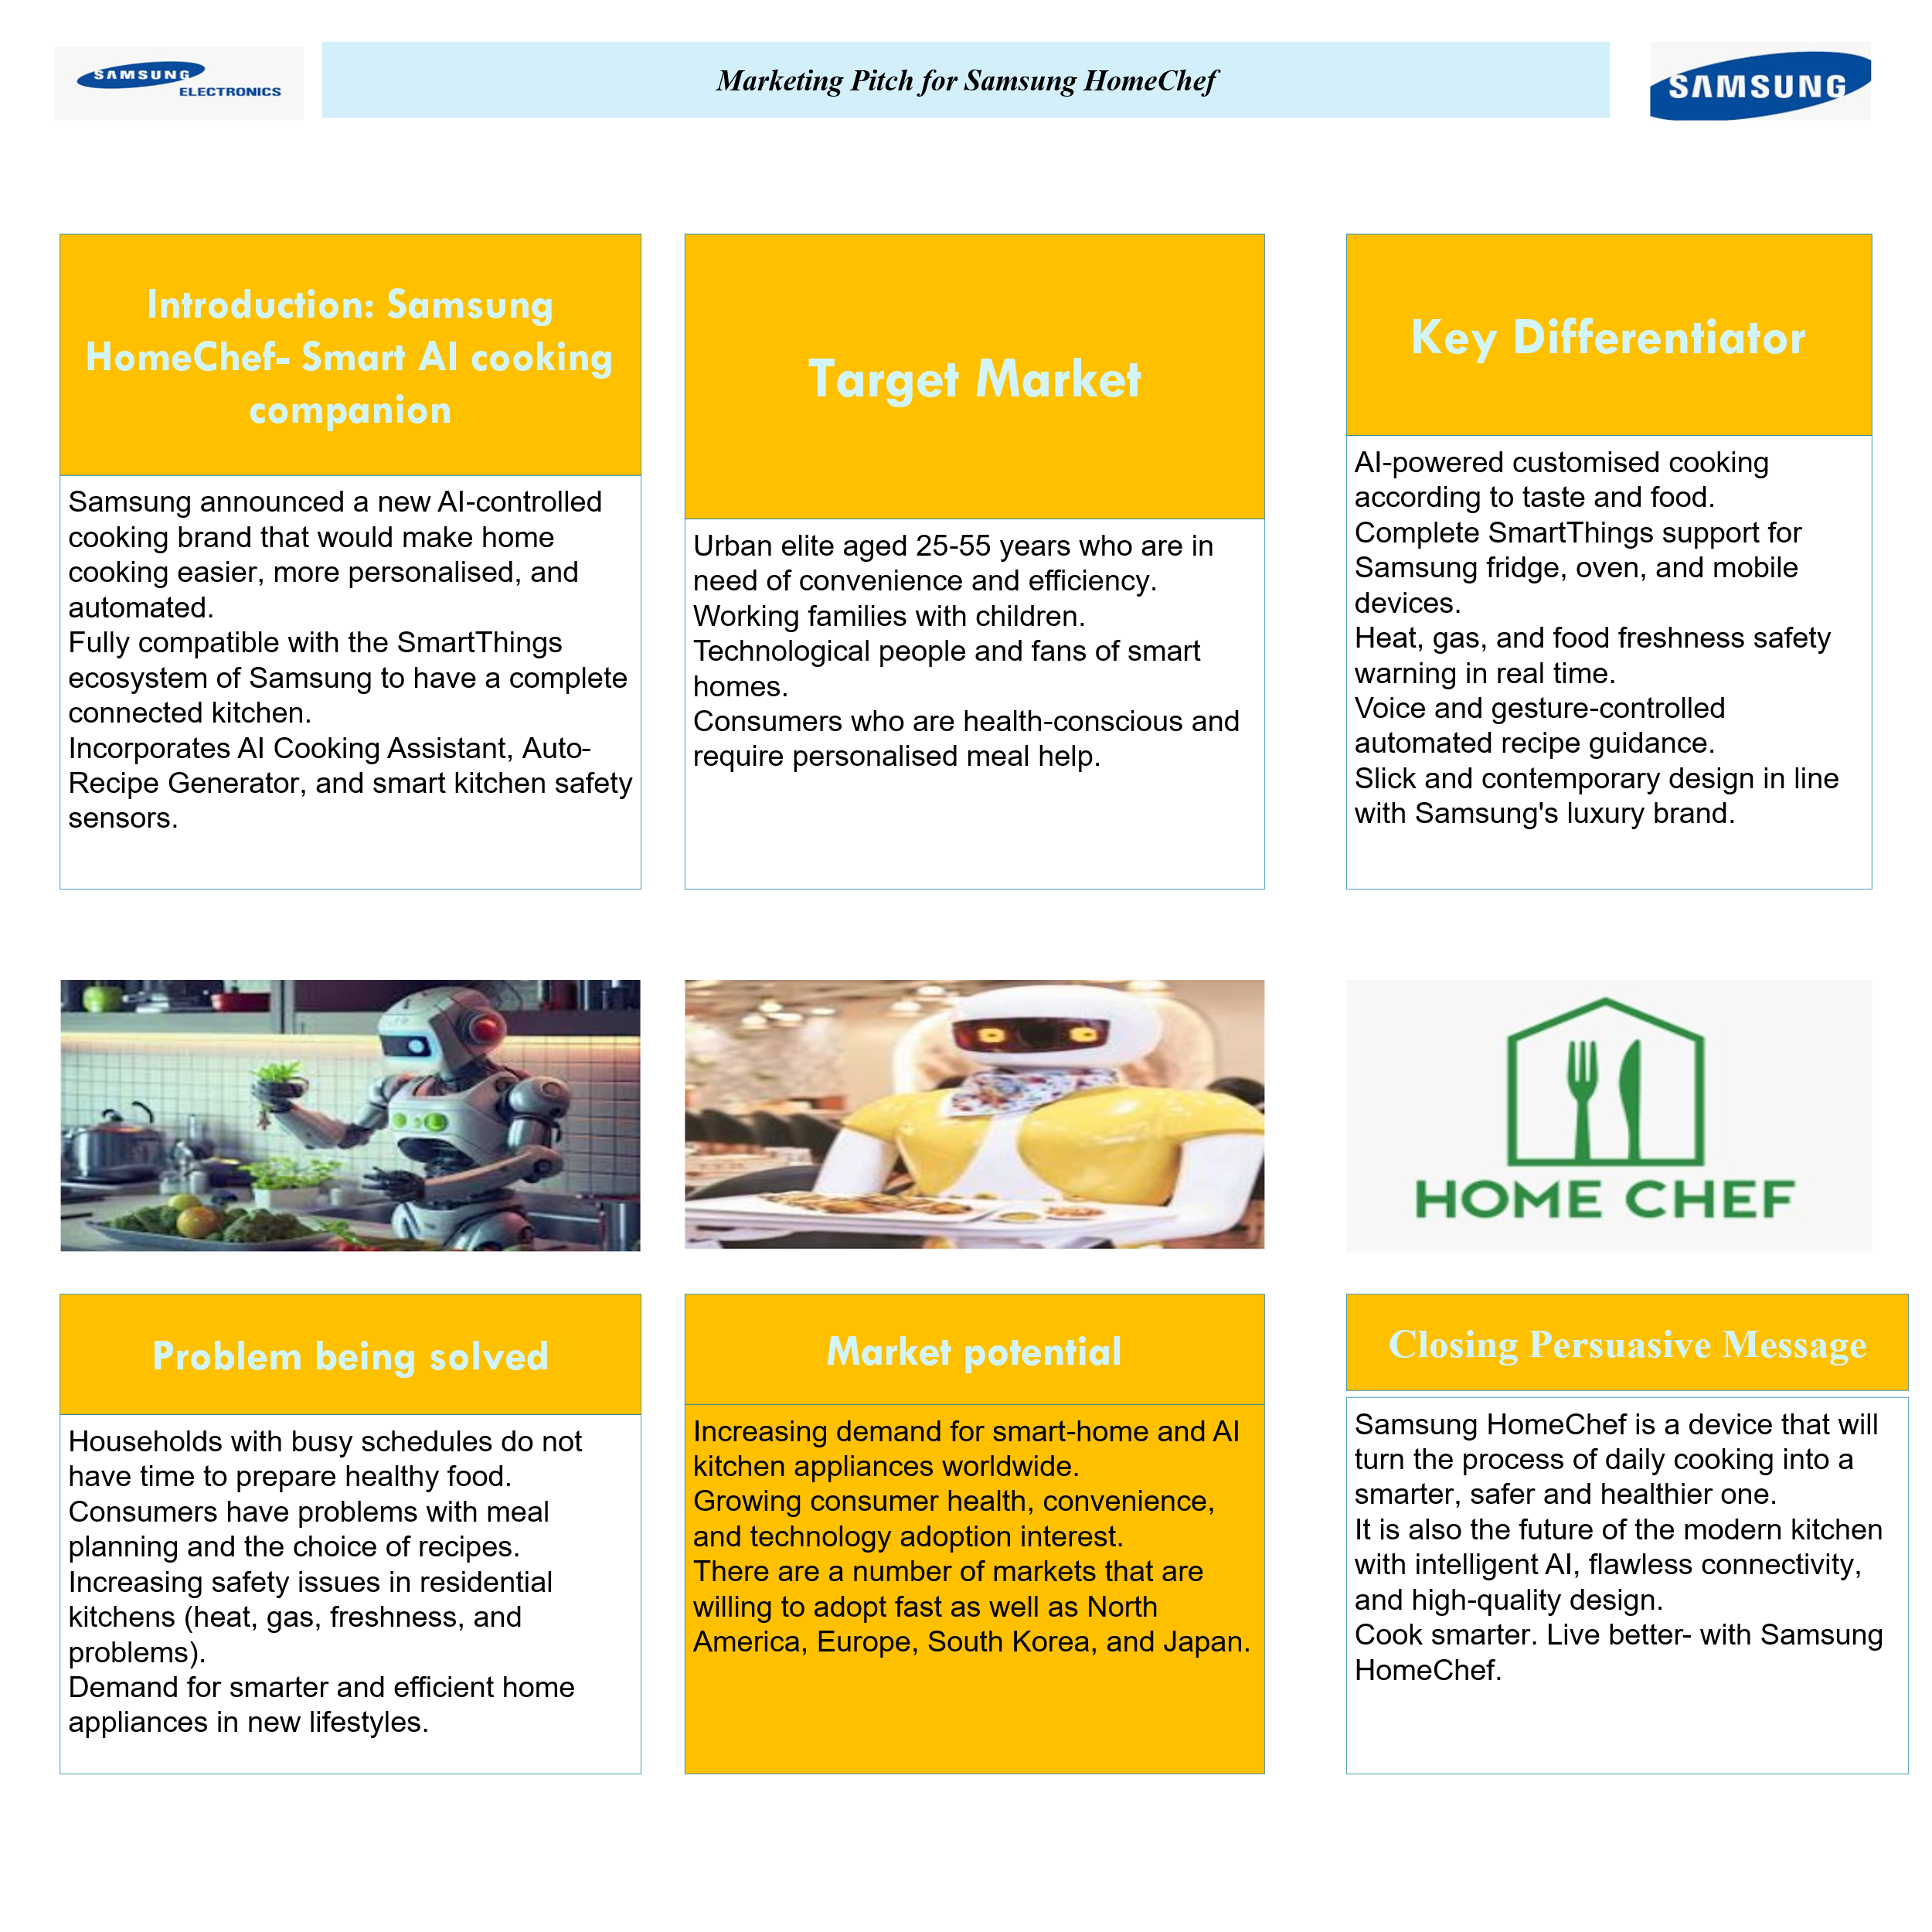
Figure 4: Marketing Pitch for HomeChef of Samsung in a digital kitchen
Samsung HomeChef is a new cooking companion that is AI-powered which is designed for making everyday cooking safer, faster, and easier. The brands help in introducing an AI cooking assistant, smart kitchen sensors, and an auto recipe generator. It suitably implements the Smart Things ecosystem of Samsung by developing an intelligent and connected kitchen experience. HomeChef helps in addressing some key issues faced by modern households that involve safety issues in the kitchen, difficulty choosing meals, and limited time for cooking. It is well designed for tech-savvy individuals, health-conscious consumers, dual-income families, and urban professionals who value personalised and convenient support. The brand looks different from competitors with the help of its AI-driven recipe recommendations, cooking automation, and real-time safety alerts. Its cross-device syncing and premium design improve its position as a reliable and modern kitchen tool. HomeChef develops strong value by improving kitchen safety, allowing healthier choices of meals, and reducing food wastage.

Element 4: Reflection
Developing the new concept of the brand for Samsung HomeChef was an important learning experience that has helped me in understanding the way that consumer needs, innovation, and branding connect in marketing strategy. Moreover, developing a new product in the established company has encouraged me for thinking creatively by considering the strengths, capabilities, and identity of the company. In this case, strong background of Samsung in smart-home technology made the cooking concept of AI for feeling achievable and realistic. The main challenges that I faced during the project were exploring the STDP framework. It needs careful thinking for segmenting the market suitably as well as selecting accurate target groups. I had realised that segmentation is related to listing demographic categories and how different patterns of lifestyle impact the adoption of a product. Furthermore, selecting the target audience also requires balancing creativity and practicality. Developing positioning and differentiation also demands clear reasoning for supporting the brand in a competitive business environment.
There are several issues in building the marketing mix, mainly in deciding which pricing levels and features could make the appealing of product appealing that is aligned with the premium brand of Samsung. I had to think effectively about distribution choices, promotional activities, and product design by ensuring that all elements are supported the overall concept of the brand. This process has improved my ability for connecting theory with effective decision-making. In the entire project, I developed various skills. Critical thinking has helped me in analysing the trends of the market and justifying strategic choices. Moreover, creativity was important for identifying the way that AI could transform the experiences of cooking. Strategic planning has guided the structure of the marketing mix and brand by allowing consistency. Research skills are required for understanding the trends of smart-home, technology adoption patterns, and consumer behaviour.
Developing the marketing pitch has helped me in analysing the importance of clear and persuasive communication. Further, summarising the entire strategy of brand strategy in a short message needs focus on some important points. I had learned how for showing benefits effectively and speak in a way which appeals to potential investors and consumers. In the projects of future marketing strategy, I could focus on collecting deep insights of consumers as well as comparing competitors suitably. I aim for improving the visual presentation of the use of data and ideas for supporting decisions. This project has improved my confidence in developing new concepts of brand and integrating marketing frameworks.

Conclusion
As per the findings above, it can be concluded that the development of Samsung HomeChef shows the way that smart-home and AI technology could develop suitable value in the era of the modern kitchen. With the help of integrating the STDP framework as well as the marketing mix, it is analysed that the brand could meet the preferences of tech-oriented, health-conscious, and busy consumers. The concept of HomeChef offers differentiation with the help of safety features, seamless smart things integration, and personalised cooking assistance. Overall, Samsung HomeChef shows an innovative and strategic opportunity that aligns with the current trends of consumers and the technological strengths of Samsung.

References
Bakashaba, R. and Bindeeba, D.S. (2025) Beyond market penetration: leveraging brand capital for competitive advantage in digitally driven SMES in resource-constrained settings. Future Business Journal, 11(1), pp.1-18.
Černikovaitė, M., Karazijienė, Ž., Bivainienė, L. and Dambrava, V. (2021) Assessing customer preferences for shopping centers: Effects of functional and communication factors. Sustainability, 13(6), p.3254.
CFI. (2025) 4 P’s of marketing. [Online]. Available at: https://corporatefinanceinstitute.com/resources/management/4-ps-of-marketing/. [Accessed on: 27 November 2025].
Dakhia, Z., Russo, M. and Merenda, M. (2025) AI-Enabled IoT for Food Computing: Challenges, Opportunities, and Future Directions. Sensors, 25(7), p.2147.
Fripp, G. (2025). Understanding the STDP process in Marketing. [Online]. Available at: segmentationstudyguide.com/understanding-the-stdp-process-in-marketing/. [Accessed on: 27 November 2025].
Luo, B., Li, L. and Sun, Y. (2022) Understanding the influence of consumers’ perceived value on energy-saving products purchase intention. Frontiers in Psychology, 12, p.640376.
Ozturkcan, S. and Kitapci, O. (2025) A sustainable solution for the hospitality industry: The QR code menus. Journal of Information Technology Teaching Cases, 15(1), pp.2-7.
Samsung. (2025) About us. [Online]. Available at: https://www.samsung.com/in/about-us/company-info/?srsltid=AfmBOorhx5lHMqUCZXDumpnWcPrGpwERhTkUpF4Fq7wbz4qO2wJZraWk. [Accessed on: 27 November 2025].
Sokolova, K., Perez, C. and Vessal, S.R. (2024) Using social media for health: How food influencers shape home-cooking intentions through vicarious experience. Technological Forecasting and Social Change, 204, p.123462.
Theocharis, D., Tsekouropoulos, G. and Athanasios, G. (2025) The Digital Generation: Branding and Consumer Behavior in Tech Adoption. Rural and Regional Development, 3(3), p.10009.
Wang, I.C., Liao, C.W., Lin, K.P., Wang, C.H. and Tsai, C.L. (2021) Evaluate the consumer acceptance of AIoT‐based unmanned convenience stores based on perceived risks and technological acceptance models. Mathematical Problems in Engineering, 2021(1), p.4416270.
Zhang, X., Ma, C., Hu, J. and Shi, W. (2023) Optimal distribution strategy and online channel mode by considering retailer’s fairness concerns. Journal of Industrial and Management Optimization, 19(4), pp.2889-2914.

Appendix

