
Skills for the Workplace
Module Assignment Submission
Student Name: | James Lewis
Student Number: | 2019456
Module No: | BMSK5008
Module Title: | Changemakers: Building your Personal Brand for Sustainable Employment

Statement of Confirmation of Authenticity
By the act of making this submission, the student declares that this is the work of the student named above. The work has not, in whole or in part, been knowingly presented elsewhere for assessment, or where assessment has been built on a previous assessment, this has been identified. Where materials have been used from other sources it has been properly acknowledged. If this statement is untrue, the student acknowledges that an assessment offence has been committed.
Attention is drawn to the plagiarism and unfair practice policies of both the University and of ILM.

Table of Contents

Description 2
Feelings 2
Evaluation 3
Analysis 3
Conclusion 5
Appendix 6

Description
After completing the modules of the Changemakers: Building your Personal Brand for Sustainable Employment, I have covered the four sections of the module: Brand You, It’s a Small World, Opportunity Knocks, and the Pursuit of Happiness. These modules covered in detail the skills needed to build a professional online presence. I will use the Gibbs reflective cycle (1988 see appendix), to evidence what I learnt while completing the modules and how my e-learning journey has helped me develop my own personal brand.

Feelings

My initial adjustment to Changemakers: Building your Personal Brand for Sustainable Employment was somewhat challenging due to the extensive learning materials and assessments I had to complete. As a result of this, I became excessively stressed due to another assignment that was running concurrently and I believe this affected the overall effort I was not able to put into this module as I do believe the main modules on the course are more important. Despite being self-taught, the online learning modules had to be completed at your own pace. I was tasked to complete two assignments while having to concentrate on completing the e-learning modules. The first assignment consisted of two parts, the first task was to create a personal development plan (PDP) and a professional CV. The second part consisted of completing a zander letter. The second assignment was the reflective part of the assignment which I had to complete after completing the E-learning. After reviewing the content within the modules, I felt more comfortable about completing the four modules and found the modules to be very interesting and beneficial to my ongoing learning process. In addition to being insightful, I found the modules to really assist me in growing my own personal brand. I was able to learn about a number of subjects that I had not previously studied, and I enjoyed them very much.

Evaluation
While my e-learning experience was positive and negative, I found that all the modules contained insightful and easy-to-understand content. In addition to providing additional content, each module included easy to follow and understand instructions. I found all modules extremely helpful when seeking additional knowledge on a particular subject. In spite of my best efforts, I encountered some technical difficulties while viewing the slides. I encountered difficulty loading certain modules, which caused me to lose some time from my learning and would also cause me to break out of a good work flow. Additionally, I encountered issues with modules that would kick me out of slides, and I was unable to find the module I was currently on because the modules did not indicate which modules had already been completed or took me directly back to the module I was currently in.
Overall, I had a positive experience with the learning process and believe it is an effective method of learning as it can be performed in your own time and can also be reviewed if necessary, compared to classroom-based learning, which has advantages such as being taught by someone who is real and having the ability to ask questions when necessary. In the event that I do not understand a module, I must regularly ask lectures for additional assistance. However, things can be misconstrued, and I frequently have to seek additional assistance.

Analysis

After reflecting on the modules, I noticed several aspects of e-learning that were particularly appealing to me. In unit 1, Shaw quoted, “lift is not about finding yourself, but about creating yourself.” This gave me the confidence to be more creative when developing my own brand, rather than just following others’.
It was also discussed in Unit 1 what authenticity means. I really liked the quote “The key to building a strong personal brand is being authentic, not trying to be someone else but being true to yourself, your skills and your expertise to create an effective personal brand”. In my line of work, it is crucial that you rely on your skills to promote yourself, especially when you are self taught.

It was particularly noteworthy in one of the modules where it explained in detail how networking is so important to building a personal brand. In order to cultivate a diverse and robust professional community, it is important to understand the importance of networking, recognise positive connections, and identify potential collaboration opportunities. Having a network can help you develop a brand for yourself by providing you with new insights and fresh perspectives. Another person may be able to offer advice and guidance if they have encountered a similar problem to ours when networking.
Building a brand can be an extremely difficult process, and having real world experience from people who have been in the same position as me can be a tremendous help to me. According to Koestler (1964), stimulating new experiences will enable you to act creatively, forge new networks, and meet new people outside your friendship circle, proving why networking is so important.

A marketing strategy known as the Five C’s was also another topic which helped me gain a better understanding of creating my personal online presence. It consists of five things that will help you succeed when creating content and promoting yourself. The five C’s are:

Communication - Publish, discuss, express and influence your opinion through blogs, media sharing, discussion forums, microblogging, and instant messaging. Examples of this type of communication include blogs, media sharing and discussion forums.

Collaboration - Collaboration is the ability to interact with others and create content. Ribeiro, S. (2020) argues that collaboration enhances your team's ability to work together, increase efficiency, and communicate effectively.

Connecting - As a result of social networking, virtual worlds, and other forms of networking, individuals can establish connections with one another and influence others positively. According to Benton, D. (2021), building connections can have a significant impact on your reputation. The simple act of making a warm comment, a friendly smile, and a positive interaction can significantly enhance your reputation.

Completing - A description of how content rating and serendipity are applied, such as tagging and social bookmarking

Combining - Using a combination of tools and technologies like platforms that allow you to schedule content for social media platforms

It was an insightful module that provided information on the four categories of influencing tools that are required to develop an online presence. They are:
- Blogs and microblogs - Twitter and WordPress
- Social networking sites - Facebook, LinkedIn
- Picture sharing - Instagram and Flickr
- Video sharing - YouTube, Vimeo, etc.

The tools described above can all be used to create a professional image for yourself on the Internet for free. Even though there may not be much cost associated with setting up an online presence, there are hidden costs associated with being online that need to be considered.

When setting up an online presence for the first time, people tend to neglect the cost and time required to maintain the resources. It is important to keep your presence up to date in order to avoid appearing unprofessional. For a comprehensive understanding of the various commitments to consider, please refer to the matrix (Mills and Plangger, 2015, see appendix). Video sharing and social media platforms are extremely intensive during the start-up phase, as are the production of high-quality content, such as videos. Starting a blog, microblog, or picture sharing platform requires substantially less resources at the beginning. As compared to blogs, microblogs and social network websites, branded video sharing and picture sharing websites require relatively less ongoing maintenance in terms of ongoing maintenance. In light of lower expectations of interaction frequency (Mills and Plangger, 2015)

Additionally, the units covered aspects of creating a personal website and blogging to help build an online presence, which is essential to showcasing my skills in my current role. The objective of creating a personal website is to provide a means to showcase my abilities online.

A blog is a website containing informal text entries intended to inform or discuss particular topics. By maintaining a blog, you are able to keep your online presence fresh and current, which is more likely to attract people's attention. Blogging is a great way to express your ideas and opinions in a way that you can control and improve your writing skills as well as allowing you to reflect on what you are saying. You can practise your arguments in a public domain in a way that brings confidence to your arguments and illustrates your ambitions by visualising your ideas in a public space.

Conclusion

I feel that my online learning has given me a deeper understanding of how to build a personal brand online. I feel that the modules have helped and will continue to support my personal brand development. My next step would be to implement what I have learned in a similar online learning course to gain a better understanding of the modules I have completed. In order to complete the two assignments to a high standard, I had limited time to devote to my studies.

Action Plan

With the knowledge that I have gained from the e-learning modules, I plan on establishing my online presence by creating a personal website to demonstrate my skills and past experience. My goal would be to create a portfolio site that stands out from the competition by incorporating my personality rather than relying on a resume, which is not the most effective method of showcasing myself. Additionally, I would use the tools highlighted in the e-learning journey to begin building my personal network.
In order to achieve the career I seek, I intend to acquire knowledge and build a network through which I will begin my personal journey. Last but not least, I intend to become an expert in a variety of fields, disciplines and sectors. Find sources from a broad range of fields, from educational texts to scientific journals to social media. I will then be able to gain an understanding of how development may affect my sector.

Appendix

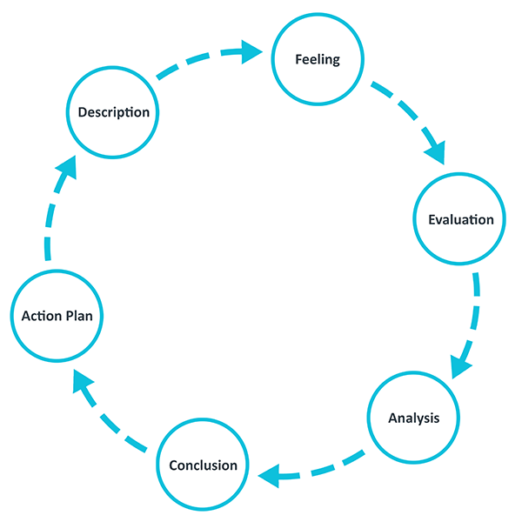
Gibbs reflective cycle

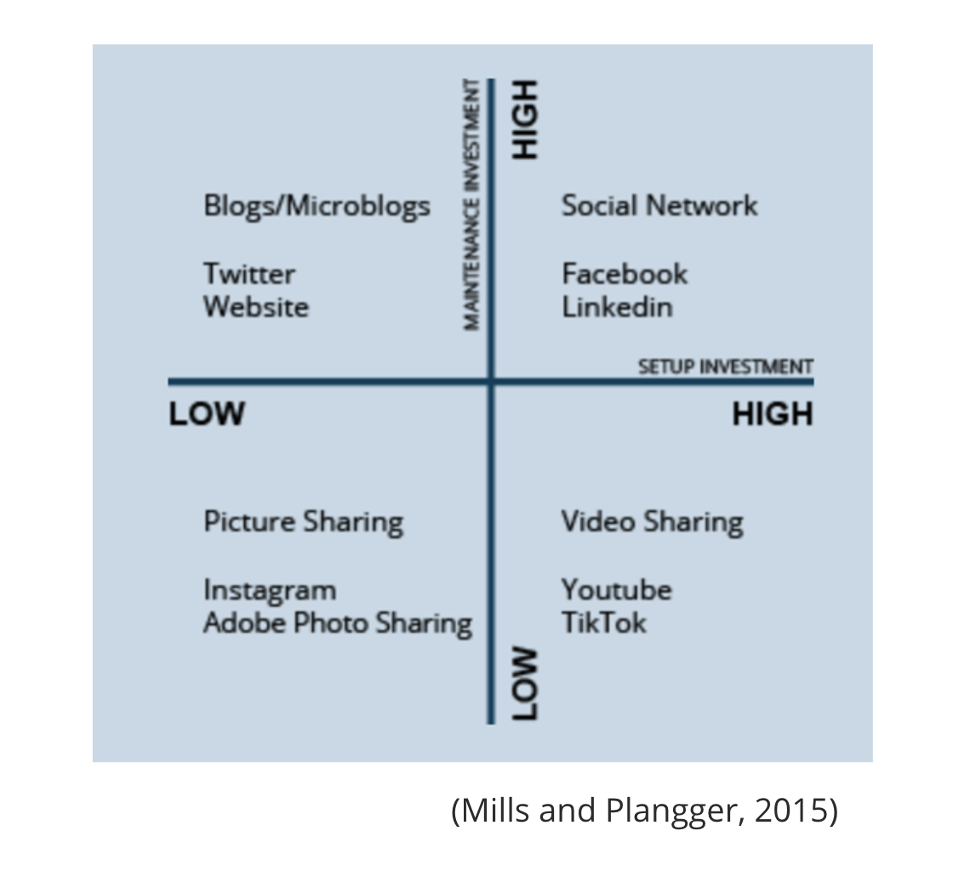
(Mills and Plangger, 2015)

References

Benton, D. (2021, June 7). The Importance Of Connections In Business. Debra Benton. https://www.debrabenton.com/blog/the-importance-of-connections-in-business/

Gibbs’ Reflective Cycle. (2020, November 11). The University of Edinburgh. https://www.ed.ac.uk/reflection/reflectors-toolkit/reflecting-on-experience/gibbs-reflective-cycle

Koestler, A. (2020). The act of creation. In Brain Function, Volume IV: Brain Function and Learning

Mills, A.J.; Plangger, K. (2020) Social media strategy for online service brands.

Ribeiro, S. (2020). The Real Benefits of Team Collaboration in the Workplace. https://blog.flock.com/benefits-team-collaboration-work

