

ASSIGNMENT 1
( BLOG 1 AND 2 , POSTER )

MODULE: POPULATION HEALTH AND DIGITLE HEALTH PROMOTION
CODE: LCHS7007
NAME: SUNAND RAJENDRABHAI PATEL
ID: 2221525
LECTURER: DR. DIOLA BIJLHOUT

Table of Contents
Part A: Blog 3
Blog 1: The Impact of Fitness Watches in Health Promotion: Advantages, Disadvantages, and Ways Forward 3
Introduction 3
Addressing the Public Health Problem 4
Fitness Watches in Health Promotion 4
Evidence of Health Promotion Impact 4
Advantages and Disadvantages 5
Addressing Challenges 5
Conclusion 6
Blog 2: Transforming Health Promotion: The Innovative Impact of Our Designed Digital Glucose Meter 7
Introduction 7
Diabetes as a Public Health Concern 7
SmartGlucoAssist as a Breakthrough Technology 8
SmartGlucoAssist as an Empowering Health Promotion Tool 9
Advantages and Disadvantages 9
Advantages 9
Disadvantages 9
Addressing Shortfalls 9
Conclusion 10
Part B: Poster Design 11
References 12

Part A: Blog

Blog 1: The Impact of Fitness Watches in Health Promotion: Advantages, Disadvantages, and Ways Forward

Introduction
Physical inactivity and its accompanying health disorders have been recognized as serious threats to public health worldwide. The modern sedentary lifestyle has led to a surge in chronic diseases, influencing individuals' general health and burdening healthcare systems (Fontana et al., 2021). As an outcome of such issues, digital health technologies, including fitness watches, are growing as feasible tools for health promotion interventions. This blog reviews the significance of fitness watches in health promotion, involving advantages, drawbacks, and potential remedies to any deficiencies.
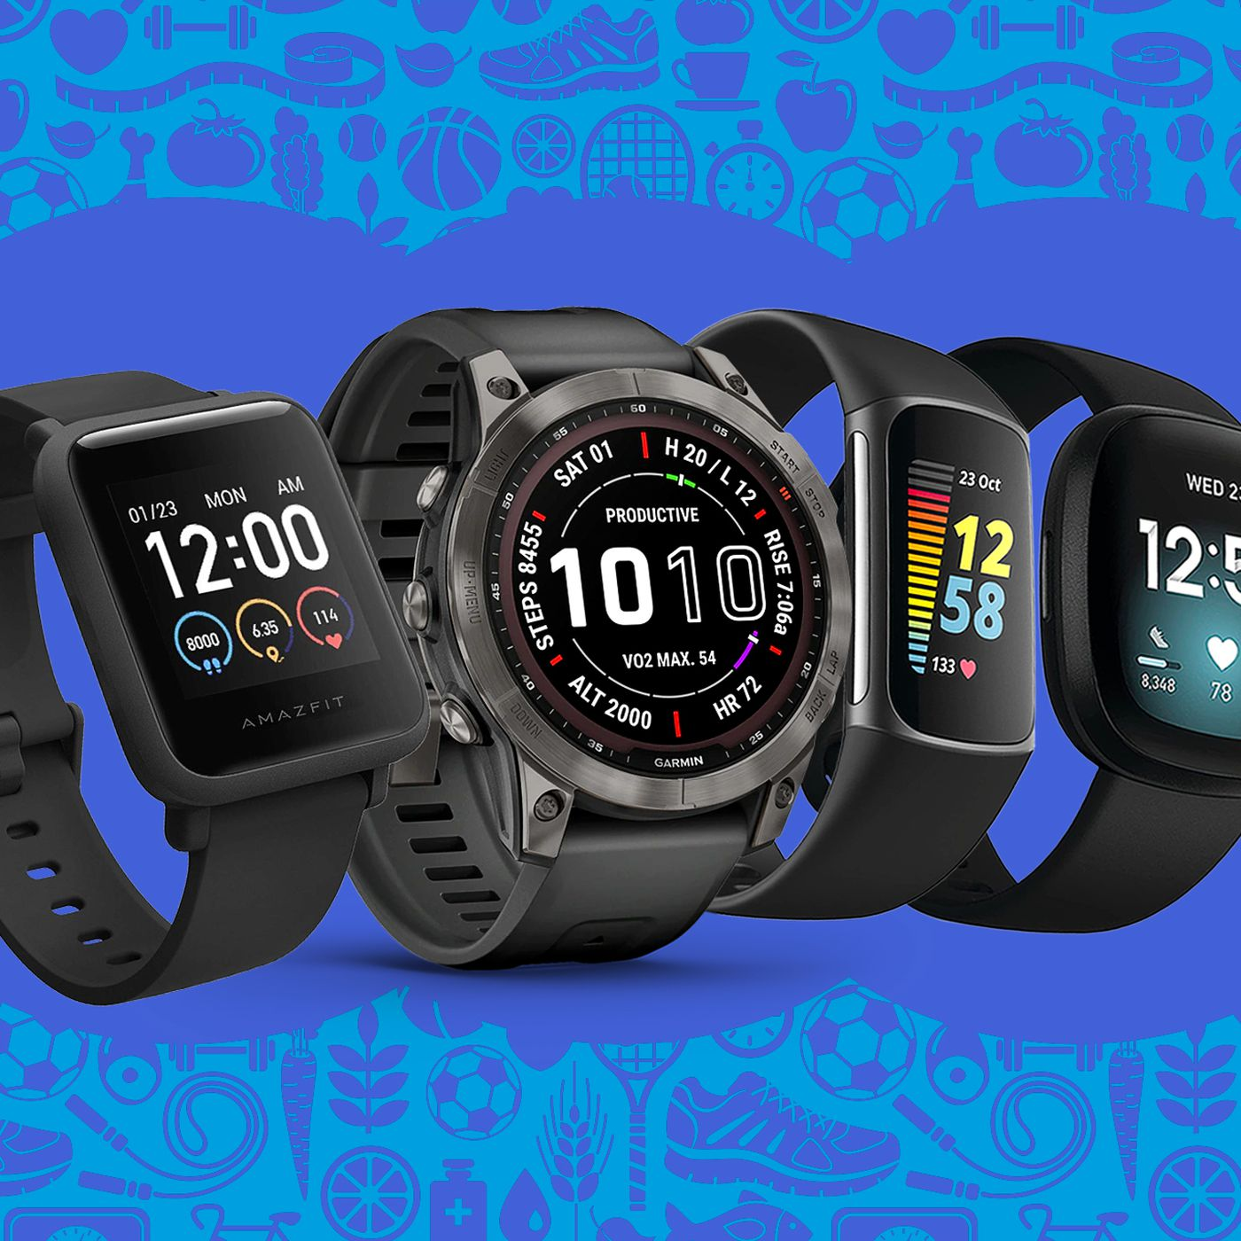
Figure 1: Fitness Watch
(Source: The Verge, 2023)

Addressing the Public Health Problem
Physical inactivity is an important threat to public health, and it appears to be connected to higher rates of cardiovascular disease, diabetes, obesity, and psychological disorders. The World Health Organization (WHO) believes that practically 1.4 billion individuals globally are insufficiently active, leading to 3.2 million premature deaths each year (WHO, 2023). In order to tackle the problem, successful programs which encourage physical activity and more accurate behaviors are needed.

Fitness Watches in Health Promotion
Fitness watches and wearable digital devices with sensors play a vital role in health promotion programs. They inform users to track various health parameters, like steps captured, heart rate, and sleep habits. Fitness watches offer real-time data, helping customers to track their advancement while making informed lifestyle and health decisions (Jerath et al., 2023). Users get motivated to improve their physical activity while creating healthy habits by receiving reminders, establishing activity goals, and collecting prizes.

Evidence of Health Promotion Impact
Numerous research support fitness watches' effectiveness in encouraging health and behavior change. Based on the research released by the Journal of Medical Internet Research (JMIR), fitness tracker users had greater physical activity (Zahrt et al., 2023). They were more knowledgeable of their health behaviors. Additionally, according to a thorough investigation released by the International Journal of Behavioural Nutrition and Physical Activity, active wearable trackers, including fitness watches, positively influenced daily physical activity and sedentary behavior (Danković et al., 2023).
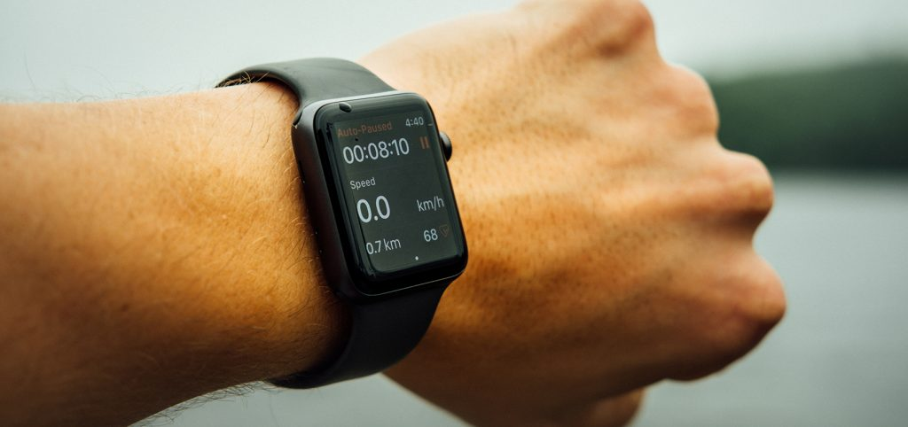
Figure 2: Health Monitoring through Fitness Watch
(Source: Northwest Primary Care, 2023)

Advantages and Disadvantages
Fitness watches offer many benefits in health promotion plans, notably customized feedback and goal-setting tools (Nuijten et al., 2022). They boost motivation and involvement via real-time reminders, statistics, and prizes, which stimulate users to participate in healthier behaviors. Also, fitness trackers enable continuous tracking, helping users to be aware of their health behaviors across the day. Nevertheless, additional limitations entail questions concerning data reliability since accuracy varies amongst devices. User retention may be challenging since some individuals lose interest or quit utilization over time. Additionally, given pricing and accessibility challenges, digital health disparity may limit access for certain groups of people (Hensel et al., 2019).

Addressing Challenges
Continuous developments in sensor technology and data validation procedures are needed to deal with data reliability. Manufacturers need to invest in studies for enhanced accuracy as well as precision. Interventions may integrate gamification components and supportive social components to improve user retention, enabling sustained motivation and engagement (Mustafa et al., 2023).

Conclusion
Fitness watches have been demonstrated to be beneficial tools in health promotion initiatives, encouraging individuals to track their physical activity and learn healthier habits. While the advantages surpass the downsides, addressing issues like user retention, data dependability, and digital health inequalities would increase the importance of fitness watches in enhancing public well-being and wellness even further.

Blog 2: Transforming Health Promotion: The Innovative Impact of Designed Digital Glucose Meter

Introduction
As we enter the field of digital health promotion, it is vital to deal with a major public health issue that impacts millions of individuals worldwide - diabetes. With the growing incidence of diabetes as well as the complications of successful glucose monitoring, we create a game-changing digital tool that will change diabetic health promotion (Klonoff et al., 2023). The SmartGlucoAssist, accordingly breakthrough solution, is a modified glucose meter with advanced features that enable consumers to take control of their health like never before.
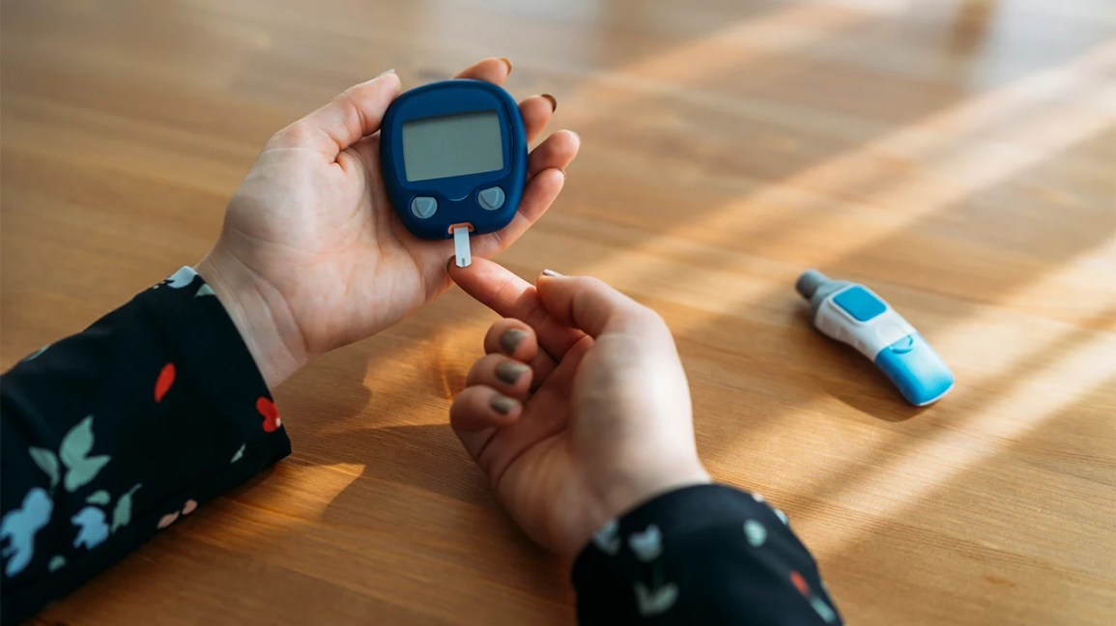
Figure 1: Glucose Meter
(Source: Healthline, 2018)

Diabetes as a Public Health Concern
Diabetes has become known as a worldwide epidemic influencing nearly 463 million people as of 2019, and this statistic is continuously growing (Sun et al., 2022). Cardiovascular disease, kidney failure, and nerve damage are among the implications of diabetes that are poorly controlled. Comprehensive diabetes care is clearly vital to decreasing the risks and boosting the quality of life for those diagnosed.

SmartGlucoAssist as a Breakthrough Technology
The SmartGlucoAssist is a digital glucose meter that aims to alleviate the shortcomings associated with traditional meters while additionally empowering those to manage their diabetes more successfully. Several attributes distinguish this cutting-edge device:
a) Continuous Glucose Monitoring (CGM): The SmartGlucoAssist presents buyers with real-time glucose data across the day. This increased information precision enables more accurate observations of glucose changes and facilitates more informed decision-making (Rehman and Farrakh, 2023).
b) Integration of Artificial Intelligence (AI): Accordengly glucose meter employs AI to analyze customer data and deliver personalized recommendations. SmartGlucoAssist recommends adjustments to lifestyles, workout routines, and dietary recommendations tailored to each user's specific requirements by learning from specific patterns.
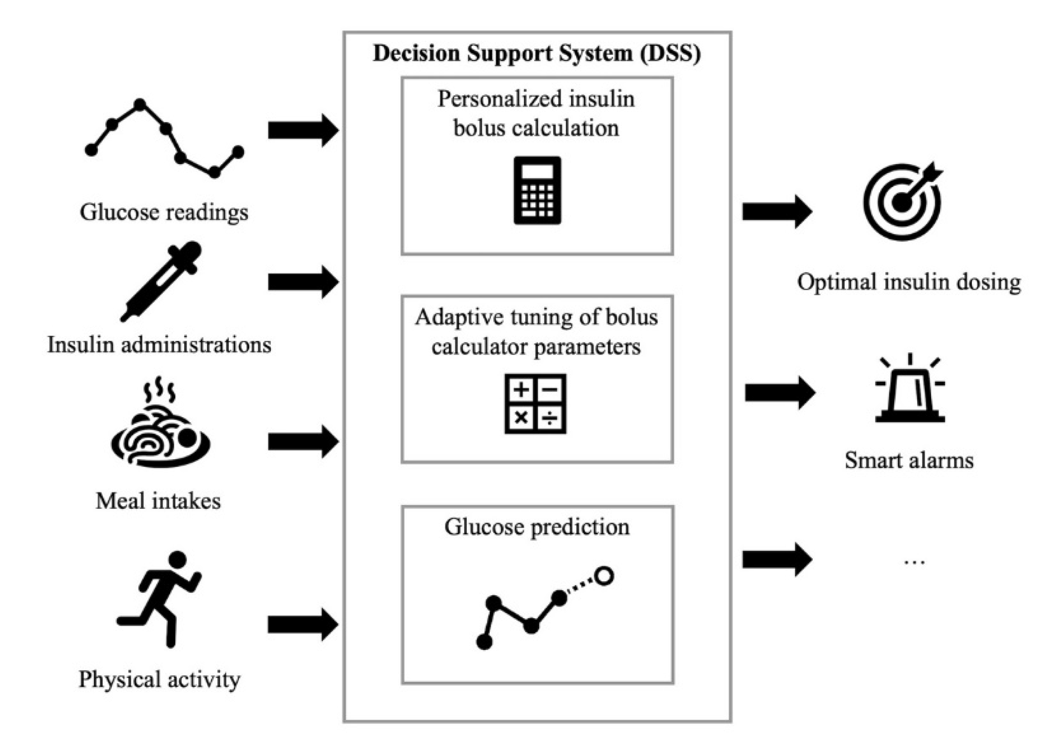
Figure 2: Use of AI in Glucose Meter
(Source: Vettoretti et al., 2020)
c) Gamification for Enhanced Engagement: We've integrated gaming components in the SmartGlucoAssist to boost long-term adherence to glucose management. Users obtain awards and bonuses for successfully satisfying glycemic targets and health targets.

SmartGlucoAssist as an Empowering Health Promotion Tool
The SmartGlucoAssist is much more than a simple glucose meter; it's a health promotion tool. It endorses behavioural change while fostering a proactive approach to diabetes care by offering users real-time data, personalized insights, as well as gamified motivation (Orte et al., 2023).

Advantages and Disadvantages

Advantages
- Improved Glucose Management: Regular surveillance and AI-powered insights enable users to recognize their glucose patterns better and make smarter choices while attaining better glycemic control (Chmayssem et al., 2023).
- Personalized Approach: Employing individual data, personalized suggestions enable consumers to make lifestyle adjustments that are personalized to their requirements, thereby boosting long-term adherence.
- Gamification for Motivation: The gamification feature fosters user involvement and accountability, enabling diabetes management to be a rewarding and enjoyable experience (Arora and Razavian, 2021).

Disadvantages
- Cost and Accessibility: In light of the cutting-edge technology involved, the initial cost may be higher, preventing access for certain people with budgetary limitations.
- Technical Dependencies: Users who rely considerably on technology may experience challenges if the equipment malfunctions or demands regular upgrades and servicing.

Addressing Shortfalls
- Collaborating with healthcare organizations along with governments for facilitating financial aid or subsidies for economically challenged users.
- Ensuring the technology retains manual functionality while enabling users to persist in monitoring even in the case of unusual cases of technical malfunctions.

Conclusion
The SmartGlucoAssist is a revolutionary digital technology changing diabetes management and health promotion. Distinct glucose meter supports individuals to properly care for their health while making educated choices via continuous tracking, AI-driven details, and gamification. While dealing with particular obstacles is essential, the SmartGlucoAssist's potential effect on diabetes treatment and comprehensive health promotion is beneficial.

Part B: Poster Design

References
Blog 1
Danković, G., Stantić, T., Herodek, R., Stamenković, S., Stojiljković, N., Jelenković, B. and Sporiš, G., 2023. Effects of Commercially Available Wearable Devices on Physical Activity Promotion and Health in Children and Adolescents: Systematic Review. Applied Sciences, 13(12), p.7194.
Fontana, L., Fasano, A., Chong, Y.S., Vineis, P. and Willett, W.C., 2021. Transdisciplinary research and clinical priorities for better health. PLoS Medicine, 18(7), p.e1003699.
Hensel, J.M., Ellard, K., Koltek, M., Wilson, G. and Sareen, J., 2019. Digital health solutions for indigenous mental well-being. Current psychiatry reports, 21, pp.1-9.
Jerath, R., Syam, M. and Ahmed, S., 2023. The Future of Stress Management: Integration Smartwatches and HRV Technology.
Mustafa, A.S., Ali, N.A., Dhillon, J.S. and Sedera, D., 2023, April. An Integrated Model for Evaluating the Sustainability of Gamified Mobile Health Apps: An Instrument Development and Validation. In Healthcare (Vol. 11, No. 7, p. 1051). MDPI.
Northwest Primary Care, 2023. 5 Ways Smartwatches Could Improve Your Health. Health and technology. [Online] Available at: https://www.nwpc.com/how-smartwatches-could-improve-your-health/. Accessed on: 25.07.2023.
Nuijten, R., Van Gorp, P., Khanshan, A., Le Blanc, P., van den Berg, P., Kemperman, A. and Simons, M., 2022. Evaluating the impact of adaptive personalized goal setting on engagement levels of government staff with a gamified mHealth tool: results from a 2-month randomized controlled trial. JMIR mHealth and uHealth, 10(3), p.e28801.
The Verge, 2023. The best fitness trackers to buy right now. From simple fitness bands to rugged sports watches to rings, these are the best trackers you can get. [Online] Available at: https://www.theverge.com/22985108/best-fitness-tracker. Accessed on: 25.07.2023.
WHO, 2023. The Global Health Observatory. Explore a World of Health Data. [Online] Available at: https://www.who.int/data/gho/indicator-metadata-registry/imr-details/3416. Accessed on: 25.07.2023.
Zahrt, O.H., Evans, K., Murnane, E., Santoro, E., Baiocchi, M., Landay, J., Delp, S. and Crum, A., 2023. Effects of wearable fitness trackers and activity adequacy mindsets on affect, behavior, and health: longitudinal randomized controlled trial. Journal of Medical Internet Research, 25, p.e40529.
Blog 2
Arora, C. and Razavian, M., 2021. Ethics of gamification in health and fitness-tracking. International Journal of Environmental Research and Public Health, 18(21), p.11052.
Chmayssem, A., Nadolska, M., Tubbs, E., Sadowska, K., Vadgma, P., Shitanda, I., Tsujimura, S., Lattach, Y., Peacock, M., Tingry, S. and Marinesco, S., 2023. Insight into continuous glucose monitoring: from medical basics to commercialized devices. Microchimica Acta, 190(5), p.177.
Healthline, 2018. Choosing a Glucose Meter. Choosing a Glucose Meter. [Online] Available at: https://www.healthline.com/health/type-2-diabetes/choosing-glucose-meter. Accessed on: https://www.healthline.com/health/type-2-diabetes/choosing-glucose-meter. Accessed on: 25.07.2023.
Klonoff, A.N., Lee, W.A., Xu, N.Y., Nguyen, K.T., DuBord, A. and Kerr, D., 2023. Six digital health technologies that will transform diabetes. Journal of diabetes science and technology, 17(1), pp.239-249.
Orte, S., Migliorelli, C., Sistach-Bosch, L., Gómez-Martínez, M. and Boqué, N., 2023. A Tailored and Engaging mHealth Gamified Framework for Nutritional Behaviour Change. Nutrients, 15(8), p.1950.
Rehman, A. and Farrakh, A., 2023. Improving Clinical Decision Support Systems: Explainable AI for Enhanced Disease Prediction in Healthcare. International Journal of Computational and Innovative Sciences, 2(2), pp.9-23.
Sun, H., Saeedi, P., Karuranga, S., Pinkepank, M., Ogurtsova, K., Duncan, B.B., Stein, C., Basit, A., Chan, J.C., Mbanya, J.C. and Pavkov, M.E., 2022. IDF Diabetes Atlas: Global, regional and country-level diabetes prevalence estimates for 2021 and projections for 2045. Diabetes research and clinical practice, 183, p.109119.
Vettoretti, M., Cappon, G., Facchinetti, A. and Sparacino, G., 2020. Advanced diabetes management using artificial intelligence and continuous glucose monitoring sensors. Sensors, 20(14), p.3870.
Poster
Alderwick, H. and Gottlieb, L.M., 2019. Meanings and misunderstandings: a social determinants of health lexicon for health care systems. The Milbank Quarterly, 97(2), p.407.
AlSlaity, A., Suruliraj, B., Oyebode, O., Fowles, J., steeves, D. and Orji, R., 2022. Mobile applications for health and wellness: a systematic review. Proceedings of the ACM on Human-Computer Interaction, 6(EICS), pp.1-29.
Bannell, D.J., France-Ratcliffe, M., Buckley, B.J.R., Crozier, A., Davies, A.P., Hesketh, K.L., Jones, H., Cocks, M., Sprung, V.S. and MOTIVATE Team, 2023. Adherence to unsupervised exercise in sedentary individuals: A randomised feasibility trial of two mobile health interventions. Digital health, 9, p.20552076231183552.
Behavioral Change Models, 2023. The Transtheoretical Model (Stages of Change). [Online] Available at: https://sphweb.bumc.bu.edu/otlt/mph-modules/sb/behavioralchangetheories/behavioralchangetheories6.html. Accessed on: 25.07.2023.
de Freitas, P.P., de Menezes, M.C., Dos Santos, L.C., Pimenta, A.M., Ferreira, A.V.M. and Lopes, A.C.S., 2020. The transtheoretical model is an effective weight management intervention: a randomized controlled trial. BMC Public Health, 20(1), pp.1-12.
Dunton, G.F., Rothman, A.J., Leventhal, A.M. and Intille, S.S., 2021. How intensive longitudinal data can stimulate advances in health behavior maintenance theories and interventions. Translational Behavioral Medicine, 11(1), pp.281-286.
Esmonde, K., 2023. exercising caution: a case for ethics analysis in Physical activity Promotion. Public Health Ethics, 16(1), pp.77-85.
Forberger, S., Reisch, L., Kampfmann, T. and Zeeb, H., 2019. Nudging to move: a scoping review of the use of choice architecture interventions to promote physical activity in the general population. International Journal of Behavioral Nutrition and Physical Activity, 16, pp.1-14.
Holko, M., Litwin, T.R., Munoz, F., Theisz, K.I., Salgin, L., Jenks, N.P., Holmes, B.W., Watson-McGee, P., Winford, E. and Sharma, Y., 2022. Wearable fitness tracker use in federally qualified health center patients: strategies to improve the health of all of us using digital health devices. NPJ Digital Medicine, 5(1), p.53.
Imeri, H., Toth, J., Arnold, A. and Barnard, M., 2022. Use of the transtheoretical model in medication adherence: A systematic review. Research in Social and Administrative Pharmacy, 18(5), pp.2778-2785.
Islam, F.M.A., Islam, M.A., Hosen, M.A., Lambert, E.A., Maddison, R., Lambert, G.W. and Thompson, B.R., 2023. Associations of physical activity levels, and attitudes towards physical activity with blood pressure among adults with high blood pressure in Bangladesh. PloS one, 18(2), p.e0280879.
Jiménez-Zazo, F., Romero-Blanco, C., Castro-Lemus, N., Dorado-Suárez, A. and Aznar, S., 2020. Transtheoretical model for physical activity in older adults: Systematic review. International journal of environmental research and public health, 17(24), p.9262.
Ketelhut, S., Martin-Niedecken, A.L., Zimmermann, P. and Nigg, C.R., 2021. Physical activity and health promotion in esports and gaming–discussing unique opportunities for an unprecedented cultural phenomenon. Frontiers in sports and active living, 3, p.693700.
Kleis, R.R., Hoch, M.C., Hogg-Graham, R. and Hoch, J.M., 2020. The effectiveness of the transtheoretical model to improve physical activity in healthy adults: a systematic review. Journal of Physical Activity and Health, 18(1), pp.94-108.
Nakabayashi, J., Melo, G.R.I. and Toral, N., 2020. Transtheoretical model-based nutritional interventions in adolescents: a systematic review. BMC Public Health, 20(1), pp.1-14.
Peng, S., Othman, A.T., Khairani, A.Z., zeng, G., Xiaogang, Z. and Fang, Y., 2023. Effectiveness of pedometer-and accelerometer-based interventions in improving physical activity and health-related outcomes among college students: A systematic review and meta-analysis. Digital Health, 9, p.20552076231188213.
World Health Organization, 2022. Bending the trends to promote health and well-being: a strategic foresight on the future of health promotion. World Health Organization.

