University of Wales Trinity Saint David
Business Management
Strategic Management and Sustainability
LCBB6004
Anca Larisa Costache
2021935

Table of Contents
Introduction 3
Main body 4
Company overview 4
The key business strategies of VW over the past five years. Use related frameworks to discuss why this strategy was pursued or changed. 5
The resources and capabilities of the case study company over the past five years and analyse to what extent the company has aligned its resources and capabilities to its current business strategies. 7
How VW has tried to become more competitive while taking into consideration sustainability and the environment. 9
Make recommendations on how further sustainability practices can help the organisation to develop competitive advantages in the future 12
Conclusion 14
References 15

Introduction
193 million euros fine to 90,000 drivers was paid by Volkswagen due to lack of sustainable products and claiming them to be sustainable in nature. The unethical practices do not even tend to decrease the financial foundation of companies but also ruin their reputation in the market place. The survival of companies and its growth post such issues can be analysed in order to understand the effective strategies applied by organisation to gain back trust of customers. The suffocated position and its accelerated growth by prominent resources and capabilities of Volkswagen will be examined in the above essay. A critical review on evidence based competitive ecosystem of organisation in context with application of models will be presented in the essay. The last section of essay will high the recommendations and strategies that in future can be applied by Volkswagen in order to function effective growth.

Main body

Company overview
Volkswagen the car “Das Auto” is a German automotive organisation that has been functioning from 86 years and is excelling if field of vehicles and more tech based machines worldwide. The organisation is not only home to many lavish brands but also subjects to function the highest employment provision company in Germany. Volkswagen is known for best engineered products with supreme quality of services and stylish vehicles in the world. In year 2015, the carbon emission claims drafted in England and Wales projected negative reputation of organisation which was a subject of concern for many of the stakeholders. However, the current market share of brand is about 8.4% in United Kingdom and tends to function as best car manufacturing company in the state (Bachmann et al. 2023).
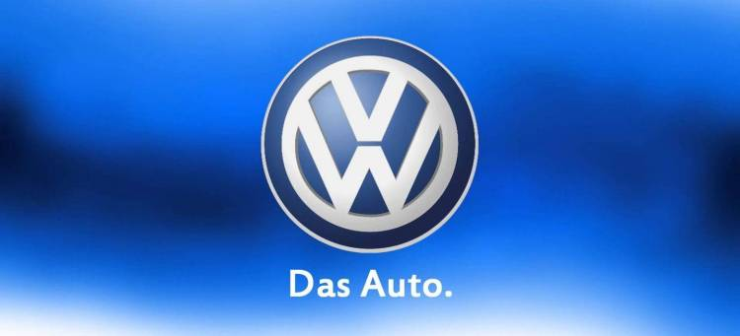
Figure 1 VW logo
(source: diariomotor.com/imagenes/picscache 2022)

The key business strategies of VW over the past five years. Use related frameworks to discuss why this strategy was pursued or changed.
China the world’s second largest populated country has 26% market share by organisation which as increased with pace of time (Tao and Li 2020). Post 2015 scandal the organisation intended to function with more responsibility drafting changes not only in engineering of products but also optimisation of internal functioning. Additionally, the first thing brand accounted for was acceptance of mistake and governing ethical solution to each. Audi, Seat and Skoda, Bentley, Bugatti, Lamborghini, Porsche, Ducati etc. are the multiple brands which are subsidiaries of organisation and functions well with same viable solutions. The company not only allocated changes in process of manufacturing of the machines but also achieved the goals in sustainability.
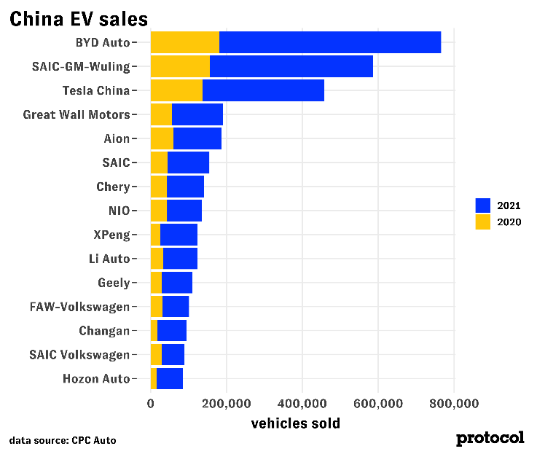
Figure 2 EV in VW
(source: cdn.statcdn.com 2022)
The key business strategies of VW over the past five years were based on sustainability, change, innovation and technology transformation. The organisation drafted changes by allocation of new subsidiaries in market place in order to govern an effective revenue from external sources as regain the reputation of VW (Jung and Sharon 2019). Volkswagen intended to have change in commitment towards sustainability and economic factors through introduction to EV cars. In year 2021, the brand introduced digital transformational strategy in which electric cars was introduced in technology market place. Industrial cloud is the another type of function which was drafted by organisation as a strategic change in which the digital production platform with respect to cloud, IT security, analysis and internet of things was launched by the brand in year 2016 (Zhang et al. 2021).
Evidently all the segments are prominently important in current time and this market place was captured by organisation before handed. New levels of productivity were introduced in internal policy of organisation in which training, guidance and innovation were promoted for level of employees which did not only govern good services and manufacturing of product but centralised the brand in optimised manner. Sustainability was focused by organisation which was recited under sustainability reports in year 2017 about WAY to Zero by Volkswagen (Zhang et al. 2021).
Extension of EV car manufacturing, suppression of diesel based cars, carbon dioxide emission reduction that is 17 tonnes per vehicles in Europe was reduced and 40% lesser was projected only by 2018 (Gaim et al. 2021). Volkswagen did not procrastinated scandal with work and quickly change was applied. Additionally, according to the policy of Volkswagen by year 2025 with an investment of 14 billion euros in EU countries de-carbonisation will be achieved. Additionally, internal energy consumption was improved by installation of 420,000 number of solar panels drafting 170 million kilowatt of electricity every year.
Volkswagen has made 15 to 20 changes in its ethical code of conduct and testing policies to revamp the idea of sustainability for all of its customers (Hassan 2019). Additionally, in the era of tech based scenario innovation and integration was practiced by the brand in which ID vehicles will commence in market place by year 2025. Intelligent design, identity and visionary technologies will be indulged in the vehicles governing 100% sustainability to all the stakeholders. Volkswagen proceeded in application of framework in such a manner that supressed action or depression in sales in scandal news was positioned.

The resources and capabilities of the case study company over the past five years and analyses to what extent the company has aligned its resources and capabilities to its current business strategies.
Resources and capabilities of company were aligned in such a manner that Volkswagen accelerated its internal and external stakeholder’s volume in qualitative manner. 610,076, 672,789 669,000 employees in year 2015, 2021 and 2022 were respectively noted to be functioning in Volkswagen which means that increment in staff volume with pace was time was drafted. Additionally, new technology companies were made partners like Amazon web, Google, D-wave etc. so that digitalisation can be promoted (Chen and Zhong 2022). In year 2021, the organisation aimed in bringing labs to the factors in Germany which functioned to be best decision as in current time R&D of Volkswagen in entire automobile sector is very efficient.
EU green deal introduced by Volkswagen in year 2021 required resources, machines, labs and employees in which entire new office set up was drafted by the organisation. The resources of organisation were more based on purchasing system and capabilities of organisation were fuelled by innovation and training. However, during the time of covid 19 the shutting of business operations gave Volkswagen with high value production loss (Zenglein 2020).
Additionally, the competitors in the paths of organisation intended to function on same pillars in such a scenario EV market place had many types of manufacturers that is Toyota, Tesla etc. which did not support the organisational growth with full boost. In order to understand the Volkswagen’s resources and capabilities the VRIO analysis is required to be performed. The attributes like financial stability, employees, organisational policies, technology, plant and equipment, location and distribution networks are the main factors that are resources and capability of the VW (Buzatu ET AL. 2019). All the above resources are valuable and organised and can be imitated by competitors. Additionally, innovation and engineering is only rarity that organisation up holds in current time.
Hence, it can be justified that Volkswagen has resources and capabilities but needs to pump action in high performance staff so that future growth can be functioned and forecasted in an optimised manner. Additionally, high labour shortage, inflation, Brexit and covid 19 are evidence based factors in the macro ecosystem of organisation in the state which are deaccelerating the growth of organisation. It can be noted that with full hands on in the projects Volkswagen might not gain sales up to mark in EU states because of external factors (Kim et al. 2022).

How VW has tried to become more competitive while taking into consideration sustainability and the environment.
Key capabilities like R&D labs in VW has budget of about 18.9 billion EUR in which 8.1% is in relation with automation revenues. 119 number of production factories in more than ten countries have been positioned by the brand (Allam et al. 2020). Additionally, Volkswagen is second largest automobile company of world through is capacity of manufacturing 40,000 cars in a day (Measso 2022). 30% of carbon emission reduction by 2025 and fully carbon neutral by year 2050 is the sustainability goal of organisation in which diesel car manufacturing is vitally reduced by organisation. 27 million cars are expected to be manufactured by brand b year 2030 in which all engines will be EV supported.
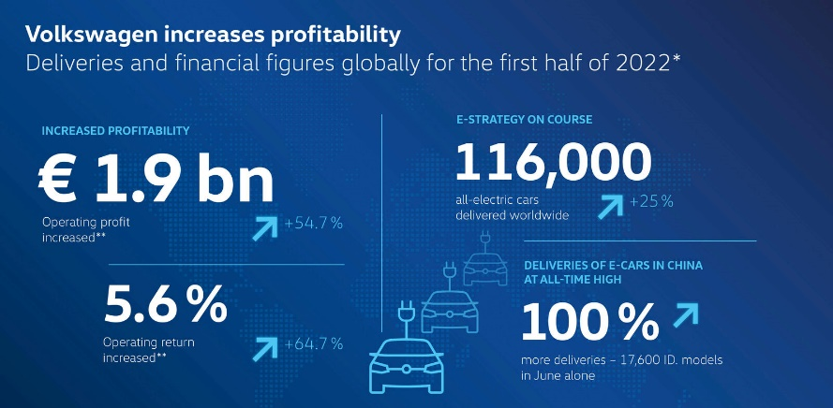
Figure 3 VW sales
(source: diariomotor.com 2022)
Through analysis of resources and capabilities it can be identified that Volkswagen is a company that has vision and systematic planning steps which are achieved by motivated staff and determined executives (Bai 2021).
However, threat from many places like China in terms of production, vague governance has a chance to blow up the brand in country (Froese et al. 2019). 26% of market share in automobile industry of China is marked up by the brand, any conflict will directly affect the financial health of organisation. On the hand, digital space regulation, AI based services and stylish models by VW cars has increased its market share from 6% to 8% in EU market place. VW even failed in the environment of India because of cultural issues but UK based sales have accelerated with very pace. The macro factors intend to both supress and up lift the sales of organisation in different places (Zhang et al. 2021).
Ansoff’s matrix will aid in implementation of correct market place strategies by the organisation. The matrix is segmented into market penetration, product development, market development and diversification. VW need to have good market penetration technique in which VW Tiguan is a car which is best sold in every market place of EU hence good marketing or pricing strategies can be applied to pump sales of this model (Chen and Zhong 2022). The organisation already has 10 brand in which all brands have streamlined manufacturing of many types of models so overall diversification projected by VW as brand is very high, but each brand does not intend to have high degree of diversification.
Product development is drafted by huge investment, research and analysis by brand which is a positive strength of organisation. Market development strategies can be applied by brand in China where in fading of VW in future can appear, so currently gripping market place will benefit the organisation. Overall some laps left the voids in market place grip by the VW which can be covered. However, with growth of EV market the number of competitors have rose as well, in such a scenario the issues in customer retention will be faced by brand (Sebastian 2022).
Sustainability was a point of question by brand in year 2015, but quick and effective changes by brand in the daily functioning and policies of organisation have altered its image in current time. However, the as liquid stains something the news of scandal cannot be completely vanished. The competitors of VW like Ford, Hyundai, Volvo, BMW, Toyota, Renault and Mercedes also intend to function on better sustainability models (Veldman 2019). BMW is termed as most sustainable automobile company in the world because of its idea of circular economy in which 30% of past products are reused by the brand. Such competitors often pen downs the position of brands and push them to think with more innovation.
Sustainability is an environmental factor which is supported by VW with number of policies and practices making it the strength of organisation. Weaknesses of VW lies in highest recall rates and terminated market share in some countries. As EV is a substitution product and have very high growth rate the effective market share can be positioned by the brand. Additionally, in UK Ford sales increased by 49.2% and Audi sales by 59.4%, the VW sale was increased by 30.2% only which means that some strategies of competitors are better (Welch 2019).
The bargaining power of customers for VW is medium and very low for brands like BMW and Toyota because of good financial strategies, marketing and lesser fuel consumption. The rising prices of fuel is a point of question for Brits in current time to purchase any automobile (Toma and Tohanean 2019). In such a scenario, VW cars have lower fuel consumption average values which is not feasible for all users in current market place. Overall, VW has better position from year 2015 by its visionary and innovative approached and crafted its position in top automobile company despite of being defamed badly. Hence, the strength of organisation is to govern market share with time.
In terms of technology and capacity of manufacturing in most sustainable manner VW stands out from its competitors and give high edged competition in the automobile market place. Volkswagen is second largest automobile company of world through is capacity of manufacturing 40,000 cars in a day. CAR2X that is traffic hazard alarm, TSI petrol engines and solid state energy system based technology have not only been discovered but patented and sued by organisation (Köhler and Zerfass 2019). VW has higher quality of cars which are more durable and govern drivers with frictionless experience while driving. Tech factors are strengths as well as opportunity for the organisation.

Make recommendations on how further sustainability practices can help the organization to develop competitive advantages in the future
Strategies that VW can apply in order have better customer base is culture orientation of adverts in respective places of marketing. Road safety, children safety, emotional connection with history of brand, stories of oldest customers etc. are types of marketing techniques which can be intended by brand in order to trigger the connection with customers. Additionally, with competitors VW needs to amplify more sustainable practices and glorify its empire with effective marketing techniques. 3.1 billion euros of EV market place with a growth of 9% has been observed in UK automobile industry, in which highly satisfied customers with EV experience of VW will subject good customer base in future (Wells and Skeete 2023).
Today is the correct time for EV launch and changes application as with growth of industry the organisation might govern effective market share. Additionally, workshops, free rides, free car in lottery etc. can be simple marketing techniques that can be applied by brand.
Technology based supply chain can be fully drafted by VW so that better sustainable practices within the framework of organisation will be projected. Additionally, achieving all goals in defined period of time will also amplify the commitment and ethics of organisation (Graf et al. 2023). Replacing offline with online in most of its departments can be one of major recommendation which VW can apply to govern competitive advantage in suitability and draft good online services to customers as well. Artificial intelligence based functioning from marketing, finance, research and production can be drafted so that follow up on each with voids examination can be drafted.
Using eco-friendly materials and provisional use of 5R rule can be another major step that VW can position in. The organisation can reuse or recycle the products with an effective up cycling technique in order to reduce the overall operational waste. Digital practices that can terminate paper waste can be used, like screens in offices of brand explaining customers about features of car and no paper based prospectus is made (Legenvre and Hameri 2023).
This idea will reduce paper waste and govern VW good brownie points as well. Joint ventures with raw material companies can be formed so that sustainable efficiency of brand overall is amplified. Additionally, it can be noted that with pace of time the defamed organisation back in 2015 has growing in an accelerated form because of determination and smart work input (Li 2023). The consistency in work can be managed by brand so that effective customer base is managed in future.

Conclusion
The above essay teaches a lesson that brands and companies might draft mistakes which have very bad impact on the financial position and reputation in market place but with acceptance of mistake and moving forward attitude the issues ca be resolved with time. The emerging techniques and ideas chis by VW were based on customer eccentricity and market place evaluation which intended the brand to project accountable market place potential in current time.

References
Allam, I., Scagnelli, S. and Corazza, L., 2020. Sustainability reporting, a new type of companies’ hypocrisy: Zara and Volkswagen cases. Responsible Business in a Changing World: New Management Approaches for Sustainable Development, pp.195-211.
Bachmann, R., Ehrlich, G., Fan, Y., Ruzic, D. and Leard, B., 2023. Firms and collective reputation: a study of the volkswagen emissions scandal. Journal of the European Economic Association, 21(2), pp.484-525.
Bai, Y., 2021, March. Analysis of Overseas Management Strategy of the Volkswagen Group. In 6th International Conference on Financial Innovation and Economic Development (ICFIED 2021) (pp. 229-234). Atlantis Press.
Buzatu, A.I., Pleșea, D.A., Iulian, C. and Valentin, W.P., 2019. Managing organizations for sustainable business development: Interaction between VRIO framework and Mckinsey 7s framework. New trends in sustainable business and consumption, pp.243-251.
Chen, J. and Zhong, M., 2022, April. Research on Volkswagen’s Development Strategy During Covid-19. In 2022 7th International Conference on Social Sciences and Economic Development (ICSSED 2022) (pp. 705-710). Atlantis Press.
Froese, F.J., Sutherland, D., Lee, J.Y., Liu, Y. and Pan, Y., 2019. Challenges for foreign companies in China: Implications for research and practice. Asian Business & Management, 18, pp.249-262.
Gaim, M., Clegg, S. and Cunha, M.P.E., 2021. Managing impressions rather than emissions: Volkswagen and the false mastery of paradox. Organization Studies, 42(6), pp.949-970.
Graf, A., Hess, T., Müller, L. and Zimmer, F., 2023. Future Mobility–Digital Transformation of Automotive Companies as a Question of Organizational Identity. In Smart Cities and Digital Transformation: Empowering Communities, Limitless Innovation, Sustainable Development and the Next Generation (pp. 129-158). Emerald Publishing Limited.
Hassan, A.S., 2019. Evaluating the marketing communication strategy of Volkswagen in post-crisis period: application of image repair theory. International Journal of Marketing Studies, 11(2), pp.87-101.
Jung, J.C. and Sharon, E., 2019. The Volkswagen emissions scandal and its aftermath. Global business and organizational excellence, 38(4), pp.6-15.
Köhler, K. and Zerfass, A., 2019. Communicating the corporate strategy: An international benchmark study in the UK, the USA, and Germany. Journal of Communication Management, 23(4), pp.348-374.
Legenvre, H. and Hameri, A.P., 2023. The emergence of data sharing along complex supply chains. International Journal of Operations & Production Management.
Li, N., 2023. Ethical Considerations for Automobile Emissions Management Background, Detriment, and Litigation. European Journal of Business and Innovation Research, 11(1), pp.11-20.
Measso, A., 2022. Event-based ecosystem structuring: lessons from the Volkswagen emissions scandal and the European transition to e-mobility.
Sebastian, G., 2022. The bumpy road ahead in China for Germany's carmakers. Berlin: Mercator Institute for China Studies (MERICS).
Tao, X. and Li, S., 2020. The developing influence of Chinese culture on finance: A literature review and case-study illustration. Research in International Business and Finance, 54, p.101302.
Toma, S.G. and Tohanean, D., 2019. Green business models: The case of a German automaker. Quality-Access to Success, 20.
Veldman, J., 2019. Boards and sustainable value creation: The legal entity, co-determination and other means. European Business Law Review, 30(2).
Welch, J., 2019. The Volkswagen recovery: leaving scandal in the dust. Journal of Business Strategy, 40(2), pp.3-13.
Wells, P. and Skeete, J.P., 2023. Circular Business Models as Instruments of Corporate Power.
Zenglein, M.J., 2020. Mapping and recalibrating Europe’s economic interdependence with China. MERICS China Monitor, p.11.
Zhang, M., Atwal, G. and Kaiser, M., 2021. Corporate social irresponsibility and stakeholder ecosystems: The case of Volkswagen Dieselgate scandal. Strategic Change, 30(1), pp.79-85.
EV market share 2022 [accessed through] [online] https://cdn.statcdn.com/Infographic/images/normal/26845.jpeg [accessed on 20th July 2023]
VW logo 2022 [accessed through] [online] https://www.diariomotor.com/imagenes/picscache/750x/volkswagen-logo_750x.jpg [accessed on 20th July 2023]

Appendix

SWOT Analysis
Strength | Weakness
- Volkswagen is a global brand and has a strong global presence  - Diverse portfolio of products  - Volkswagen has a strong research and development team | - Recently Volkswagen had to recall the product due to quality issues  - There has been emission scandals which has damaged the reputation.
Opportunities | Threats
- Growing demand for electric vehicles  - Growing demand for Volkswagen products in emerging markets of Asia and Africa | - Intense competition in electric vehicle segment  - Due to Covid-19, there has been disruptions in Supply Chain

PESTLE Analysis
Political:
- The UK's exit from the EU affects trade, regulations, and international diplomacy.
- The country's political stability and rule of law encourage business and investment.
- Taxes, labour laws, and incentives affect business and economic growth.
Economic:
- The UK's GDP growth and economic performance impact consumer spending, investment, and business activities.
- Changes in inflation rates and interest rates influence consumer purchasing power and business investment decisions.
Social:
- Ageing and changing demographics affect workforce, healthcare, and consumer preferences.
- Lifestyle changes, technology adoption, and urbanisation affect product demand.
Technological:
- The UK's emphasis on research and development fosters technological advancements
- Increasing digitalization impacts industries, consumer behaviour, and business models, driving e-commerce and remote working trends.

Environmental:
- Efforts to address climate change impact regulations, sustainability initiatives, and consumer preferences for eco-friendly products.
- Stricter environmental regulations influence industries' practices, waste management, and emissions control.
Legal:
- Employment regulations, including minimum wage and worker protections, influence business operations and labour costs.
- Stringent data protection regulations like GDPR affect how companies handle customer data and conduct online operations.

VRIO Analysis
Value | Brand Reputation, Technological Innovation
Rarity | Diverse Brand Portfolio, Innovative R&D
Imitability | Brand Reputation
Organization | Strong distribution network, Strong management

