Alexandra Evans
1807524
Workplace practice e-portfolio

Table of Contents
Evidence 2
GCSE Qualifications 1.1 2
GCSE Mathematics 1.2 3
As Level Art & Design 1.3 3
BTEC Diploma Applied Science 1.4 4
BTEC Diploma Art & Design 1.5 5
Working in Retail 6
Caring for my grandfather 6
Current place of work 6
Healthcare Assistant Job Role 6
Benefits of working as a healthcare assistant 6
E-Learning Training 7
1.6 7
Development in my current studies 10
Work Placement 11
Placement Hours/ Pay Slips 1.7 11
Documenting my work placement journey 12
1st December 2018 12
15th December 2018 12
5th January 2019 13
Personal Statement 14
Receiving an interview 15
Receiving an Offer 15
Reference list 16

Introduction

My name is Alexandra Evans and I am currently a student at the University of Wales Trinity Saint David studying the Certificate of Higher Education in Nursing Studies and Health. Before beginning my studies at UWTSD my academic development and knowledge was not advanced enough to secure a place on the adult nursing degree which I so desperately wanted, therefore I decided to continue my studies and work part time in a nursing home as a healthcare assistant to gain experience on the job as well as increasing my academic development.

Evidence

UCAS, (2019) states that it is usually a requirement to attain a GCSE grade C or above in mathematics and a GCSE grade C or above in English, which I have achieved, before applying for adult nursing along with a pass in the Certificate of Higher Education in Nursing Studies and Health. I have qualifications for other GCSE’s, As level and BTEC Diplomas which have all had a positive impact on my academic development this year as I came onto this course with the ability to expand on the skills I have already gained.
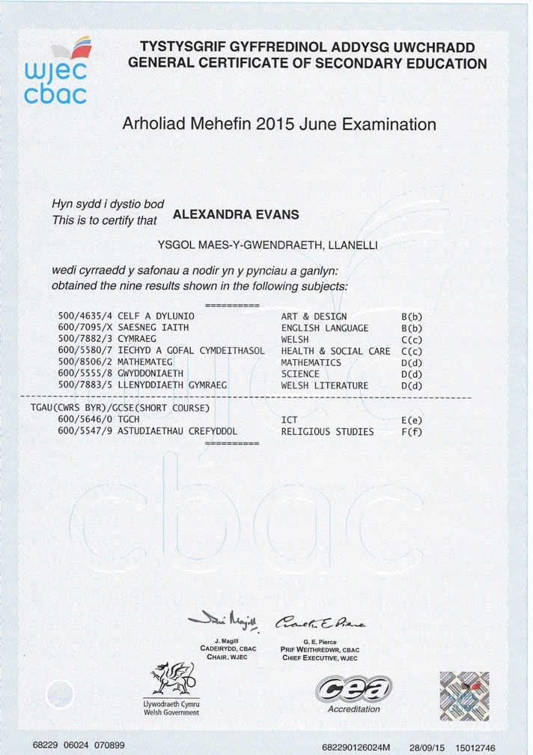

GCSE Qualifications 1.1

Here is a photocopy of the GCSE qualifications I obtained in June 2015 which includes English Language. Unfortunately, I did not achieve a C grade in Mathematics on my first attempt. If I wanted to peruse my career in Nursing, I would need to pass my maths and increase knowledge in science, preferably biology.

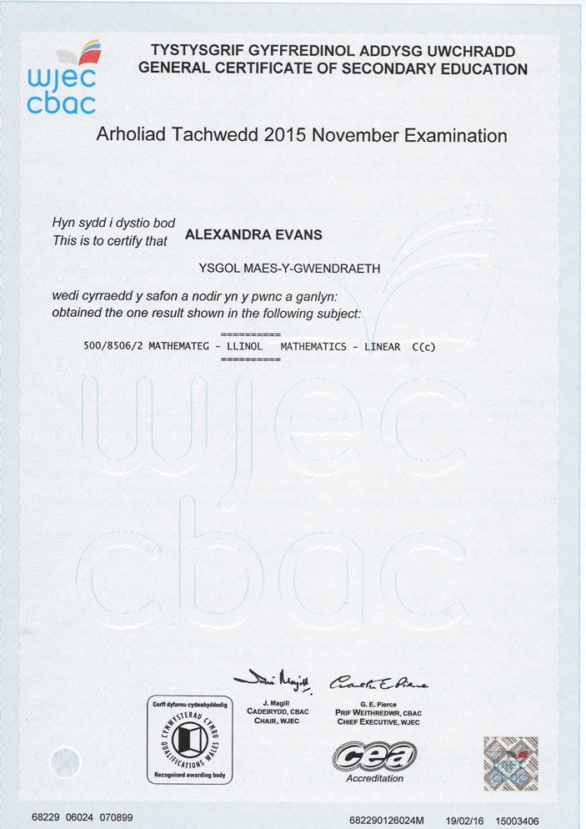

GCSE Mathematics 1.2

Having not obtained a C grade in mathematics in June 2015, which is required for nursing, I re-sat the exam in November 2015 and passed. Here is a photocopy of my certificate. Having the knowledge and understanding of mathematics is very important in nursing as a nurse is required to ensure medication dosages are the right amount when giving tablets, injections, IV drips and many other methods (Chron, 2019).

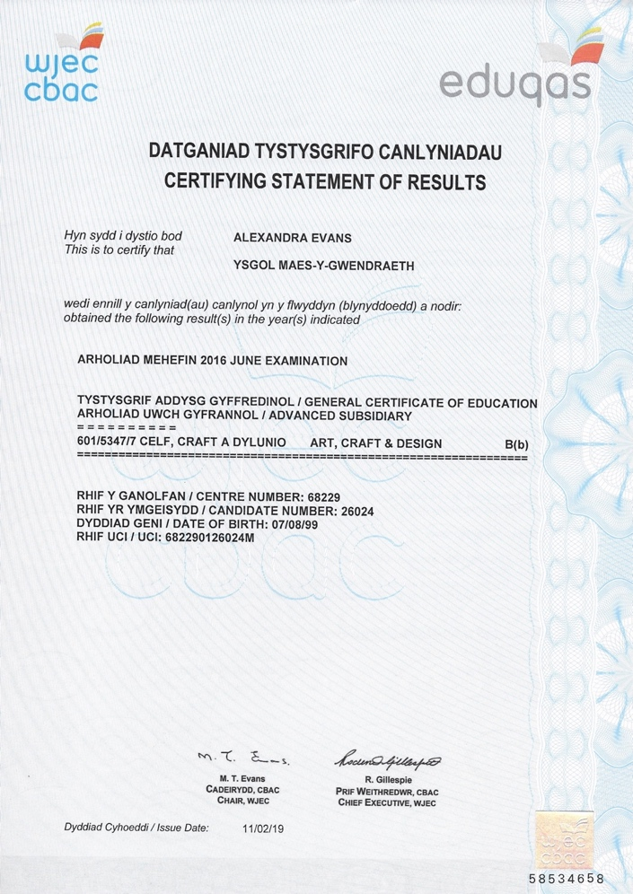

As Level Art & Design 1.3

During my first year of A Levels I achieved a B grade in Art and Design. Having studied this particular subject, I learnt to examine in much greater detail and not to make assumptions. This taught me to visualise and involved critical thinking. This subject surprisingly helped develop my academic skills which can also be used within nursing like thinking outside the box and critical thinking. Studying art can improve student nurses’ clinical observational skills that is required when studying patients by using a technique for analysing visual art (Merrifield, 2015).

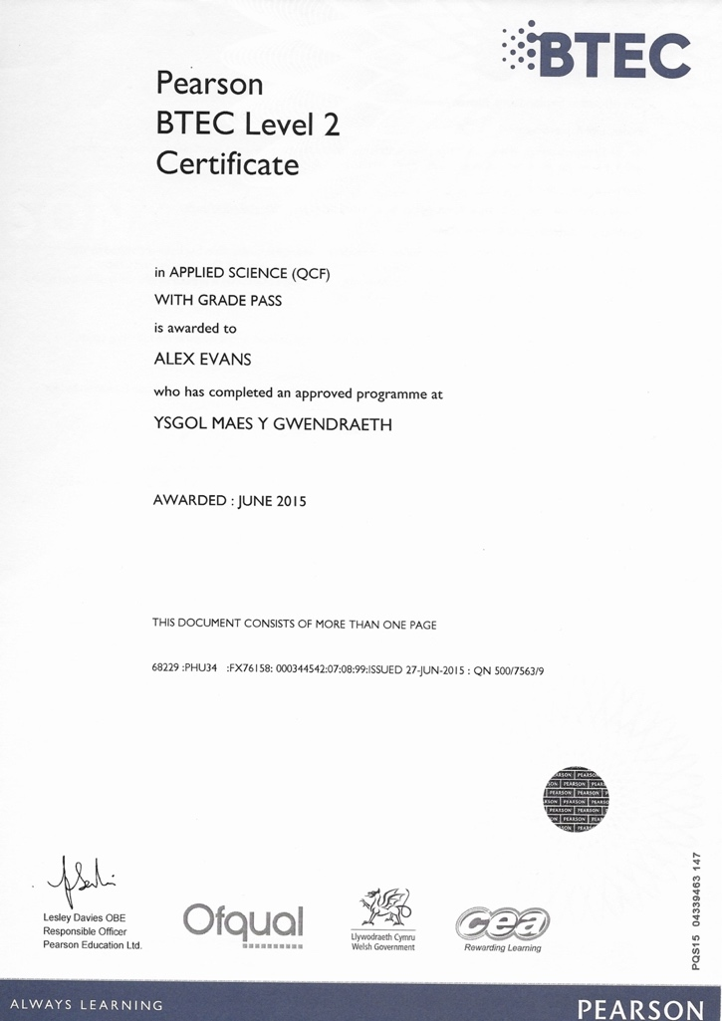

BTEC Diploma Applied Science 1.4

As I didn’t achieve a GCSE C grade in Science, I had the opportunity to study a BTEC course which enabled me to obtain a pass in all of my modules. Having this qualification has helped me during my course in Nursing Studies and Health as I had some knowledge in anatomy and physiology.

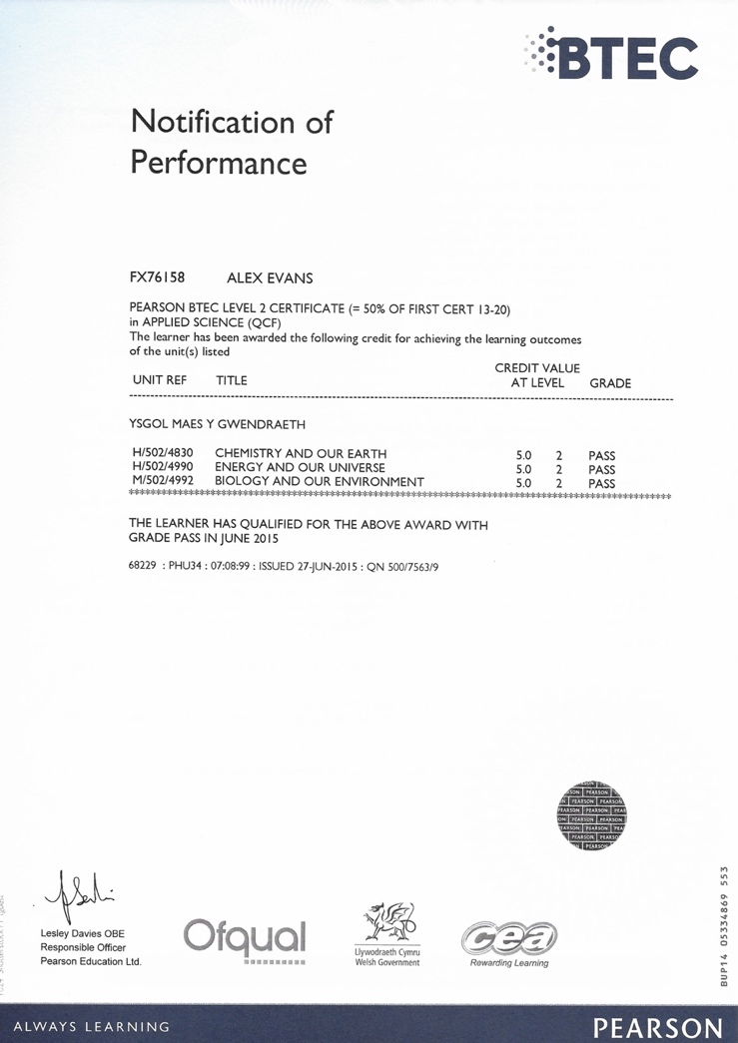

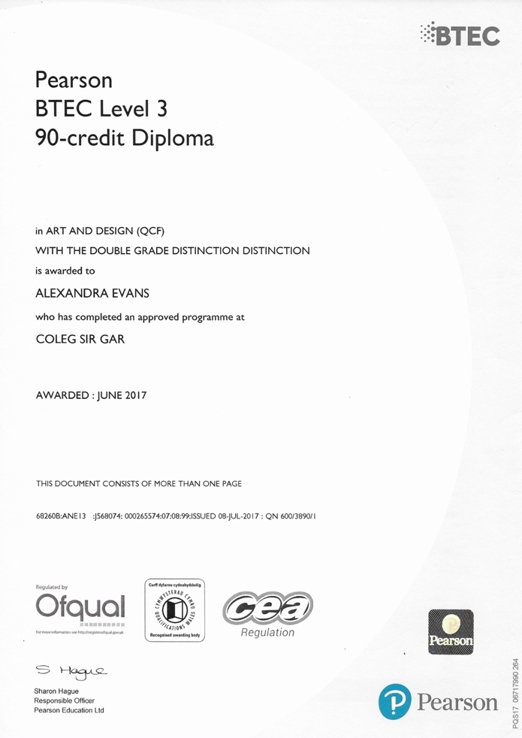

BTEC Diploma Art & Design 1.5

I decided to further my studies in art and design as I felt that studying art was improving my performance in areas that other subjects hadn’t, such as my improvement in problem solving, complex analysis, critical thinking and lateral thinking. I became so passionate that my development strengthened and this evidently had a positive effect as I achieved an overall Double Distinction. Here are the certificates and a breakdown of the grades I achieved for each module.

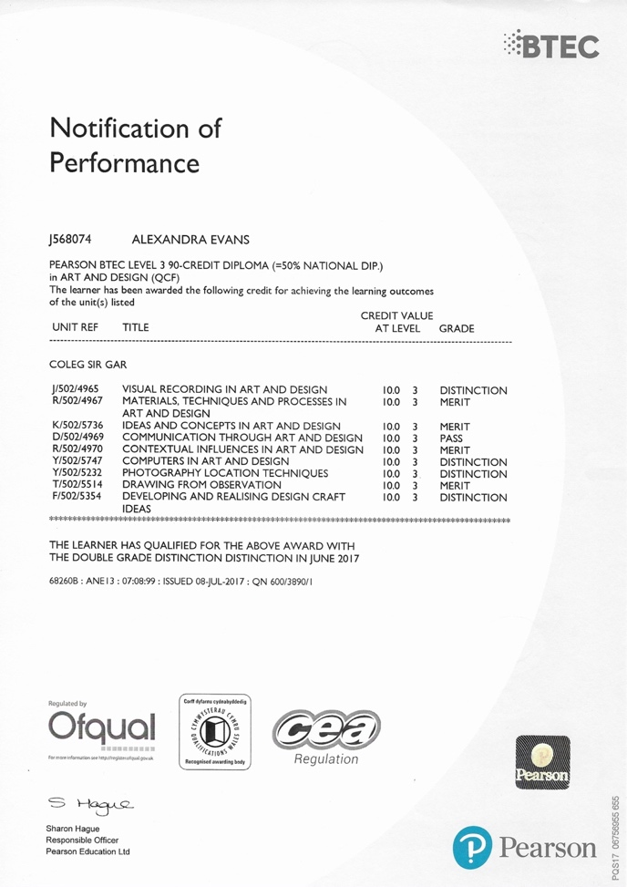

Working in Retail

Before dedicating myself to a nursing career I decided to work in retail where I would learn fundamental transferable skills such as attention to detail, communication, empathy, adaptability and flexibility, team working and dealing with complaints using tact and sensitivity (Health Careers NHS, 2019). Working in retail was an eye opener, dealing with customers every day and altering to their needs could be difficult at times but with the right approach people began putting their trust into me and from there on this became almost second nature. The importance of respect and compassion when taking care of the public is crucial, especially while under pressure. My experience working within retail has helped me understand the importance of these transferable skills and empathising with others in order to provide the best care necessary and ensuring that I always handle situations in a tactful and caring manner when dealing with difficult customers.

Caring for my grandfather

My grandfather suddenly became unwell which worsened over a short period. It became obvious that he would need full time care, therefore I decided to take on the role of caring for him alongside my mum. Knowing that my grandfather eventually relied and depended on my support was a huge responsibility and being in a position to do this was a privilege and something which was very important to me. Nursing my grandfather towards his final moths of life really made me realise the difference I can make in someone’s life and how rewarding this role can be. When he sadly passed away, I decided to apply for the job as a healthcare assistant and started thinking further into my career as a nurse.

Current place of work

As I am currently a health care assistant within a nursing home, I have learnt over the past couple of months that compassion is a key aspect of caring for service users as a considerable large part of my role is washing and dressing. I have learned how important respect and dignity is and that it is vital to help service users feel as if they are being cared for the correctly way. I have also learnt that communication is important in order to gain a trusting relationship.

Healthcare Assistant Job Role

Being a healthcare assistant comes with a variety of other tasks such as helping service users to eat and move about, taking observations such as blood pressure and temperature, washing and dressing and listening to the service users’ needs (University Hospital Southampton NHS Foundation, 2014).

Benefits of working as a healthcare assistant

Having had the experience of working alongside qualified nurses and working the position of a healthcare assistant, I believe this has provided me with a good set of skills to take further in my career of becoming a nurse. Working as a healthcare assistant can give a good insight into the role of a nurse and is a useful experience to have when applying for a nursing degree (Search, 2018).

E-Learning Training

On the day of completion from training I was able to access MyLearning online training which is an ongoing requirement to log into, complete sections and receive certificates. Below are copies of certificates I have received for completing sections of the E-learning training.

1.6

E-learning training comes with a number of benefits, it is cost effective, saves time and money, it is flexible for the employees as it can be done at a time and place where it suits the learner and with it being self-directed learning the participant tends to be more engaged and are more likely to remember information (eCom Scotland, 2019).

Development in my current studies

As I am currently studying the Certificate of Higher Education in Nursing Studies and Health, this course has enabled me to gain a variety of new transferable skills linked to being a nurse such as taking initiative, adaptability and flexibility, problem solving and planning and organising. Before starting this course, I was not a confident writer, struggled with exams and did not feel that my academic level was strong enough to pursue the nursing degree, but this course has changed that for me. Studying anatomy and physiology has strengthened a weak area in my knowledge of biology and has surprisingly almost become second nature. Comparing my development in school to university it is clear that I am much more focused this year which has benefitted my studies as I am dedicated to this career choice of becoming a nurse.

Work Placement

As part of the Certificate of Higher Education in Nursing Studies and Health course, it is a requirement to complete at least 60 hours of work placement in the first year and 120 hours over the course of two years. As I currently work in a nursing home, I decided to complete my placement where I work and use my payslips as evidence for the hours I have completed. From the 1st of December to the 31st of January I have completed 153.75 hours. I also have evidence on my payslip for the hours of training I completed prior to starting my job where I learnt (GET MY BOOKLET THAT HAS SIGNATURES FOR WHAT I DID DURING TRAINING AND PHOTOCOPY AS EVIDENCE.) (PUT IN DATES OF THE TRAINING WEEK)

Placement Hours/ Pay Slips 1.7

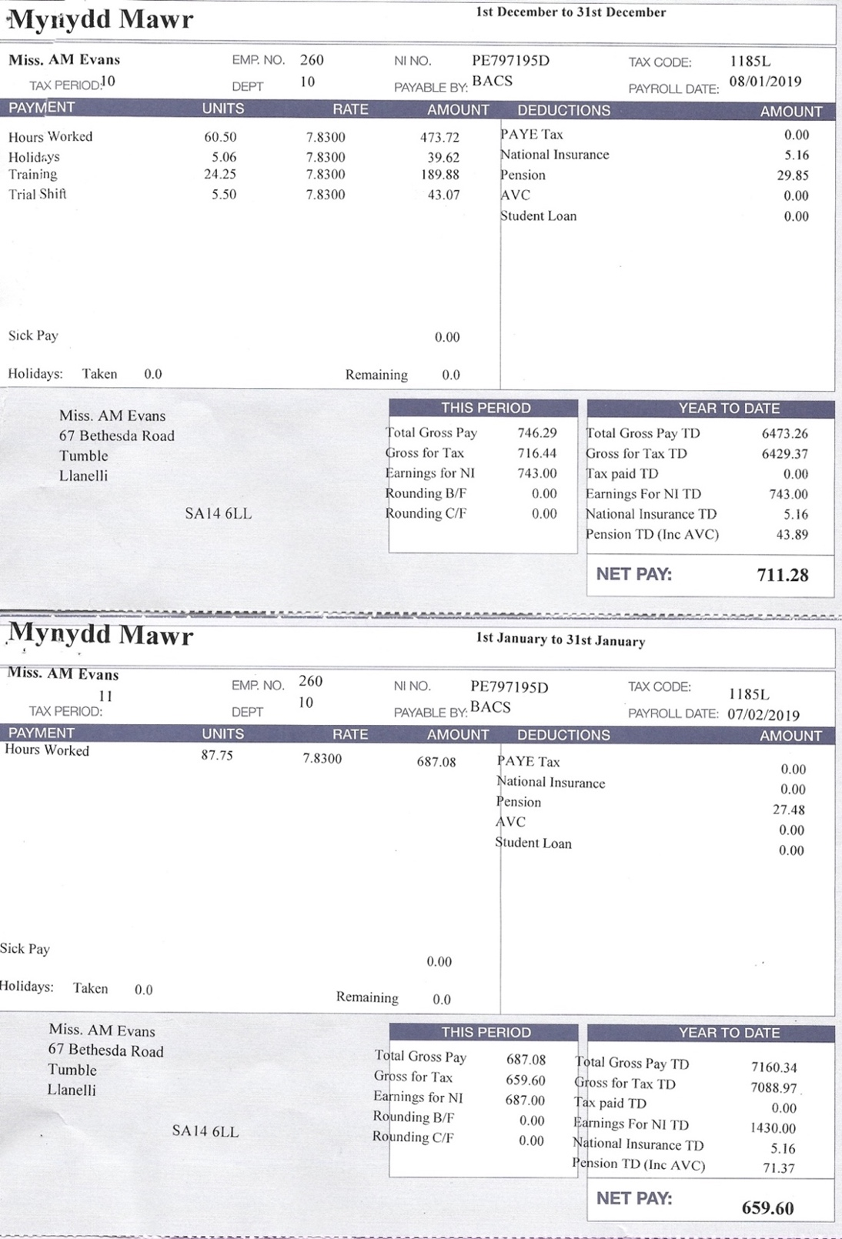

Here are two copies of my payslips stating how many hours I have worked for work placement between the 1st of December to the 31st of January. This also includes evidence of training days I had to complete before starting my job and a trial shift.

Documenting my work placement journey

1st December 2018

Today I worked a twelve-hour shift on a unit that specialises mainly with service users suffering with Dementia and Parkinson’s Disease. The morning began by reading the written handover sheet which has information of each service users’ behaviours and well-being over the last twenty-four hours. Handover sheets ensure that the service users’ care is continuously updated and documented, providing nurses and healthcare assistants with information at the start of each shift (Conwy & Denbighshire NHS Trust, 2007). Once I was aware of each service users’ well-being, I was assisted with another healthcare assistant to wash and dress the service users, ensuring their dignity was kept, engaging in conversation and that we enabled the service users by giving them the choice and control of what to wear, what they would like for breakfast etc. Parkinson’s UK, (2019) believe that service users should be given choices about the health and social care being provided. Disposable aprons and gloves were also worn during personal care to minimise the risk of body fluids, secretions or blood coming into contact with my uniform as this can carry bacteria and infection (Health Protection Scotland NHS, 2015). During breakfast I had to wear a disposable apron and so did the service user to minimise the risk of food getting on my uniform and reduce food contamination. Similar to the handover sheet, a daily record sheet is kept for each service user from 8am to 8am the following morning, documenting every hour their fluid and food intake, pad changes, bowel movement and recording if the service user had personal care in the morning, a bath or shower and if the male service users had a shave. I learnt a lot during this shift as I have not long started the job either, therefore I was learning the job through my placement too. This experience has helped me gain an insight into what nursing has to offer, but it has also given me the confidence to peruse my career in this job role.

15th December 2018

As it was nearing up to Christmas, we decided to take some of the service users out for a roast dinner. Preparation for a trip out is vital, especially with service users suffering with dementia or learning difficulties as it is best not to take them to extremely busy environments, a secure car park that is ideally away from any main roads, ensuring the buses have been inspected before taking any wheelchair users, sensible clothing for weather conditions and spare clothing in case of an accident and contacting the restaurant to enquire if they have wheelchair access. I was unaware as to how much preparation was needed before today to ensure the safety and well-being of the service users. Once all checks were complete, we headed out for lunch. Documenting their meals, drinks and behaviours was still necessary when we arrived back at the nursing home and informing the shift lead nurse of any incidents during the trip. One important aspect I have learnt from today is that providing high quality patient care is not only about the care you provide in the health care environment but the care that must be provided in any environment, the service users relied on my care being provided from morning to evening and this has shown me the impact I have on other people’s lives.

5th January 2019

I have been working on a particular male only unit for the past month of my work placement, but today I was allocated on a female only unit that I had never worked on before. I felt very nervous to be placed on a new unit, but I was aware that part of the job is being flexible to the company’s requirements. This unit was far more intense than the male only unit I had previously worked on as most service users on the female unit were assisted with feeding, some fully hoisted, unable to communicate and could be aggressive. Adapting to this change was challenging but I decided to embrace this and use it to my advantage of learning new areas of care that I had not been faced with yet. Although I have applied for the Adult Nursing degree, mental health is an area that I will always come across throughout my career and having the experience of working in a mental health nursing home has enabled me to gain experiences and new skills that I can take further in my career as a nurse.

Personal Statement

Having gained the GCSE requirements and currently studying Nursing Studies and Health at the University of Wales Trinity Saint David, I currently have the academic requirement to apply for Adult Nursing. Here is my personal statement which provides further insight as to why I want to peruse my career in nursing. I submitted this to UCAS on the 27th of December 2018 applying for Adult Nursing at Swansea University.
I am currently a health care assistant within a nursing home. During my time here, I have learnt that compassion is a key aspect of caring for service users as a major part of my role is washing and dressing. I have learned how important dignity and respect is and that it is vital to help service users feel as if they are being cared for correctly. I have also learnt that communication is important in order to gain a trusting relationship. I am currently a first-year student studying the Certificate of Higher Education in Nursing Studies and Health at the University of Wales Trinity Saint David. This course has enabled me to gain a number of skills and attributes linked to be a nurse such as dedication and patience, excellent communication skills, commitment, respect, attention to detail and emotional stability which I’m already putting into practice within my job role as a health care assistant. Not only has this course enabled me to gain practical skills but it has helped me develop academically in subjects relating to nursing such as anatomy and physiology and communication and counselling. Having studied Art and Design as one of my AS choices, this was a subject where I learnt to examine in much greater detail and not to make assumptions, it taught me to visualise the larger picture and involved critical thinking. Now that I’m studying a subject relating to the health care environment, I can see a link between the key skills taught in both nursing and art. After studying Art and Design, I wanted to gain my knowledge and experience within my field of choice before applying for Adult Nursing, so I started my job. Working in retail was an eye opener, dealing with customers and adapting to their needs could be challenging at times but with the right approach people would begin putting their trust into me and from there on this became almost second nature. I cannot stress enough the importance of respect and compassion that is needed when taking care of the public, especially while under pressure. My experience working within retail has really helped me understand the importance of interpersonal skills and empathising with others in order to provide the best care necessary and ensuring that I handle situations in a sensitive and caring manner when dealing with irate customers. Unexpectedly my grandfather became unwell which worsened over a period of eight months. As time went on it was obvious that he would need full time care, so I took on the role of caring for him alongside my mum. It was essential that I had a balance to care for my grandfather without taking his independence away and ensuring that his dignity and privacy was kept whilst having to undertake personal care. Knowing how much my grandfather depended on my support was quite a responsibility and being in a position to do this was a privilege and something which was very important to me. Having the experience of nursing my grandfather in his final months really brought home to me, the difference I can make in someone’s life and how rewarding this role can be. I learnt to regulate my emotions so that I could approach his suffering with care and compassion. I believe that I’m a suitable candidate to study Adult Nursing at your university because I’m a very committed, trustworthy and hardworking individual who cares about the quality of my work, take instruction well and always gives any task 100%. I would describe myself as having a gentle manner who can empathise with others. I’m calm in a crisis and a problem solver; I work well with others and on my own initiative. I would welcome the opportunity to be offered a place to study nursing and I will continually strive to be the best that I can be.

Receiving Interview for Adult Nursing

Receiving an interview
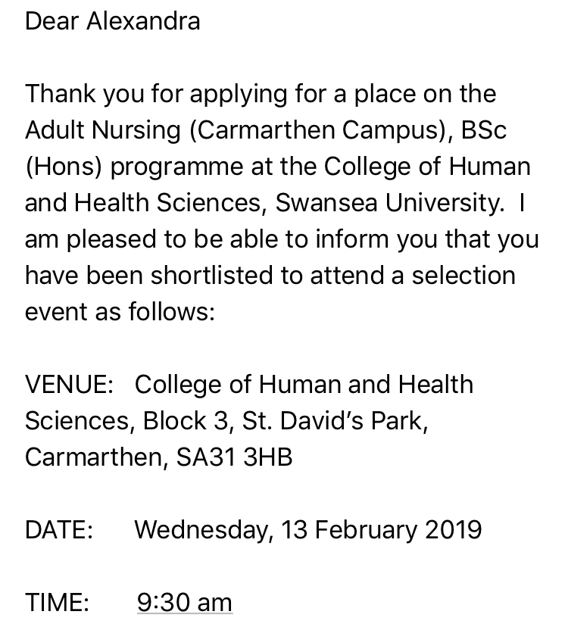

After submitting my UCAS application, I received an email from Swansea university stating that I had been shortlisted to attend a selection event for Adult Nursing. Here is a copy of the email.

Receiving an Offer
After just under a week of being interviewed, I was made an offer from my first choice to study Adult Nursing at Swansea University with the condition that I pass the HE Certificate in Nursing Studies and Health.

Reference list

Chron (2019) Why Do RNs Use Math in Their Jobs? Available at: https://work.chron.com/rns-use-math-jobs-15760.html [Accessed 20 April 2019]

Conwy & Denbighshire NHS Trust (2007) NURSING HANDOVER FOR ADULT PATIENTS GUIDELINES. Available at: http://www.wales.nhs.uk/sitesplus/documents/861/additional%20info%20048.pdf [Accessed 20 April 2019]

eCom Scotland (2019) The Benefits of eLearning in the Workplace. Available at: https://ecomscotland.com/resources/insight-the-benefits-of-elearning-in-the-workplace/ [Accessed 20 April 2019]

Health Protection Scotland NHS (2015) Standard Infection Control Precautions Literature Review: Personal Protective Equipment (PPE) Aprons/Gowns. Available at: http://www.nipcm.hps.scot.nhs.uk/documents/sicp-ppe-apronsgowns/ [Accessed 20 April 2019]

Health Careers NHS (2019) Transferable skills whilst at medical school. Available at: https://www.healthcareers.nhs.uk/explore-roles/doctors/medical-school/transferable-skills-whilst-medical-school [Accessed 20 April 2019]

Merrifield, N. (2015) Student nurses improve observation skills through visual arts course in US. Available at: https://www.nursingtimes.net/roles/nurse-educators/student-nurses-improve-observation-skills-through-visual-arts-course-in-us/5084010.article [Accessed 20 April 2019]

Parkinsons UK (2019) Control, choice and personalised services in health and social care. Available at: https://www.parkinsons.org.uk/about-us/control-choice-and-personalised-services-health-and-social-care [Accessed 20 April 2019]

Search (2018) How to climb the NHS career ladder from Healthcare Assistant to Registered Nurse. Available at: https://www.search.co.uk/blog/2018/09/how-to-climb-the-nhs-career-ladder-from-healthcare-assistant-to-registered-nurse [Accessed 20 April 2019]

University Hospital Southampton NHS Foundation (2014) Healthcare Assistants. Available at: http://www.uhs.nhs.uk/WorkingHere/Typesofjob/HealthcareAssistant.aspx [Accessed 20 April 2019]

UCAS (2019) Nurses look after people when they are sick or injured. Available at: https://www.ucas.com/ucas/after-gcses/find-career-ideas/explore-jobs/job-profile/nurse [Accessed 22 April 2019]

