University of Wales Trinity Saint David University

[ACCA6021] Graphics and Games Programming
[Assignment 1] Application of Graphics Principles

Joshua Piecko
Student Number: 2112389

20th November 2023

Contents
Figures 3
Tables 3
1. Introduction 4
2. Overview of the Graphics Pipeline 4
2.1. Core Stages of the Graphics Pipeline 4
2.2. Transformations and Coordinate Systems 4
3. Identifying Bottlenecks and Challenges 5
3.1. Object Space Complexity 5
3.2. Complex Transformation in World and View Space 5
3.3. Projection and Rasterization Challenges 5
3.4. Shader Execution 5
4. Optimizing the Graphics Pipeline 6
4.1. Algorithmic Optimizations 6
4.2. Parallelization with Modern GPUs 6
4.3. Shader Compilation and Execution 6
5. State-of-the-art GPU Technology 6
5.1. Overview of Cutting-Edge GPU Architectures 6
5.2. Memory and Bandwidth Improvements 6
6. Demonstrating Transforms 7
6.1. Transform from Object Space to World Space 7
6.1.1. Translation 7
6.1.2. Rotation 8
6.1.3. Acquired Values (Pw, Point in World Space) 8
6.2. Transform from World Space to View Space 9
6.2.1. Calculating the camera rotation angles (UVN) 9
6.2.2. Creating the View Matrix 12
6.2.3. Applying the Viewing Transform to Pw 13
6.2.4. Acquired Values (Pc, Point in Camera Space) 14
6.3. Transform from View Space to Projection Space 14
6.3.1. Calculating Perspective Matrix Values 14
6.3.2. Constructing the Perspective Matrix 17
6.3.3. Applying Perspective Matrix to Pc (Point with Perspective Proj. Applied) 17
6.3.4. Applying Perspective Divide to Acquire NDC (Normalized Device Coordinates) 17
6.3.5. Acquired Values (Pv, Point in Projection Space), (NDC), and Assumptions 18
6.4. Calculating Distance from Culling Plane 18
6.4.1. Acquired Value and Assumption (Culling Plane Distance) 19
7. Real-World Applications 19
8. Conclusion 19
9. References 20
Appendix A 22

Figures
Figure 1: Overview of the Graphics Pipeline 4
Figure 2: Assignment Brief Appendix A 7
Figure 3: Formula for Matrix Translation 7
Figure 4: Formula for Matrix Rotation 8
Figure 5: Formula for View Space Transform 9
Figure 6: Formula for calculating UVN 9
Figure 7: Formula for Creating View Matrix 12
Figure 8: Depiction of Camera Frustum and Projection Space 14
Figure 9: Formulas for constructing Perspective Matrix 14

Tables
Table 1: View Matrix Multiplication Output Values 12

Introduction
The graphics pipeline stands as a pivotal element in the realm of computer graphics rendering. It serves as the foundation upon which intricate virtual worlds, simulations, and visualizations are constructed [1]. This pipeline orchestrates a sequence of stages, each playing a vital role in the transformation from number-values into the vibrant, immersive scenes we witness on our screens [1].
In pursuit of ever more realistic and detailed graphics, the optimization of this pipeline has become paramount. State-of-the-art GPU technology has emerged as a driving force behind this optimization, harnessing immense processing power to expedite the rendering process and unlocking new realms of visual fidelity and interactivity [2].

Overview of the Graphics Pipeline

Core Stages of the Graphics Pipeline
The graphics pipeline is a multi-stage process that transforms geometric data into a final rendered image. These stages include Object Space, World Space, View Space, Projection Space, and Screen Space [1] [3]. The transformations from one space to the next occur as depicted in Fig. 1.

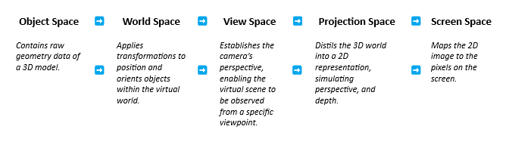
Figure 1: Overview of the Graphics Pipeline

Each stage serves a crucial purpose, allowing for precise control over the final visual output, enabling effects like perspective, lighting, and shadowing to be accurately applied.

Transformations and Coordinate Systems
Coordinate systems and transformations are pivotal components of the graphics pipeline. As an object moves through the pipeline, it undergoes a series of transformations between different coordinate spaces. These transformations facilitate positioning, scaling, and rotation operations, ensuring that objects are correctly placed and oriented in the final rendered scene [3]. Understanding these transformations is essential for achieving accurate and visually appealing graphics [1].

Identifying Bottlenecks and Challenges

Object Space Complexity
Processing object space coordinates can pose potential bottlenecks - especially when we are dealing with complex and highly detailed models. The sheer volume of vertices and polygons in a scene can cause serious strain on computational resources [4]. Optimization techniques such as spatial partitioning and level of detail (LOD) algorithms play a crucial role in managing this complexity [5] [6], allowing for efficient handling of large-scale models.

Complex Transformation in World and View Space
Moving from object space to world and view space introduces challenges in accurately transforming and positioning objects. Complex geometries and non-uniform scaling can lead to distortions [7]. Advanced algorithms, like quaternion rotations and matrix decomposition, mitigate these issues, ensuring that objects maintain their visual integrity and composition through various transformations.

Projection and Rasterization Challenges
Projection involves converting 3D coordinates into 2D space, simulating perspective. Rasterization further converts geometric primitives into pixels for rendering. Both stages can be computationally demanding, especially in scenes with high levels of detail [1]. Techniques such as hierarchical depth buffering and early-z culling help alleviate these processing burdens, enabling for a smoother rendering performance [8] [9].

Shader Execution
Shaders are essential for applying visual effects and materials to objects in the scene. Complex shader operations, especially in scenarios with advanced lighting models or post-processing effects, can strain GPU resources. By employing techniques like shader instancing and dynamic branching optimization we can significantly enhance shader performance, further ensuring smooth and visually appealing rendering [10].

Optimizing the Graphics Pipeline

Algorithmic Optimizations
Optimizing the graphics pipeline involves employing a series of efficient algorithms at each stage. Techniques such as spatial partitioning for culling invisible objects [5] and advanced rendering techniques like screen space reflections (SSR) can significantly enhance rendering efficiency [11]. Additionally, employing LOD algorithms and mesh simplification techniques in object space can drastically reduce computational requirements [6].

Parallelization with Modern GPUs
Modern GPUs leverage parallel processing to accelerate graphics rendering. Concepts like Single Instruction, Multiple Data (SIMD) and Single Instruction, Multiple Thread (SIMT) enable the execution of multiple operations simultaneously [12]. This dramatically enhances the throughput of graphics operations, allowing for the handling of complex scenes with ease [12]. For instance, tasks like vertex and fragment shading can be parallelized to process multiple vertices or fragments simultaneously, improving overall rendering performance [12].

Shader Compilation and Execution
Shader optimization is a critical aspect of maximizing GPU performance. Compiler advancements and shader model improvements play a significant role in enhancing the efficiency of shader execution [12]. Utilizing shader profiling tools and applying shader-specific optimizations such as loop unrolling and register allocation [13], can/should lead to substantial gains in rendering speed and visual quality.

State-of-the-art GPU Technology

Overview of Cutting-Edge GPU Architectures
Recent GPU architectures have introduced groundbreaking capabilities, revolutionizing graphics rendering. Advancements in ray tracing technology have enabled realistic lighting and reflections, vastly improving visual fidelity [14]. The integration of AI cores and dedicated hardware for ray tracing acceleration has propelled real-time ray tracing into the realm of possibility for a broader range of applications [14].

Memory and Bandwidth Improvements
Modern GPUs boast significant strides in memory and bandwidth management. High memory bandwidth ensures rapid data access, crucial for processing large textures and complex models. Advanced memory management techniques, such as memory compression and caching, optimize the utilization of available memory resources [15], further enhancing rendering performance.

Demonstrating Transforms
Utilizing provided coordinates and parameters, we can demonstrate the transformation of a vertex from object space to normalized device coordinates. This process involves a series of mathematical operations, including matrix multiplications and coordinate conversions, which are efficiently executed by modern GPUs. The GPU's parallel processing capabilities play a pivotal role in expediting this transformation, allowing for real-time rendering of complex scenes with intricate geometries.
Figure 2: Assignment Brief Appendix A

Transform from Object Space to World Space
The transition from Object Space to Model Space involves applying transformations (such as translation, rotation, and scaling) to an 3D object's vertices. This positions and orientates the object relative to a coordinate system centred around the object itself, this allows for easier manipulation and positioning of objects before further transformations and rendering in the camera's view.

Translation
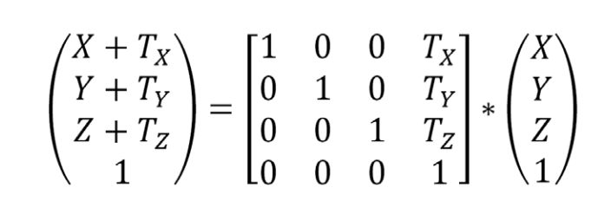
Figure 3: Formula for Matrix Translation
$$\left[\begin{matrix}\begin{matrix}1 & 0 \\ 0 & 1\end{matrix} & \begin{matrix}0 & 1.5 \\ 0 & 0\end{matrix} \\ \begin{matrix}0 & 0 \\ 0 & 0\end{matrix} & \begin{matrix}1 & -1 \\ 0 & 1\end{matrix}\end{matrix}\right]*\left({\begin{matrix}1 \\ 3\end{matrix} \atop \begin{matrix}-2 \\ 1\end{matrix}}\right)$$
$$= \left[\begin{matrix}\left(1*1\right) & + & \left(0*3\right) & + & \left(0*-2\right) & + & \left(1.5*1\right) \\ \left(0*1\right) & + & \left(1*3\right) & + & \left(0*-2\right) & + & \left(0*1\right) \\ \left(0*1\right) & + & \left(0*3\right) & + & \left(1*-2\right) & + & \left(-1*1\right) \\ \left(0*1\right) & + & \left(0*3\right) & + & \left(0*-2\right) & + & \left(1*1\right)\end{matrix}\right]$$
$$=\left[\begin{matrix}1 & + & 0 & + & 0 & + & 1.5 \\ 0 & + & 3 & + & 0 & + & 0 \\ 0 & + & 0 & + & -2 & + & -1 \\ 0 & + & 0 & + & 0 & + & 1\end{matrix}\right]$$
$$=\left( {\begin{matrix}2.5 \\ 3\end{matrix} \atop \begin{matrix}-3 \\ 1\end{matrix}} \right)$$

Rotation
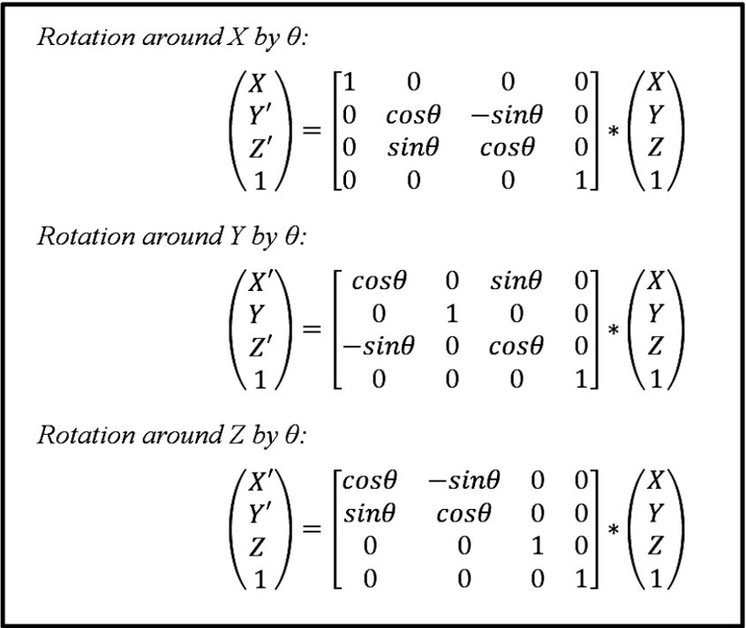
Figure 4: Formula for Matrix Rotation
$$\left[\begin{matrix}1 & 0 & 0 & 0 \\ 0 & \cos{70} & -\sin{70} & 0 \\ 0 & \sin{70} & \cos{70} & 0 \\ 0 & 0 & 0 & 1\end{matrix}\right]*\left(\begin{matrix}2.5 \\ 3 \\ -3 \\ 1\end{matrix}\right)$$
$$=\left[\begin{matrix}\left(1*2.5\right) & + & \left(0*3\right) & + & \left(0*-3\right) & + & \left(0*1\right) \\ \left(0*2.5\right) & + & \left(0.34202014332*3\right) & + & \left(-0.93969262078*-3\right) & + & \left(0*1\right) \\ \left(0*2.5\right) & + & \left(0.93969262078*3\right) & + & \left(0.34202014332*-3\right) & + & \left(0*1\right) \\ \left(0*2.5\right) & + & \left(0*3\right) & + & \left(0*-3\right) & + & \left(1*1\right)\end{matrix}\right]$$
$$=\left[\begin{matrix}2.5 & + & 0 & + & 0 & + & 0 \\ 0 & + & 1.02606042996 & + & 2.81907786234 & + & 0 \\ 0 & + & 2.81907786234 & + & -1.02606042996 & + & 0 \\ 0 & + & 0 & + & 0 & + & 1\end{matrix}\right]$$
$$=\left(\begin{matrix}2.5 \\ 3.8451382923 \\ 1.79301743238 \\ 1\end{matrix}\right)$$

Acquired Values (Pw, Point in World Space)

Pw = (2.5, 3.8451382923, 1.79301743238, 1)

Transform from World Space to View Space
Going from Model Space to View Space in graphics programming involves transforming the coordinates of objects from their local, object-relative coordinates (Model Space) to a global, camera-relative coordinate system (View Space). This transformation is achieved using a combination of transformation matrices, including the point in world space (Pw) and the view matrix (which represents the camera's position and orientation).
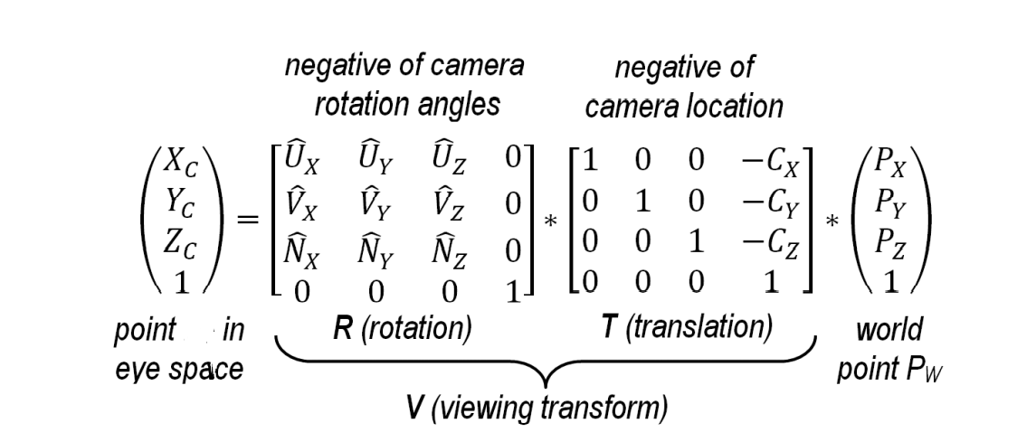
Figure 5: Formula for View Space Transform

Calculating the camera rotation angles (UVN)
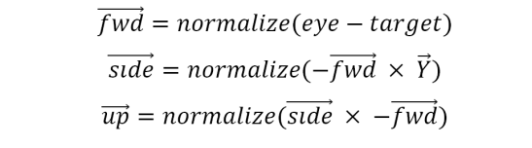
Figure 6: Formula for calculating UVN

Calculating the forward vector (N)

$$\vec{forward}=normalize\left(\left(0, 4.5, -1\right)-\left(2, 0, 0\right)\right)$$
$$\vec{forward}=normalize\left(-2, 4.5, -1\right)$$
$$\vec{forward}= \frac{\left(-2, 4.5,-1\right)}{\left\|\left(-2, 4.5,-1\right)\right\|}$$
$$\left\|\left(-2, 4.5,-1\right)\right\|= \sqrt{-2^{2}+{4.5}^{2}+{-1}^{2}}= 5.02493781056…$$
$$\vec{forward}= \frac{\left(-2, 4.5,-1\right)}{5.02493781056}$$
$$\vec{forward}=(-0.398015, 0.895533, -0.199007)$$

Calculating the side vector(U)

$$\vec{side}=normalize\left(\left(0.398015, -0.895533, 0.199007\right)x\left(0, 1, 0\right)\right)$$

$$\vec{side}=normalize\left(\left(-0.895533*0\right)-\left(0.199007*1\right), \left(0.199007*0\right)-\left(0.398015*0\right),\left(0.398015*1\right)-\left(-0.895533*0\right)\right)$$

$$\vec{side}=normalize\left(0-0.199007, 0-0, 0.398015-0\right)$$

$$\vec{side}=normalize\left(-0.199007, 0, 0.398015\right)$$

$$\vec{side}= \frac{\left(-0.199007, 0, 0.398015\right)}{\left\|\left(-0.199007, 0, 0.398015\right)\right\|}$$
$$\left\|\left(0.199007, 0, 0.398015\right)\right\|= \sqrt{-{0.199007}^{2}+0^{2}+{0.398015}^{2}}= 0.44499407443…$$

$$\vec{side}= \frac{\left(-0.199007, 0, 0.398015\right)}{0.44499407443}$$

$$\vec{side}=\left(-0.44721269661, 0, 0.89442764044\right)$$

Calculating the up vector(V)

$$\vec{up}=normalize\left(\left(-0.44721269661, 0, 0.89442764044\right)x\left(0.398015, -0.895533, 0.199007\right)\right)$$

$$\vec{up}=normalize(\left(0*0.199007\right)-\left(0.89442764044*-0.895533\right),\left(0.89442764044*0.398015\right)-\left(-0.44721269661*0.199007\right),\left(-0.44721269661*-0.895533\right)-(0*0.398015))$$

$$\vec{up}=normalize(0+0.80098946813, 0.35599561731+0.08899845711, 0.40049372783-0)$$

$$\vec{up}=normalize\left(0.80098946813, 0.44499407442, 0.40049372783\right)$$

$$\vec{up}= \frac{\left(0.80098946813, 0.44499407442, 0.40049372783\right)}{\left\|\left(0.80098946813, 0.44499407442, 0.40049372783\right)\right\|}$$

$$\left\|\left(0.80098946813, 0.44499407442, 0.40049372783\right)\right\|= \sqrt{{0.80098946813}^{2}+{0.44499407442}^{2}+{0.40049372783}^{2}}= 0.99999954018…$$

$$\vec{up}= \frac{\left(0.80098946813, 0.44499407442, 0.40049372783\right)}{0.99999954018}$$

$$\vec{up}=\left(0.80098983644, 0.44499427904, 0.400493911985\right)$$

Acquired Values (Forward, Side, Up)
$$\vec{forward}=(-0.398015, 0.895533, -0.199007)$$

$$\vec{side}=\left(-0.44721269661, 0, 0.89442764044\right)$$

$$\vec{up}=\left(0.80098983644, 0.44499427904, 0.400493911985\right)$$

Creating the View Matrix

Figure 7: Formula for Creating View Matrix

$$V=\left[\begin{matrix}-0.44721269661 & 0 & 0.89442764044 & 0 \\ 0.80098983644 & 0.44499427904 & 0.400493911985 & 0 \\ -0.398015 & 0.895533 & -0.199007 & 0 \\ 0 & 0 & 0 & 1\end{matrix}\right]*\left[\begin{matrix}1 & 0 & 0 & 0 \\ 0 & 1 & 0 & -4.5 \\ 0 & 0 & 1 & 1 \\ 0 & 0 & 0 & 1\end{matrix}\right]$$

$$=\left[\begin{matrix}\left(\left(-0.44721269661*1\right)+\left(0*0\right)+\left(0.89442764044*0\right)+\left(0*0\right)\right) & \left(\left(-0.44721269661*0\right)+\left(0*1\right)+\left(0.89442764044*0\right)+\left(0*0\right)\right) & \left(\left(-0.44721269661*0\right)+\left(0*0\right)+\left(0.89442764044*1\right)+\left(0*0\right)\right) & \left(\left(-0.44721269661*0\right)+\left(0*-4.5\right)+\left(0.89442764044*1\right)+\left(0*1\right)\right) \\ \left(\left(0.80098983644*1\right)+\left(0.44499427904*0\right)+\left(0.400493911985*0\right)+\left(0*0\right)\right) & \left(\left(0.80098983644*0\right)+\left(0.44499427904*1\right)+\left(0.400493911985*0\right)+\left(0*0\right)\right) & \left(\left(0.80098983644*0\right)+\left(0.44499427904*0\right)+\left(0.400493911985*1\right)+\left(0*0\right)\right) & \left(\left(0.80098983644*0\right)+\left(0.44499427904*-4.5\right)+\left(0.400493911985*1\right)+\left(0*1\right)\right) \\ \left(\left(-0.398015*1\right)+\left(0.895533*0\right)+\left(-0.199007*0\right)+\left(0*0\right)\right) & \left(\left(-0.398015*0\right)+\left(0.895533*1\right)+\left(-0.199007*0\right)+\left(0*0\right)\right) & \left(\left(-0.398015*0\right)+\left(0.895533*0\right)+\left(-0.199007*1\right)+\left(0*0\right)\right) & \left(\left(-0.398015*0\right)+\left(0.895533*-4.5\right)+\left(-0.199007*1\right)+\left(0*1\right)\right) \\ \left(\left(0*1\right)+\left(0*0\right)+\left(0*0\right)+\left(1*0\right)\right) & \left(\left(0*0\right)+\left(0*1\right)+\left(0*0\right)+\left(1*0\right)\right) & \left(\left(0*0\right)+\left(0*0\right)+\left(0*1\right)+\left(1*0\right)\right) & \left(\left(0*0\right)+\left(0*-4.5\right)+\left(0*1\right)+\left(1*1\right)\right)\end{matrix}\right]$$

Column 1
$$\left(\left(-0.44721269661*1\right)+\left(0*0\right)+\left(0.89442764044*0\right)+\left(0*0\right)\right)$$
$$\left(\left(0.80098983644*1\right)+\left(0.44499427904*0\right)+\left(0.400493911985*0\right)+\left(0*0\right)\right)$$
$$\left(\left(-0.398015*1\right)+\left(0.895533*0\right)+\left(-0.199007*0\right)+\left(0*0\right)\right)$$
$$\left(\left(0*1\right)+\left(0*0\right)+\left(0*0\right)+\left(1*0\right)\right)$$
Column 2
$$\left(\left(-0.44721269661*0\right)+\left(0*1\right)+\left(0.89442764044*0\right)+\left(0*0\right)\right)$$
$$\left(\left(0.80098983644*0\right)+\left(0.44499427904*1\right)+\left(0.400493911985*0\right)+\left(0*0\right)\right)$$
$$\left(\left(-0.398015*0\right)+\left(0.895533*1\right)+\left(-0.199007*0\right)+\left(0*0\right)\right)$$
$$\left(\left(0*0\right)+\left(0*1\right)+\left(0*0\right)+\left(1*0\right)\right)$$
Column 3
$$\left(\left(-0.44721269661*0\right)+\left(0*0\right)+\left(0.89442764044*1\right)+\left(0*0\right)\right)$$
$$\left(\left(0.80098983644*0\right)+\left(0.44499427904*0\right)+\left(0.400493911985*1\right)+\left(0*0\right)\right)$$
$$\left(\left(-0.398015*0\right)+\left(0.895533*0\right)+\left(-0.199007*1\right)+\left(0*0\right)\right)$$
$$\left(\left(-0.398015*0\right)+\left(0.895533*0\right)+\left(-0.199007*1\right)+\left(0*0\right)\right)$$
Column 4
$$\left(\left(-0.44721269661*0\right)+\left(0*-4.5\right)+\left(0.89442764044*1\right)+\left(0*1\right)\right)$$
$$\left(\left(0.80098983644*0\right)+\left(0.44499427904*-4.5\right)+\left(0.400493911985*1\right)+\left(0*1\right)\right)$$
$$\left(\left(-0.398015*0\right)+\left(0.895533*-4.5\right)+\left(-0.199007*1\right)+\left(0*1\right)\right)$$
$$\left(\left(-0.398015*0\right)+\left(0.895533*0\right)+\left(-0.199007*1\right)+\left(0*0\right)\right)$$
Table 1: View Matrix Multiplication Output Values

Partially Simplified
$$V=\left[\begin{matrix}\left(-0.44721269661+0+0+0\right) & \left(0+0+0+0\right) & \left(0+0+0.89442764044+0\right) & \left(0+0+0.89442764044+0\right) \\ (0.80098983644+0+0+0) & (0+0.44499427904+0+0 & (0+0+0.400493911985+0) & (0+\left(-2.00247425568\right)+0.400493911985+0) \\ (-0.398015+0+0+0) & (0+0.895533+0+0) & (0+0+\left(-0.199007\right)+0) & (0+\left(-4.0298985\right)+\left(-0.199007\right)+0) \\ (0+0+0+0) & (0+0+0+0) & (0+0+0+0) & (0+0+0+1)\end{matrix}\right]$$
Simplified
$$V=\left[\begin{matrix}-0.44721269661 & 0 & 0.89442764044 & 0.89442764044 \\ 0.80098983644 & 0.44499427904 & 0.400493911985 & -1.601980343695 \\ -0.398015 & 0.895533 & -0.199007 & -4.2289055 \\ 0 & 0 & 0 & 1\end{matrix}\right]$$

Applying the Viewing Transform to Pw
Figure 5: Formula for View Space Transform

$$Pc= \left[\begin{matrix}-0.44721269661 & 0 & 0.89442764044 & 0.89442764044 \\ 0.80098983644 & 0.44499427904 & 0.400493911985 & -1.601980343695 \\ -0.398015 & 0.895533 & -0.199007 & -4.2289055 \\ 0 & 0 & 0 & 1\end{matrix}\right]*\left[\begin{matrix}2.5 \\ 3.8451382923 \\ 1.79301743238 \\ 1\end{matrix}\right]$$
$$Pc= \left[\begin{matrix}\left(-0.44721269661*2.5\right)+\left(0*3.8451382923\right)+\left(0.89442764044*1.79301743238\right)+\left(0.89442764044*1\right) \\ \left(0.80098983644*2.5\right)+\left(0.44499427904*3.8451382923\right)+\left(0.400493911985*1.79301743238\right)+\left(-1.601980343695*1\right) \\ \left(-0.398015*2.5\right)+\left(0.895533*3.8451382923\right)+\left(-0.199007*1.79301743238\right)+\left(-4.2289055*1\right) \\ \left(0*2.5\right)+\left(0*3.8451382923\right)+\left(0*1.79301743238\right)+\left(1*1\right)\end{matrix}\right]$$
Partially Simplified
$$Pc=\left[\begin{matrix}\left(-1.11803174153+0+1.60372435131+0.89442764044\right) \\ \left(2.0024745911+1.7110645419+0.71809256575+\left(-1.601980343695\right)\right) \\ \left(\left(-0.9950375\right)+3.44344823032+\left(-0.35682302017\right)+\left(-4.2289055\right)\right) \\ \left(0+0+0+1\right)\end{matrix}\right]$$
Simplified
$$Pc=\left[\begin{matrix}1.38012025022 \\ 2.82965135506 \\ -2.13731778985 \\ 1\end{matrix}\right]$$

Acquired Values (Pc, Point in Camera Space)
$$Pc=\left[\begin{matrix}1.38012025022 \\ 2.82965135506 \\ -2.13731778985 \\ 1\end{matrix}\right]$$

INVERT THE Z AXIS
$$Pc=\left[\begin{matrix}1.38012025022 \\ 2.82965135506 \\ 2.13731778985 \\ 1\end{matrix}\right]$$

Transform from View Space to Projection Space
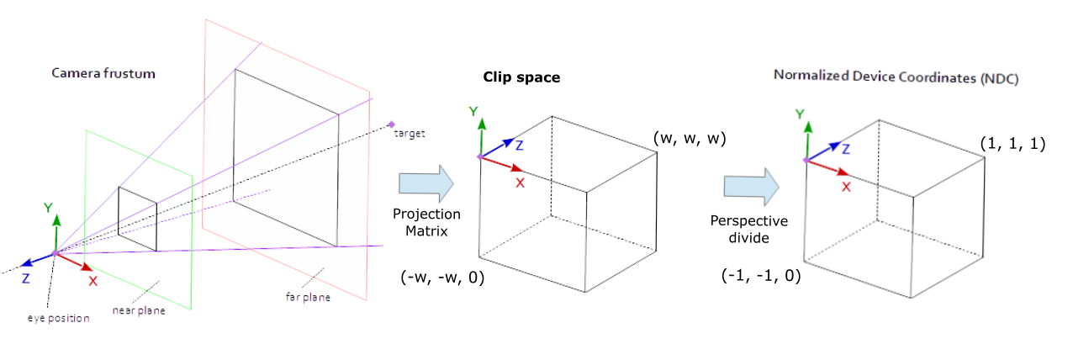
Figure 8: Depiction of Camera Frustum and Projection Space

Calculating Perspective Matrix Values
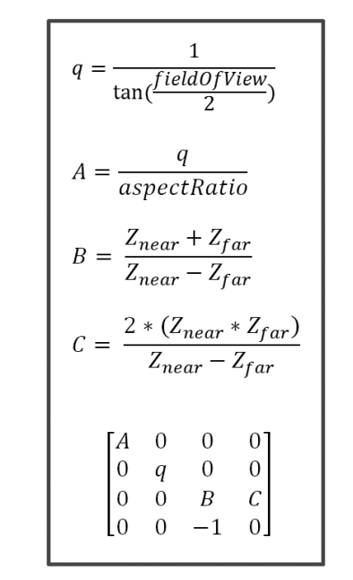
Figure 9: Formulas for constructing Perspective Matrix

Calculating the Perspective Matrix (q)

$$q=\frac{1}{\tan\left(\frac{37.0}{2}\right)}$$
$$q=\frac{1}{\tan\left(18.5\right)}$$
$$q=-2.74329361453$$

Calculating the Perspective Matrix (aspectRatio)
$$aspectRatio= \frac{1}{\tan{(\frac{FoVRadian}{2})}}$$
$$FoVRadian=\frac{37.0*π}{180}$$
$$FoVRadian≈0.645772$$

$$aspectRatio= \frac{1}{\tan{(\frac{0.645772}{2})}}$$
$$aspectRatio= 2.98868408492$$

Calculating the Perspective Matrix (A)

$$A=\frac{-2.74329361453}{2.98868408492}$$
$$A=-0.91789347304$$

Calculating the Perspective Matrix (B)

$$B= \frac{1+90}{1-90}$$
$$B=\frac{91}{-89}$$
$$B=-\frac{91}{89}≈ -1.02247191011$$

Calculating the Perspective Matrix (C)

$$C=\frac{2*\left(1*90\right)}{1-90}$$
$$C=\frac{2*90}{-89}$$
$$C=\frac{180}{-89}$$
$$C=-\frac{180}{89}≈-2.02247191011$$

Constructing the Perspective Matrix

$$Perspective Matrix= \left[\begin{matrix}-0.91789347304 & 0 & 0 & 0 \\ 0 & -2.74329361453 & 0 & 0 \\ 0 & 0 & -1.02247191011 & -2.02247191011 \\ 0 & 0 & -1 & 0\end{matrix}\right]$$

Applying Perspective Matrix to Pc (Point with Perspective Proj. Applied)

$$Pv=\left[\begin{matrix}-0.91789347304 & 0 & 0 & 0 \\ 0 & -2.74329361453 & 0 & 0 \\ 0 & 0 & -1.02247191011 & -2.02247191011 \\ 0 & 0 & -1 & 0\end{matrix}\right]*\left[\begin{matrix}1.38012025022 \\ 2.82965135506 \\ 2.13731778985 \\ 1\end{matrix}\right]$$

$$Pv=\left[\begin{matrix}\left(-0.91789347304*1.38012025022\right)+\left(0*2.82965135506\right)+\left(0*2.13731778985\right)+(0*1) \\ \left(0*1.38012025022\right)+\left(-2.74329361453*2.82965135506\right)+\left(0*2.13731778985\right)+(0*1) \\ \left(0*1.38012025022\right)+\left(0*2.82965135506\right)+\left(-1.02247191011*2.13731778985\right)+(-2.02247191011*1) \\ \left(0*1.38012025022\right)+\left(0*2.82965135506\right)+\left(-1*2.13731778985\right)+(0*1)\end{matrix}\right]$$

$$Pv=\left[\begin{matrix}-1.26680336969 \\ -7.76256449368 \\ -4.20781931321 \\ -2.13731778985\end{matrix}\right]$$

Applying Perspective Divide to Acquire NDC (Normalized Device Coordinates)

$$NDC\left[x\right]=\frac{Pv\left[x\right]}{Pv\left[w\right]} NDC\left[y\right]=\frac{Pv\left[y\right]}{Pv\left[w\right]} NDC\left[z\right]=\frac{Pv\left[z\right]}{Pv\left[w\right]} NDC[w]=\frac{Pv[w]}{Pv[w]}$$

$$NDC= \left[\begin{matrix}0.59270673666 \\ 3.63191872010 \\ 1.96873826307 \\ 1\end{matrix}\right]$$

Acquired Values (Pv, Point in Projection Space), (NDC), and Assumptions

$$Pv=\left[\begin{matrix}-1.26680336969 \\ -7.76256449368 \\ -4.20781931321 \\ -2.13731778985\end{matrix}\right]$$

$$NDC= \left[\begin{matrix}0.59270673666 \\ 3.63191872010 \\ 1.96873826307 \\ 1\end{matrix}\right]$$

Given that the Normalized device coordinates fall outside of the range of w, w, w where the value of w ranges from -1 to 1 ((-1, -1, -1) and (1, 1, 1)) it is safe to assume that the vertex falls outside the viewing frustum as the NDC do not satisfy the requirements.

Calculating Distance from Culling Plane

A culling plane is given by the plane equation $x∙\underline{n} + p_{0}∙\underline{n }$ = 0; where p₀ = (2 ,2.5 , 3) and n = (1,2,0). The true distance from the plane can be calculated as $d=\frac{x∙\underline{n} + p_{0}∙\underline{n }}{\left\|\begin{matrix}n\end{matrix}\right\|}$

Substituting for our own values:

$$d=\frac{\left(1.38012025022, 2.82965135506, 2.13731778985\right)∙\left(1, 2, 0\right)+\left(2, 2.5, 3\right)∙\underline{\left(1, 2, 0\right)}}{\left\|\left(1, 2, 0\right)\right\|}$$
$$d=\frac{(\left(1.38012025022*1\right)+\left(2.82965135506*2\right)+(2.13731778985*0)+(\left(2*1\right)+\left(2.5*2\right)+(3*0))}{\left\|\left(1, 2, 0\right)\right\|}$$
$$d=\frac{\left(1.38012025022+5.65930271012+0\right)+\left(2+5+0\right)}{\left\|\left(1, 2, 0\right)\right\|}$$

$$d=\frac{\left(7.03942296034\right)+\left(7\right)}{\left\|\left(1, 2, 0\right)\right\|}$$
$$d=\frac{14.03942296034}{\left\|\left(1, 2, 0\right)\right\|}$$
$$d=\frac{14.03942296034}{\sqrt{1^{2}+2^{2}+0^{2}}}$$
$$d=\frac{14.03942296034}{\sqrt{5}}$$
$$d=\frac{14.03942296034}{2.2360679775}$$
$$d=6.27862082084$$

Acquired Value and Assumption (Culling Plane Distance)

$$d=6.27862082084$$

Given that the distance of the vertex from the culling plane is positive, this tells us that the vertex is on the side considered "inside" and may be culled; however, if the number was negative, it's would be on the side considered "outside" and should/would not be culled.

Real-World Applications
Numerous industries and applications have witnessed remarkable advancements in graphics rendering efficiency through GPU optimization. In fields such as gaming, where visual fidelity and performance are paramount, optimized graphics pipelines have enabled the creation of breathtakingly realistic virtual worlds [1] [14]. Industries such as architecture and engineering benefit from the accelerated rendering of complex 3D models, expediting the design and visualization processes.
In healthcare, GPU-driven rendering facilitates the visualization of intricate medical imagery, aiding in diagnosis and treatment planning [16]. The entertainment industry also relies on optimized graphics pipelines to produce high-quality visual effects in movies and animations, pushing the boundaries of what is visually possible [17].

Conclusion
The graphics pipeline is the bedrock of modern computer graphics, orchestrating a series of stages to bring virtual worlds to life. Optimizing this pipeline through cutting-edge GPU technology is paramount for achieving high-fidelity, real-time rendering.
Through this deep dive into the core stages and transformations, we have identified potential bottlenecks and challenges that may arise at each step. The use of Algorithmic optimizations, Parallelization with Modern GPUs, and Shader Compilation improvements offer powerful tools for overcoming these hurdles. State-of-the-art GPU technologies with their advancements in ray tracing and memory management, bring forth in a new era of visual realism.
By showcasing real-world applications, we've underscored the tangible impact of GPU optimization across various industries. It's clear that maximizing graphics pipeline efficiency with modern GPU technology is not just a technical achievement but a catalyst for innovation in fields ranging from gaming to healthcare and beyond.

9. References

[1] | G. Unfolding, “How graphics works? Render pipeline explained. Example OpenGL + Defold,” 8 February 2023. [Online]. Available: https://www.youtube.com/watch?v=oLiJTcdBCkM. [Accessed 16 November 2023].
[2] | J. Robinson, “Medium,” 17 August 2023. [Online]. Available: https://itnext.io/level-up-how-video-games-revolutionized-parallel-computing-6473af870b92. [Accessed 18 November 2023].
[3] | Imperial College London, “Graphics pipeline,” [Online]. Available: https://www.doc.ic.ac.uk/~bkainz/graphics/notes/GraphicsNotes0405.pdf. [Accessed 17 November 2023].
[4] | E. Stepp, “LinkedIn,” 2 March 2020. [Online]. Available: https://www.linkedin.com/pulse/polycount-understanding-model-efficiency-emerson-stepp/. [Accessed 9 November 2023].
[5] | Game Programming Patterns, “Spatial Partition,” [Online]. Available: https://gameprogrammingpatterns.com/spatial-partition.html. [Accessed 16 November 2023].
[6] | S. Wall, “cgspectrum - What is Level of Detail (LOD) in 3D Modeling?,” 1 February 2023. [Online]. Available: https://www.cgspectrum.com/blog/what-is-level-of-detail-lod-3d-modeling. [Accessed 16 November 2023].
[7] | Nanyang Technological University, “3D Graphics with OpenGL,” [Online]. Available: https://www3.ntu.edu.sg/home/ehchua/programming/opengl/CG_BasicsTheory.html. [Accessed 20 November 2023].
[8] | M. Turitzin, “MikeTuritzin,” 25 March 2020. [Online]. Available: https://miketuritzin.com/post/hierarchical-depth-buffers/#:~:text=Hierarchical%20depth%20(also%20known%20as,%2C%20volumetric%20fog%2C%20and%20more.. [Accessed 19 November 2023].
[9] | K. ANAGNOSTOU, “TO Z-PREPASS OR NOT TO Z-PREPASS,” 21 December 2020. [Online]. Available: https://interplayoflight.wordpress.com/2020/12/21/to-z-prepass-or-not-to-z-prepass/. [Accessed 19 November 2023].
[10] | Unity3D, “Shader Branching,” [Online]. Available: https://docs.unity3d.com/Manual/shader-branching.html. [Accessed 12 November 2023].
[11] | V. M. C. Toledo, “Medium - Screen Space Reflections in Unity,” 17 November 2023. [Online]. Available: https://medium.com/@victormct/exploring-the-unique-charm-of-screen-space-reflections-in-unity-b7f3c30d307a. [Accessed 17 November 2023].
[12] | Nvidia, “Nvidia CUDA Toolkit Documentation,” 19 August 2019. [Online]. Available: https://docs.nvidia.com/cuda/archive/10.1/cuda-c-programming-guide/. [Accessed 17 November 2023].
[13] | University of Edinburgh, “A Cross-platform Evaluation of Graphics Shader Compiler,” 2 April 2018. [Online]. Available: https://www.pure.ed.ac.uk/ws/portalfiles/portal/56917122/A_Cross_platform_Evaluation_of_Graphics_Shader_Compiler_Optimization.pdf. [Accessed 16 November 2023].
[14] | NVIDIA, “Graphics Reinvented: Ray Tracing, AI, and Advanced Shading Deliver A Whole New Way To Experience Games,” 26 September 2018. [Online]. Available: Graphics Reinvented: Ray Tracing, AI, and Advanced Shading Deliver A Whole New Way To Experience Games. [Accessed 16 November 2023].
[15] | LinkedIn, “How do you effectively manage rendering resources and memory?,” [Online]. Available: https://www.linkedin.com/advice/0/how-do-you-effectively-manage-rendering-resources. [Accessed 17 November 2023].
[16] | H. Shinde, “Transforming Healthcare: The Role of Cloud Rendering in Medical Visualization,” 3 November 2023. [Online]. Available: https://www.linkedin.com/pulse/transforming-healthcare-role-cloud-rendering-medical-shinde-jkpvf/?trk=article-ssr-frontend-pulse_more-articles_related-content-card. [Accessed 17 November 2023].
[17] | RealSpace, “WHAT IS CGI,” [Online]. Available: https://www.realspace3d.com/resources/what-is-cgi/. [Accessed 17 November 2023].

Appendix A

File: Source.cpp:

// Include all GLM core / GLSL features
#include "glm/glm.hpp" // vec2, vec3, mat4, radians
// Include all GLM extensions
#include "glm/ext.hpp" // perspective, translate, rotate
#include <glm/gtx/string_cast.hpp>
#include <iostream>
using namespace std;

int main(void)
{
// Defined point P in homogenous coordinates
glm::vec4 p(1.0, 3.0, -2.0, 1.0);
cout << "Point in Local Space: " << "X: " << p.x << " Y: " << p.y << " Z: " << p.z << " W: " << p.w << "\n";

// Definition of values for local translation and rotation
glm::mat4 Translate1 = glm::translate(glm::mat4(1.f), glm::vec3(1.5f, 0.0f, -1.0f));
glm::mat4 Rotate1 = glm::rotate(glm::mat4(1.f), glm::radians(70.0f), glm::vec3(1, 0, 0));

// Construct Model Matrix
glm::mat4 Model = Rotate1 * Translate1;

// Apply Model Matrix to point p
glm::vec4 pWorld = Model * p;
cout << "Point in World Space: " << "X: " << pWorld.x << " Y: " << pWorld.y << " Z: " << pWorld.z << " W: " << pWorld.w << "\n";

// Define the camera viewpoint (cameraPos), target (lookingAtPoint), and up vector (cameraUpVector)
glm::vec3 cameraPos(0, 4.5, -1);
glm::vec3 lookingAtPoint(2, 0, 0);
glm::vec3 cameraUpVector(0, 1, 0);

// Calculate the Forward, Side and Up Vectors (UVN)
glm::vec3 cForward, cSide, cUp;
cForward = glm::normalize(cameraPos - lookingAtPoint);
cSide = glm::normalize(glm::cross(-cForward, cameraUpVector));
cUp = glm::normalize(glm::cross(cSide, -cForward));

// Calculate the Translation Vector T
glm::vec3 T;
T.x = glm::dot(cSide, cameraPos);
T.y = glm::dot(cUp, cameraPos);
T.z = glm::dot(-cForward, cameraPos);

// Create the camera matrix V
glm::mat4 View = glm::mat4(cSide.x, cUp.x, -cForward.x, 0.0, // note this is the leftmost column, not the top row
cSide.y, cUp.y, -cForward.y, 0.0,
cSide.z, cUp.z, -cForward.z, 0.0,
-T.x, -T.y, -T.z, 1.0);

// Apply the Camera Matrix to the point P
glm::vec4 pView = View * pWorld;
cout << "Point in View Space: " << pView.x << " Y: " << pView.y << " Z: " << pView.z << " W: " << pView.w << "\n";

// Calculate Aspect Ratio for Perspective Matrix
float aspectRatio = 1 / tan(glm::radians(37.0f) / 2);
cout << "Aspect Ratio: " << aspectRatio << "\n";

// Construct Perspective Matrix
glm::mat4 projectionMatrix = glm::perspective(37.0f, aspectRatio, 1.0f, 90.0f);

// Apply projection Matrix to point in view space (Pview)
glm::vec4 pClip = projectionMatrix * pView;
cout << "Point in Clip Space: " << " X: " << pClip.x << " Y: " << pClip.y << " Z: " << pClip.z << " W: " << pClip.w << "\n";

// Perspective Divide for NDC
glm::vec4 NDC;
NDC.x = (pClip.x / pClip.w);
NDC.y = (pClip.y / pClip.w);
NDC.z = (pClip.z / pClip.w);
NDC.w = (pClip.w / pClip.w);
cout << "Normalized Device Coordinates: " << " X: " << NDC.x << " Y: " << NDC.y << " Z: " << NDC.z << " W: " << NDC.w << "\n";

// Define values for culling plane equation
glm::vec3 cullingPlaneNormal(1.0f, 2.0f, 0.0f);
glm::vec3 cullingPlanePoint(2.0f, 2.5f, 3.0f);

// Calculates the signed distance from the culling plane
float signedDistance = glm::dot(glm::vec3(pView.x, pView.y,pView.z), cullingPlaneNormal) +
glm::dot(cullingPlanePoint, cullingPlaneNormal);

// Normalize the signed distance
float normalizedDistance = signedDistance / glm::length(cullingPlaneNormal);
cout << "The normalized distance is = " << normalizedDistance << "\n";

// Determine Culling Decision
if (normalizedDistance == 0.0f) {
std::cout << "Vertex is on the culling plane." << "\n";
}
else if (normalizedDistance > 0.0f) {
std::cout << "Vertex is in front of the culling plane." << "\n";
}
else {
std::cout << "Vertex is behind the culling plane." << "\n";
}

return 0;
}

